* ***University****:* JNU
* ***Department****:* Computer Science and Technology
* ***Course****:*Human-Computer Interaction
* ***Project Title****:* Requirements Discovery and Specification
* ***Project Part****:* Part 3
* ***Author****:*蒋云翔 2022102330（Yunxiang Jiang）（Accomplish the task by myself only）
* ***Instructor****:*龙锦益（Jinyi Long）
* ***Date****:* October 29, 2024

Catalog

1. Abstract 2

2. Requirements Discovery 2

2.1 Target Users 2

2.2 Interview/Questionnaire 2

3. Use Cases and HCI Scenarios 3

3.1 Persona 3

3.2 HCI Scenarios 3

3.3 Use Case Diagram 4

4. Functional Requirements 5

4.1 Level 1: Fully Implemented Features (To be completed by December 2020) 5

4.2 Level 2: Partially Implemented Features 5

4.3 Level 3: Future Development 5

# 1. Abstract

This project aims to develop an interactive computer application that focuses on enhancing user experience through innovative design and advanced technologies. The application will feature cross-platform compatibility, fast response times, and customizable options. It is intended to assist designers, developers, and educators in improving their efficiency while promoting sustainable economic and environmental practices.

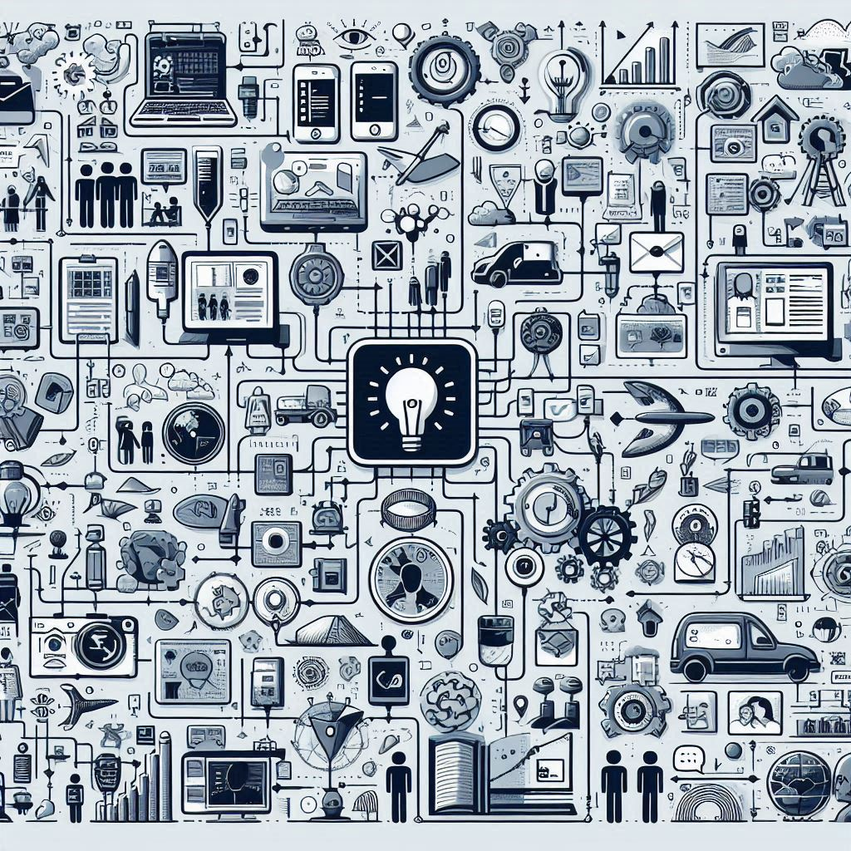

# 2. Requirements Discovery

## 2.1 Target Users

The target users include designers, developers, educators, and general users who require efficient tools.

## 2.2 Interview/Questionnaire

Interviews or questionnaires were conducted with 2-3 target users. Below are **sample questions** (at least 8-10 questions):

1. What are the biggest challenges you face when using existing design tools?
2. How would you like to customize the interface of the application?
3. Which features are most important for improving your productivity?
4. How do you evaluate the cross-platform compatibility of existing tools?
5. How important is real-time collaboration to your workflow?
6. Would machine learning integration (e.g., intelligent design suggestions) appeal to you? Why?
7. What kind of interface design would reduce the learning curve for you?
8. What are your performance and response time expectations for such a tool?
9. What features would help reduce your reliance on physical design tools?
10. Any other expectations or suggestions for an interactive design tool?

**Summary of Responses**: Users need a tool that is easy to learn, highly customizable, and fast, with strong interest in real-time collaboration and intelligent features.

# 3. Use Cases and HCI Scenarios

## 3.1 Persona

**Name**: Alex, 28 years old, UI/UX Designer

* **Background**: Works at a startup and is under high pressure to complete design tasks quickly.
* **Needs**: A tool that is easy to use, works across platforms, and provides intelligent design suggestions.
* **Pain Points**: Existing tools have a steep learning curve and poor performance.

## 3.2 HCI Scenarios

1. **Scenario 1**: Alex needs to collaborate with a remote team to design a new product. He uses the application's real-time collaboration feature to share designs and receive feedback.
2. **Scenario 2**: Alex uses machine learning integration to receive intelligent design suggestions and automatically detect and correct design errors.

## 3.3 Use Case Diagram

Include at least the following 8-10 use cases:

1. User login and authentication
   * The user provides a username and password to access the application. The system verifies the credentials and grants access if authentication is successful.
2. Customizing the interface layout
   * Users can modify the interface by adjusting the layout, themes, and shortcuts to match their preferences, enhancing their workflow and comfort.
3. Creating and saving a new project
   * Users can start a new design project, input project details, and save their progress locally or in the cloud for future access.
4. Real-time collaboration and sharing
   * Multiple users can collaborate on the same project in real-time, sharing updates instantly and receiving feedback from team members.
5. Importing and exporting design files
   * Users can import design files from external sources and export completed projects in various file formats compatible with other design tools.
6. Generating design suggestions using machine learning
   * The application analyzes user inputs and provides intelligent design suggestions, such as layout improvements and color scheme recommendations, based on machine learning models.
7. Detecting and fixing design errors
   * The system automatically identifies common design issues (e.g., alignment problems or color contrast issues) and suggests fixes to improve the overall design quality.
8. Optimizing workflow with keyboard shortcuts
   * Users can use customizable keyboard shortcuts to quickly execute common tasks, such as saving projects, undoing actions, and switching between tools.
9. Seamlessly switching between different platforms
   * Users can access the application on different operating systems (Windows, macOS, Linux) without losing functionality or data, enabling a seamless experience.
10. Managing user permissions and collaboration settings
    * Administrators can control user permissions, assign roles, and configure collaboration settings to ensure secure and efficient teamwork within the application.



**Figure 2: Use Case Diagram:**

# 4. Functional Requirements

## 4.1 Level 1: Fully Implemented Features (To be completed by December 2020)

* User login/registration
* Customizable interface layout
* Cross

## 4.2 Level 2: Partially Implemented Features

* Real-time collaboration (some features may have limited performance)
* Basic intelligent design suggestions (initial version)
* User management and permission control for collaboration

## 4.3 Level 3: Future Development

* Fully optimized machine learning models for advanced design suggestions
* Advanced cross-platform synchronization and file management
* Support for virtual reality (VR) and augmented reality (AR) design environments
* Deep integration with third-party applications (e.g., Adobe, Figma)