**Data Structures project:**

**Network Analysis Using Graphs:**

**Group Members:**

* Ehtsham Walidad **21I-0260**
* Sarim Aeyzaz **21I-0328**

**We used the data set: (**[**https://arxiv.org/archive/gr-qc**](https://arxiv.org/archive/gr-qc)**)**

But the code is generic it can run on the other 2 datasets.

**Number of Nodes and edges:**

We read the total number of Nodes and Edges from the third line of the text file display it.

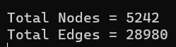

**Number of Source Nodes:**

A vertex with zero in-degree is called a source node. This means that no other node in the graph has an edge which points towards our node. We count the total source nodes by counting how many nodes are not present over every single node’s neighbour list.

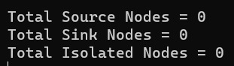

**Number of Sink Nodes:**

A vertex with zero out-degree is called a sink vertex. This means that this node does not have an edge towards any other node in the graph. We count the total Sink Nodes by counting how many nodes point to nothing as their neighbour.



**Number of Isolated Nodes:**

A vertex with in-degree and out-degree both equal to zero is called an isolated vertex. We count the total Isolated Nodes by counting how many nodes in our graph exhibit properties of both sink and source node.



**Number of Bridge Edges:**

A bridge edge is an edge which upon removal, disconnects the graph. We used our linked list array for the graph and traversed over every edge in the graph. We’ll now refer to the 2 nodes associated with the edge as parent and child node. Next, perform the BFS (Breadth-First Search) on the parent node and if it still includes the child node in its BFS list, then the aforementioned edge will be considered as a bridge. Reconnect the edge and do the same procedure on every single edge and count the total number of bridges and store it in a file (as this procedure will take several hours). Now, at any later point, just read the file again and display the value of total bridges.



**Number of Articulation Nodes:**

An articulation node is defined as a node which when deleted disconnects the graph. It has almost the same procedure as calculating bridge edges. First, traverse over a node, delete it and store the linked list associated with it in a temporary value. Now, do the BFS on every neighbor it points to and see if the node is included in the BFS. If they all don’t exist, that means our node is an articulation node and thus, increase the count for our total number of articulation nodes. Finally, store the value in a file and at any later point, just read the file and display the value of total articulation nodes.



**Shortest path Length Distribution and diameter:**

Traverse the entire node’s list and for every node, get its shortest path to every other node using Dijkstra’s algorithm. After the algorithm completes, store this in a file on append mode where the index of line number represents the node’s number in our linked list array it’s referring to. Do this for every single node and a file of 5000x5000 numbers should be saved. Each number in this file represents the path length from 1 node to another.

Now create an array where the index will represent the path length and the value of the index represents the count of said path length. For example, there are 14 paths with path length 17 in this entire network. We also find the maximum path length in this which will be the diameter of our graph. On the next page is the probability distribution table of the path length.

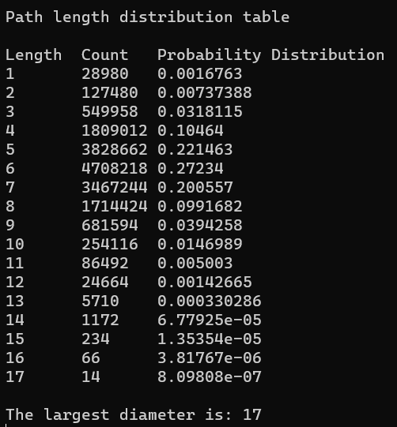

**In-Degree Distribution:**

We calculate the in-Degree of a node by counting how many nodes point towards it in the entire graph. As such, these values are stored in an array where the index represents the degree number and the value of the index represents the count of the degree number. E.g. In the below picture, there are 1197 nodes with an in-Degree of 1. For the sake of displaying it properly, we removed the degree entries which had a count of 0. We also included a probability distribution of every degree too.

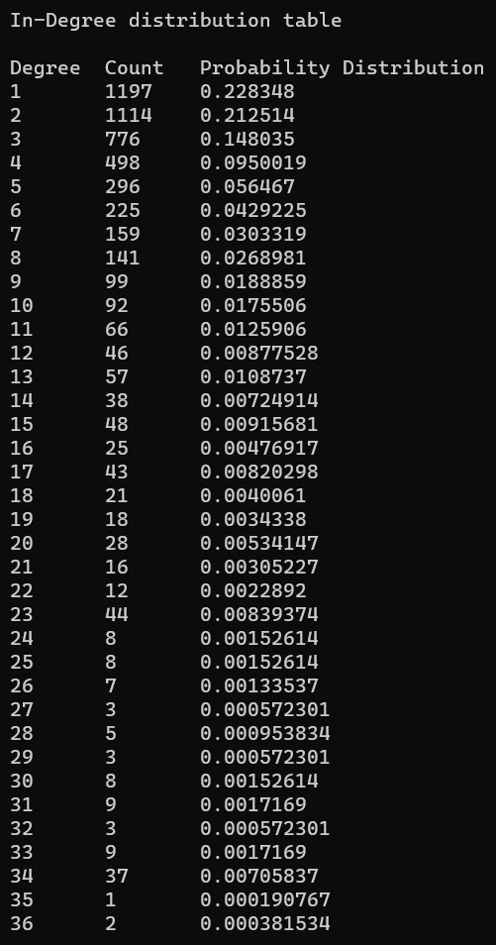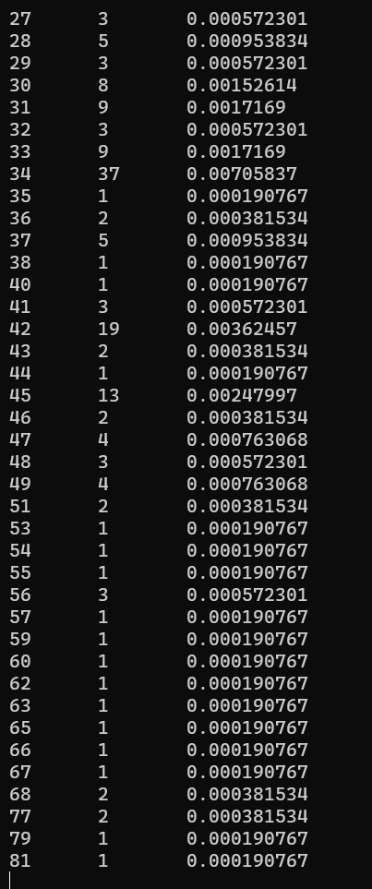

**Out-Degree Distribution:**

We calculate the Out-Degree of a node by counting the neighbors of the specific node, and store in array. As such, these values are stored where the index represents the degree number and the value of the index represents the count of the degree number. E.g. In the below picture, there are 1197 nodes with an in-Degree of 1. For the sake of displaying it properly, we removed the degree entries which had a count of 0. We also included a probability distribution of every degree too. It is very important to note here that both in-Degree and out-Degree table are the same and they should be the same as every single cluster is a completely connected graph. This will be touched on more in depth later.

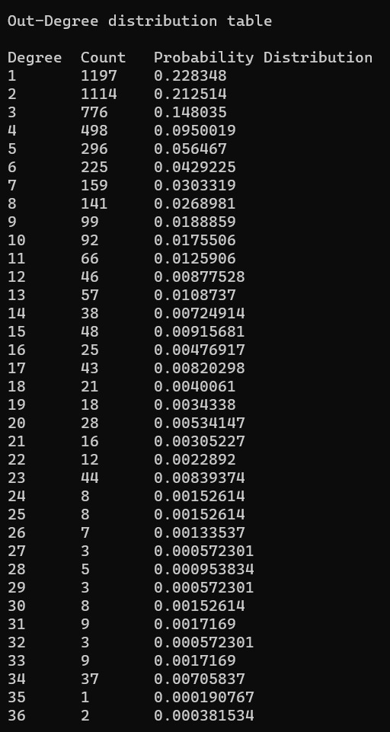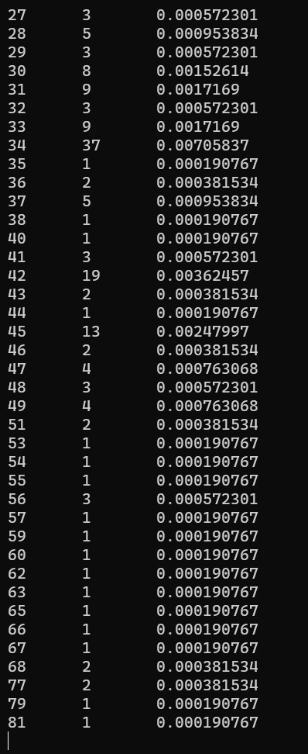

**Size of the largest strongly connected component (SCC) and distribution of all SCCs:**

We first made two algorithms functions called the in-Algorithm and Out-Algorithm. The In-algorithm gathers a list of all nodes that point towards the node 'v' and Out-Algorithm gathers a list of all nodes that point away from node 'v'. Then we made a function which finds the strongly connected nodes this function. Return the list of all the nodes which are found commonly between the In-Algorithm and Out-Algorithm of each node. However, this is replaced with a shortcut thanks to the unique properties of our dataset provided. In our project, it is mentioned that every cluster is a completely connected sub-graph. We can double-check this by counting source, sink and isolated nodes. If all 3 values equate to 0, according to graph theory, the entire graph will become fully connected and as such, every single node in the graph will be included in the SCC list.

Therefore, the shortcut way to calculate SCC list in our graph is just to create a list of every single node in our graph.

Now we will discuss the SCC Table. Loop over every single node in the SCC list and generate it’s BFS and get the count of all of the nodes of the BFS which are included in the SCC list. Store this ‘size of cluster’ in an array where the index represents the size of the cluster and the value represents the count of the cluster sizes found. However, there is also another shortcut we can use here which will save a lot of calculations. If the next SCC node is already present in the previous BFS list, that means it will generate the same BFS since this is a fully connected cluster. So, instead of calculating another BFS, just increment the size count of previous cluster again and continue over to the next iteration. Finally, store this array in a text file and display it whenever you need it again.

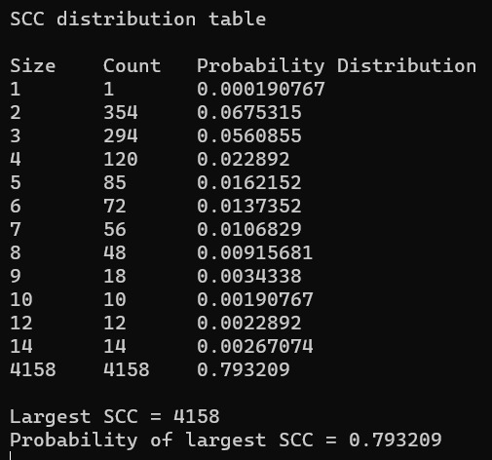

**Size of the largest weakly connected component (WCC) and distribution of all WCCs:**

For WCC it’s the exact same logic as SCC but this time, any BFS/LinkedList array associated function is grabbed from an undirected version of this graph. The table, nodes calculation and the Probability Distribution are same as mentioned above for SCC but this time the undirected graph is used. It is important to note that both these table will and **should** generate the same exact values since our graph is fully connected on every cluster.

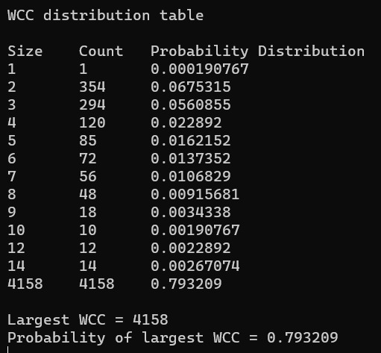

Thank you!