TASK 1
code

#include<stdio.h>
int main(){
double number1;
double number2;
double result;
printf("Enter number 1 :");
scanf("%lf",&number1);
printf("Enter number 2 :");
scanf("%lf",&number2);
result=number1+number2;
printf("The result of addition of number 1 and number 2 is %.3lf.",result);
}

output

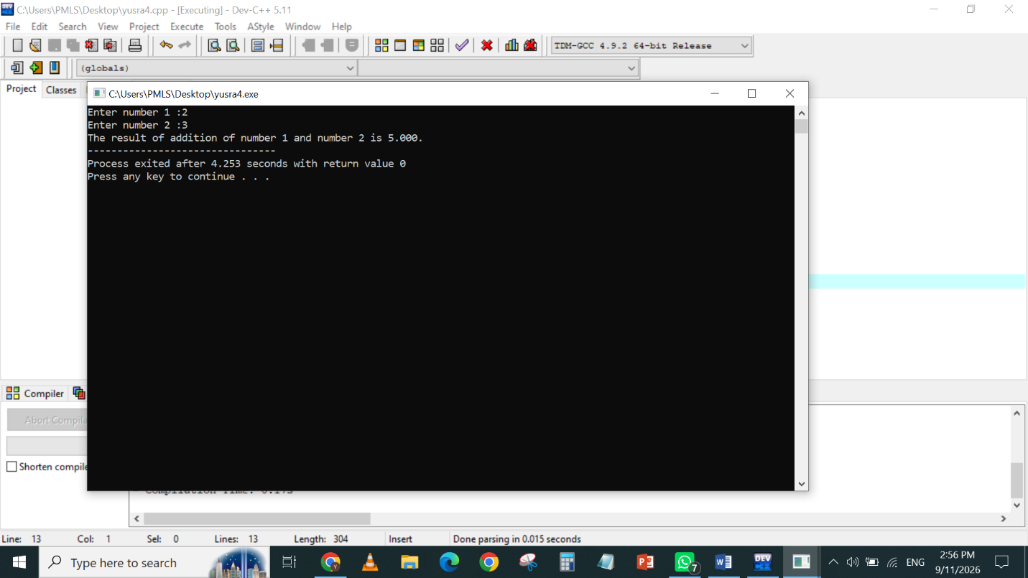

TASK 2
code
#include<stdio.h>
int main(){
double obtained_marks;
double total_marks;
double percentage;
printf("Enter obtained marks:");
scanf("%lf",&obtained_marks);
printf("Enter total marks:");
scanf("%lf",&total_marks);
percentage=(obtained_marks/total_marks)*100;
printf("The percentage of the student is %.3lf.",percentage);
}

output

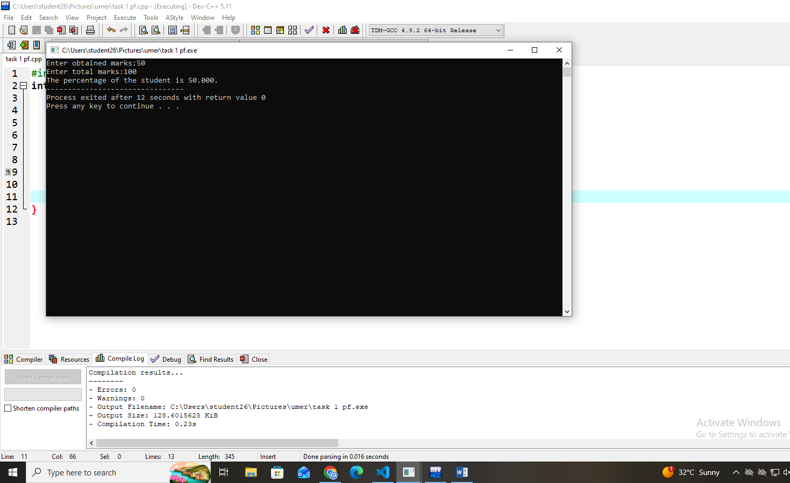

TASK 4
code

#include<stdio.h>
int main(){
int age;
printf("Enter your age :");
scanf("%d",&age);
if(age>=18)
{
printf("You are eligible to vote");
}else{
printf("You are not eligible to vote");
}
}

Output

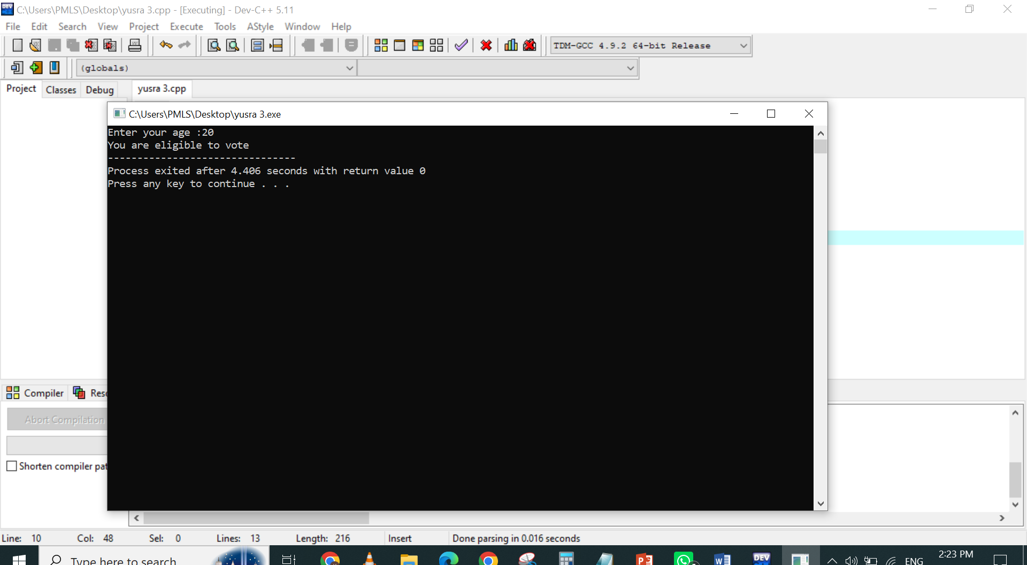

TASK 3
code

#include<stdio.h>
int main(){
int number;
int remainder;
printf("Enter your number:");
scanf("%d",&number);
remainder=number%2;
if(remainder==0)
{
printf("Your number is even");
}else{
printf("Your number is odd");
}
}

output

