TASK 1
#include<stdio.h>
int main()
{
float temperature;
printf("Enter Temperature in Celsius : ");
scanf("%f",&temperature);
if(temperature<30)
{
if(temperature<15)
{
printf("Cold");
}
else
{
printf("Normal");
}
}
else
{
printf("Hot");
}
return 0;
}

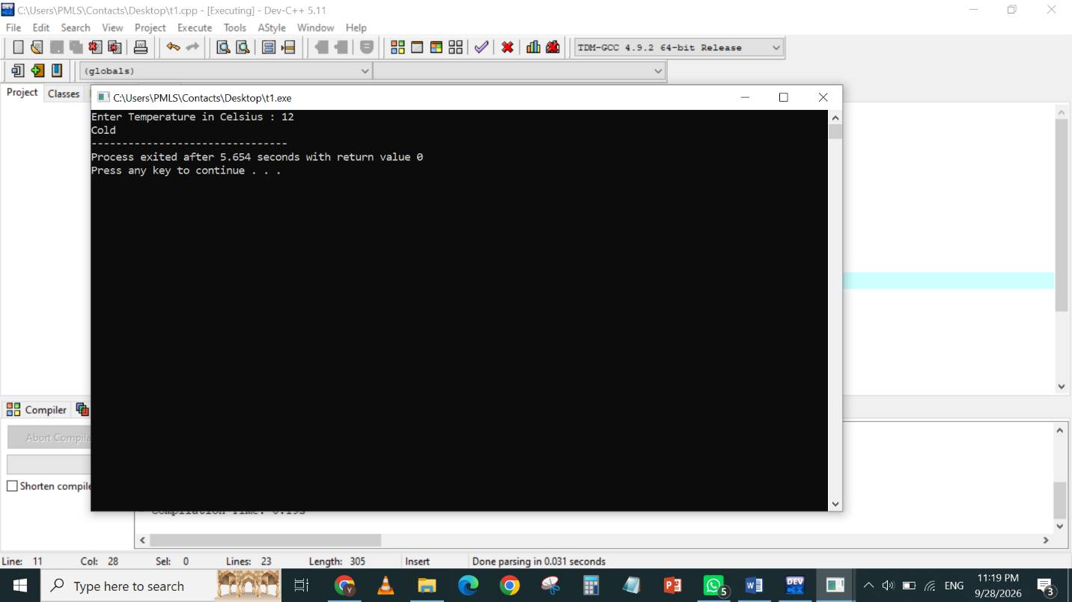

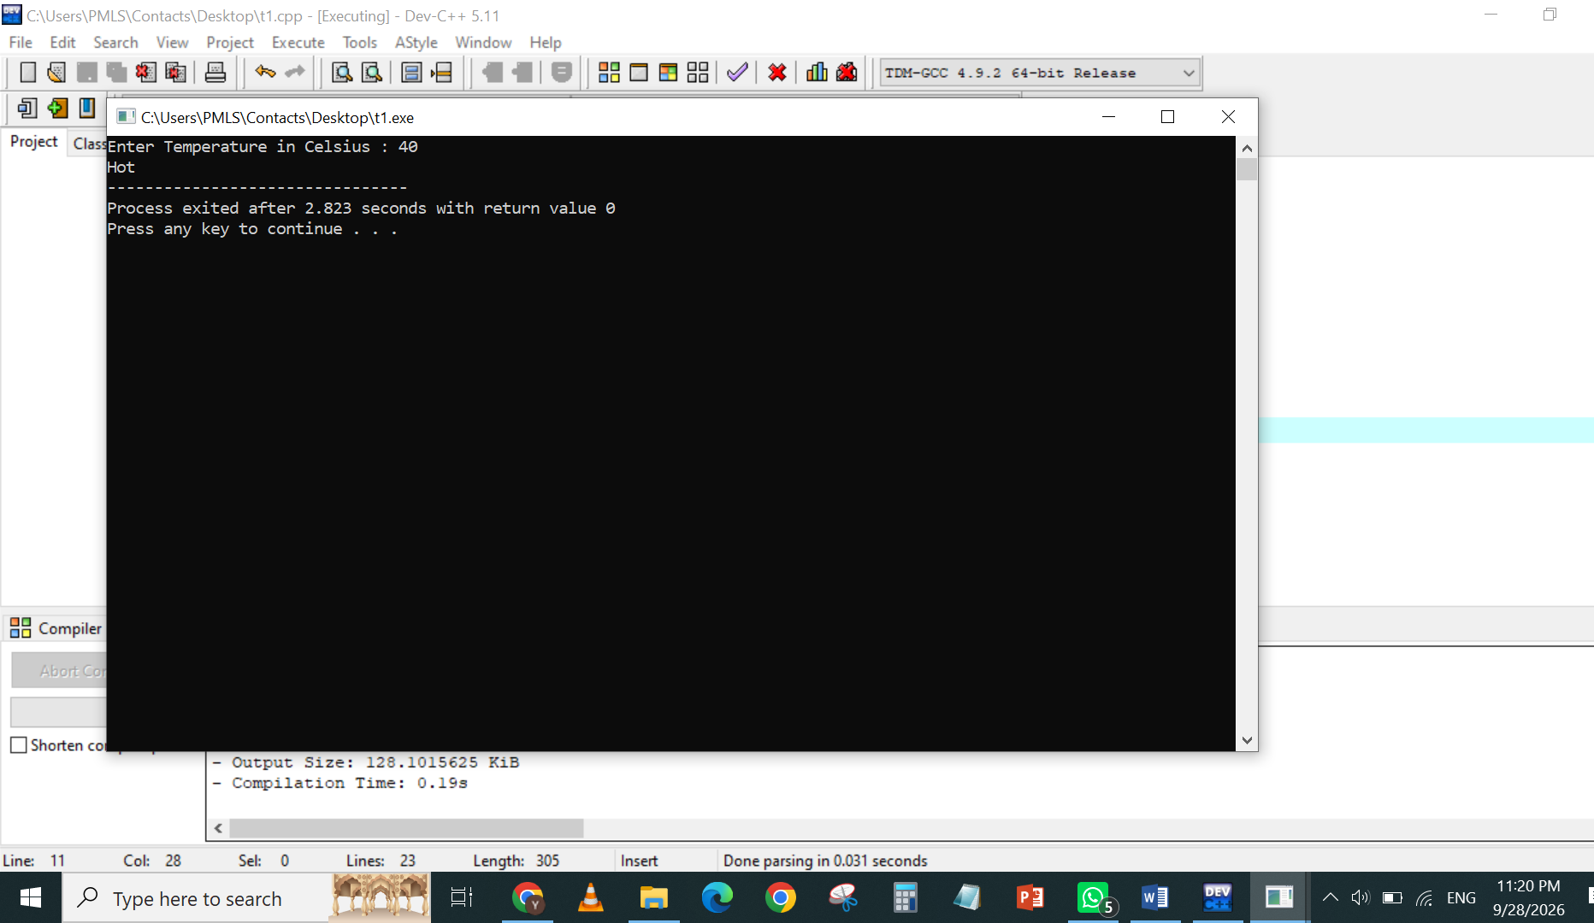
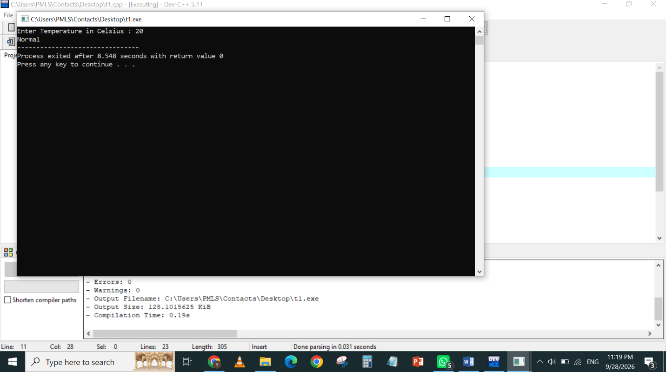

TASK 2
#include<stdio.h>
int main()
{
int balance;
printf("Enter your balance : ");
scanf("%d",&balance);
if(balance<2000)
{
if(balance<500)
{
printf("Low Balance");
}
else
{
printf("Sufficient Balance");
}
}
else
{
printf("Premium Balance");
}
return 0;
}
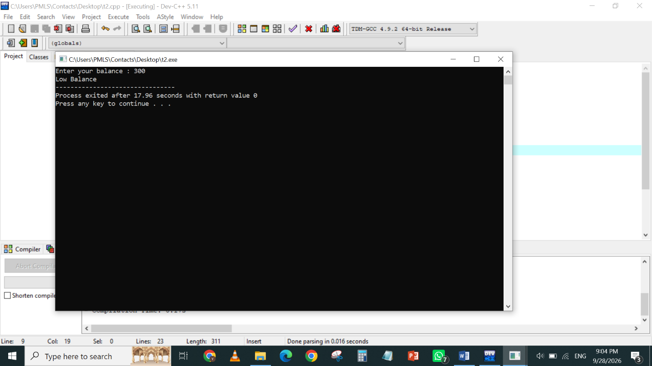
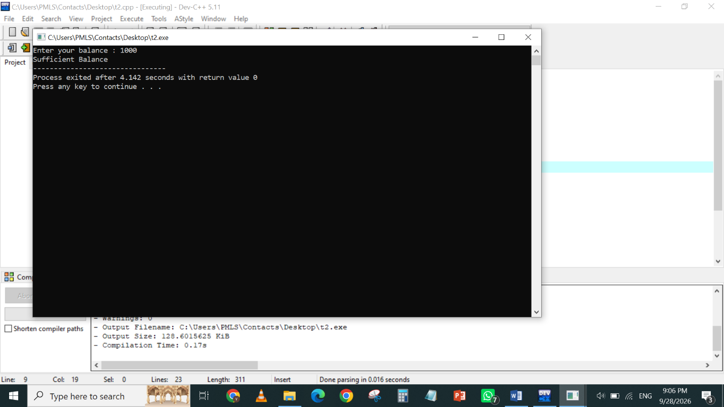
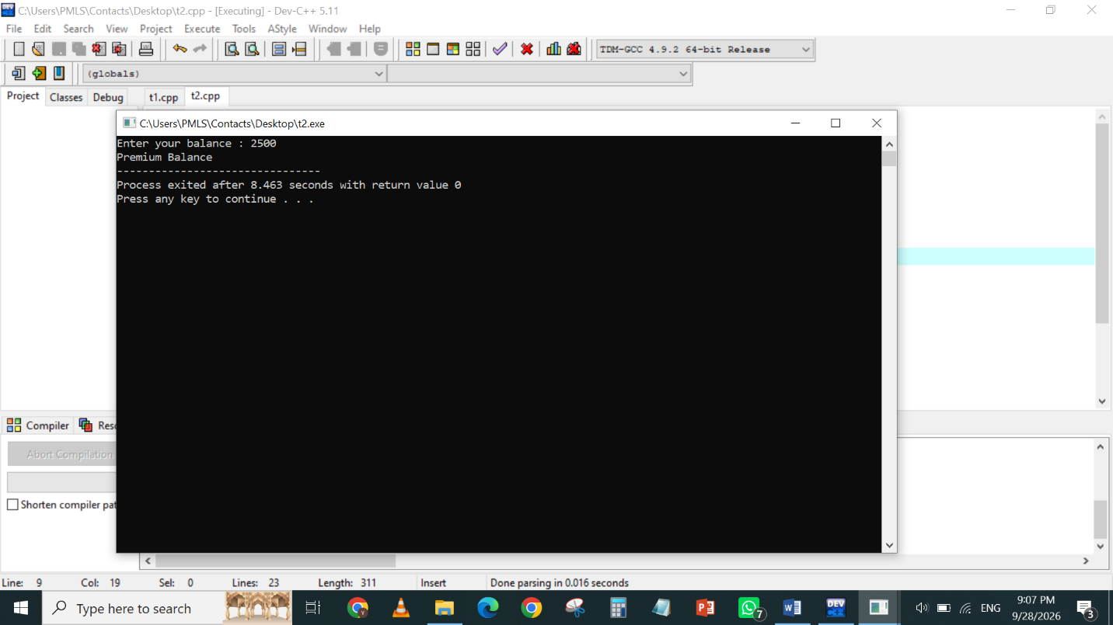
TASK 3

#include<stdio.h>
int main()
{
int appointment;
int doctoravailable;
int registrationCompleted;

printf("Do you have an appointment? (1 for Yes, 0 for No): ");
scanf("%d", &appointment);

printf("Is the doctor available? (1 for Yes, 0 for No): ");
scanf("%d", &doctoravailable);

printf("Is your registration completed? (1 for Yes, 0 for No): ");
scanf("%d", &registrationCompleted);

if(appointment==1)
{
if(doctoravailable==1)
{
if(registrationCompleted==1)
{

printf("You can meet the doctor. ");
}
else
{
printf("You cannot meet the doctor. ");
}
}
else
{
printf("You cannot meet the doctor. ");
}
}
else
{
printf("You cannot meet the doctor. ");
}
return 0;
}
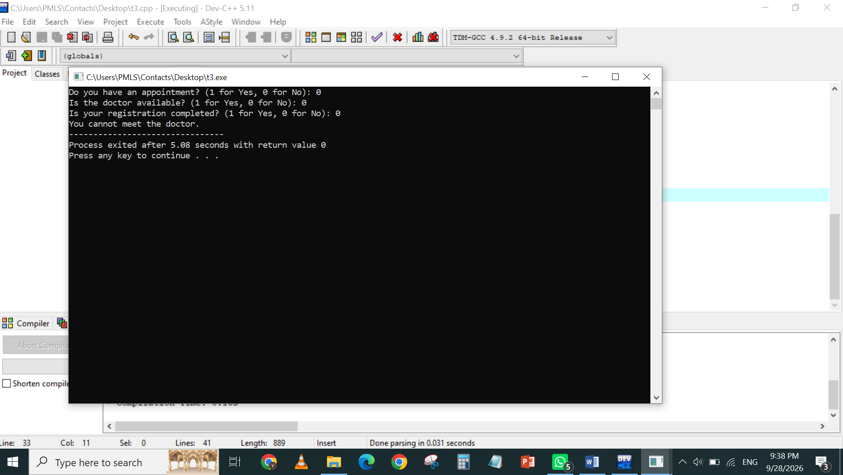
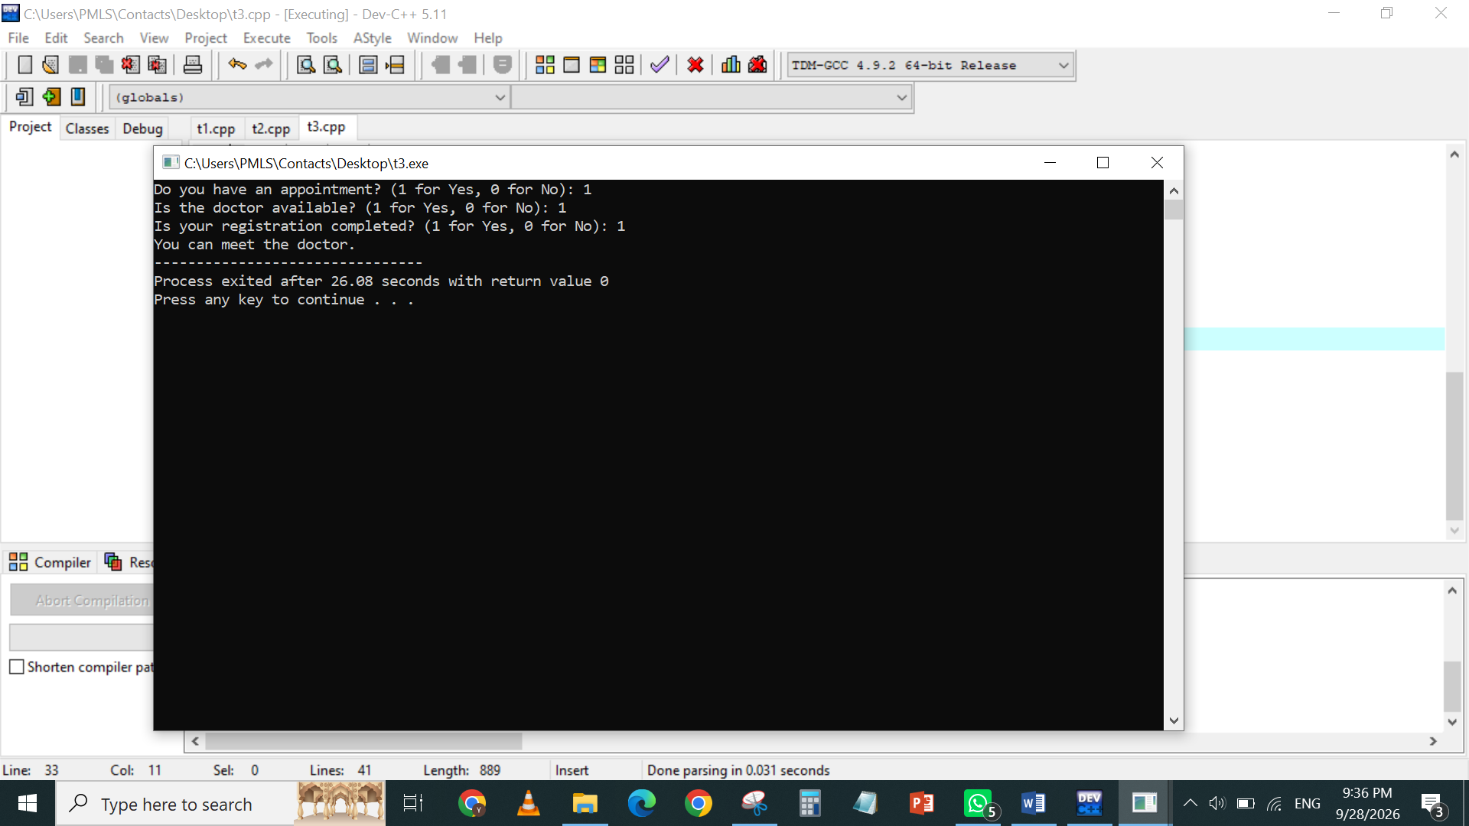

TASK 4
#include<stdio.h>
int main()
{
int restaurantOpen;
int itemAvailable;
int balanceSufficient;

printf("Is the restaurant open? (1 for Yes, 0 for No): ");
scanf("%d", &restaurantOpen);

printf("Is your selected food item available? (1 for Yes, 0 for No): ");
scanf("%d", &itemAvailable);

printf("Do you have sufficient balance to place the order? (1 for Yes, 0 for No): ");
scanf("%d", &balanceSufficient);

if(restaurantOpen==1)
{
if(itemAvailable==1)
{
if(balanceSufficient==1)
{

printf("Your order has been placed successfully!\n");
}
else
{
printf("Insufficient balance. Please recharge your account.\n");
}
}
else
{
printf("Sorry, the selected item is not available.\n");
}
}
else
{
printf("Restaurant is currently closed.\n ");
}
return 0;
}

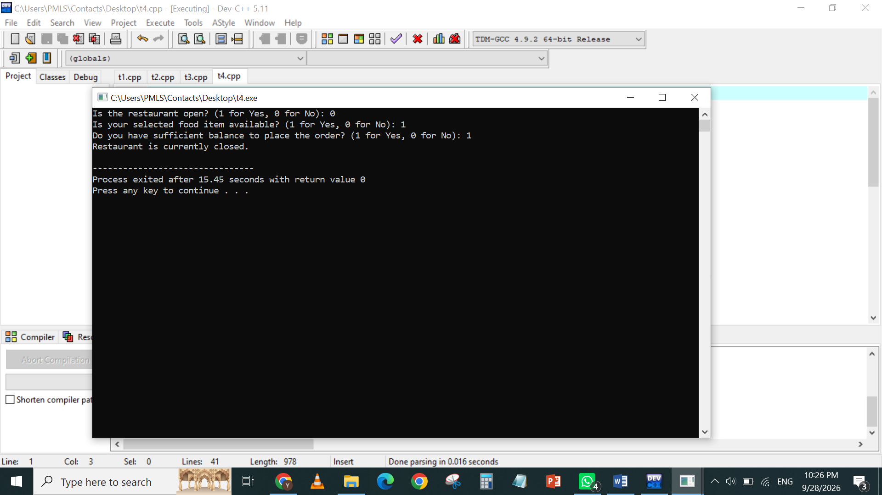
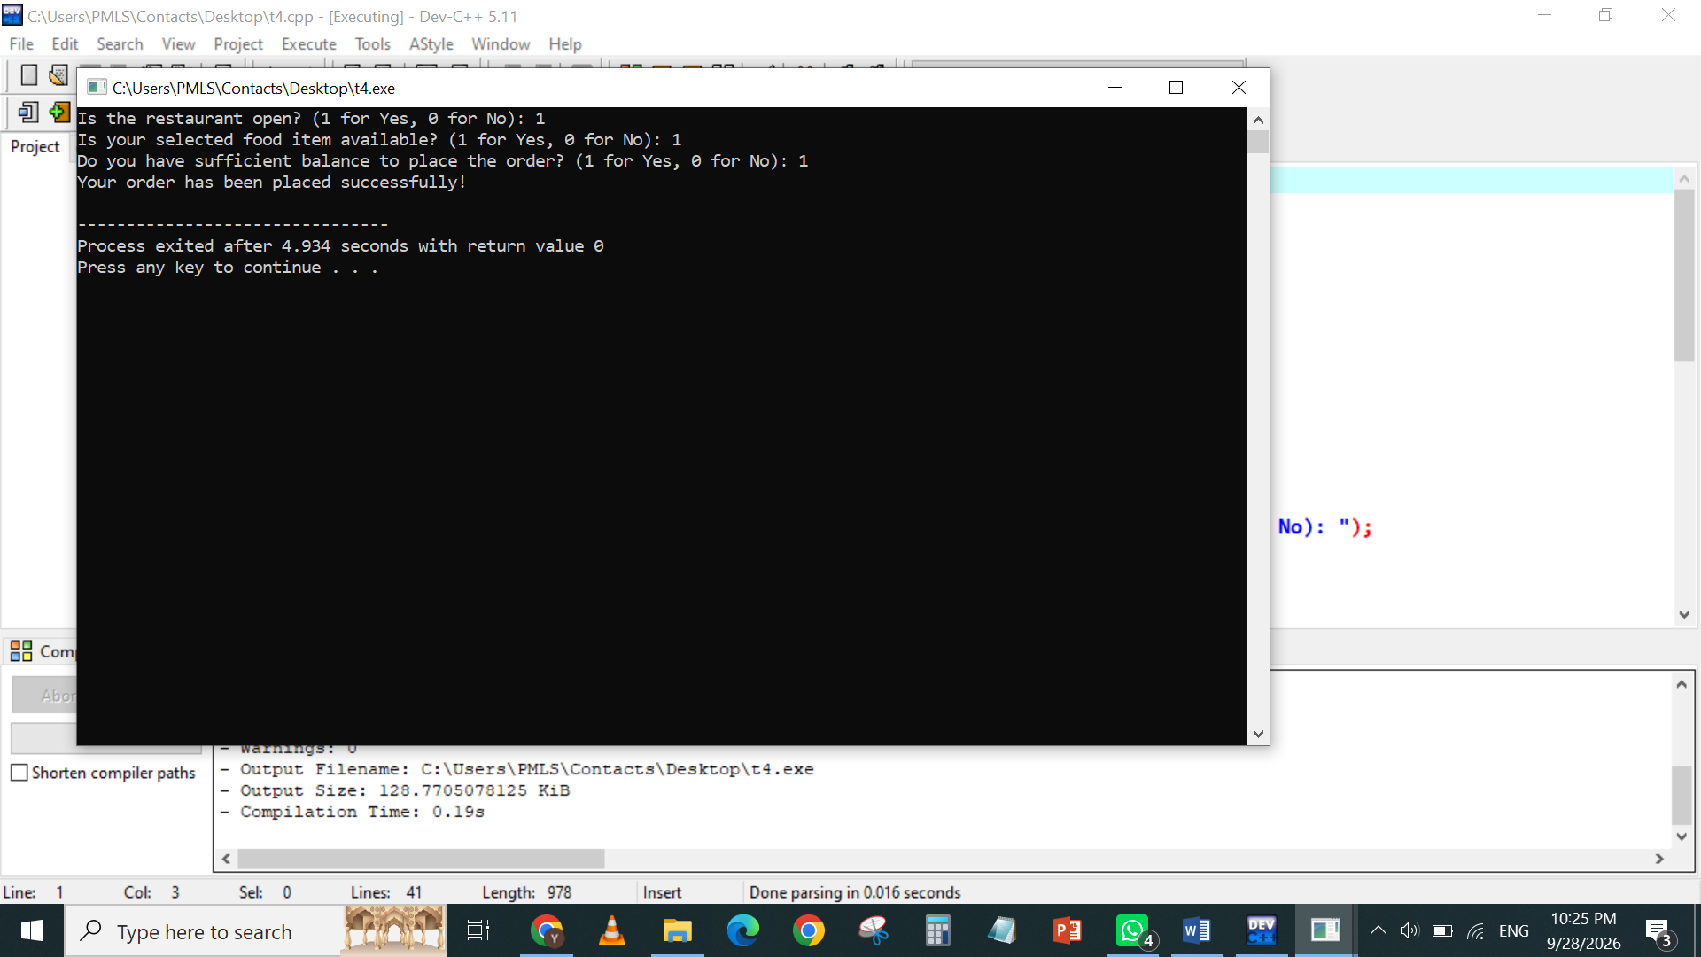

TASK 5

#include<stdio.h>
int main()
{
int operation;
int account;
printf("Enter your desired operations . \n Press 1 for Balance Inquiry, 2 for Cash Withdrawal, 3 for Cash Deposit, and 4 for PIN Change : ");
scanf("%d",&operation);
switch(operation)
{
case 1:
printf(" Balance Inquiry \n");
printf("Press 1 for Savings Account or 2 for Current Account : ");
scanf("%d",&account);
switch(account)
{
case 1:
printf("Operation : Balance Inquiry \n Account Type : Savings Account \n");
break;

case 2:
printf("Operation : Balance Inquiry \n Account Type : Current Account \n");
break;

default:
printf("Invalid Account Type!");
break;
}
break;

case 2:
printf(" Cash Withdrawal \n");
printf("Press 1 for Savings Account or 2 for Current Account : ");
scanf("%d",&account);
switch(account)
{
case 1:
printf("Operation : Cash Withdrawal \n Account Type : Savings Account \n");
break;

case 2:
printf("Operation : Cash Withdrawal \n Account Type : Current Account \n");
break;

default:
printf("Invalid Account Type!");
break;
}
break;

case 3:
printf(" Cash Deposit \n");
printf("Press 1 for Savings Account or 2 for Current Account : ");
scanf("%d",&account);
switch(account)
{
case 1:
printf("Operation : Cash Deposit \n Account Type : Savings Account \n");
break;

case 2:
printf("Operation : Cash Deposit \n Account Type : Current Account \n");
break;

default:
printf("Invalid Account Type!");
break;
}
break;

case 4:
printf(" PIN Change \n");
printf("Press 1 for Savings Account or 2 for Current Account : ");
scanf("%d",&account);
switch(account)
{
case 1:
printf("Operation : PIN Change \n Account Type : Savings Account \n");
break;

case 2:
printf("Operation : PIN Change \n Account Type : Current Account \n");
break;

default:
printf("Invalid Account Type!");
break;
}
break;

default:
printf("Invalid Operation! Please enter 1 to 4.");
break;

}

return 0;
}

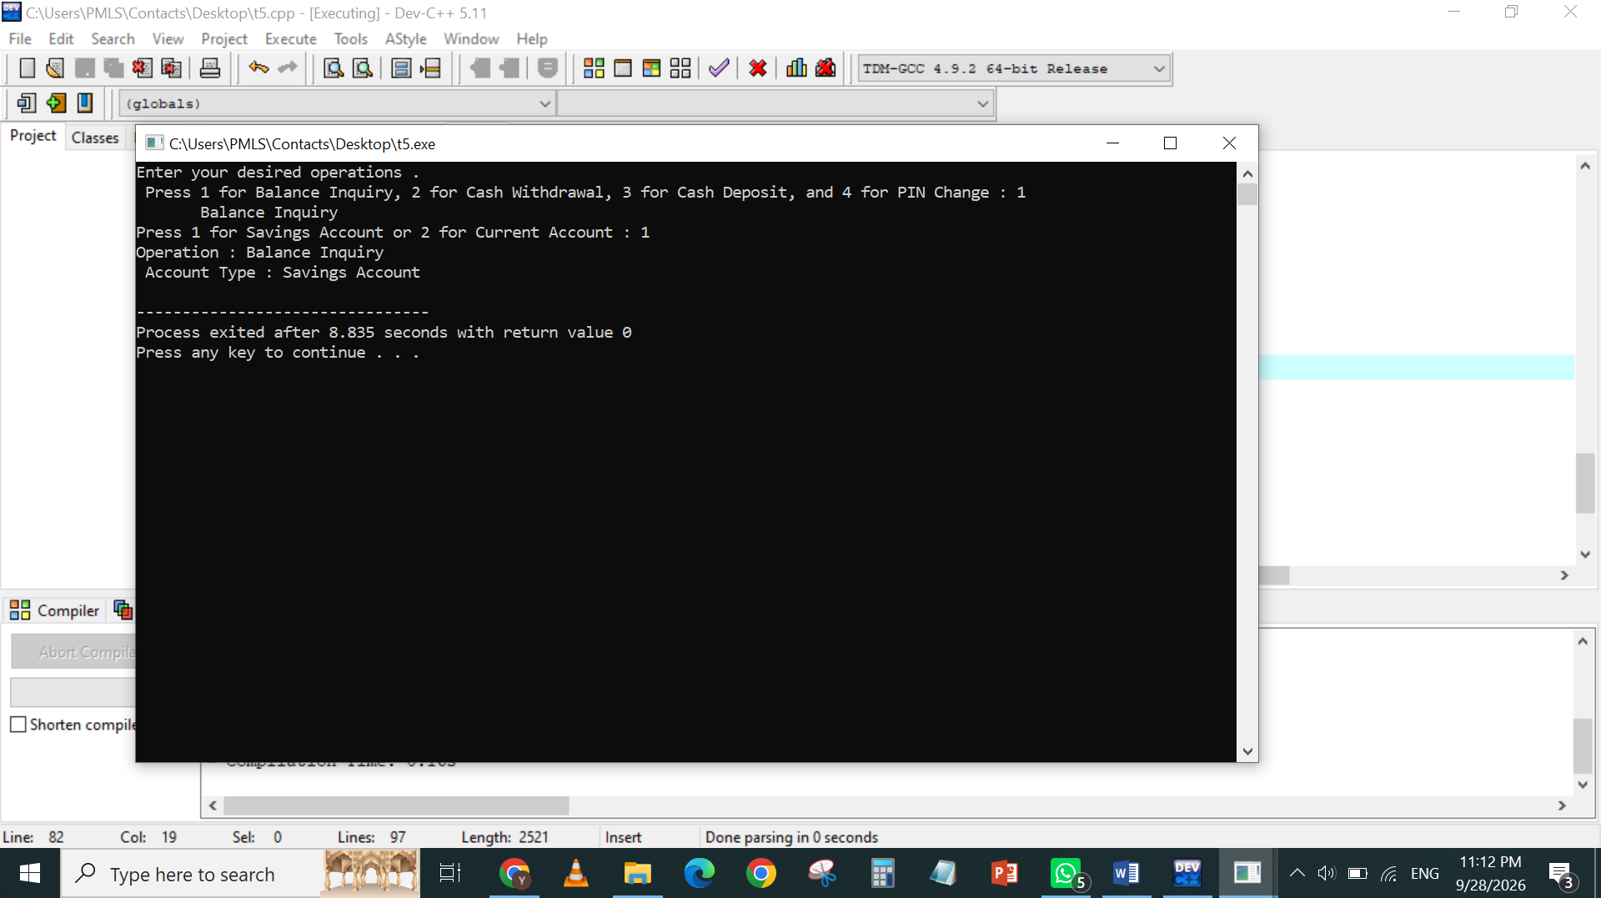
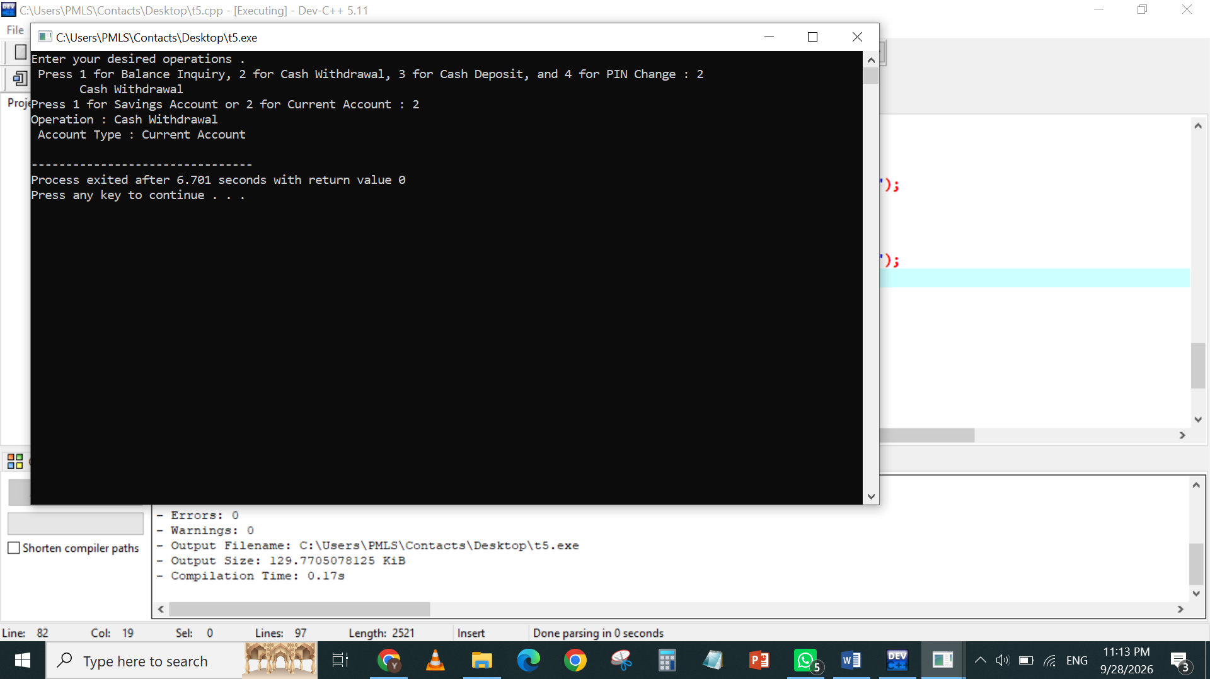
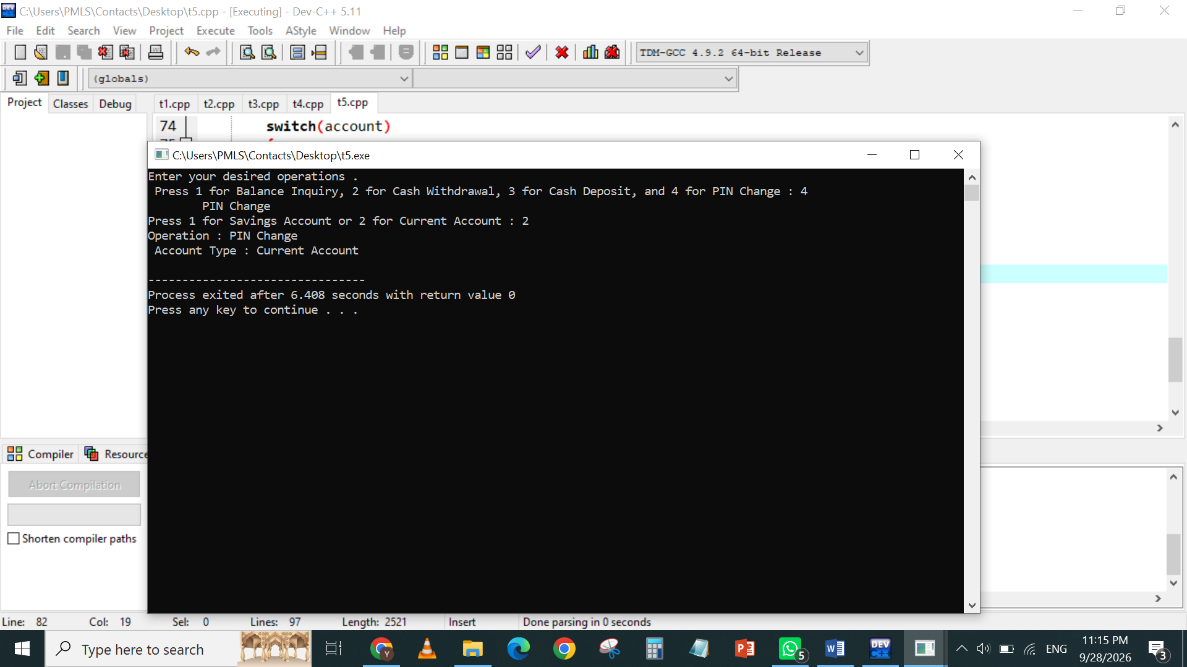

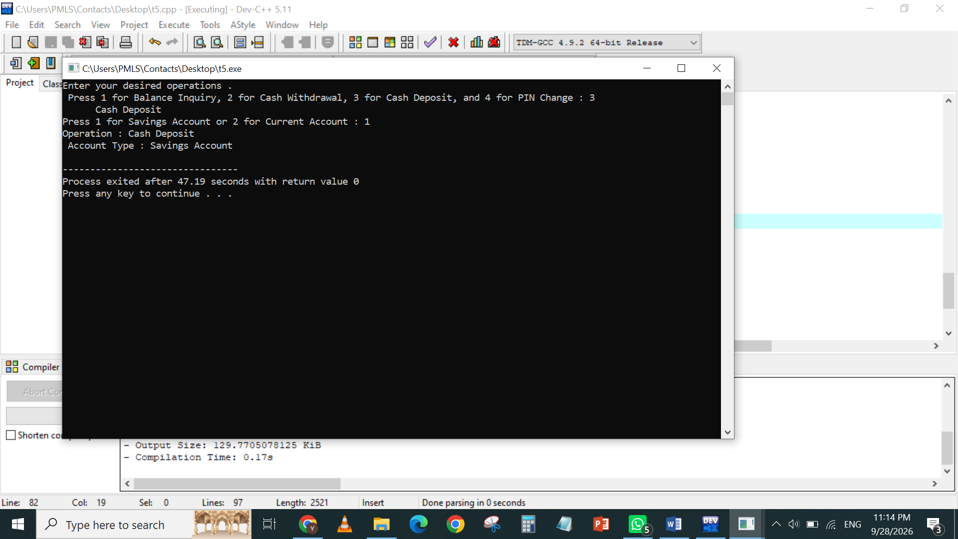
NAME YUSRA ANSARI
ROLL NUMBER 26K-3132
SECTION BSE- 1D

