**DEPARTMENT OF COMPUTER SCIENCE**

**FAST NUCES, ISLAMABAD**

**SUBJECT NAME: DATA BASE**

**PROJECT**

**Submitted By:**

Yusra Masood_23i-0565

Sana Khalid_19i-1955

Salar Shoib_20i-0830

**Course Code: SS2012**

**Instructor: Ms. Hira Mastoor**

**Section: BS-CS-G**

Submission Due-Date: April 22, 2025

**EERD**

**Screenshots:**

Following is the screen shot of the entity relationship model. For easy navigation part wise screenshots are also attached in the document:

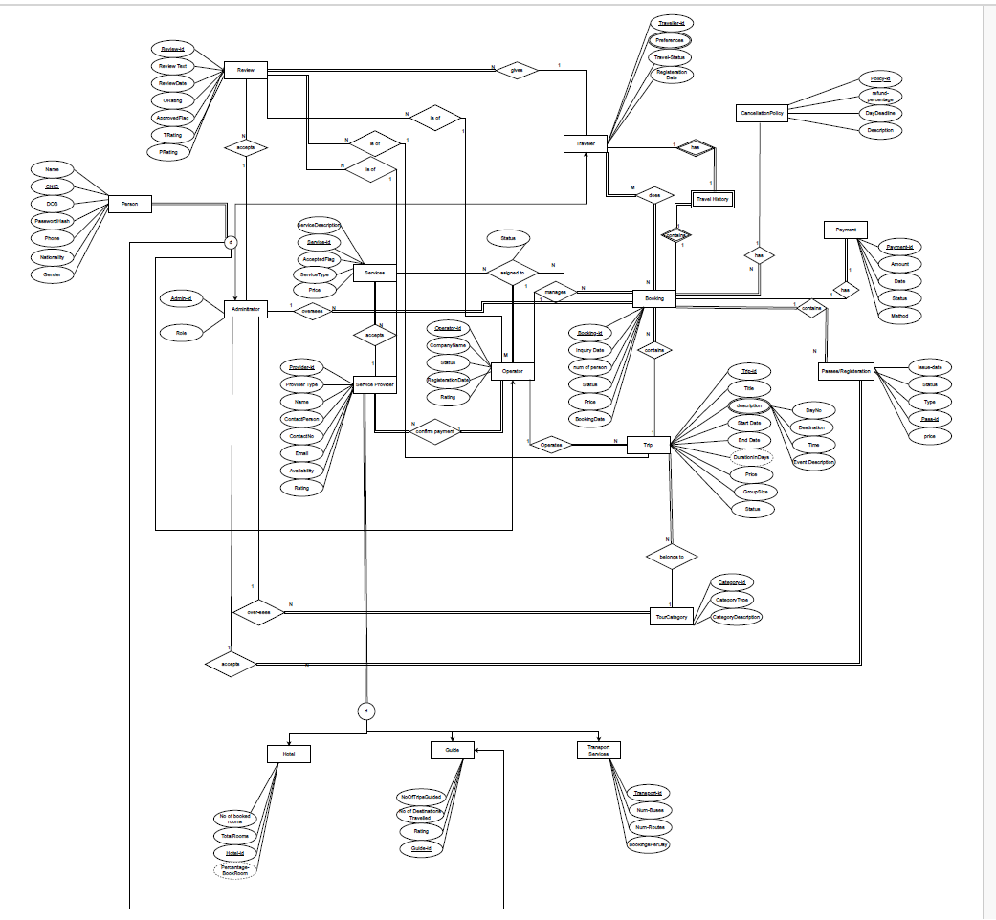

The part wise screenshots in 3 parts are as follows:

**Assumptions:**

It has been assumed that in each review, traveler provides review of operator, trip and service provider assigned to it. Each booking has a cancellation policy, and each traveler has a travel history that is the same as the bookings made by a traveler. Furthermore, Trip description is a multivalued composite attribute as the frontend must show list of trips and activities done on the trip. Due to this implementation of the trip description, the need for an itinerary entity is also fulfilled. A new registration entity has been added as booking has registrations and the administrator manages all the registrations and can cancel any registration. Service Provider confirms the service registration payment through the operator. Operator can manage N trips at a time, but it is not necessary for every operator to manage a trip. It has been tried to give each entity a unique id.

**RELATIONAL MAPPING**

**Screenshots:**

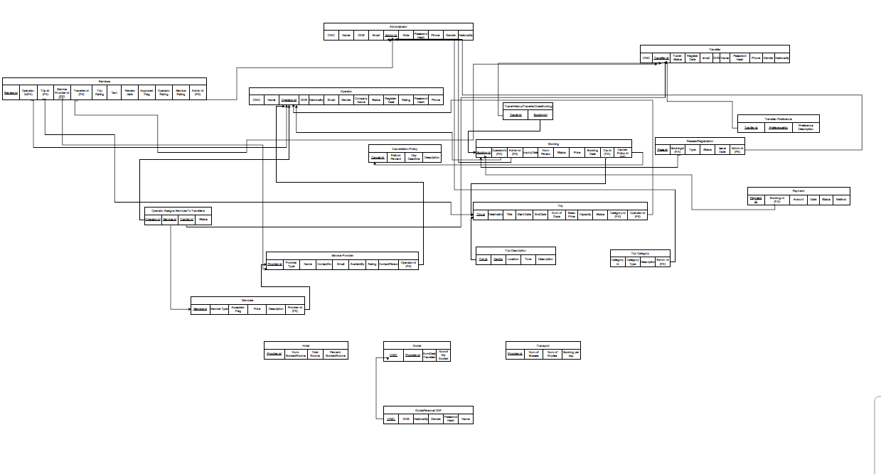

Part wise screenshots are as follows:

The person class has a specialization in Operator, Traveler, Guide and Administrator. The concept of 8b that is merging the tables has been followed here and the primary key is unique in each table that is their id. Other possible prime attributes are not including into the primary key to avoid composite key. In the scenario that service provider can be a hotel, guide or transport department, specialization has been done to incorporate this. Rule 8a has been followed that says duplication of primary key

All the tables are in First normal form and separate tables have been created for multivalued attributes and many to many relations. Furthermore, composite key is avoided to keep the project implementation as simple as possible. This step of avoiding composite key is done by giving a unique id in the respective entities.

The table of guide info as inherited from person has 2 ids that is CNIC and Provider-Id therefore to convert it into second normal form the table is split into guide personal info and guide info respectively.

**SQL_ TABLE CREATION AND INSERTIONS**

**Details:**

The SQL file containing the table creations and insertions is provided in the zip folder. Insertions were done using SQL code and then the resultant tables were exported as csv files. The query of SELECT* from (Table Name) was run and the results were saved in the given format. The csv files are also present in the zip folder