🎨 Master Prompt: Abstract Art Gallery Website
Project Name: The Abstract Art
Goal: Design a clean, creative, and responsive art gallery website using HTML5 and CSS that demonstrates semantic structure, styling techniques, and modern design principles for an academic evaluation.

1️⃣ Website Overview
Create a single-page abstract art gallery website that showcases four artworks and a brand logo.
The site should feel artistic, modern, and visually engaging while remaining neat and readable.

2️⃣ Assets (Use Exactly These File Names)
- Logo: logo.jpeg
- Gallery Images (in order):
  - img1.jpeg
  - img2.jpeg
  - img3.jpeg
  - img4.jpeg

3️⃣ HTML Requirements (Must Use HTML5 Semantic Elements)
Use semantic HTML5 elements clearly and correctly:
- <header> – logo + site title
- <nav> – navigation bar
- <main> – main gallery content
- <section> – art gallery section
- <article> – individual artwork cards
- <footer> – copyright & icons
Follow HTML5 best practices and clean indentation.

4️⃣ CSS Requirements
Create and link an external CSS file (style.css) and demonstrate:
✔ Selectors
- Type selectors (e.g., body, h1, p)
- Class selectors (e.g., .gallery, .art-card)
- ID selectors (e.g., #navbar, #logo)
✔ Pseudo-classes
Apply pseudo-classes to navigation and buttons:
- :hover
- :active
- :focus
Example: hover effects on navbar links.

5️⃣ Navigation Bar
- Horizontal navigation bar
- Include links such as:
  - Home
  - Gallery
  - About
  - Contact
- Sticky or fixed navigation is encouraged
- Use pseudo-classes for interaction effects

6️⃣ Typography & Colors
- Use Google Web Fonts for neat typography
- Change:
  - Background color or background image
  - Text colors
  - Font styles and sizes
- Maintain good contrast and readability

7️⃣ Icons
Include CSS icons from:
- Google Icons or
- Font Awesome
Use icons in:
- Navigation bar
- Footer (social media / contact icons)

8️⃣ Responsive Web Design
Implement media queries so the website:
- Works on desktop, tablet, and mobile
- Displays gallery images in:
  - Grid layout on desktop
  - Stacked layout on mobile
Use CSS media queries only (no frameworks).

9️⃣ Creativity & Design
- Artistic layout inspired by abstract art
- Image hover effects (zoom, overlay, shadow, opacity)
- Smooth transitions
- Clean spacing and alignment
- Modern, minimal, and elegant look

🔟 Output Instructions
Generate:
- index.html (HTML5 semantic structure)
- style.css (external CSS file)
Ensure:
- Code is neat, commented, and well-structured
- All requirements are clearly demonstrated
- No unnecessary libraries or frameworks

✅ Best Practice Recommendation
Use CSS Grid for the gallery layout.
This ensures cleaner alignment, better responsiveness, and modern layout control with minimal code.
Last but not the least there shall be an about link in navigation and a feedback form link and the main home link called gallery

Analysis Ans comparison prompt:
analysis & comparison section (what they observed, differences, learning) analyze and compare the two websites (AI gen html AI gen css) And my website ( html , css) codes were provided.
Analysis & Comparison of the Two Websites
1. Overall Observation
Both websites successfully present an Abstract Art Gallery with navigation, gallery images, informational sections, and feedback forms. However, the AI-generated website follows a more modern, structured, and CSS-driven approach, while my own website focuses on manual control, visual customization, and creative layout using inline styling. Each approach demonstrates different web-development techniques and learning priorities.

2. Structure & HTML Semantics
- AI-Generated Website
  - Uses proper HTML5 semantic elements such as <header>, <nav>, <main>, <section>, <article>, and <footer>.
  - Content is well-organized and easy to understand for both browsers and developers.
  - Improves accessibility, SEO, and maintainability.
- My Website
  - Uses basic structural tags like <section>, <table>, <div>, and inline layout techniques.
  - Gallery layout is created using a table, which works visually but is not ideal in modern semantic design.
  - Semantic elements are partially used, but not consistently.
Comparison:
The AI-generated website demonstrates better semantic correctness, while my website shows a traditional and creative but less semantic structure.

3. CSS Styling Approach
- AI-Generated Website
  - Uses a separate external CSS file, keeping structure and design separate.
  - Makes use of type selectors, IDs, classes, and pseudo-classes (:hover, :focus, :active).
  - Includes transitions, animations, shadows, and grid layouts.
  - Easier to update and scale.
- My Website
  - Relies heavily on inline CSS, giving full control over individual elements.
  - Uses fewer reusable classes and more direct styling.
  - External CSS exists but is not fully integrated with the HTML structure.
Comparison:
The AI approach is cleaner and more professional, while my approach is hands-on and visually expressive, but harder to maintain in large projects.

4. Navigation & Interactivity
- AI-Generated Website
  - Sticky navigation bar with hover, focus, and active effects.
  - Smooth user interaction using CSS transitions.
  - Navigation is responsive and consistent across screen sizes.
- My Website
  - Fixed navigation bar with inline styles.
  - Functional scrolling and linking, but minimal hover effects.
  - More manual positioning and styling.
Comparison:
The AI website provides better user experience and interaction, while my website prioritizes custom layout control.

5. Layout & Responsiveness
- AI-Generated Website
  - Uses CSS Grid and media queries for responsive design.
  - Automatically adapts to mobile, tablet, and desktop screens.
- My Website
  - Layout is mostly fixed-width.
  - Limited responsiveness, especially in the gallery and header images.
Comparison:
The AI website is fully responsive, whereas my website is partially responsive.

6. Visual Design & Creativity
- AI-Generated Website
  - Minimalist, modern, and consistent design.
  - Focuses on usability and clarity.
- My Website
  - More artistic and expressive.
  - Uses background images, shadows, color contrasts, and visual emphasis.
  - Strong creative identity.
Comparison:
My website shows strong artistic expression, while the AI website emphasizes design consistency and best practices.

7. Learning Outcomes
From this comparison, I learned that:
- Semantic HTML improves structure, accessibility, and professionalism.
- External CSS is more scalable and maintainable than inline styling.
- Modern layouts (Grid/Flexbox) are superior to tables for design.
- Pseudo-classes and transitions greatly enhance user interaction.
- Creative design and technical best practices should be balanced.

8. Conclusion
Both websites achieve the goal of presenting an abstract art gallery, but from different perspectives.
The AI-generated website reflects industry-standard practices, while my website reflects creativity, experimentation, and manual control. Combining the strengths of both approaches would result in a visually creative, technically strong, and user-friendly website.

My Website:
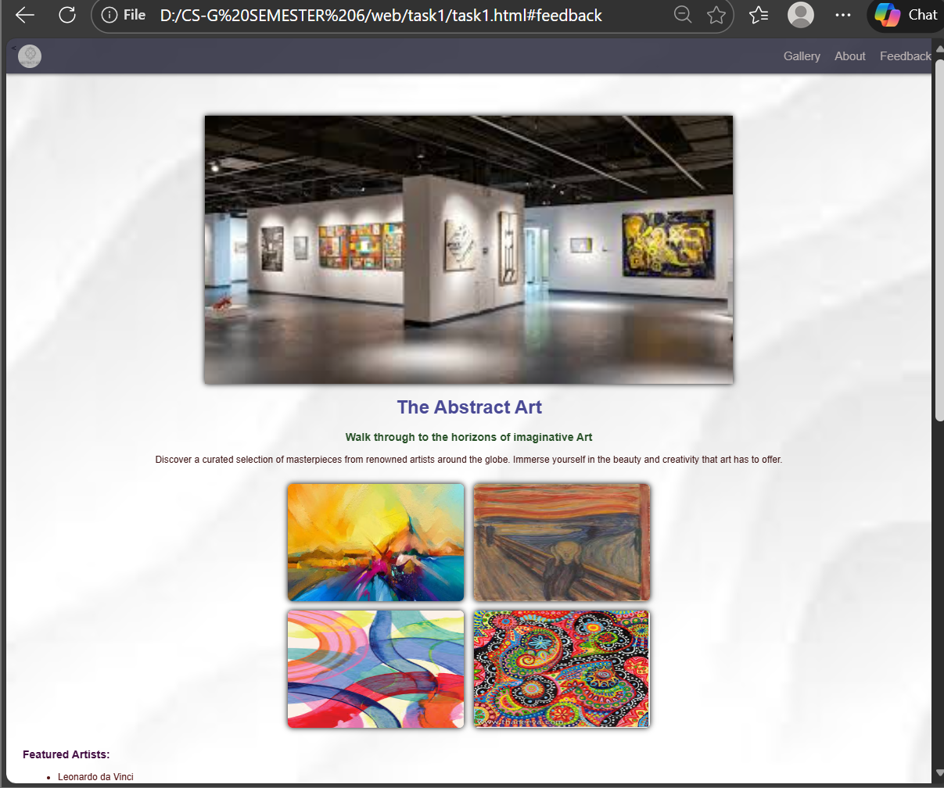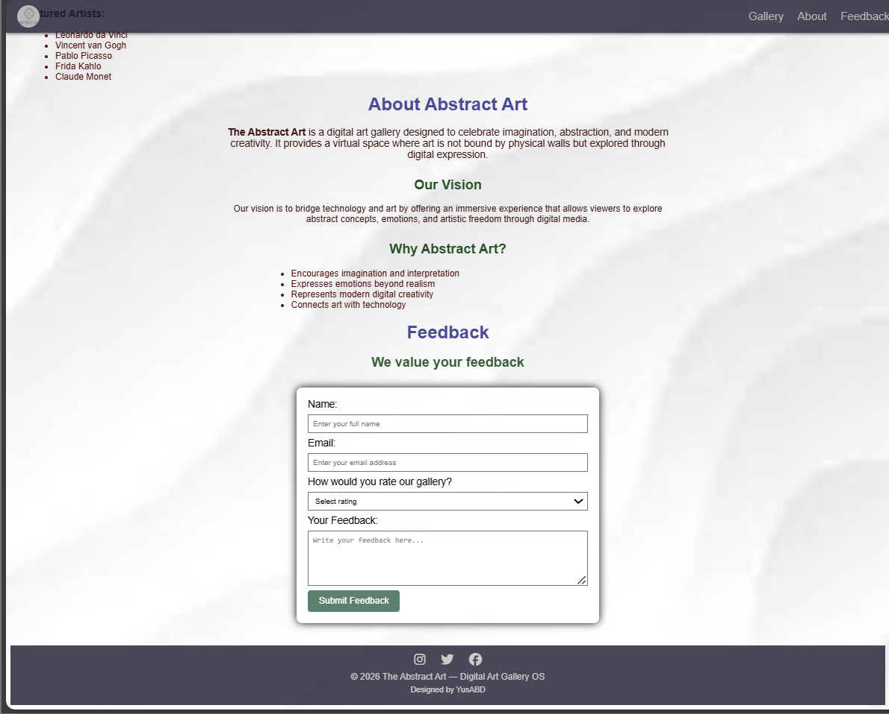
Ai genrerated website:
