Fundamentals of Data Science
Project Report

Topic: HR Employee Attrition in IBM


Done By (Div: B) :-
- Anubhuti Singh – 23030141007
- Sonal Hadmode – 23030141024
- Kunwar Dhruv Parmar– 23030141036
- Yusra Sayed – 23030141082

Table of Contents

Sl. No. | Topic
1. | Introduction
2. | Problem Statement
3. | Objectives
4. | Data Description
5. | Methodology
6. | Business Understanding
7. | Process Understanding
8. | Code
9. | Key insights
10. | Conclusion
11. | Challenges

INTRODUCTION
The IBM HR Employee Attrition dataset, available on Kaggle, is a valuable resource for studying employee attrition and understanding the factors that contribute to it. With over 1,400 observations and 35 features, this dataset provides a comprehensive look into employee characteristics, performance metrics, and reasons for attrition. By analyzing this dataset, researchers and HR professionals can gain insights into the patterns and trends of employee turnover, allowing them to make informed decisions and develop effective strategies to reduce attrition rates. With its rich data and potential for analysis, the IBM HR Employee Attrition dataset is a valuable tool for anyone interested in understanding and addressing employee attrition in the workplace. One of the key advantages of the IBM HR Employee Attrition dataset is its ability to provide a holistic view of employee attrition by including a wide range of features. These features encompass various aspects such as demographics, job-related factors, performance metrics, and employee satisfaction. By examining the relationships between these factors and attrition, researchers can identify potential predictors and risk factors associated with employee turnover. This information can then be used to develop targeted interventions and strategies to address these factors and mitigate attrition rates, ultimately leading to a more engaged and satisfied workforce. Additionally, the dataset's large sample size allows for robust statistical analyses and generalizability of findings, making it a valuable resource for both academic research and practical applications in human resource management.

Furthermore, the dataset includes information on employees from different departments and job roles, providing a diverse and representative sample. This allows researchers to explore how attrition varies across different departments and roles, and identify any specific patterns or trends. By understanding the factors that contribute to attrition in specific areas of the organization, HR professionals can tailor their retention strategies accordingly.

PROBLEM STATEMENT
This project originates from the possibility of enhancing employee contentment, cutting down expenses, elevating organizational efficiency, and fostering a favorable workplace atmosphere. It represents a chance to leverage data and analytics to enact substantial improvements that are advantageous to both employees and the entire organization.

OBJECTIVES
1. Assess the degree of employee satisfaction regarding their job and working environment.
2. Identify the elements that contribute to employee dissatisfaction with the company's policies and guidelines.
3. Pinpoint the areas where the company is falling short or facing shortcomings.
4. Understand the underlying causes of attrition within the company.
5. Develop strategies and methods to minimize attrition rates within the organization.

DATA DESCRIPTION
This data set presents an employee survey from IBM, indicating if there is attrition or not. The data set contains approximately 1500 entries. Given the limited size of the data set, the model should only be expected to provide modest improvement in identification of attrition vs. a random allocation of probability of attrition. IBM has gathered information on employee satisfaction, income, seniority and some demographics. It includes the data of 1470 employees.
Feature Name | Feature Description
Age | Age of employee
Attrition | Attrition in business describes a gradual but deliberate reduction in staff numbers that occurs as employees retire or resign, [NOTE: Target Variable] (0=no, 1=yes)
BusinessTravel | Business travel is travel undertaken for work or business purposes, as opposed to other types of travel
DailyRate | It is the billing cost for an individual's services for a single day.
Department | Consists three departments that contribute to the company's overall mission.
DistanceFromHome | It is the distance between company and home of the employee
Education | Education qualification of the employees of company.
EducationField | Education field of the employees
EmployeeCount | Count of employee
EmployeeNumber | It is a unique number that has been assigned to each current and former employee.
EnvironmentSatisfaction | It is all about an individual's feelings about the work environmentand organization culture.
Gender | Gender of the employee
HourlyRate | The amount of money that is paid to an employee for every hour worked
JobInvolvement | Job involvement refers to the degreeto which a job is central to a person'sidentity.
JobLevel | Job levels are categories of authority in an organization.
JobRole | These refer to the specific activities or work that the employee will perform.
JobSatisfaction | Job satisfaction happens when an employee feels he or she is having job stability.
MaritalStatus | Marital Status of the employee
MonthlyIncome | Gross monthly income is the amountof income an employee earn in one month.
MonthlyRate | If a monthly rate is set, employees should be paid in exchange for normal hours of work of a full-time worker.
NumCompaniesWorked | Number of other companies the employee previously worked for
Over18 | If the employee was above 18 years of age. (Yes or no)
OverTime | Yes or no
PercentSalaryHike | The amount a salary is increased of an employee in percentage
PerformanceRating | Rating means gauging and comparing the performance
RelationshipSatisfaction | It is the rate of satisfaction between Employer employee relationship. 1 being lowest and 4 being highest.
StandardHours | Standard number of hours the employee works
StockOptionLevel

TotalWorkingYears | Total years worked by the employee
TrainingTimesLastYear | Frequency of trainings taken by the employee
WorkLifeBalance
YearsAtCompany | Number of years worked in this company
YearsInCurrentRole | Number of years spent working in the current role.
YearsSinceLastPromotion | Number of years since the employee was last promoted.
YearsWithCurrManager | Number of years spent working with a specific manager.

METHODOLOGY
The methodology for IBM HR Analytics Employee Attrition and Performance Prediction is as follows:-
• Input is taken by loading the IBM dataset, from Kaggle.
• Load the Dataset: The IBM HR Analytics Attrition Dataset is loaded using the pd.read_csv() function. The head() and info() methods are used to display the first few rows and get information about the dataset, respectively.
• Knowing the Dataset: Basic Information about the dataset is generated; numerical and categorical attributes are enlisted.
• Data Cleaning: Any missing values in the dataset are dropped using the dropna() method. In our case, we did not have any missing values or outliers. There was no need to perform any imputation.
• Data Visualization: Matplotlib and Seaborn libraries are used to visualize the data.
• Data Preprocessing: The target variable 'Attrition' is mapped to binary values (1 for 'Yes' and 0 for 'No'). Some other features that were mapped are –
‘BusinessTravel’ where Travel_Frequently, Travel_Rarely and Non-Travel corresponds to 2, 1, 0 respectively.
‘Department’ where Research & Development, Sales and Human Resources corresponds to 2, 1, 0 respectively.
‘Education Field’ where Life sciences, Medical, Marketing, Technical Degree, Other, Human Resources corresponds to 5, 4, 3, 2, 1, 0.
The ‘Gender’ column was encoded using One Hot Encoding method using get_dummies() function where Female gets encoded as 0 and Male as 1. ‘
JobRole’ where Laboratory technician, Sales Executive, Research Scientist, Sales Representative, Human Resources Manufacturing Director, Healthcare Representative, Manager, Research Director Corresponds to 8,7,6, 5,4, 3,2,1, 0 respectively.
‘MaritalStatus’ was encoded using Label Encoding from sklearn library where ‘Single’ is 2 and ‘Married’ is 1.
‘OverTime’ was also encoded using the same label encoding method.
After this our dataset was completely ready to train a machine learning algorithms built by data scientists.

BUSINESS UNDERSTANDING
- Forecasting Attrition: By studying the dataset, businesses can build predictive models to forecast attrition rates. This information can be used to anticipate potential attrition and take proactive measures to retain valuable employees.
- Identifying Risk Factors: The dataset can help businesses identify the risk factors associated with attrition, such as job satisfaction, work-life balance, and career growth opportunities. This knowledge can guide businesses in implementing targeted interventions to address these factors and reduce attrition rates.

PROCESS UNDERSTANDING
The process understanding of the IBM HR Attrition employee dataset involves analyzing the data to gain insights into the factors that contribute to employee attrition. By examining the various attributes and variables in the dataset, such as age, job role, performance ratings, and work-life balance, researchers can identify patterns and trends that may be indicative of why employees are leaving the company. This analysis can help HR professionals and management teams make informed decisions and implement strategies to reduce attrition rates. One of the key steps in analyzing the IBM HR Attrition employee dataset is to clean and preprocess the data. This involves removing any duplicate or irrelevant entries, handling missing values, and transforming categorical variables into numerical representations. By ensuring the data is accurate and properly formatted, researchers can generate more reliable insights and predictions about employee attrition. Additionally, exploratory data analysis techniques can be applied to visualize the dataset and uncover any relationships or correlations between different attributes.

CODE
- Import the libraries
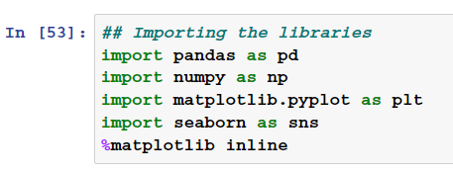
- Loading the dataset
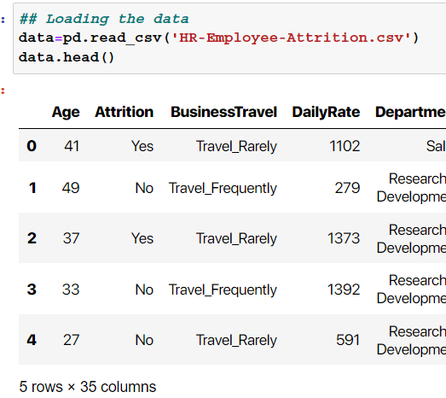

- Perform EDA
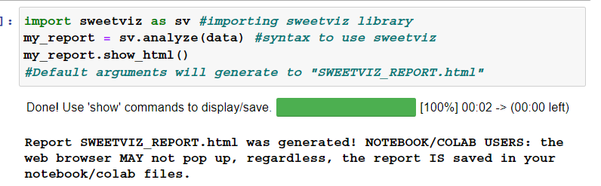
Using this library we will be able to see a detailed report showcasing univariate analysis.
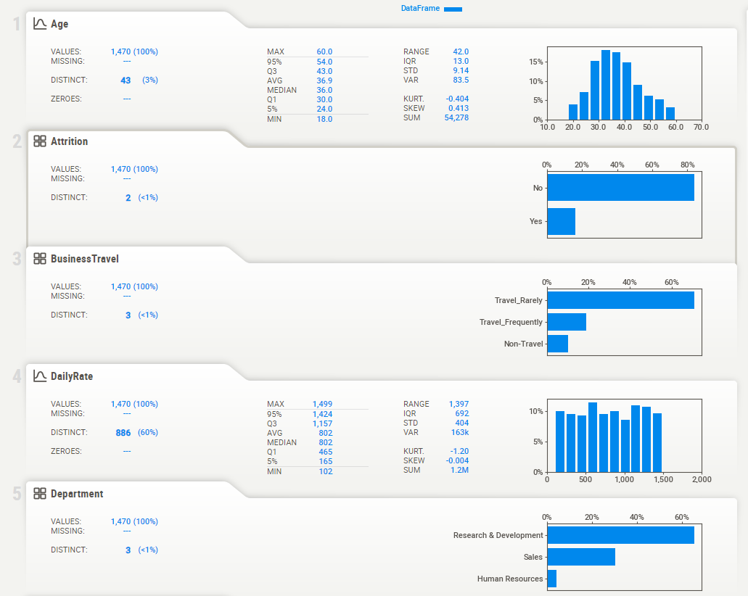
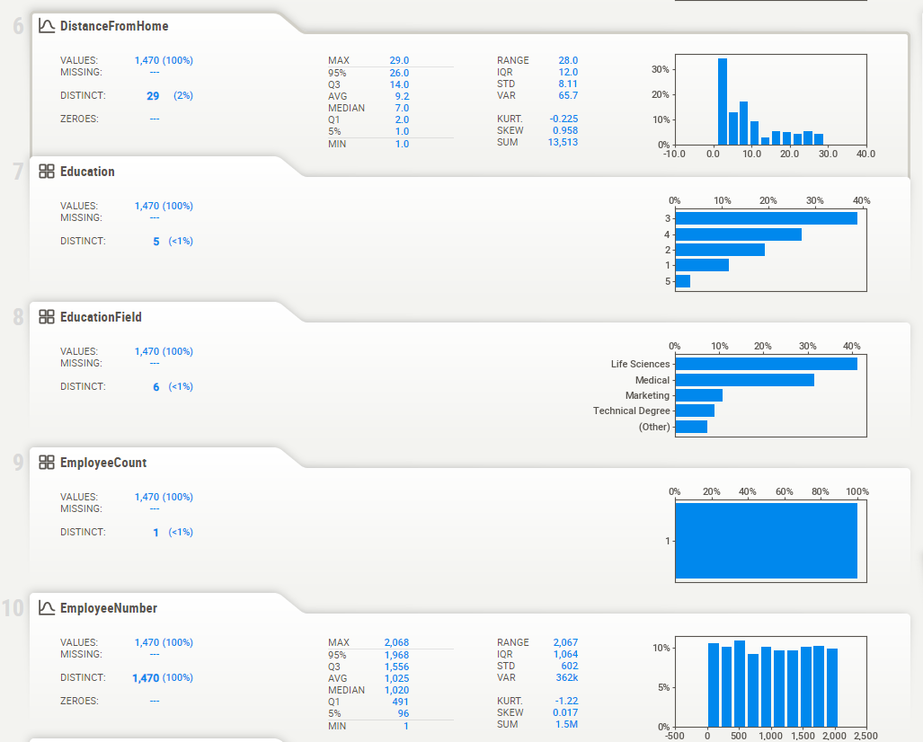

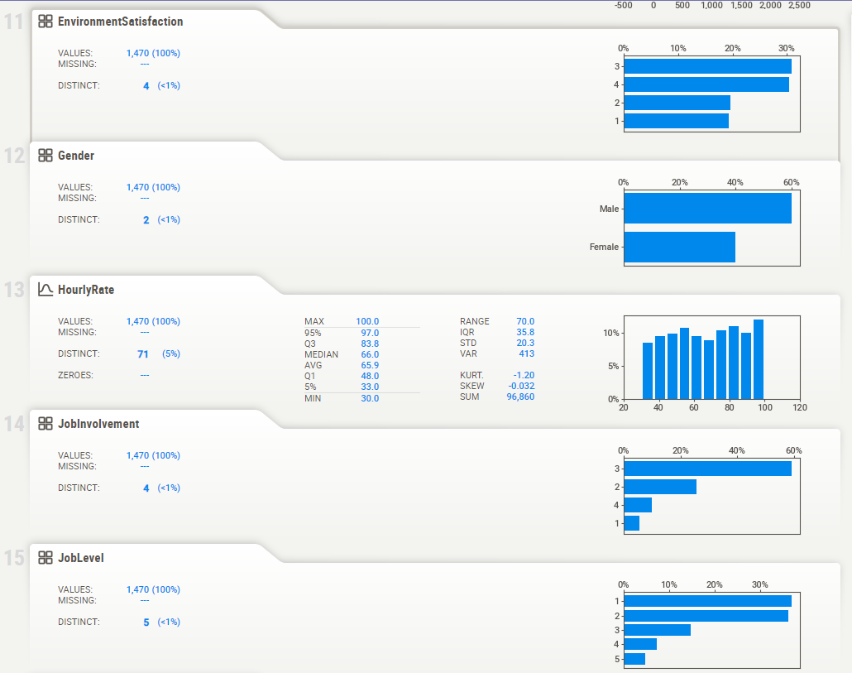
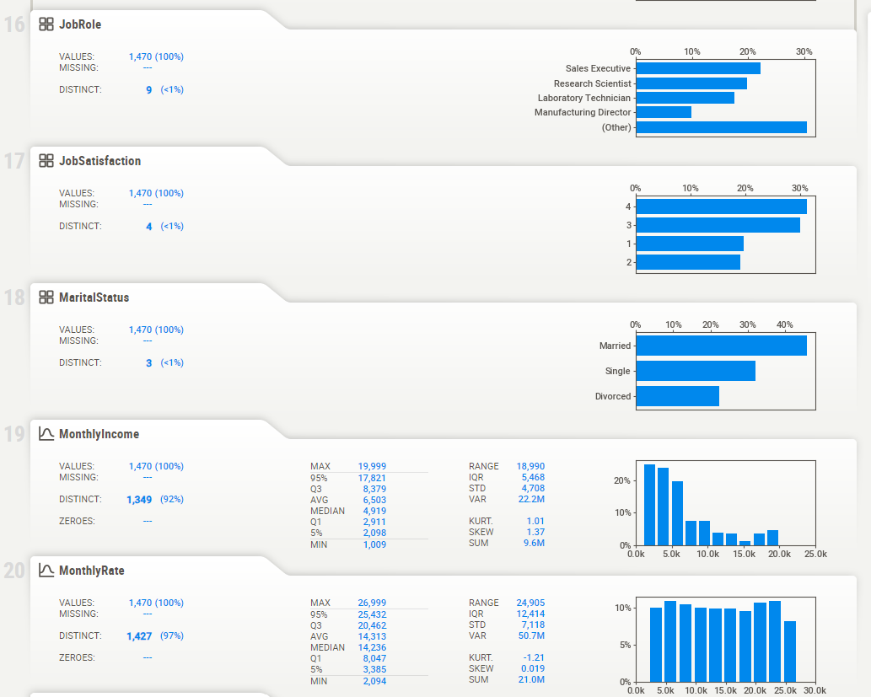
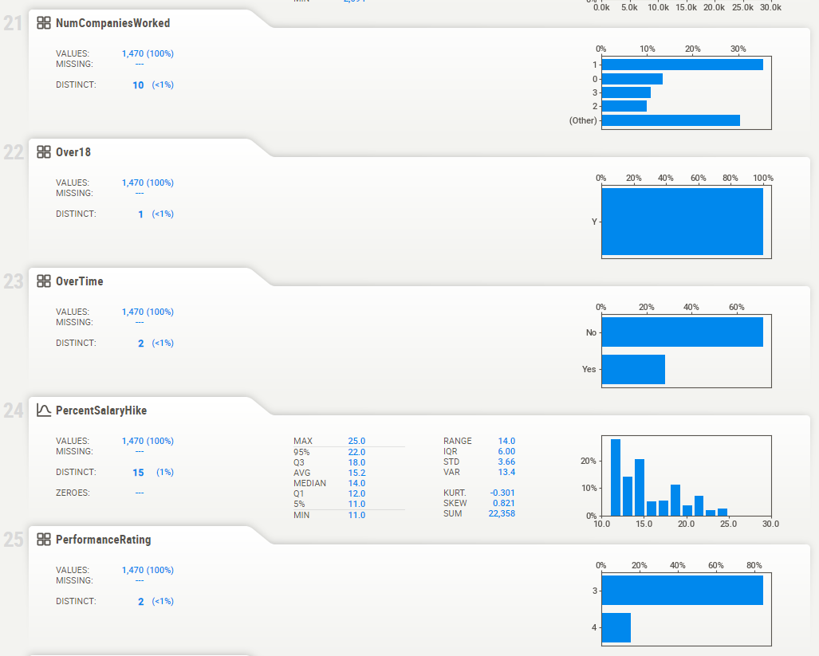
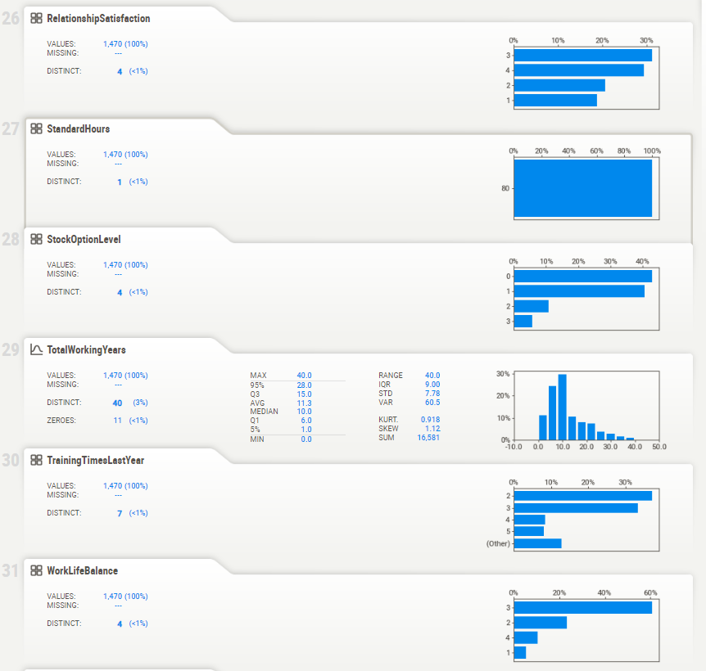
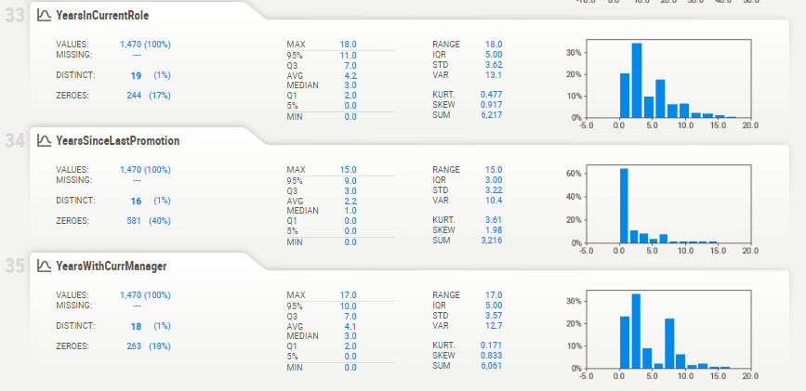

3.1 Plotting categorical variables with the target variable ‘Attrition’
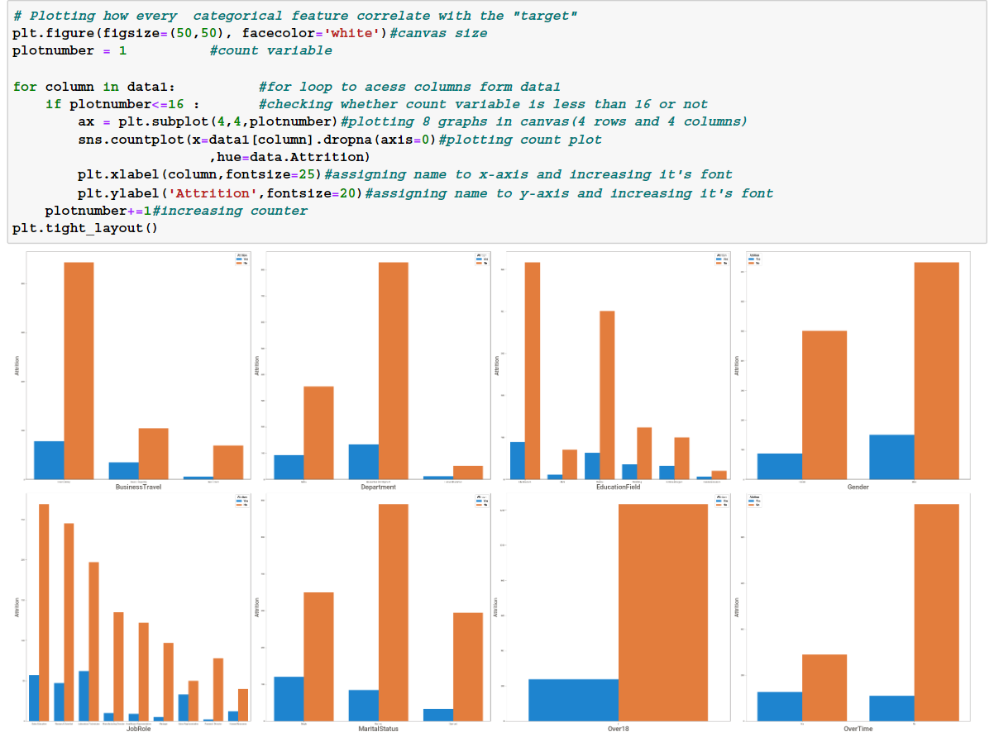

3.2 Plotting discrete value features with ‘Attrition’
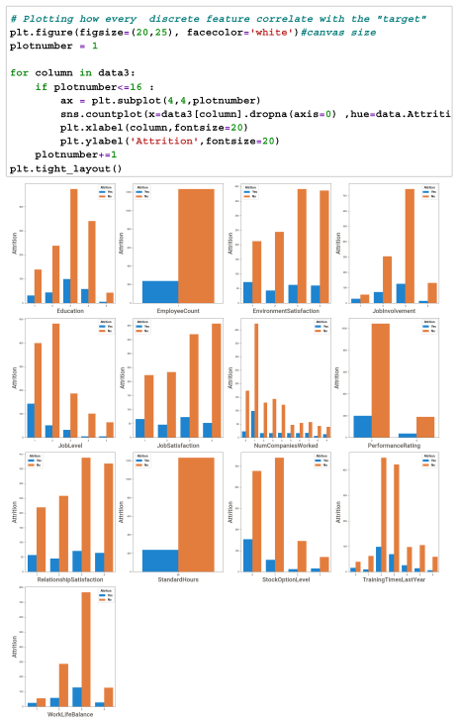
3.3 Bar graph depicting Attrition vs. Distance from home.
Insight: Employees who live further away from the office, tend to leave the company.
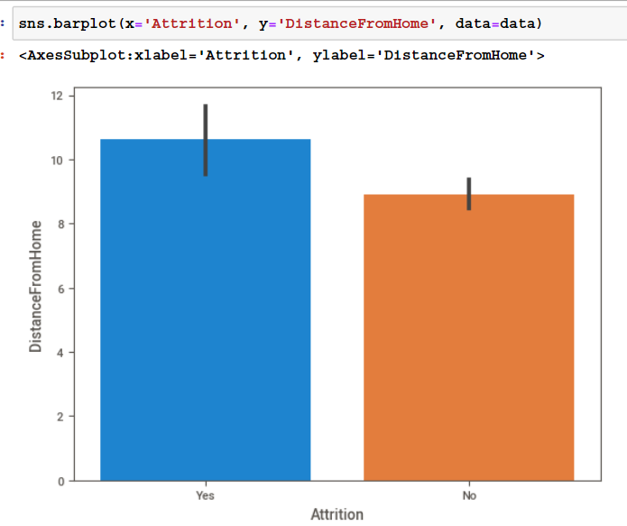

  - Bar graph depicting Attrition vs. Age
Insight: There is no definite reason for leaving the company on the basis of age.
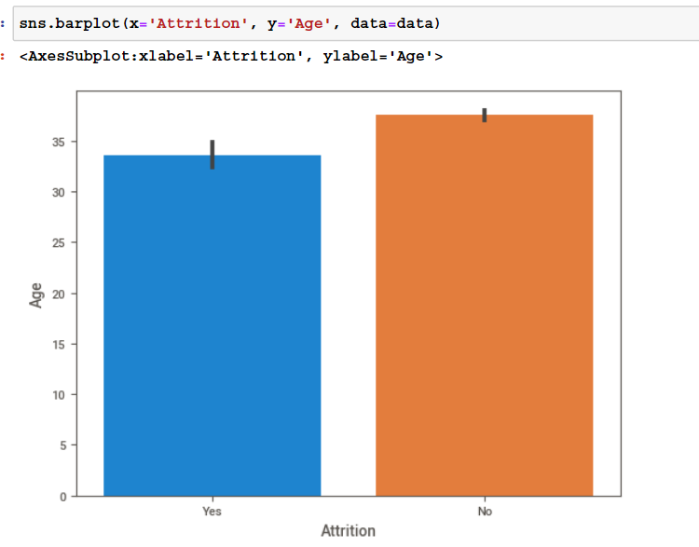
3.4 Bar graph depicting Attrition vs. Number of companies worked in.
Insight: People who have worked in more than 2 companies, tend to leave the organization.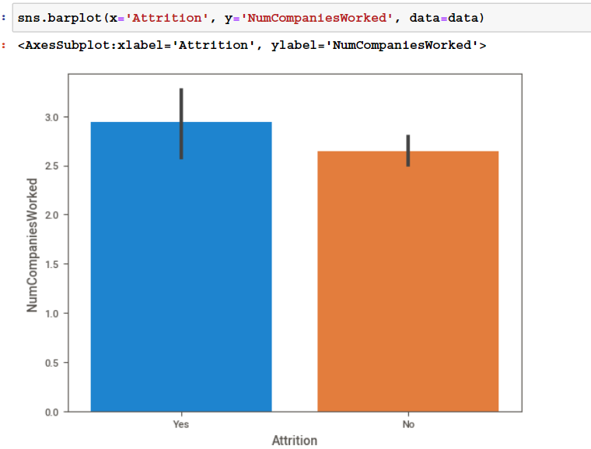
  - Boxplot of Age vs. Attrition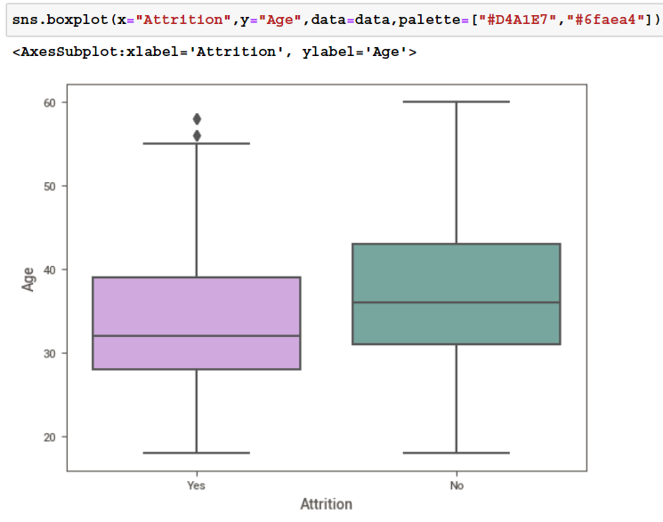
  - Pie chart showing Attrition percentage
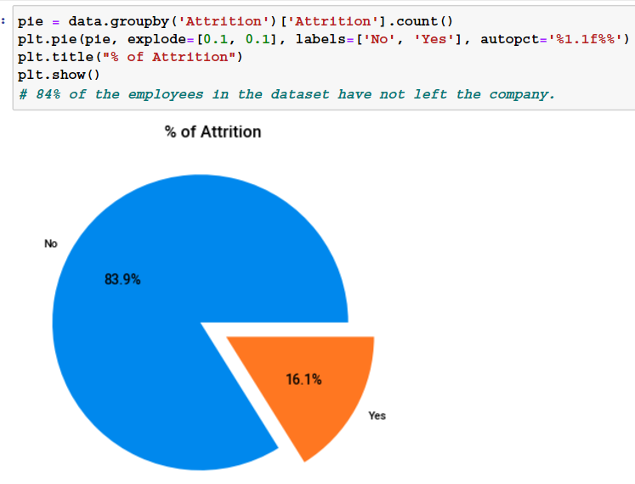

  - Double bar graph showing Monthly Income against Job Role.
Insight:Research Directors have the highest income among all the Job Roles. Most amount of attrition comes from Healthcare Representative. People from this sector tend to leave the organization faster than they join one.1
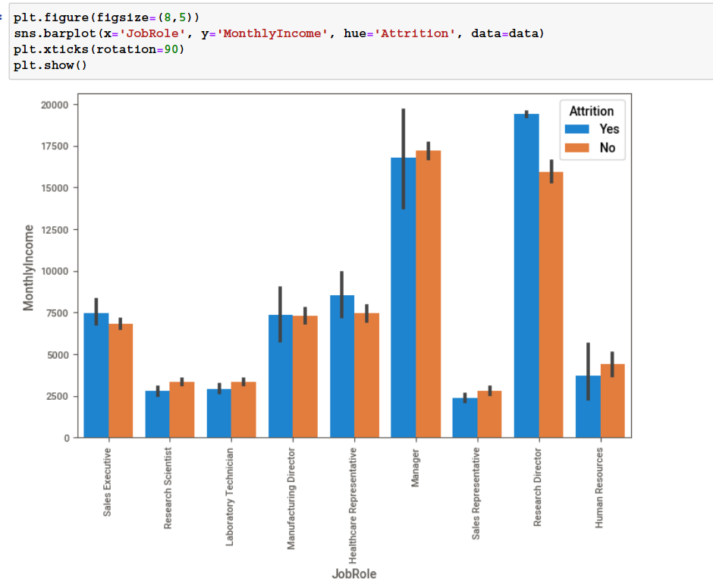

- Checking correlation between all the features
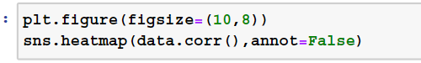
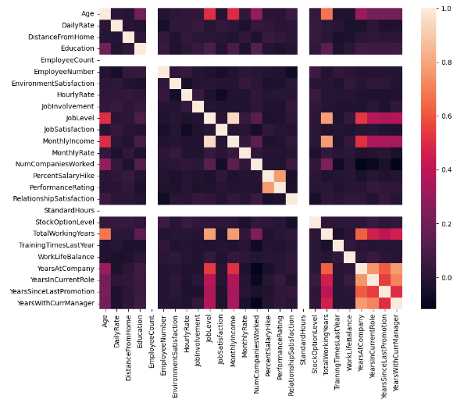

Here, 0 indicates no correlation, 1 indicates high or strong correlation and -1 indicates weak or low correlation

KEY INSIGHTS
- BusinessTravel : The workers who travel alot are more likely to quit then other employees.
- Department : The worker in Research & Development are more likely to stay then the workers on other departement.
- EducationField : The workers with Human Resources and Technical Degree are more likely to quit then employees from other fields of educations.
- Gender : The Male are more likely to quit.
- JobRole : The workers in Laboratory Technician, Sales Representative, and Human Resources are more likely to quit the workers in other positions.
- MaritalStatus : The workers who have Single marital status are more likely to quit the Married, and Divorced.
- The employee attrition rate of this organization is 16.12%
- According to experts in the field of Human Resources, says that the attrition rate 4% to 6% is normal in organization.
- So we can say the attrition rate of the organization is at a dangerous level.
- Therefore the organization should take measures to reduce the attrition rate.
- The number of male employees in the organization accounts for a higher proportion than female employees by more than 20%.
- Male employees are leaving more from the organization compared to female employees.
- Most of the employees are between ages 30 to 40.
- Most of the employees in the organization Travel Rarely.

IMPLEMENTING ML ALGORITHM (Decision Tree)
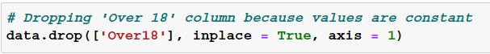
- Drop unnecessary columns in the dataset. Here, we dropped ‘Over18’ column because the values in this column are constant, which is not useful to our analysis. Here, axis 1 denotes column drop.

- Define x and y variables
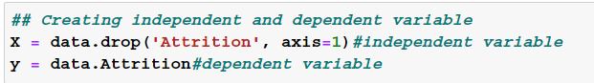
X contains all the independent variables or features, y contains the target variable i.e. Attrition.
- Importing sklearn library to split the dataset into training and testing dataset. We have assigned 25% data for testing.
- Import decision tree classifier from sklearn.tree and train the model.
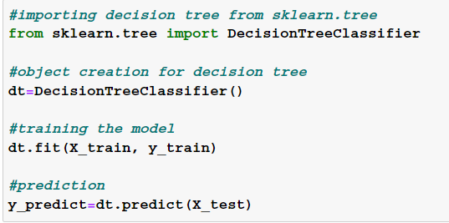
- Evaluate the classifier model’s accuracy
The classification report shows us that the dataset has 85% recall score and 89% precision score.
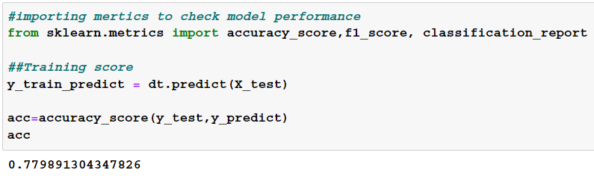
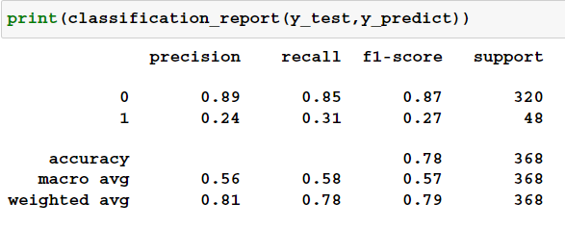
CONCLUSION
Employee attrition is a major concern for companies, but by using data analysis, companies can gain valuable insights into why employees leave and take proactive measures to improve retention. The IBM HR Dataset is a valuable resource for this, providing a wide range of variables that can help companies understand the root causes of attrition and improve employee engagement. By using this dataset, companies can reduce turnover rates, improve productivity, and create a positive work environment for their employees.

CHALLENGES
While the IBM HR Attrition employee dataset is a valuable resource for exploring employee churn, there are some challenges to be aware of when working with it:

Data quality and limitations
- Missing values: The dataset contains missing values in some attributes, which can require imputation or exclusion depending on your analysis.
- Fictional nature: It's important to remember that the dataset is fictional, and may not perfectly reflect real-world employee populations or IBM's specific employee demographics.
- Limited scope: The dataset focuses on a specific subset of IBM employees, and may not be generalizable to other industries or company cultures.

Imbalanced classes: The dataset has an imbalanced class distribution, with many more non-attrition cases than attrition cases. This can pose challenges for machine learning models, which may need special balancing techniques.

Analytical challenges:
Feature engineering: Many of the categorical features require careful encoding or transformation before they can be used in models.
Model selection and interpretation: Choosing the right machine learning model and interpreting its results can be complex, especially with imbalanced data.
Overfitting: The dataset is relatively small, so it's important to be cautious about overfitting and use techniques like cross-validation to ensure model generalizability.
Ethical considerations:
Privacy: While anonymized, it's important to be mindful of potential privacy concerns when using employee data, even if fictional.
Bias: The dataset may contain inherent biases that could be reflected in your analysis or model results. It's crucial to be aware of these biases and take steps to mitigate them.

ADDITIONAL CHALLENGES

Data access and licensing: While the dataset is publicly available, there may be specific terms of use or licensing requirements to be aware of.
Computational resources: Depending on your analysis and chosen models, working with the dataset may require significant computational resources.
Despite these challenges, the IBM HR Attrition employee dataset can be a valuable tool for learning about employee churn and practicing data analysis techniques. By being aware of the limitations and potential pitfalls, you can ensure your analysis is robust and informative.

