From chroma_db and From excel
King James Bible
Ref : Jude 1:22
Text : And of some have compassion, making a difference:
The Quran
Ref : Ar-Rahman 55:1
Text : The Most Compassionate
Tanakh (JPS 1917)
Ref : Daniel 9:9
Text : To the Lord our God belong compassions and forgivenesses; for we have rebelled against Him;
Bhagavad Gita
Ref : Gita 13:7
Text : 13.7 Desire, hatred, pleasure, pain, the aggregate (the body), intelligence, fortitude the field has thus been briefly ...
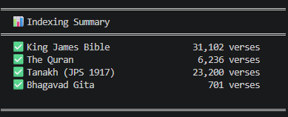

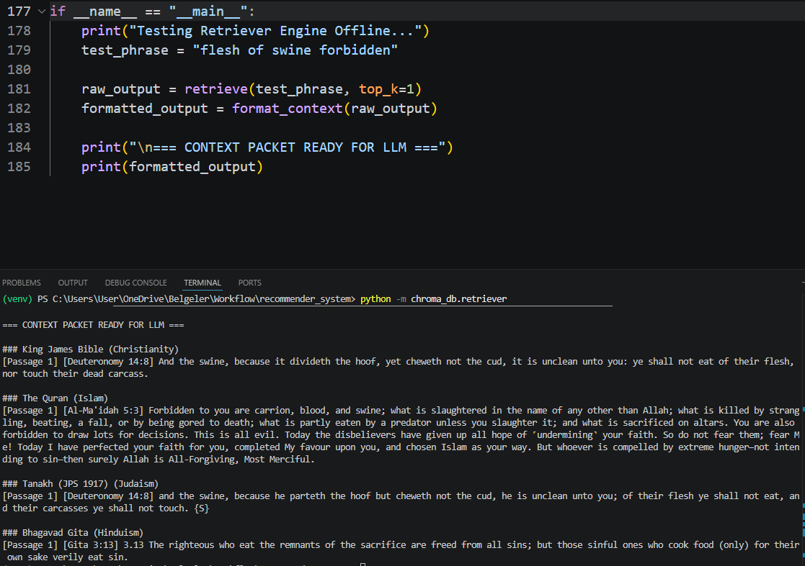
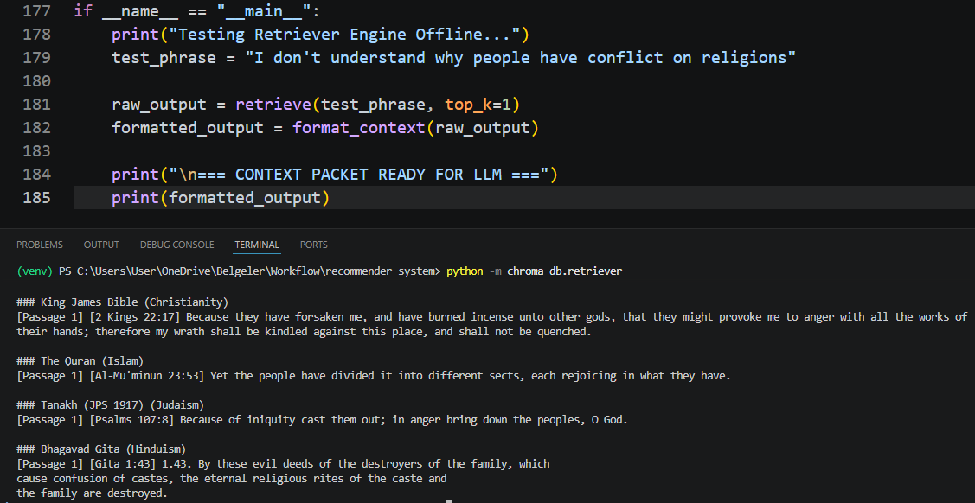
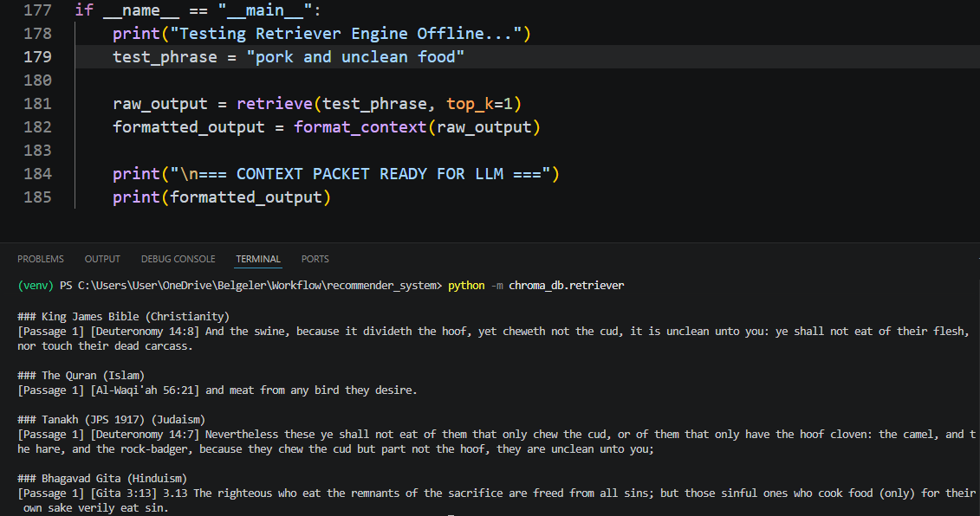
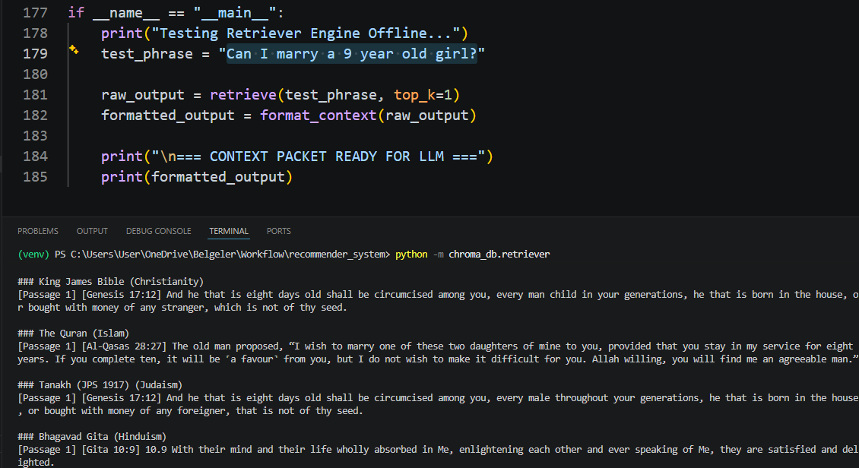
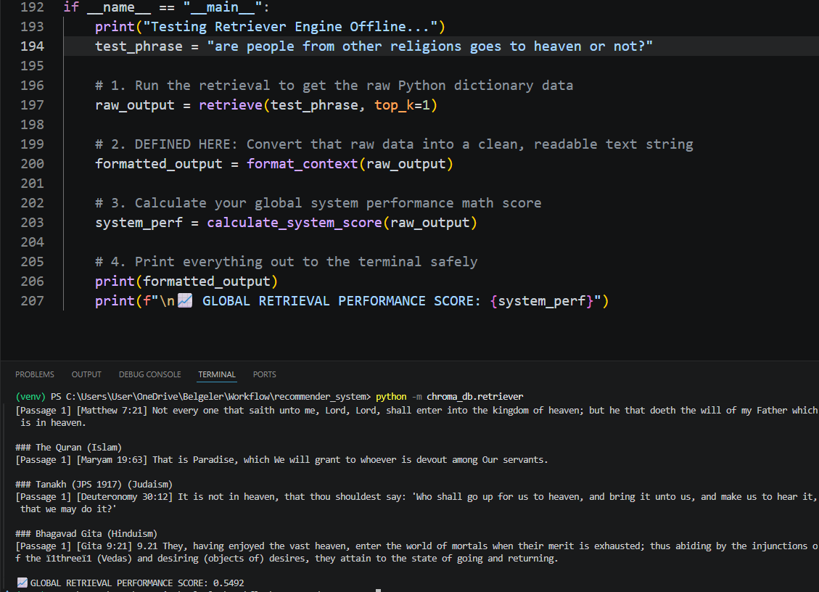
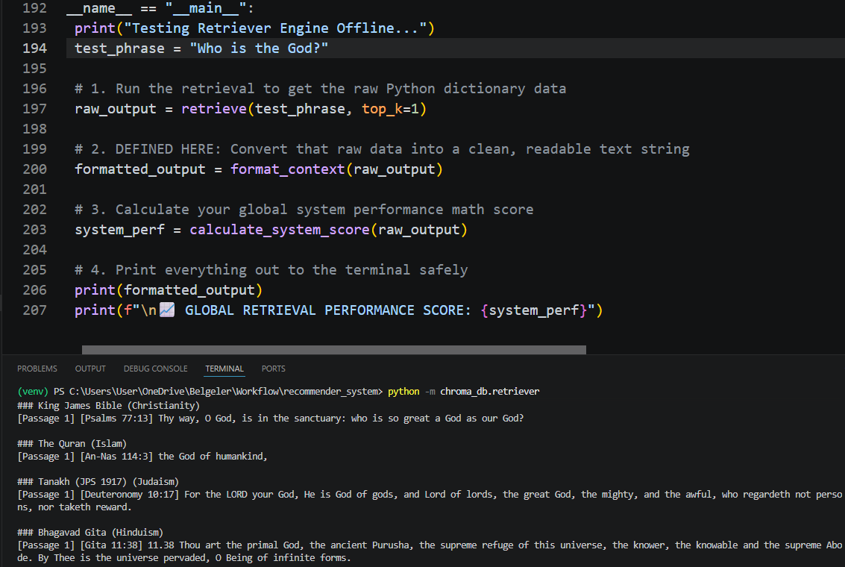

all-MiniLM-L6-v2 is fast but was trained for general sentence similarity. For a Q&A system searching religious texts, a model trained specifically for semantic search does significantly better:

used this model: "multi-qa-mpnet-base-dot-v1"

