|  |  |  |  |  |  |  |
| --- | --- | --- | --- | --- | --- | --- |
| **SMESTER** | | | **SPRING** | **BSCS-(Section)** | | **2021** |
| **TITLE OF PROJECT** | | | | | | |
| **HOSTEL MANAGEMENT SYSTEM** | | | | | | |
| **Group Members** | | | | | | |
| **S#** | **Student(s) Name** | | | | **Registration Number** | |
| **1** | SHAHEER IMRAN | | | |  | |
| **email:** | | [**02-134202-049@student.bahria.edu.pk**](mailto:02-134202-049@student.bahria.edu.pk) | | **No:**  0347-2160327 | **02-134202-049** | |
| **2** | YUSRA ATHER SYED | | | |  | |
| **email:** | | [**02-134202-057@student.bahria.edu.pk**](mailto:02-134202-057@student.bahria.edu.pk) | | **No:**  0334-1313158 | **02-134202-057** | |
| **3** | DARAKSHAN AHMED | | | |  | |
| **email:** | | [**02-134202-036@student.bahria.edu.pk**](mailto:02-134202-036@student.bahria.edu.pk) | | **No:**  0320-3005726 | **02-134202-036** | |
| **EXECUTIVE SUMMARY OF PROJECT PROPOSAL (MAXIMUM 300 WORDS)** | | | | | | |
| We design **Hostel management system** to facilitate the hostel admin in the hostel management. Hostel management project is a very user-friendly software that is why they do not require specially trained person to handle the software.  Hostel management system is a desktop application for managing hostel records. Hostel management system helps hostel admin in managing records of the hostel in an efficient manner. This project manage records of the students, hostel rooms and other things related to the hostel.  The manual way of hostel record management it is very difficult to find the record of all students their mess bills and the information of about old students who had left the hostel many years before.  Hostel management project can automatically calculate all the bills and gives proper notifications wherever it is required.  Hostel management system’ provides a detailed view of how the students records, room allocation and courses. The hostel management system also equipped with some special features for helping hostel admin.  Each record in the system has unique identity and it can be searched by a unique id. For developing front end of the Hostel management system MS Access has been used and  Netbeans has been used  for its back end. | | | | | | |
| **PROJECT PURPOSE, SCOPE AND OBJECTIVES (MAXIMUM 1000 WORDS)** | | | | | | |
| The main objective of the java project on Hostel Management System is to manage the details of Beds, Hostel, Rooms, Allotees, Rent. It manages all the information about Beds, Payments, Rents. The project is totally built at administrative end and thus only the administrator is guaranteed the access. The purpose of the project is to build an application program to reduce the manual work for managing the Beds, Hostel, Payments, Rooms. It tracks all the details about the Rooms, Allotees, Rent.  **SCOPE:**  The proposed project Hostel management project is a computerized system. The use of this project in the hostel can reduce all the problems Like lost of Allotees Data, Manually arranging of information, Excessive use of paper etc.  Use of this project in the hostel reduce the paperwork in the hostel and also improves to the students of the hostel and admin. | | | | | | |
| **PROJECT DESCRIPTION (most important part)** | | | | | | |
| Hostel management system is a desktop application for managing hostel records. Hostel management system helps hostel admin in managing records of the hostel in an efficient manner. This project manage records of the students, hostel rooms and other things related to the hostel.  **FUNCTIONALITIES PROVIDED BY HOSTEL MANAGEMENT SYSTEM:**   * Provides the searching facilities based on various factors. Such as beds, Rooms, Allotees, Rent. * It tracks all the information of Hostel, Payments, Allotees etc. * Manage the Hostel. * It deals with monitoring the information and transactions of Allotees. * Manage all beds Details. * Manage the information of Allotees. * Editing, Adding and Updating of Records is improved which results in proper resource management of beds data. | | | | | | |
| **TEAM PROFILE** | | | | | | |
| Shaheer Imran ( programming, presentation, documentation, management and organization )  Yusra Ather Syed ( programming, design, presentation, documentation )  Darakshan Ahmed ( programming, design, presentation, documentation ) | | | | | | |
| **ASSUMPTIONS AND CONSTRAINTS** | | | | | | |
| The main objective of developing hostel management system is to save money and time. The proposed system generates following reports to help management of the hostel in decision making:   * Allocated Room report * Unallocated Room Report * Partially allocated room * Allotees Report   **Software Requirements of Hostel Management System :**  •    Netbeans 8.0.2 •   MS Access | | | | | | |
| **PROJECT DELIVERABLES NOT CHANGEABLE** | | | | | | |
| **Deliverables include**   * Software Project Proposal. * Project progress * Project report (template will be uploaded) * Team member’s work, as per their contribution, you should have to be honest with your future. | | | | | | |
| **Time Line** | | | | | | |
| |  |  |  | | --- | --- | --- | | **ITEM** | **DATE** | **SIGNATURE** | | Group Member Names |  |  | | Project title |  |  | | Project Proposal + classes name |  |  | | Project Structure Diagram + Data Sample |  |  | | Classes UML diagram and apply OOP Concepts |  |  | | Project Prototype |  |  | | Project Review 1 |  |  | | Project Review 2 |  |  | | Project Submission |  |  | | | | | | | |

**UML DIAGRAM OF HOSTEL MANAGEMENT SYSTEM**

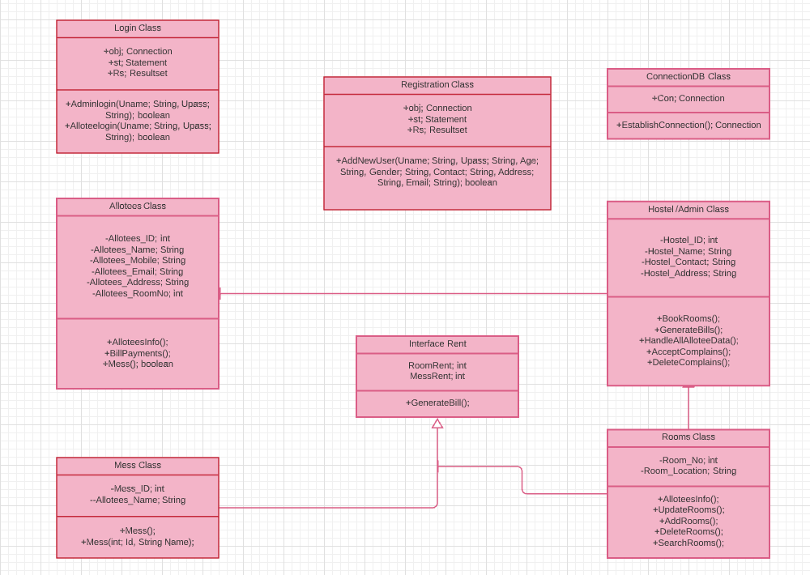

|  |
| --- |
| **For Teacher Use Only** |

|  |
| --- |
| **REMARKS** |
|  |

|  |  |  |  |  |  |
| --- | --- | --- | --- | --- | --- |
| **Course Teacher** | **Madam Sameena Javaid** | **Signature** |  | **Date** |  |
| **Name** | **Ms. Salas Akbar** | **Signature** |  | **Date** |  |