March 11, 2024

**Subject**: Request for Allocation of Additional Incentives for eSports-Related Subjects/Courses

Dear Heads of Departments and Administrators,

I hope this message finds you well. We are currently in the process of planning an incentive system for our upcoming eSports Tournament. As part of this initiative, we are exploring the possibility of aligning the incentives with subjects or courses that directly relate to eSports.

The incentive system aims to encourage active participation and engagement in the tournament by offering additional grades or academic recognition to students involved in relevant subjects. To ensure the effectiveness of this system, we kindly request your cooperation in allocating additional grades to the subjects offered at your institution that are related to eSports.

Your collaboration would greatly contribute to our planning process and help us tailor the incentive system to maximize its impact on student engagement.

Your assistance in providing this information would greatly aid us in our planning process.

Thank you for your attention, and we look forward to your positive response.

Sincerely,



Romulo Jr. Curimao

Head - Marketing Department

Section 302A, BSIT Department

curimao_romulo@spcc.edu.ph

**Noted by:**

_____________________________

Ms. Mary Jane T. Coralde

Multimedia and Communications Head

**Approved by:**

_____________________________

Ms. Mary Jane G. Cabral

Head of Activities

_____________________________

Ms. Lorena L. Santos

Admissions, Activities and Student Affairs Head

(GS/JHS)

_____________________________

Ms. Maria Myma G. Nuque

ABM/HE Head, CBHTM Dean

_____________________________

Ms. Maria Chona B. Arce

School Director / BED Principal

_____________________________

Mr. Jhensen F. Foronda

CIT Dean

_____________________________

Mr. Apolinario M. Gape Jr.

Administrative Affairs Head, PPFCS Head

March 11, 2024

EPTEA KA MUNA

Ms. Ariane Alfonso

141 3rd St, Grace Park East, Caloocan, 1400 Metro Manila

**Subject**: Proposal for Sponsorship - Section 302A eSports Tournament

Dear EPTEA KA MUNA,

I am Voltaire M. Victoriano, representing Section 302A, BSIT Department at **Systems Plus Computer College — Caloocan City.** Our upcoming eSports tournament, on **April 3, 2024** (Mobile Legends), and **April 10, 2024** (Call of Duty Mobile), aims to provide a thrilling gaming experience to raise awareness and funds for **Animal Rescue PH.**

Sponsorship Benefits:

* Prominent online and on-site brand exposure.
* Recognition in promotional materials, press releases, and social media.
* Direct engagement with our diverse college community.
* Positive brand association with a cause promoting inclusivity.

We respectfully seek your support, be it financial or otherwise, and would be honored to engage in discussions regarding how **EPTEA KA MUNA** can contribute to the success of our event. Your valued assistance will undoubtedly make a significant impact on the well-being of 650 rescued animals through our collaboration with **Animal Rescue PH.**

Thank you for considering our proposal.

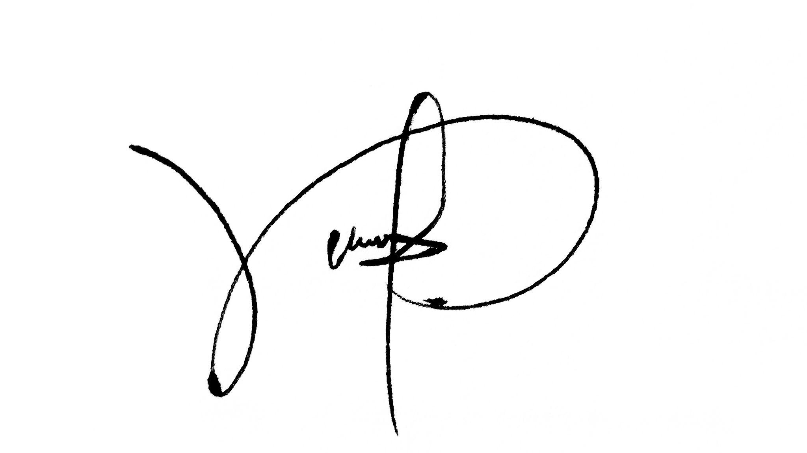

Sincerely,

Voltaire M. Victoriano

Event Coordinator

Section 302A, BSIT Department

09058122825 / victoriano_voltaire@spcc.edu.ph

[Date]

Atty. Miguel De Guzman

[Office]

[City, State, Zip Code]

**Subject**: Proposal for Sponsorship - Section 302A eSports Tournament

Dear Atty. De Guzman,

I hope this letter finds you well. My name is Voltaire M. Victoriano, and I am a 3rd-year BSIT student representing Section 302A of the **College of Information Technology Department** at **Systems Plus Computer College - Caloocan.**

We are excited to inform you about our upcoming event, the second season of our eSports tournament, which is set to take place on **April 3, 2024** (Mobile Legends), and **April 10, 2024** (Call of Duty Mobile). Our tournament aims to not only provide a thrilling gaming experience but also serve a greater purpose. This year, we have partnered with **Animal Rescue PH**, an organization committed to the welfare of 650 rescued animals, to raise awareness and funds for their cause.

Your support will not only contribute to the success of our tournament but also make a significant impact on the lives of animals in need through our collaboration with **Animal Rescue PH**.

Thank you for considering our proposal. We look forward to discussing this exciting opportunity further.



Sincerely,

Voltaire M. Victoriano

Event Coordinator

Section 302A, BSIT Department

Systems Plus Computer College — Caloocan City

09058122825 / victoriano_voltaire@spcc.edu.ph

March 11, 2024

ChubbyNChunky Cafe

141 3rd St, Grace Park East, Caloocan, 1400 Metro Manila

**Subject**: Proposal for Sponsorship - Section 302A eSports Tournament

Dear ChubbyNChunky Cafe,

I am Voltaire M. Victoriano, representing Section 302A, BSIT Department at **Systems Plus Computer College — Caloocan City.** Our upcoming eSports tournament, on **April 3, 2024** (Mobile Legends), and **April 10, 2024** (Call of Duty Mobile), aims to provide a thrilling gaming experience to raise awareness and funds for **Animal Rescue PH.**

Sponsorship Benefits:

* Prominent online and on-site brand exposure.
* Recognition in promotional materials, press releases, and social media.
* Direct engagement with our diverse college community.
* Positive brand association with a cause promoting inclusivity.

We respectfully seek your support, be it financial or otherwise, and would be honored to engage in discussions regarding how **ChubbyNChunky Cafe** can contribute to the success of our event. Your valued assistance will undoubtedly make a significant impact on the well-being of 650 rescued animals through our collaboration with **Animal Rescue PH.**

Thank you for considering our proposal.



Sincerely,

Voltaire M. Victoriano

Event Coordinator

Section 302A, BSIT Department

09058122825 / victoriano_voltaire@spcc.edu.ph