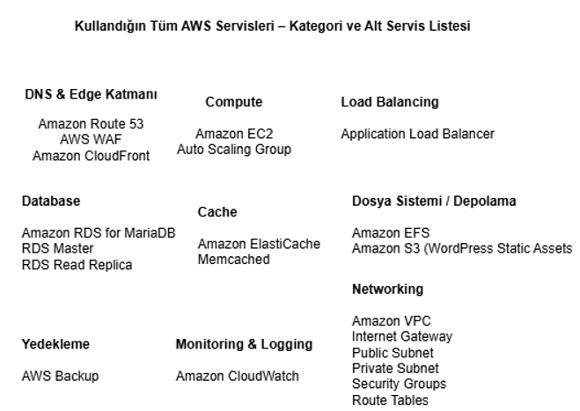
1. Amazon Route 53
- Hosted Zone: 1 adet
- DNS Queries: Aylık 1M (varsayılan, ihtiyaç halinde değiştirirsin)
- Record Type: A/AAAA + CNAME

2. AWS WAF
- Web ACL: 1 adet
- Rule Count: 5 Managed Rule
- Request Count: Aylık 10M – 20M arası (10.000 anlık trafik için ideal)
- Scope: CloudFront

3. Amazon CloudFront
- Origin 1: Application Load Balancer
- Origin 2: S3 Static Assets Bucket
- Data Transfer Out (To Internet): Aylık 1–5 TB
- Requests (HTTP): Aylık 10M–50M
- Dynamic Content: Enabled
- Cache Policy: CachingOptimized

4. Application Load Balancer (ALB)
- Load Balancer Hours: 730 saat (tam ay)
- LCU Estimate: 5 LCU
- Number of AZs: 2
- Target Groups: 1
- Protocol: HTTP/HTTPS

5. EC2 (WordPress Sunucuları)
- Instance Type: t3.medium veya t3.large
- AMI: Amazon Linux 2023 + PHP 8.1
- Min Instances: 2
- Max Instances: 8
- Avg Running: 3 instance olarak hesaplayabilirsin
- EBS Disk:
  - Root Volume: 30GB GP3
- Compute Hours: 3 × 730 saat

6. Auto Scaling Group
(Pricing Calculator’da ayrı ücret yok — EC2 içinde dahil)
Ama şu şekilde işaretlersin:
- Scaling Policy: Target Tracking
- Metric: CPU 50%
- AZ Count: 2
- Desired Capacity: 3

7. Amazon RDS for MariaDB
- Instance Class: db.m5.large
- Deployment: Multi-AZ
- Instances:
  - Primary: 1
  - Read Replica: 1
- Storage:
  - 100GB GP3
- Backup Retention: 7 days
- I/O: Default

8. Amazon ElastiCache (Memcached)
- Engine: Memcached
- Node Type: cache.t3.medium
- Node Count: 2 nodes
- AZ Mode: Single-AZ (Memcached multi-AZ desteklemez)
- Data Transfer: Çok düşük (Pricing’de genelde yok sayılır)

9. Amazon EFS
- Storage Size: 30GB
- Performance Mode: General Purpose
- Throughput Mode: Bursting
- Lifecycle Policy: 30 days
- Data Transfer: Default

10. AWS Backup
- Resources:
  - RDS
  - EFS
- Backup Frequency: Daily
- Retention: 30 days
- Backup Size:
  - RDS: 100GB
  - EFS: 30GB

11. Amazon CloudWatch
- Metrics: Basic (free) + ek metrics
- Log Storage: 10GB / month
- Log Ingestion: 5GB / month
- Alarms: 5 adet (CPU, Memory, Status Check, WAF Block, ALB 5xx)

12. Amazon VPC + Networking
(Pricing Calculator’da ayrı servis olarak girilir)
- NAT Gateway: 2 adet (Her public subnet için 1)
- NAT Data Processing: Aylık ~200GB
- Internet Gateway: Free
- VPC: Free
- Subnets: Free
- Route Tables: Free

13. Amazon S3 (WordPress Static Assets)
- Bucket Count: 1
- Storage Class: S3 Standard
- Storage Size: 20GB
- PUT Requests: 100K / month
- GET Requests: 10M / month
- Data Transfer to CloudFront: Free (S3 → CloudFront free)
- Versioning: Enabled

