

T.R.
ESKISEHIR OSMANGAZI UNIVERSITY

DEPARTMENT OF ELECTRICAL-ELECTRONICS ENGINEERING
AND
DEPARTMENT OF COMPUTER ENGINEERING

INTRODUCTION TO MICROCOMPUTERS TERM PROJECT

Home Automation System

Students:

151220212097, Anıl ÇETİN, Electrical and Electronics Engineering
151220212099, Doğancan KÜÇÜK, Electrical and Electronics Engineering
151220212067, Nihan ÇARDAK, Electrical and Electronics Engineering
152120221075, Yusuf YAMAN, Computer Engineering
152120221106, Yiğit ATA, Computer Engineering

January 2025

Introduction
Within the scope of this term project, an integrated Home Automation System controlled via various sensors and actuators has been designed and implemented using the PIC16F877A microcontroller. The primary objective of the project is to develop a comprehensive system that enables the simultaneous monitoring and management of household devices through both localized hardware control panels and a remote PC interface. To achieve this, the system architecture is partitioned into two distinct hardware modules within the PICSimLab simulation environment.
The functional distribution of the system ensures specialized management of different home environments. Board #1 is responsible for the home’s climate control, measuring ambient temperature to autonomously drive heating, cooling, and fan components. The data acquired from the temperature sensor is processed by the microcontroller to maintain user-defined comfort levels. In parallel, Board #2 manages window automation using a unipolar stepper motor for curtain positioning. This second module also performs continuous environmental monitoring by tracking ambient light intensity via a Light Dependent Resistor (LDR) and outdoor atmospheric data through a pressure sensor.
From a software perspective, the system utilizes a multi-layered architecture to balance performance and usability. All low-level control firmware running on the PIC16F877A microcontrollers is developed in Assembly language to ensure precise timing and efficient resource management. On the PC side, a monitoring and control application is implemented using the Python programming language. Data transmission between the simulation environment and the PC application is facilitated by asynchronous UART communication over virtual serial port pairs created with com0com software. Python was specifically chosen for the host-side application due to its ability to handle serial communication seamlessly via the pySerial library and its efficiency in developing a robust console-based user interface for real-time data logging and system overrides.

Design

Board 1: Climate Control and User Interface
Board #1 is designed to act as the primary environmental controller for the home, managing the heating and cooling systems through a feedback loop driven by the PIC16F877A microcontroller .
Thermostat Logic and ADC Processing
The temperature control system relies on the ADC_OKU routine to convert analog signals from the LM35 sensor into digital data. The microcontroller’s ADCON0 and ADCON1 registers are configured to use AN0 as the input channel with a right-justified result format .
The system utilizes a 10-bit Analog-to-Digital Converter; however, the software performs a right-shift operation (RRF) to simplify the scaling to an 8-bit integer stored in TEMP_VAL . Once the ambient temperature is acquired, the SISTEM_KONTROL routine performs a comparison using the SUBWF instruction. By checking the Status Register's Carry (C) flag, the software decides whether to activate the heater (RC1) or the cooler (RC2) . This creates a hysteresis-free controller that ensures the environment stays as close to the DESIRED_TEMP as possible.

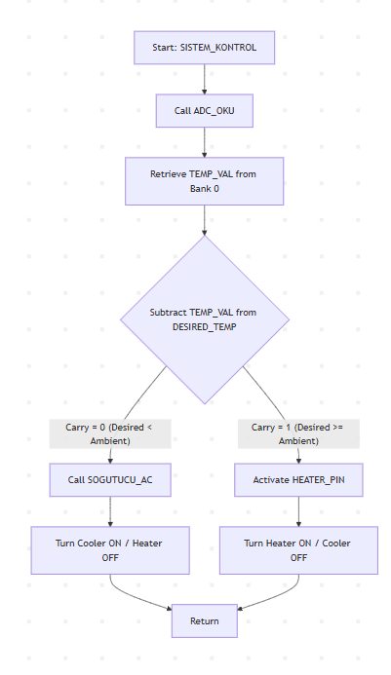
Figure 2.1 1Thermostat control logic flowchart illustrating the feedback loop between temperature acquisition and actuator state management.

Matrix Keypad Scanning and Input Validation
User interaction is facilitated through a 4x4 matrix keypad, managed by the SCAN_KEYPAD_SAFE function. The logic employs a "Row-Scanning" technique where the rows (RB0-RB3) are driven low one by one while the columns (RB4-RB7) are monitored for logic zero .
To handle mechanical noise, a software debouncing routine is implemented via the WAIT_AND_REFRESH and STABLE_CNT mechanisms, ensuring a key is only registered if it remains stable for several milliseconds . The system follows a specific input sequence: the user must press 'A' to start entry, input the numerical value, and press '#' to confirm . If a value is accepted, the INPUT_VAL is transferred to DESIRED_TEMP, effectively updating the thermostat's reference point.
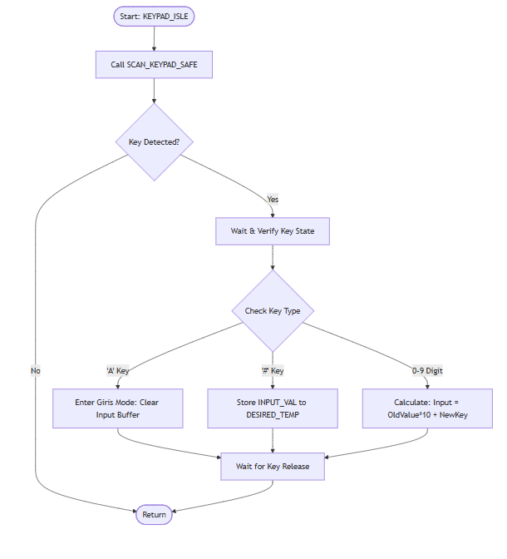
Figure 2.1 2.Keypad scanning and multi-digit input validation algorithm flowchart.
Dual-Digit 7-Segment Multiplexing
The system visualizes data using a multiplexed 7-segment display. To save I/O pins, the display segments are tied to a common 8-bit bus (PORTD), while individual digits are enabled via RA3 and RA5 . The EKRANI_GOSTER function rapidly toggles these digits at a frequency high enough to exploit the human eye's persistence of vision, creating the illusion of a steady display. Before being sent to the display, the binary temperature data is processed by the HEX_TO_DEC routine, which separates the value into Tens and Ones using a subtraction loop, ensuring the correct digit is sent to the GET_SEG lookup table .
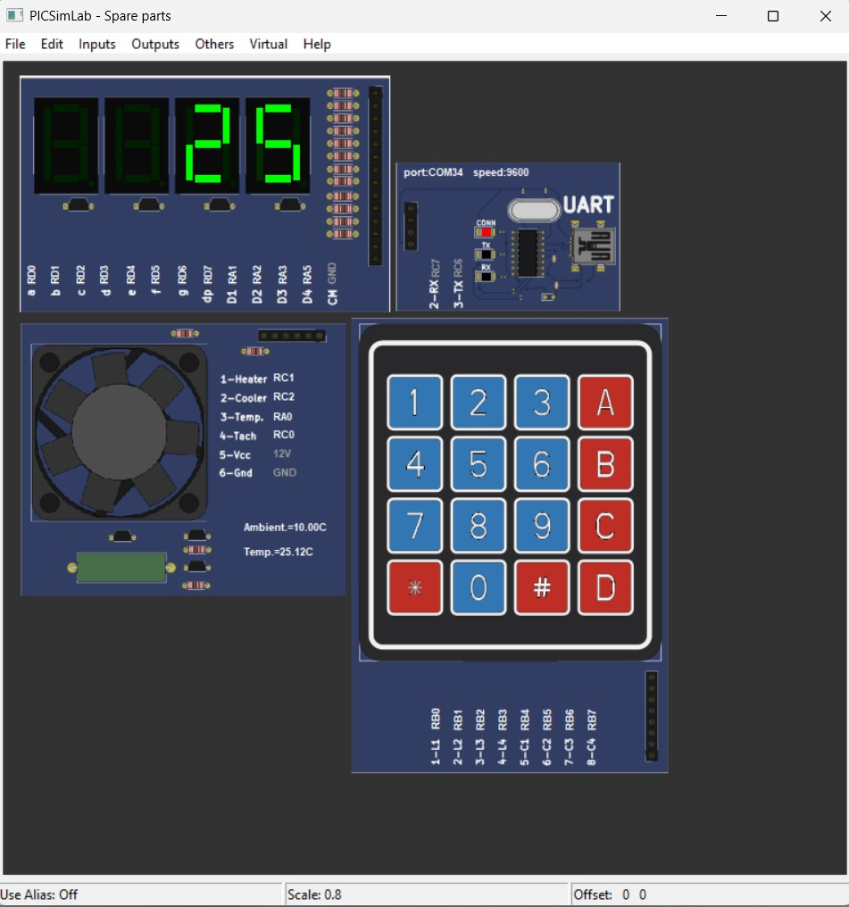
Figure 2.1.3Dual-digit 7-segment display on Board #1 visualizing the current ambient temperature 25 degree using multiplexing logic to exploit persistence of vision.
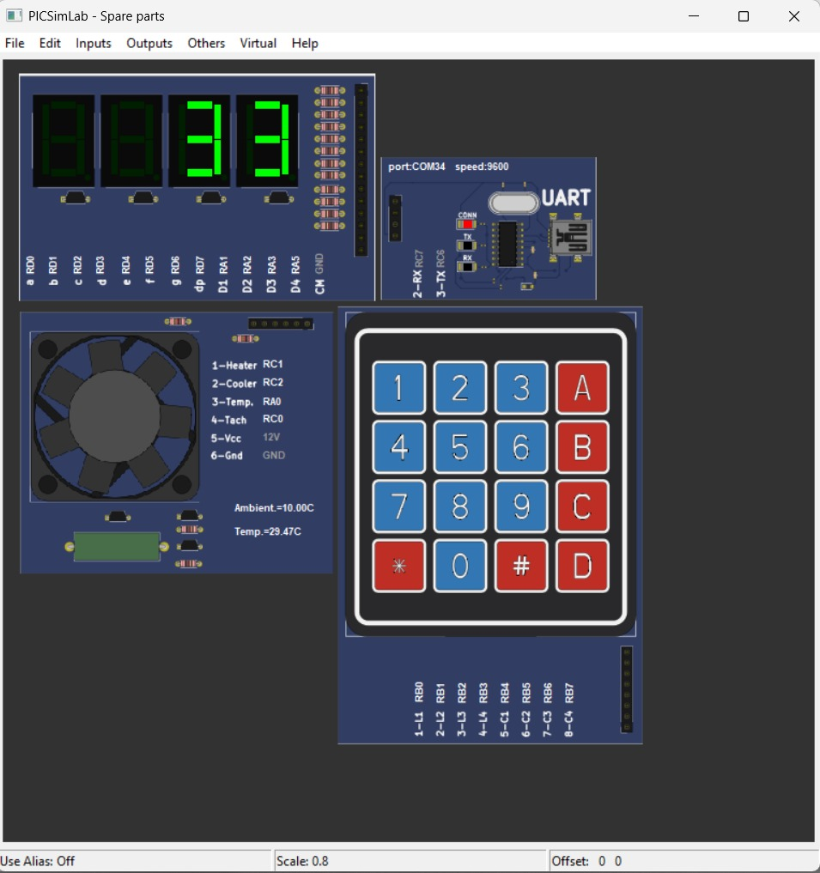
Figure 2.1 4.Board #1 displaying a user-defined target temperature entered via the 4x4 matrix keypad

UART Communication Module (Board #1)
Board #1 serves as a data server for the PC-side application, transmitting real-time climate statistics and receiving remote setpoint overrides. The communication is established using an asynchronous serial protocol with a baud rate of 9600 (8N1), managed by the PIC16F877A’s internal EUSART module.

1. Command-Response Architecture
The communication logic is strictly request-driven. Board #1 continuously monitors the RCIF (Receive Interrupt Flag) within its main loop or through a dedicated UART_DINLE_VE_ISLE routine. The system recognizes two primary types of incoming packets:
- GET Commands (Data Requests): These are single-byte triggers used by the Python API to poll sensors.
  - 0x01: Returns the current TEMP_VAL (Ambient Temperature).
  - 0x02: Returns the current DESIRED_TEMP (User-set Target).
  - 0x05: Returns the FAN_SPEED_RPS (Calculated Cooler Speed).
- SET Commands (Remote Overrides): Board #1 employs bitmasking to distinguish data updates. When a byte matches the 11xxxxxx mask, the lower 6 bits are extracted and stored directly into the DESIRED_TEMP register. This allows the PC application to adjust the thermostat remotely, bypassing the physical keypad.

2. Transmission Reliability (TX_W)
To ensure data integrity, the transmission routine (TX_W) polls the TXIF (Transmit Interrupt Flag) before loading the TXREG. This hardware-level handshaking prevents "overrunning" the buffer, ensuring that every temperature reading or status update is fully transmitted before the next byte is processed
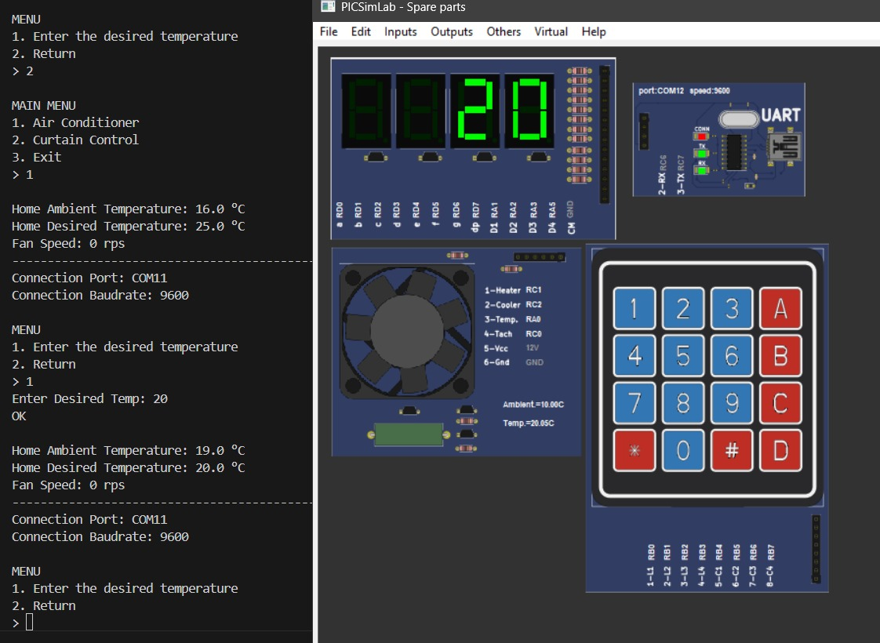
Figure 2.1 5 Technical Verification of the UART Communication Link
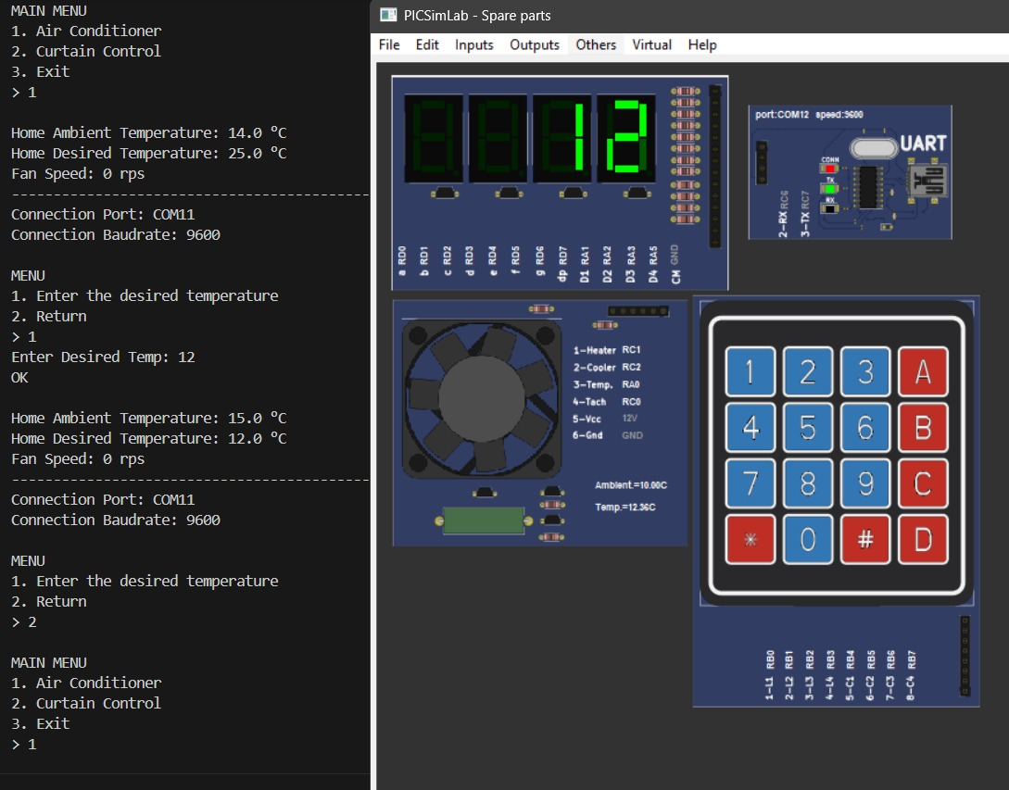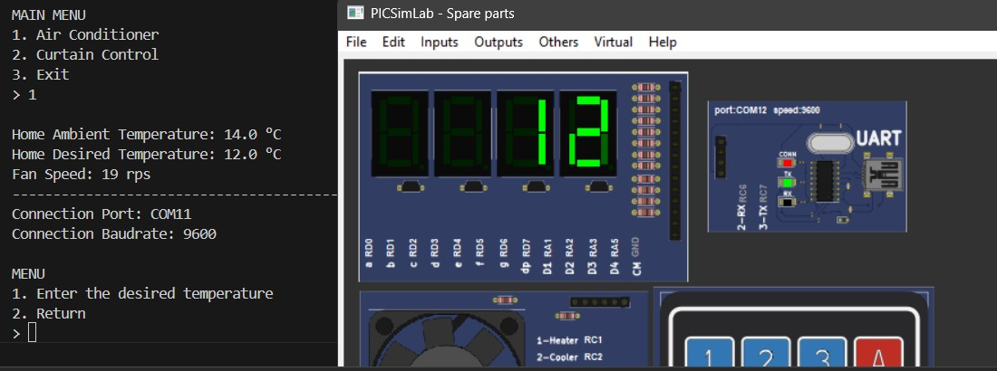
Figure 2.1 6 Remote Temperature Override and Cooling System Response Verification
Variable Definitions And Data Structures
The memory management of Board #1 is optimized for high-speed temperature control and real-time 7-segment display scanning. Variables are addressed in RAM to prevent conflicts with asynchronous UART interrupts.
- System and Interrupt Management Variables: These variables are used to preserve the processor state and manage system timing during interrupts.
Variable Name | Description
W_TEMP | Temporarily stores the data in the W (Working) register when an interrupt occurs to prevent data loss.
STATUS_TEMP | Stores the STATUS register (flags) during an interrupt.
DELAY_VAR1 / 2 | Counter variables used to generate specific delay durations within the EKRANI_GOSTER and SCAN_KEYPAD_SAFE routines.
STABLE_CNT | Verification counter used to validate "Debounce" (contact filtering) in keypad entries.

- Temperature Control and Sensor Data: Contains the fundamental parameters for the thermostat function.

Variable Name | Description
TEMP_VAL | Ambient temperature read from the LM35 sensor and converted to an 8-bit integer.
DESIRED_TEMP | Target temperature setpoint defined by the user via keypad or UART.
FAN_SPEED_RPS | Stores the fan rotation speed data measured via the tachometer.
- User Interface and Display Variables: Used to process keypad inputs and drive the 7-Segment display.
Variable Name | Description
KEY_VAL | Holds the raw value of the currently pressed key scanned from the keypad.
INPUT_VAL | Buffer that temporarily holds the multi-digit number being entered by the user.
DIGIT_3_VAL / 4_VAL | Stores the numerical values to be displayed on the 3rd and 4th digits of the 7-Segment display.
DISPLAY_MODE | Mode flag determining which data (Ambient Temp, Target Temp, or Fan Speed) is shown on the screen.

- Communication Variables

Variable Name | Description
UART_DAT | Stores the 8-bit command data received from the computer via UART (Serial Port).

Function Definitions and Operations
The software for Board #1 is partitioned between an interrupt-driven structure and the main execution loop.
1. Thermostat and Control Logic :This routine acts as the decision mechanism for the thermostat, comparing TEMP_VAL with DESIRED_TEMP:
- If the target temperature is higher than the ambient temperature (checked via the Carry flag), the heater is activated (RC1).
- If the ambient temperature reaches or exceeds the target, the heater is turned off, and the cooling fan (RC2) is engaged via the SOGUTUCU_AC routine.
2. Keypad Processing (KEYPAD_ISLE) Keypad scanning is performed using the SCAN_KEYPAD_SAFE function:
- BASLAT_GIRIS: Initiates entry mode and clears the INPUT_VAL register when the 'A' key is pressed.
- ONAYLA_GIRIS: Saves the entered value as DESIRED_TEMP and incorporates it into the control loop when the '#' key is pressed.
3-) Display Management (EKRANI_GOSTER) Manages the multiplexed (multi-digit) driving of the 7-Segment display:
- HEX_TO_DEC: Uses a subtraction loop to separate the 8-bit temperature data into tens and ones digits.
- GET_SEG: A lookup table function that converts numerical values into 7-segment character patterns.
4-) Communication (UART_DINLE_VE_ISLE) Handles requests from the PC. It transmits temperature and fan data in response to commands (0x01-0x05) and updates the target temperature for commands with a 11xxxxxx mask.

Pin Assignment Table (Board #1)
The following table details the pin assignments for Board #1 based on the firmware configurations:
Pin | Port | Function | Direction | Component
2 | RA0 | Analog Input 0 | Input | LM35 Temperature Sensor
5 | RA3 | Digit 1 Select | Output | 7-Segment Display (10s Digit)
7 | RA5 | Digit 2 Select | Output | 7-Segment Display (1s Digit)
33-36 | RB0-RB3 | Keypad Rows | Output | 4x4 Keypad Row Drive
37-40 | RB4-RB7 | Keypad Cols | Input | 4x4 Keypad Column Read
34 | RC1 | Heater Control | Output | Heater Relay Drive (HEATER_PIN)
35 | RC2 | Cooler Control | Output | Cooler/Fan Relay Drive (COOLER_PIN)
25 | RC6 | UART TX | Output | Serial Data to PC
26 | RC7 | UART RX | Input | Serial Data from PC
19-30 | PORTD | Segment Bus | Output | 7-Segment Data (a-g)

Board 2: Curtain Control System Design

Board #2 functions as a specialized subsystem dedicated to the automation of window curtains. The primary objective is to regulate curtain positioning based on autonomous sensor feedback, manual user input, and remote serial commands. The hardware architecture is centered around a PIC16F877A microcontroller and includes a unipolar stepper motor, an LDR light sensor, a rotary potentiometer, and a 16x2 character LCD.

Stepper Motor Actuation Logic

The mechanical movement of the curtains is driven by a unipolar stepper motor interfaced through PORTB pins (RB0-RB3). The system treats the curtain position as a logical percentage from 0% (Fully Open) to 100% (Fully Closed)

- Gear Ratio and Resolution: According to the project specifications, the motor requires 5 full turns to move from one extreme to the other. Since each step is 1.8° (200 steps per turn), the total mechanical range is 200 × 5 = 1000 steps. To simplify the software logic, the code implements a 10:1 gear ratio:

$$10 steps = 1\% logical change$$

This allows the CURRENT_ST variable to stay within an 8-bit range (0-63 in raw units, representing 0-100% visually).
- Drive Sequence and Protection Masking: The DRIVE routine retrieves phase patterns from the STEP_TABLE lookup table (0x01, 0x02, 0x04, 0x08) . A critical feature of your implementation is the protection mask used on PORTB. Since the LCD control pins (RS and EN) are shared on the upper bits of PORTB (RB4, RB5), the motor driver uses a bitwise ANDLW B'11110000' followed by an IORWF to ensure motor pulses do not corrupt the display data.

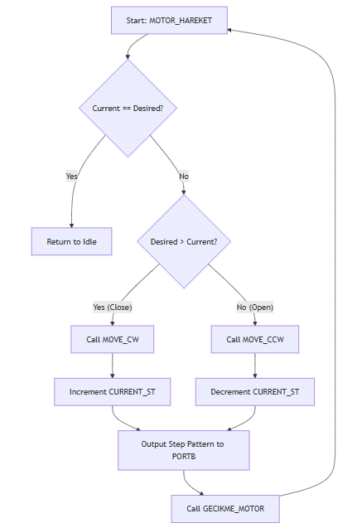
Figure 2.2.1 Stepper motor directional logic and positional feedback loop
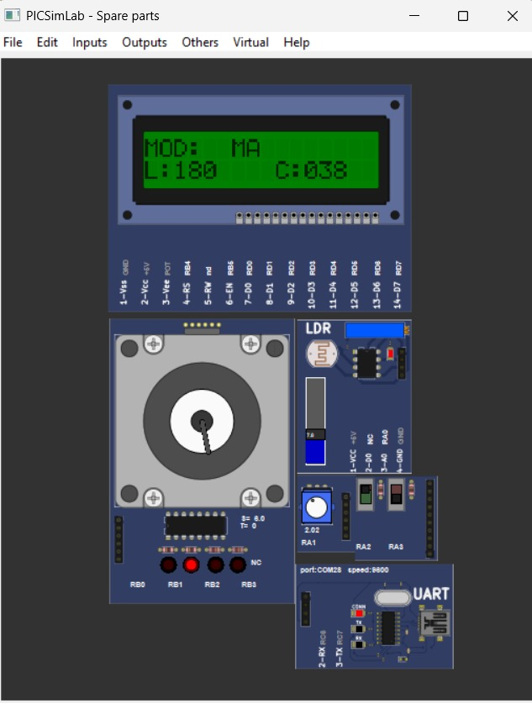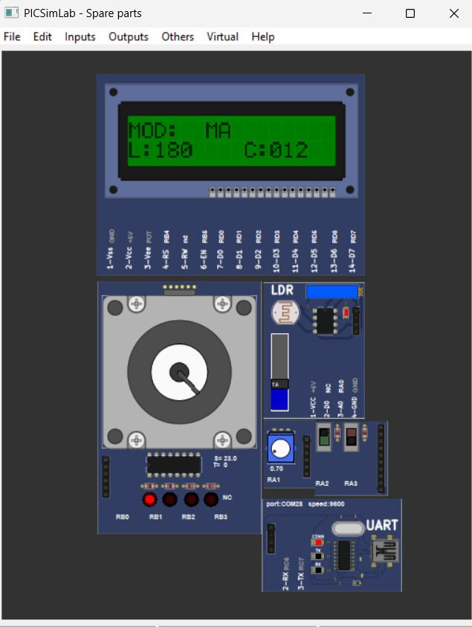
Figure 2.2 2Board #2 operating in Manual Mode with initial potentiometer status and Dynamic update of curtain status following manual potentiometer adjustment.

Environmental Sensing and Night Mode Algorithm
The system continuously monitors the environment via an LDR light sensor connected to the AN0
analog input.

- Data Acquisition and Stability: The SENSORLERI_OKU routine utilizes a "Double Read" method to ensure signal stability. The first ADC conversion acts as a dummy read to discharge the acquisition capacitor, while the second read captures the actual light level (LDR_VAL) . This prevents cross-talk between the LDR and the potentiometer readings.

- Autonomous Night Mode: In Auto Mode, the system evaluates the light level against a defined threshold. If LDR_VAL falls below 100 (indicating twilight or darkness), the AUTO_KARANLIK routine is triggered . This forces the DESIRED_ST to 63 (100% closed), overriding other inputs for safety and privacy. If light levels are sufficient, the system opens the curtains by setting the target to 0%.

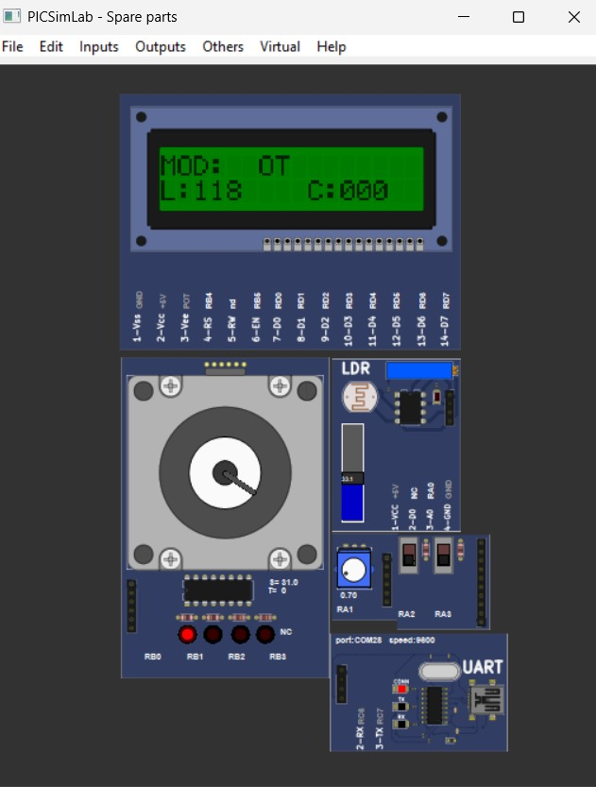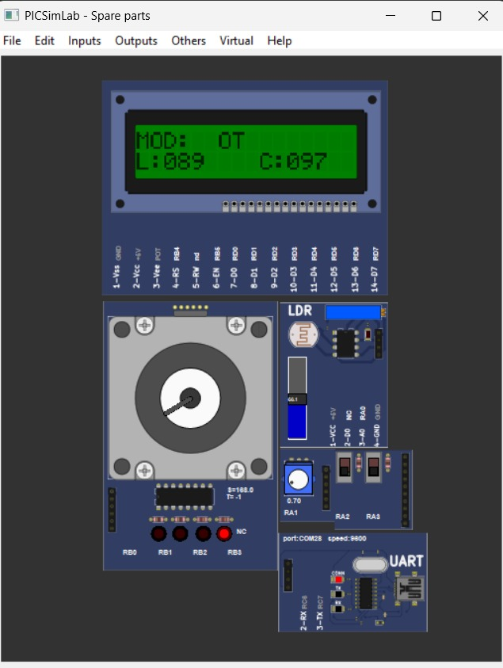
Figure 2.2 3Autonomous Curtain Response to Ambient Light Transitions

Smart Manual Override

Users can manually adjust the curtain position using a rotary potentiometer connected to AN1. The 8-bit ADC result (POT_VAL, range 0-255) must be mapped to the curtain's 6-bit internal range (0-63).

Instead of using CPU-intensive division, the code employs efficient bit-shifting:

MOVF POT_VAL, W
RRF TEMP_MATH, F ; Divide by 2
RRF TEMP_MATH, W ; Divide by 4 (Result: 0-63)

This maps the 0–5 V analog input linearly to the 0–100% curtain range. The LIMIT_63 function further ensures that the target value never exceeds the mechanical bounds of the motor.

LCD Interface and Data Visualization
The system utilizes an hd44780 LCD in 8-bit mode, with PORTD serving as the data bus and PORTB (RB4, RB5) handling control signals.
1. Visual Layout: The EKRAN_SABLON routine initializes the display with static text to guide the user :
- Top Row: Shows the current mode (OT for Auto, MA for Manual, PC for Remote) .
- Bottom Row: Displays light intensity (L:) and curtain percentage (C:) .
- Flicker Prevention: To maintain a professional UI, the EKRANI_GUNCELLE routine compares CURRENT_ST and LDR_VAL with their previous values (LAST_DISP_ST, LAST_LDR) . The screen is only refreshed if a change is detected, preventing the "flickering" effect caused by constant rewriting to the LCD.

UART Communication Protocol
Board #2 implements a master-slave communication protocol at 9600 Baud . The UART_DINLE_VE_ISLE routine polls the RCIF flag to catch incoming bytes from the PC API.
- GET Requests: When the PC sends 0x07 or 0x08, the board transmits the LDR_VAL bytes back . If 0x01 or 0x02 is received, it sends the curtain's current status .
- SET Commands: The board uses bitmasking (ANDLW B'11000000') to identify remote position updates. Receiving a SET command automatically switches the SYSTEM_MODE to 2 (PC Control), granting the remote user full priority over the motor .
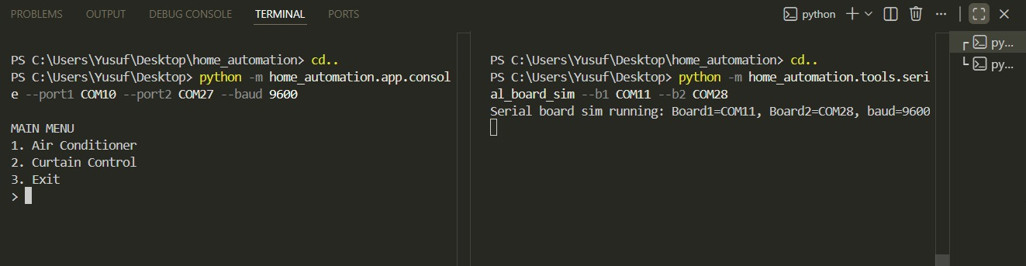
Figure 2.2 4Terminal-based initialization of the Python application, showing COM port assignments and baud rate setup for UART communication
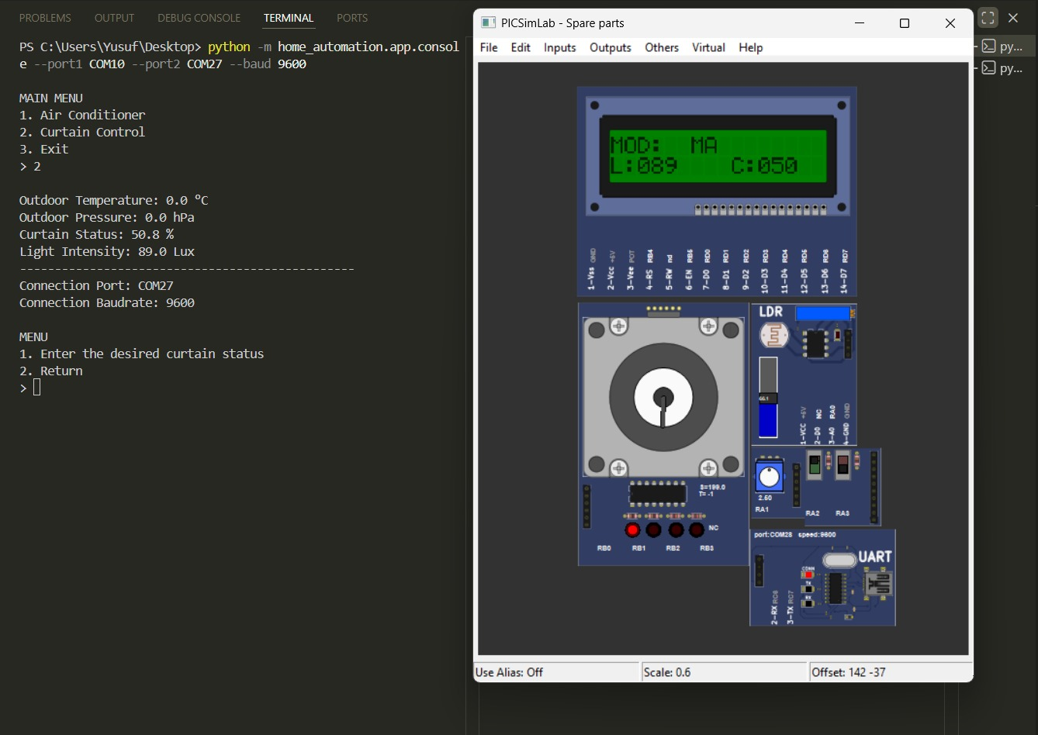
Figure 2.2 5Successful data synchronization between the PC and microcontrollers, verifying real-time sensor updates across both systems.
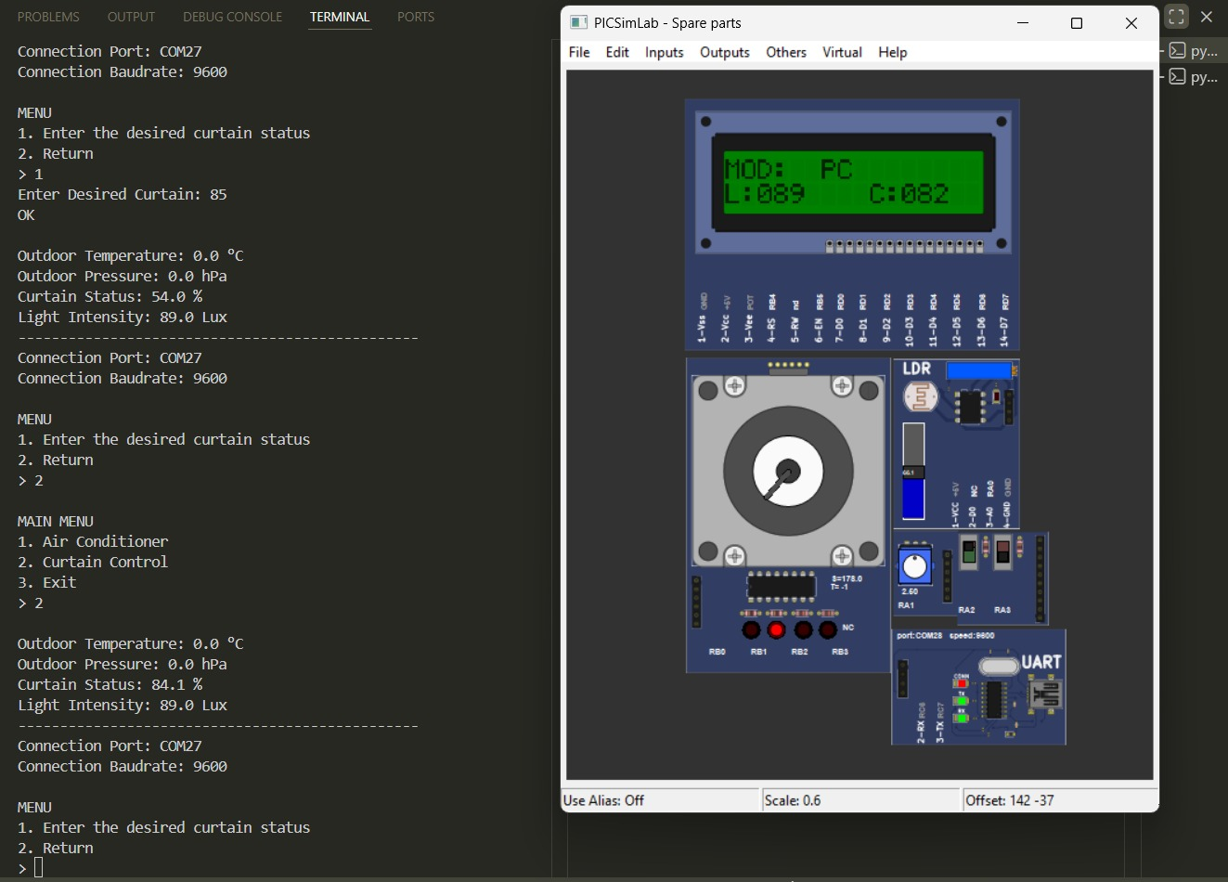
Figure 2.2 6Remote PC override: system switching to PC mode to execute a target position command

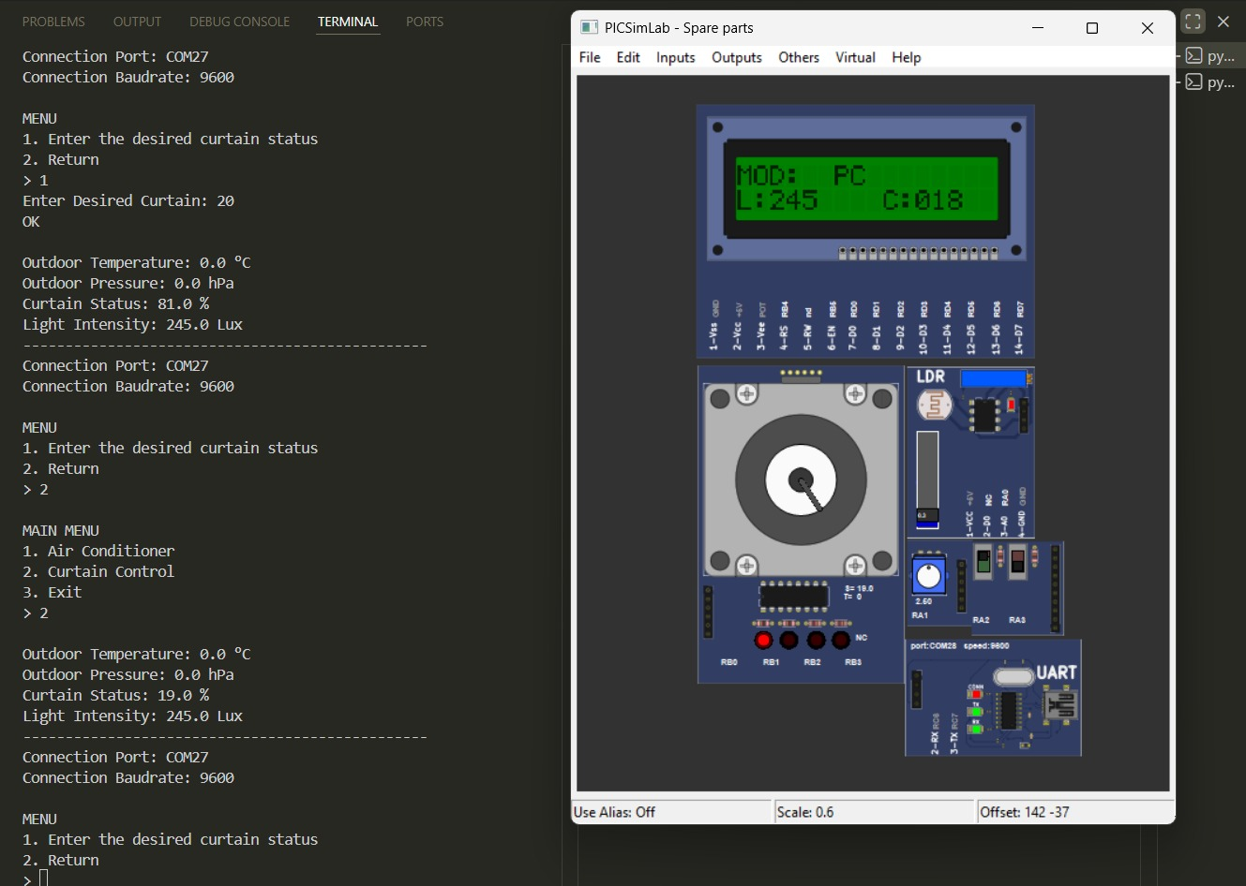
Figure 2.2 7Successful execution of a remote curtain command (20%) via the UART command parser.

Pin Assignment Table
The following table details the hardware connections as implemented in the board2.asm firmware:
Pin | Port | Function | Direction | Component
2 | RA0 | Analog Input 0 | Input | LDR Light Sensor
3 | RA1 | Analog Input 1 | Input | Rotary Potentiometer
4 | RA2 | Digital Input | Input | Mode Selection Switch
33 | RB0 | Digital Output | Output | Step Motor Phase A
34 | RB1 | Digital Output | Output | Step Motor Phase B
35 | RB2 | Digital Output | Output | Step Motor Phase C
36 | RB3 | Digital Output | Output | Step Motor Phase D
37 | RB4 | Digital Output | Output | LCD Register Select
38 | RB5 | Digital Output | Output | LCD Enable
25 | RC6 | UART TX | Output | Serial Transmit to PC
26 | RC7 | UART RX | Input | Serial Receive from PC
19-30 | PORTD | 8-bit Bus | Output | LCD Data Bus (D0-D7)
Variable Definitions And Data Structures
The RAM organization for the Curtain Control System is designed for high-speed motor indexing and flicker-free display management. The following variables are allocated in the GPR (General Purpose Register) area starting at address 0x20.
1. Motion and Positioning Variables:These registers track the physical and logical state of the window curtains and the stepper motor's internal phase sequence.
Variable Name | Description
DESIRED_ST | Stores the target curtain position (range 0–63). This value is updated via the LDR, Potentiometer, or UART SET commands.
CURRENT_ST | Tracks the actual real-time position of the motor (range 0–63). The motor moves until CURRENT_ST equals DESIRED_ST.
PHASE_STEP | An index counter (0–3) used to cycle through the STEP_TABLE. It determines which  motor coil is currently energized.
2.Environmental Sensor Data:Registers used to store digitized readings from the analog-to-digital converter (ADC).
Variable Name | Description
LDR_VAL | Stores the 8-bit light intensity value read from AN0. Used by the Auto-Mode algorithm to detect Night Mode.
POT_VAL | Stores the 8-bit manual input value from the rotary potentiometer (AN1).
TEMP_MATH | A general-purpose working register used for intermediate calculations, such as bit-shifting for ADC-to-percent mapping.

3.Display and User Interface Variables: These variables manage the content shown on the 16x2 LCD and implement flicker-reduction logic.
Variable Name | Description
SYSTEM_MODE | Indicates the operational state: 0 for Auto (OT), 1 for Manual (MA), or 2 for PC Override.
LAST_DISP_ST | Stores the curtain position displayed in the previous loop. Used to skip redundant LCD writes to prevent screen flicker.
LAST_LDR | Stores the previous light intensity reading to ensure the LCD only refreshes when a meaningful change occurs.
BIN_H / BIN_L | 16-bit binary registers used as input for the Binary-to-BCD conversion routine.
YUZ_H, ON_H, BIR_H | Store the resulting Hundreds, Tens, and Ones digits (in ASCII) after processing a sensor value for LCD display.
4.Communication and System Management: Buffers and counters used for UART stability and timing.
Variable Name | Description
UART_TEMP | Captures the incoming command byte from the RCREG before it is parsed by the command logic.
SAYAC1 / 2 | Counter variables used to create nested loops for the GECIKME_MOTOR and G_LCD timing routines.
Function Definitions and Operations
The firmware logic is divided into specialized subroutines to ensure modularity and ease of debugging.
1. System and Initialization Subroutines
- SETUP: Configures Port directions (TRISA, TRISB, TRISC, TRISD), sets the UART Baud Rate to 9600, initializes the ADC module, and clears system variables.
- ANA_DONGU: The executive loop that sequentially calls UART processing, sensor polling, mode selection, motor movement, and display updates.
2. Actuation and Motion Control
- MOTOR_HAREKET: Compares CURRENT_ST with DESIRED_ST. If a difference exists, it determines the direction (CW/CCW) and initiates movement.
- STEP_CW / STEP_CCW: Increments or decrements the PHASE_STEP index to rotate the motor by one physical step.
- DRIVE: The low-level driver that retrieves a bit pattern from the STEP_TABLE and outputs it to PORTB while using bitwise masking to protect LCD control pins.
- GECIKME_MOTOR: A precision delay that controls the RPM of the stepper motor, preventing mechanical stall during movement.
3. Sensor and Logic Processing
- SENSORLERI_OKU: Uses a "Double-Read" technique to ensure ADC stability. It polls both the LDR (Channel 0) and Potentiometer (Channel 1).
- ISLEM_MANUEL: Maps the 0–255 potentiometer value to a 0–63 curtain range using bitwise right-shifts (RRF), effectively performing high-speed division.
- ISLEM_AUTO: Compares the LDR reading against the 100-lux threshold. If darkness is detected, it branches to AUTO_KARANLIK to force the curtain to a 100% closed state.
- LIMIT_63: A safety routine that clamps the target position to a maximum of 63 to prevent motor over-travel.
4. Communication and UI (User Interface)
- UART_DINLE_VE_ISLE: Polls the RCIF flag. It distinguishes between GET requests (0x01-0x08) and SET commands (11xxxxxx mask).
- TX_W: Transmits data to the PC API. It monitors the TXIF flag to ensure the hardware buffer is ready for the next byte.
- EKRANI_GUNCELLE: Evaluates if a screen refresh is necessary. If a change is detected, it calls YAZDIR to rewrite the LCD content.
- SAYI_BAS: A Binary-to-ASCII utility. It separates an 8-bit number into decimal digits using a subtraction loop and sends the characters to the LCD.
- SAYI_63_TO_PERCENT: Performs a linear mapping to convert the internal 6-bit motor units (0-63) into a user-friendly percentage (0-100%) for display.
- LCD_KOMUT / LCD_VERI: Low-level routines that toggle the RS and EN pins to send instructions or characters to the hd44780 controller.

API Design and Implementation
The software integration layer of the Home Automation System is implemented as a modular Python API. This layer abstracts the low-level UART byte-streams into high-level, object-oriented structures, allowing the host application to interact with the hardware through intuitive methods and managed state variables.

2.3.1. Architectural Overview and Base Connection
The API is designed with a focus on Encapsulation and Modularity. At its core, the system utilizes a centralized connection manager to handle the physical serial link.
- HomeAutomationSystemConnection: This base class (imported from .common) serves as the foundation for all hardware interactions. It manages the pySerial lifecycle, providing atomic write() and read() operations that ensure data integrity during high-frequency communication.
- Object-Oriented State Management: Each board is represented by a specific class that maintains a "Local Cache" of the board’s registers. This design minimizes redundant serial traffic by allowing the UI to read from local memory between synchronization cycles.
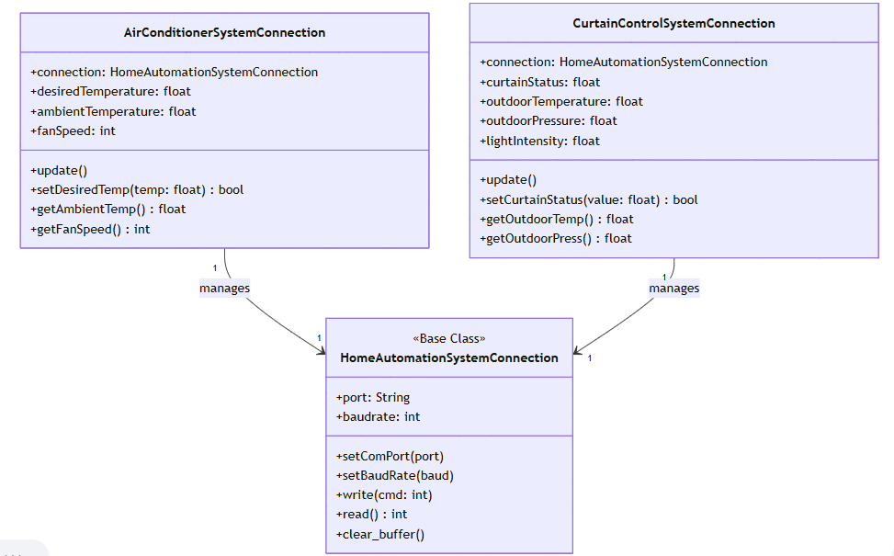
Figure 2.3 1 UML Class Diagram

2.3.2. Air Conditioner API (Board #1)
The AirConditionerSystemConnection class is responsible for the climate control logic. It implements the requirements for Board #1, specifically focusing on the synchronization of floating-point temperature data.
- State Tracking: The class utilizes Python @dataclasses to store desiredTemperature, ambientTemperature, and fanSpeed.
- Polling Logic (update method): Since the PIC16F877A processes data in 8-bit registers, the API requests 10-bit or fractional values in two stages (High Byte and Low Byte). The update() method transmits specific GET commands (e.g., GET_AMBIENT_TEMP_HIGH) and utilizes a decoding utility to reconstruct the actual float value.
- Remote Command Execution (setDesiredTemp): This method implements a safety-critical validation check. Per requirement [R2.1.2-3], it verifies that the input temperature is within the 10.0°C to 50.0°C range before encoding the value into UART-compatible command bytes and transmitting them to the hardware.

2.3.3. Curtain Control API (Board #2)
The CurtainControlSystemConnection class manages the window automation and environmental monitoring for Board #2. It features a more complex data structure due to the multiple sensors (LDR, Pressure, and Temperature) present on the board.
- Multi-Sensor Data Fusion: The API polls four distinct parameters during each update() cycle: Curtain Position, Outdoor Temperature, Outdoor Pressure, and Light Intensity. It uses a helper req() function to execute a "Write-Read" transaction for each parameter.
- Protocol Flexibility: A key feature of this implementation is the curtain_set_mode configuration. It allows the system to switch between "scaled_0_63" (mapping user-friendly 0-100% values to PIC units) and "raw_0_63" modes, ensuring compatibility with different mechanical gear ratios.
- Exception Handling: The setCurtainStatus method includes a try-except block to catch ValueErrors during input validsation. This ensures that the Python host application remains stable even if the user provides invalid input, preventing the serial port from hanging.

2.3.4. Data Synchronization and Polling Sequence
The API operates on a Command-Response model. Every transaction is initiated by the PC (Master) and answered by the Microcontroller (Slave).
- Request Phase: The API sends a 1-byte command representing a specific register request.
- Wait/Read Phase: The API waits for the PIC to return the 8-bit value of that register.
- Decoding Phase: The raw bytes are passed to a decode_get_response utility which handles the conversion from binary units to standard units (Celsius, hPa, or Percentage).
By implementing this architecture, the Home Automation System achieves seamless real-time synchronization, where the state shown on the PC terminal perfectly mirrors the physical state of the microcontrollers and their attached sensors.

2.3.5. UART Communication Sequences
The communication between the Python API and the microcontrollers follows a strict request-response (master-slave) model. The host application acts as the master, periodically polling the boards for data or sending command overrides, while the microcontrollers act as slaves, responding only when a valid command byte is detected .

1. Polling Cycle (Data Acquisition)
To maintain real-time synchronization, the API executes a polling cycle at regular intervals. During this cycle, the update() method in the API classes transmits specific GET commands (e.g., 0x01, 0x03) to the target board. Since the PIC16F877A architecture uses 8-bit registers, fractional values like temperature are requested in two stages—High Byte and Low Byte. Once both components are received, the API’s decoding logic reconstructs them into floating-point numbers for display on the console UI.
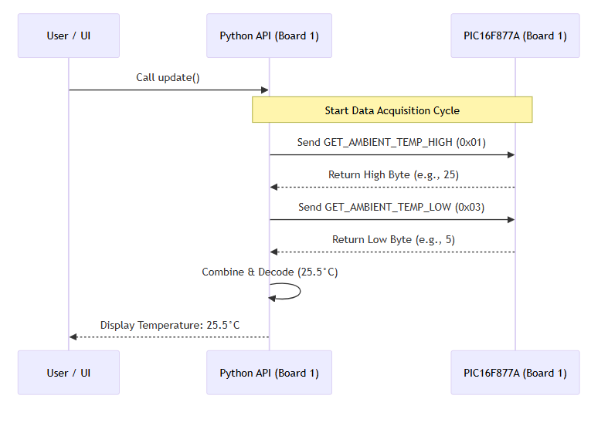
Figure 2.3 2 Monitoring Sequence Diagram

2. Command Cycle (System Overrides)
A command cycle is initiated whenever a user provides a new setpoint through the terminal interface . The process begins with the API validating the input range (e.g., ensuring a temperature is between 10°C and 50°C). After validation, the API encodes the value into a bit-masked byte (using the 11xxxxxx mask) and transmits it to the UART bus. Upon reception, the microcontroller's Interrupt Service Routine (ISR) immediately captures the data, updates the target register, and triggers the corresponding actuator, such as the heater or the stepper motor .
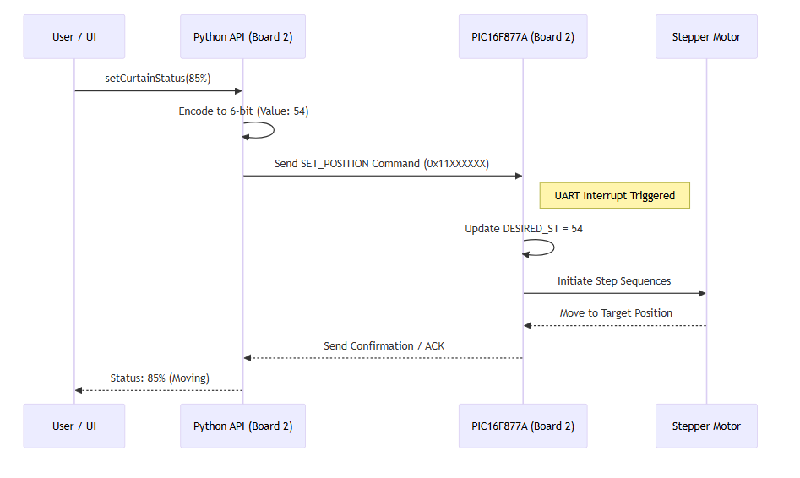
Figure 2.3 3 Command Sequence Diagram
Task Assignments
Group Member | Primary Responsibilities and Tasks
Nihan Çardak | Technical Documentation Lead & Board #2 System Integration Support.  * Authored the final comprehensive technical report and designed the high-level system architecture via UML Class and Sequence diagrams .  * Developed the interfacing logic for Board #2, focusing on the integration of user input signals and real-time feedback mechanisms for the LCD and local sensors .
Doğancan  Küçük | Board #1 Core Hardware Specialist:  * Responsible for the primary autonomous logic of the Air Conditioner System.  * Developed the assembly firmware for ADC sensor acquisition from the LM35, thermostat control algorithms, and the high-frequency 7-segment multiplexing system.
Anıl Çetin | Board #2 Lead (Structure & Comm) & Board #1 Communication Specialist:  * Managed the hardware design and electromechanical logic of Board #2, including the stepper motor phase sequences and autonomous LDR-based logic.  * Implemented the Board #1 hardware-level communication, focusing on the UART data framing required to transmit climate data to the PC.
Yiğit Ata | API Co-Developer & Board #1 General Integration:  * Collaborated on the architectural design and coding of the centralized Python API classes .  * Responsible for the General Integration of Board #1, synchronizing the hardware-level data acquisition subroutines with the high-level application monitoring cycles.  * Implemented local keypad validation for temperature setpoints.
Yusuf Yaman | API Co-Developer & Board #2 Structure and Communication Lead:  * Collaborated on the architectural design and coding of the centralized Python API classes .  * Served as the Board #2 Structure and Communication Lead, managing the software-hardware interface for the curtain system and implementing interrupt-driven command parsing for remote positioning.

3.Conclusion
The completion of the "Home Automation System" project marks the successful integration of embedded systems programming with high-level software application development. Throughout this term project, a fully functional prototype was designed and simulated using two PIC16F877A microcontrollers, demonstrating a comprehensive approach to modern home automation. The project achieved its primary goal of creating a responsive environment where domestic parameters such as climate and window positioning are managed through both localized hardware interfaces and a centralized PC console. By strictly adhering to the modular design requirements, the system proved that low-level Assembly programming can effectively communicate with high-level Python scripts to provide a user-friendly and reliable management platform .
The development phase of Board #1 provided deep insights into the complexities of real-time environmental monitoring. The core of this module, the autonomous thermostat logic, was successfully implemented to process analog data from the LM35 sensor and drive heating and cooling actuators based on user-defined setpoints . One of the most technically demanding aspects was the implementation of the dual-digit 7-segment display multiplexing. By utilizing the persistence of vision effect through high-frequency switching in the interrupt service routine, a clear and flicker-free visual interface was achieved, allowing the user to monitor temperatures and fan speeds accurately . Furthermore, the robust keypad scanning algorithm ensured that user inputs were captured and validated efficiently, maintaining a safe operating range for the heating system .
Simultaneously, the implementation of Board #2 highlighted the precision required for motorized actuation and multi-sensor data fusion. The unipolar stepper motor logic was engineered to provide high-resolution curtain positioning, effectively translating logical percentages into mechanical steps . The system’s ability to transition between autonomous light-sensing mode and manual potentiometer control demonstrated a sophisticated priority logic . Specifically, the "Night Mode" feature, which automatically secures the curtains when light levels drop, emphasized the potential of embedded systems in enhancing home security. The 16x2 LCD provided a constant stream of status updates, ensuring that the current operational mode and environmental values were always visible to the user .
The bridge between the simulated hardware and the human operator was the UART-based communication protocol. Operating at 9600 Baud, this asynchronous link facilitated a seamless flow of data requests and commands . The development of the Python API and the console-based user interface proved that real-time monitoring does not require complex graphical engines to be effective. By utilizing a command-response architecture, the PC application was able to override local sensor logic, allowing for remote management of the home’s parameters . This integration emphasized the importance of standardized communication protocols in modern engineering, as the system remained stable even during rapid data exchanges over virtual serial ports.
In conclusion, this project served as an invaluable educational journey, bridging the gap between theoretical microcomputer concepts and practical engineering applications. Facing challenges such as bus conflicts on PORTB and the synchronization of multiple analog channels required careful debugging and a deep understanding of the PIC16F877A architecture. The successful outcome is a testament to the collaborative efforts of the group members, who each contributed specialized knowledge to create a unified system. This project has not only solidified our understanding of Assembly language and serial communication but has also provided a strong foundation for future professional endeavors in the field of embedded systems and automation.

4.Project Resources
The complete source code, including Assembly files (.asm), Python scripts (.py), and simulation schematics, can be accessed via the following GitHub repository:

        - GitHub Repository: https://github.com/Yusuf-Ymn/home_automation_IntToMicrocomputer

5.References
[1] L. C. G. Lopes, "PICsimLab - Programmable IC Simulator Laboratory," GitHub Repository, 2025. [Online]. Available: https://github.com/lcgamboa/picsimlab. [Accessed: Jan. 15, 2026].
[2] Microchip Technology Inc., "PIC16F877A Data Sheet: 28/40/44-Pin Enhanced Flash Microcontrollers," Chandler, AZ, USA, 2003.
[3] L. C. G. Lopes, "PICSimLab Documentation: Temperature System Module," 2025. [Online]. Available: https://lcgamboa.github.io/picsimlab_docs/0.9.2/TemperatureSystem.html.
[4] L. C. G. Lopes, "PICSimLab Documentation: LCD hd44780 Module," 2025. [Online]. Available: https://lcgamboa.github.io/picsimlab_docs/0.9.2/LCDhd44780.html.
[5] L. C. G. Lopes, "PICSimLab Documentation: Unipolar Stepper Motor Control," 2025. [Online]. Available: https://lcgamboa.github.io/picsimlab_docs/0.9.2/StepMotor.html.
[6] J. W. Nilsson and S. Riedel, Electric Circuits, 11th ed. New York, NY, USA: Pearson, 2018.
[7] L. C. G. Lopes, "Serial Communication Emulator for PICSimLab," 2025. [Online]. Available: https://lcgamboa.github.io/picsimlab_docs/stable/SerialCommunication.html.
[8] V. Vyas, "Null-modem emulator (com0com)," SourceForge, 2025. [Online]. Available: http://sourceforge.net/projects/com0com/. [Accessed: Jan. 12, 2026].
[9] Python Software Foundation, "pySerial: Python Serial Port Extension Documentation," 2024. [Online]. Available: https://pyserial.readthedocs.io/.
[10] M. Mazidi, R. D. McKinlay, and D. Causey, PIC Microcontroller and Embedded Systems: Using Assembly and C for PIC18, 1st ed. Upper Saddle River, NJ, USA: Pearson, 2008.
[11] L. C. G. Lopes, "PICSimLab Documentation: LDR (Light Dependent Resistor) and Analog Interfacing," 2025. [Online]. Available: https://lcgamboa.github.io/picsimlab_docs/0.9.2/LDR.html.
[12] J. W. Nilsson and S. Riedel, Electric Circuits, 11th ed. New York, NY, USA: Pearson, 2018.

