Part 1

Part 1.1

%%%%%%%%%%Part 1.1%%%%%%%%%%%%%%

n=0:1:359;

figure(1)

xd1=6\*cos((pi./30)\*n+(pi./3));

stem(n,xd1);

title("Discrete Time Cosine");

xlabel("Index");

ylabel("xd1");

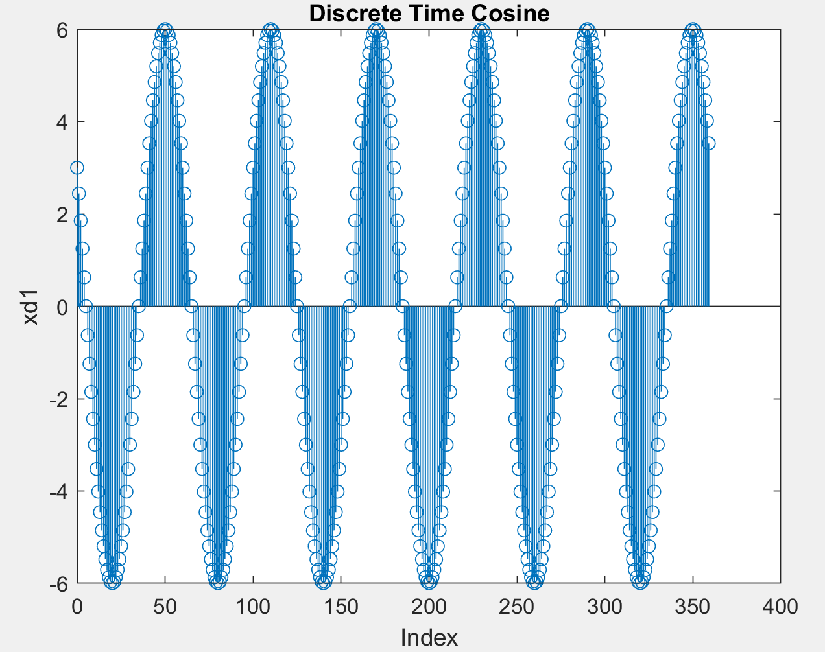

Figure 1 (Part 1.1 xd1 signal, Period is 60)

Part1.2

%%%%%%%%%%Part 1.2%%%%%%%%%%%%%%%

n=0:1:119;

figure(2)

xd2=2\*cos((pi./10)\*n+(pi));

stem(n,xd2);

title("Discrete Time Cosine");

xlabel("Index");

ylabel("xd2");

figure(3)

xd1=6\*cos((pi./30)\*n+(pi./3));

s1=stem(n,xd1);

hold on

xd2=2\*cos((pi./10)\*n+(pi));

s2=stem(n,xd2);

title("Discrete Time Cosine");

xlabel("Index");

ylabel("xd1 and xd2");

legend("xd1","xd2");

s2.Marker = 'x';

hold off

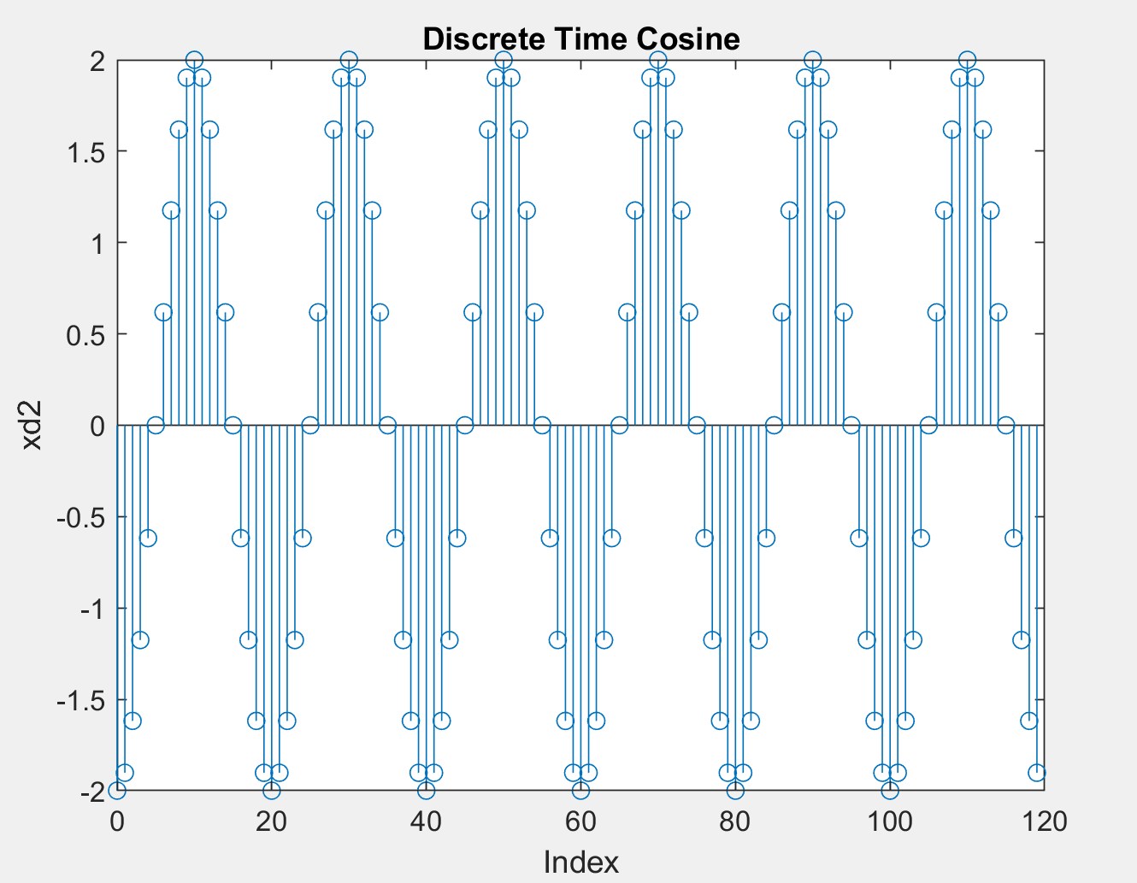

Figure 2(Part 1.2 xd2 signal, Period is 20)

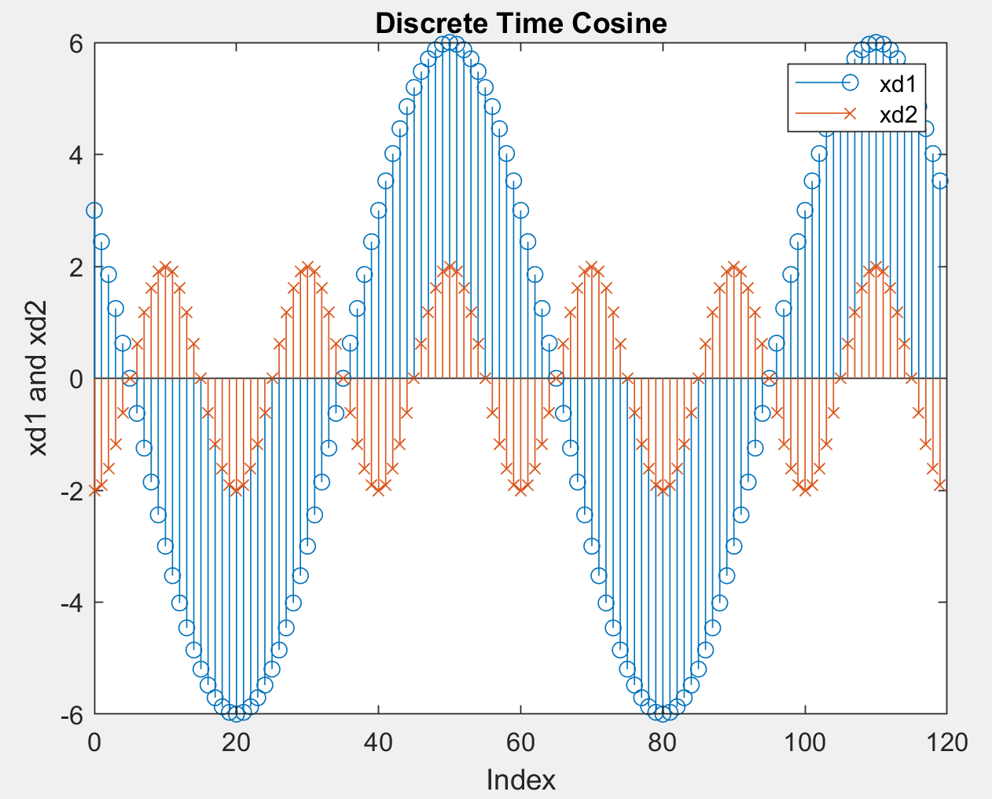

Figure 3 (xd1 from part 1.1 and xd2 from part 1.2 in the same plot)

Part 1.3

%%%%%%%%%%%Part 1.3%%%%%%%%%%%%%%

n=0:1:359;

xb1=exp(-0.005972531.\*n).\*(6.\*cos((pi./30).\*n+(pi./3)));

figure(4)

stem(n,xb1);

title("Discrete Time Cosine");

xlabel("Index");

ylabel("xb1");

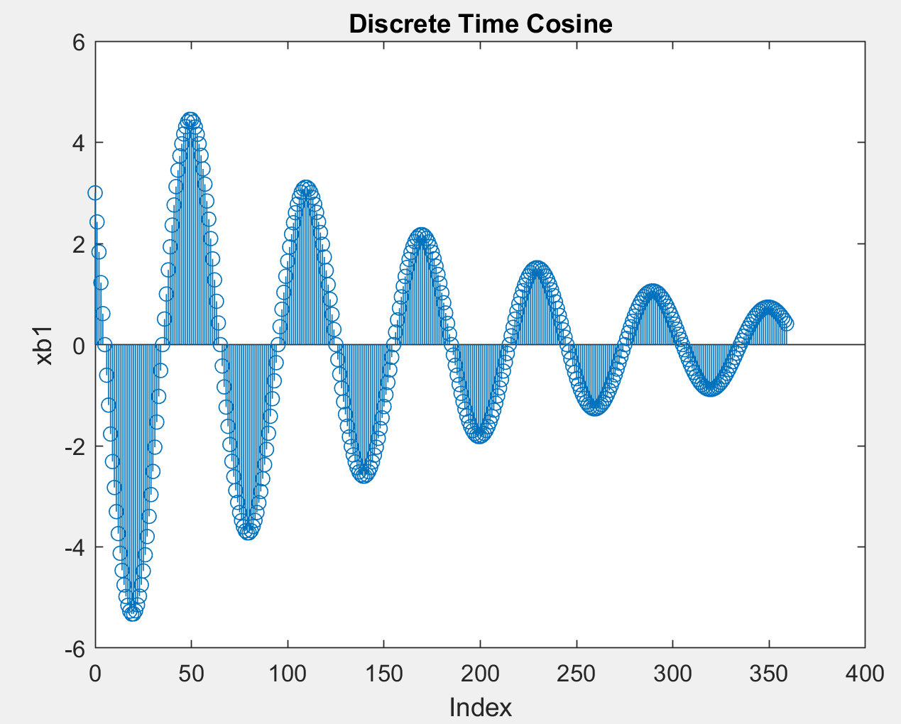

Figure 4 (Part 1.3 xb1, decaying cosine)

Part 2

Part 2.1

Part 2.2

Part 2.3

%%%%%%%%%%%Part2.3%%%%%%%%%% f = 698.46hz

t=0:0.000014311:20;

xc1=cos((4390.438565).\*t);

soundsc(xc1,69846);

Part 2.4

%%%%%%%%%%%Part2.4%%%%%%%%%% f = 698.46hz

t=0:0.000014311:20;

xc2=cos((4390.438565).\*t+(pi./4));

xc3=cos((4390.438565).\*t+(pi./2));

xc4=cos((4390.438565).\*t+pi);

soundsc(xc2,69846);

soundsc(xc3,69846);

soundsc(xc4,69846);

Part 2.5

Part 2.6

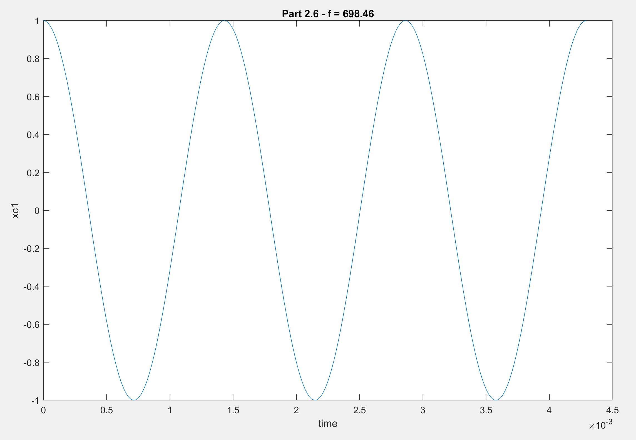

%%%%%%%%%%Part 2.6%%%%%%%%%%%

t1=0:0.000014311:0.0042933;

xc1=cos((4390.438565).\*t1);

plot(t1,xc1);

title("Part 2.6 - f = 698.46");

xlabel("time");

ylabel("xc1");

Part 2.7

%%%%%%%%%%%% f = 329.63hz

t2=0:0.0000303370:20;

xc2=cos((2071.1263728).\*t2);

soundsc(xc2,32963);

Part 2.8

a)

b)

%%%%%%%%%%%Part2.8 SOUND %%%%%%%%%%%

t2=0:0.0000303370:20;

xc2=exp((-0.1155245300).\*t2).\*cos((2071.1263728).\*t2);

soundsc(xc2,32963);

c)

%%%%%%%%%%%Part2.8 PLOT %%%%%%%%%%%

tp=0:0.0000303370:20;

xc2=exp((-0.1155245300).\*tp).\*cos((2071.1263728).\*tp);

plot(tp,xc2);

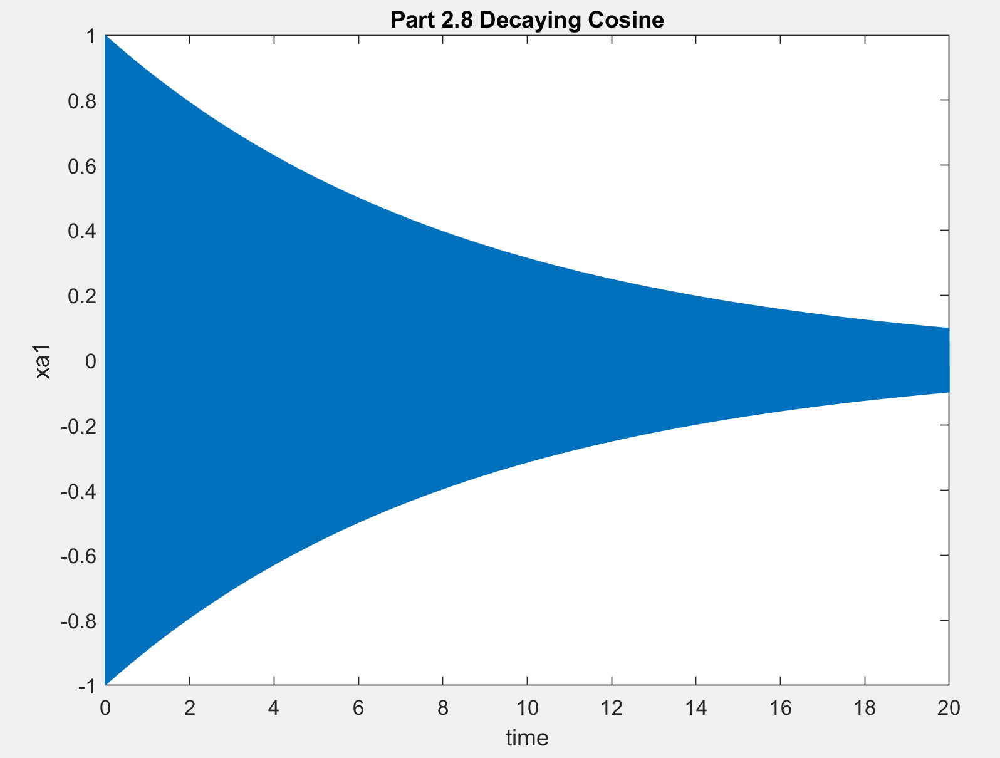

Figure 5 (Decaying Cosine, You can see that value drops to half in 6th second)

Note: In 20 seconds interval we can’t see the cosine itself very well from the plot itself but the decaying form is visible nonetheless.

Part 3

Part 3.1

Part 3.2

%%%%%%%%%Part 3 %%%%%%%%

t=0:0.000014311:0.03;

x=exp(j\*4390.4385\*t)+exp(j\*2071.126\*t);

subplot(2,2,1);

plot(t,real(x));

title("Real Part");

xlabel("time");

ylabel("x(t)");

subplot(2,2,2);

plot(t,imag(x));

title("Imaginary Part");

xlabel("time");

ylabel("x(t)");

subplot(2,2,3);

plot(t,abs(x));

title("Amplitude");

xlabel("time");

ylabel("x(t)");

subplot(2,2,4);

plot(t,angle(x));

title("Phase");

xlabel("time");

ylabel("x(t)");

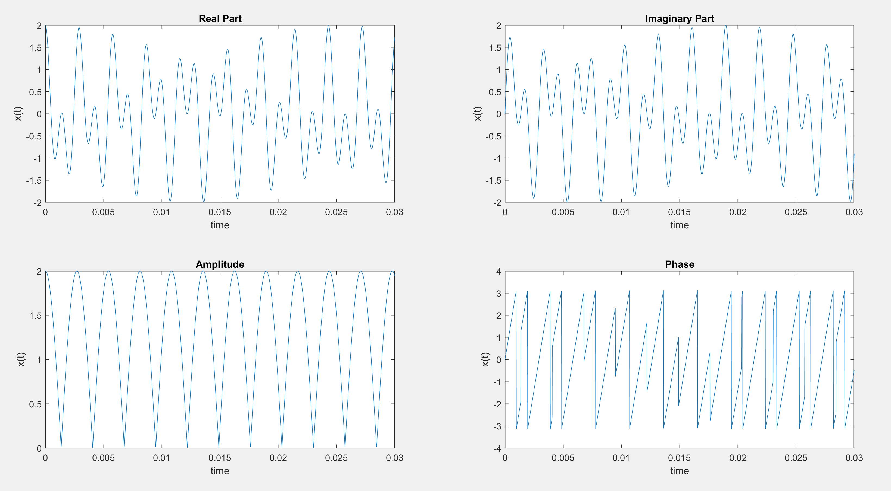

Figure 6 (Real part, Imag part, Amplitude and Phase of the Complex Sinusoid)

Part 3.3

Part 4

ON LAB