**PART 1**

Part1.1

Part1.2

clc;

clear all;

%%%%%%%%%%% PART 1.2 %%%%%%%%%%

delta = 0.01;

t=0:delta:6;

x=zeros(size(t));

counter = 1;

for index1 = t

if(index1<0.5 && index1>=0)

x(counter) = 4.*index1;

elseif(index1<1.5 && index1>=0.5)

x(counter) = 3 - index1;

elseif(index1<2 && index1>=1.5)

x(counter) =index1;

elseif(index1<2.5 && index1>=2)

x(counter) = 4.*(index1-2);

elseif(index1<3.5 && index1>=2.5)

x(counter) = 3 - (index1-2);

elseif(index1<4 && index1>=3.5)

x(counter) =(index1-2);

elseif(index1<4.5 && index1>=4)

x(counter) = 4.*(index1-4);

elseif(index1<5.5 && index1>=4.5)

x(counter) = 3 - (index1-4);

elseif(index1<6 && index1>=5.5)

x(counter) =(index1-4);

end

counter = counter + 1;

end

plot(t,x);

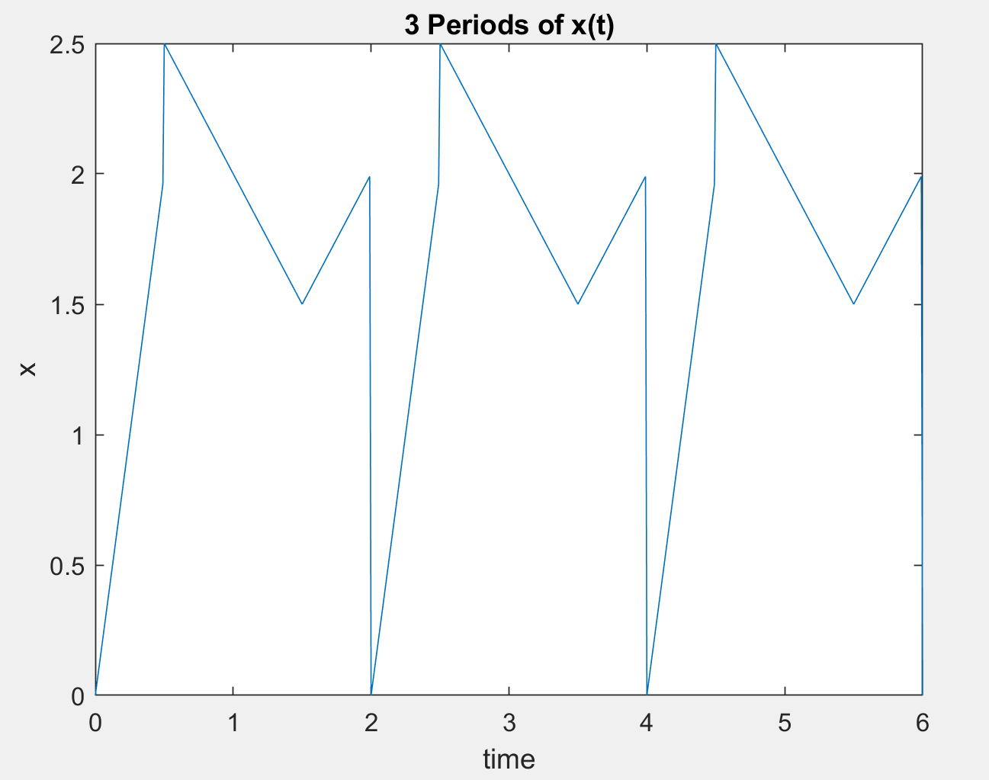

Figure 1 (3 periods of given x(t) function)

Part1.3

Part1.4

%%%%%%%%%PART 1.4 %%%%%%%%%

%%%%%%%%%%%% THIS CODE CALCULATES ENERGY VALUES

syms t

f = (abs(4*t)).^2;

f2 = (abs(3-t)).^2;

f3 = (abs(t)).^2;

part1 = int(f,t,[0 0.5]);

part2 = int(f2,t,[0.5 1.5]);

part3 = int(f3,t,[1.5 2]);

final = ((1./2).*(part1+part2+part3))-((1.6875).^2);%%%%%% extract a0, we want k is not 0

double(final) %%%%%%%%%% All energy

a = (95./100).*(final);

double(a) %%%%%%%%%%% 95 percent of the energy

clear all;

syms t

syms k

syms y(t)

y(t) = 0;

for k = -3:1:3

f = 4*t*exp(-j*k*pi*t);

f2 = (3-t)*exp(-j*k*pi*t);

f3 = t*exp(-j*k*pi*t);

part1 = int(f,t,[0 0.5]);

part2 = int(f2,t,[0.5 1.5]);

part3 = int(f3,t,[1.5 2]);

weight = (1/2)*(part1+part2+part3);

y(t) = y(t) + ((abs(weight)).^2);

end

double(y(t)-((1.6875).^2)) %%%%%%%%%%%% a0 is exluded

Part1.5

%%%%%%%%%%%% Part 1.5 %%%%%%%%%%%%

syms t

syms k

x = [];

interval = -15:1:15;

counter = 1;

for k = -15:1:15

f = 4*t*exp(-j*k*pi*t);

f2 = (3-t)*exp(-j*k*pi*t);

f3 = t*exp(-j*k*pi*t);

part1 = int(f,t,[0 0.5]);

part2 = int(f2,t,[0.5 1.5]);

part3 = int(f3,t,[1.5 2]);

weight = (1/2)*(part1+part2+part3);

x(counter) = weight;

counter = counter + 1;

end

x(1)

subplot(2,1,1);

stem(interval, abs(x));

title("Magnitude");

xlabel("index");

ylabel("Magnitude(Xk)");

subplot(2,1,2);

stem(interval, angle(x));

title("Phase");

xlabel("index");

ylabel("Angle(Xk)");

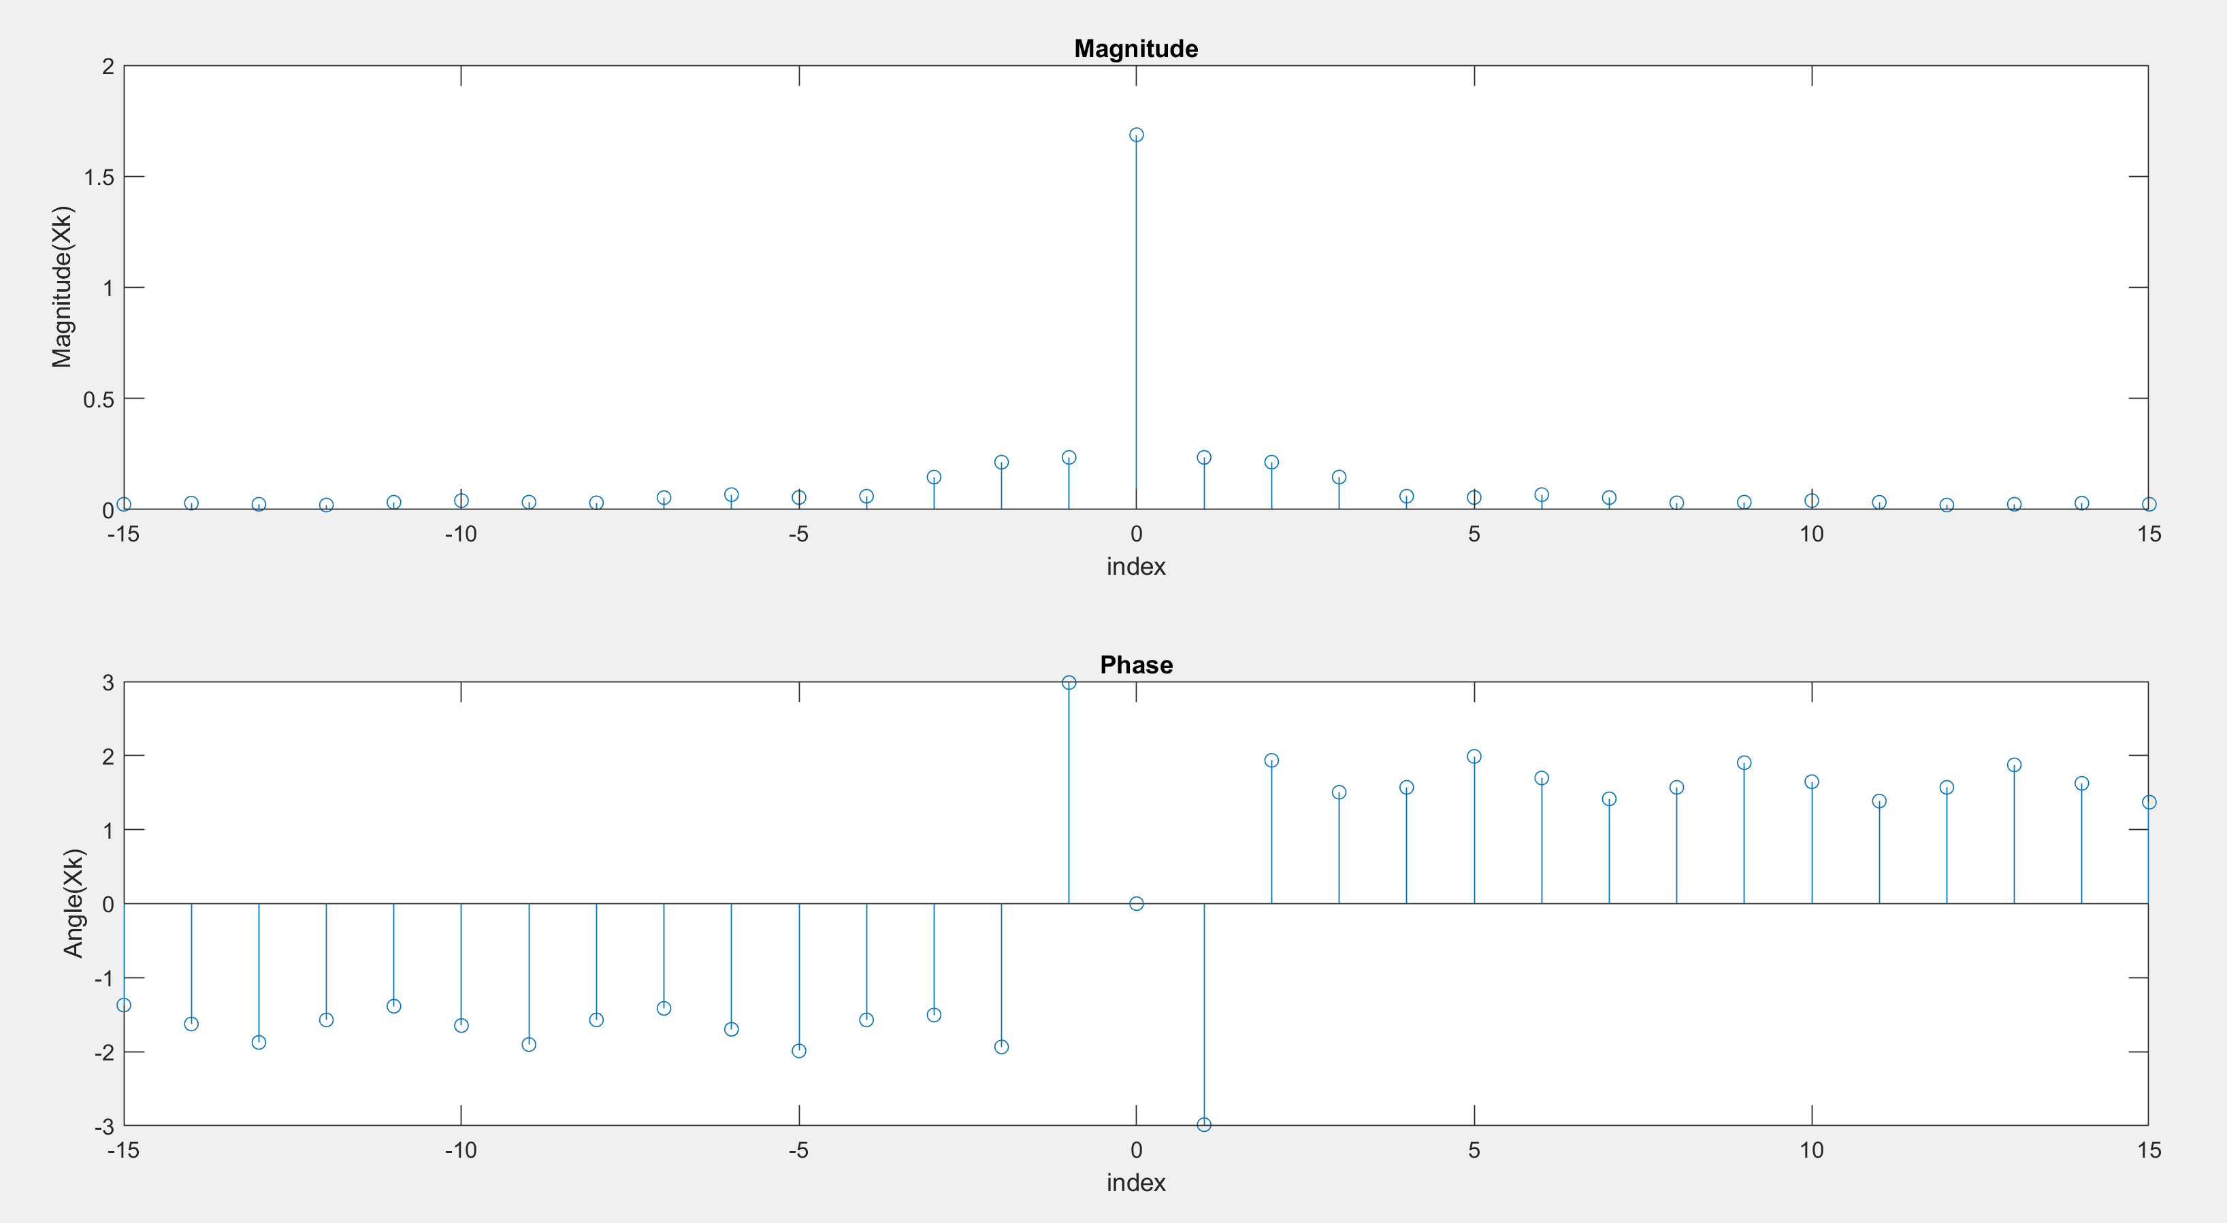

Figure 2 (Magnitude and Phase of Xks)

**PART 2**

%%%%%%%%%%% PART 2 %%%%%%%%%%

syms t

syms k

syms y(t)

y(t) = 0;

interval = 0:0.01:6;

for k = -15:1:15

f = 4*t*exp(-j*k*pi*t);

f2 = (3-t)*exp(-j*k*pi*t);

f3 = t*exp(-j*k*pi*t);

part1 = int(f,t,[0 0.5]);

part2 = int(f2,t,[0.5 1.5]);

part3 = int(f3,t,[1.5 2]);

weight = (1/2)*(part1+part2+part3);

y(t) = y(t) + weight.*(exp(j*k*pi*t));

end

plot(interval, real(y(interval)));

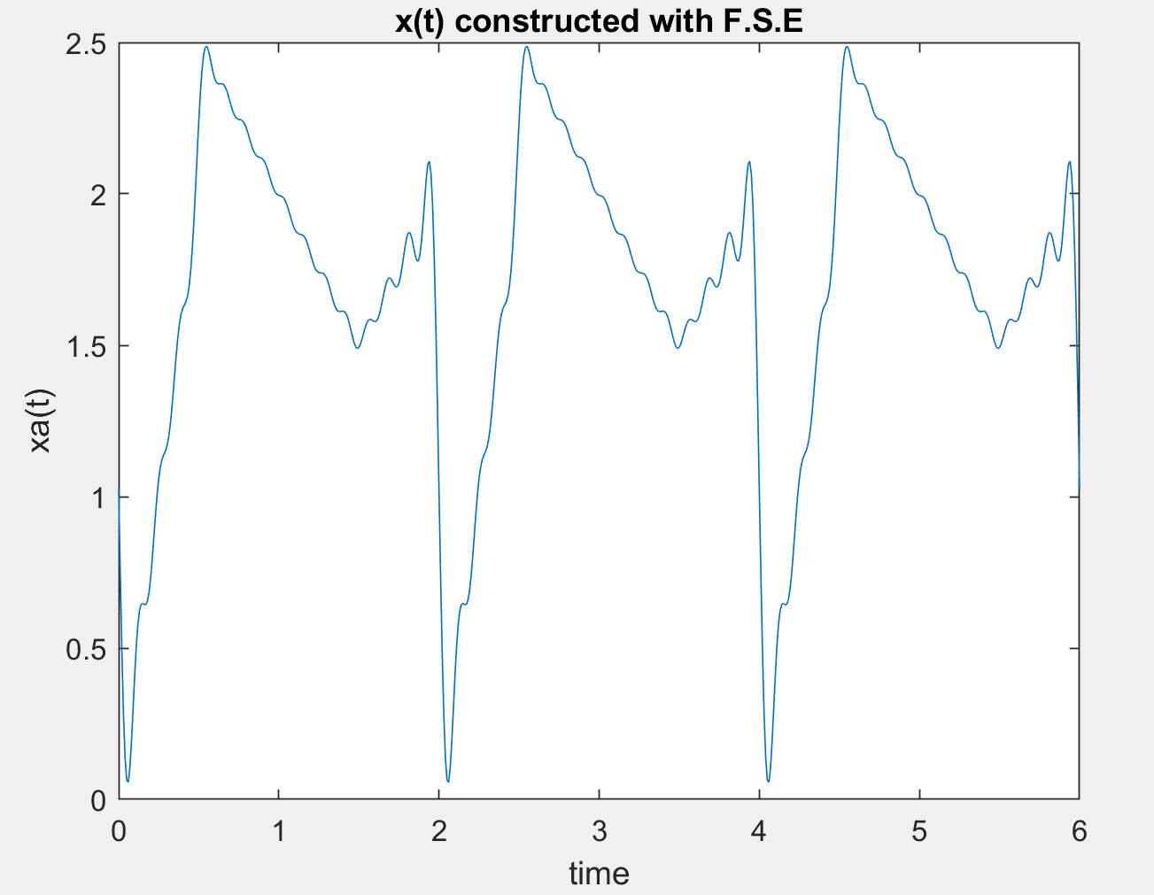

Figure 3 (plot of xa(t) drawn by using Xk and T)

**PART 3**

Part3.1 and Part 3.2

%%%%%%%%%%%%%%%%Part 3.1 %%%%%%%%%%%%%%

syms t

syms k

syms y(t)

y(t) = 0;

interval = 0:0.01:6;

for k = -5:1:5 %%%%%%%%%%%% -N:1:N

f = 4*t*exp(-j*k*pi*t);

f2 = (3-t)*exp(-j*k*pi*t);

f3 = t*exp(-j*k*pi*t);

part1 = int(f,t,[0 0.5]);

part2 = int(f2,t,[0.5 1.5]);

part3 = int(f3,t,[1.5 2]);

weight = (1/2)*(part1+part2+part3);

y(t) = y(t) + weight.*(exp(j*k*pi*t));

end

figure(1)

plot(interval, real(y(interval)));

title("N = 1");

xlabel("time");

ylabel("x");

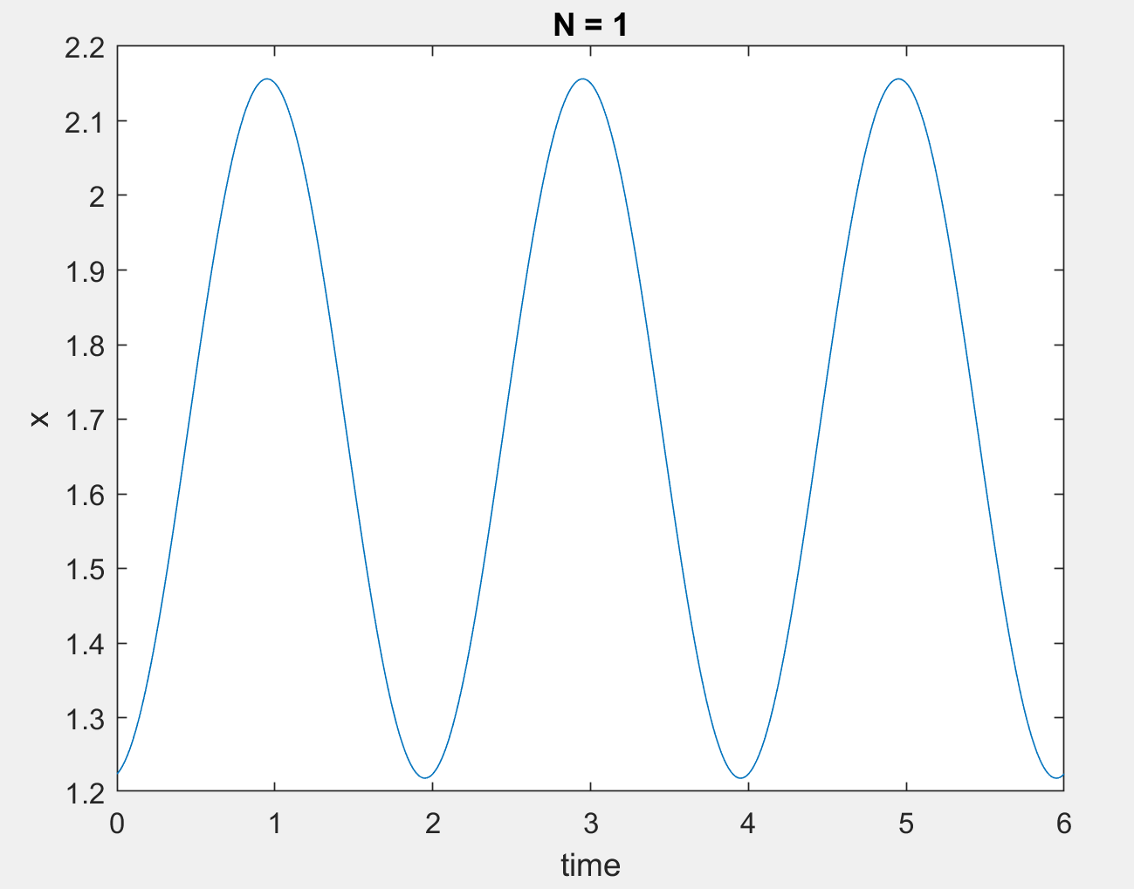

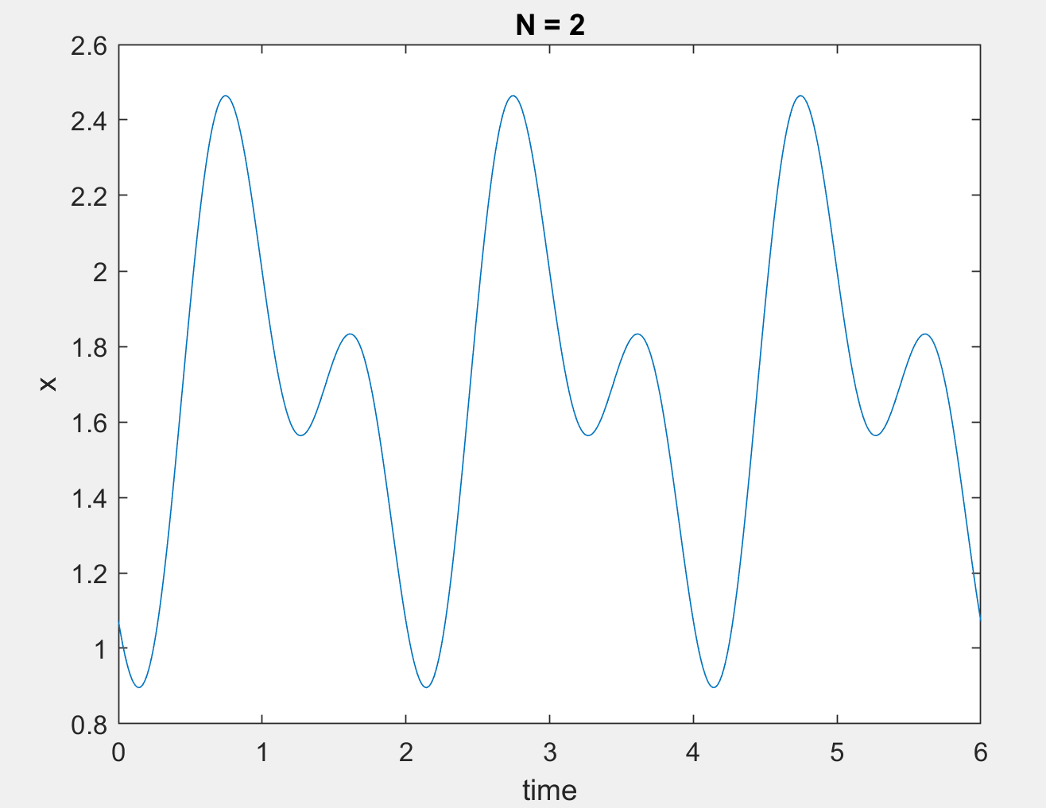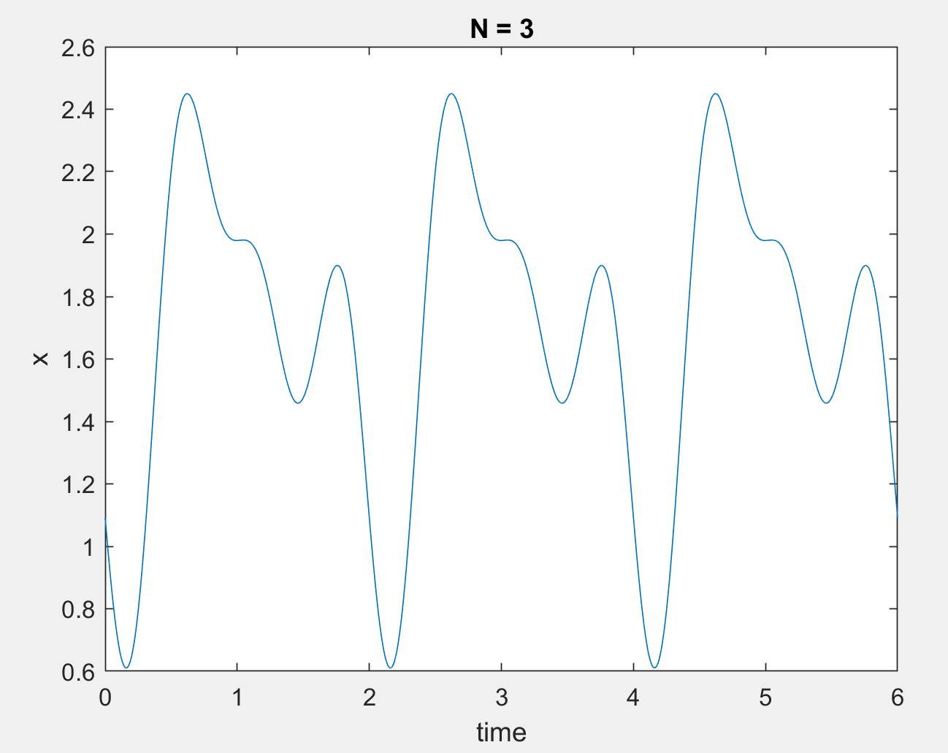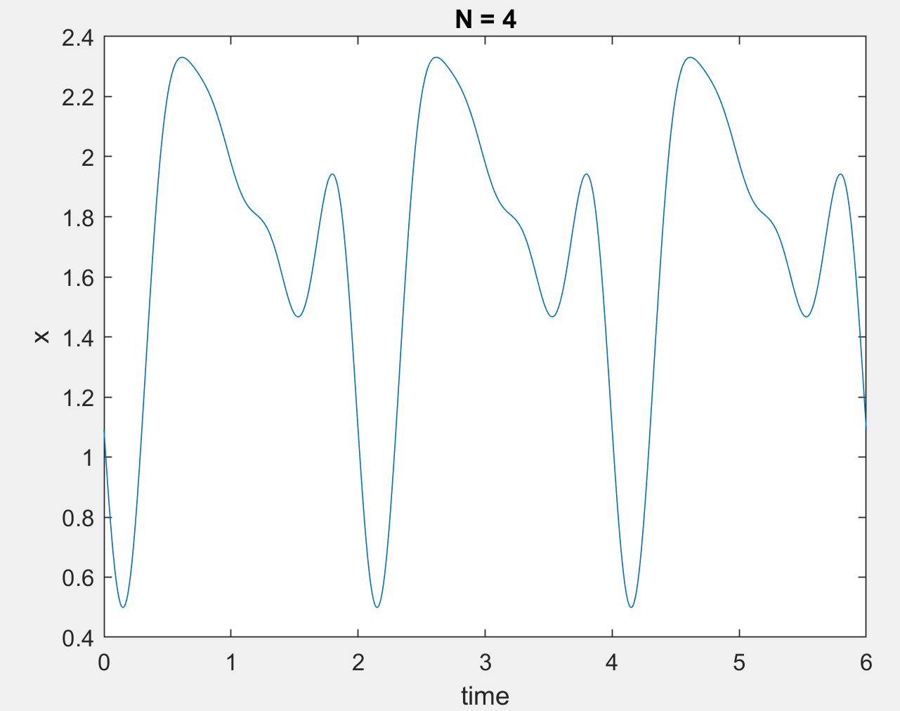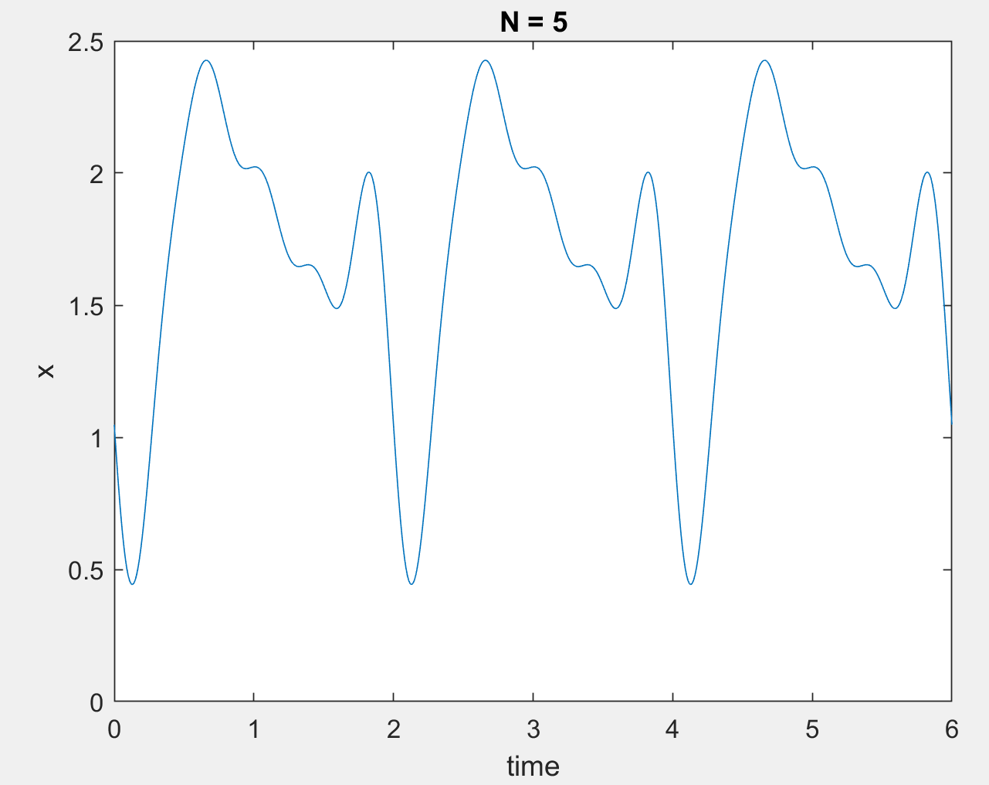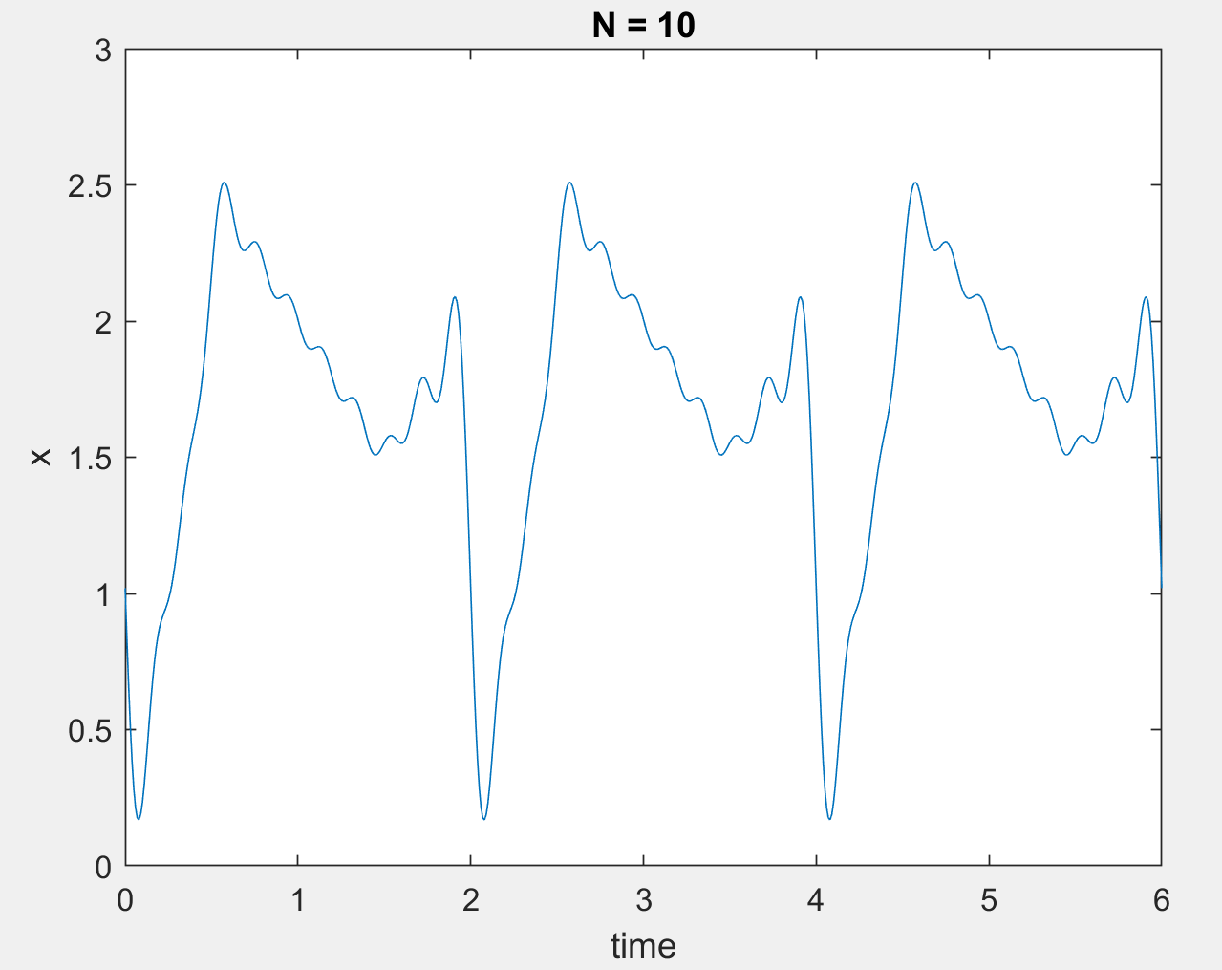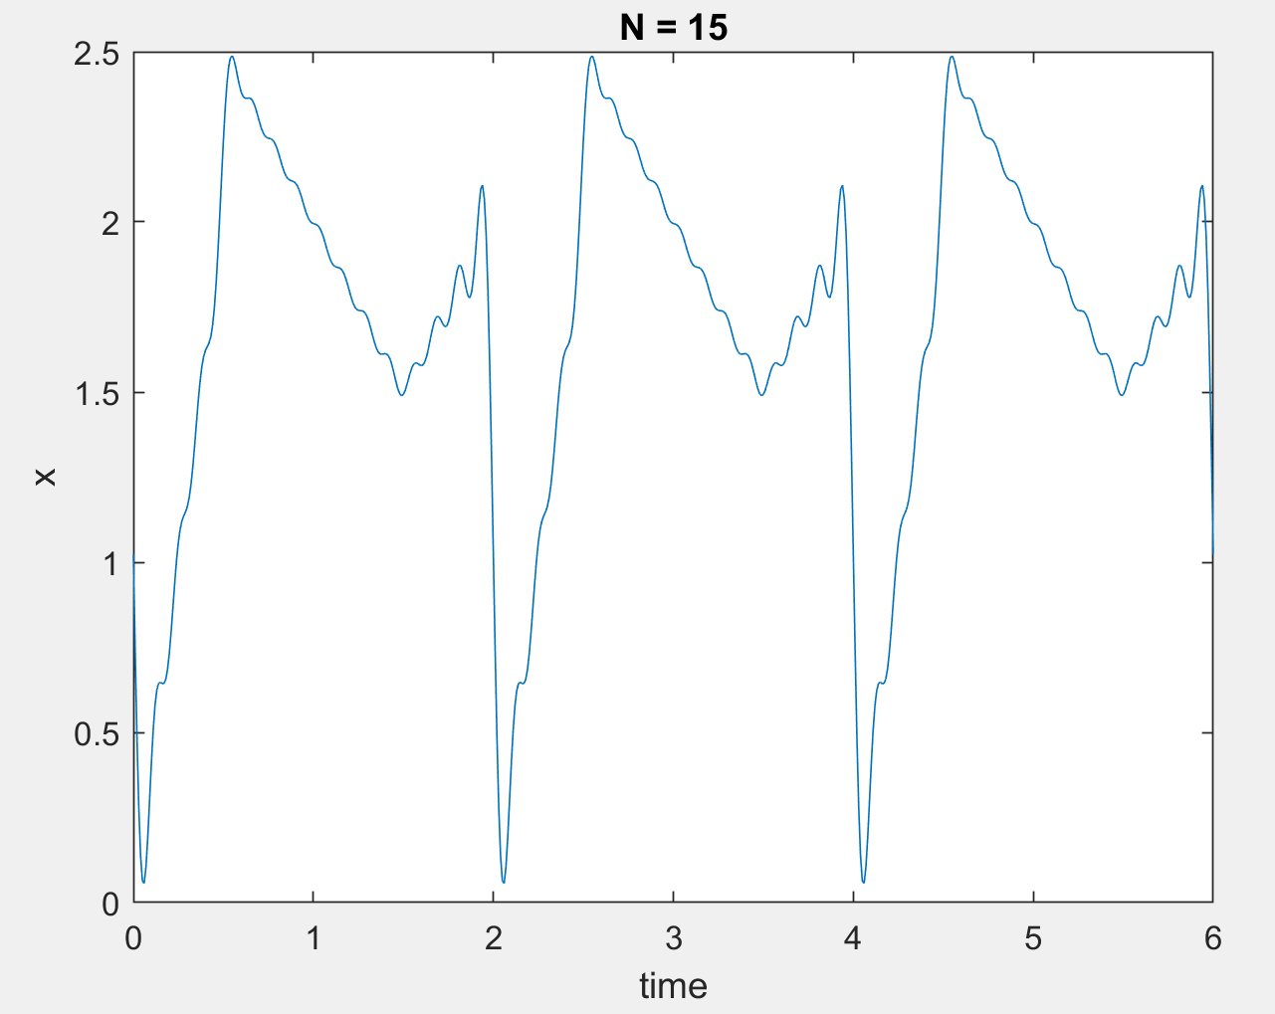

Part3.3

%%%%%%%%%%%%% Part 3.3 %%%%%%%%%%% Code for error calculation

syms t

syms k

syms y(t)

y(t) = 0;

for k = -15:1:15 %%%%%CHANGE THIS VALUE -N:1:N FOR ERROR CALCULATION

f = 4*t*exp(-j*k*pi*t);

f2 = (3-t)*exp(-j*k*pi*t);

f3 = t*exp(-j*k*pi*t);

part1 = int(f,t,[0 0.5]);

part2 = int(f2,t,[0.5 1.5]);

part3 = int(f3,t,[1.5 2]);

weight = (1/2)*(part1+part2+part3);

y(t) = y(t) + weight.*(exp(j*k*pi*t));

end

%%%%%%%%%%%%%%%%%

delta = 0.01;

t1=0:delta:2;

x=zeros(size(t1));

counter = 1;

for index1 = t1

if(index1<0.5 && index1>=0)

x(counter) = 4.*index1;

elseif(index1<1.5 && index1>=0.5)

x(counter) = 3 - index1;

elseif(index1<2 && index1>=1.5)

x(counter) =index1;

elseif(index1<2.5 && index1>=2)

x(counter) = 4.*(index1-2);

elseif(index1<3.5 && index1>=2.5)

x(counter) = 3 - (index1-2);

elseif(index1<4 && index1>=3.5)

x(counter) =(index1-2);

elseif(index1<4.5 && index1>=4)

x(counter) = 4.*(index1-4);

elseif(index1<5.5 && index1>=4.5)

x(counter) = 3 - (index1-4);

elseif(index1<6 && index1>=5.5)

x(counter) =(index1-4);

else

x(counter) = 0;

end

counter = counter + 1;

end

%%%%%%%%%%

syms z(t)

z(t)=0;

delta = 0.01;

t2=0:delta:2;

count = 1;

for i = t2

z(t) =z(t) + (abs(x(count)-y(i))).^2;

count = count + 1;

end

double(z(t)) %%%%% THE RESULT

**PART 4**

%%%%%%%%%%%%%%%%Part 4 %%%%%%%%%%%%%%

syms t

syms k

syms y(t)

y(t) = 0;

interval = 0:0.01:6;

for k = -10:1:10 %%%%%CHANGE THIS VALUE -N:1:N FOR DIFFERENT Ns

f = 4*t*exp(-j*k*pi*t);

f2 = (3-t)*exp(-j*k*pi*t);

f3 = t*exp(-j*k*pi*t);

part1 = int(f,t,[0 0.5]);

part2 = int(f2,t,[0.5 1.5]);

part3 = int(f3,t,[1.5 2]);

weight = (1/2)*(part1+part2+part3)*(exp(-j*k*pi*7));

y(t) = y(t) + weight.*(exp(j*k*pi*t));

end

figure(1)

plot(interval, real(y(interval)));

title("N = 10");

xlabel("time");

ylabel("x");

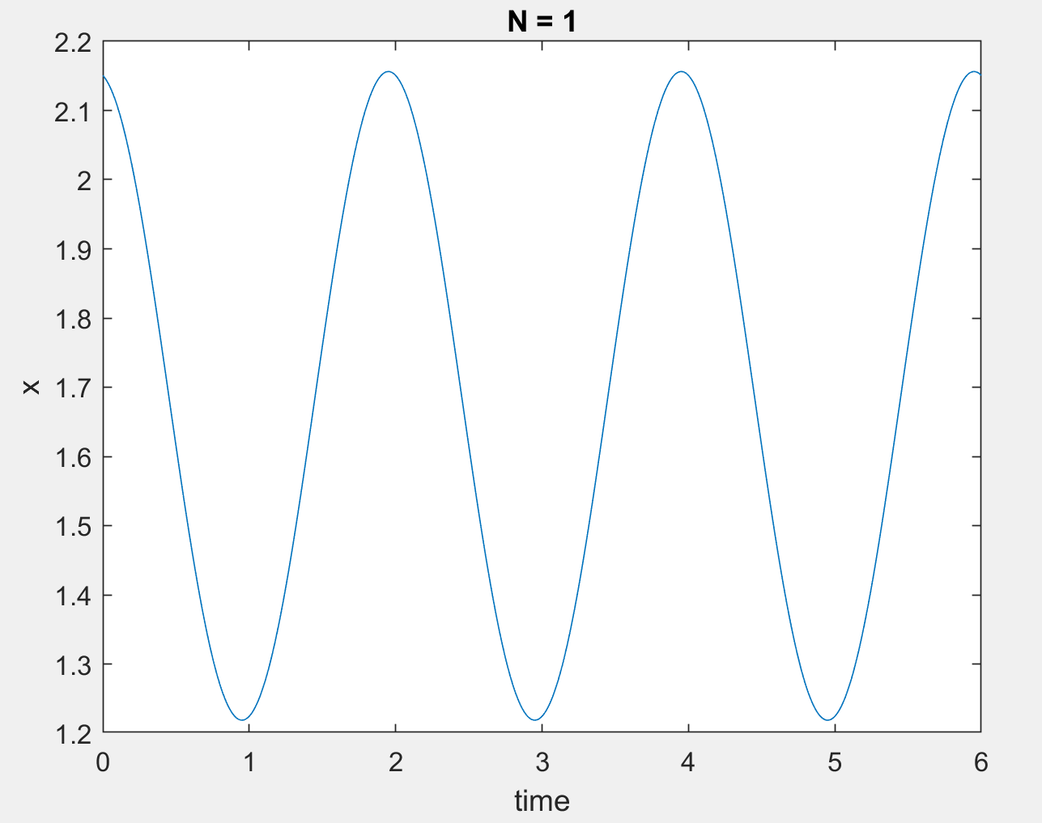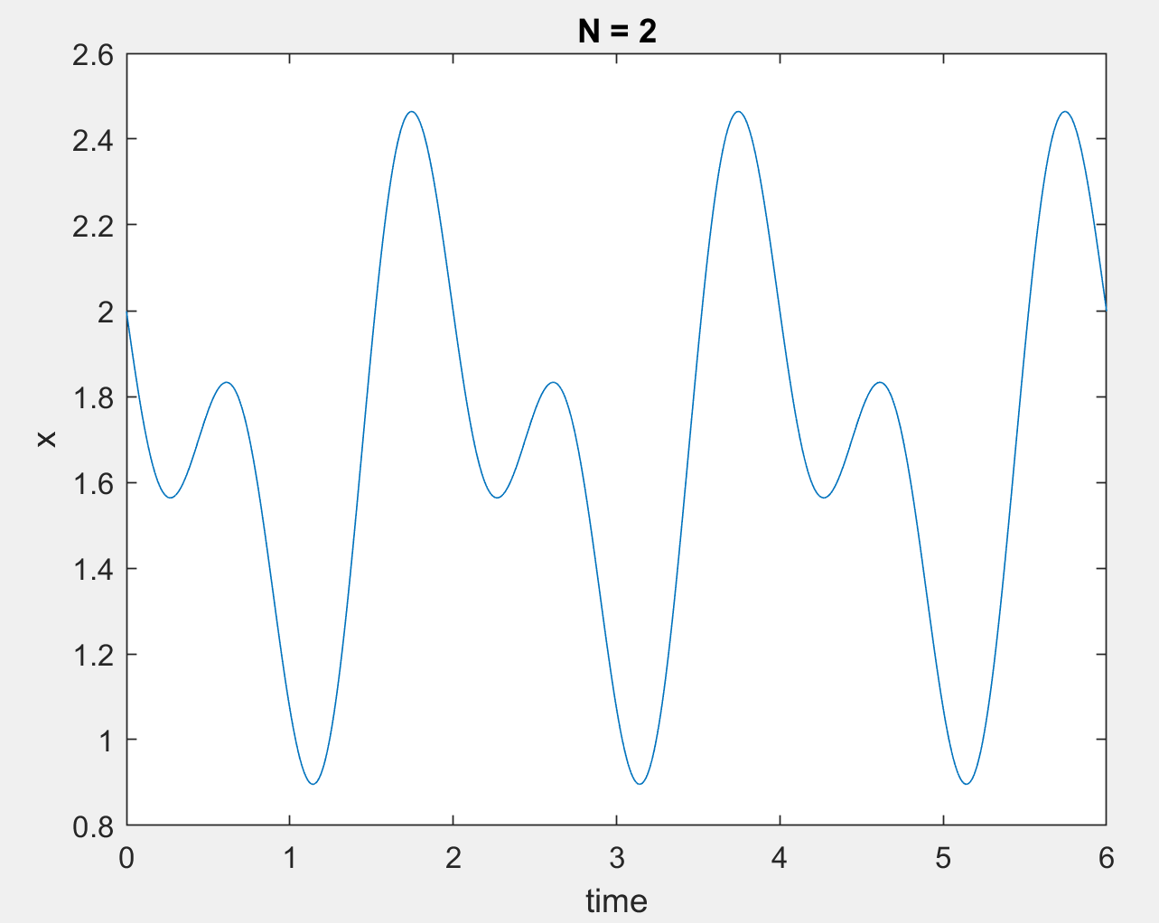

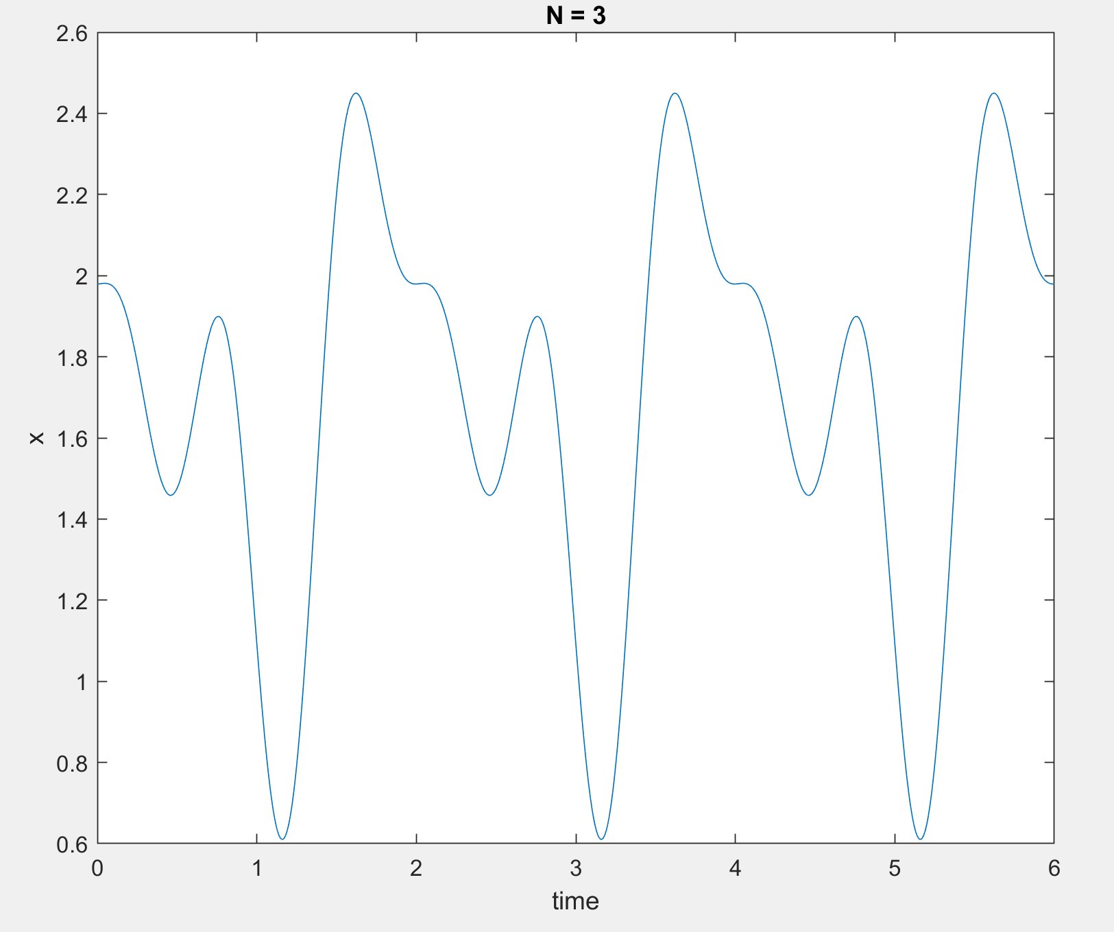

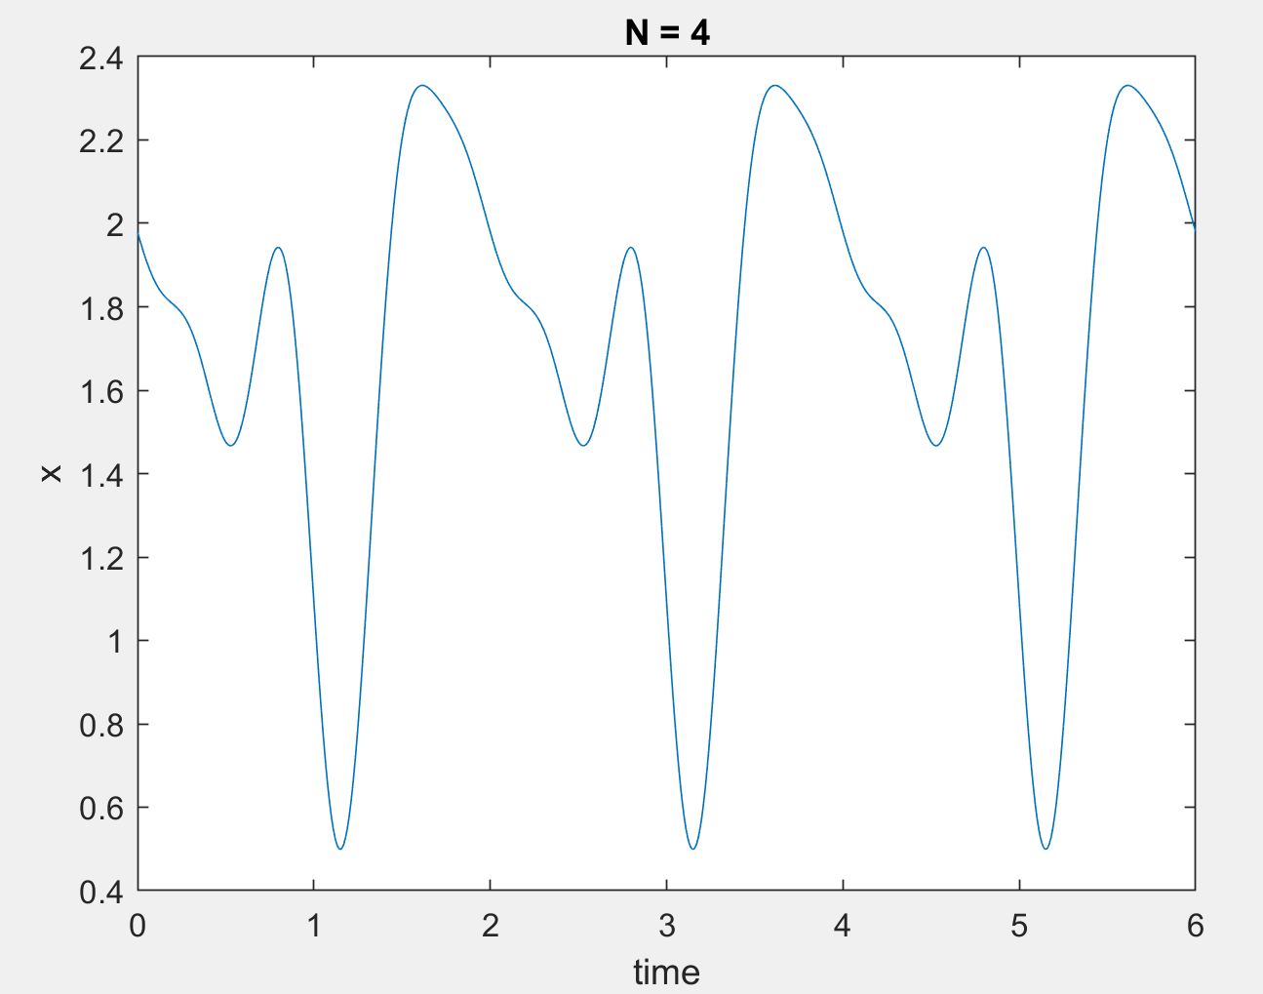

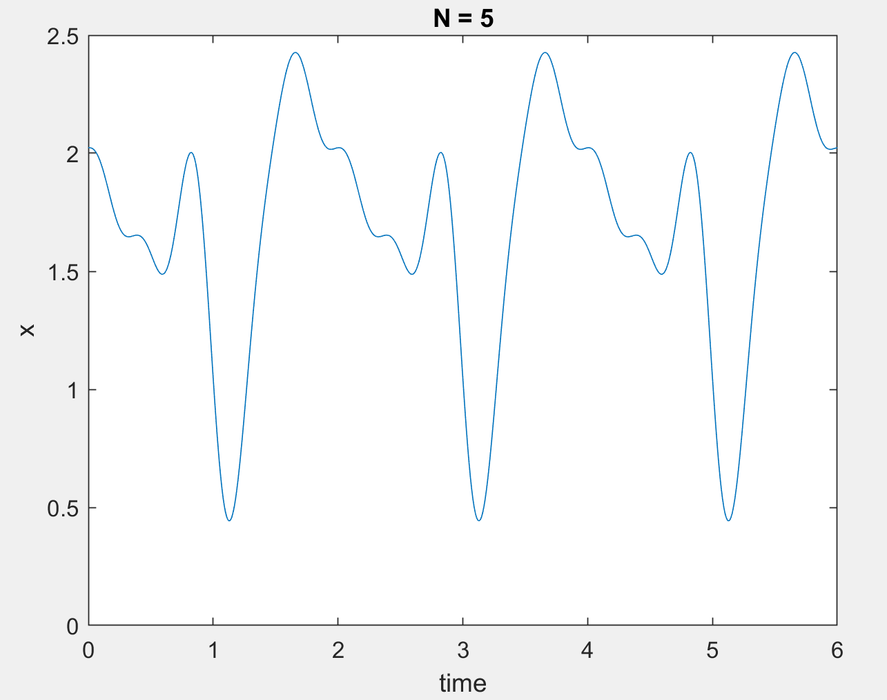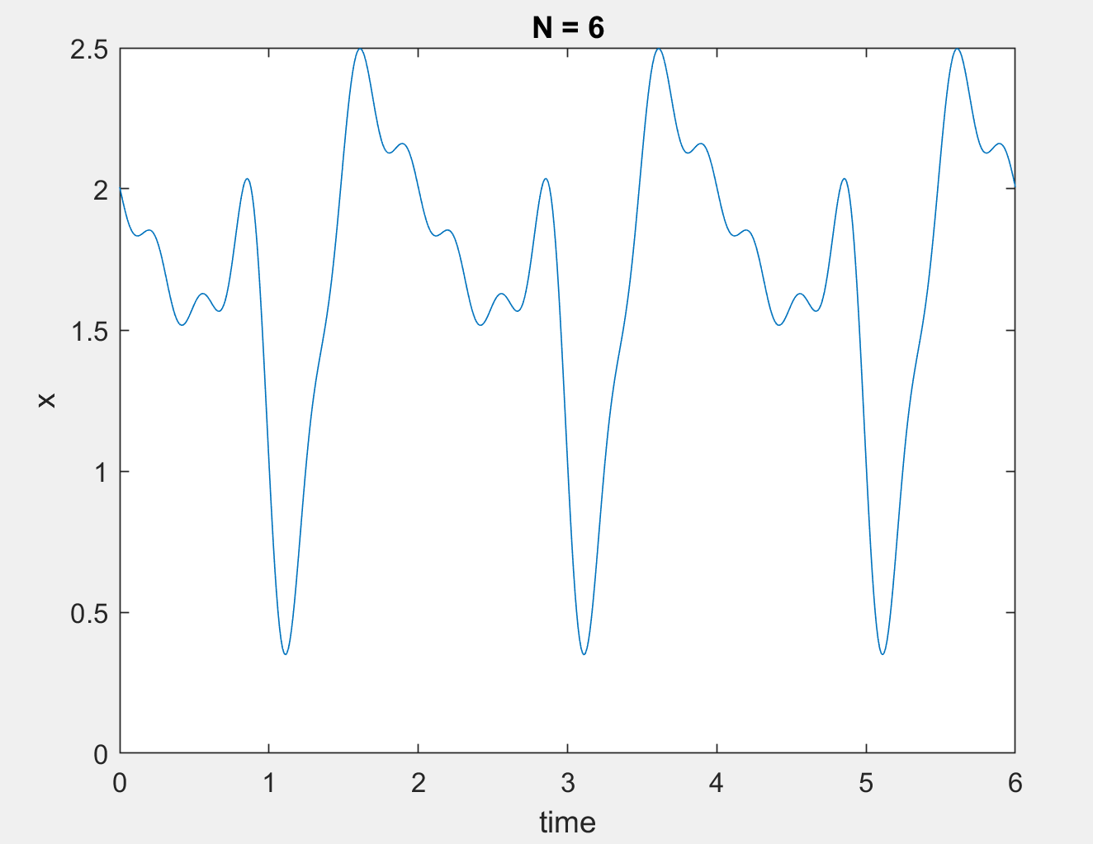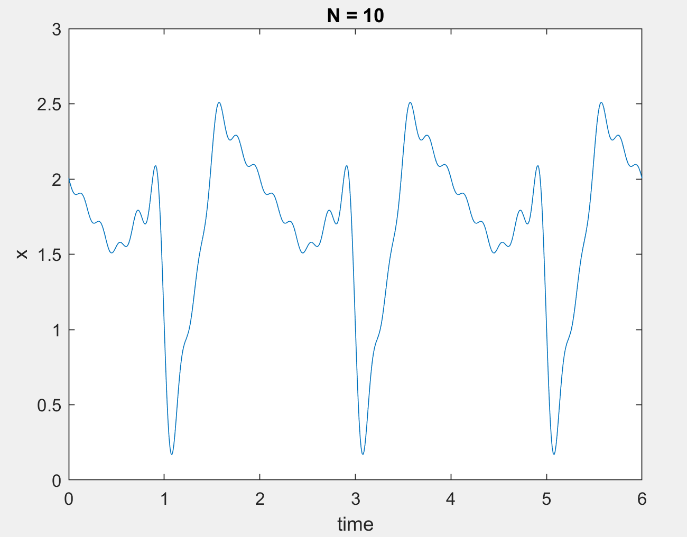

**PART 5**

%%%%%%%%%%%%%%%%Part 5 %%%%%%%%%%%%%%

syms t

syms k

syms y(t)

y(t) = 0;

interval = 0:0.01:6;

for k = -10:1:10 %%%%%CHANGE THIS VALUE -N:1:N FOR DIFFERENT Ns

f = 4*t*exp(-j*k*pi*t);

f2 = (3-t)*exp(-j*k*pi*t);

f3 = t*exp(-j*k*pi*t);

part1 = int(f,t,[0 0.5]);

part2 = int(f2,t,[0.5 1.5]);

part3 = int(f3,t,[1.5 2]);

weight = (1/2)*(part1+part2+part3)*(j*k*3*pi);

y(t) = y(t) + weight.*(exp(j*k*pi*t));

end

figure(1)

plot(interval, real(y(interval)));

title("N = 10");

xlabel("time");

ylabel("x");

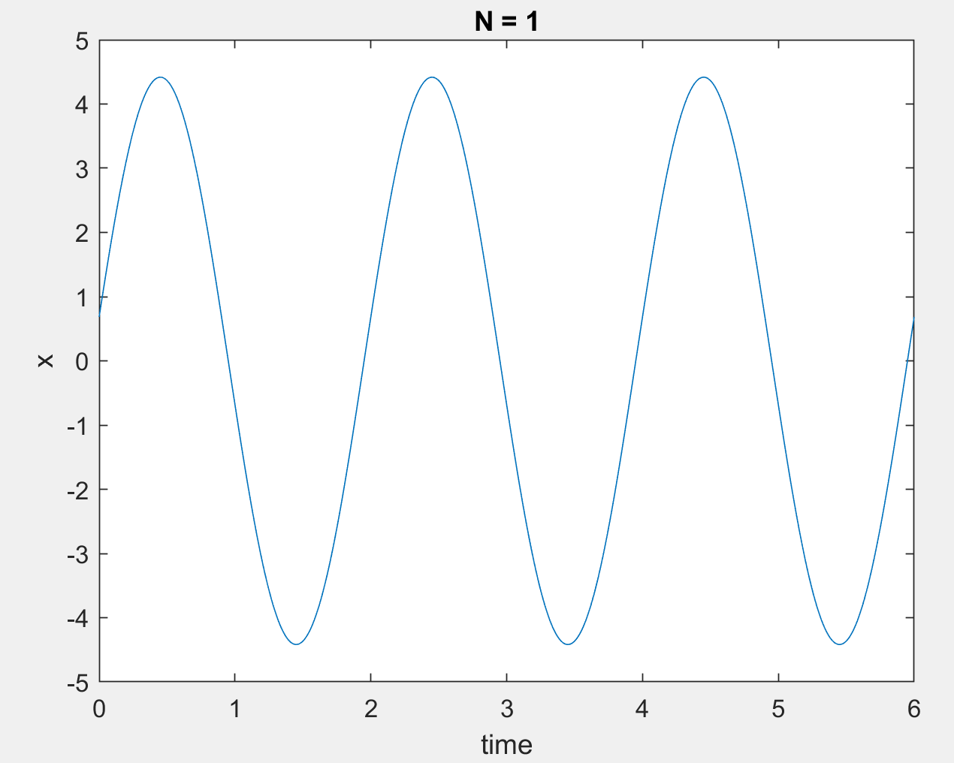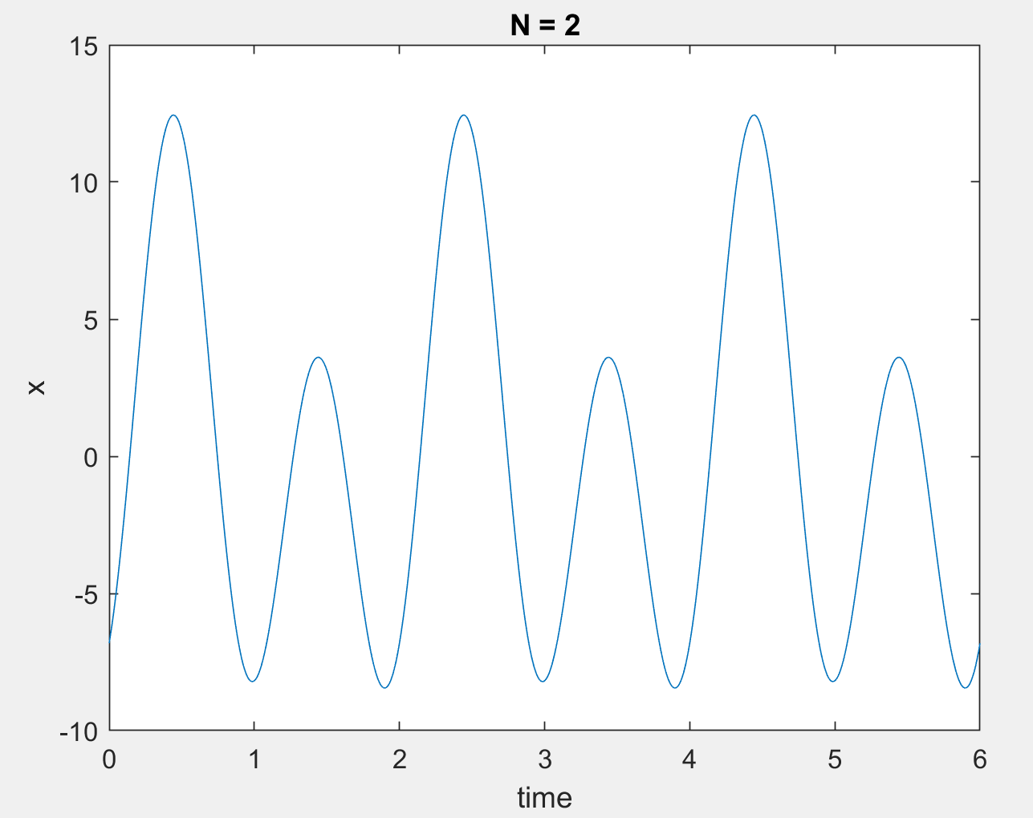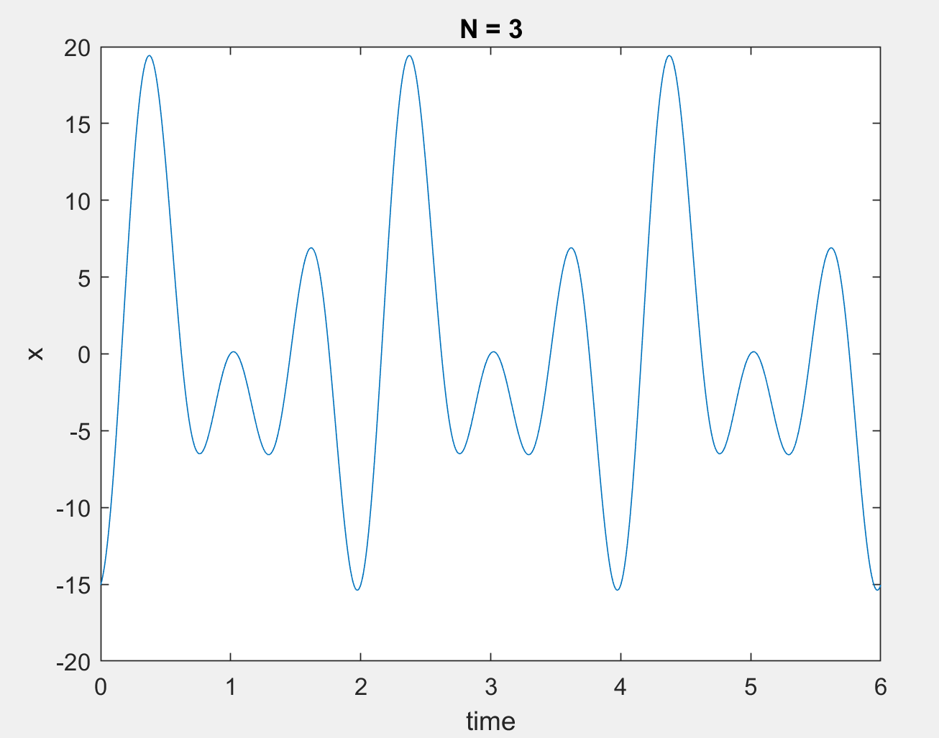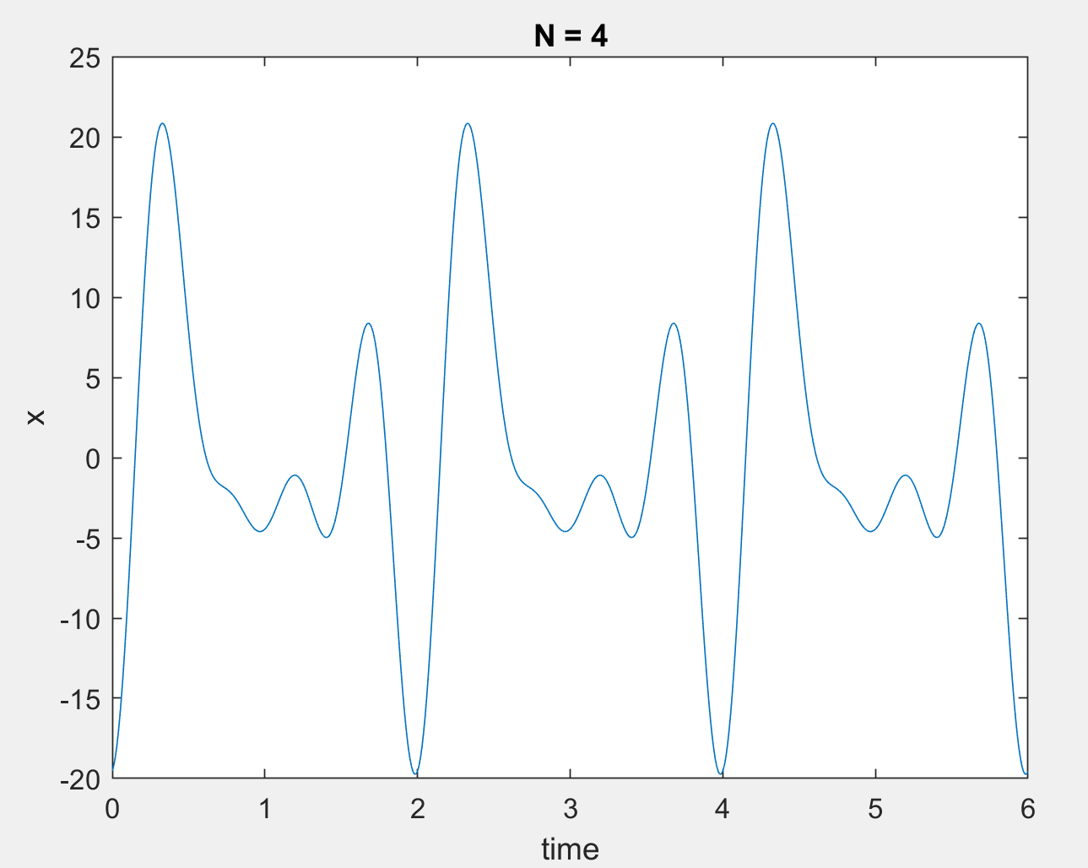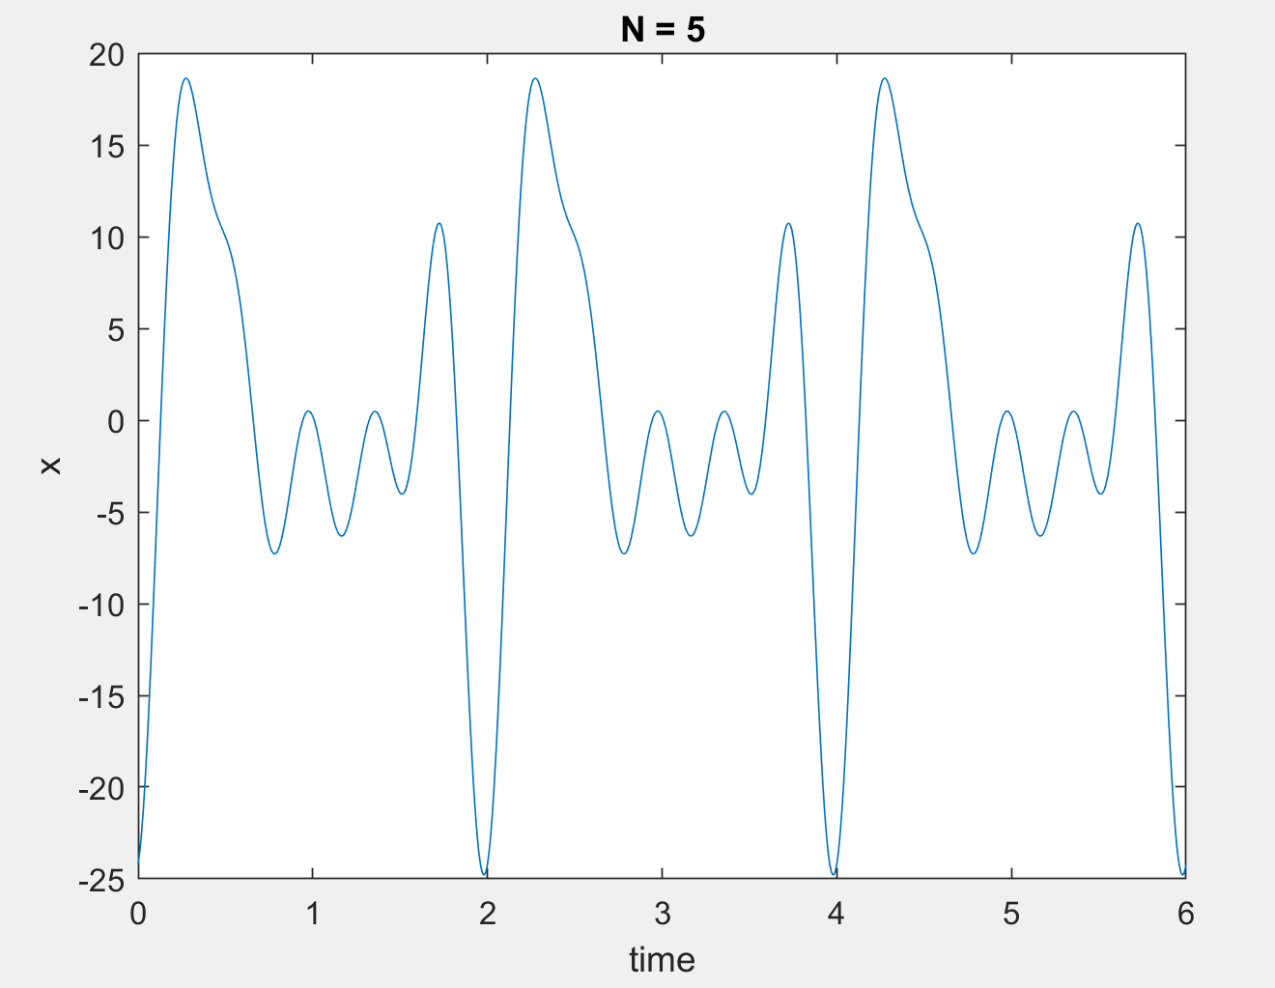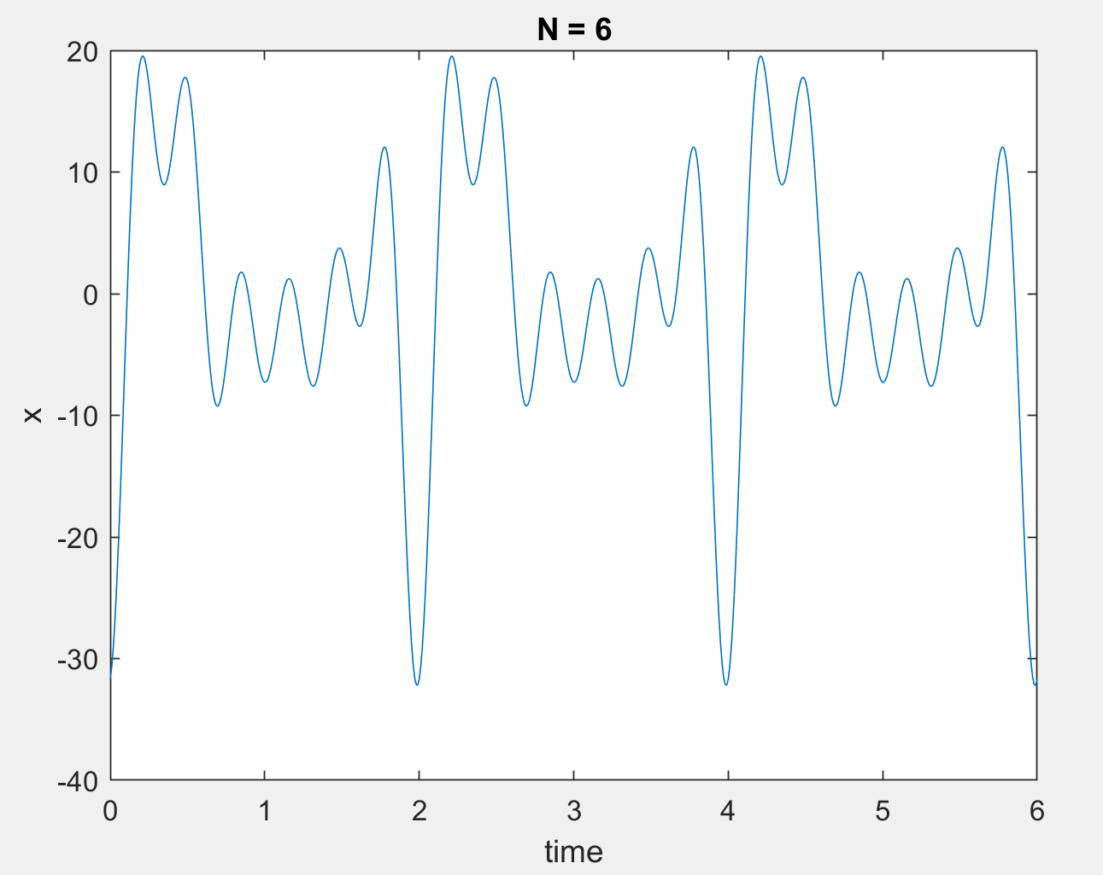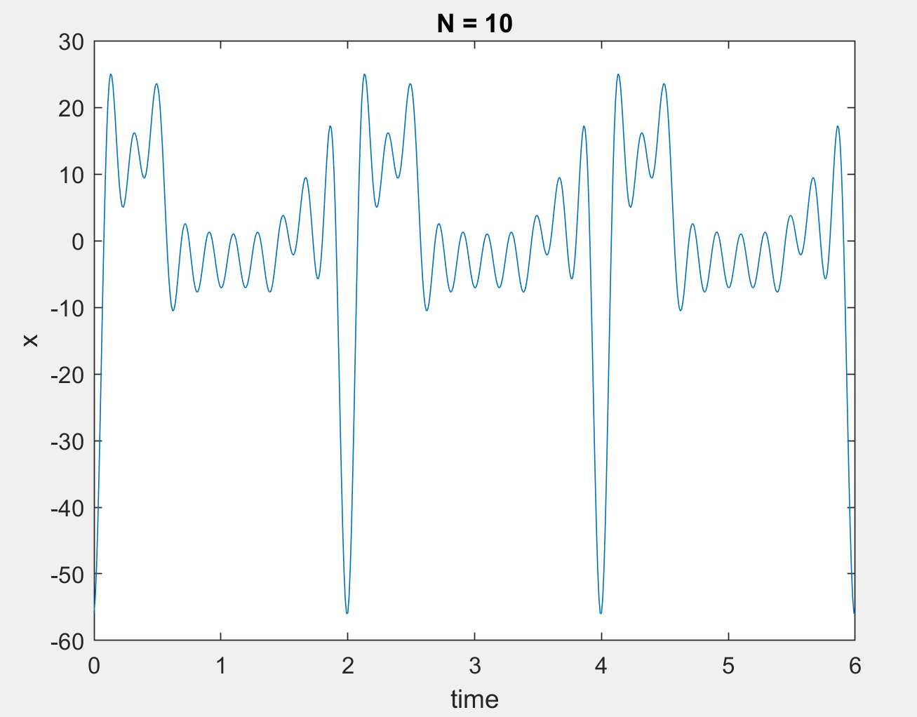

**LAB-02 ON LAB**

Part 1

Part 2

Part 3

syms t

syms k

syms y(t)

y(t) = 0;

interval = 0:0.01:6;

for k = -5:1:5 %%%%%%%% k = -N:1:N Change N value for plotting

if(k == 0)

y(t) = y(t) -1;

else

f = 2*t*exp(-j*k*pi*t);

f2 = (4-2*t)*exp(-j*k*pi*t);

part1 = int(f,t,[0 1]);

part2 = int(f2,t,[1 2]);

Xk = ((1/2)*(part1+part2));

y(t) = y(t) + Xk*(exp(j*k*pi*t));

end

end

plot(interval, y(interval));

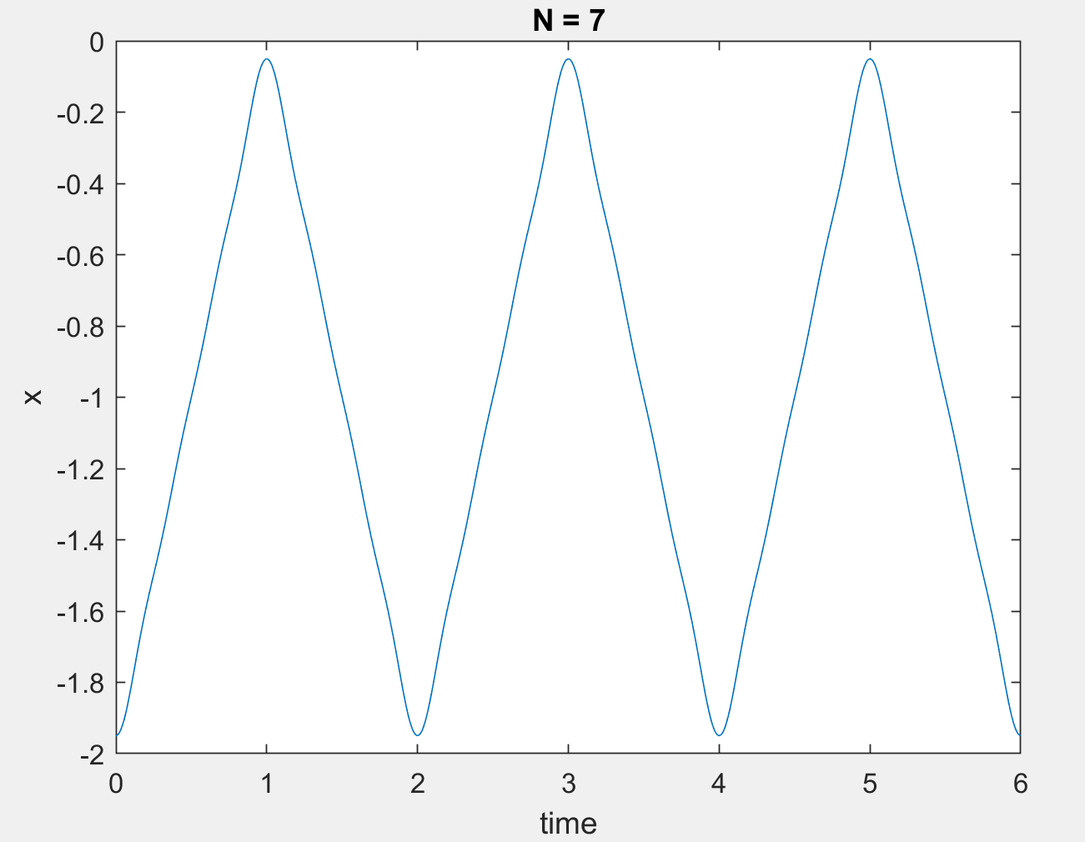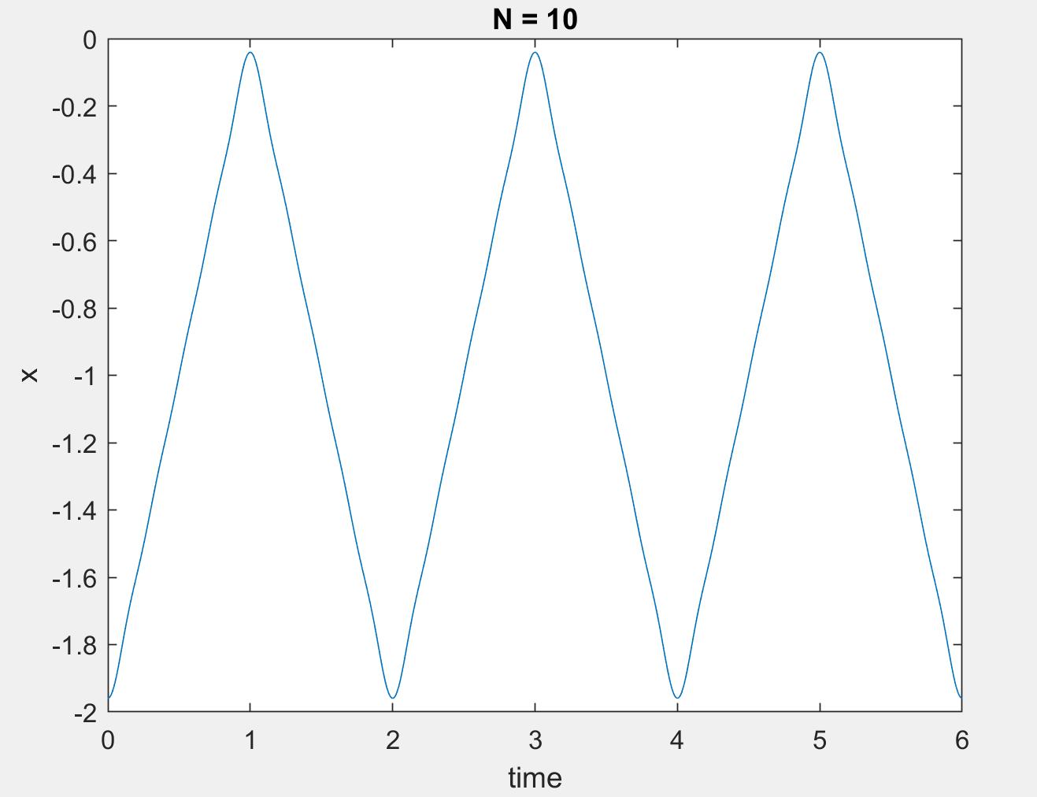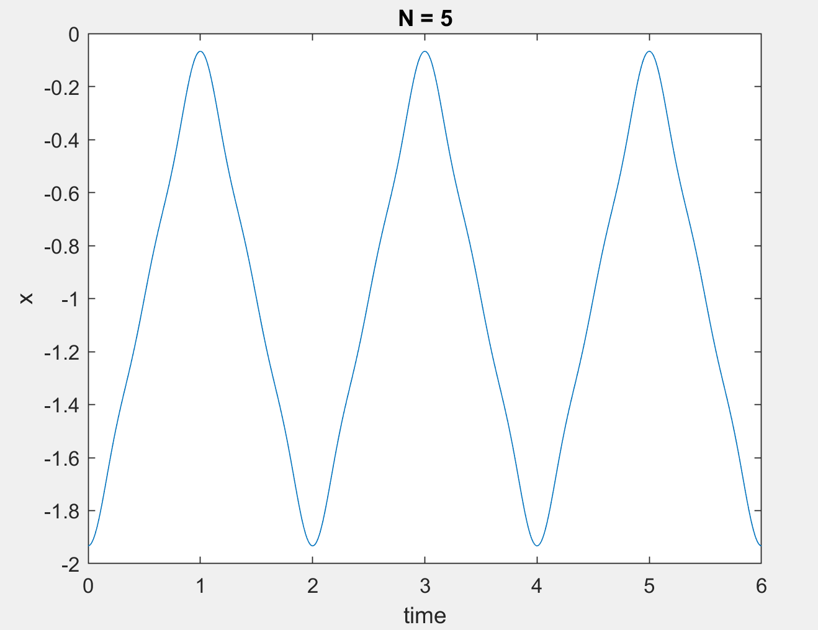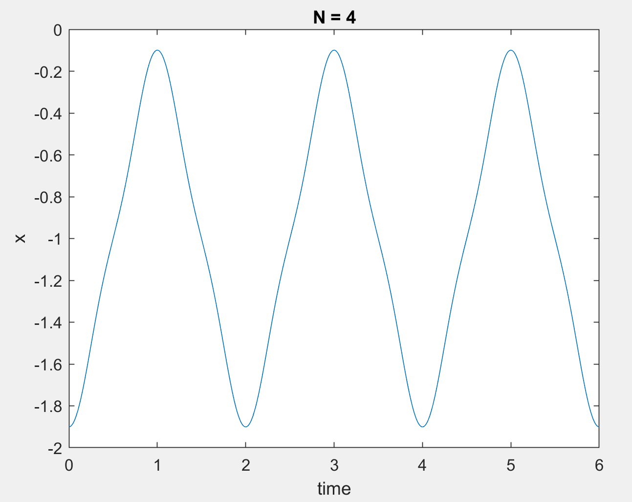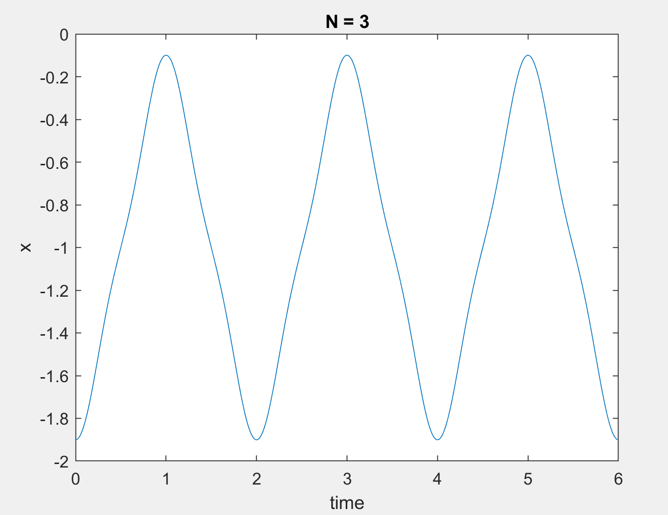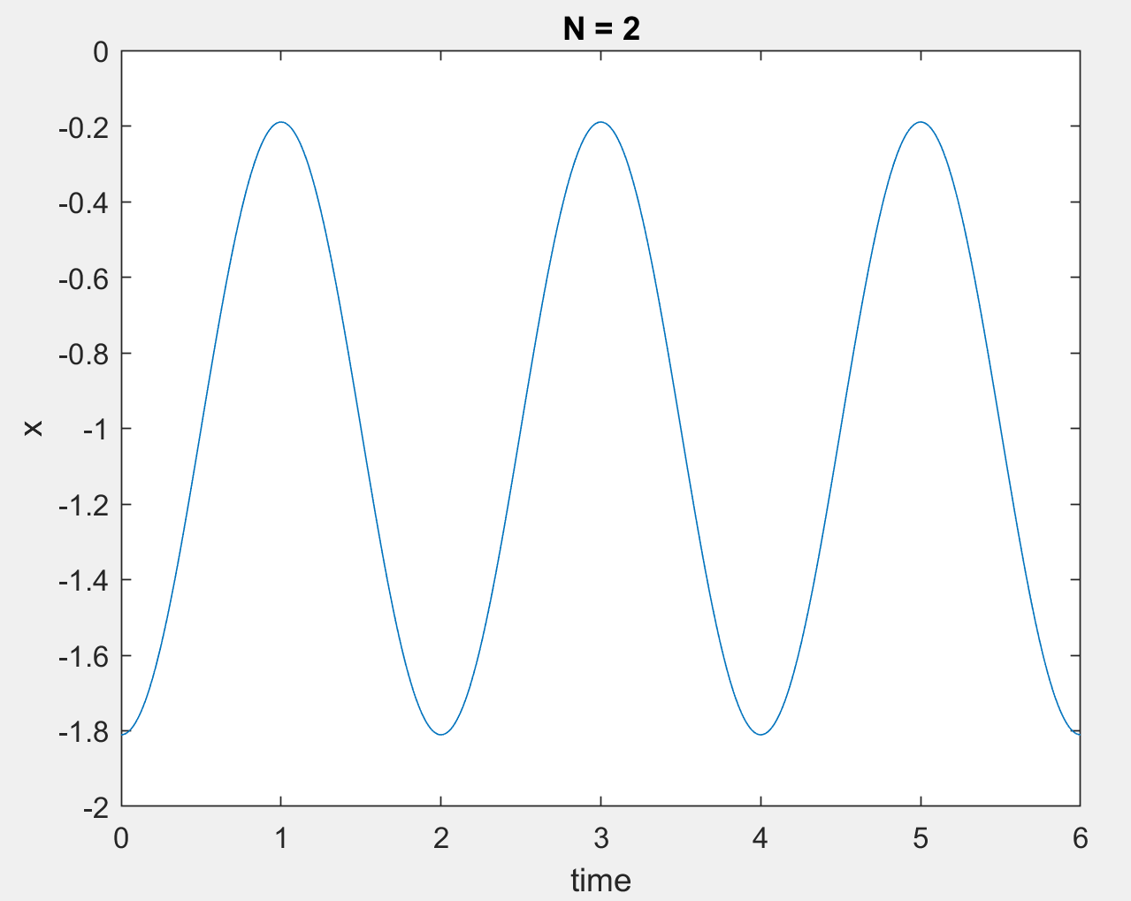

Code for Error Calculation:

clc;

clear all;

syms t

f = (abs(2*t)).^2;

f2 = (abs(4-2*t)).^2;

part1 = int(f,t,[0 1]);

part2 = int(f2,t,[1 2]);

final = ((1./2).*(part1+part2))-1;%%%%%% extract a0, we want k is not 0

double(final) %%%%%%%%%% All energy

a = (90./100).*(final);

double(a)

clear all;

syms t

syms k

syms y(t)

y(t) = 0;

for k = -5:1:5

f = 2*t*exp(-j*k*pi*t);

f2 = (4-2*t)*exp(-j*k*pi*t);

part1 = int(f,t,[0 1]);

part2 = int(f2,t,[1 2]);

Xk = (1/2)*(part1+part2);

y(t) = y(t) + ((abs(Xk)).^2);

end

double(y(t)-1) %%%%%%%%%%%% Energy of approximated signal