***Part 1***

%%%% Part 1 g(t) constructed from ramp and unit step functions

t = -3:0.01:5;

r1 = ramp1(t);

r2 = ramp2(t);

r3 = ramp3(t);

r4 = ramp4(t);

unitstep1 = t>=0;

unitstep2 = t-4>=0;

unitstep2 = unitstep2./2;

g = r1-unitstep1-r2-r3+r4+unitstep2;

plot(t,g);

title("g(t) as a composite of singularity functions ");

xlabel("t");

ylabel("g(t)");

%%%%Looking at the spectrum

omega=linspace(-1000*pi,1000*pi,1000*2+1);

omega=omega(1:end);

G = FT(g);

figure(2)

plot(omega,G);

function r = ramp1(x)

r = max(0,3*x/2);

end

function r = ramp2(x)

r = max(0,3*x/2-(3/2));

end

function r = ramp3(x)

r = max(0,(x/2)-(1));

end

function r = ramp4(x)

r = max(0,(x/2)-2);

end

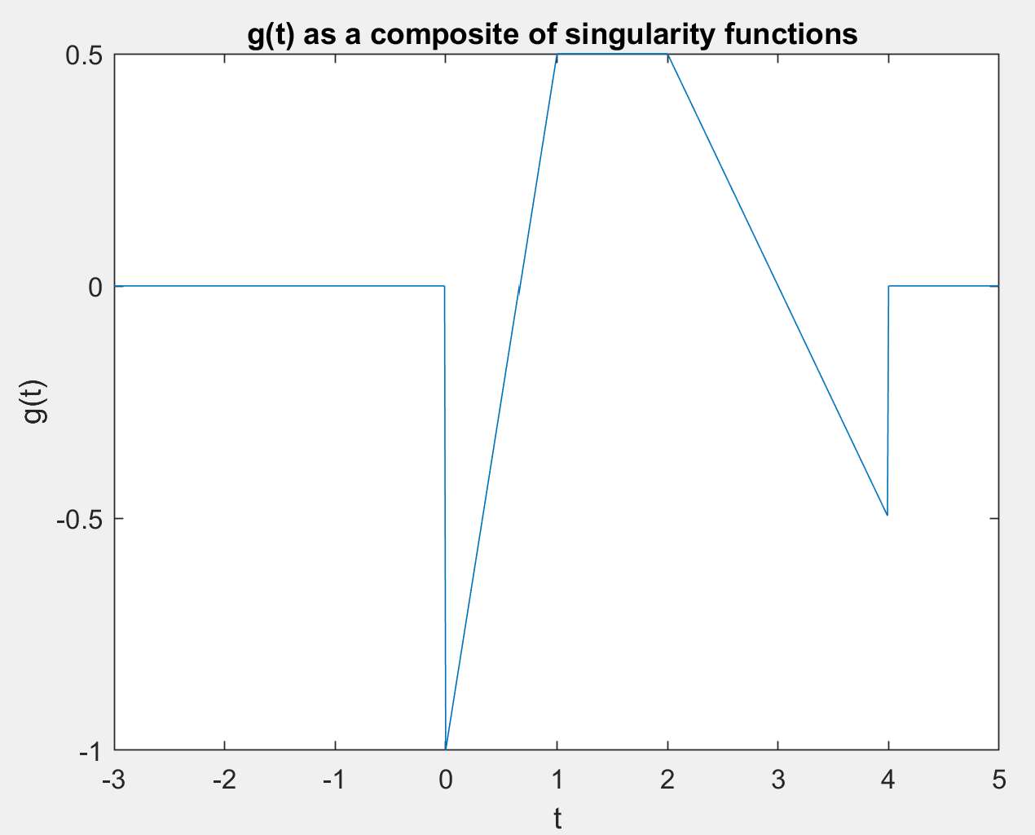

***Part 3***

%%%%%%%%%%%%%% PART 3 %%%%%%%%%%%%%%%

dur = 2;%%%ID = 21501462 Hence dur value is 2

Ts = dur/6;

t = (-dur/2):(Ts/1000):((dur/2)-(Ts/1000));

hZ = generateInterp(0,Ts,dur);

hL = generateInterp(1,Ts,dur);

hI = generateInterp(2,Ts,dur);

figure(1)

plot(t,hZ);

title("hz(t) = rect(t/Ts) ");

xlabel("t");

ylabel("hz(t)");

figure(2)

plot(t,hL);

title("hl(t) = tri(t/2*Ts) ");

xlabel("t");

ylabel("hl(t)");

figure(3)

plot(t,hI);

title("hI(t) = sinc(t/Ts) ");

xlabel("t");

ylabel("hI(t)");

dur = 6;%%%ID = 21501462 Hence dur value is 6

Ts = dur/3;

t = (-dur/2):(Ts/1000):((dur/2)-(Ts/1000));

hZ = generateInterp(0,Ts,dur);

hL = generateInterp(1,Ts,dur);

hI = generateInterp(2,Ts,dur);

figure(4)

plot(t,hZ);

title("hz(t) = rect(t/Ts) -- dur = 6 ");

xlabel("t");

ylabel("hz(t)");

figure(5)

plot(t,hL);

title("hl(t) = tri(t/2*Ts) -- dur = 6 ");

xlabel("t");

ylabel("hl(t)");

figure(6)

plot(t,hI);

title("hI(t) = sinc(t/Ts) -- dur = 6 ");

xlabel("t");

ylabel("hI(t)");

function h = generateInterp(type,Ts,dur)

t = (-dur/2):(Ts/1000):((dur/2)-(Ts/1000));

h = zeros(1,length(t));

if type == 0

h(t<=1/2*Ts & t>=-1/2*Ts) = 1;

elseif type == 1

h(t>-Ts & t<Ts) = 1-abs(t(t>-Ts & t<Ts))/Ts;

elseif type == 2

h(t==0) = 1;

h = sin(pi*(t/Ts))./(pi*(t/Ts));

else

msg = 'Type value should be 0,1 or 2';

error(msg);

end

end

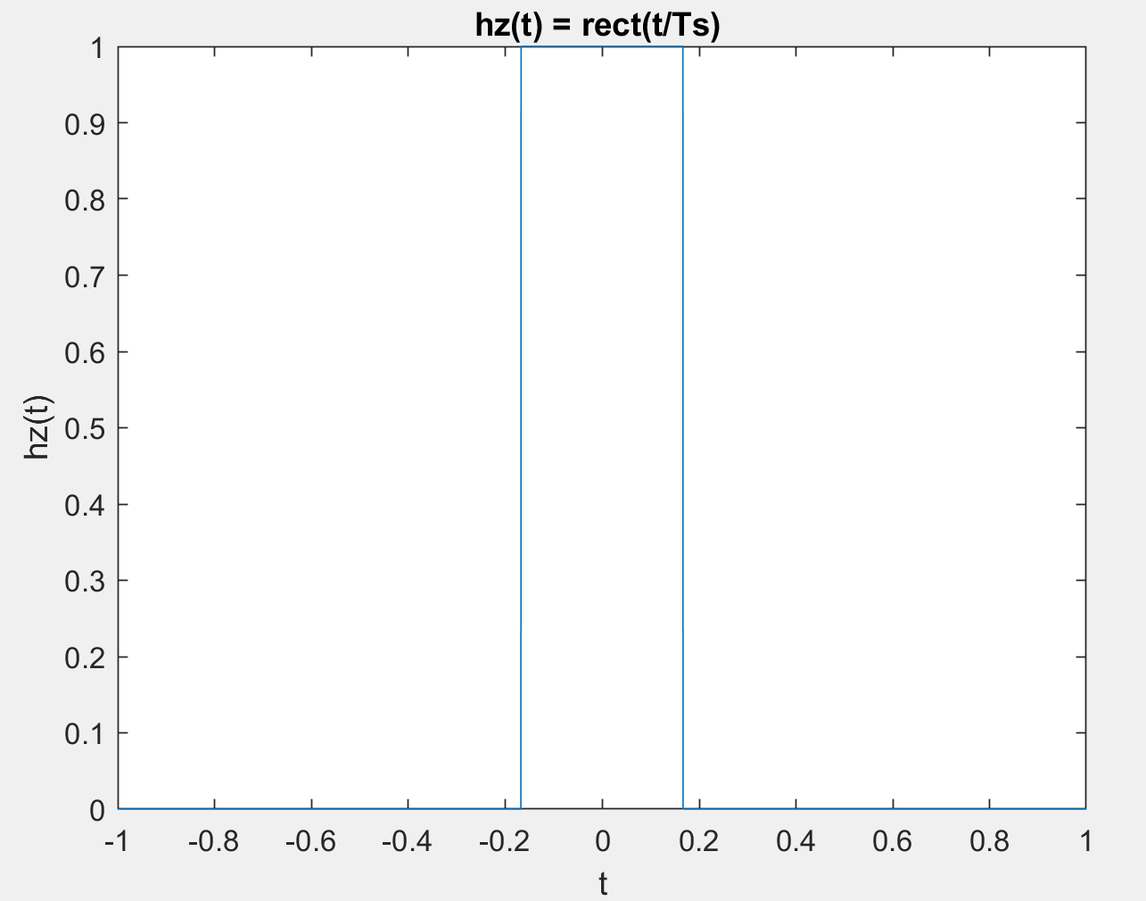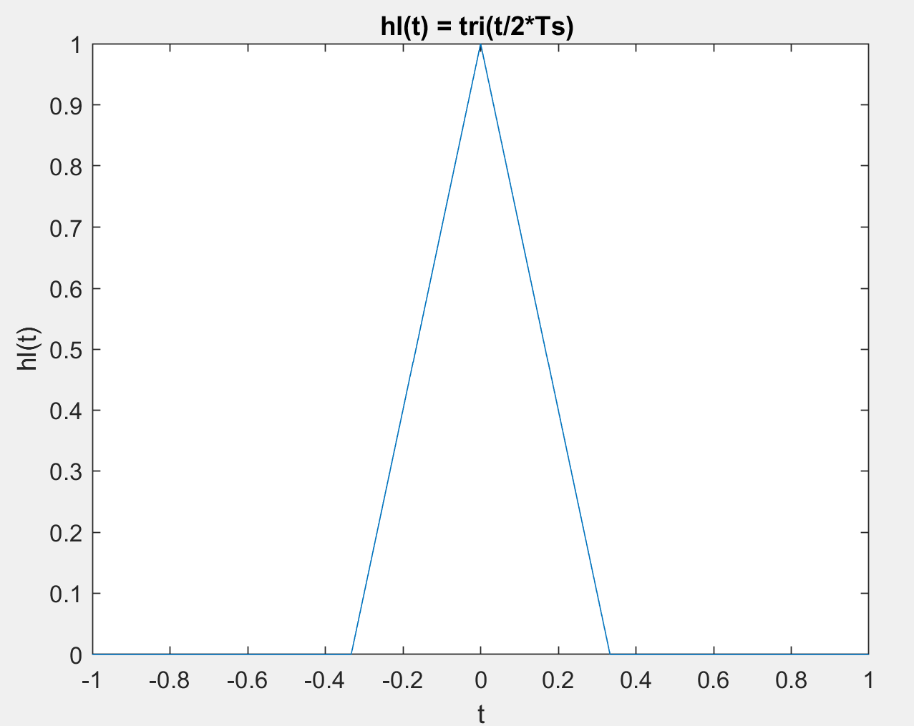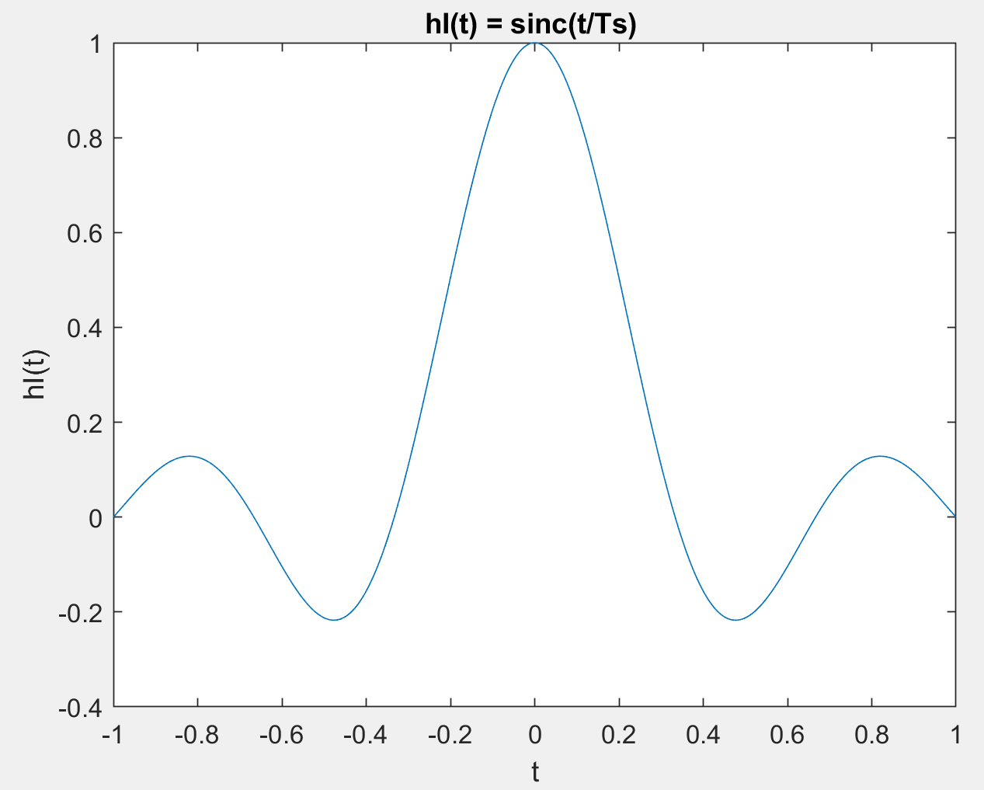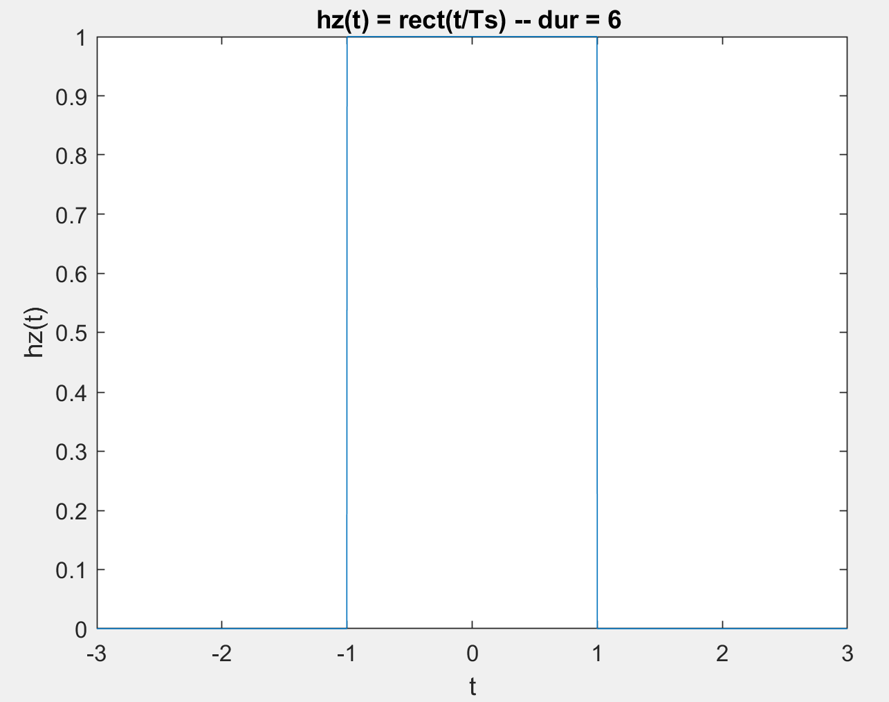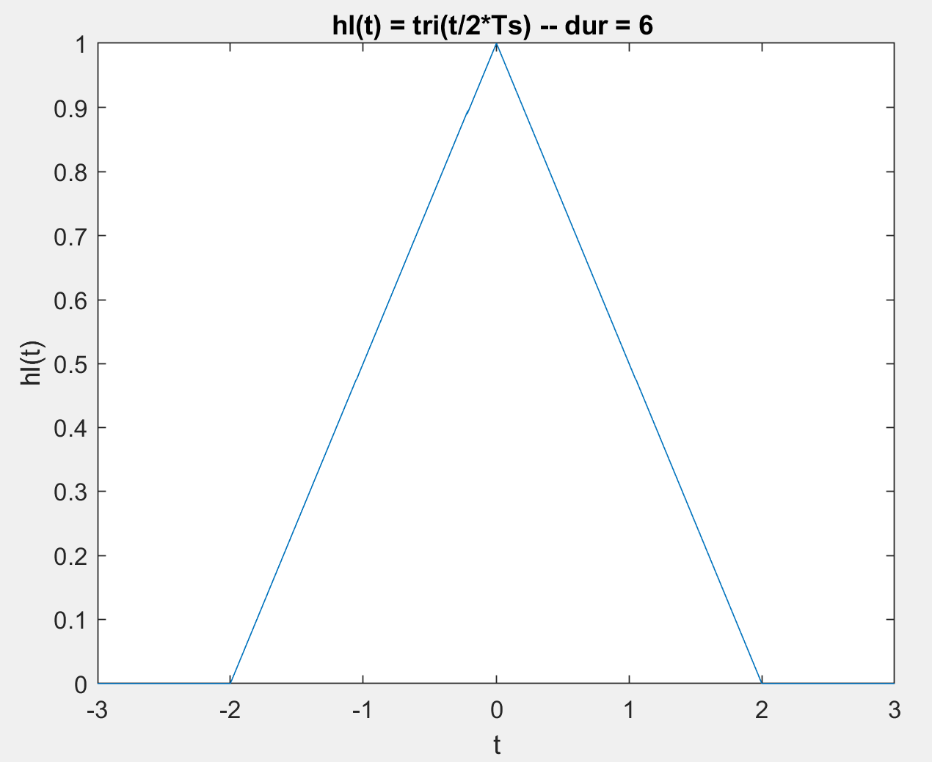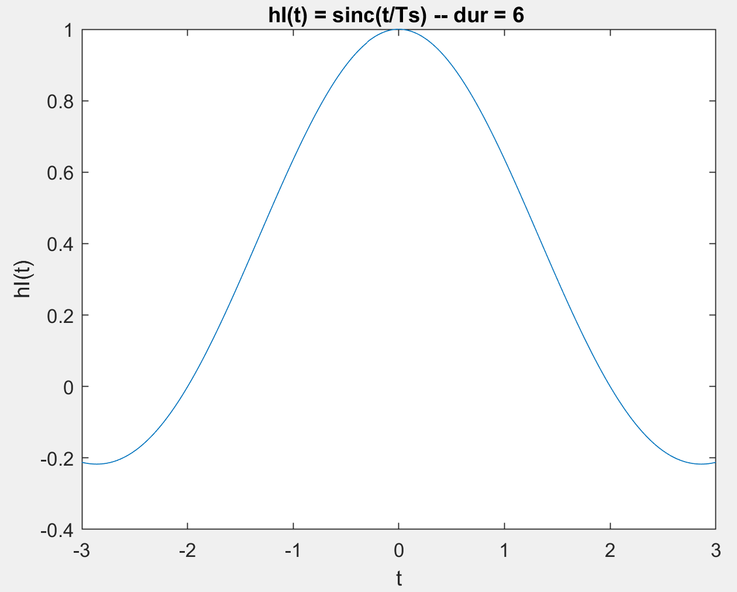

***Part 4***

function xR=DtoA(type,Ts,dur,Xn)

h = generateInterp(type,Ts,dur);

span = length(Xn)*1000 + length(h);

xR = zeros(1, span);

for n = 1:length(Xn)

xR(1+1000*(n-1):1000*(n-1)+length(h)) = xR(1+1000*(n-1):1000*(n-1)+length(h)) + Xn(n)*h;

end

xR = xR(500*length(Xn)+1 : end-length(Xn)*500);

end

***Part 5***

%%%%%%%%%%%%% PART 5 %%%%%%%%%%%%%

rnd = randi([2 6],1,1);

Ts = 1/(10*rnd)

t = 0:Ts:4;

%%%%%%%Constructing the g(t)%%%%%%%

g = zeros(1,length(t));

ramp1 = max(0,3*t/2);

ramp2 = max(0,3*t/2-(3/2));

ramp3 = max(0,(t/2)-(1));

ramp4 = max(0,(t/2)-2);

unitstep1 = t>=0;

unitstep2 = t-4>=0;

unitstep2 = unitstep2./2;

g = ramp1-unitstep1-ramp2-ramp3+ramp4+unitstep2;

figure(1)

stem(t,g);

title("Stem plot of the g(t) as a composite of singularity functions ");

xlabel("t");

ylabel("g(t)");

gR = DtoA(0,Ts,4,g);

interval = linspace(0,4,length(gR));

figure(2)

stem(interval,gR);

title("Zero order interpolation ");

xlabel("t");

ylabel("gR(t)");

gR2 = DtoA(1,Ts,4,g);

interval = linspace(0,4,length(gR2));

figure(3)

stem(interval,gR2);

title("Linear interpolation ");

xlabel("t");

ylabel("gR2(t)");

gR3 = DtoA(2,Ts,4,g);

interval = linspace(0,4,length(gR3));

figure(4)

stem(interval,gR3);

title("Ideal interpolation ");

xlabel("t");

ylabel("gR3(t)");

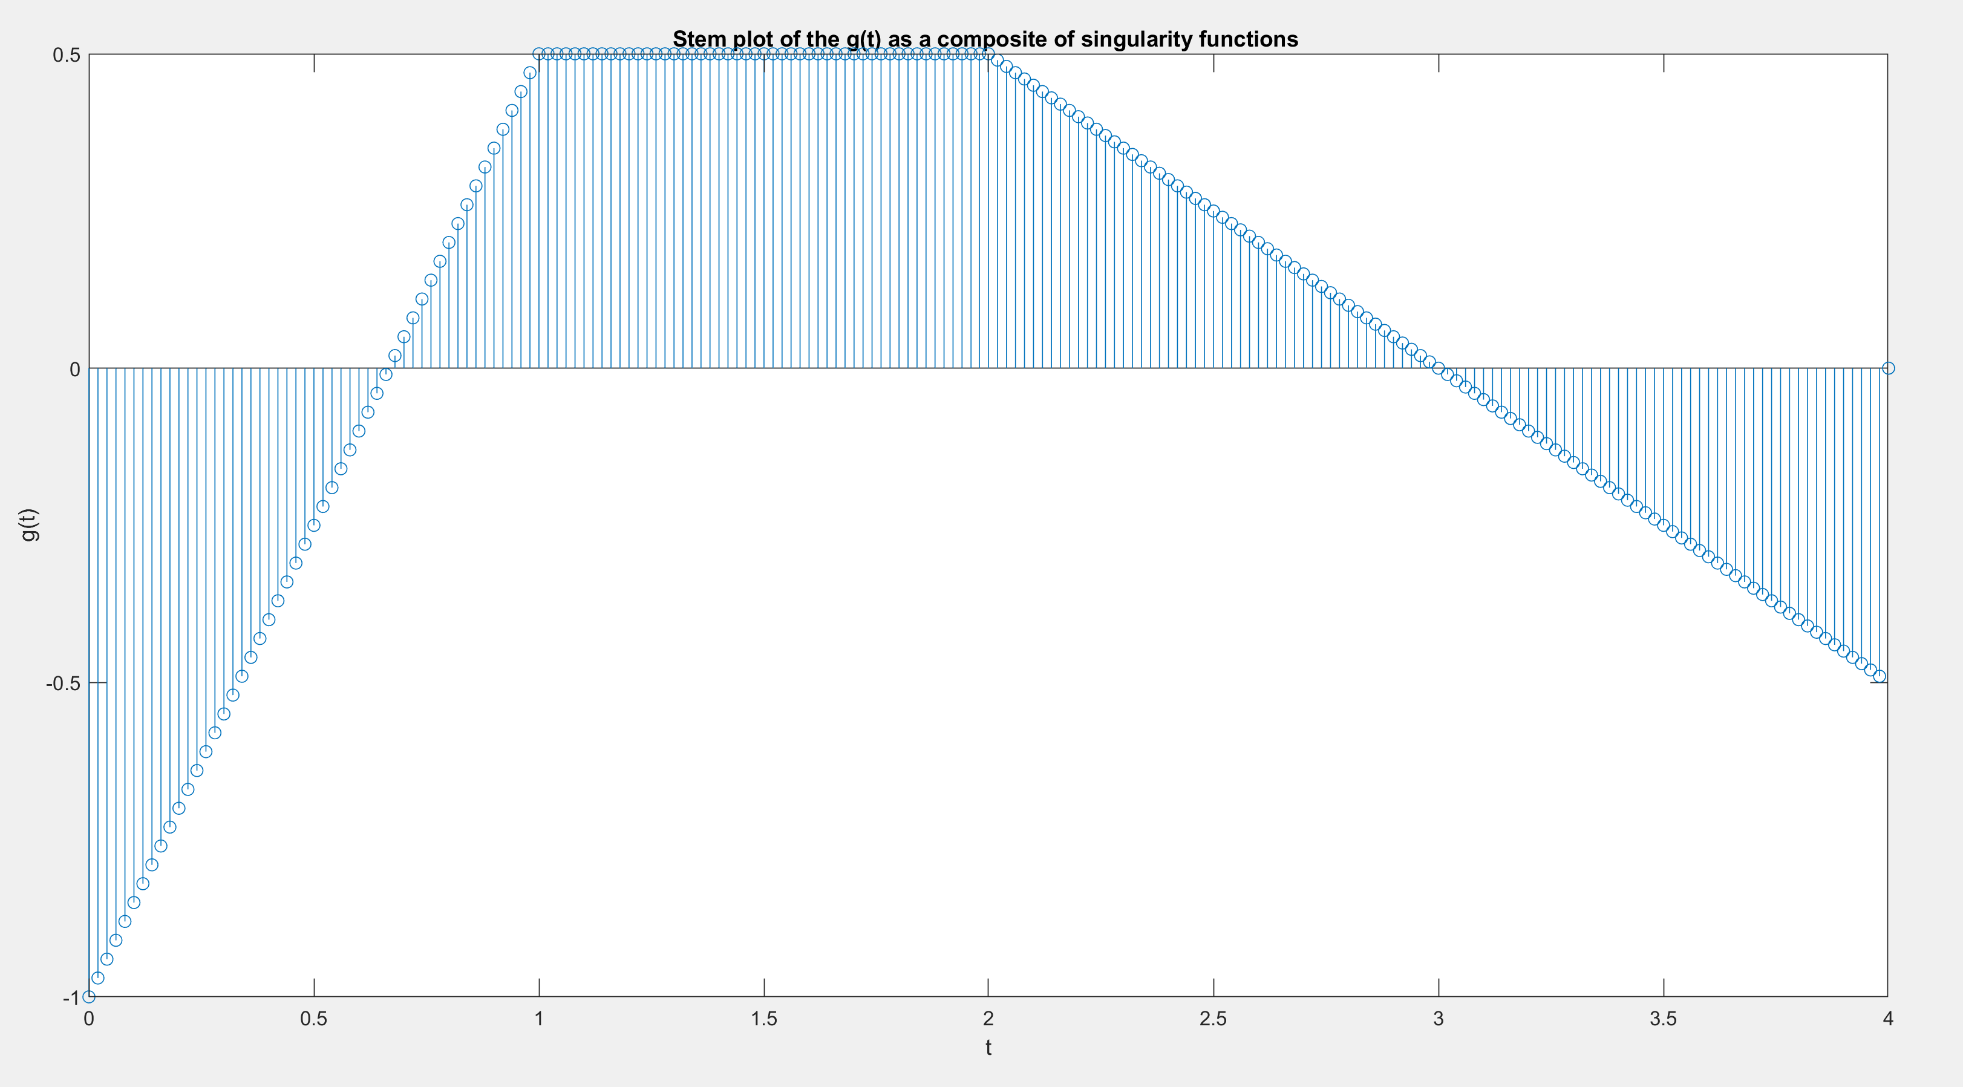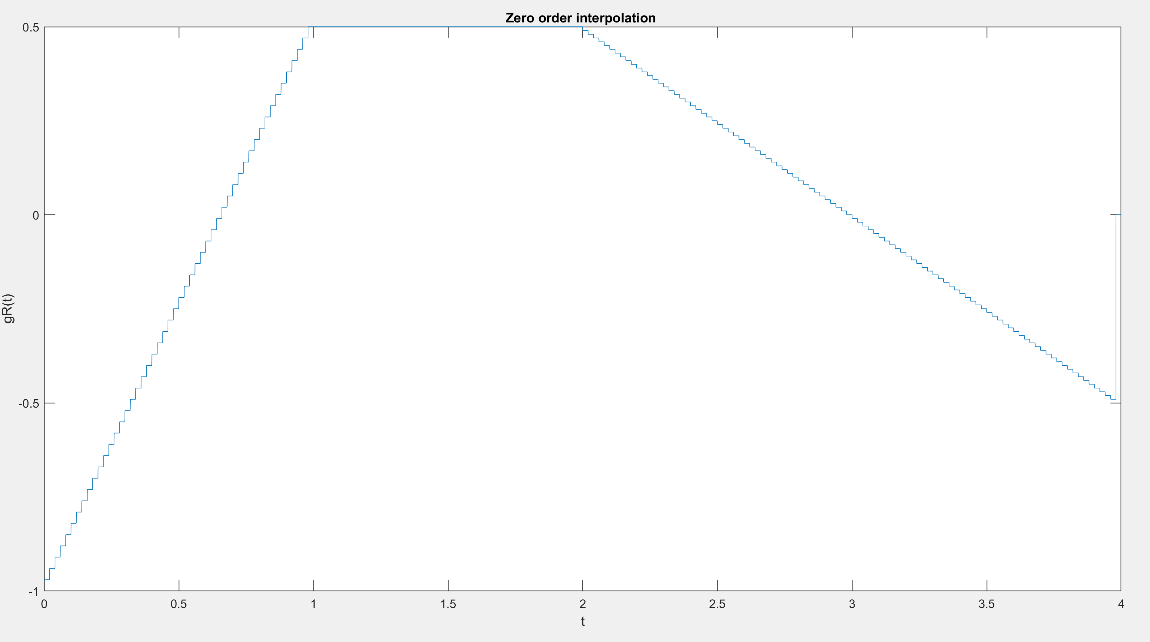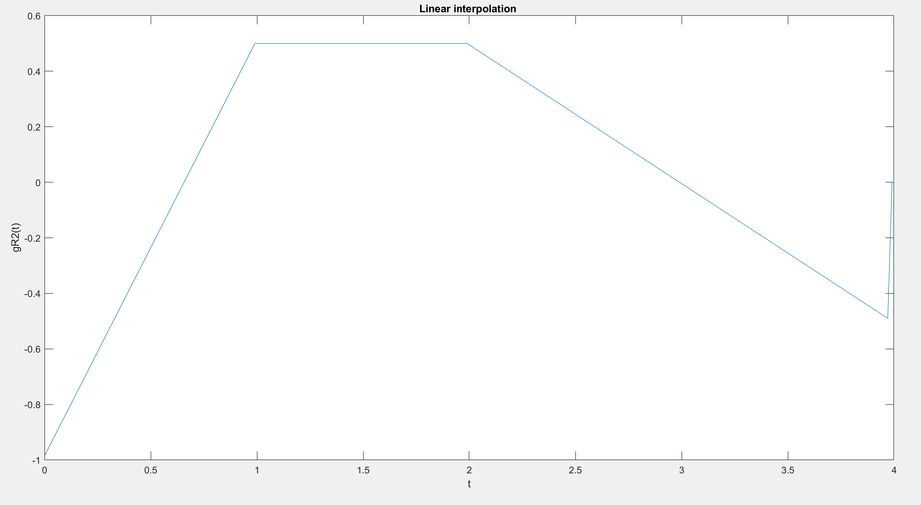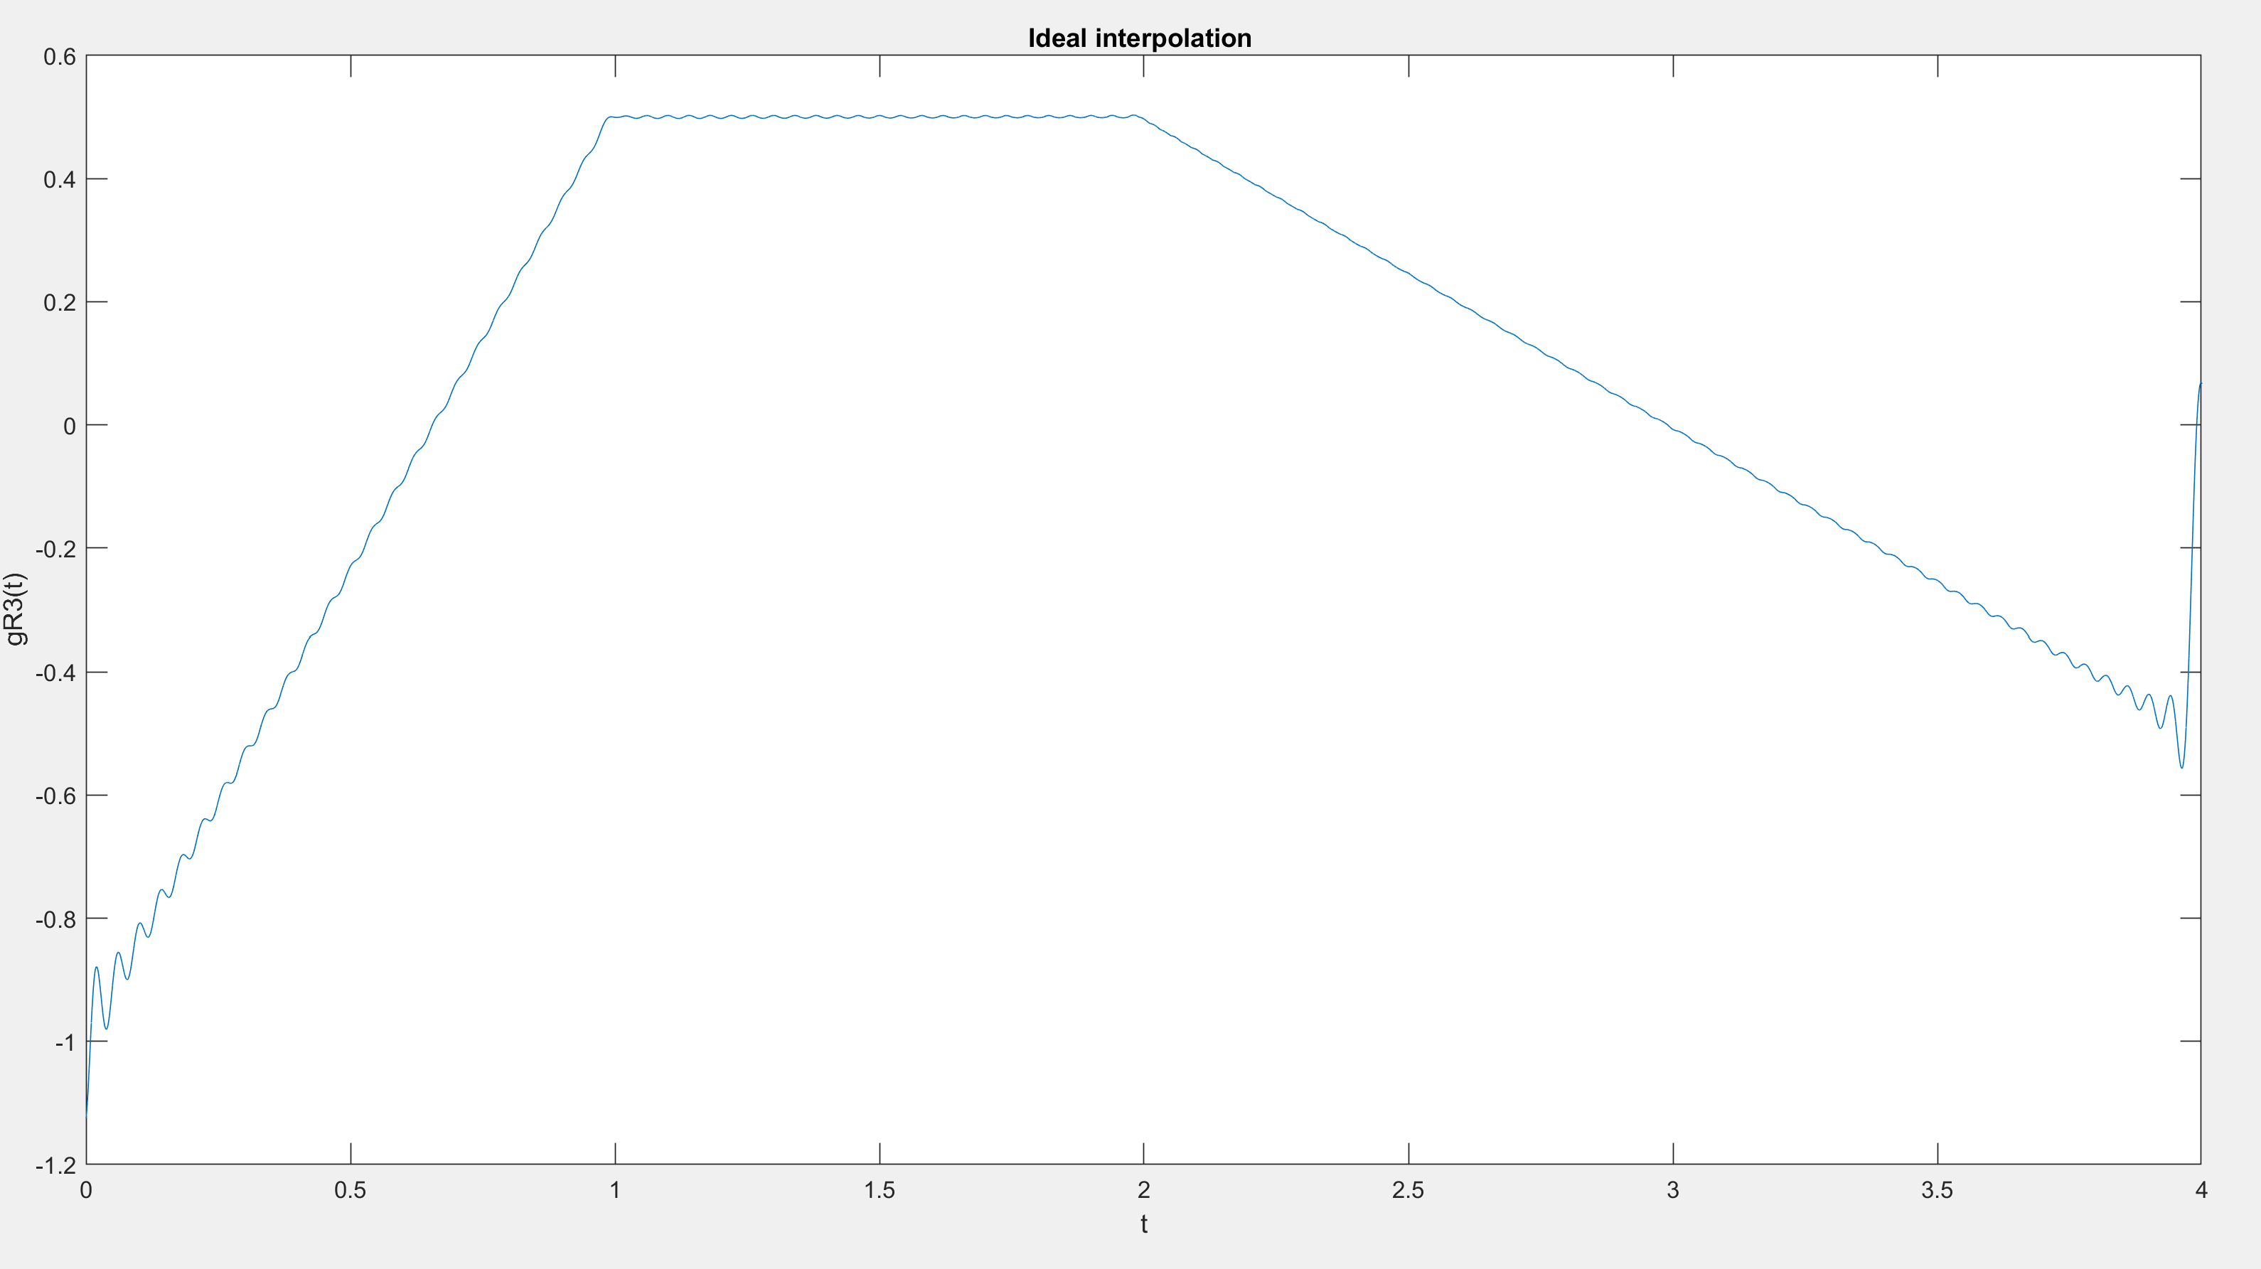

***Part 6***

clc;

clear all;

%%%%%%%%% Part 6.a %%%%%%%%%%%%%

D = mod(21501462,4);

Ts = 0.003*(D+2);

t = -2:Ts:2;

t_cont = -2:Ts/1000:2-(Ts/1000);

x = 0.7*cos(3*pi*t+(2*pi)/5)+0.4*sin(2*pi*t+(1/3))+0.5*cos(5*pi*t-(0.8*exp(1)));

x_cont = 0.7*cos(3*pi*t_cont+(2*pi)/5)+0.4*sin(2*pi*t_cont+(1/3))+0.5*cos(5*pi*t_cont-(0.8*exp(1)));

figure(1)

subplot(2,2,1);

hold on

plot(t_cont,x_cont);

stem(t,x);

title("x(t) and x(nTs) --> Ts = 0.003(D4+2) = " + Ts);

xlabel("t");

ylabel("x(t) --- x(nTs)");

hold off

xR = DtoA(0,Ts,4,x);

subplot(2,2,2);

interval = -2:Ts/1000:2-(Ts/1000);

plot(interval,xR)

title("Zero Order Interpolation --> Ts = 0.003(D4+2) = " + Ts);

xlabel("t");

ylabel("xR1(t)");

xR2 = DtoA(1,Ts,4,x);

subplot(2,2,3);

plot(interval,xR2)

title("Linear Interpolation --> Ts = 0.003(D4+2) = " + Ts);

xlabel("t");

ylabel("xR2(t)");

xR3 = DtoA(2,Ts,4,x);

subplot(2,2,4);

plot(interval,xR3)

title("Ideal (bandlimited) Interpolation --> Ts = 0.003(D4+2) = " + Ts);

xlabel("t");

ylabel("xR3(t)");

%%%%%%%%%%%%%%%%%%%%%%%%%%%%%%%%%%%%%%%%%%%%%%%%%%%%%%%%%%%%%%%%%%%%%%%%%%%%%%

clc;

clear all;

%%%%%%%%% Part 6.b %%%%%%%%%%%%%

D = mod(21501462,4);

Ts = 0.3+0.02*D;

t = -2:Ts:2;

t_cont = -2:Ts/1000:2-(Ts/1000);

x = 0.7*cos(3*pi*t+(2*pi)/5)+0.4*sin(2*pi*t+(1/3))+0.5*cos(5*pi*t-(0.8*exp(1)));

x_cont = 0.7*cos(3*pi*t_cont+(2*pi)/5)+0.4*sin(2*pi*t_cont+(1/3))+0.5*cos(5*pi*t_cont-(0.8*exp(1)));

figure(2)

subplot(2,2,1);

hold on

plot(t_cont,x_cont);

stem(t,x);

title("x(t) and x(nTs) --> Ts = 0.3+0.02D4 = " + Ts);

xlabel("t");

ylabel("x(t) --- x(nTs)");

hold off

xR = DtoA(0,Ts,4,x);

subplot(2,2,2);

interval = -2:Ts/1000:2-(Ts/1000);

plot(interval,xR)

title("Zero Order Interpolation --> Ts = 0.3+0.02D4 = " + Ts);

xlabel("t");

ylabel("xR1(t)");

xR2 = DtoA(1,Ts,4,x);

subplot(2,2,3);

plot(interval,xR2)

title("Linear Interpolation --> Ts = 0.3+0.02D4 = " + Ts);

xlabel("t");

ylabel("xR2(t)");

xR3 = DtoA(2,Ts,4,x);

subplot(2,2,4);

plot(interval,xR3)

title("Ideal (bandlimited) Interpolation --> Ts = 0.3+0.02D4 = " + Ts);

xlabel("t");

ylabel("xR3(t)");

%%%%%%%%%%%%%%%%%%%%%%%%%%%%%%%%%%%%%%%%%%%%%%%%%%%%%%%%%%%%%%%%%%%%%%%%%%%%%%

clc;

clear all;

%%%%%%%%% Part 6.c %%%%%%%%%%%%%

D = mod(21501462,4);

Ts = 0.099;

t = -2:Ts:2;

t_cont = -2:Ts/1000:2-(Ts/1000);

x = 0.7*cos(3*pi*t+(2*pi)/5)+0.4*sin(2*pi*t+(1/3))+0.5*cos(5*pi*t-(0.8*exp(1)));

x_cont = 0.7*cos(3*pi*t_cont+(2*pi)/5)+0.4*sin(2*pi*t_cont+(1/3))+0.5*cos(5*pi*t_cont-(0.8*exp(1)));

figure(3)

subplot(2,2,1);

hold on

plot(t_cont,x_cont);

stem(t,x);

title("x(t) and x(nTs) --> Ts = " + Ts);

xlabel("t");

ylabel("x(t) --- x(nTs)");

hold off

xR = DtoA(0,Ts,4,x);

subplot(2,2,2);

interval = -2:Ts/1000:2-(Ts/1000);

plot(interval,xR)

title("Zero Order Interpolation --> Ts = " + Ts);

xlabel("t");

ylabel("xR1(t)");

xR2 = DtoA(1,Ts,4,x);

subplot(2,2,3);

plot(interval,xR2)

title("Linear Interpolation --> Ts = " + Ts);

xlabel("t");

ylabel("xR2(t)");

xR3 = DtoA(2,Ts,4,x);

subplot(2,2,4);

plot(interval,xR3)

title("Ideal (bandlimited) Interpolation --> Ts = " + Ts);

xlabel("t");

ylabel("xR3(t)");

