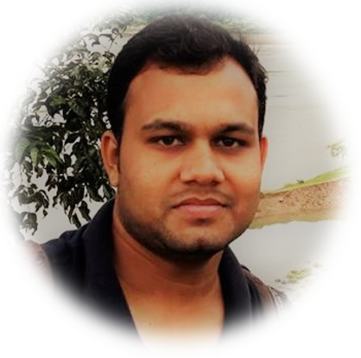

**Md. Yusuf Ali**

**EDUCATION**

Cell: +8801754182799

Email: yusufali1046@gmail.com

**April 2015 – Jan 2019 (Expected)**

**Shahjalal University of Science and Technology**

4 year long BSc(Eng.) in Computer Science and Engineering. Total of 163 Credits (138.50 Completed). CGPA 3.57 in Majors.

**PROGRAMMING AND PROBLEM SOLVING ACTIVITIES**

**Solved Over 1500 Problems**

Solved: 291+ Problems

Solved: 166+ Problems

Max Rated: 1537

Solved: 50+ Problems

Participate: 100+ Contest

User Name: Yusuf_sust

User ID: 31202

Handle: Yusuf_sust

User Name: Yusuf_sust

User Name: Yusuf_sust

* UVa Online Judge
* LightOJ Online Judge
* Codeforces
* Hacker Rank
* Virtual Judge

**PROJECT AND THESIS**

**Projects**

* **Facebook Data Crawler & Comment Mention:**  In this project anyone can crawl Facebook data and by comment he/she know about the particular person. JAVA, Facebook API.
* **CAAN Management System:** It is a web application that student can send their complain, application, assignment to their particular teacher and see the department notice board. PHP, Xampp.
* **A Multiple Chat Server System Using Socket Programming:** It is a java GUI application that many user chat each other connecting a particular server. JAVA GUI, Socket Programming
* **Waving Bangladesh Flag:** It is a graphics project that continuously wave BD flag. C++, GLUT
* **Online Exam Taker:** It is a web site that teacher create exam and student participate their particular exam. Laravel Framework, Xampp
* **Bangla Document Summarizer:** In this project user select a document and automatically summarize the document. Python

**Thesis**

* **Bangla Document Categorization:** A deep neural network model with LSTM that automatically categorize document into 12 predefined categories. NLP, ML, Python, Tensorflow

**ADDITIONAL EXPERIENCE**

* **Mentor:** Guided the junior problem solvers and arranged many programming contest.
* **Organizer:** ICT fest, NHSPC, Science and Math Fair 2015 organizer.
* **IUBAT Inter University Programming Contest:** Placed 15th
* **SUST Inter University Programming Contest 2017:** Placed 28th
* **ACM ICPC Online 2017 Dhaka Regional Preliminary Contest:** Placed 62th
* **ACM ICPC Online 2018 Dhaka Regional Preliminary Contest:** Placed 58th

**LANGUAGE, SKILLS AND TECHNOLOGIES**

* Laravel Framework
* GitHub
* C/C++, JAVA, Python,
* PHP, JavaScript
* SQL, Oracle Database, Xampp

Bangabandhu Hall

Shahjalal University of Science & Technology

Sylhet - 3114