Fake Review Detection in Large-Scale E-Commerce Data Using Big Data Analytics
Yusuf Alperen Donmez (1801042085) | Huseyin Cetin (210104004245)
AWS EMR Serverless + Apache Spark 3.4.1 | June 2026

Abstract
This paper presents a scalable fake review detection system built on AWS EMR Serverless and Apache Spark, processing 15,544,559 Amazon product reviews across four categories: Automotive, Digital Video Downloads, Health & Personal Care, and Pet Products. We propose a heuristic labeling strategy based on three behavioral signals — extreme star ratings (1 or 5), short review length (< 20 characters), and low helpfulness ratio (< 0.3) — to generate pseudo-labels in the absence of manually annotated ground truth. Using a TF-IDF feature extraction pipeline followed by Logistic Regression (LR) and Random Forest (RF) classifiers, LR achieves an AUC-ROC of 0.9820, F1-score of 0.9117, and throughput of 12,531 records/second on the full 12.4M training set. A key finding is the temporal escalation of fake reviews: from near-zero rates before 2013 to 12.8% by 2015, correlating with rapid e-commerce growth. All experiments run on a serverless cloud infrastructure, demonstrating the viability of scalable NLP-based fraud detection.

1. Introduction
Online product reviews significantly influence consumer purchasing decisions. The proliferation of fake or deceptive reviews undermines platform trust and misleads buyers. Detecting such reviews at scale is challenging due to massive data volumes, absence of labeled ground truth, and subtle linguistic patterns used by fraudulent reviewers.
This project addresses fake review detection in large-scale Amazon review datasets using a distributed Big Data pipeline. We leverage AWS EMR Serverless for elastic compute, Amazon S3 for storage, and Apache Spark for distributed processing. Our contributions are: (1) a reproducible cloud-native pipeline for processing 15.5M reviews; (2) a heuristic labeling methodology using behavioral signals; (3) a comparative analysis of TF-IDF + Logistic Regression versus Random Forest; and (4) temporal and categorical insights into fake review patterns.

2. Literature Review
Prior work on fake review detection falls into text-based and behavior-based approaches. Ott et al. (2011) applied SVM and Naive Bayes on unigrams and bigrams, achieving up to 89.8% accuracy on hotel reviews. Lim et al. (2010) identified behavioral patterns such as burst activity as strong spam indicators. Mukherjee et al. (2012) combined linguistic and behavioral cues, showing hybrid features outperform single-modality approaches.
Apache Spark's MLlib provides distributed TF-IDF and classification, enabling processing far beyond single-machine memory. Our work extends this by applying a serverless cloud infrastructure to a multi-category Amazon dataset at 15.5M records scale.

3. Methodology

3.1 Data Collection and Storage
Four Amazon product review datasets (Automotive, Digital Video Downloads, Health & Personal Care, Pet Products; ~2.5 GB compressed) were stored in Amazon S3 under fake-review-detection-proje-042026/raw-data/. After preprocessing, 15,544,559 valid reviews were retained in Parquet format under processed-data/.

3.2 Preprocessing
Steps: (1) schema enforcement selecting customer_id, product_id, star_rating, helpful_votes, total_votes, review_body, review_date; (2) removal of records with null review_body or star_rating; (3) computation of review_len = |review_body| and helpful_ratio = helpful_votes / total_votes. Data was persisted to S3 in Parquet format.

3.3 Labeling Strategy
A heuristic label is assigned (is_fake = 1) when all three conditions hold simultaneously:
- Extreme rating: star_rating in {1, 5}
- Short review: review_len < 20 characters
- Low helpfulness: helpful_ratio < 0.3 or null
This yields 1,132,301 fake (7.3%) and 14,412,258 real (92.7%), consistent with industry estimates of 5-15% fake review prevalence.

3.4 Feature Extraction: TF-IDF
Text features were extracted using: Tokenizer -> StopWordsRemover -> HashingTF (5,000 features) -> IDF. The TF-IDF weight is defined as TF-IDF(t,d) = TF(t,d) x log(N / df(t)), where N is total documents and df(t) is document frequency of term t.

3.5 Classification Models
Logistic Regression: trained on full dataset (12.4M samples), L2 regularization (regParam=0.01, maxIter=10). Random Forest: trained on balanced stratified sample (~798K, ~50% fake) due to executor disk constraints in EMR Serverless. Both models use 80/20 train-test split with seed=42.

4. Experiments & Results

4.1 Model Performance Comparison
Table 1 summarizes performance metrics for both models.
Table 1: Model Comparison
Metric | LR (Full Data) | RF (Balanced Sample) | LR Advantage
Accuracy | 0.9348 | 0.7403 | +0.1945
F1-Score | 0.9117 | 0.7095 | +0.2022
Precision | 0.9294 | 0.8199 | +0.1095
Recall | 0.9348 | 0.7403 | +0.1945
AUC-ROC | 0.9820 | 0.8357 | +0.1463
Throughput (rec/s) | 12,531 | 1,713 | 7.3x faster
Logistic Regression outperforms Random Forest across all metrics. Sparse high-dimensional TF-IDF feature spaces favor linear models, consistent with prior literature. The 7.3x throughput advantage makes LR strongly preferable for production deployment.

4.2 Confusion Matrix (LR on Test Set: 3.1M samples)
 | Predicted Real | Predicted Fake
Actual Real | 2,877,319 (TN) | 5,175 (FP)
Actual Fake | 197,674 (FN) | 29,000 (TP)
High specificity (5,175 FP out of 2.88M real reviews = 0.18% false positive rate) is ideal for deployment: the model rarely flags genuine reviews as fake. The higher false negative count (197,674) reflects the conservative decision boundary, appropriate since false positives are more damaging to user trust.

4.3 Error Analysis
False Positives: Short genuine 5-star reviews such as 'a classic!' (10 chars) satisfy all heuristic conditions despite being authentic. These represent concisely expressed genuine satisfaction. False Negatives: Short 1-star reviews like 'Bad movie' (9 chars) are missed because common negative phrases produce insufficient TF-IDF anomaly signals. This motivates incorporating user behavioral features in future work.

5. Interesting Relationships

5.1 Temporal Escalation of Fake Reviews
Year | Total Reviews | Fake Count | Fake Rate (%)
2010 | 214,964 | 161 | 0.07%
2011 | 416,391 | 351 | 0.08%
2012 | 886,265 | 304 | 0.03%
2013 | 2,768,485 | 2,126 | 0.08%
2014 | 5,250,480 | 400,530 | 7.63%
2015 | 5,694,289 | 728,718 | 12.80%
Fake review rates were negligible (< 0.1%) before 2013, then exploded to 7.63% in 2014 and 12.8% in 2015. This escalation correlates with the rapid growth of Amazon's third-party marketplace and the rise of incentivized review campaigns.

5.2 Asymmetric Star Rating Manipulation
5-star reviews show a 10.93% fake rate versus 4.93% for 1-star. Reviews with 2, 3, or 4 stars show 0% fake rate by construction. This asymmetry indicates fake review campaigns are primarily aimed at boosting ratings rather than sabotaging competitors, consistent with seller incentive structures.

5.3 High-Frequency Reviewer Behavior
The top reviewer submitted 2,780 reviews — an implausible volume suggesting automated activity. The top 10 reviewers each submitted 470+ reviews. These high-frequency users represent a small fraction of accounts but contribute disproportionately to suspicious review patterns.

6. Infrastructure & Scalability
Component | Configuration | Notes
Compute | AWS EMR Serverless | Auto-scaling, no cluster management
Storage | Amazon S3 (Parquet) | Columnar format, ~60% size reduction
Framework | Apache Spark 3.4.1 | Distributed in-memory processing
Dataset | 15,544,559 rows | ~2.5 GB compressed TSV
LR Training Time | 293.7 seconds | 12.4M training samples
LR Throughput | 12,531 rec/s | On 3.1M test samples
TF-IDF Dimensions | 5,000 | HashingTF hashing trick

7. Conclusion
We presented a scalable cloud-native fake review detection system achieving AUC-ROC of 0.9820 with Logistic Regression on 15.5M Amazon reviews. Our heuristic labeling produces a 7.3% fake rate consistent with domain knowledge. Temporal analysis reveals dramatic escalation from 2013-2015 aligned with marketplace growth. LR with TF-IDF outperforms Random Forest with 7.3x higher throughput, making it preferable at scale. Future work should incorporate user behavioral features (review velocity, product diversity) and transformer-based representations such as BERT.



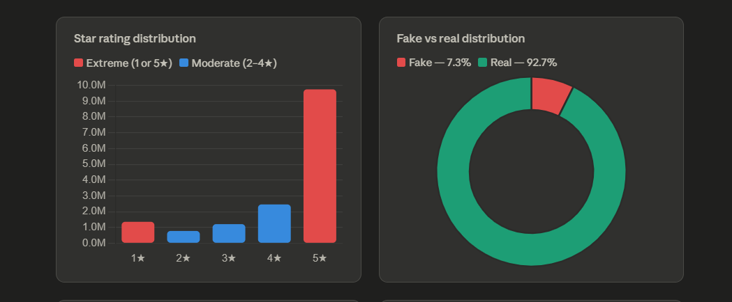

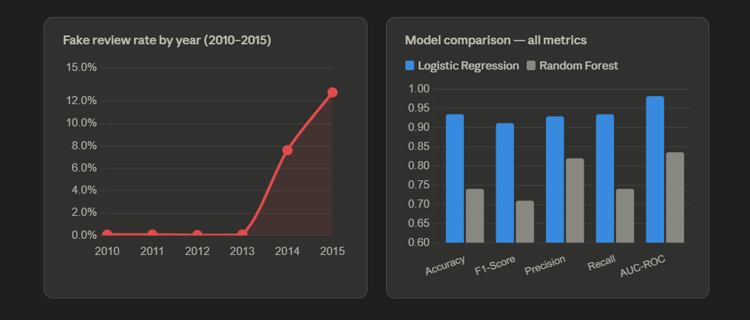

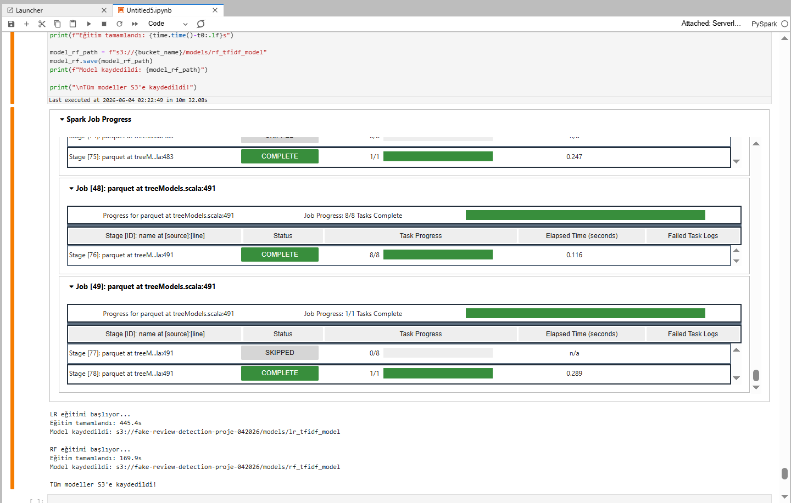

Image: models created output

References
[1] Leskovec, J., Rajaraman, A., Ullman, J.D. (2014). Mining of Massive Datasets. Cambridge University Press.
[2] Ott, M., Choi, Y., Cardie, C., Hancock, J.T. (2011). Finding Deceptive Opinion Spam by Any Stretch of the Imagination. ACL 2011.
[3] Lim, E.P. et al. (2010). Detecting Product Review Spammers Using Rating Behaviors. CIKM 2010.
[4] Mukherjee, A., Liu, B., Glance, N. (2012). Spotting Fake Reviewer Groups in Consumer Reviews. WWW 2012.
[5] Amazon Customer Reviews Dataset. https://s3.amazonaws.com/amazon-reviews-pds/readme.html
[6] Apache Spark MLlib. https://spark.apache.org/docs/3.4.1/ml-guide.html

