Global COVID-19 Data Analysis: Uncovering Hidden Patterns & Causality

INTRODUCTION

1.1. Background
The COVID-19 pandemic has generated an unprecedented amount of data, offering a unique opportunity for data scientists and engineers to analyze global health trends, resource allocation, and policy effectiveness. However, the complexity of this data often leads to misinterpretations when superficial correlations are mistaken for causation.

1.2. Problem Statement
Raw data analysis often conceals underlying variables. For instance, high death rates in developed nations or low correlation between lockdowns and case reductions can be misinterpreted without accounting for demographic structures (e.g., age distribution) or lag effects. A naive approach to data analytics can lead to incorrect strategic conclusions.

1.3. Objectives
The primary objective of this project is to analyze the global COVID-19 dataset using advanced statistical methods and Python-based visualization tools. The specific goals are:
- To identify and correct misleading correlations (e.g., Simpson’s Paradox).
- To evaluate the true effectiveness of vaccination campaigns by isolating cumulative data effects.
- To assess the impact of healthcare capacity (hospital beds) and comorbidities on mortality rates.
- To analyze the responsiveness of government "Stringency Policies" relative to infection waves.

DATA & METHODOLOGY

Data Source
The dataset used in this study is the comprehensive "Our World in Data" (OWID) COVID-19 dataset. This dataset aggregates information from reputable sources such as the WHO (World Health Organization) and Johns Hopkins University. It includes daily updated variables concerning confirmed cases, deaths, vaccinations, testing, and government policy indices across 200+ countries.

Data Preprocessing & Feature Engineering
To ensure analytical accuracy, raw data underwent a rigorous cleaning process using Python:
- Normalization: Absolute numbers (e.g., total deaths) were converted to relative metrics (e.g., Total Deaths per Million) to allow for fair comparison between countries with vastly different population sizes.
- Smoothing: To mitigate the noise caused by daily reporting irregularities (e.g., weekend lags), a 7-day rolling average was applied to daily case and death figures.
- Data Cleaning: Countries with missing critical data (e.g., GDP, hospital beds) or micro-states with populations under 1 million were filtered out to prevent statistical outliers from skewing the results.
- Feature Creation: A new metric, Case Fatality Rate (CFR), was calculated as the ratio of total deaths to total cases (Total Deaths / Total Cases x 100) to measure the severity of the virus in each region.

Tools & Technologies
The analysis was conducted using the Python programming language within a Jupyter Notebook environment. Key libraries included:
- Pandas: For data manipulation and time-series management.
- Matplotlib & Seaborn: For generating static statistical correlations and regression plots.

DATA ANALYSIS & FINDINGS

Demographic Paradoxes: The "Simpson’s Paradox" Case
One of the initial findings of the exploratory data analysis was a counter-intuitive correlation between smoking rates and COVID-19 mortality.
- Initial Observation: A weak negative correlation (approx. -0.07) was observed between Female Smokers and Total Deaths per Million. This misleading statistic suggested that countries with higher smoking rates had better health outcomes.

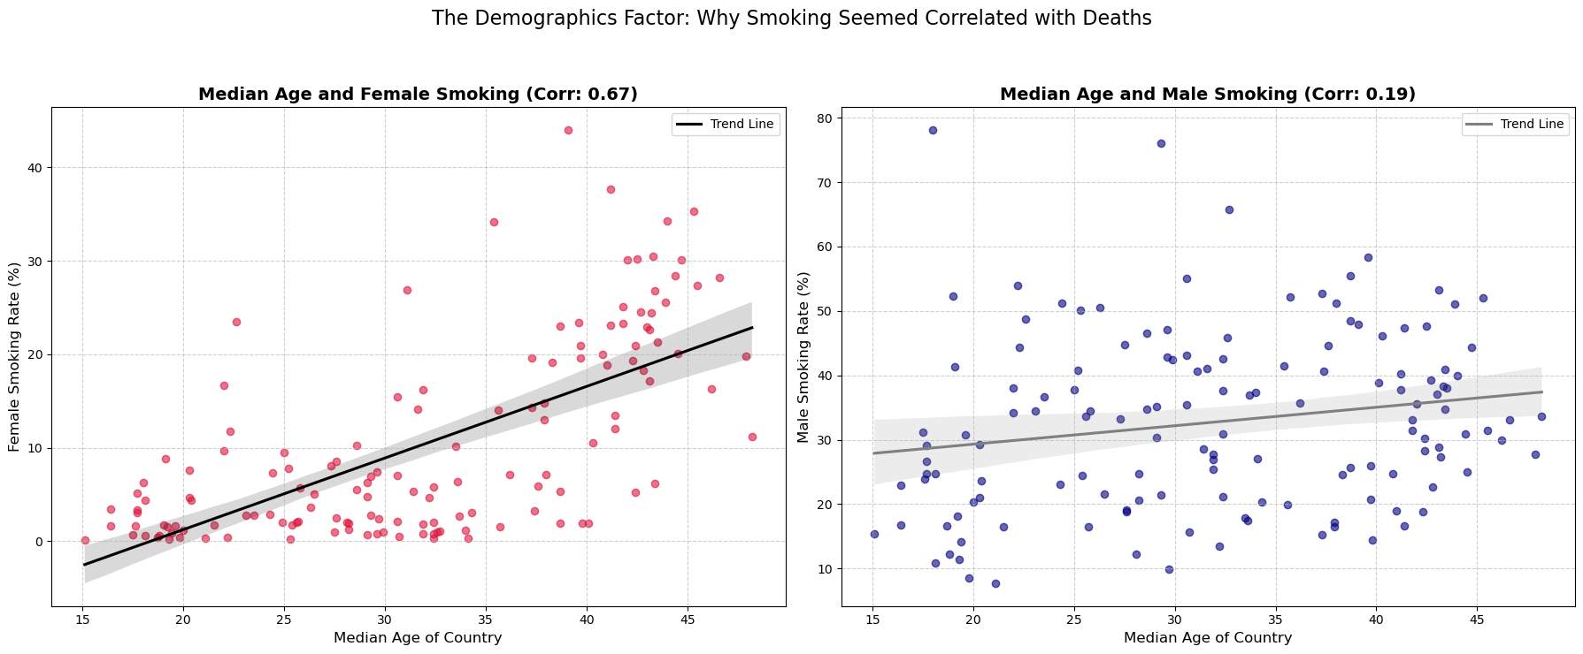
Figure 1: The misleading correlation between smoking and country demographics.

- Root Cause Analysis: Upon further stratification, it was revealed that developed nations with high smoking rates also possess significantly older populations.

- Correction: When the variable Median Age was isolated, a strong positive correlation (+0.65) was found between age and mortality. This confirms that the initial negative correlation was a classic instance of Simpson’s Paradox, where the "Age" variable acted as a confounding factor, masking the true risk.

Efficacy of Vaccination
Analyzing the impact of vaccination on mortality required a methodological shift. Initial attempts to correlate Total Vaccination Rate with Cumulative Death Counts failed to show a strong negative relationship. This is attributed to the "Cumulative Trap," where high death tolls from the pre-vaccine era (2020) continue to weigh down the statistics of 2021-2022.
To resolve this, the study adopted a "Binning" (Stratification) approach. Instead of looking at cumulative totals, the analysis examined the Average Daily Deaths (per million) at different milestones of vaccination coverage (e.g., when a population is 10% vaccinated vs. 70% vaccinated).
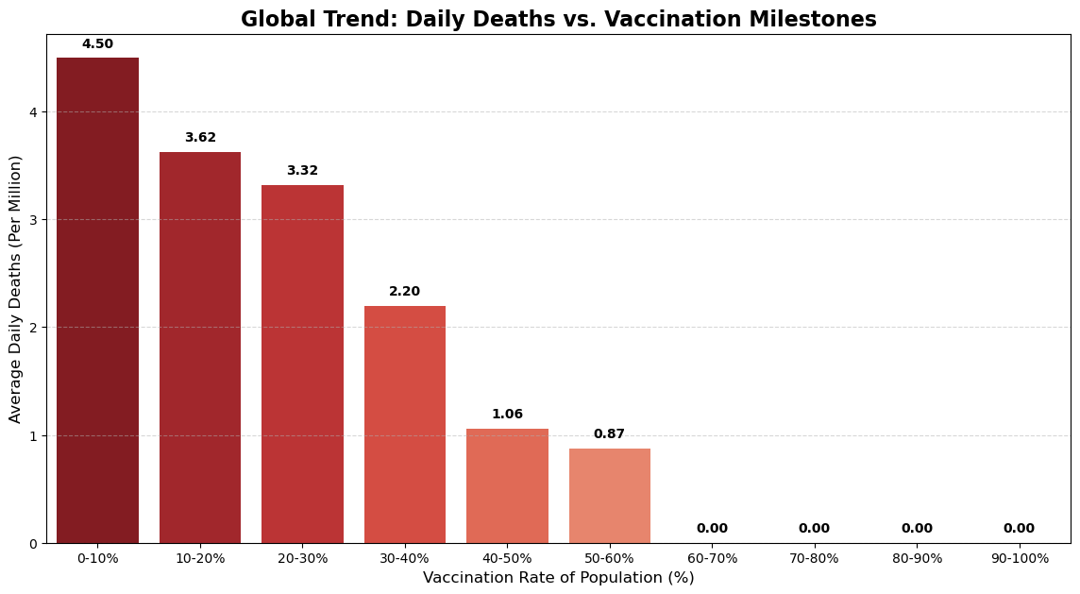
Figure 2: The step-down trend in daily deaths as vaccination rates increase.

- Findings: The analysis demonstrates a clear inverse relationship. As countries moved from the 0-10% vaccination bracket to the >60% bracket, the daily death rate per million dropped significantly. This proves that while vaccines may not immediately erase historical death tolls, they drastically reduce concurrent mortality risks.

Socio-Economic Factors & The Healthcare Paradox
The study investigated whether economic prosperity (GDP per capita) and healthcare infrastructure (Hospital Beds per Thousand) directly correlated with lower mortality rates.
- Hypothesis: It was hypothesized that developed nations with higher hospital capacity would exhibit significantly lower Case Fatality Rates (CFR).
- The Anomaly: Contrary to expectations, data from developed nations (Median Age > 35) showed a neutral to slightly positive correlation between bed capacity and death rates. Countries with high bed capacities (e.g., Russia, Eastern European nations) still experienced high mortality.

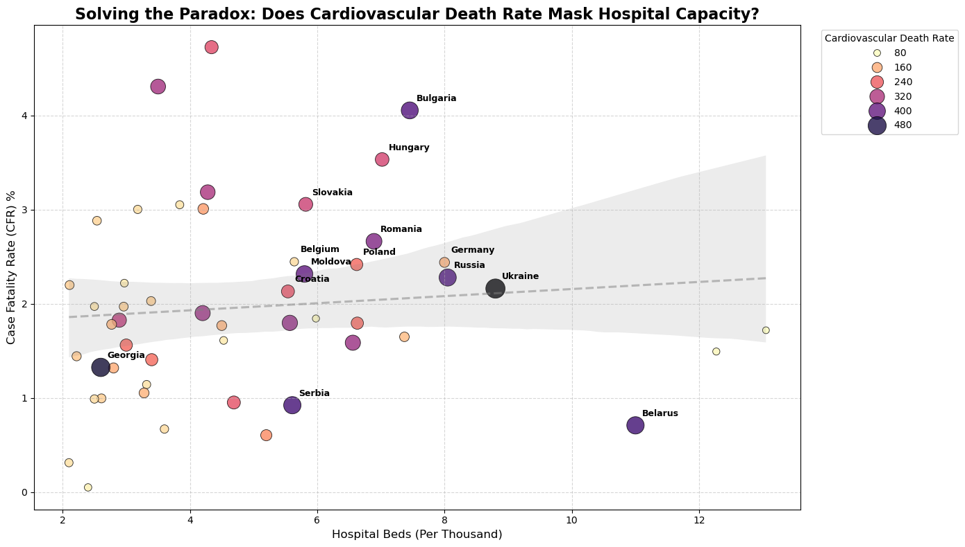
Figure 3: Hospital Beds vs. CFR, colored by Cardiovascular Death Rate.

- Root Cause Analysis: By introducing Cardiovascular Death Rate as a third variable, the paradox was resolved. The visualization reveals that countries with high hospital capacity but high mortality are clustered in regions with severe chronic health issues (High CVD rates).

- Conclusion: Healthcare infrastructure alone is insufficient to prevent mortality if the underlying population has high comorbidity rates (e.g., heart disease, diabetes). The biological vulnerability of the population outweighs the logistical advantage of hospital beds.

Evaluation of Government Policies: The Reactive Cycle
The final phase of the analysis focused on the correlation between government restrictions (measured by the Stringency Index, scale 0-100) and the trajectory of infection waves.
- Methodology: A dual-axis time-series analysis was conducted for key countries (e.g., Germany, Turkey) to observe the synchronization between policy implementation (Red Line) and daily case spikes (Blue Area).
- Observation: The visual analysis revealed a consistent "Lag Effect." In most instances, the Stringency Index spiked after the exponential rise in cases had already begun.
- Interpretation: This pattern suggests a "Reactive Policy Making" approach. Restrictions were primarily used as emergency brakes to control spiraling outbreaks rather than as preventative measures. The lack of a proactive lead time indicates that decision-making mechanisms often lagged behind the biological transmission speed of the virus.

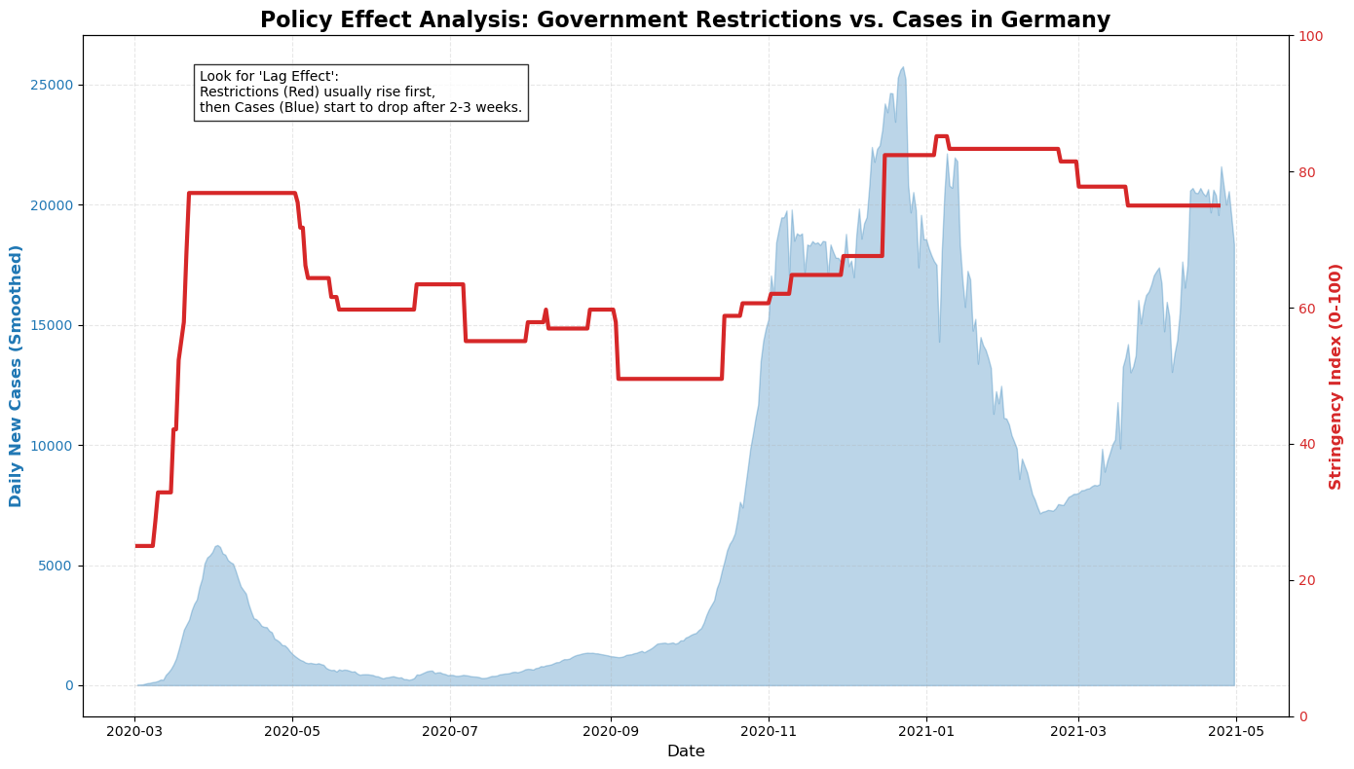
Figure 4: The time-lag between rising cases and government restrictions.

CONCLUSION & RECOMMENDATIONS

Summary of Insights
This project highlights that in global health crises, raw data can be deceptive without contextual layering.
- Demographics Matter: Mortality rates are more strongly correlated with the age structure of a population than with behavioral factors like smoking (Simpson’s Paradox).
- Vaccines Save Lives: When stripped of cumulative historical burdens, vaccination shows a high efficacy in reducing daily death rates.
- Chronic Health is Key: A robust healthcare infrastructure (hospital beds) cannot fully compensate for a population plagued by chronic comorbidities (heart disease, diabetes).
- Policy Timing: Government interventions often operated on a reactive basis, highlighting a need for better predictive modeling.

Strategic Recommendations
Based on these data-driven findings, the following recommendations are proposed for future pandemic management:
- Data Granularity: Decisions should be based on stratified data (age groups, comorbidity levels) rather than national averages.
- Preventative Health: Long-term investment should focus on reducing chronic disease prevalence (preventative care) rather than solely increasing emergency capacity (curative care).
- Early Warning Systems: Policy mechanisms must transition from reactive measures to predictive triggers based on early transmission rates ($R_0$) to minimize the economic impact of delayed lockdowns.

REFERENCES & APPENDIX
Data Source:
- Ritchie, H. et al. (2020) - "Coronavirus Pandemic (COVID-19)". Published online at OurWorldInData.org.
Technical Stack:
- Language: Python 3.9
- Libraries: Pandas (Data Processing), Matplotlib/Seaborn (Visualization).
- Environment: Jupyter Notebook.

