**Abstract**

Depression has become a global public health concern in recent years, affecting millions of people all over the world. That's why depression detection has become a crucial step in analyzing as well as diagnosing depression among patients, ensuring better treatment and support for their mental health condition. Our present study focuses on developing algorithms that can recognize depression patterns by studying Electroencephalogram (EEG) data and investigates the potential of Electroencephalogram (EEG) data in depression detection. Understanding and predicting depressive symptoms in patients is challenging because brain signals (EEG) are complicated and constantly changing. Additionally, differences in age and gender among patients add to the complexity. Creating an accurate and effective prediction, as well as visually representing depressive conditions in patients, becomes difficult due to these factors. Our EEG signal data are collected from Kaggle and are used to study depression which is a subcategory of mental diseases highlighted in the dataset. Here 5 minutes eye closed resting state EEG data collected from 19 channels with 500 sampling rate. In this study, we employed two robust machine learning models, Random Forest and XGBoost, to analyze the EEG data for depression. Among them XGBoost has shown 82.5% accuracy rate with the given dataset where Random Forest has 81.25% accuracy.

**Keywords:** Depression detection, Electroencephalogram (EEG), Machine learning, Random Forest, XGBoost, Depressive disorder.

**Introduction**

**Depression:**

Depression doesn’t mean just feeling sad or losing interest in something, instead depression is related to a person’s everyday life. It may create a feeling that can make everything seem overwhelming and joyless. It generates difficulty functioning in regular activity and affects a person's thoughts, feelings, and behavior. So, to get rid of depression, depression detection, and diagnosis have become a very needy and trendy issue. It needs proper treatment and guidance to ensure a normal life for every affected patient.

[ ADD Image for depression ]

**Introduction to EEG:**

Depression is often diagnosed based on self-reported symptoms, clinical interviews, and observations by mental health professionals so-called psychiatrists. But brain signals called EEG (Electroencephalogram) help a lot in detecting as well as analyzing this mental health condition. It is a gift of technological advancement for present days. In previous research, it is shown that individuals with depression often exhibit distinct patterns in their EEG signals compared to those without the disorder. These patterns may include specific frequency alterations, changes in connectivity between brain regions, and variations in the overall electrical activity of the brain. Researchers have been trying to identify the indicators of depression in brain signal behaviors. The more acceptable scenario can be something like, increased theta and alpha wave activity or decreased beta wave activity in certain brain regions may be associated with depressive symptoms. Coherence is an important part of EEG that helps to identify neuronal correlation and measures relationships between bandwidths of EEG signal collected from the scalp using electrodes. Coherence is a measure of the linear relationship between two signals at different frequencies. In the context of EEG, it is often used to quantify the degree of synchronization between different brain regions. High coherence indicates a strong linear relationship or synchronization between the electrical activities of two brain regions at a specific frequency. Low coherence, on the other hand, implies a weak or absent linear relationship between two EEG signals at a specific frequency which refers to independent activity. Coherence in EEG provides an effective process for analyzing depression using brain activity. Several Key EEG frequency bands associated with depression detection are Delta(0.5-4Hz), Theta(4-8Hz), Alpha(8-13Hz), Beta(13-30Hz) and Gamma(30-40Hz). Delta waves are associated with deep sleep and unconscious. Increased delta activity in certain brain regions may be observed in individuals with depression. Theta waves are more generally associated with relaxation. However the abnormal amount of theta activity can be associated with depression. Alpha bands are more generally associated with Relaxation and mental calmness. But in a depressed patient Reduced alpha activity, particularly in frontal and parietal regions, is often observed. Beta waves are mostly associated with active thinking, and concentration. Abnormal beta activity, especially in frontal and central regions may point to depression symptom. Finally comes the Gamma. I our study we didn’t directly use Gamma as feature to train ML models though Gamma is associated with depression detection using EEG. Altered gamma activity patterns are related to depression.

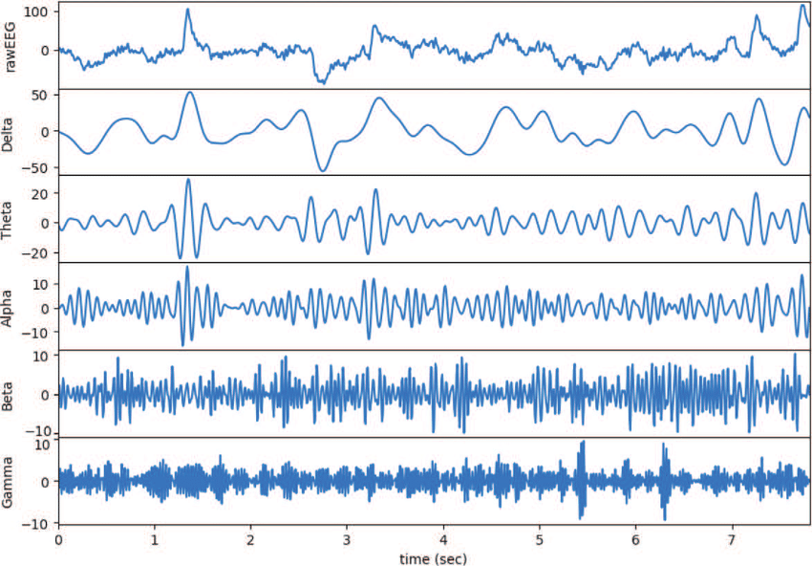

Fig. A view of EEG signal and different frequency bands

**Depression detection overview with diagram:**

A typical Block diagram to show depressive and non-depressive patients using machine learning models that we’ve used are shown below.

Classification

Testing Data

Feature

Extraction

EEG Signal

(Testing Data)

Training

parameters

EEG Signal

(Training Data)

Feature

Extraction

Final

Result

Fig. A Generalized Block Diagram of EEG Based depression detection

In this study we’ve used secondary dataset from Kaggle for which 128 electrode-elastic cap is used for signal recording and 19 channels are considered for achieving EEG data. For our study 95 healthy participants are considered against 266 depressed patients.

**Objectives of the thesis:**

Our base goals of this thesis are as follows:

* Investigating the effectiveness of using EEG signals for depression analysis
* Optimizing machine learning models/techniques for improved accuracy