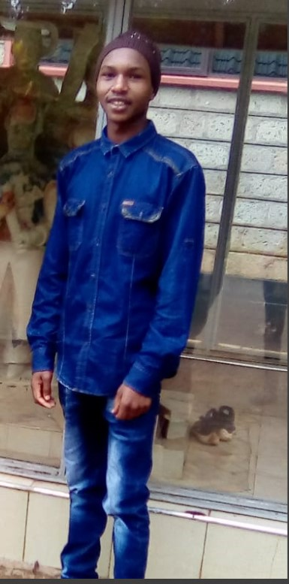

**Yusuf Kantai**

Web designer

Kenya

+254 7 06652327

Yusufkantai130@gmail.com

// ABOUT ME

 I'm a computer science student with a knack for databases, web UI/UX design, and mobile app development using Flutter. Passionate about creating streamlined user experiences, I merge creativity with technical expertise to build intuitive digital solutions. Eager to contribute my skills and learn in the ever-evolving tech world.

// WORK EXPERIENCE

09/2023– Present **WEB DESIGNER**

Frelancer, Online

Creative and skilled freelance web designer, specializing in responsive and user-friendly designs. Collaborate closely with clients to transform concepts into visually appealing and functional websites. Expertise in UX/UI design, ensuring optimal user experience. Proven track record of meeting deadlines and exceeding client expectations. developing all kind of websites largest online retailer in the world.

02/2021 – 12/2022 **LAB TECHNICIAN**

Lemek High School, Narok

Served as a dedicated lab technician at Lemek High School, Narok, from February 2021 to December 2022. Expertly managed laboratory operations, ensuring safety protocols and assisting students with experiments.

// ACADEMIC BACKGROUND

**BACHELOR OF SCIENCE COMPUTER SCIENCE**

KISII UNIVERSITY

2021 - NOW

**JUNIOR CYBER SECURITY**

CISCO NETWARKING ACADEMY

2022

**KCSE**

OLCHEKUT SUPAT APOSTOLIC SCHOOL

2016-2020

// MAIN HARD SKILLS

WEB DEVELOPMENT

REACT

JAVA

TABLEAU

FLUTTER APPS DEVELOPMENT

MYSQL

// LANGUAGES

English - Native or bilingual

Spanish - Native or bilingual

French - Intermediate

// CERTIFICATES

* INTRODUCTION TO PYTHON – TRY KIBO SCHOOL
* JUNIOR CYBER ANALYST – CISCO NETWARKING ACADEMY