System Requirements Specification: UniCycle
Riga 2026

1. Description of the Subject Area
The subject area is a university-focused peer-to-peer marketplace (UniCycle). The system allows RTU students to securely buy, sell, and donate second-hand items. The website is online, requires authorization via university email, is easy to use, and has an intuitive design with real-time messaging, Google Maps integration, and listing management.

2. Simplified System Model

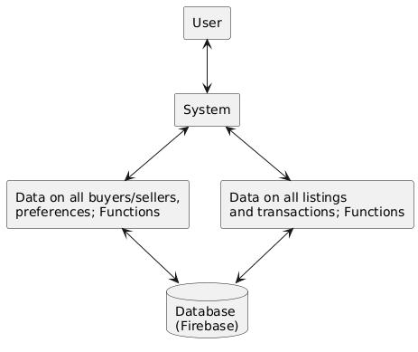
Figure 1. Simplified system model diagram

3. Description of the System Model
1. User logs in with Google Authentication (@edu.rtu.lv email).
2. The system provides access to the marketplace based on the user's role.
3. The system retrieves and edits/adds data in the Cloud Firestore database.
4. The system updates the data and stores media via Firebase Storage.
5. The user receives updated information in real-time.

4. System Environment Diagram

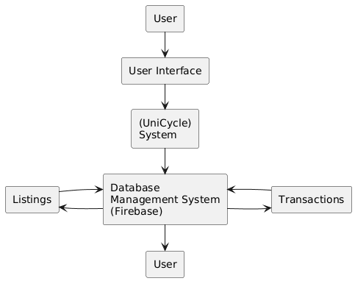
Figure 2. System environment diagram

5. Description of the System Environment Diagram
Interaction with the user occurs through the web interface. After authorization, the user accesses system functions like listing items or chatting.
The system interacts with the Firebase database containing information about users, listings, and messages. Modified data is sent back to the program and displayed to the user instantly.

6. Hierarchical View Diagram
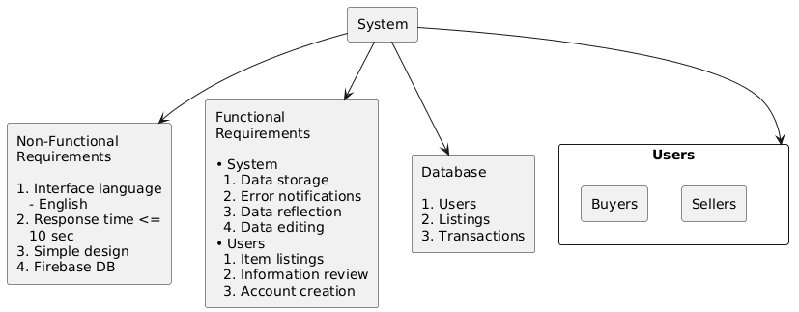
Figure 3. Hierarchical view diagram: Breakdown of opinions
The subject area was explored. The information obtained can be divided into opinions that cover areas such as:
• Opinions about users and their roles - buyers and sellers - who have their own capabilities and functions;
• Opinions about non-functional requirements;
• Opinions about functional requirements: system functions and functions available to users;
• Opinions about the database and its objects.

7. Tabular Diagrams of Opinions

8.1. System opinion
Source | Input | Process | Output | Place of Assignment
User | OAuth 2.0 token (Google Sign-In), Email string (@edu.rtu.lv) | Token validation, Domain verification, Session creation | Authenticated user session OR Error message (Invalid domain) | Screen, Firebase Auth
User | JSON payload (title, price, coordinates), Multipart form data (images) | Input sanitization, Image upload to Storage, DB document write | Firestore Document ID, Image URLs, UI success confirmation | Screen, Database (Firestore & Storage)

8.2. User – buyer opinion
Source | Input | Process | Output | Place of Assignment
Buyer | Query strings, Category filters, Price range integers, Location radius | Database query execution, Index filtering | Array of matching listing objects rendered in UI | Screen
Buyer | Sender ID, Receiver ID, Message string, Timestamp | Real-time database write, Push notification trigger | Message appended to chat thread, Delivery status update | Screen, Database

8.3. User – seller opinion
Source | Input | Process | Output | Place of Assignment
Seller | Seller ID, Item metadata (strings/integers), Geolocation data | Data validation, DB document creation | Published listing status, Unique Listing ID | Screen, Database
Seller | Seller ID (from Session), Target Listing ID, Action type (Edit/Delete/Sold) | Ownership authorization check, DB document update/delete | Updated listing status, Refreshed listing array for the user | Screen, Database

8. Activity Diagrams

9.1. User registration/authorization activity diagram
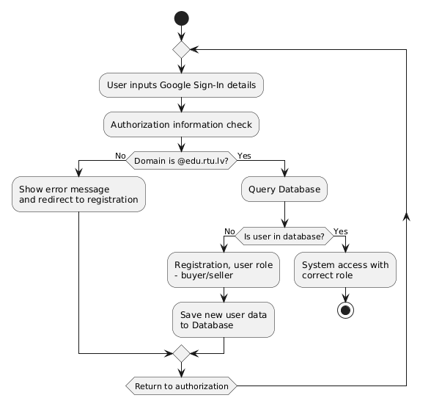
Figure 4. User registration/authorization activity diagram

9.2. System function activity diagram

Figure 5. Function activity diagram

9. System Requirements

10.1. Functional requirements
1. User Classification.
1.1. User – Seller.
1.2. User – Buyer.
2. User Access to the System.
2.1. User authorization – using Google Sign-In with university email verification (@edu.rtu.lv).
3. Functions Available to a Logged-In User.
3.1. Seller – adding new listings with images, descriptions, categories, and location via Google Maps.
3.2. Seller – editing or deleting own listings, marking as sold.
3.3. Buyer – browsing and filtering listings by category, price, and condition.
3.4. Buyer – searching for items using keywords.
3.5. Buyer and Seller – real-time chatting to negotiate or arrange meetup.
3.6. User profile management, viewing own listings.
3.7. All users – book/item overview. All items registered in the marketplace are displayed in a grid/table format with their availability status.
3.8. All users – single item overview. By selecting an item, its full information can be reviewed – title, desc, category, condition, price, and location.

10.2. Non-Functional Requirements.
1. Website Requirements.
1.1. System interface language – English.
1.2. Design – modern, mobile-first responsive design using Tailwind CSS.
1.3. Secure university-only access.
2. Process Requirements.
2.1. System development framework – Next.js with React and TypeScript.
2.2. Database implementation – Cloud Firestore (NoSQL).
2.3. Real-time updates for chat and listing status.
2.4. Hosted securely on Firebase Hosting.

