ECE 318 Lab 1

InLab Data

1.

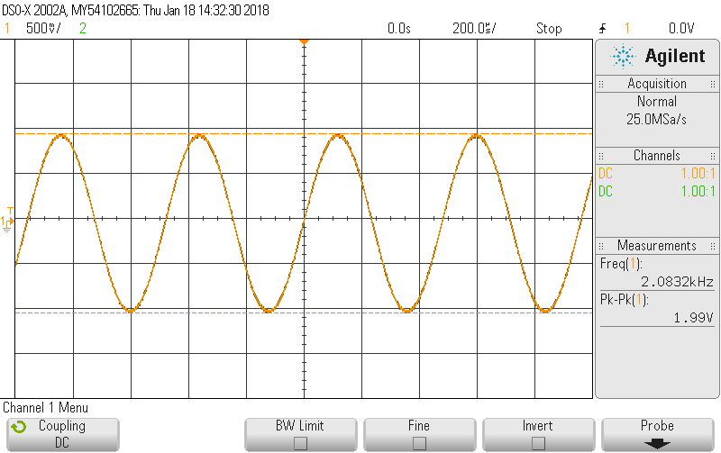

Figure 1b A single sinusoid in the time domain

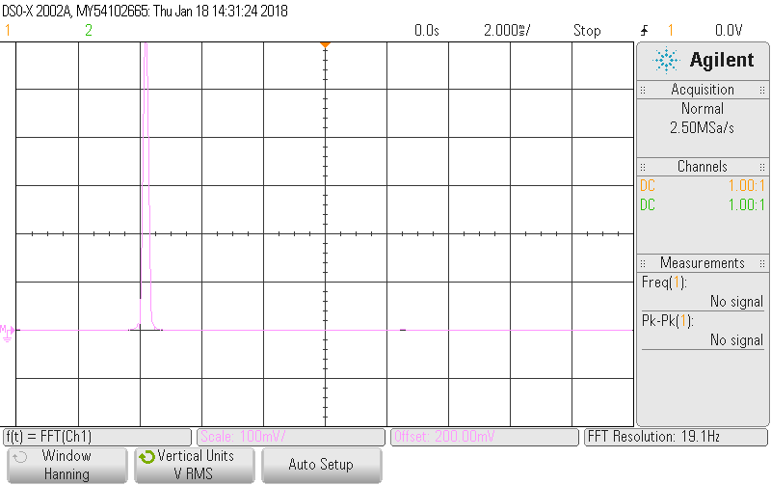

Figure 1c A single sinusoid in the frequency domain

2.

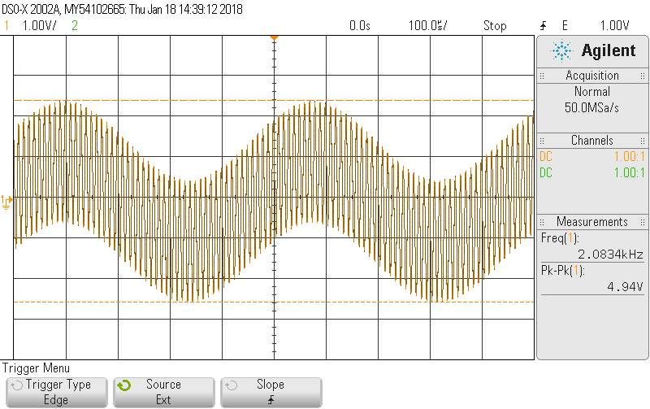

Figure 2b Sum of two sinusoids in the time domain

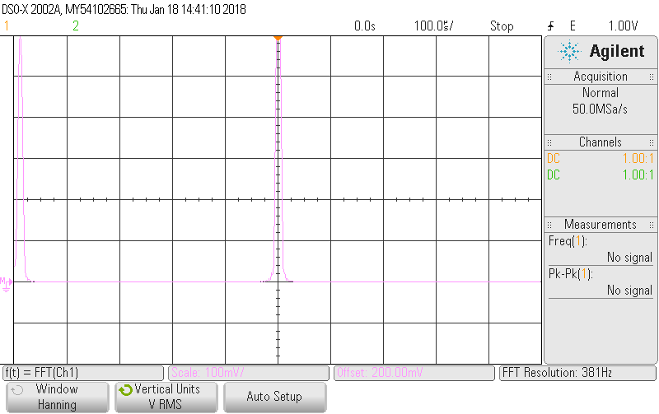

Figure 2c Sum of two sinusoids in the frequency domain

3.

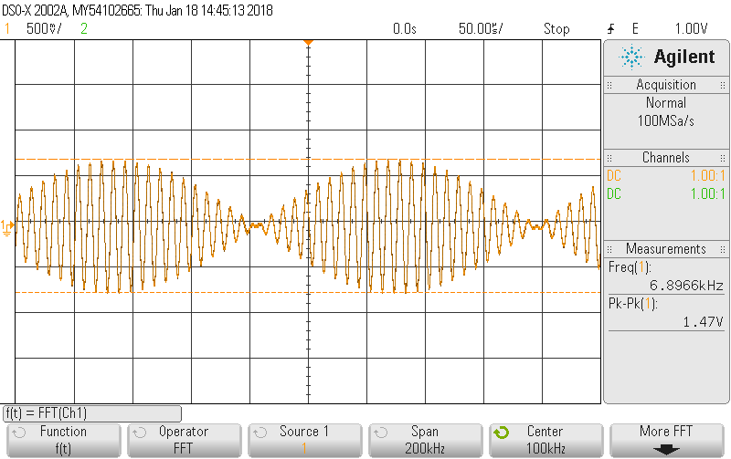

Figure 3b Product of two sinusoids in the time domain

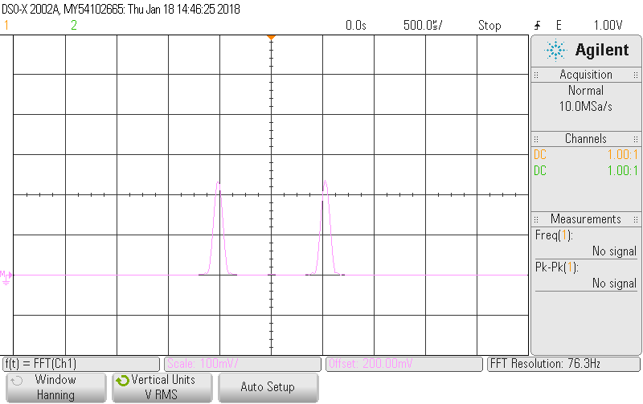

Figure 3c Product of two sinusoids in the frquency domain

4.

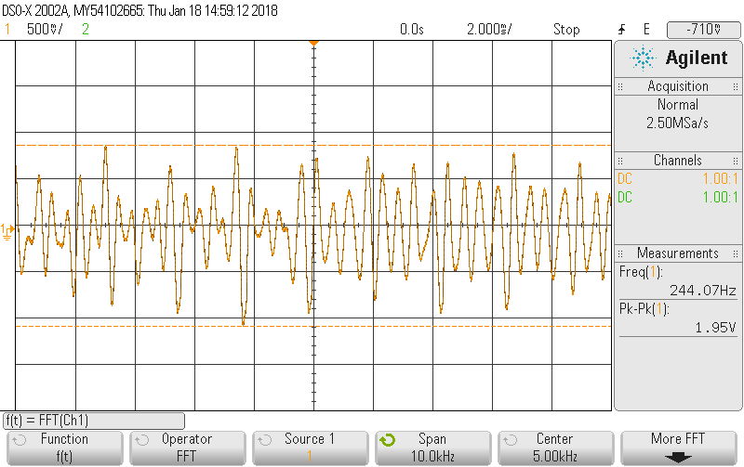

Figure 4b Speech in the time domain

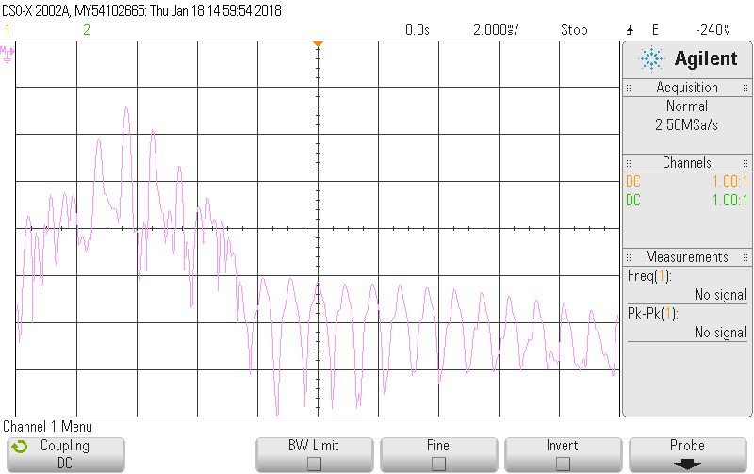

Figure 4c Speech in the frequency domain

By inspection, the 2kHz signal had more clean and neat displays in both time and frequency domain. The 2kHz sine wave signal was a regular signal that produced uniform waveform in time domain; However, the recording was more like a kind of noise that had different loudness and frequencies. Thus, the recording had irregular waveform in time domain. For the frequency domain, the sine wave was 2kHz, thus there was a spike noticed at the specific frequency. As said, the noise had different frequencies due to high and low tones of the voice. Thus, the frequency spikes were spread in the span.

5.

Table 1 VCO data

|  |  |  |  |
| --- | --- | --- | --- |
| Conditions | Adjust VCO | Frequency counter (Hz) | Vin measured  (Vdc = Vaverage) |
| Vin set to zero | fo | 9 k | 0 Vdc |
| Vin set to minimum | Gain(K) | 13 k | -2.5729 V |
| Vin set to maximum | fo&K no change | 5.160 k | 2.4774 V |

6.

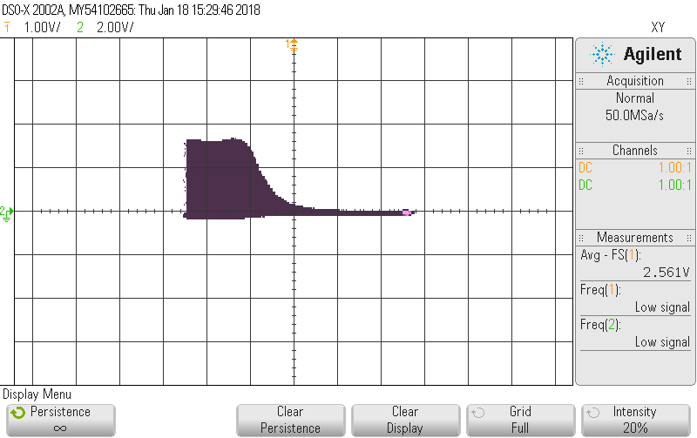

Figure 6b Oscilloscope X-Y display showing spectral analysis plot

Report:

$f\left(t\right)=A\cos\left(2πf_{0}t\right)= \frac{A}{2}(e^{j2πf_{0}t}+e^{-j2πf_{0}t})$

$$Fn= \frac{1}{T}\int_{0}^{T}{f\left(t\right)}e^{-jnω_{o}t}dt$$

Fourier series coefficient is $\frac{A}{2}$

Distinct frequencies are $2πf_{0}$ and $-2πf_{0}$

Description:

$f_{1}\left(t\right)=A_{1}\cos\left(2πf_{0}t\right)$

$$f_{2}\left(t\right)=A_{2}\cos\left(m2πf_{0}t\right)$$

$$f_{1}\left(t\right)+ f_{2}\left(t\right)= A_{1}\cos\left(2πf_{0}t\right)+A_{2}\cos\left(m2πf_{0}t\right) = \frac{A_{1}}{2}\left(e^{j2πf_{0}t}+e^{-j2πf_{0}t}\right)+ \frac{A_{2}}{2}(e^{jm2πf_{0}t}+e^{-jm2πf_{0}t})$$

Fourier series coefficients are $\frac{A_{1}}{2}$ and $\frac{A_{2}}{2}$

Distinct frequencies are $2πf_{0}$, $-2πf_{0}$, $2πmf_{0}$ and $-2πmf_{0}$

Description:

$f_{1}\left(t\right)* f_{2}\left(t\right)= A_{1}\cos\left(2πf_{0}t\right)*A_{2}\cos\left(m2πf_{0}t\right)$

$$= \frac{A_{1}A_{2}}{2}\left(e^{j2πf_{0}(m+1)t}+e^{j2πf_{0}t(m-1)}+e^{j2πf_{0}(1-m)t}+ e^{-j2πf_{0}(m+1)t}\right)$$

Fourier series coefficients = $\frac{A_{1}A_{2}}{2}$

Distinct frequency are $2πf_{0}(m+1)$, $2πf_{0}(m-1)$, $2πf_{0}(1- m)$, $-2πf_{0}(m+1)$

Description:

1. By inspection, the 2kHz signal had more clean and neat displays in both time and frequency domain. The 2kHz sine wave signal was a regular signal that produced uniform waveform in time domain; However, the recording was more like a kind of noise that had different loudness and frequencies. Thus, the recording had irregular waveform in time domain. For the frequency domain, the sine wave was 2kHz, thus there was a spike noticed at the specific frequency. As said, the noise had different frequencies due to high and low tones of the voice. Thus, the frequency spikes were spread in the span.
2. f = $f_{0}+{K*V}_{in}$, $V_{in}$ = -2.5729V (From in lab)

f = 9 k = $f_{0}$ + 0

$f_{0}$ = 9 k Hz

13 k = $9 k+{K*V}_{in}$

K = -1554.67 Hz/ V

Description:

1. Description:

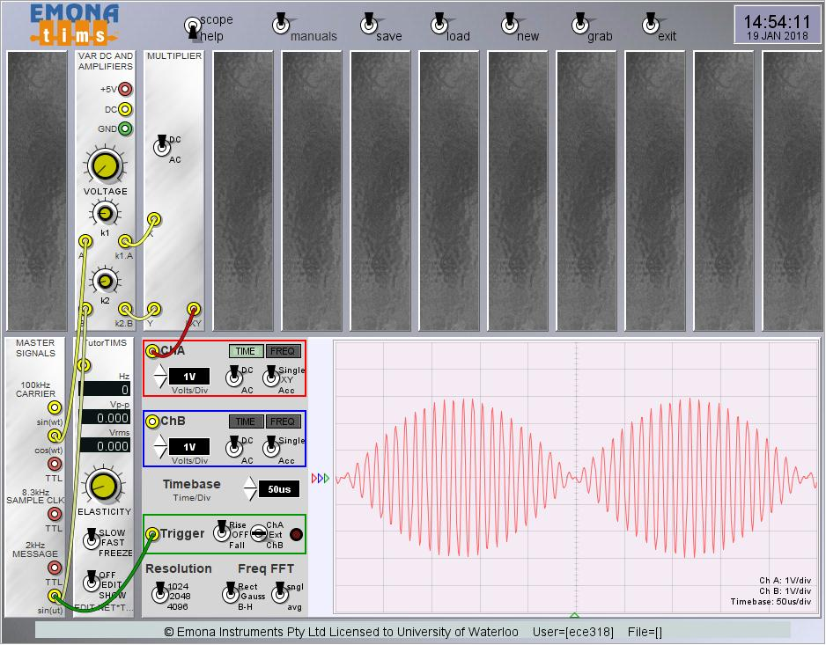

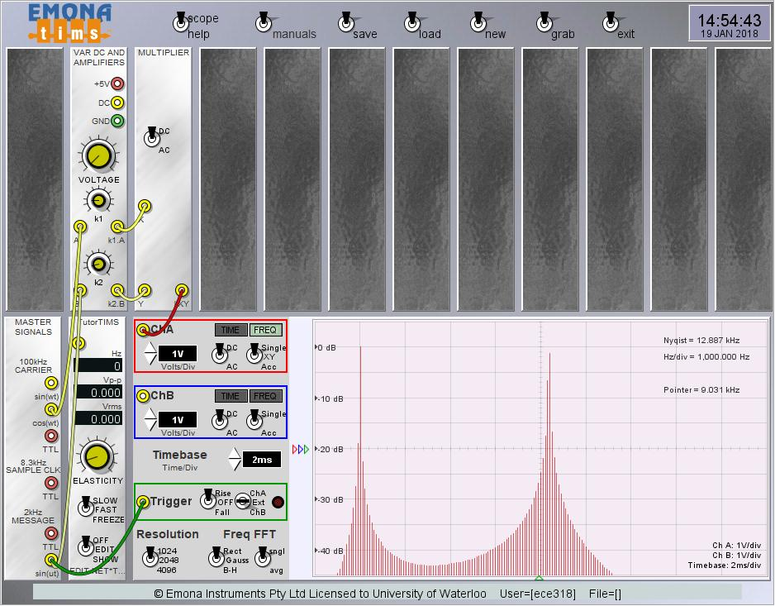

1. i) 911

ii) UW-police extension 22222 or 519-888-4911

Industry Canada’s Spectrum Management and Telecommunications Official Publications (www.ic.gc.ca/eic/site/smt-gst.nsf/eng/h_sf01841.html) and Health Canada's Safety Code 6 (SC6) guideline regarding RF exposure. (www.hc-sc.gc.ca/ewh-semt/pubs/radiation/radio_guide-lignes_direct-eng.php)