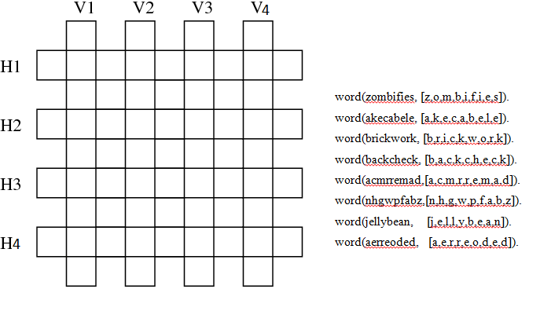

1. Input: 2-Output:

8 words:

------------------------------------------

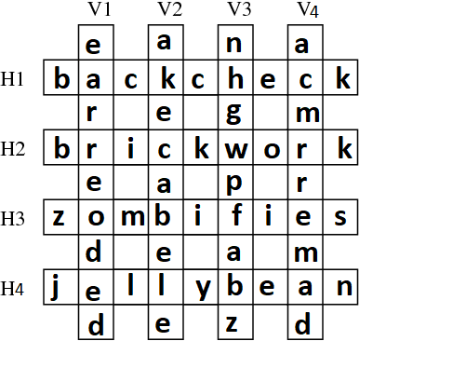word( [z,o,m,b,i,f,i,e,s]).

word( [a,k,e,c,a,b,e,l,e]).

word( [b,r,i,c,k,w,o,r,k]).

word( [b,a,c,k,c,h,e,c,k]).

word( [a,c,m,r,r,e,m,a,d]).

word([n,h,g,w,p,f,a,b,z]).

word([j,e,l,l,y,b,e,a,n]).

word([e,a,r,r,e,o,d,e,d]).