BINCOM ACADEMY
CYBER SECURITY CLASS
FINAL PRACTICAL TEST
FULL SECURITY SIMULATION
SIEM IMPLEMENTATION, WAF DEFENSE,
EVENT CORRELATION & INCIDENT-RESPONSE EVIDENCE REPORT

Prepared by: Oyewumi Yusuf Olayemi
Role: Cybersecurity Analyst
Email: Yusufvic98@gmail.com
Programme: BINCOM Academy Internship
Assessment: Final Practical Test – Full Security Simulation
Date: 23 September 2026
Environment: Authorized VirtualBox Host-Only cybersecurity laboratory
EVIDENCE-BASED REPORT — NO UNSUPPORTED PROCEDURES OR RESULTS

Important Project Classification
This document records the BINCOM Academy Final Practical Test – Full Security Simulation. It is not a continuation of the earlier BINCOM projects. Earlier assignments were used as preliminary learning, preparation, reference material and technical support for the final test, but the work documented here is treated as the final practical assessment itself.
The supplied BINCOM test document explicitly identifies this exercise as a “Final Practical Test – Full Security Simulation” and requires the student to build, attack, defend and monitor a small-scale enterprise environment. Its tasks include DVWA deployment, external-attack simulation using Nmap and Metasploit, ModSecurity/WAF defense, Security Onion/ELK monitoring and a comprehensive incident-response report. The listed deliverables include a network diagram, screenshots of attack and defense evidence, security logs/dashboards and the final incident-response report.
Classification | Correct interpretation for this report
Current project | BINCOM Academy Final Practical Test – Full Security Simulation
Purpose | Final practical assessment of build, attack, defend and monitor capability
Earlier BINCOM projects | Preliminary/reference material and technical preparation only
Current evidence | Evidence actually captured during the final-test work
Reporting rule | Only procedures/results supported by the captured evidence are stated as completed

Evidence Integrity Statement
This report deliberately separates three categories: (1) actions visibly demonstrated by the supplied screenshots, (2) configuration and technical context already documented in the supplied BINCOM material, and (3) interpretation of what the evidence demonstrates. No missing command output, event, vulnerability or successful attack has been invented to make the report appear more complete.

Executive Summary
The final practical test established an end-to-end defensive monitoring pipeline in the authorized laboratory. The final SIEM phase connected the protected DVWA application and ModSecurity WAF to Apache WAF logs, Filebeat 9.5.4, Elasticsearch 9.5.4 and Kibana Discover. The supplied screenshots document the actual configuration, troubleshooting, validation and event-investigation sequence.
The evidence shows that the WAF generated controlled security events for SQL Injection and XSS attempts, including HTTP 403 denial and the configured laboratory rule identifiers. Those events were written to the Apache WAF error log, collected by the dedicated Filebeat filestream input, indexed in Elasticsearch and subsequently displayed in Kibana.
The Filebeat configuration required troubleshooting. The screenshots show an initial YAML parsing failure, restoration from a known-good configuration, creation and independent testing of a dedicated WAF input, deployment under inputs.d, successful Filebeat configuration validation, successful Elasticsearch/TLS output testing and an active Filebeat service.
The final evidence is therefore not based solely on a final screenshot. It preserves the chronological technical trail from environment preparation through configuration, failure, recovery, ingestion and event correlation.

1. Official Final-Test Requirements
Requirement from supplied test | Evidence addressed in this report
Deploy a vulnerable web app (DVWA) | DVWA access and protected reverse-proxy evidence
Deploy a honeypot | Prior laboratory preparation evidence is retained only where directly visible; this report does not claim additional honeypot activity not evidenced here
Simulate external attacks using Nmap and Metasploit | Network/service discovery evidence is included where captured; this report does not invent Metasploit output
Configure ModSecurity WAF or firewall | Apache/ModSecurity, WAF listener and WAF-log evidence
Monitor using Security Onion / ELK Stack | Filebeat → Elasticsearch → Kibana evidence
Produce comprehensive incident-response report | This document
Network diagram | Laboratory topology is described; a screenshot-based evidence record is used where available
Attack/defense screenshots | Included throughout the evidence chain
Security logs and dashboards | Apache WAF logs, Elasticsearch searches and Kibana Discover evidence

2. Laboratory Environment and Scope
The final-test evidence shows Kali Linux as the security/SIEM workstation and Metasploitable2 as the intentionally vulnerable laboratory target. The prior report documents the Host-Only laboratory as 192.168.56.0/24, with Kali at 192.168.56.101 and Metasploitable2 at 192.168.56.103. Elasticsearch, Kibana and Filebeat were operated on the Kali environment.
Component | Role | Evidence-supported detail
Kali Linux | Security workstation / WAF / SIEM host | Screenshots show Kali terminal, services and Elastic components
Metasploitable2 | Authorized vulnerable target | Screenshot shows 192.168.56.103
DVWA | Vulnerable web application | Browser screenshot shows DVWA login/application page
Apache + ModSecurity | Protected reverse proxy / WAF | WAF listener and Apache log evidence
Filebeat 9.5.4 | Log collector | Service status, configuration and journal evidence
Elasticsearch 9.5.4 | Index/search backend | TLS output and index/data-stream evidence
Kibana | Investigation interface | Discover screenshots with BINCOM Filebeat Logs

3. Evidence Chain Used for the Final Test
- Laboratory network and host identity established.
- Target network address and DVWA availability verified.
- Apache/ModSecurity protection path verified.
- WAF access/error logs verified as the source telemetry.
- Filebeat configuration inspected and the dedicated WAF input created.
- Configuration errors were observed and corrected.
- The corrected WAF input was independently tested before deployment.
- The input was placed under /etc/filebeat/inputs.d/ and permissions were set.
- The final Filebeat configuration returned Config OK.
- Filebeat output testing validated the Elasticsearch HTTPS endpoint and TLS negotiation.
- Filebeat service status showed the collector active.
- Elasticsearch indices/data streams were inspected.
- Direct Elasticsearch searches returned the dvwa-waf events.
- Kibana Discover displayed the WAF events.
- SQL Injection and XSS events were opened and inspected as JSON documents.

4. Chronological Step-by-Step Evidence
The following section intentionally uses the screenshots supplied during the actual work. Each figure is tied to the specific visible action/output and is followed by a short statement of what that evidence establishes.

Step 1 — Identify the Kali laboratory host and network interfaces
The terminal evidence begins by identifying the Kali host and displaying its network interfaces. The visible output includes the Kali hostname and the 10.0.2.15 interface; the later Host-Only evidence establishes the 192.168.56.x laboratory network.
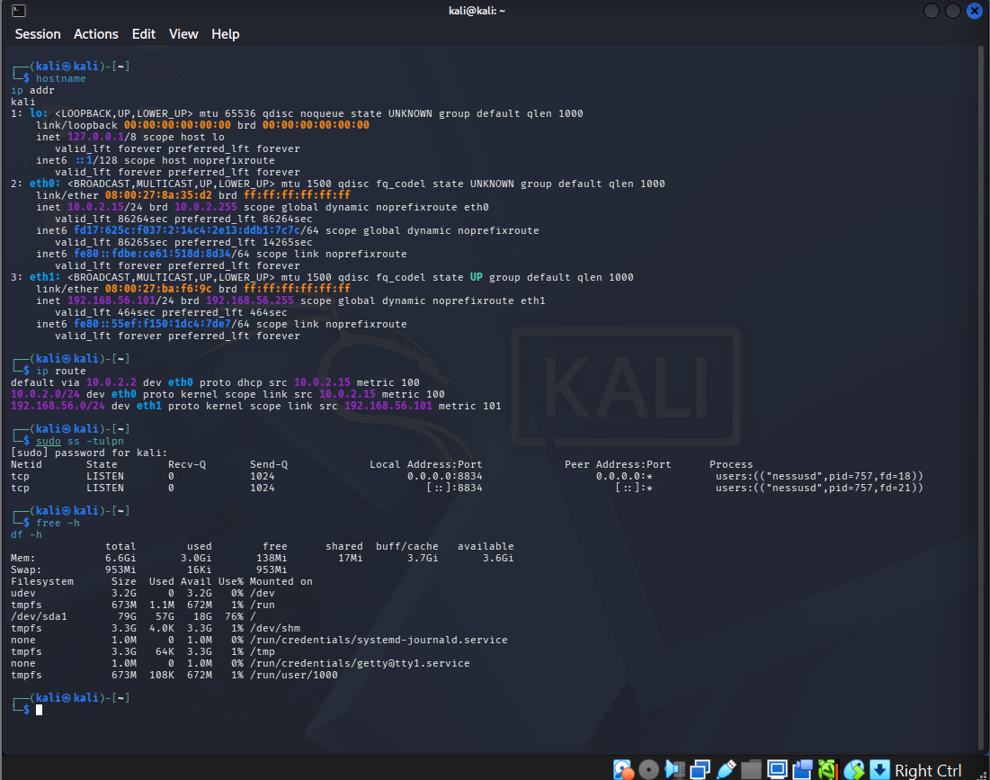
Figure 1. Identify the Kali laboratory host and network interfaces
The screenshot records the actual Kali host/network identification command and output.

Step 2 — Check the installed/running security services
The service-list evidence shows the Elastic/Filebeat-related services present in the Kali environment. This is an environment-readiness checkpoint before SIEM validation.
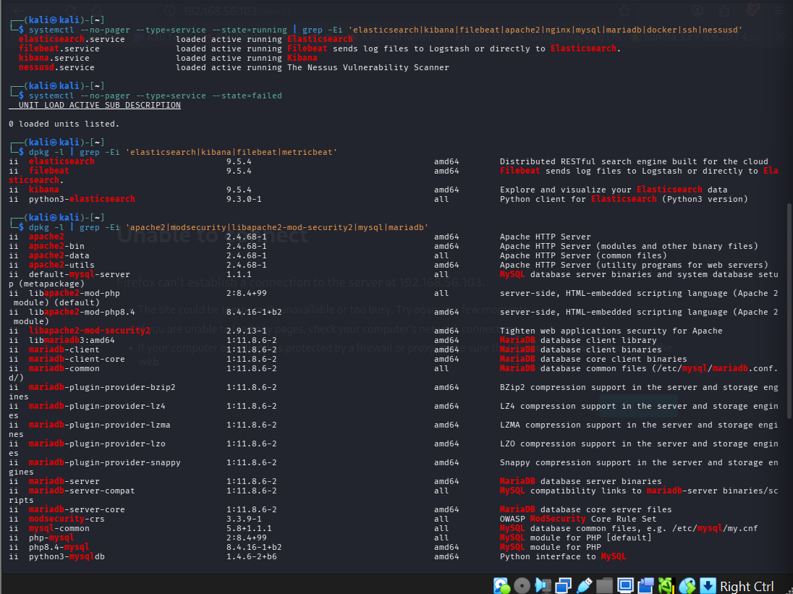
Figure 2. Check the installed/running security services
The screenshot shows the service inventory used to confirm the relevant security stack was present.

Step 3 — Verify ModSecurity/OWASP CRS and listening services
The terminal evidence shows ModSecurity CRS packages and listening sockets being inspected. This establishes that the WAF components were present before the later WAF-log and SIEM validation.
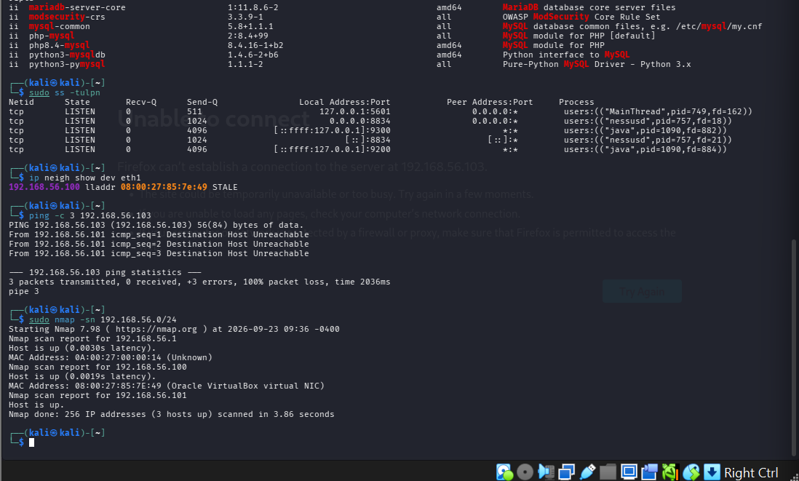
Figure 3. Verify ModSecurity/OWASP CRS and listening services
Visible package/service output includes modsecurity-crs and listening-service information.

Step 4 — Initial Elasticsearch certificate-path troubleshooting
The first direct curl attempt used /etc/elasticsearch/certs/http_ca.crt and returned an error stating that the supplied CA file did not exist. This is retained as evidence of the actual troubleshooting sequence rather than being omitted.
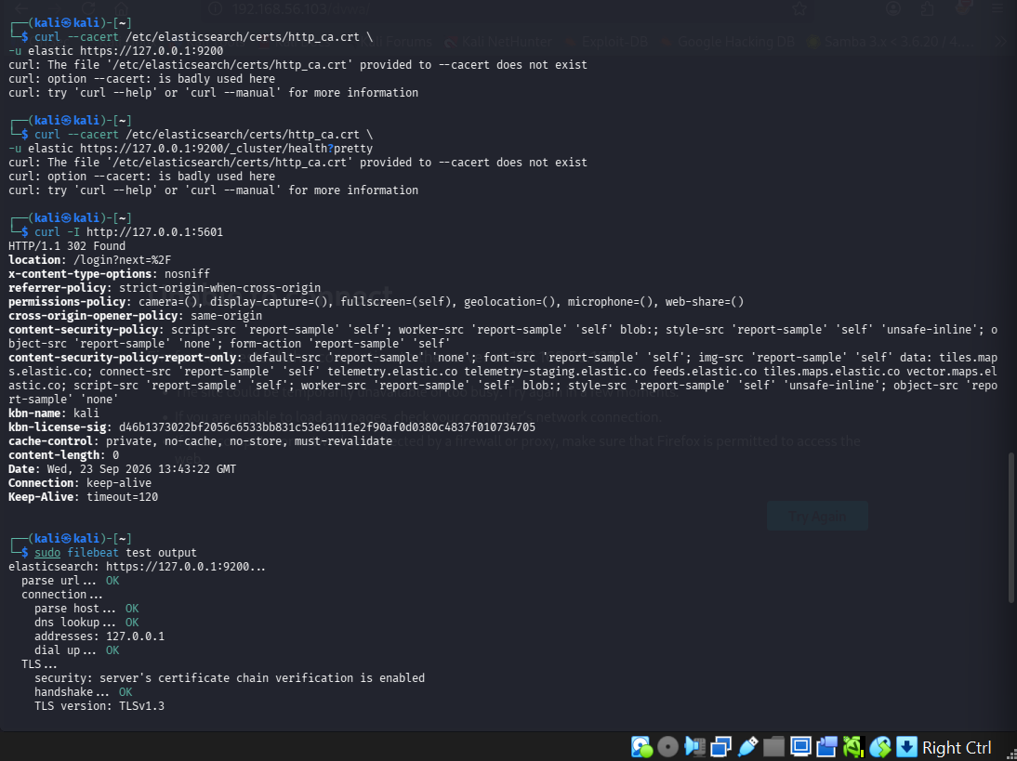
Figure 4. Initial Elasticsearch certificate-path troubleshooting
The screenshot visibly records the failed --cacert path and curl error.

Step 5 — Successful Elasticsearch connectivity/TLS validation
After the certificate-path issue was corrected, the Filebeat/Elasticsearch connectivity test showed successful URL parsing, host lookup, connection, certificate-chain verification, TLS handshake and server communication.
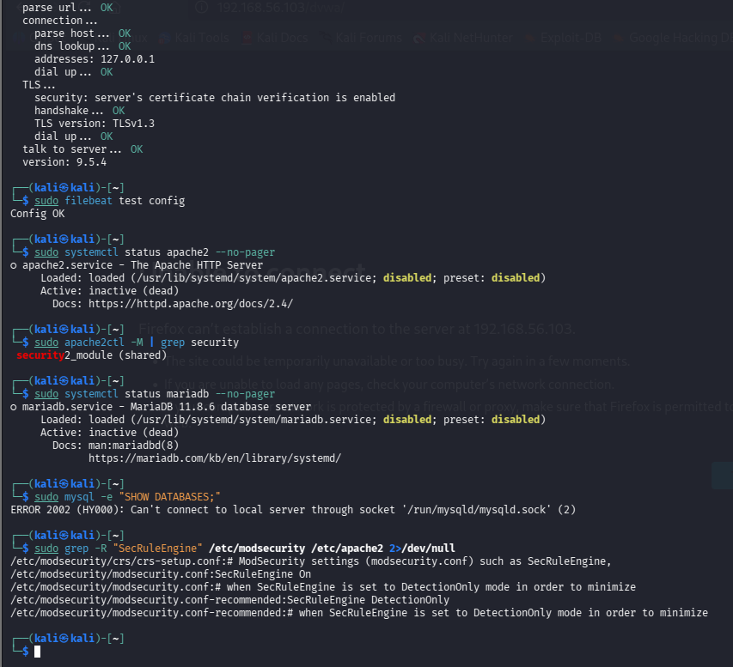
Figure 5. Successful Elasticsearch connectivity/TLS validation
The output explicitly shows OK states for URL parsing, connection, TLS verification and server communication.

Step 6 — Locate Elasticsearch certificate material
The certificate search evidence shows the locations of the Elasticsearch CA certificate and the copy used by the Kali user.
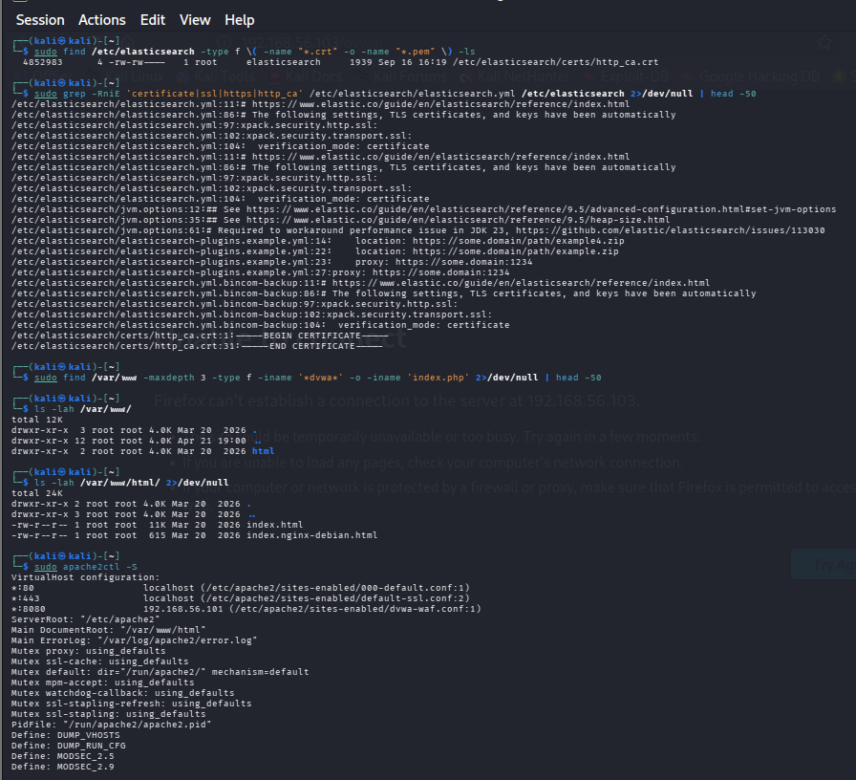
Figure 6. Locate Elasticsearch certificate material
The screenshot documents the certificate-location search performed during TLS troubleshooting.

Step 7 — Validate Apache configuration syntax
The Apache syntax-check evidence returned 'Syntax OK'. This was used to confirm that Apache configuration changes did not leave the web/WAF layer syntactically invalid.
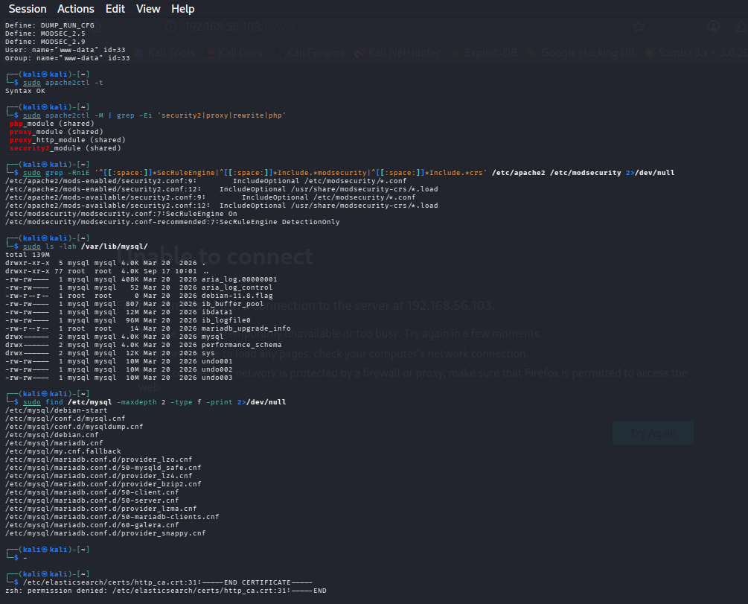
Figure 7. Validate Apache configuration syntax
The terminal visibly reports Apache configuration syntax as OK.

Step 8 — Confirm Host-Only networking for the laboratory
The VirtualBox network evidence shows the Host-Only Adapter configuration used for the controlled laboratory. This establishes the isolation context for the final test.
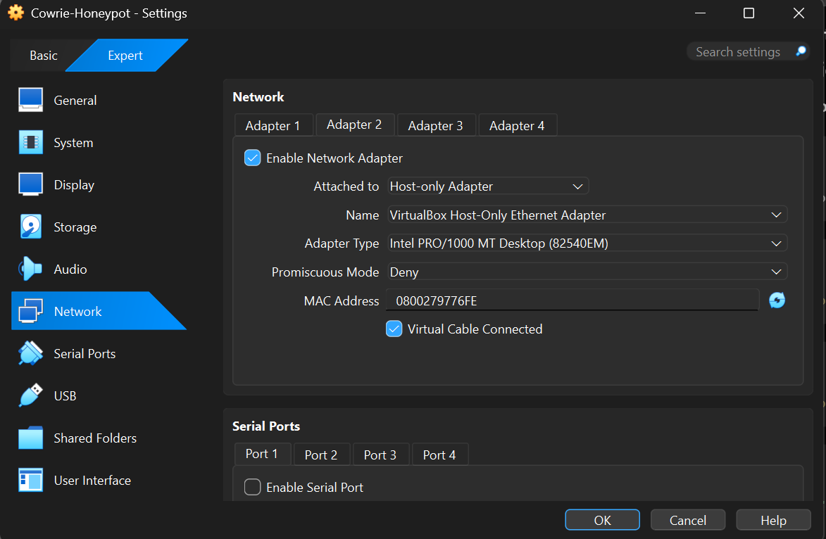
Figure 8. Confirm Host-Only networking for the laboratory
The VirtualBox settings visibly show the Host-only Adapter selected and the virtual cable connected.

Step 9 — Confirm Metasploitable2 laboratory address
The target-side terminal shows Metasploitable2 with eth0 configured as 192.168.56.103/24. This is the target address used in the subsequent DVWA connectivity evidence.
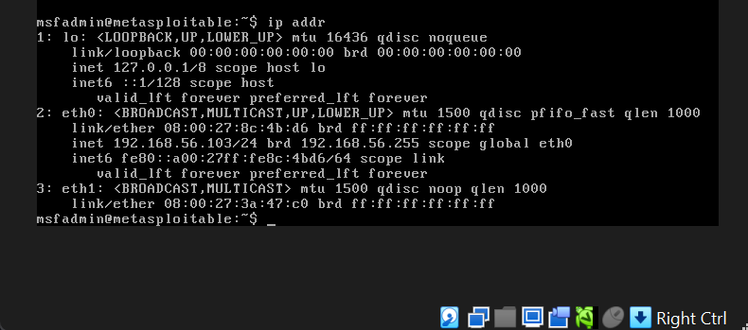
Figure 9. Confirm Metasploitable2 laboratory address
The target terminal visibly reports 192.168.56.103/24 on eth0.

Step 10 — Access the DVWA application
The browser evidence shows the Damn Vulnerable Web Application login page on the authorized target. This confirms that the vulnerable web application required by the final-test scenario was available.
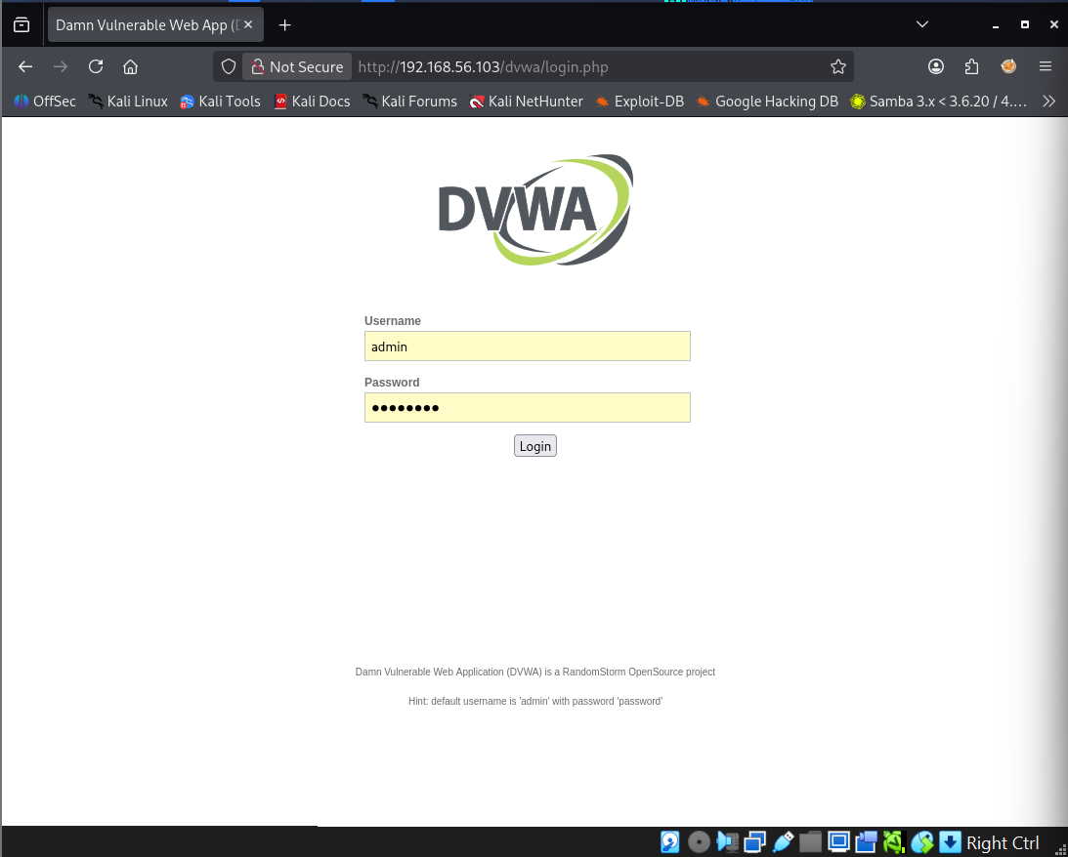
Figure 10. Access the DVWA application
The screenshot visibly shows the DVWA application interface.

Step 11 — Start and verify Apache
The terminal evidence shows an HTTP request to /dvwa/ followed by Apache being started and its service status checked. This established the web-service path used by the WAF.
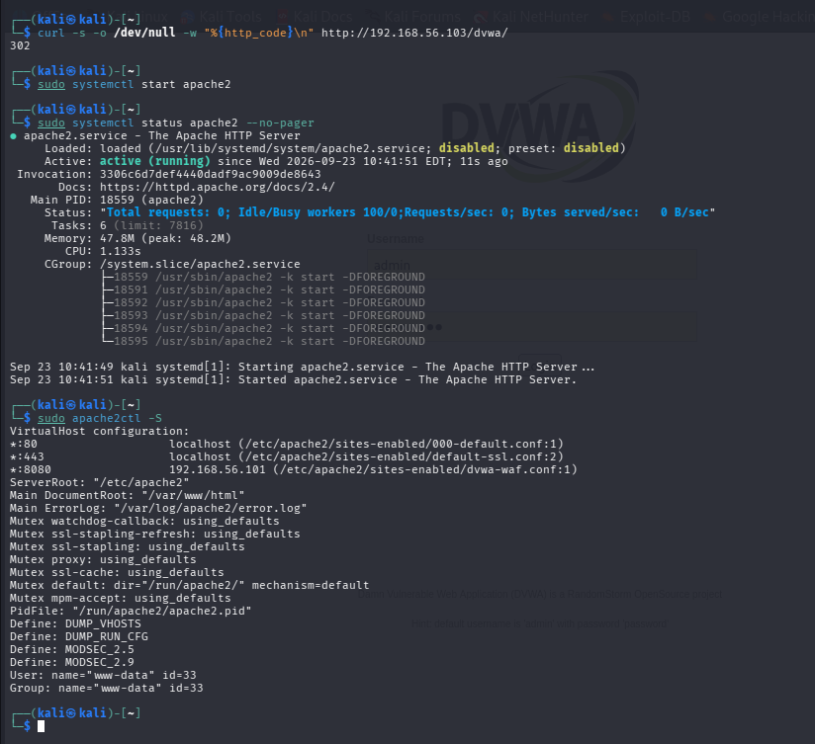
Figure 11. Start and verify Apache
The screenshot contains the HTTP status check and Apache service-start/status output.

Step 12 — Verify the protected WAF listener
The HTTP header check against 192.168.56.101:8080/dvwa/ returned HTTP/1.1 302 Found and identified Apache in the response. This demonstrates that the protected listener was responding.
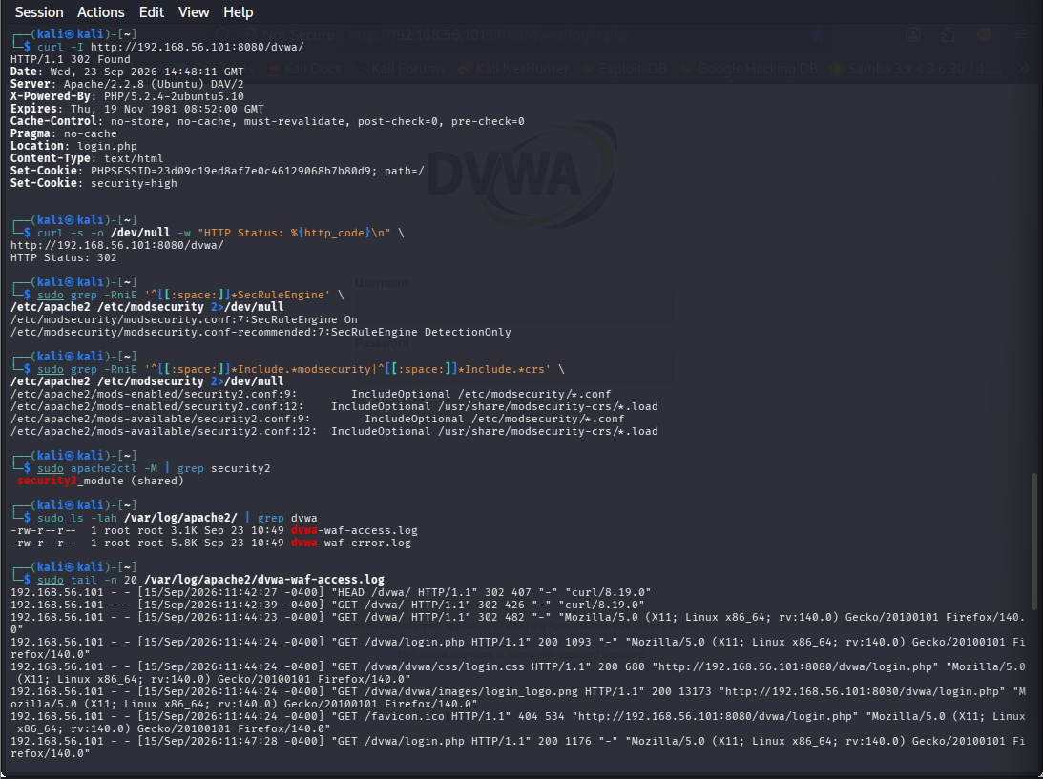
Figure 12. Verify the protected WAF listener
The terminal visibly shows the curl -I request to port 8080 and the 302 response.

Step 13 — Verify WAF log files and access telemetry
The WAF log evidence lists dvwa-waf-access.log and dvwa-waf-error.log and displays recent access entries. These files became the source logs for Filebeat collection.
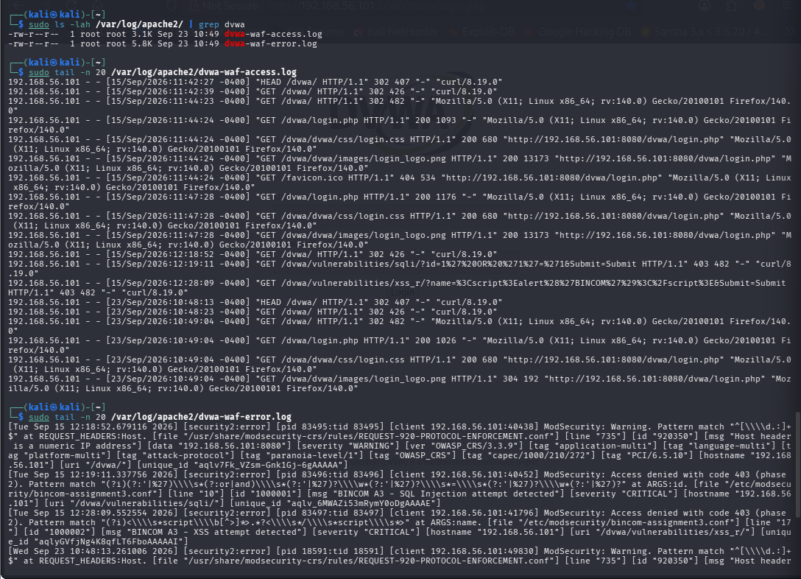
Figure 13. Verify WAF log files and access telemetry
The screenshot shows the WAF log files and tail output containing HTTP requests.

Step 14 — Review Filebeat modules
The Filebeat module inventory was inspected before creating the dedicated WAF filestream input. This is an actual configuration-discovery step captured in the terminal.
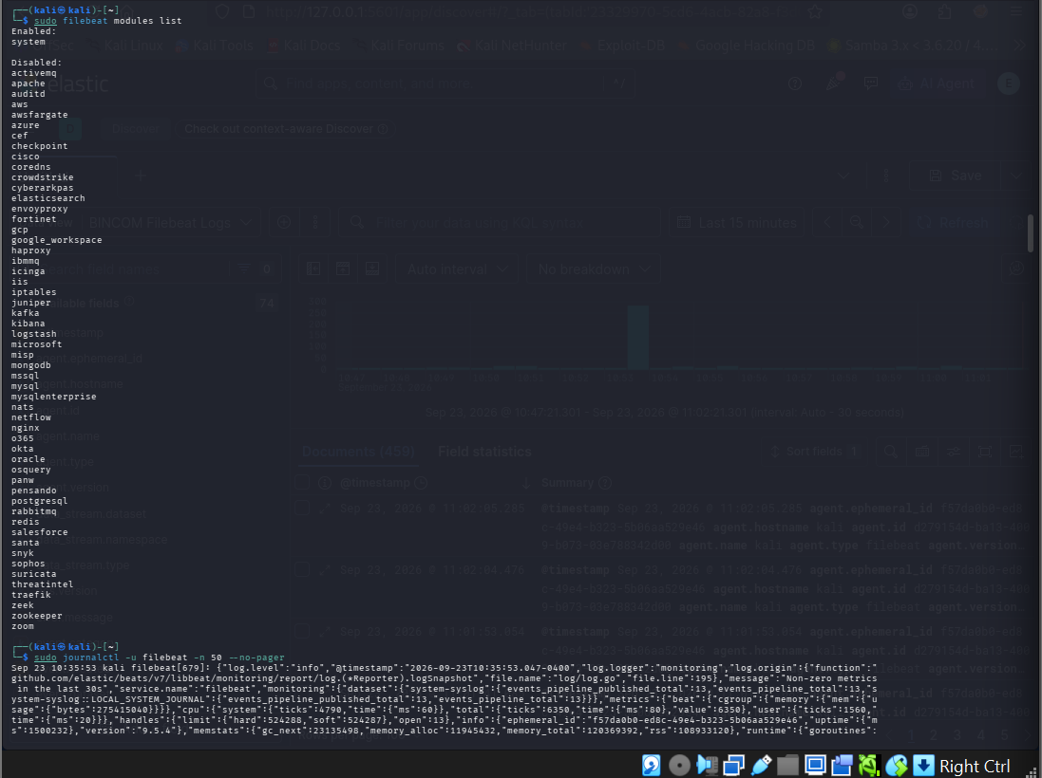
Figure 14. Review Filebeat modules
The terminal displays the Filebeat modules list.

Step 15 — Inspect Filebeat configuration directives
The configuration was inspected to locate filebeat.inputs, setup.kibana and output.elasticsearch sections. This was necessary before editing the collector configuration.
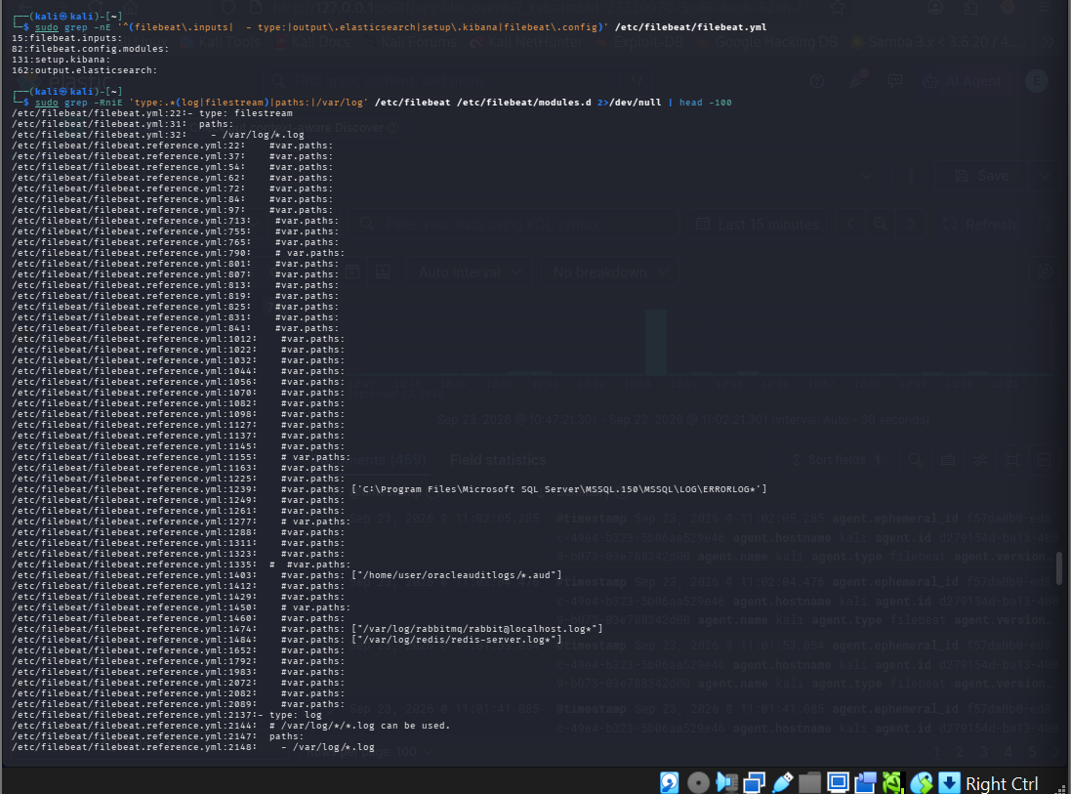
Figure 15. Inspect Filebeat configuration directives
The screenshot shows grep output locating the relevant Filebeat configuration sections.

Step 16 — Inspect the Filebeat reference configuration
The reference configuration was reviewed to understand the expected filestream input structure and supported fields before adding the WAF input.
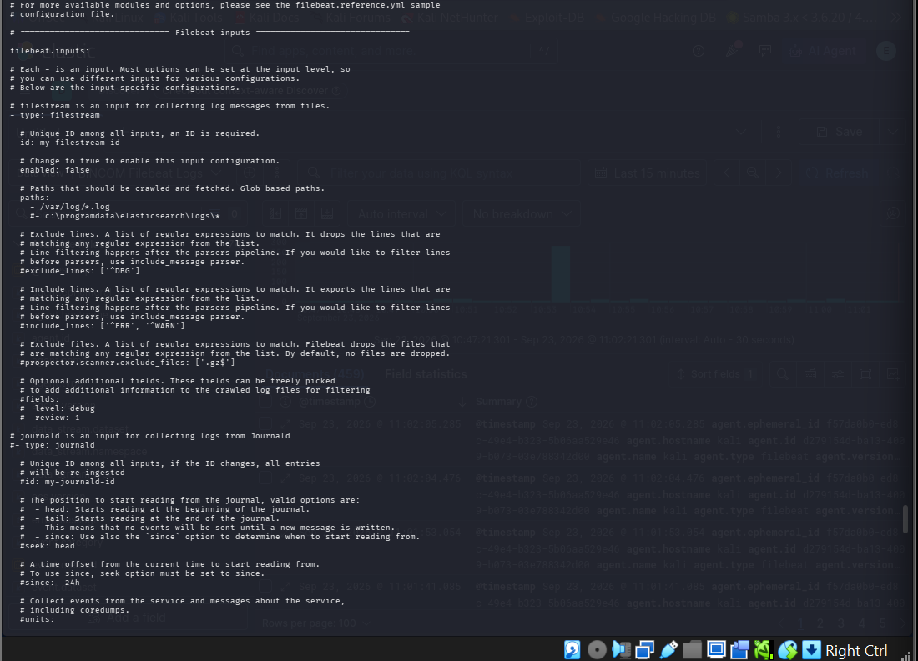
Figure 16. Inspect the Filebeat reference configuration
The screenshot visibly shows the Filebeat Configuration Example and filestream input documentation.

Step 17 — Inspect the Elasticsearch output section
The Filebeat configuration output section was inspected to verify the Elasticsearch output settings and certificate-related parameters.
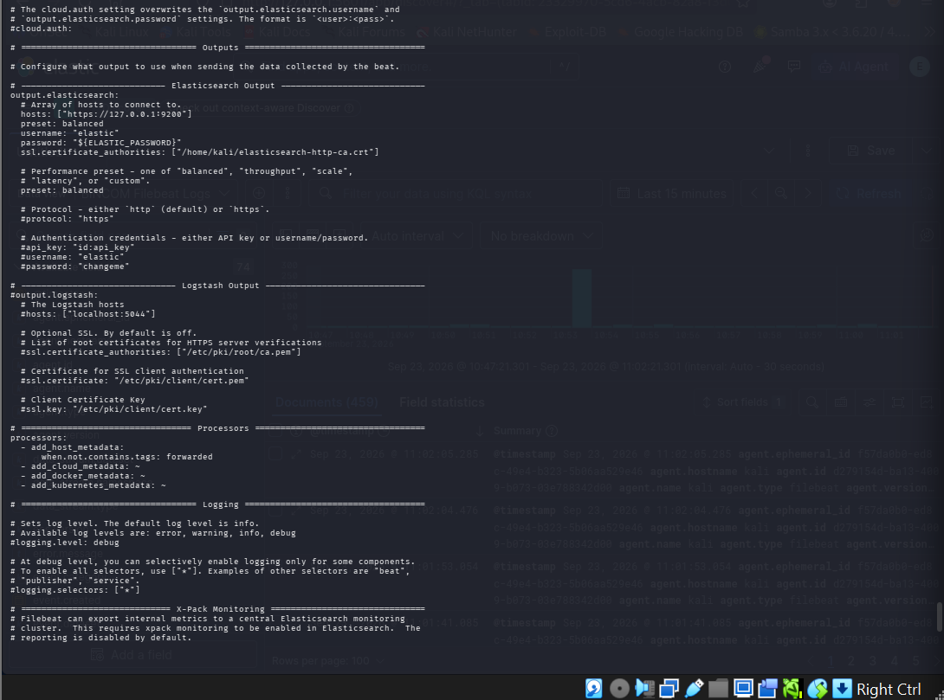
Figure 17. Inspect the Elasticsearch output section
The screenshot shows the output.elasticsearch section and certificate configuration area.

Step 18 — Confirm the existing ModSecurity/WAF error events
The Apache WAF error log was counted and tailed. The visible entries include ModSecurity security2:error records, establishing that security events were already being generated at the WAF layer.
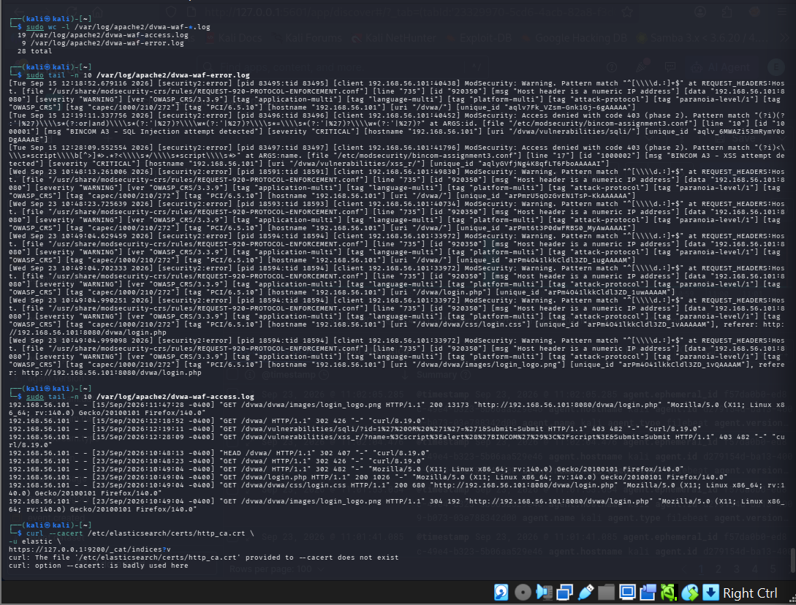
Figure 18. Confirm the existing ModSecurity/WAF error events
The screenshot shows dvwa-waf log counts and ModSecurity error-log entries.

Step 19 — Confirm the usable Elasticsearch CA copy
The terminal evidence confirms the CA certificate was copied to /home/kali/elasticsearch-http-ca.crt and that the file existed with the expected ownership/permissions shown.
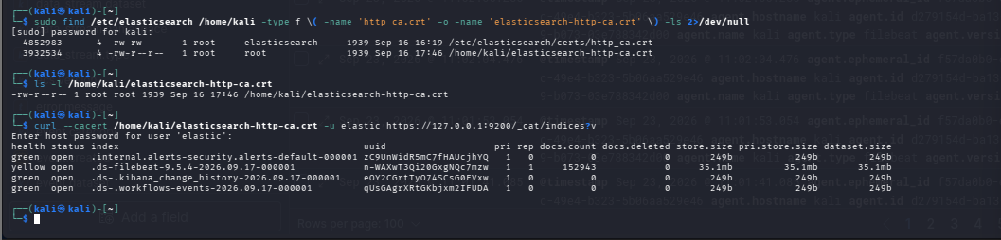
Figure 19. Confirm the usable Elasticsearch CA copy
The screenshot visibly shows the certificate files under /etc/elasticsearch and /home/kali.

Step 20 — Create a pre-WAF Filebeat backup
Before modifying the collector configuration, a backup named filebeat.yml.bincom-pre-waf was created. Additional earlier backups are visible in the same evidence.
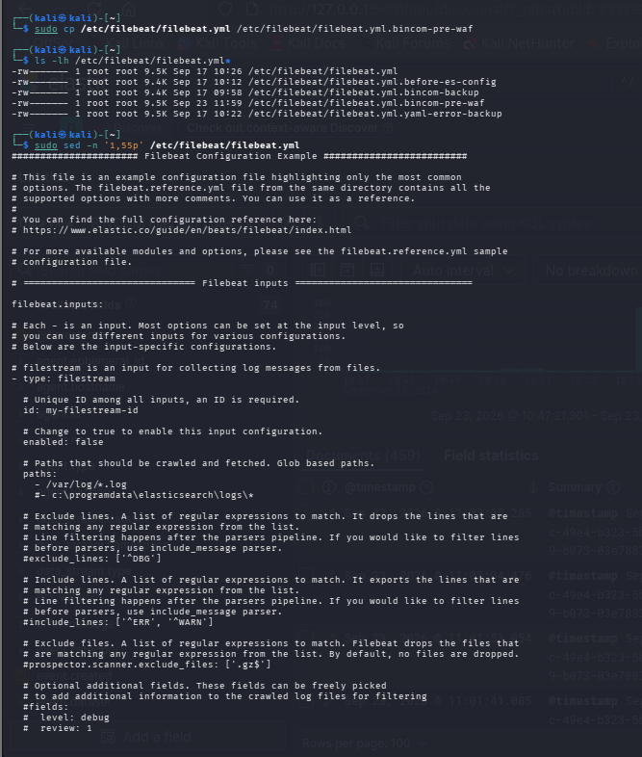
Figure 20. Create a pre-WAF Filebeat backup
The screenshot lists the Filebeat backup copies, including filebeat.yml.bincom-pre-waf.

Step 21 — Inspect the Filebeat input area before editing
The Filebeat configuration was opened/inspected around the filebeat.inputs area to determine where the WAF input would be introduced.
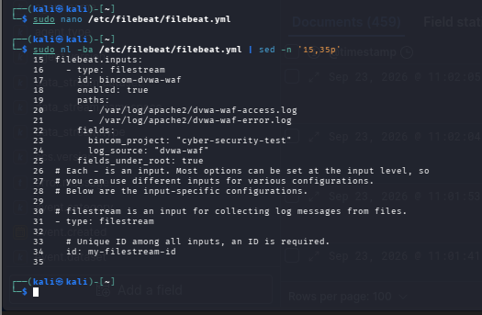
Figure 21. Inspect the Filebeat input area before editing
The screenshot shows the filebeat.inputs area and the intended bincom-dvwa-waf block.

Step 22 — Restore and validate the known-good Filebeat configuration
A clean configuration was restored from the pre-WAF backup and filebeat test config returned Config OK. This is an important recovery checkpoint in the troubleshooting history.
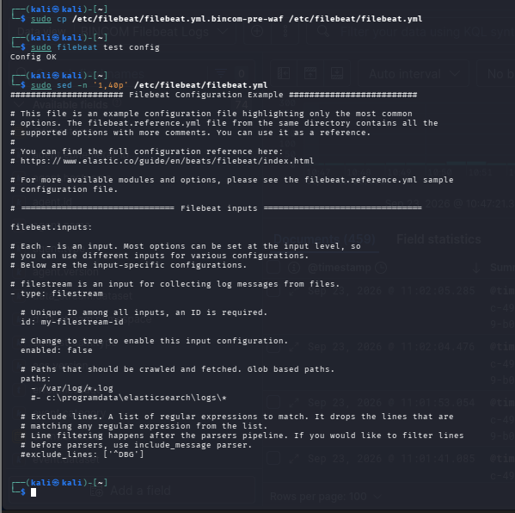
Figure 22. Restore and validate the known-good Filebeat configuration
The screenshot visibly shows the restore operation followed by 'Config OK'.

Step 23 — Use a controlled programmatic insertion attempt
A Python-based text-editing attempt was used to insert the WAF block into filebeat.yml. The subsequent screenshots document the resulting validation issue; this step is retained to show the actual troubleshooting path.
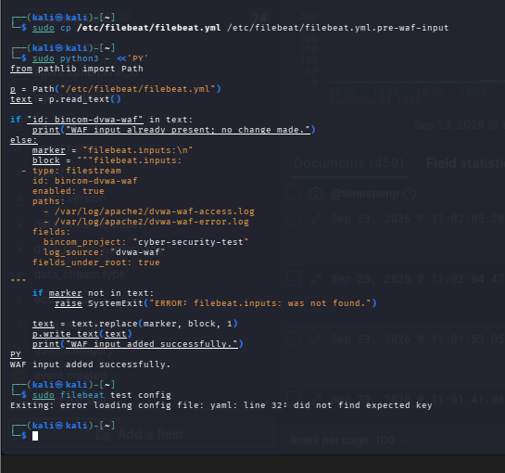
Figure 23. Use a controlled programmatic insertion attempt
The screenshot shows the Python text-editing procedure applied to filebeat.yml.

Step 24 — Re-establish the backup and inspect the resulting configuration
The known-good pre-WAF configuration was again restored and the relevant portion of filebeat.yml was inspected. This was part of isolating the YAML problem before deployment.
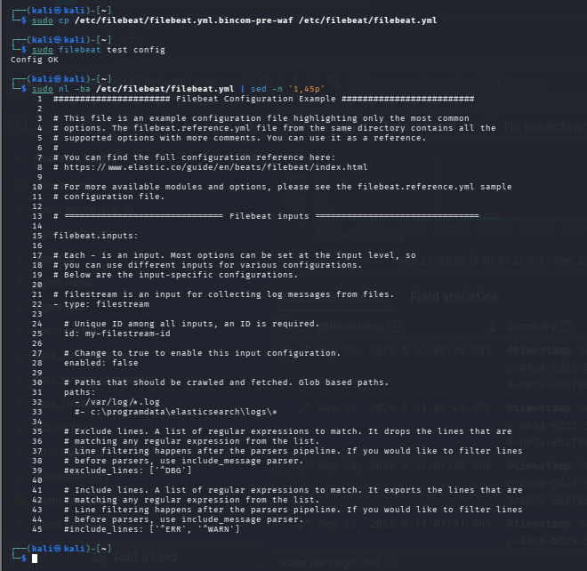
Figure 24. Re-establish the backup and inspect the resulting configuration
The screenshot shows restoration of the pre-WAF file and subsequent configuration inspection.

Step 25 — Insert the dedicated WAF filestream input
The WAF input was inserted with type filestream, id bincom-dvwa-waf, paths for dvwa-waf-access.log and dvwa-waf-error.log, and root-level bincom_project/log_source fields.
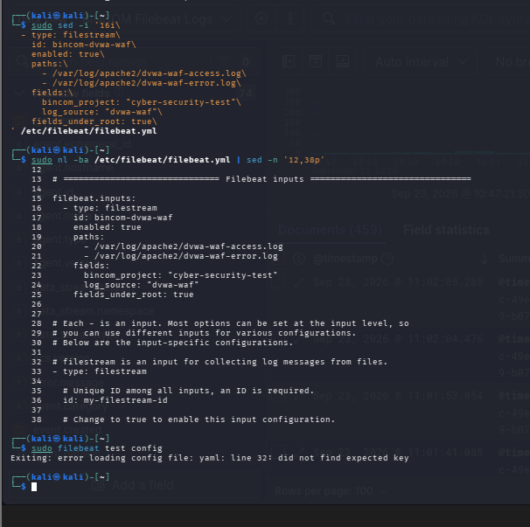
Figure 25. Insert the dedicated WAF filestream input
The screenshot visibly contains the WAF input fields and both Apache WAF log paths.

Step 26 — Capture and diagnose the YAML parsing failure
The modified main configuration produced a YAML error. The terminal evidence reports 'yaml: line 32: did not find expected key'. This failure is explicitly documented rather than hidden.
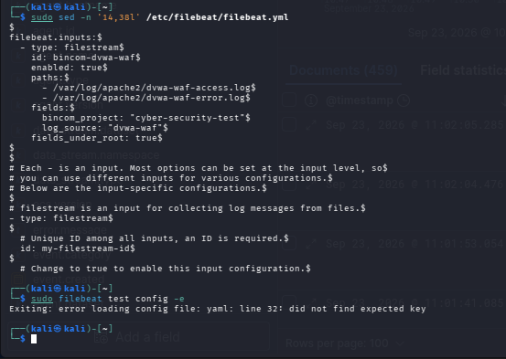
Figure 26. Capture and diagnose the YAML parsing failure
The screenshot records the malformed configuration state and YAML parsing error.

Step 27 — Create a minimal independent WAF configuration for testing
A minimal /tmp/bincom-waf-test.yml was created containing only the dedicated WAF filestream input and an output_console section. This isolated the WAF input from the larger configuration.
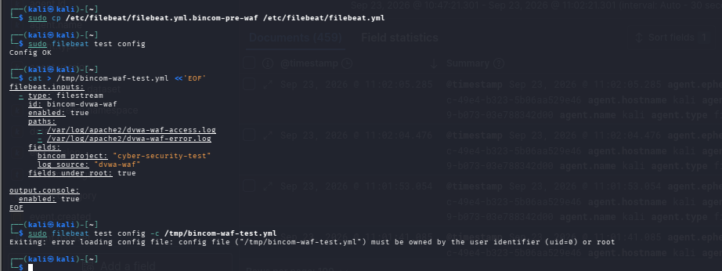
Figure 27. Create a minimal independent WAF configuration for testing
The screenshot shows creation of the temporary test configuration and the test command.

Step 28 — Validate the isolated WAF configuration
The temporary WAF configuration was copied with controlled ownership/permissions and validated with filebeat test config -c. The output returned Config OK.
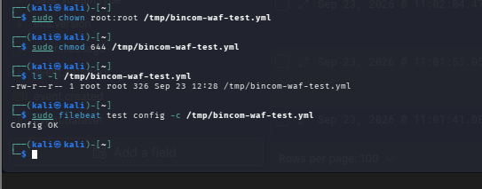
Figure 28. Validate the isolated WAF configuration
The screenshot clearly shows the temporary file ownership/permissions and 'Config OK'.

Step 29 — Deploy the validated WAF input under inputs.d
The /etc/filebeat/inputs.d directory was created, the validated WAF input copied into it, ownership set to root:root and permissions set to 644.
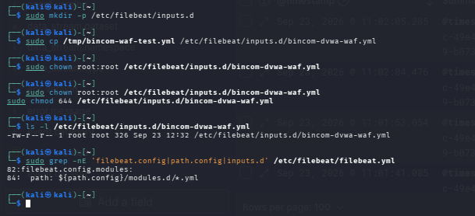
Figure 29. Deploy the validated WAF input under inputs.d
The screenshot documents creation, copy, chown and chmod operations for the final modular input.

Step 30 — Inspect the final modular WAF input
The deployed input was opened and reviewed. It contains the two WAF log paths and the bincom_project/log_source metadata used for later Kibana filtering.
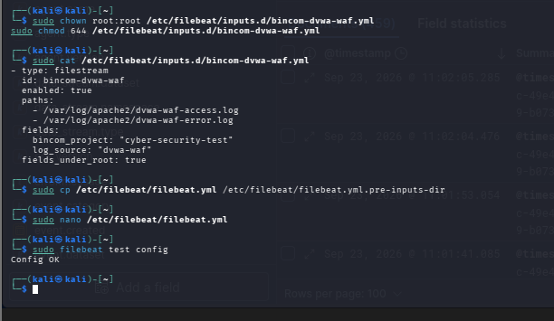
Figure 30. Inspect the final modular WAF input
The screenshot shows the final /etc/filebeat/inputs.d/bincom-dvwa-waf.yml contents.

Step 31 — Validate Filebeat output to Elasticsearch
The final Filebeat output test connected to https://127.0.0.1:9200 and reported successful parsing, DNS/host lookup, connection, certificate-chain verification, TLS handshake, TLSv1.3 and server communication.
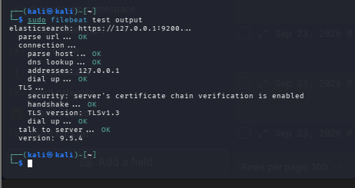
Figure 31. Validate Filebeat output to Elasticsearch
The screenshot records the successful Elasticsearch/TLS output validation.

Step 32 — Verify the Filebeat service is active
The systemctl status evidence shows the Filebeat service loaded and running. The accompanying journal output shows Filebeat startup and component activity.
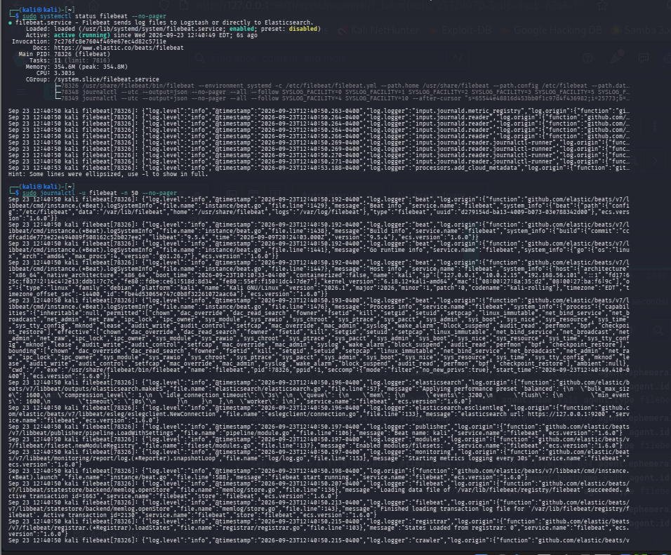
Figure 32. Verify the Filebeat service is active
The screenshot visibly reports the Filebeat service as active/running and includes journal messages.

Step 33 — Inspect Filebeat runtime configuration and journal activity
The exported configuration and journal/monitoring output were inspected after startup to verify that the intended WAF input existed in the active configuration and that Filebeat was producing runtime telemetry.
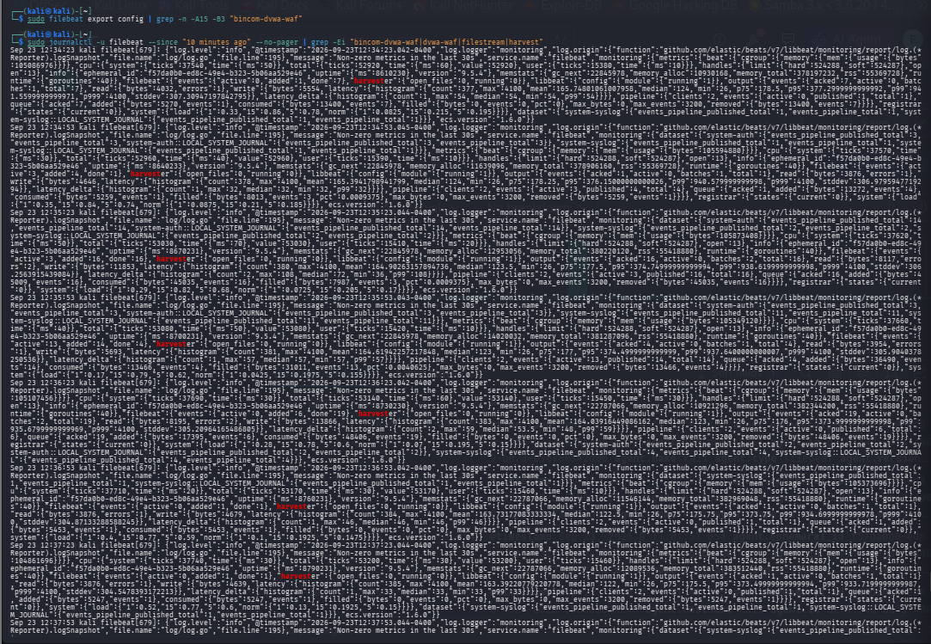
Figure 33. Inspect Filebeat runtime configuration and journal activity
The screenshot shows the Filebeat export/configuration inspection and journal output.

Step 34 — Attempt an Elasticsearch search against the wrong concrete backing index
A direct search was initially made against a concrete .ds-filebeat index name that did not exist in that form. The resulting 'no such index' response is retained as a real search troubleshooting event.
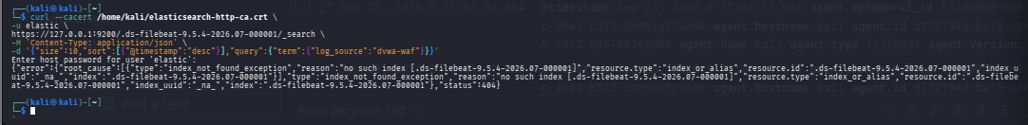
Figure 34. Attempt an Elasticsearch search against the wrong concrete backing index
The screenshot records the no-such-index response from the first direct Elasticsearch search.

Step 35 — Inspect Elasticsearch data streams
The Elasticsearch _data_stream output was queried to identify the active data streams and their backing indices. This provided the correct backend naming information for subsequent searches.
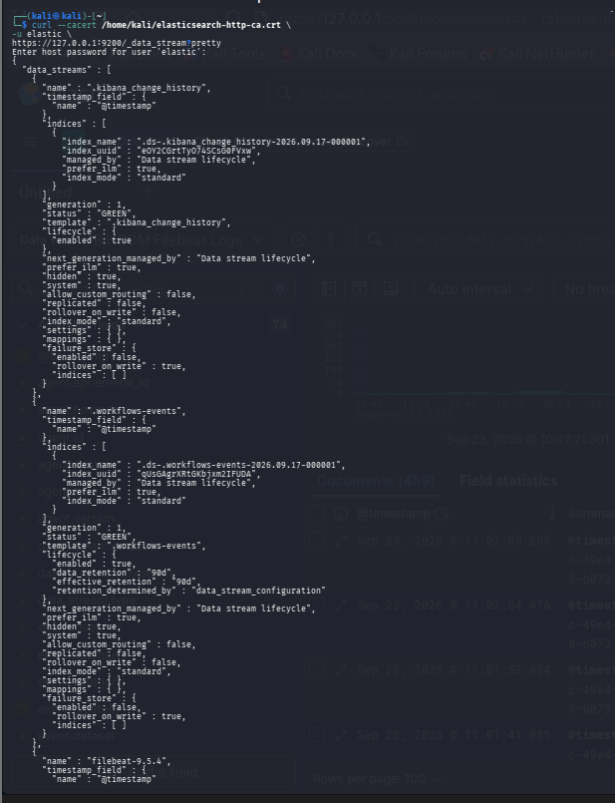
Figure 35. Inspect Elasticsearch data streams
The screenshot shows the data_stream response and active Filebeat-related data stream information.

Step 36 — Inspect Elasticsearch indices
The _cat/indices output was queried to list the active indices. This confirmed the Filebeat data stream/backing index that should be used for investigation.
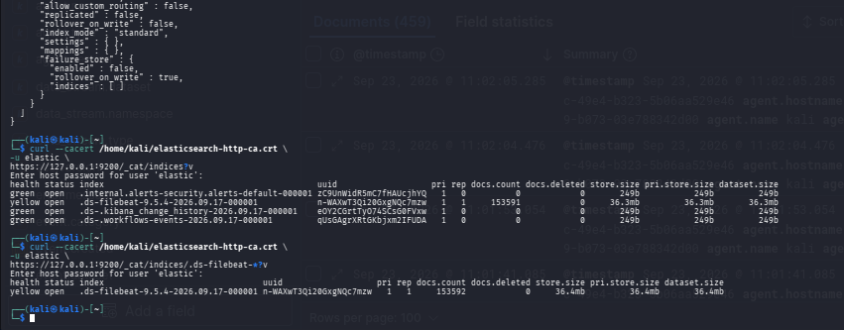
Figure 36. Inspect Elasticsearch indices
The screenshot shows the Elasticsearch index listing command and response.

Step 37 — Search the Filebeat index for WAF metadata
A direct Elasticsearch search was then performed against the Filebeat index using JSON query parameters. The search was refined around the log_source and file-path metadata generated by the dedicated WAF input.
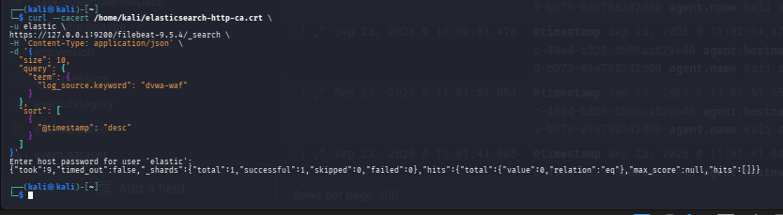
Figure 37. Search the Filebeat index for WAF metadata
The screenshot shows the authenticated Elasticsearch search request and response.

Step 38 — Search WAF access/error log paths and project metadata
The search was further refined to locate events whose log.file.path matched dvwa-waf-access.log or dvwa-waf-error.log. This returned WAF records containing the configured project/source metadata.
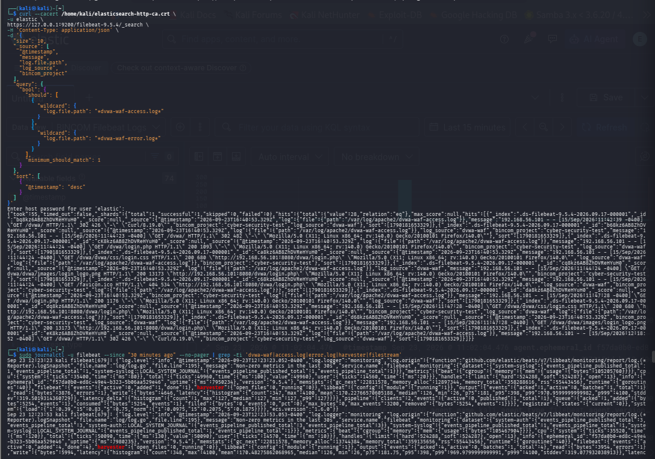
Figure 38. Search WAF access/error log paths and project metadata
The screenshot shows the wildcard search criteria for the two WAF log paths.

Step 39 — Confirm the WAF event search result in Elasticsearch
The returned documents contain the WAF event data and the Filebeat/host metadata needed for correlation. This is the backend confirmation before using Kibana for visual investigation.
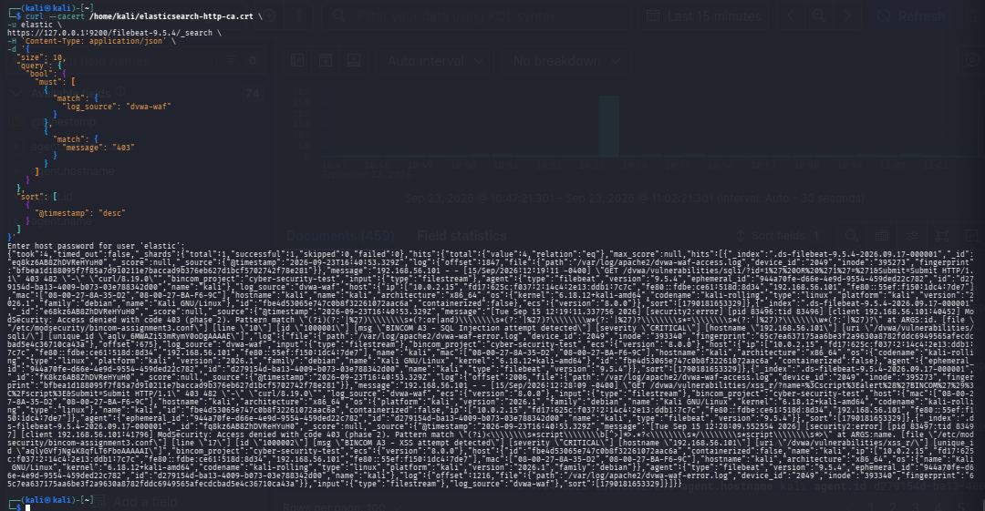
Figure 39. Confirm the WAF event search result in Elasticsearch
The screenshot presents confirmed indexed WAF events in the Elasticsearch search output.

Step 40 — Open the Kibana Discover data view
Kibana Discover was opened with the BINCOM Filebeat Logs data view. The visible query uses log_source:"dvwa-waf" and the interface shows the returned WAF documents.
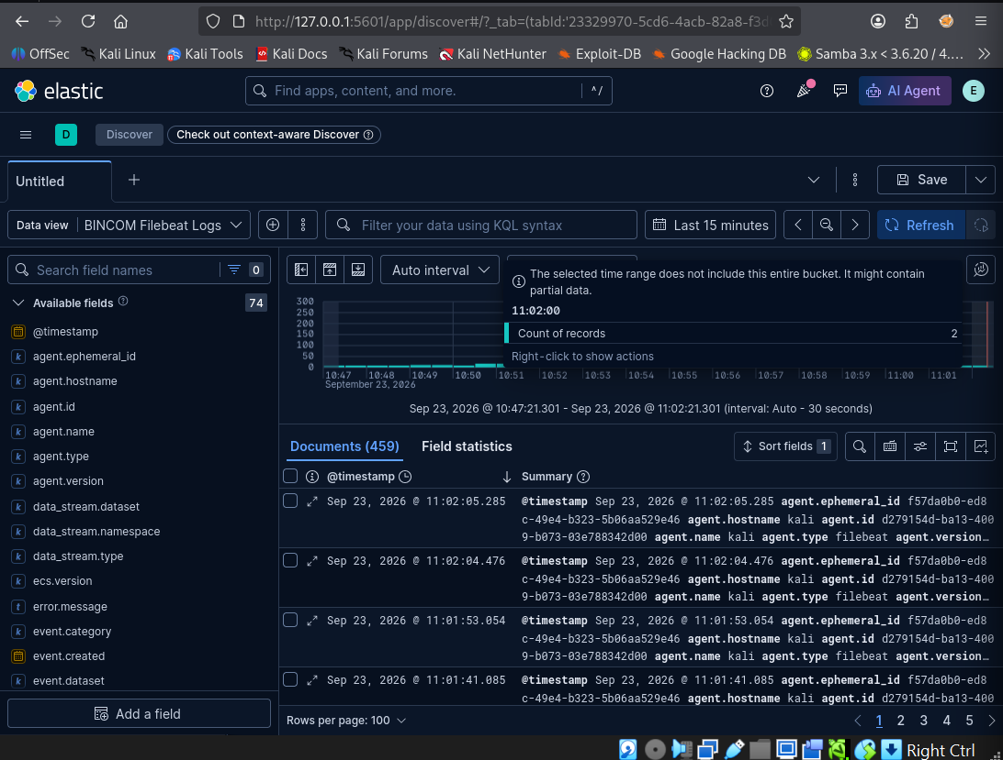
Figure 40. Open the Kibana Discover data view
The screenshot visibly shows Kibana Discover, the BINCOM Filebeat Logs data view and the dvwa-waf filter.

Step 41 — Inspect a collected WAF document
The first detailed Kibana document view exposes the indexed record, including the original log file path, timestamp and message. This demonstrates that the SIEM retained the source-log context.
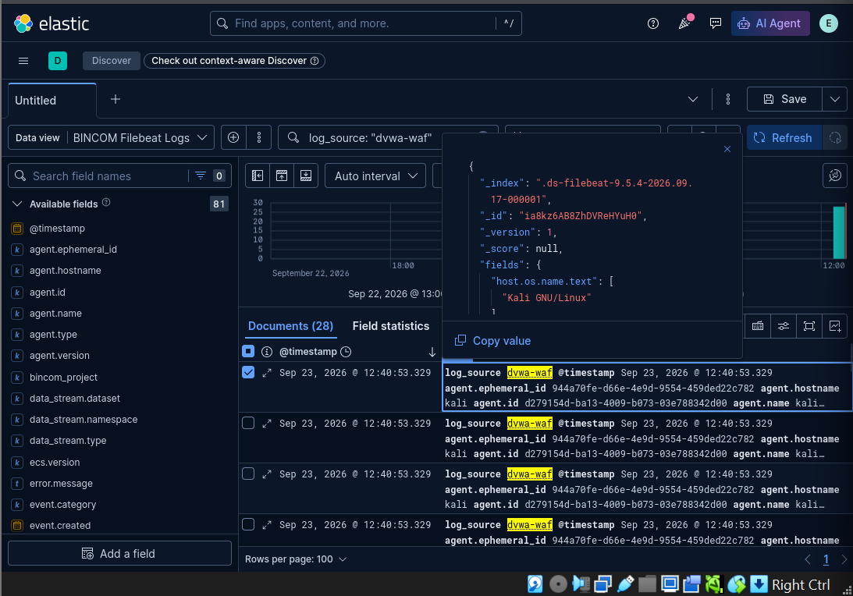
Figure 41. Inspect a collected WAF document
The screenshot shows the Kibana JSON document view and indexed WAF fields.

Step 42 — Inspect the controlled SQL Injection event
The SQL Injection event was opened as a Kibana document. The visible evidence identifies the ModSecurity access denial with HTTP 403, the laboratory rule ID 1000001, the CRITICAL severity and the 'BINCOM A3 - SQL Injection attempt detected' message.
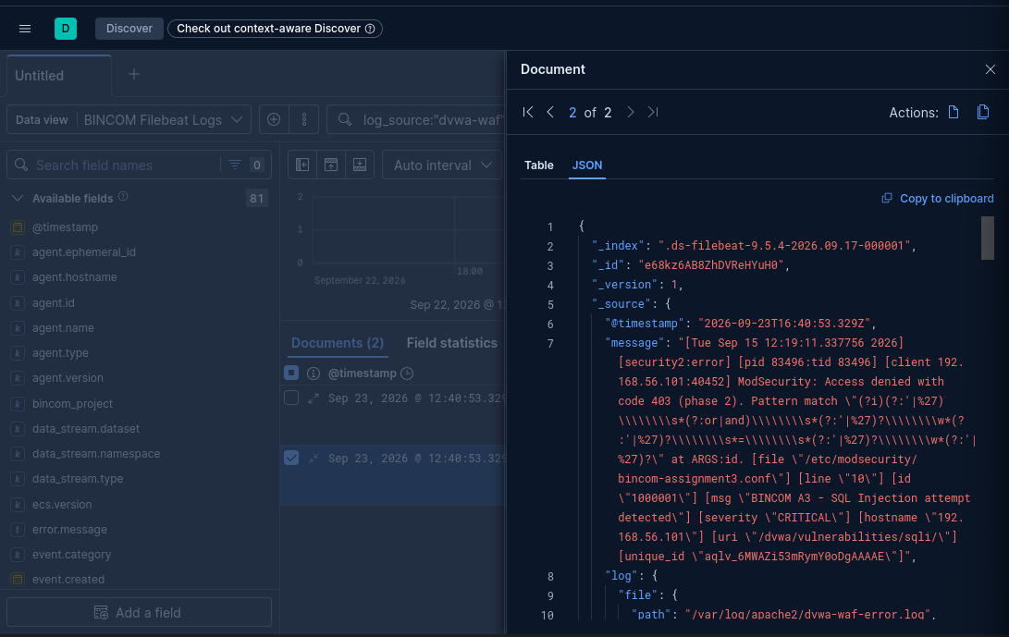
Figure 42. Inspect the controlled SQL Injection event
The screenshot is the primary SQL Injection event evidence in Kibana.

Step 43 — Inspect SQL Injection source-log metadata
The SQL Injection event's expanded JSON metadata shows the original /var/log/apache2/dvwa-waf-error.log path, log_source dvwa-waf and bincom_project metadata. This ties the SIEM record back to the WAF source.
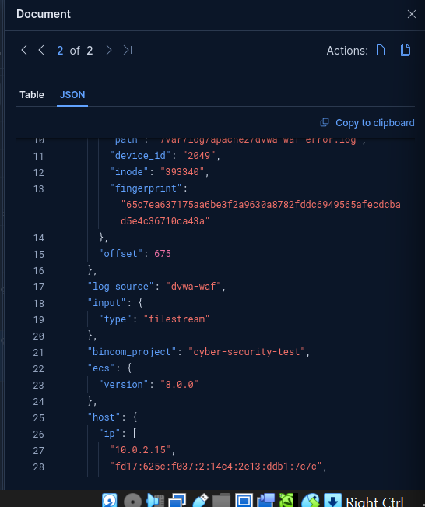
Figure 43. Inspect SQL Injection source-log metadata
The screenshot shows the event's log-file path, log_source and project metadata.

Step 44 — Inspect the WAF event collection view
The Kibana Discover view shows the WAF documents under the dvwa-waf filter. This provides the broader event-list context around the individual document inspection.
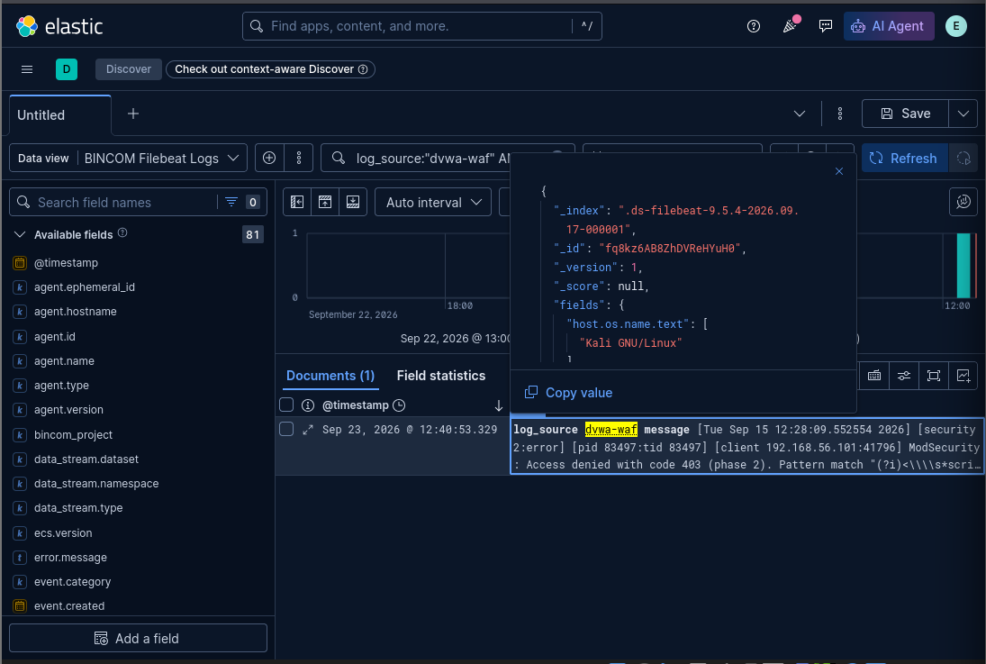
Figure 44. Inspect the WAF event collection view
The screenshot shows the Discover results and WAF-filtered documents.

Step 45 — Inspect the controlled XSS event
The XSS event was opened as a Kibana document. The visible event reports ModSecurity access denial with HTTP 403, laboratory rule ID 1000002, CRITICAL severity and the 'BINCOM A3 - XSS attempt detected' message.
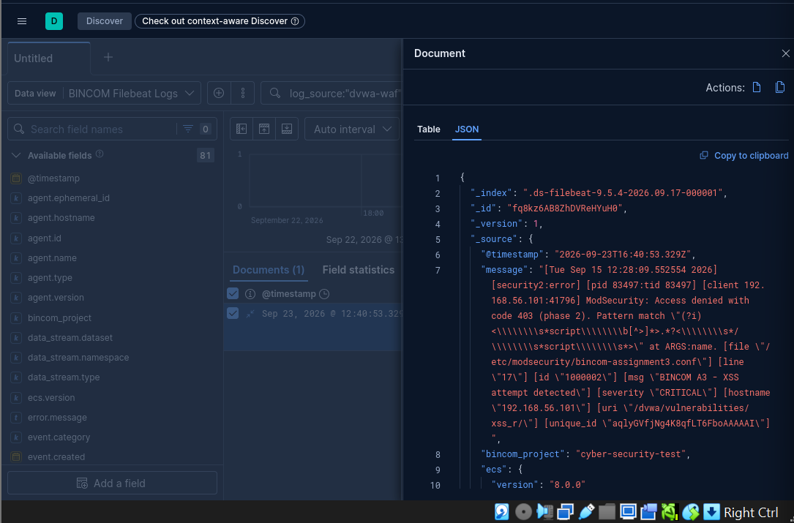
Figure 45. Inspect the controlled XSS event
The screenshot is the primary XSS event evidence in Kibana.

Step 46 — Inspect XSS host and Filebeat metadata
The expanded XSS document shows the Kali host, operating-system information and Filebeat agent metadata, demonstrating that the event was collected and enriched by the Filebeat pipeline.
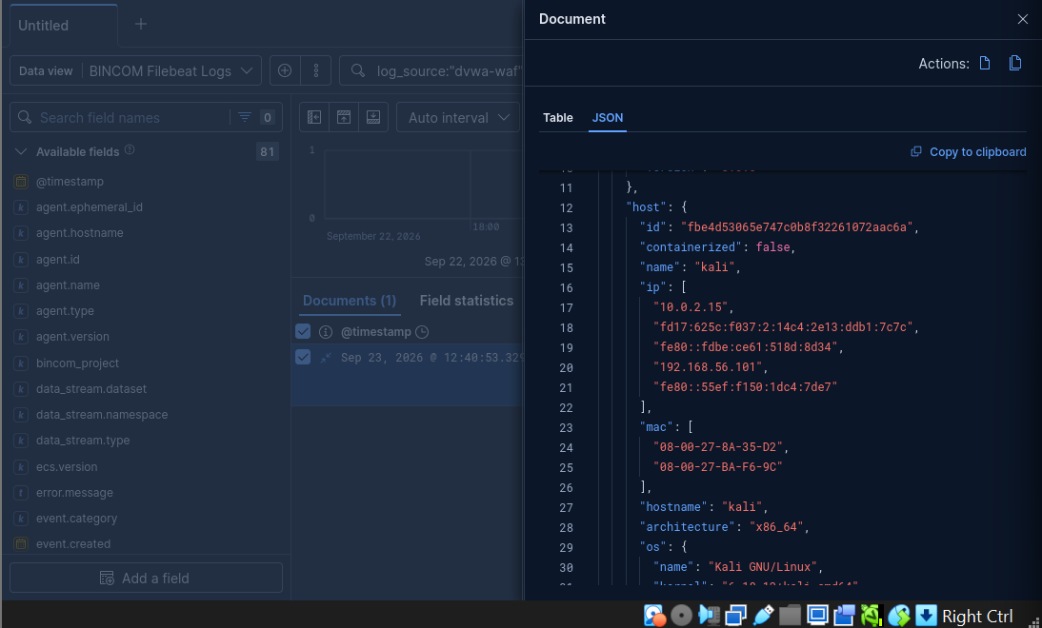
Figure 46. Inspect XSS host and Filebeat metadata
The screenshot shows host and Filebeat metadata associated with the indexed event.

Step 47 — Inspect XSS event source context
The final XSS document view shows the collected document fields and Kali host/agent context under the dvwa-waf data view. This completes the source-to-SIEM evidence chain for the second controlled WAF event.
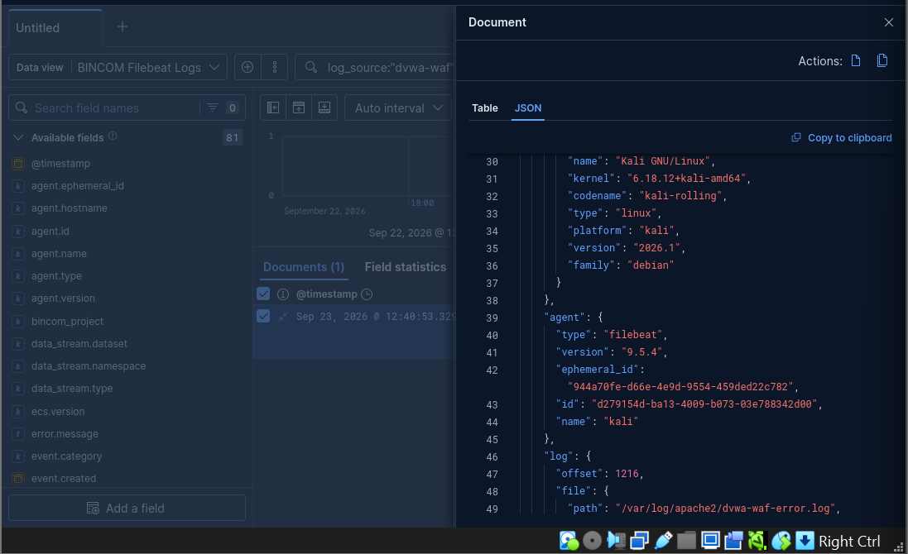
Figure 47. Inspect XSS event source context
The screenshot shows the indexed XSS document and associated host/agent metadata.

Step 48 — Confirm the second WAF event directly in Elasticsearch
A separate Elasticsearch evidence screenshot shows the confirmed WAF event set, providing an additional backend record alongside the Kibana investigation screenshots.
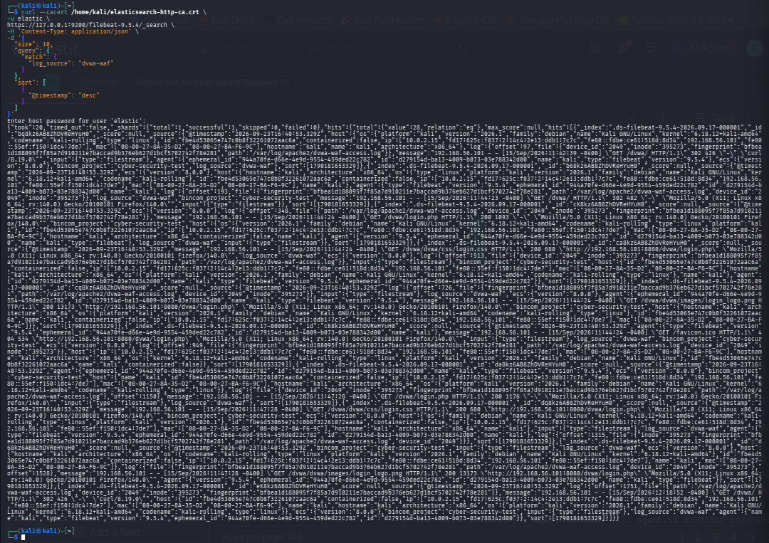
Figure 48. Confirm the second WAF event directly in Elasticsearch
The screenshot provides independent Elasticsearch-side confirmation of the WAF event records.

5. Final SIEM Correlation Results
Event | Observed evidence | Correlation meaning
SQL Injection | ModSecurity access denied with HTTP 403; rule ID 1000001; CRITICAL; 'BINCOM A3 - SQL Injection attempt detected'; DVWA SQLi endpoint; WAF error-log source | The controlled SQLi request generated a WAF security event that was retained and searchable in the SIEM.
XSS | ModSecurity access denied with HTTP 403; rule ID 1000002; CRITICAL; 'BINCOM A3 - XSS attempt detected'; DVWA XSS endpoint; WAF error-log source | The controlled XSS request generated a WAF security event that was retained and searchable in the SIEM.
These are controlled final-test security events. They demonstrate WAF detection/blocking and SIEM telemetry flow in the laboratory. They should not be interpreted as evidence of compromise of a production or third-party system.

6. Troubleshooting Record
Problem actually observed | Corrective action actually evidenced | Final state
Incorrect Elasticsearch CA path | Located the certificate and used the usable CA copy under /home/kali. | Elasticsearch TLS output test succeeded.
Filebeat YAML parsing error: line 32 did not find expected key | Restored known-good configuration, created an isolated temporary WAF input, tested it independently, then deployed it under inputs.d. | Main Filebeat config returned Config OK.
Initial direct search against a concrete .ds index returned no such index | Queried _data_stream and _cat/indices to identify the active Filebeat data stream/backing index. | Subsequent searches returned WAF documents.
Need to preserve the WAF source context | Configured root-level bincom_project and log_source fields and used the dvwa-waf filter in Kibana. | WAF events were searchable and identifiable in Kibana.
This troubleshooting record is important because it shows that the final result was reached through validation and correction, not by omitting failed attempts from the evidence.

7. What the Evidence Proves — and What It Does Not
Evidence supports | Evidence does not by itself establish
DVWA was available in the authorized lab. | A real-world compromise.
The WAF listener responded and Apache WAF logs existed. | That an external attacker compromised the system.
ModSecurity generated controlled SQLi/XSS blocking events. | That the simulated requests came from an unauthorized real-world actor.
Filebeat configuration and service were validated. | Enterprise-wide SIEM coverage.
Elasticsearch accepted and indexed the WAF telemetry. | Production-scale resilience or retention.
Kibana displayed and allowed inspection of the indexed WAF events. | Detection of the earlier NFS case by this exact WAF pipeline.
This distinction follows the evidence-first approach used in the supplied previous BINCOM report, which explicitly cautioned against treating controlled SIEM correlation as proof of detection of an unrelated laboratory NFS incident.

8. Final Test Deliverable Mapping
Deliverable | Where demonstrated
Network/lab setup | Environment section and Figures 1, 8 and 9
Attack/defense evidence | DVWA/WAF and ModSecurity log evidence; SQLi/XSS Kibana evidence
Security logs | Apache dvwa-waf-access.log and dvwa-waf-error.log evidence
SIEM backend | Elasticsearch TLS, data-stream/index and search evidence
SIEM dashboard/investigation | Kibana Discover evidence
Incident-response report | This document

9. Evidence Register
Evidence file | Captured artifact | Use
1 | Screenshot 2026-09-23 143037.png | Included in chronological evidence appendix
2 | Screenshot 2026-09-23 143824.png | Included in chronological evidence appendix
3 | Screenshot 2026-09-23 143850.png | Included in chronological evidence appendix
4 | Screenshot 2026-09-23 144707.png | Included in chronological evidence appendix
5 | Screenshot 2026-09-23 144730.png | Included in chronological evidence appendix
6 | Screenshot 2026-09-23 145817.png | Included in chronological evidence appendix
7 | Screenshot 2026-09-23 150051.png | Included in chronological evidence appendix
8 | Screenshot 2026-09-23 151900.png | Included in chronological evidence appendix
9 | Screenshot 2026-09-23 153420.png | Included in chronological evidence appendix
10 | Screenshot 2026-09-23 154122.png | Included in chronological evidence appendix
11 | Screenshot 2026-09-23 154300.png | Included in chronological evidence appendix
12 | Screenshot 2026-09-23 155324.png | Included in chronological evidence appendix
13 | Screenshot 2026-09-23 155351.png | Included in chronological evidence appendix
14 | Screenshot 2026-09-23 160447.png | Included in chronological evidence appendix
15 | Screenshot 2026-09-23 164739.png | Included in chronological evidence appendix
16 | Screenshot 2026-09-23 164829.png | Included in chronological evidence appendix
17 | Screenshot 2026-09-23 164937.png | Included in chronological evidence appendix
18 | Screenshot 2026-09-23 165001.png | Included in chronological evidence appendix
19 | Screenshot 2026-09-23 165806.png | Included in chronological evidence appendix
20 | Screenshot 2026-09-23 170042.png | Included in chronological evidence appendix
21 | Screenshot 2026-09-23 170818.png | Included in chronological evidence appendix
22 | Screenshot 2026-09-23 171639.png | Included in chronological evidence appendix
23 | Screenshot 2026-09-23 172014.png | Included in chronological evidence appendix
24 | Screenshot 2026-09-23 172204.png | Included in chronological evidence appendix
25 | Screenshot 2026-09-23 172442.png | Included in chronological evidence appendix
26 | Screenshot 2026-09-23 172638.png | Included in chronological evidence appendix
27 | Screenshot 2026-09-23 172902.png | Included in chronological evidence appendix
28 | Screenshot 2026-09-23 173050.png | Included in chronological evidence appendix
29 | Screenshot 2026-09-23 173346.png | Included in chronological evidence appendix
30 | Screenshot 2026-09-23 173852.png | Included in chronological evidence appendix
31 | Screenshot 2026-09-23 173947.png | Included in chronological evidence appendix
32 | Screenshot 2026-09-23 174202.png | Included in chronological evidence appendix
33 | Screenshot 2026-09-23 174501.png | Included in chronological evidence appendix
34 | Screenshot 2026-09-23 174620.png | Included in chronological evidence appendix
35 | Screenshot 2026-09-23 174926.png | Included in chronological evidence appendix
36 | Screenshot 2026-09-23 174943.png | Included in chronological evidence appendix
37 | Screenshot 2026-09-23 175144.png | Included in chronological evidence appendix
38 | Screenshot 2026-09-23 175441.png | Included in chronological evidence appendix
39 | Screenshot 2026-09-23 180245.png | Included in chronological evidence appendix
40 | Screenshot 2026-09-23 180459.png | Included in chronological evidence appendix
41 | Screenshot 2026-09-23 181113.png | Included in chronological evidence appendix
42 | Screenshot 2026-09-23 181136.png | Included in chronological evidence appendix
43 | Screenshot 2026-09-23 181756.png | Included in chronological evidence appendix
44 | Screenshot 2026-09-23 181819.png | Included in chronological evidence appendix
45 | Screenshot 2026-09-23 181836.png | Included in chronological evidence appendix
46 | WAF Event Visible in Elastic & Kibana.png | Included in chronological evidence appendix
47 | Confirmed WAF Events (1).png | Included in chronological evidence appendix
48 | Confirmed WAF Events (2).png | Included in chronological evidence appendix

10. Conclusion
The BINCOM Academy Final Practical Test SIEM phase has been documented as a complete evidence chain. The report demonstrates the actual sequence used: laboratory preparation, DVWA availability, WAF operation, WAF log generation, Filebeat configuration and troubleshooting, Elasticsearch connectivity, data-stream/index discovery, backend event searching, Kibana investigation and final SQL Injection/XSS event correlation.
Most importantly, the evidence has been preserved chronologically. Failed configuration attempts and search errors are included where they materially explain the troubleshooting process. Successful validation points are supported by their own screenshots. This makes the report suitable for professional inspection because an assessor can follow the procedure and inspect the captured terminal or Kibana evidence rather than relying on unsupported narrative claims.
Earlier BINCOM assignments remain useful as preliminary technical preparation and reference material, but the assessment documented here is the Final Practical Test itself. The earlier work was not treated as the current test result.
Final closure chain: Finding → Risk → Remediation → Re-test → Evidence → Residual Risk.
The final security posture should be considered closed only after the identified vulnerabilities have been remediated at the appropriate layer, the same attack scenarios have been re-tested, the WAF/SIEM monitoring path has been re-validated and any remaining residual risk has been documented. In this final practical test, the demonstrated evidence establishes controlled WAF blocking and end-to-end SIEM telemetry. The application-level remediation items above are the recommended treatment plan and require separate implementation evidence before being described as completed fixes.

11.6 Final Remediation Closure
- Document remediation ownership, target dates and verification evidence for identified findings.
- Regularly review WAF rules, SIEM detection logic and log-source health to ensure that security controls remain effective.
- Establish an incident-response workflow covering detection, triage, containment, eradication/remediation, recovery and lessons learned.
- Maintain centralized security logging and SIEM alerting for high-severity WAF events.
- Perform periodic vulnerability scanning and penetration testing within authorized environments.
- Adopt secure coding practices and regular application vulnerability testing for web applications.

11.5 Recommendations for Continued Security Improvement
Even after remediation, residual risk remains if application components are not comprehensively reviewed, WAF rules are not maintained, logs are not monitored, or new attack techniques are introduced. The controls demonstrated in this assessment should therefore be treated as layers of a defense-in-depth strategy rather than as proof that all future attacks will be prevented.

11.4 Residual Risk
- Capture before/after screenshots or terminal output for the remediation and re-test evidence.
- Confirm that the resulting WAF events are still collected by Filebeat, indexed in Elasticsearch and visible in Kibana.
- Confirm that ModSecurity continues to block malicious requests where the WAF rule is expected to intervene.
- Re-test the controlled XSS scenario and confirm that untrusted input is not rendered or executed in an unsafe context.
- Re-test the controlled SQL Injection scenario and confirm that the application no longer processes the malicious input as an unsafe query.
Remediation should be verified by repeating the same controlled attack scenarios after the proposed fixes are applied. A successful closure should demonstrate both prevention at the application/control layer and continued visibility at the monitoring layer.

11.3 Verification and Re-Test Plan
- Apply network segmentation and least-privilege access between the attacker workstation, monitored services and supporting security infrastructure.
- Keep the honeypot isolated from production systems and restrict unnecessary outbound and inbound connectivity. Honeypot activity should be treated as monitored security telemetry rather than as a trusted application environment.

11.2.4 Honeypot and Network Controls
- Preserve relevant WAF and SIEM logs according to the organization's retention requirements so that future investigations can reconstruct events.
- Maintain Kibana investigation views/data views for WAF events so that analysts can search, filter and correlate security activity efficiently.
- Maintain the Filebeat-to-Elasticsearch pipeline and verify that WAF security events continue to arrive with sufficient source, rule, severity and host metadata.

11.2.3 Logging and SIEM Remediation
- Use the WAF as a defense-in-depth control, not as a substitute for secure application development and vulnerability remediation.
- Review WAF rules periodically to reduce false positives while preserving coverage for SQL Injection, XSS and other relevant web attack patterns.
- Keep ModSecurity enabled and maintain the OWASP CRS/custom laboratory rules used to detect and block malicious web requests.

11.2.2 WAF Remediation and Hardening
- Review affected application components and database interactions after remediation so that the vulnerability is addressed at its source rather than relying only on the WAF as the primary control.
- XSS — Apply context-appropriate output encoding, validate and safely handle input, and ensure application responses do not place untrusted data into executable HTML/JavaScript contexts.
- SQL Injection — Replace dynamically constructed SQL statements with parameterized queries/prepared statements and apply secure database-access practices. Validate inputs according to their expected type and context, while avoiding reliance on blacklist-only filtering.

11.2.1 Application-Level Remediation

11.2 Remediation Actions
- Security telemetry: The WAF events were successfully forwarded through Filebeat 9.5.4 to Elasticsearch 9.5.4 and made available for investigation in Kibana.
- Cross-Site Scripting (XSS): The controlled XSS test triggered laboratory WAF rule ID 1000002, was denied with HTTP 403 and generated a CRITICAL ModSecurity event that was subsequently visible through the SIEM pipeline.
- SQL Injection: The controlled SQL Injection test triggered the laboratory WAF rule ID 1000001, was denied with HTTP 403 and generated a CRITICAL ModSecurity event that was subsequently visible through the SIEM pipeline.

11.1 Security Findings Requiring Remediation
The final practical test did not stop at detection and correlation. The security findings identified from the controlled SQL Injection and Cross-Site Scripting (XSS) tests are translated below into remediation actions, verification requirements and longer-term security recommendations. The evidence in this report demonstrates that the ModSecurity WAF blocked the controlled requests with HTTP 403 responses and that the resulting security telemetry was collected by Filebeat, indexed in Elasticsearch and investigated in Kibana. The report does not claim that the underlying DVWA application source code was permanently remediated; application-level fixes are therefore presented as recommended remediation actions unless separately evidenced.

11. Remediation and Recommendations

12. Source Materials Used
Primary source materials supplied for this report:
- BINCOM Academy — Cyber Security Class — Final Practical Test – Full Security Simulation.
- BINCOM project guidelines supplied for the assessment workflow.
- Oyewumi Yusuf Olayemi — BINCOM 4th Contact Assignment Report, used as preliminary/reference material for terminology, laboratory context and professional reporting structure.
- Screenshots captured during the final-test technical work on 23 September 2026, incorporated throughout this report.

13. Assessor Review Note
For assessment review, the recommended reading order is: Important Project Classification → Official Final-Test Requirements → Laboratory Scope → Chronological Step-by-Step Evidence → Final SIEM Correlation Results → Troubleshooting Record → Evidence Register. This order allows the assessor to verify not only the final state but also the actual work performed to reach it.

