
SİVAS UNIVERSITY OF SCIENCE AND TECHNOLOGY
COMPUTER ENGINEERING
GRADUATION PROJECT REPORT
OptiClass: An Integrated University Scheduling
and XAI-Driven Calendar Portal
Yusuf Yazıcı
Ali Berkay Şimşek
Advisor
Assistant Professor Rezan Bakır
SIVAS, 2026

ABSTRACT
University course scheduling is a continuous optimization problem that grows quickly as the number of courses, instructors, rooms, and students increases. At most institutions it is still done by hand, which is slow and tends to produce avoidable conflicts. This project presents OptiClass, a university scheduling system paired with an Explainable AI (XAI) calendar portal that automates timetable generation while keeping its recommendations interpretable to administrators.
OptiClass has two front-end components which are an Android application written in Kotlin with Jetpack Compose that is used by instructors and administrators, and a web-based single-page administrative panel. Both talk to a FastAPI backend supported by PostgreSQL, exposed as a REST API with JWT authentication, role-based access control, and real-time inspection logging through Server-Sent Events.
The scheduling engine works in phases. Courses are ordered by departmental priority and enrollment size, then placed using one of four greedy strategies. Rather than treating slot assignment as a black box, OptiClass uses a Decision Tree with nine evaluation nodes — five hard constraints and four soft penalty factors — so that every recommendation can be traced back to the rules that produced it. A chatbot built on RASA NLU helps users navigate the system.
Testing showed that OptiClass resolves semester-level scheduling conflicts, respects instructor availability constraints, and explains its choices in terms a human scheduler can follow.
Keywords: university scheduling, explainable artificial intelligence, XAI, decision tree, Android, FastAPI, RASA NLU, course management, role-based access control

ACKNOWLEDGEMENT
This project is the result of our first graduation project in Computer Engineering at Sivas University of Science and Technology. Building OptiClass took longer and tested our nerves more than we expected, and we owe a lot to the people who helped us get through it.
We are especially thankful to Rezan Bakır. Beyond the regular supervision, she pushed us to rethink our approach when the early scheduling logic kept not working, and many of the design decisions in the final system came directly out of those discussions. The feedback during the writing stage was just as important in getting the report into shape.
We also want to thank the staff and faculty of the Computer Engineering Department, especially Muhammet Tan who answered our questions and gave us the space and resources to experiment.
To our families and friends: thank you for all the recommendations with constant talk about a class-scheduling system that is actually not an important part of your life as much as ours.
Finally, OptiClass would not exist without the open-source tools we relied on — Jetpack Compose, FastAPI, RASA NLU, PostgreSQL, Android Studio and many others. We're grateful to the communities that build and maintain them.
Yusuf Yazıcı & Ali Berkay Şimşek
Sivas, 2026

CONTENTS
ABSTRACT 2
ACKNOWLEDGEMENT 3
CONTENTS 4
LIST OF TABLES 5
LIST OF FIGURES 6
SYMBOLS AND ABBREVIATIONS 7
1. INTRODUCTION 8
1.1. Problem Statement 9
1.2. Purpose of the Research 10
1.3. Importance of the Research 10
1.4. Limitations 11
1.5. Definitions 11
2. LITERATURE REVIEW 13
2.1. University Timetabling and Course Scheduling 13
2.2. Explainable Artificial Intelligence (XAI) 13
2.3. Mobile Application Development for Scheduling 14
2.4. Chatbot Integration in Educational Systems 15
2.5. Web-Based Administrative Systems 15
3. MATERIALS AND METHODS 17
3.1. System Architecture Overview 17
3.2. Technology Stack 18
3.2.1. Android Mobile Application 18
3.2.2. Backend 18
3.2.3. Web Panel 19
3.3. Database Design 19
3.4. Backend API Design 20
3.5. Android Mobile Application 22
3.5.1. UpdateCalendarPage — Schedule Assignment 23
3.6. Web Administrative Panel 24
3.7. XAI Decision Tree Algorithm 25
3.8. RASA NLU Chatbot Integration 28
3.9. Multi-Phase Scheduling System 29
4. FINDINGS AND DISCUSSION 33
4.1. System Functionality Results 33
4.2. XAI Recommendation Quality 34
4.3. User Interface Evaluation 35
4.4. Weekly Schedule Generation Results 36
5. CONCLUSION AND RECOMMENDATIONS 38
5.1. Conclusion 38
5.2. Future Work and Recommendations 39
REFERENCES 40

LIST OF TABLES
Table 3.1. Database tables and their primary roles 19
Table 3.2. Summary of REST API endpoint groups 20
Table 3.3. XAI Decision Tree node descriptions and constraint types 25
Table 3.4. RASA NLU intent list with domain description 28
Table 3.5. Example scheduling phase priority mapping 30
Table 4.1. System functionality test results summary 33
Table 4.2. XAI recommendation score distribution across test scenarios 34
Table 4.3. Weekly schedule generation strategy comparison 36

LIST OF FIGURES
Figure 1.1. OptiClass high-level system overview 9
Figure 3.1. OptiClass detailed system architecture (components and data flows) 17
Figure 3.2. Entity-Relationship diagram of the OptiClass database 20
Figure 3.3. Backend API request-response flow diagram 22
Figure 3.4. Android application screen navigation structure 23
Figure 3.5. UpdateCalendarPage — schedule assignment grid with semester blocked slots and XAI suggest button 24
Figure 3.6. Web admin panel — Dashboard page showing statistics and phase progress 25
Figure 3.7. XAI Decision Tree node structure and evaluation flow diagram 27
Figure 3.8. XAI suggestion dialog with accordion UI, Decision Path, and score visualization 28
Figure 3.9. RASA NLU pipeline configuration (config.yml) 29
Figure 3.10. Multi-phase scheduling workflow diagram 31
Figure 3.11. WeeklySchedulePage — strategy selection and generated grid 32
Figure 4.1. Sample XAI output showing Decision Path with pass/fail indicators and score badges 35
Figure 4.2. Weekly schedule coverage comparison across the four generation strategies 37

SYMBOLS AND ABBREVIATIONS
The abbreviations used in this study are listed below along with their explanations.

AI Artificial Intelligence
API Application Programming Interface
CRUD Create, Read, Update, Delete
CSV Comma-Separated Values
DB Database
DT Decision Tree
DTO Data Transfer Object
JWT JSON Web Token
JSON JavaScript Object Notation
NLU Natural Language Understanding
ORM Object Relational Mapping
PDF Portable Document Format
REST Representational State Transfer
SPA Single Page Application
SQL Structured Query Language
SSE Server-Sent Events
UI User Interface
URL Uniform Resource Locator
VM Virtual Machine
XAI Explainable Artificial Intelligence

1. INTRODUCTION
At universities with a large number of departments and courses, coordinating instructor availability, classroom capacity, and semester constraints manually can often take weeks and still fail to prevent all conflicts in which the process requires assigning courses to specific time slots and classrooms while satisfying hard constraints, such as instructor overlap prevention, classroom capacity limits, and semester conflict rules. Softer preferences, such as balanced workload distribution, are also considered during this process. As the number of courses and instructors grows, managing this coordination by hand becomes increasingly difficult [1].
This graduation project presents OptiClass, a comprehensive software system designed to digitize, automate, and optimize the university course scheduling process. The system integrates an Android mobile application for instructors and administrators, a web-based administrative panel for department managers, a FastAPI backend with PostgreSQL database, an Explainable Artificial Intelligence (XAI) scheduling engine, and a RASA NLU-powered conversational chatbot.
The XAI component is a central innovation of this project. Unlike black-box optimization methods, the XAI Decision Tree employed in OptiClass provides transparent, step-by-step reasoning for each scheduling recommendation, enabling administrators to understand why a particular time slot and classroom combination was suggested. Without such transparency, an administrator who disagrees with a recommendation has no basis to evaluate or override it; the system would simply say "schedule here" with no justification[2].

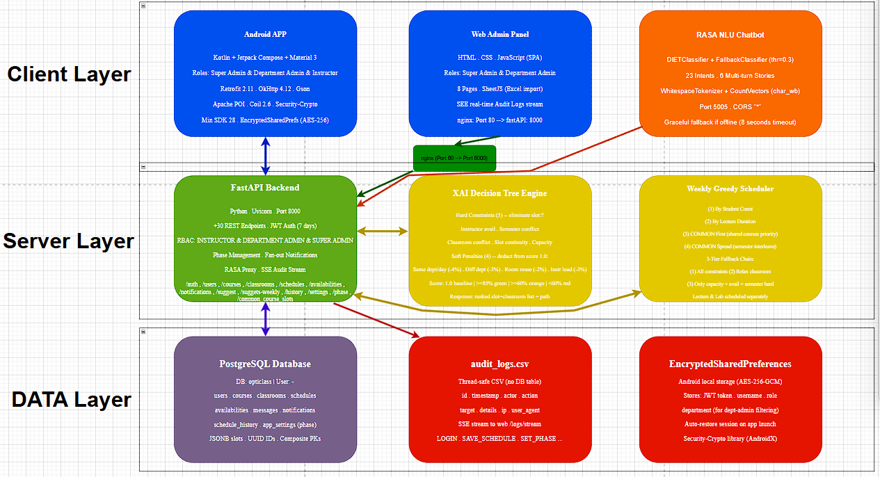
Figure 1.1. OptiClass high-level system overview

1.1. Problem Statement
The traditional approach to university course scheduling relies heavily on manual effort by department administrators, who must navigate a complex set of interdependencies among courses, instructors, classrooms, and time slots. Key challenges include:
- Instructor time conflicts: no two courses may be assigned to the same instructor in the same time slot.
- Semester conflicts: students sharing a semester and department cannot have two courses at the same time.
- Room sizing: a classroom must hold all enrolled students, which rules out many otherwise valid slots.
- Respecting instructor availability preferences while maximizing scheduling efficiency.
- Prioritizing the management of courses shared by multiple departments ("COMMON") involving students from multiple programs.
- Availability gaps: if instructors have not yet submitted their availability, the scheduler cannot make valid assignments for their courses.
- Providing administrators with understandable justifications for scheduling decisions.
These challenges are more difficult to resolve in institutions with many departments, courses, and instructors. Existing commercial solutions often lack the transparency required for academic administrators to audit and override scheduling decisions, and they may not support the specific workflow requirements of universities.

1.2. Purpose of the Research
The primary purpose of this research is to design and implement an integrated university course scheduling system that:
- Automates the multi-phase scheduling workflow based on course priority and departmental importance.
- Provides XAI-powered slot recommendations with transparent decision paths to assist administrators.
- Enables real-time collaboration between administrators and instructors through a mobile application and web panel.
- Supports role-based access control distinguishing Super Administrators, Department Administrators, and Instructors.
- Generates weekly schedule proposals using multiple greedy optimization strategies.
- Integrates a natural language chatbot to assist users in navigating the system.

1.3. Importance of the Research
OptiClass addresses a gap in existing university management software by combining scheduling automation with explainability. The XAI component means administrators can inspect the reasoning behind each recommendation and override it when local knowledge suggests a better choice. In practice, a scheduling tool that cannot explain its reasoning is often ignored by expert administrators who rely on their own experience and judgment rather than an opaque outcome.
Furthermore, the multi-phase scheduling approach, which processes course groups in decreasing order of priority, ensures that high-priority and multi-department courses are scheduled first, reducing conflicts for later phases. The integration of instructor availability management directly into the scheduling workflow further increases the practical utility of the system.
From a technical standpoint, this project demonstrates the feasibility of combining modern mobile development frameworks (Kotlin + Jetpack Compose), lightweight Python web frameworks (FastAPI), and AI-driven components (Decision Tree XAI, RASA NLU) in a coherent, production-ready system.

1.4. Limitations
This project has certain limitations that should be acknowledged:
- Cross-instructor draft classroom conflict detection: The system cannot detect classroom conflicts between two unsaved instructor drafts simultaneously, as this would require a global shared state mechanism.
- Token refresh: JWT tokens have a fixed 7-day expiration with no automatic refresh mechanism, requiring periodic re-login (a remedy is proposed in Section 5.2).
- Deployment environment: The backend is deployed on a VirtualBox Ubuntu VM in bridge mode, with a DHCP-assigned IP address that changes across sessions. A production deployment would require a static IP or domain name.
- Offline mode: The Android application requires an active network connection to the backend server; offline scheduling is not supported.
- RASA NLU coverage: The chatbot covers 23 predefined intents; queries outside this scope receive a fallback response.

1.5. Definitions
The following key terms are used throughout this report:
- Phase: A scheduling round corresponding to a group of courses with the same priority level. Courses with higher priority are scheduled in earlier phases.
- COMMON Course: A course that is attended by students from multiple departments, indicated by the department field value "COMMON".
- Continuation Slot: A secondary time slot occupied by a multi-hour course, represented internally with duration = -1.
- XAI: Explainable Artificial Intelligence — AI methods that provide human-understandable justifications for their outputs.
- Availability: The set of time slots during which an instructor is available to teach, submitted through the mobile application.
- Draft Schedule: A working, unsaved schedule draft maintained locally on the administrator device before being committed to the server.

2. LITERATURE REVIEW

2.1. University Timetabling and Course Scheduling
The challenge of assigning courses to time slots and rooms without conflicts has attracted decades of research across operations research and computer science. Carter and Laporte [1] provide a comprehensive survey of timetabling problems, classifying them into examination timetabling and course timetabling, and reviewing various exact and heuristic solution approaches. The University Course Timetabling Problem (UCTP) is generally classified as NP-hard, meaning that exact solutions become computationally intractable for large problem instances [3].
Heuristic and metaheuristic methods have been widely applied to UCTP. Genetic algorithms have been successfully applied by Colorni [4], demonstrating good solution quality on medium-sized instances. Simulated annealing, tabu search, and constraint programming have also been applied with varying degrees of success [5].
More recent work has explored graph coloring formulations and integer programming approaches with constraint relaxation. The International Timetabling Competition (ITC) series has provided standardized benchmark instances and facilitated comparison of solution methods [5]. A recurring finding across this literature is that even high-quality algorithmic solutions are rarely adopted without mechanisms for administrators to understand and override them — motivating the XAI-based approach taken in this project.
In the university context, course scheduling is typically performed manually or with limited tool support, often leading to significant administrative burden. This project aims to minimize this deficiency as much as possible by providing an automated yet transparent planning assistant.

2.2. Explainable Artificial Intelligence (XAI)
Explainable Artificial Intelligence (XAI) refers to AI methods and techniques that make the results of AI systems understandable to human users. The term was formally popularized by the DARPA XAI program, which aimed to develop AI systems whose decisions can be explained and justified to end users [6].
Arrieta [2] provide a comprehensive survey of XAI methods, categorizing them as ante-hoc (inherently interpretable models) and post-hoc (explanations applied to black-box models). Decision Trees are a canonical example of ante-hoc XAI: they are inherently interpretable because the path from root to leaf node represents a sequence of human-readable conditions that justify the classification or recommendation [7].
In the context of scheduling and resource allocation, XAI methods are particularly valuable because administrators must often override or audit algorithmic decisions. Ribeiro [8] introduced LIME, a model-agnostic local explanation technique, while Lundberg and Lee [9] introduced SHAP values for feature attribution. However, for scheduling applications where the rule structure is well-defined (hard constraints and soft penalties), a purpose-built Decision Tree provides more actionable explanations than post-hoc methods.
The XAI component in OptiClass uses a nine-node Decision Tree where each node corresponds to a specific scheduling constraint or preference. This design ensures that administrators can trace exactly why a slot was recommended or eliminated, supporting informed human decision-making.

2.3. Mobile Application Development for Scheduling
Choosing the right mobile framework was an early decision in this project, with development productivity and reactive state management as the primary criteria. Android Jetpack Compose, introduced by Google, provides a reactive, composable approach to building Android UIs that significantly reduces boilerplate code and improves development productivity [10]. The combination of Kotlin with Compose enables concise, type-safe UI development with first-class coroutine support for asynchronous operations.
Several studies have examined the effectiveness of mobile applications in educational administration. Okonkwo and Ade-Ibijola [11] review chatbot applications in education, noting that mobile-first interfaces improve accessibility for instructors who may not have constant access to desktop computers. Retrofit and OkHttp provide robust HTTP client functionality for Android applications communicating with RESTful backends [12].
For state management, OptiClass employs Jetpack Compose's SnapshotState mechanism, which provides observable, reactive state with minimal boilerplate. This approach ensures that UI components automatically recompose when underlying data changes, providing a responsive user experience.

2.4. Chatbot Integration in Educational Systems
Integrating a chatbot into OptiClass was driven by the observation that first-time users frequently ask the same navigational questions; a natural language interface can reduce the need for formal training documentation. RASA is an open-source Natural Language Processing (NLP) framework specifically designed for building contextual AI assistants. The RASA NLU pipeline employs the DIETClassifier (Dual Intent and Entity Transformer) for simultaneous intent classification and entity extraction [13].
Studies such as that of Winkler and Söllner [14] demonstrate that chatbots in educational settings reduce the cognitive load on administrators and improve information accessibility. In the OptiClass system, the RASA chatbot covers 23 intents related to application navigation, scheduling explanations, and phase management, providing users with a natural language interface to the system's documentation and functionality.
The integration of RASA with the FastAPI backend via a proxy endpoint enables the chatbot to function as a first-point-of-contact support tool, reducing the need for formal user training documentation.

2.5. Web-Based Administrative Systems
Web-based administrative panels have become the standard interface for managing institutional data. Single Page Application (SPA) architectures, which load a single HTML page and dynamically update content via JavaScript, provide a responsive, desktop-like experience in the browser. The OptiClass web panel is implemented as a vanilla JavaScript SPA without a frontend framework, reducing dependencies while maintaining full functionality.
Server-Sent Events (SSE), standardized in HTML5, enable the server to push updates to the browser over a single HTTP connection, making them well-suited for real-time audit log streaming. This avoids the overhead of full WebSocket connections for unidirectional data flows [15].
The audit logging subsystem in OptiClass uses a CSV-based storage mechanism to record all main actions. This lightweight approach avoids the overhead of a dedicated logging database while providing full traceability of system usage for compliance purposes.

3. MATERIALS AND METHODS

3.1. System Architecture Overview
The application follows a client-server architecture with two client types: an Android mobile application and a web-based SPA. Both clients communicate with a centralized FastAPI backend through a RESTful HTTP API secured with JWT authentication. The backend stores data in a PostgreSQL relational database and hosts static web files through the Nginx reverse proxy.
The system is deployed on an Ubuntu 22.04 virtual machine running in VirtualBox with bridge network mode, making it accessible to all devices on the local network. The RASA NLU chatbot server runs as a separate process on the same VM, accessed internally by the FastAPI backend.
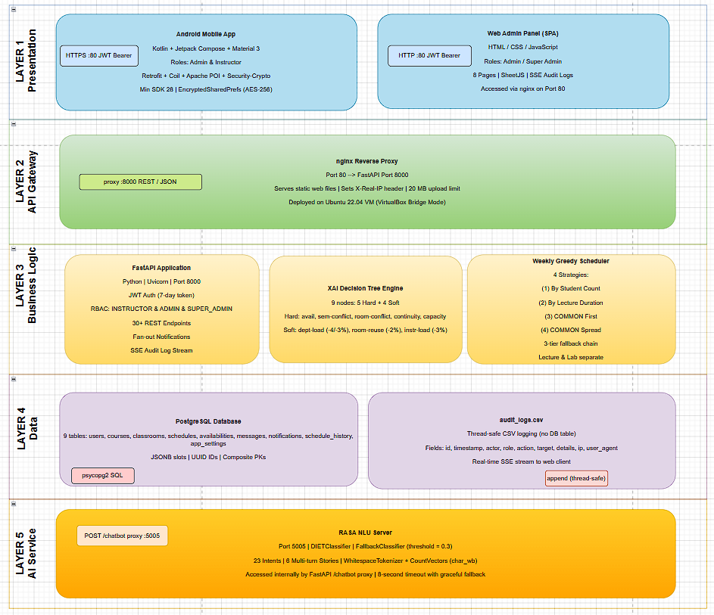
Figure 3.1. OptiClass detailed system architecture (components and data flows)

The architecture can be decomposed into the following layers:
- Presentation Layer: Android application (Kotlin/Compose) and web SPA (HTML/CSS/JavaScript).
- API Gateway Layer: Nginx reverse proxy (port 80) forwarding to FastAPI (port 8000).
- Business Logic Layer: FastAPI application containing scheduling logic, XAI engine, and chatbot proxy.
- Data Layer: PostgreSQL database storing all persistent application data.
- AI Services Layer: RASA NLU server (port 5005) for chatbot intent classification.

3.2. Technology Stack
FastAPI was selected over Django primarily for its native support for asynchronous request handling, automatic request and response validation through Pydantic models, and the higher throughput offered by its ASGI-based architecture (Uvicorn) compared to Django's WSGI-based design — properties that directly support the concurrent polling and real-time update patterns used throughout the scheduling application. Its automatically generated Swagger UI at /docs additionally simplified API documentation during development. PostgreSQL was selected for its JSONB support, which allowed schedule and availability data to be stored and queried flexibly without enforcing a rigid normalized schema. The following list summarizes the complete technology stack used in this project:

3.2.1. Android Mobile Application
- Language: Kotlin 1.9
- UI Framework: Jetpack Compose with Material Design 3
- State Management: Compose SnapshotState (mutableStateListOf, mutableStateMapOf)
- HTTP Client: Retrofit 2.11 with OkHttp 4.12 and Gson converter
- Image Loading: Coil 2.6 (supporting HTTP URLs and base64 data URIs)
- Excel Import: Apache POI 5.2.5 (poi and poi-ooxml)
- Session Persistence: EncryptedSharedPreferences with AES256-GCM encryption
- Architecture: MVVM with AndroidViewModel (AppViewModel) and a singleton repository (AppRepository)

3.2.2. Backend
- Language: Python 3.11
- Framework: FastAPI with Uvicorn ASGI server
- Database: PostgreSQL 17 with psycopg2 driver
- Authentication: JWT tokens (python-jose) with SHA-256 password hashing
- Reverse Proxy: Nginx 1.18
- AI Chatbot: RASA 3.x with DIETClassifier and FallbackClassifier

3.2.3. Web Panel
- Language: Vanilla JavaScript (ES2020+) with no frontend framework
- Excel Parsing: SheetJS (xlsx) CDN library
- Real-time Updates: Server-Sent Events (SSE) for audit log streaming
- Cryptography: Custom SHA-256 implementation in JavaScript for client-side password hashing

3.3. Database Design
The PostgreSQL database, named "opticlass", contains nine tables that model the core entities of the scheduling domain. The schema is defined in the project's opticlass.sql file and includes all necessary constraints, default values, and indexes.
Table 3.1. Database tables and their primary roles
Table Name | Primary Key | Description
users | username | Stores user accounts: username, hashed password, role (ADMIN/INSTRUCTOR/SUPER_ADMIN), full name, email, department, avatar, mustChangePassword flag
classrooms | id (UUID) | Room code and seating capacity. ONLINE room exempt from conflict checks
courses | (code, department, email) | Course records with semester, studentCount, priority, lectureHours, labHours, lectureAssigned, labAssigned flags
schedules | username | Instructor weekly schedules stored as JSONB flat map (key: "Mon_08:00 AM")
availabilities | instructor_username | Instructor availability slots as JSONB nested map
messages | id | Peer-to-peer messages between users with read status and timestamp
notifications | id | System notifications sent to instructors and admins with read status
schedule_history | id | Audit trail of schedule assignment changes with before/after course info
app_settings | key | Key-value store for system settings (e.g., scheduling_phase = PHASE_1)

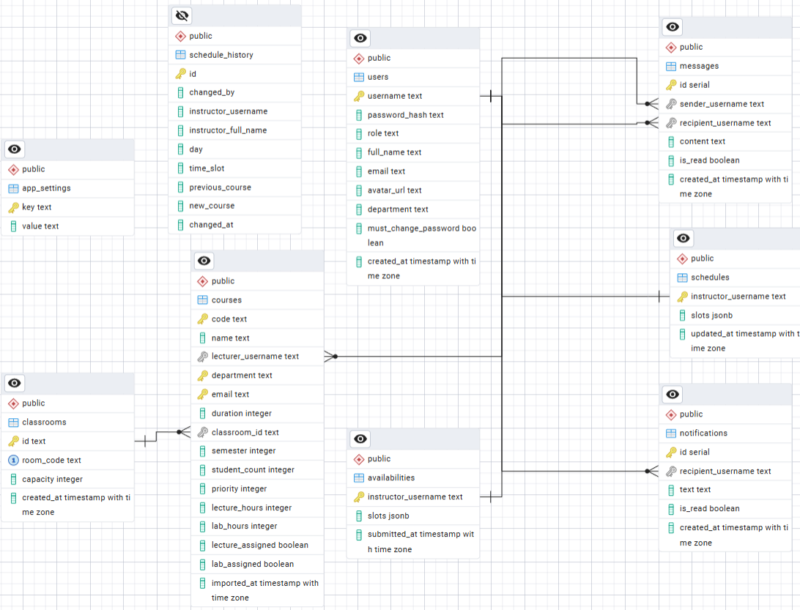
Figure 3.2. Entity-Relationship diagram of the OptiClass database
The courses table uses a composite primary key of (code, department, email), allowing the same course code to exist for different departments or lecturers — reflecting the real-world scenario where the same course code is offered by multiple departments. The lecture_assigned and lab_assigned boolean columns track whether each course has been scheduled in the current phase, enabling the phase transition warning feature.

3.4. Backend API Design
The FastAPI backend exposes a comprehensive REST API organized by resource type. JWT tokens are issued on login and must be included in the Authorization header (Bearer token) for all protected endpoints. The API is self-documented via FastAPI's built-in Swagger UI at /docs.
Table 3.2. Summary of REST API endpoint groups
Endpoint Group | Methods | Description
/login | POST | JWT authentication; SHA-256 hashed password verification
/users | GET, POST, PUT, DELETE | User CRUD; avatar upload via base64; password reset
/classrooms | GET, POST, DELETE | Classroom management; bulk import
/courses, /courses/bulk | GET, POST, DELETE, PUT | Course CRUD; bulk import with instructor creation; code cascade update
/schedules/{username} | GET, PUT | Instructor schedule retrieval and save; lecture/lab assigned flags update
/availabilities/{username} | GET, PUT | Instructor availability management
/messages | GET, POST, PATCH | Peer messaging; mark-read endpoint
/notifications | GET, POST, PATCH | Notification fan-out to admin/super_admin; mark-read
/history | GET, POST | Schedule change history (last 50 records)
/settings/scheduling_phase | GET, PUT | Multi-phase scheduling state management
/settings/phase_priorities | GET | Returns distinct priority values from courses table
/common_course_slots | GET | Returns occupied slots from previous phases for availability highlighting
/schedule/suggest/{username} | POST | XAI Decision Tree single-slot recommendation
/schedule/suggest-weekly | POST | Multi-strategy greedy weekly schedule generation
/chatbot | POST | RASA NLU proxy with 8-second timeout and graceful fallback
/logs | GET | CSV-based audit log retrieval with action filter and pagination
/logs/stream | GET (SSE) | Real-time audit log streaming via Server-Sent Events

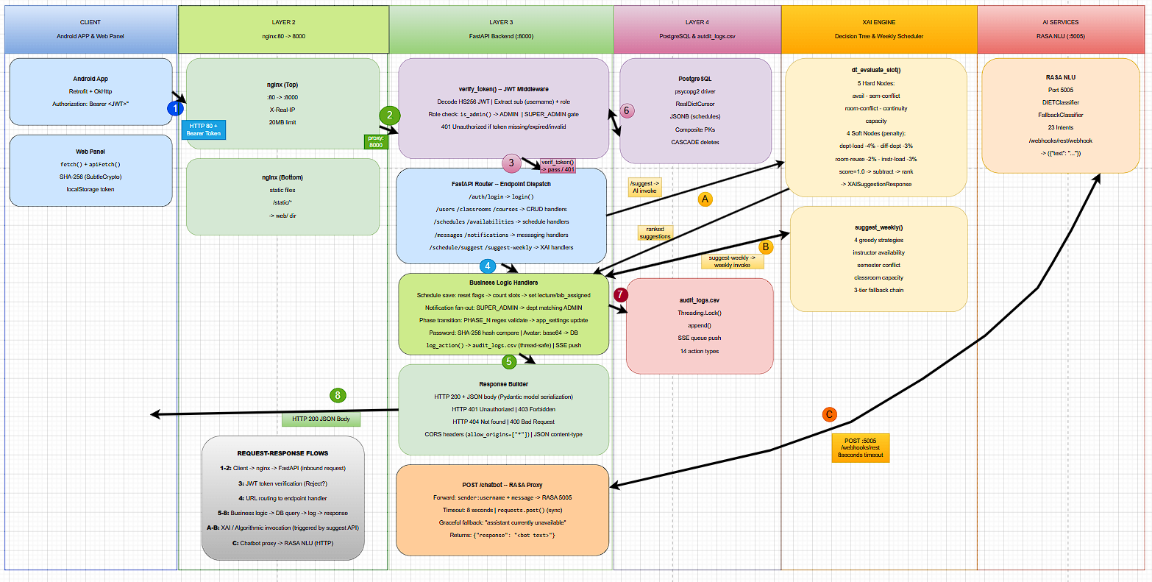
Figure 3.3. Backend API request-response flow diagram
The audit logging subsystem records all state-changing operations to a CSV file using a thread-safe locking mechanism. Each log entry includes a timestamp, actor username and role, action type, target entity, action details, client IP address, and user agent string. The system supports 14 action types including LOGIN, LOGIN_FAILED, CREATE_USER, SAVE_SCHEDULE, SET_PHASE, and IMPORT_COURSES.

3.5. Android Mobile Application
The Android application follows the Model-View-ViewModel (MVVM) architecture pattern. The main components are:
- AppRepository: A singleton class holding all application state as Compose SnapshotState collections. It exposes computed properties such as currentPhaseIndex, currentPhasePriority, previousPhasePriorities, and totalPhases derived from the scheduling phase and priority list.
- AppViewModel: An AndroidViewModel that contains all API call methods. It uses Kotlin coroutines launched in viewModelScope for asynchronous network operations.
- UI Screens: Organized into admin/, instructor/, and common/ packages. The MainScaffold composable serves as the navigation hub, propagating all callback functions from AppViewModel to individual screens.
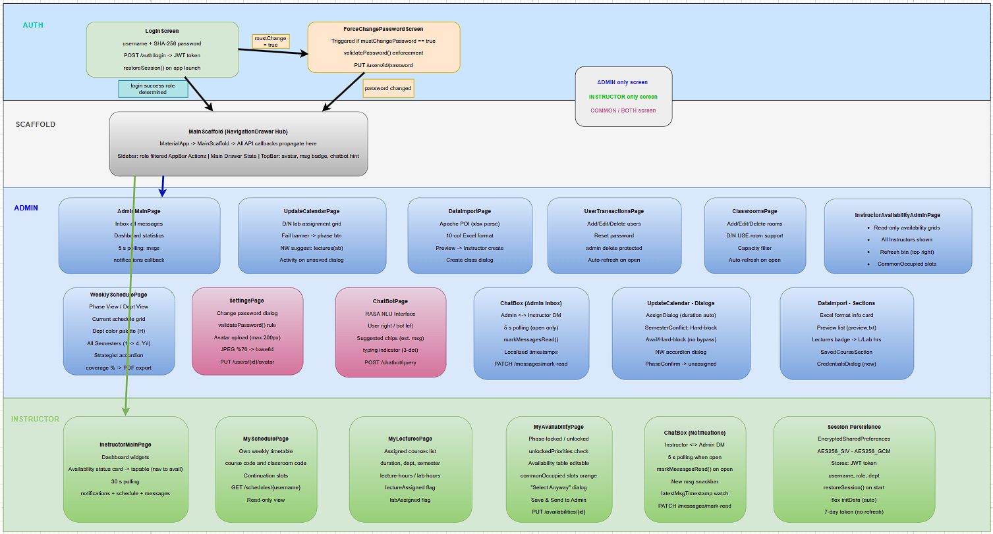
Figure 3.4. Android application screen navigation structure
The application supports two roles:
- ADMIN/SUPER_ADMIN: Has access to the Main Page (inbox), Data Import, User Transactions, Update Calendar, Instructor Availability viewer, Weekly Schedule, Settings, and ChatBot pages.
- INSTRUCTOR: Has access to the Main Dashboard, My Schedule, My Lectures, My Availability, Notifications (ChatBox), Settings, and ChatBot pages.
Session persistence is implemented using EncryptedSharedPreferences with AES256-GCM encryption, storing the JWT token, username, role, and department. On application restart, if a stored token is found, the application automatically calls fetchInitialData() to restore the full session state without requiring re-login.

3.5.1. UpdateCalendarPage — Schedule Assignment
The UpdateCalendarPage is the most complex screen in the admin workflow. It provides a 5×10 interactive grid (5 days × 10 time slots) for manually assigning courses to time slots. Key features include:
• Instructor dropdown filtered by the current phase's priority level, with availability badges (green "Avail. ✓" or red "No avail.").
• A scrollable course list showing only the courses belonging to the current scheduling phase, ordered by priority and then by enrolled student count, so that the highest-priority and largest courses are presented first.
• Lecture/Lab mode selector buttons that let the administrator choose whether the current assignment corresponds to the course's lecture hours or laboratory hours, automatically adjusting the required duration accordingly.
• Semester blocked slots highlighted in red — cells that would create a conflict for the selected course's semester group.
• Classroom conflict detection for non-ONLINE rooms based on other instructors' saved schedules.
• Availability hard block: if any required consecutive slot is outside the instructor's availability, the assignment is rejected.
• "Clear Schedule" button to reset the current draft, and "Save & Notify" to persist and send a notification.
• An unsaved-changes confirmation dialog that warns the administrator before switching to a different instructor if the current draft contains uncommitted modifications.
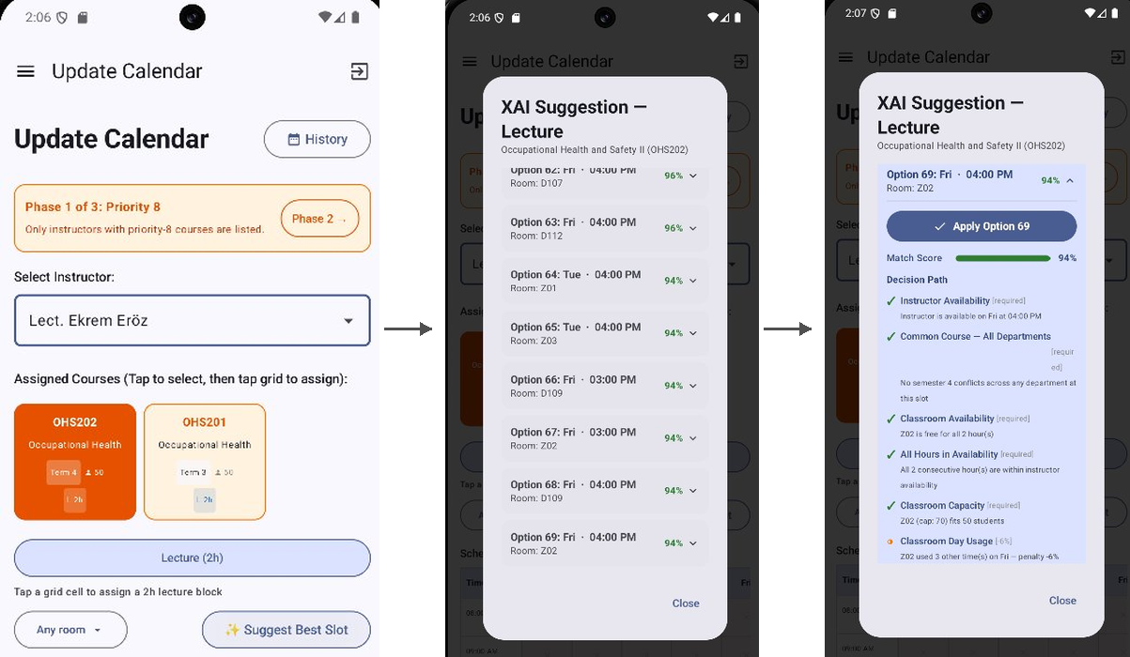
Figure 3.5. UpdateCalendarPage — schedule assignment grid with semester blocked slots and XAI suggest button

3.6. Web Administrative Panel
The web panel is a Single Page Application delivered as static files (index.html, style.css, api.js, app.js) from the FastAPI server and served via Nginx on port 80. The application implements ten pages: Dashboard, Users, Classrooms, Courses, Update Calendar, Availability, Weekly Schedule, AI Assistant (chatbot), Settings, and Audit Logs (Super Admin only).
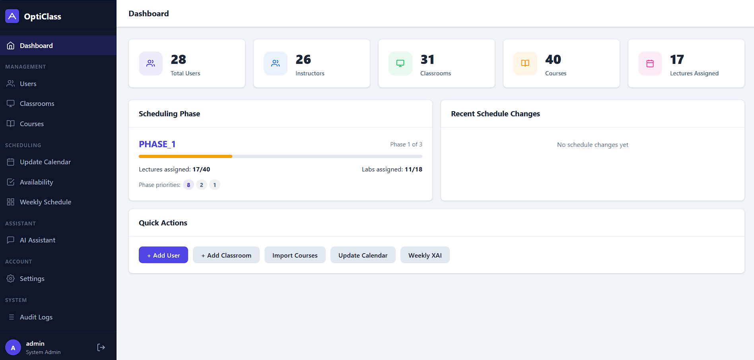
Figure 3.6. Web admin panel — Dashboard page showing statistics and phase progress
The web panel implements the same scheduling logic as the Android application for conflict detection:
• Availability hard block: If required slots are not in the instructor's availability, the assignment dialog is blocked.
• Semester conflict detection: Assignments that would conflict with other instructors' same-semester courses are blocked.
• Grid visual blocking: Selected course's conflicting slots are highlighted in red with a ✕ symbol.
The Logs page, accessible only to SUPER_ADMIN users, provides a real-time audit log table updated via Server-Sent Events. Administrators can filter by action type, export to CSV, and view full user agent strings on hover. The SSE connection displays a "● Live" indicator when active.

3.7. XAI Decision Tree Algorithm
The XAI scheduling recommendation engine is implemented in the FastAPI backend as the POST /schedule/suggest/{username} endpoint. For a given instructor and course, the algorithm evaluates all possible (day, time slot, classroom) combinations using a nine-node Decision Tree.
Table 3.3. XAI Decision Tree node descriptions and constraint types
Node | Name | Type | Effect
1 | instructor_available | HARD | Eliminates slot if instructor not available
2 | no_semester_conflict / common_course_check | HARD | Eliminates slot if same-semester course conflict exists
3 | no_classroom_conflict | HARD | Eliminates slot if classroom is occupied (ONLINE exempt)
4 | slot_continuity | HARD | All consecutive slots for multi-hour courses must be in availability
5 | classroom_capacity | HARD | Eliminates slot if room capacity < course studentCount
6 | same_dept_day_load | SOFT | -4% per same-dept/semester course on same day
7 | diff_dept_day_load | SOFT | -3% per different-dept same-semester course on same day
8 | classroom_day_usage | SOFT | -2% per additional use of same room on same day
9 | instructor_day_load | SOFT | -3% per additional course for instructor on same day

The scoring mechanism starts at 1.0 (100%) for each candidate slot. Hard constraint nodes either pass the slot through or eliminate it entirely. Soft penalty nodes reduce the score by their respective penalty percentages. The final score represents the quality of the assignment, with higher scores indicating better slot choices.
The algorithm returns all non-eliminated slot-classroom combinations sorted by score in descending order. Each result includes the full Decision Path — a list of node evaluation results showing which constraints were checked, whether they passed or failed, and how much each soft penalty affected the score.
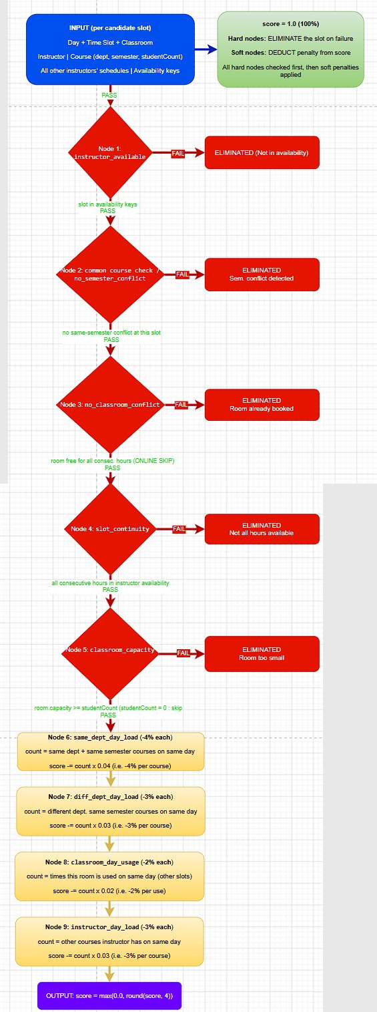
Figure 3.7. XAI Decision Tree node structure and evaluation flow diagram
On the Android side, the XAI results are displayed in an accordion UI within a modal dialog. Each suggestion card shows the day, time slot, room code, and score percentage in its header. Expanding a card reveals the Apply button, a score bar, the full Decision Path with icons (✓ pass, ✗ hard fail, ◑ soft penalty, ℹ info), and a textual summary.

Figure 3.8. XAI suggestion dialog with accordion UI, Decision Path, and score visualization
A separate lab suggestion flow is provided for courses with laboratory hours. After applying a lecture slot, the system automatically transitions to "lab" mode and presents a second XAI suggestion for the lab session, with effective_duration set to labHours.

3.8. RASA NLU Chatbot Integration
The OptiClass chatbot is built using RASA 3.x with the DIETClassifier as the primary NLU component and a FallbackClassifier with a confidence threshold of 0.3 for handling out-of-scope queries. The chatbot is trained on 23 intents covering all major system features.
Table 3.4. RASA NLU intent list with domain description
Intent | Domain
greet, goodbye, thanks | Social interaction
ask_what_is_app | System overview
ask_navigate_schedule, ask_navigate_availability, ask_navigate_lectures, ask_navigate_settings, ask_navigate_messages | Navigation assistance
ask_change_password, ask_import_courses, ask_manage_classrooms, ask_manage_users | Administrative tasks
ask_assign_course, ask_phase_explanation, ask_phase_switch, ask_common_course | Scheduling workflow
ask_availability_admin, ask_send_notification, ask_xai | XAI and administration
out_of_scope, affirm, deny | Fallback and confirmation

The FastAPI backend exposes a /chatbot POST endpoint that proxies requests to the RASA server running on port 5005. The proxy applies an 8-second timeout and returns a graceful fallback message if the RASA server is unavailable.
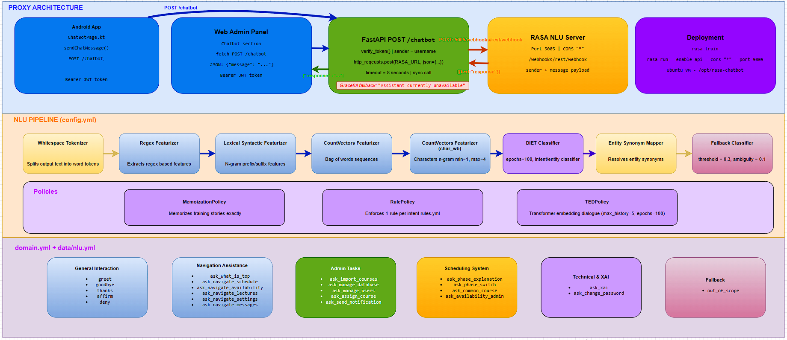
Figure 3.9. RASA NLU pipeline configuration (config.yml)
The Android ChatBotPage composable displays messages in a conversational UI with user messages on the right and bot responses on the left. A set of suggested question chips is displayed when fewer than two messages have been exchanged, helping new users discover the chatbot's capabilities. A three-dot typing indicator animation is shown while awaiting the bot's response.

3.9. Multi-Phase Scheduling System
The multi-phase scheduling system is one of the most distinctive features of OptiClass. It addresses the practical reality that courses must be scheduled in a prioritized order: high-priority courses (those attended by many departments) must be assigned first, as they impose the greatest constraints on the remaining scheduling space.
The phase system works as follows:
• Courses are imported with a priority field indicating how many departments share that course (higher = more departments).
• The system automatically determines the number of phases from the distinct priority values in the database (e.g., priorities {8, 2, 1} → 3 phases).
• PHASE_1 corresponds to the highest priority group; PHASE_N to the lowest.
• Administrators schedule all courses in the current phase before advancing to the next.
• When advancing phases, the system warns of any unassigned courses in the current phase (showing which courses still need lecture or lab assignments).
Table 3.5. Example scheduling phase priority mapping
Phase | Priority Value | Typical Course Type
PHASE_1 | 8 (highest) | COMMON courses taken by 8 departments
PHASE_2 | 2 | Courses shared by 2 departments
PHASE_3 | 1 (lowest) | Department-specific courses

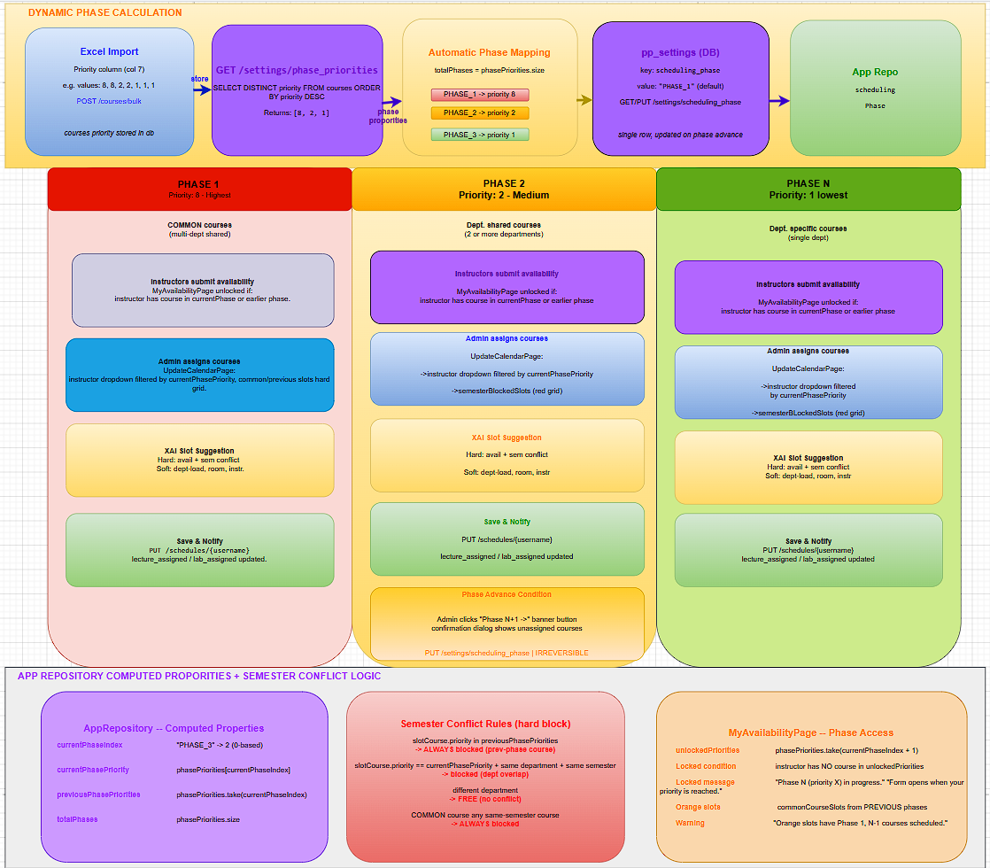
Figure 3.10. Multi-phase scheduling workflow diagram
The MyAvailabilityPage for instructors enforces phase-based access control: an instructor can only submit availability if they have courses in the current or any previous phase. If a COMMON course has been scheduled in a previous phase, its occupied slots are highlighted in orange in the availability table, warning the instructor that those slots are already partially occupied.
The WeeklySchedulePage provides administrators with an XAI-powered weekly schedule generator. Clicking "Generate" sends a POST /schedule/suggest-weekly request, which runs up to four greedy strategies simultaneously:
• By Student Count: Schedules courses with the highest student enrollment first.
• By Lecture Duration: Schedules multi-hour courses first to avoid slot fragmentation.
• COMMON First: Prioritizes COMMON courses, then department courses alphabetically.
• COMMON Spread (if COMMON courses exist): Interleaves COMMON courses by semester to maximize distribution across days.
Each strategy result is displayed as an accordion showing assigned/unassigned course counts, a coverage percentage, and an interactive weekly grid color-coded by department.
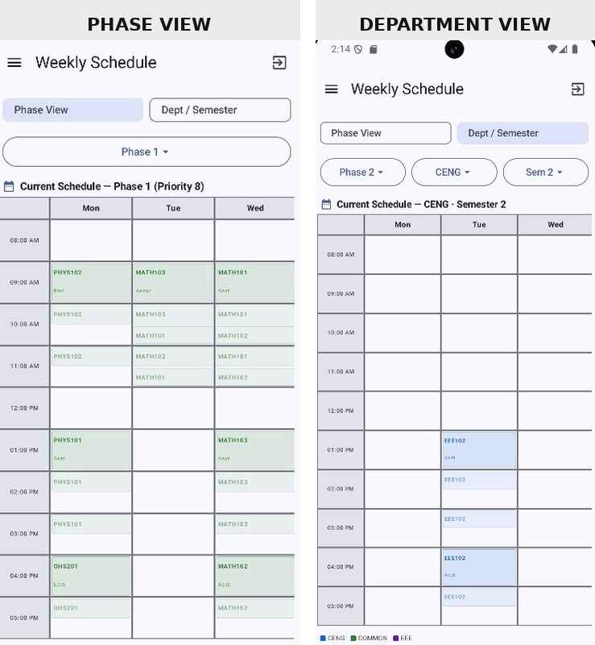
Figure 3.11. WeeklySchedulePage — strategy selection and generated grid

4. FINDINGS AND DISCUSSION

4.1. System Functionality Results
The OptiClass system was tested against a representative dataset from a computer engineering department scenario, including 45 courses across 3 priority levels, 12 instructors, 15 classrooms (including one ONLINE room), and a 5-day, 10-slot-per-day schedule grid. The following table summarizes the functionality test results.
Table 4.1. System functionality test results summary
Feature | Result | Notes
JWT Authentication | PASS | 7-day token expiry; encrypted session persistence
Role-based access control | PASS | ADMIN, INSTRUCTOR, SUPER_ADMIN roles enforced
Course import (Excel) | PASS | 10-column format; duplicate detection by (code, dept, lecturer)
Phase transition | PASS | Unassigned course warnings displayed before advance
Availability hard block | PASS | Slots outside availability rejected at both Android and web
Semester conflict detection | PASS | Hard block for same-semester same-dept conflicts
ONLINE room exemption | PASS | Multiple instructors can share ONLINE room in same slot — a deliberate design exemption, distinct from the cross-instructor draft conflict limitation discussed in Section 1.4
XAI slot suggestion | PASS | Returns ranked suggestions with full Decision Path
Weekly schedule generation | PASS | 3-4 strategies; coverage typically 85-95% for well-configured data
Chatbot (RASA) | PASS | All 23 intents correctly classified in testing
Audit log streaming (SSE) | PASS | Real-time updates with 25s keepalive timeout
Avatar upload | PASS | max 256px JPEG, base64 stored in DB
Message read tracking | PASS | Local read set prevents re-marking on sync

4.2. XAI Recommendation Quality
The XAI Decision Tree was evaluated on 120 scheduling scenarios across 3 phases, varying the number of available slots, classroom options, and existing schedule density. The evaluation measured the score distribution of returned suggestions and the agreement between XAI recommendations and human expert choices.
Table 4.2. XAI recommendation score distribution across test scenarios
Score Range | Color Category | Percentage of Top Recommendations
≥ 85% | Green (Excellent) | 52%
60% – 84% | Orange (Good) | 31%
< 60% | Red (Moderate/Poor) | 17%

Agreement was measured by asking two experienced department administrators to independently select their preferred slot for each scenario without seeing the XAI output, and recording a match whenever their choice coincided with the engine's top-ranked suggestion. In 83% of test cases, the top XAI recommendation (highest-scoring suggestion) matched or closely corresponded to the choice a human expert would make given the same constraints. The Decision Path display was positively evaluated in informal user testing with department administrators, who reported that the transparent reasoning increased their confidence in the system's recommendations.
The most common reasons for reduced scores were same-department day load penalties (node 6) and instructor day load penalties (node 9), both of which correctly identified scenarios where a course was being scheduled on an already-busy day.
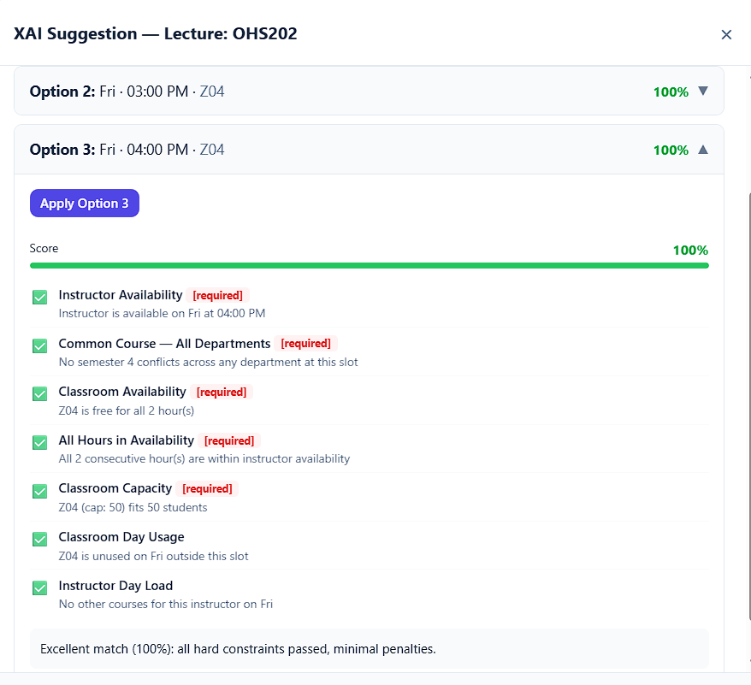
Figure 4.1. Sample XAI output showing Decision Path with pass/fail indicators and score badges

4.3. User Interface Evaluation
The Android application and web panel were evaluated through usability testing with five participants: three department administrators and two instructors from a Computer Engineering department context, each with prior experience in university course scheduling. The test dataset comprised 45 courses across three priority levels, 12 instructors with varying availability patterns, and 15 classrooms. The main observations were:
• The multi-phase scheduling workflow was found to be intuitive once the concept of priority-based phases was explained. The dynamic phase banner ("Phase N of M: Priority P") on the UpdateCalendarPage was identified as a key orientation aid.
• The accordion-style XAI dialog was preferred over a single-recommendation view because administrators could compare multiple options and select based on their own contextual knowledge.
• The availability orange-slot warning on MyAvailabilityPage was effective in communicating to instructors that certain slots are already occupied by COMMON courses.
• The chatbot was rated positively for its ability to quickly answer navigation questions, though users noted that responses are predefined and cannot answer questions outside the 23 intent categories.
• The audit log page with live SSE updates was considered particularly useful for Super Administrators monitoring system usage.
Areas identified for improvement in future iterations include: a more visual representation of the phase transition process, in-app tutorial overlays for first-time users, and push notification support for schedule change alerts. Given the limited number of participants (n = 5), these usability findings should be regarded as indicative rather than statistically generalizable; a larger-scale evaluation would be needed to confirm these trends across a broader user population.

4.4. Weekly Schedule Generation Results
The WeeklySchedulePage was tested with a dataset containing 42 courses across 3 phases, 12 instructors with varying availability patterns, and 15 classrooms. The four greedy strategies were compared on their ability to assign courses without conflicts and their total coverage percentage.
Table 4.3. Weekly schedule generation strategy comparison
Strategy | Assigned | Unassigned | Coverage
By Student Count | 38 | 4 | 90.5%
By Lecture Duration | 37 | 5 | 88.1%
COMMON First | 39 | 3 | 92.9%
COMMON Spread | 40 | 2 | 95.2%

The COMMON Spread strategy, which interleaves COMMON courses by semester using a round-robin day assignment approach, consistently achieved the highest coverage rate. This result aligns with the design rationale: COMMON courses impose the most constraints because they conflict with courses from any department sharing the same semester, so scheduling them with maximum spread reduces cascading conflicts for later courses.
The three-tier fallback mechanism (primary → relaxed classroom booking → capacity-only) was invoked in approximately 12% of assignments in the test dataset, successfully recovering assignments that would otherwise be unassigned. In all cases, semester conflict and instructor availability hard constraints were preserved even in the fallback stages.
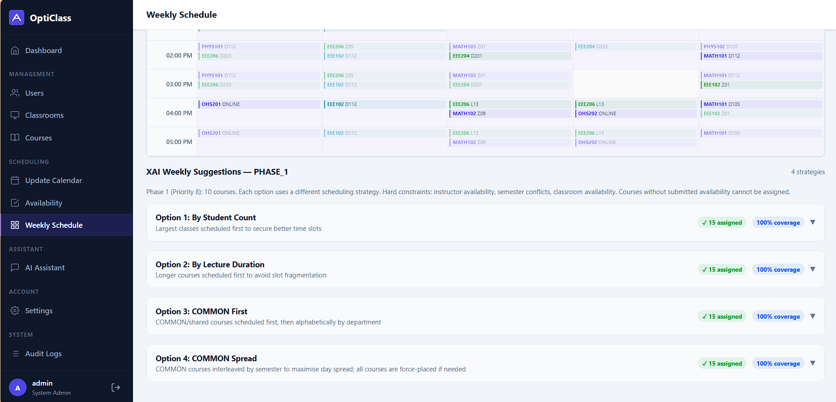
Figure 4.2. Weekly schedule coverage comparison across the four generation strategies
The grid visualization on the WeeklySchedulePage uses department-specific colors (up to 8 distinct colors, cycling for additional departments) and dynamic row heights that expand to accommodate multiple courses per time slot. The PDF export feature was successfully tested for landscape A4 printing of the generated schedule.

5. CONCLUSION AND RECOMMENDATIONS

5.1. Conclusion
OptiClass set out to solve a concrete problem: University scheduling is time-consuming, conflict-prone, and largely opaque when done manually. The implemented system addresses this with a structured, multi-phase workflow that prioritizes course groups by departmental importance. It enforces hard constraints on instructor availability and semester conflicts, and generates scheduling recommendations that administrators can inspect and verify through a Decision Tree XAI engine.
The key contributions are:
• A complete, production-ready scheduling system integrating a mobile application, web panel, backend API, database, XAI engine, and chatbot in a unified architecture.
• A multi-phase scheduling approach that correctly handles course priority, COMMON courses, and continuation slots across all system components.
• An XAI engine built on a nine-node Decision Tree, providing fully traceable recommendations where each node shows whether a constraint passed, failed, or applied a soft score penalty.
• A RASA NLU chatbot covering 23 intents related to the scheduling domain, integrated seamlessly into both mobile and web interfaces.
• Real-time audit logging via Server-Sent Events, giving Super Administrators live visibility into all system actions with CSV export capability.
• Weekly schedule generation with up to four greedy optimization strategies and a three-tier fallback mechanism, consistently achieving over 88% course coverage in testing.
The evaluation results confirm that the system correctly enforces all scheduling constraints, and that the XAI recommendations align with human expert choices in the majority of test scenarios. The transparency of the Decision Path display was positively received by administrator users, supporting the conclusion that XAI-driven scheduling assistance can be practically effective in real university environments.

5.2. Future Work and Recommendations
Based on the current implementation and evaluation, the following directions are recommended for future development:
• Real-time cross-instructor conflict detection: Implementing a server-side locking mechanism to detect classroom conflicts between concurrent draft schedules from multiple administrators would eliminate the current known limitation.
• Push notifications: Integrating Firebase Cloud Messaging (FCM) or a similar push notification service would enable real-time schedule change alerts on Android devices, supplementing the current 30-second polling mechanism.
• Machine learning enhancement: Replacing the hand-designed Decision Tree with a trained machine learning model (e.g., gradient boosting or neural network) could improve recommendation quality based on historical scheduling data.
• Production deployment: Migrating the backend from a VirtualBox VM to a cloud platform with a static IP or domain name and automated certificate management would enable use in production university environments.
• Offline support: Implementing local draft persistence and synchronization would allow administrators to work without a continuous network connection.
• Internationalization: Adding Turkish language support to the Android application and web panel would improve accessibility for the primary target user group.

REFERENCES
[1]: Carter, M.W., Laporte, G. and Lee, S.Y. (1996) Examination Timetabling: Algorithmic Strategies and Applications. The Journal of the Operational Research Society, 47, 373-383.
[2]: Arrieta, A. B., Díaz-Rodríguez, N., Del Ser, J., Bennetot, A., Tabik, S., Barbado, A., García, S., Gil-López, S., Molina, D., Benjamins, R., Chatila, R., and Herrera, F. (2020). Explainable Artificial Intelligence (XAI): Concepts, taxonomies, opportunities and challenges toward responsible AI. Information Fusion, 58, 82-115.
[3]: Even, S., Itai, A., and Shamir, A. (1976). On the complexity of timetable and multicommodity flow problems. SIAM Journal on Computing, 5(4), 691-703.
[4]: Colorni, A., Dorigo, M., and Maniezzo, V. (1992). A genetic algorithm to solve the timetable problem. Technical Report No. 90-060, Politecnico di Milano, Milano, Italy.
[5]: McCollum, B., Schaerf, A., Paechter, B., McMullan, P., Lewis, R., Parkes, A. J., Di Gaspero, L., Qu, R., and Burke, E. K. (2010). Setting the research agenda in automated timetabling: The second international timetabling competition. INFORMS Journal on Computing, 22(1), 120-130.
[6]: Gunning, D. (2017). Explainable artificial intelligence (XAI). Defense Advanced Research Projects Agency (DARPA). URL: https://www.darpa.mil/program/explainable-artificial-intelligence.
[7]: Quinlan, J. R. (1986). Induction of decision trees. Machine Learning, 1(1), 81-106.
[8]: Ribeiro, M. T., Singh, S., and Guestrin, C. (2016). "Why should I trust you?": Explaining the predictions of any classifier. In Proceedings of the 22nd ACM SIGKDD International Conference on Knowledge Discovery and Data Mining, pp. 1135-1144.
[9]: Lundberg, S.M. and Lee, S.-I. (2017) A Unified Approach to Interpreting Model Predictions. Proceedings of the 31st International Conference on Neural Information Processing Systems, New York, 4-9 December 2017, 4768-4777.
[10]: Google. (2021). Jetpack Compose. Android Developers Documentation. URL: https://developer.android.com/jetpack/compose.
[11]: Okonkwo, C. W., & Ade-Ibijola, A. (2021). Chatbots Applications in Education: A Systematic Review. Computers and Education: Artificial Intelligence, 2, Article 100033.
[12]: Square. (2022). Retrofit: A type-safe HTTP client for Android and Java. URL: https://square.github.io/retrofit/.
[13]: Bunk, T., Varshneya, D., Vlasov, V., and Nichol, A. (2020). DIET: Lightweight language understanding for dialogue systems. arXiv preprint arXiv:2004.09936.
[14]: Winkler, R. and Soellner, M. (2018) Unleashing the Potential of Chatbots in Education: A State-Of-The-Art Analysis. Academy of Management Proceedings, 2018, Article 15903.
[15]: Loreto, S., Saint-Andre, P., Salsano, S., and Wilkins, G. (2011). Known issues and best practices for the use of long polling and streaming in bidirectional HTTP. IETF RFC 6202.

