ARTÉA • WORLD ONE SIMPLE DEVELOPER GUIDE

MIND SPARK
  - Player Story, Quests, Combat, Boss & World Building Guide
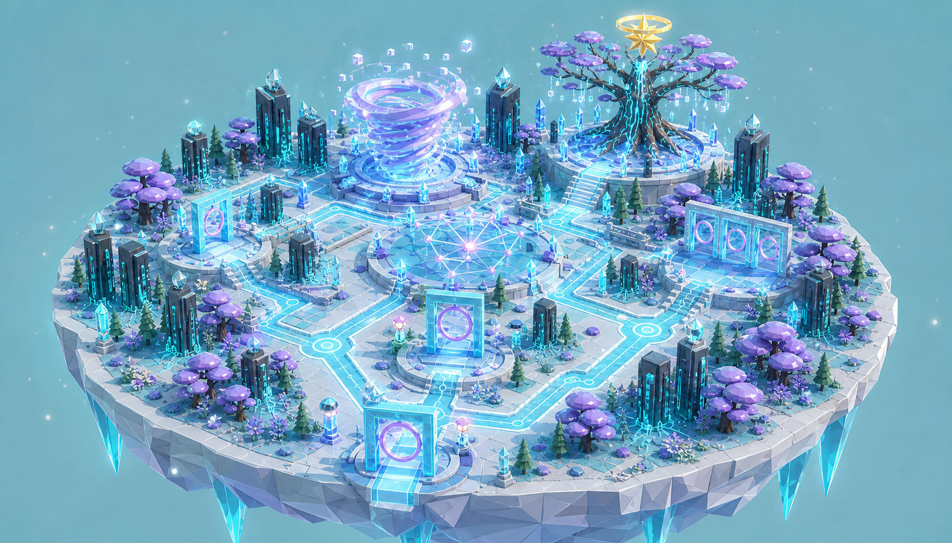
World One direction: Technology and Science lead. Nature and Magic support them.
SIMPLE EDITION This guide keeps the agreed world identity while using a smaller, clearer set of quests, enemies, and objects.

Version 2.1 • 14 August 2026 • Prepared for David Sovann and the ARTÉA team
GUIDE ORIENTATION

What is inside this guide
This guide follows the player from the town to the Art Castle, through Mind Spark, and to the first train unlock. It also explains four quests, sword combat, the boss, and five blueprint sheets.

Recommended world scope
TARGET 4 main quests • 10 required tasks • 5 enemy types • 1 combat-puzzle boss • Levels 1–5 • 6 required Thought Sparks • About 55–70 minutes for the first playthrough.

Contents
- 1. Mind Spark identity
- 2. The player’s journey from the town through World One
- 3. Four quests, tasks, time, and unlock steps
- 4. Sword combat, monsters, XP, and player levels
- 5. The Thought Storm Warden boss encounter
- 6. The world path and building scope
- 7. Five numbered blueprint sheets and object lists
- 8. Simple art, sound, UI, access, and programming rules

How the smaller plan works
- The first plan had eight quests. This guide combines them into four clear quests.
- The world keeps every type of object. Repeated objects use the same base model with small changes.
- Five enemy types reuse one shared Static Blight material and effect family.
- The boss has three stages. Each stage combines sword combat with a skill learned earlier.
MAIN STORY RULE The player fights the Static Blight that has trapped the world. The player does not fight thoughts or feelings. Defeated creatures break into clean light and return their energy to nature.

PART 1

Mind Spark Identity
A world where Technology and Science lead. Nature makes it feel alive, and Magic gives it wonder.
Identity field | Approved direction
World | Mind Spark Kingdom
Theme | I can understand my thoughts.
Dominant force | Technology / Science
Supporting forces | Nature and Magic
Treasure | Star of Wisdom
Guide | Mayor Milo Cat, the wise elder town leader and fatherly guide
Guardian | Guardian of Clear Thinking / Everlasting Father
Next unlock | The Crown Railway itself, then the route to Heart Melody, World Two

How the three forces work together
- Technology and Science lead (about 60%): server trees, thought maps, logic gates, circuits, scanners, and the train system.
- Nature supports (about 25%): roots, rain, flowers, lavender trees, pools, and new growth make the world feel warm and alive.
- Magic supports (about 15%): Thought Sparks, the Truth Path, the Guardian, and the Star of Wisdom make the world feel special.
WORLD IDEA A living computer forest where thoughts grow like stars and wisdom changes the path.

Important tone rules
- Sword fighting is clear and family-friendly. There is no blood or gore.
- Enemies show their attack before it happens. A defeat returns the player to the last safe node with no XP loss.
- The player attacks Static Blight shells, never thoughts, feelings, Milo, the Guardian, or friendly creatures.
- Gold shows wisdom, success, and the way forward.
- The path and tasks must stay easy to see during rain, lights, and effects.
- Every main object should mix Technology, Nature, and Magic.
PART 2

The Player’s Journey Through Mind Spark
This story begins in the town. Mayor Milo guides the player to the Art Castle. The train stays locked until the player saves Mind Spark.

Journey overview
A strange Static Blight has spread from the Art Castle. It mixes broken machines, wild roots, and unstable magic into monsters. Mayor Milo asks the player for help because the player’s crystal sword can break the dark Blight shell without harming the living world inside. The player enters Mind Spark through the first World Gate, defeats the creatures, repairs the wisdom systems, and faces the Thought Storm Warden. When the Star of Wisdom is restored, the Crown Railway wakes for the first time and becomes the travel system for later worlds.

Opening — Meet Mayor Milo
Town Square • Meet the mayor and accept his request
The player arrives in the town with a crystal sword. The streets are quiet, and small pieces of violet static move near the drains and roots. Mayor Milo waits in the square. He is an old, wise cat with a silver moustache, glasses, a mayor’s chain, and the Art Castle key. Milo explains that creatures have appeared near the castle and the town is losing power. He asks, ‘Will you help me wake the castle and protect our town?’ The player agrees. Milo gives the player a small map and leads the way.

Walk to the Art Castle
Town Road and Castle Entrance • Follow Milo and learn the basic controls
The player follows Milo through the town. Short signs teach walking, looking, dodging, and using the sword. Two weak Static Mites block the final bridge. Milo stays behind the safe line while the player defeats them. The creatures break into clean cyan light, and the roots below them become healthy again. This shows that the sword removes the Blight shell instead of hurting nature. Milo uses the town key, and the large Art Castle doors open.

The Game Begins — Enter the Art Castle
Main Gallery and Locked Crown Railway • See the problem and open the first World Gate
Inside the castle, the player sees empty Star displays and a beautiful train behind a dark glass seal. Milo explains that this is the Crown Railway, but it has no power. It cannot be ridden yet. The first Star must wake the train. A violet signal then moves across the Gallery and opens the Mind Spark World Gate. Milo says the Star of Wisdom has stopped protecting its world. Without it, the Thought Storm has covered the land and created Static Blight monsters. Milo asks the player to recover the Star so the town, the castle, and the railway can live again.

World Entry — Milo explains the mission
Mind Spark Arrival Grove • Enter World One and receive the four goals
The player and Milo walk through the gate together. They arrive in a floating forest of server trees, glowing roots, and lavender plants. The Thought Storm covers the Oldest Tree. Milo stays at the safe entrance beside a Mayor’s Beacon and gives hints from there. He explains four goals: clear the Static Blight, collect six Thought Sparks, repair the Wisdom Path, and defeat the Warden. Then the Star and return gate can open.

Quest 1 — Wake the Living Network
Arrival Grove and Living Server Forest • Learn combat, restore two nodes, and collect three Sparks
Static Mites and Glitch Sprouts guard two forest power nodes. The player learns a light attack, strong attack, dodge, and safe-node healing. After each fight, clean energy returns to the roots. The player repairs both nodes and collects three Thought Sparks. Milo explains that a Spark is not an enemy; it is wisdom that must be carried safely. The third Spark opens the Constellation Court.

Quest 2 — Read the Broken Pattern
Constellation Court and Logic Plaza • Fight new monsters, solve the pattern, and collect proof
Circuit Wisps attack from the air, and Root Stalkers charge across the court. The player learns to deflect a spark shot and dodge a charge to expose the rear core. After the fight, the player moves three thought points into a clear pattern. The Logic Gate asks if the signal is a fact now or a fear about later. Proof pieces and the final three Sparks open the Truth Gate.

Quest 3 — Build the Hope Path
Truth Gate and Hope Garden • Defeat the elite guard and build a path to the storm
A Blight Sentinel blocks the Truth Gate. The player dodges its shield slam and strikes the open chest core. The Sentinel becomes clean gold and cyan light. The player turns the Truth rings and chooses another answer that may also be true. Three Hope tiles—helpful thought, small action, and support—grow a new path toward the storm.

Quest 4 — Defeat the Thought Storm Warden
Thought Storm Arena • Use sword skill and clear thinking in the boss battle
The Warden is a large shell of dark glass, roots, and storm energy. The player defeats summoned monsters, powers three focus anchors, solves the shield pattern, and attacks the exposed core. At zero boss health, the player places the final Hope tile instead of making a killing blow. The shell breaks into light, the Guardian is freed, and the storm becomes gentle rain.

Finale — The Star of Wisdom
Oldest Tree Sanctuary • Receive the treasure and return through the World Gate
Gentle rain wakes the Oldest Tree, and the Star of Wisdom appears. The Guardian says, ‘You had the courage to protect this world, understand the truth, and choose hope.’ The player receives the Star and reaches Level 5. The player and Milo return through the World Gate and place the Star in the Gallery. The dark railway seal opens, the train lights turn on for the first time, and Heart Melody appears on the route map. The player has earned train travel between completed and unlocked worlds.
PART 3

Quest, Task & Story Plan
Four clear quests move the story forward. Required fights give enough XP to reach the right level without grinding.
# | Quest | Required fights | Quest XP | Time | Other required actions | What opens next
1 | Wake the Living Network | 4 Mites + 2 Sprouts | 50 | 12–15 min | Repair 2 nodes and collect 3 Sparks. | Court opens; Level 2.
2 | Read the Broken Pattern | 2 Wisps + 2 Stalkers | 75 | 14–17 min | Fix the pattern; collect proof and 3 Sparks. | Truth Gate opens; Level 3.
3 | Build the Hope Path | 2 Stalkers + 1 Sentinel | 100 | 12–15 min | Choose another truth and place 3 Hope tiles. | Boss path opens; Level 4.
4 | Defeat the Storm Warden | Boss + up to 3 Mites | 50 | 17–23 min | Break 3 anchors; attack the core; place Hope. | Star and train unlock; Level 5.

Five short questions
# | Stage | Question for the player | Why we ask it
1 | Network | Which root still has no power? | Teach the player to read cyan power lines.
2 | Pattern | Which point makes the lines clear? | Teach the pattern action used in the boss.
3 | Fear | Is this happening now, or might it happen? | Show the difference between fact and fear.
4 | Proof | What do we know, and what is still missing? | Teach the player to check proof.
5 | Hope | What is one small helpful next step? | Build the Hope Path and finish the boss safely.
QUESTION RULE These are short game choices, not school tests. A wrong answer gives a hint and lets the player try again. Only the five story choices are required.

Steps that unlock World Two
- Complete the three story quests, collect all 6 Thought Sparks, and reach Level 4.
- Finish all 3 boss stages and remove the Warden’s Static Blight shell.
- Receive the Star of Wisdom and save the calm, rainy version of Mind Spark.
- Walk through the World Gate and place the Star in the Art Castle Gallery.
- The Crown Railway wakes for the first time. Heart Melody becomes the first train destination.
PART 4

Sword Combat, Monsters & Player Levels
The combat plan matches the current Godot player: 100 health, 25 sword damage, attack, block, and an Area3D sword hitbox.
GODOT SCOPE Build one reusable EnemyBase scene and five small enemy variations. Use simple low-poly meshes, one body collision shape, Area3D hit and hurt boxes, AnimationPlayer, and short state machines. Do not use cloth, physics bones, or heavy effects.

ID | Enemy | HP | XP | Small state machine | Player answer
01 | Static Mite | 25 | 10 | Idle → chase → lunge → recover | One sword hit. Step aside from the clear lunge line.
02 | Glitch Sprout | 50 | 15 | Hidden → aim → seed shot → open | Two hits. Dodge the shot and strike the open gold core.
03 | Circuit Wisp | 50 | 20 | Hover → aim → 3 spark shots → stunned | Deflect a spark with the sword, then hit the stunned Wisp.
04 | Root Stalker | 75 | 30 | Patrol → charge → missed charge → recover | Dodge the charge and strike the bright rear core three times.
05 | Blight Sentinel | 150 | 60 | Guard → shield slam → open core → guard | Dodge the slam. Attack the chest only while the shield is open.
06 | Storm Warden | 300 core | 150 | Phase 1 → shield → exposed core → final Hope | Break anchors, attack the core during three openings, then place Hope.

Level plan — no grinding needed
Level | Total XP | Simple reward
1 | 0 XP | Start with light sword attack, block, dodge, and 100 health.
2 | 100 XP | Health rises to 110. Milo opens the first safe-node heal.
3 | 250 XP | Unlock the strong sword attack for stunned or open enemies.
4 | 450 XP | Perfect block can return a Circuit Wisp shot.
5 | 700 XP | World One complete. Gain one skill point for the next world.
- Required quest fights and quest rewards give about 700 XP. Optional fights are only for practice and a small buffer.
- Use a maximum of four normal enemies at one time. The boss may summon no more than three Mites.
- If health reaches zero, reload the last safe node with full health. Keep XP, Sparks, solved puzzles, and opened shortcuts.
PART 4 • GODOT BUILD NOTES

Godot 4.7 Implementation Plan
This plan uses systems already present in the ARTÉA project and keeps every monster small enough for the mobile/GL Compatibility renderer.
CURRENT PROJECT CHECK The current player already has 100 health, 25 sword damage, attack, block, an Area3D sword hitbox, and take_damage(amount, source). EnemyBase should use this same contract.

Reusable scene plan
Godot item | Implementation rule
Shared base | EnemyBase.tscn uses CharacterBody3D, simple CollisionShape3D, NavigationAgent3D, AnimationPlayer, Detection Area3D, Attack Area3D, and light particles. EnemyBase.gd stores health, damage, XP, target, cooldown, and take_damage(amount, source).
Enemy variations | Five scenes inherit EnemyBase and change mesh, size, stats, movement, and one attack. A shared Area3D projectile stores speed, damage, and lifetime. Do not copy the full enemy script.
Boss + performance | One CharacterBody3D boss uses a three-stage enum, three anchors, one core hurt box, timers, and reward signals. For the mobile/GL Compatibility renderer, use low-poly meshes, 1–2 materials, simple shadows, limited particles, and LOD meshes.

Build in this order
- Create EnemyBase.tscn and prove that the current sword can damage it.
- Add chase, attack warning, attack, hit reaction, defeat, and XP signals.
- Make Static Mite first. Test one enemy, then test four at the same time.
- Inherit the base for Sprout, Wisp, Stalker, and Sentinel. Give each only one main attack.
- Create one shared projectile for the Sprout and Wisp.
- Build the Warden from the same damage rules, then add the three boss stages.
- Test checkpoints, saved XP, mobile frame rate, reduced motion, and combat assist.

Small animation list
Asset | Required animations
Normal enemies | Idle, move, attack warning, attack, hit, defeat. Use 4–6 short clips.
Special states | Sprout open, Wisp stunned, Stalker missed charge, Sentinel shield open.
Warden | Idle storm, summon, anchor hit, core open, core hit, kneel, transform to rain.
FEASIBILITY LIMIT Use simple shapes for collision and never animate every root or armour piece. The blueprint shows the look; the Godot model uses a small skeleton, shared materials, and light particles.

PART 5

The Thought Storm Warden Boss
The boss is a sword battle and a world puzzle together. It checks combat, pattern reading, and the Hope choice learned in the first three quests.
BOSS RULE The player attacks the Warden’s dark Blight armour and exposed core. The final action is a Hope choice, not a killing blow. The Guardian is freed, and the storm becomes gentle rain.

Stage | What the player does | What changes | Skill used
1 — Focus | Defeat up to 3 Mites and switch on 3 focus anchors. | The storm slows, the Warden lands, and its shield pattern becomes visible. | Quest 1 taught combat, nodes, and following powered roots.
2 — Break the shield | Dodge storm lines, move 3 pattern points, and strike each matching anchor. | The shield breaks and opens the gold chest core for a short time. | Quest 2 taught patterns, proof, deflection, and weak points.
3 — Free the Guardian | Damage the core during 3 openings. At zero boss HP, place the final Hope tile. | The Blight shell dissolves, the Guardian is freed, and the storm becomes rain. | Quest 3 taught the Hope Path and the meaning of the final choice.

How the boss should feel
- Start: the Warden is large and powerful, but every attack has a clear cyan or violet warning.
- Combat: sword hits must feel strong. Use a brief flash, sound, small pause, and simple knockback. Do not use blood or gore.
- Progress: every broken anchor removes one storm layer and reveals more of the Oldest Tree.
- Defeat: reload the arena checkpoint with the player’s XP, Sparks, and completed quests kept.
- Finish: the Warden kneels at zero HP and waits for the Hope action. Violet wind becomes rain and gold light.
- Reduced motion: use slow clear rings and gentle particles instead of a fast spiral.

Reward steps
- The Warden gives 150 XP and the player reaches Level 5.
- The storm becomes gentle rain, and a path grows to the Oldest Tree.
- The Star of Wisdom appears, and the Guardian thanks the player.
- The player walks through the World Gate and places the Star in the Gallery.
- The Crown Railway turns on for the first time, and Heart Melody becomes available.
PART 6

World Path & Smaller Building Plan
Mind Spark has six connected areas. Reusing the same object families keeps the world beautiful and lowers the work needed to build it.
# | Area | What happens here | Main objects
0 | Town + Art Castle | Meet Mayor Milo, fight 2 tutorial Mites, enter the castle, and see the locked train. | Town square, road, bridge, castle doors, Main Gallery, World Gate, sealed train.
1 | World Gate + Arrival Grove | Walk into Mind Spark with Milo and see the storm and Oldest Tree. | World Gate, arrival bridge, Mayor’s Beacon, entry arch, root light.
2 | Living Server Forest | Collect main and optional Sparks; learn their shapes. | Server trees, glowing roots, lavender and green plants, guide posts.
3 | Constellation + Logic Plaza | Fix a pattern, choose fear or fact, and check proof. | Constellation court, logic gate, proof holder.
4 | Truth Gate + Hope Garden | Choose another possible truth and build the Hope Path. | Truth rings, Hope tiles, flowers, memory seed, shortcut.
5 | Thought Storm Arena | Complete the three-stage combat-puzzle boss. | Warden, storm rings, focus anchors, arena walls, checkpoint, rain version.
6 | Oldest Tree + World Gate | Receive the Star, meet the Guardian, and return to unlock the train. | Oldest Tree area, Star, Guardian platform, return path, World Gate.

Small object budget
Build group | Amount | Simple rule
Main landmarks | 8 unique | Entry portal, three gates, Constellation Court, server trees, storm arena, and Oldest Tree.
World building | 6 groups | Island, paths, bridges, railway, technology forest, and living nature.
Quest and magic | 6 groups | Sparks, pattern puzzle, logic tools, Mayor’s hints, Hope and growth, and Star reward.
Enemies | 5 + 1 boss | One shared Godot base scene, five enemy variations, and one three-stage boss.
Characters and dressing | 6 groups | Player, Milo, Guardian, small life, signs and lights, and rest and display objects.
Optional content | Small | Reuse enemies and objects for one or two short side paths. No new gameplay system is needed.
World versions | 3 versions | Sleeping, waking, and gentle rain use the same world models with different lights and effects.
REUSE RULE Before making a new model, reuse an approved object by changing its size, direction, group, material, light, or plants.
PART 7 • BLUEPRINT PLATE A

Eight Key Landmarks
Eight important places show the main path, teach the thought skills, hold the boss battle, and give the final reward.
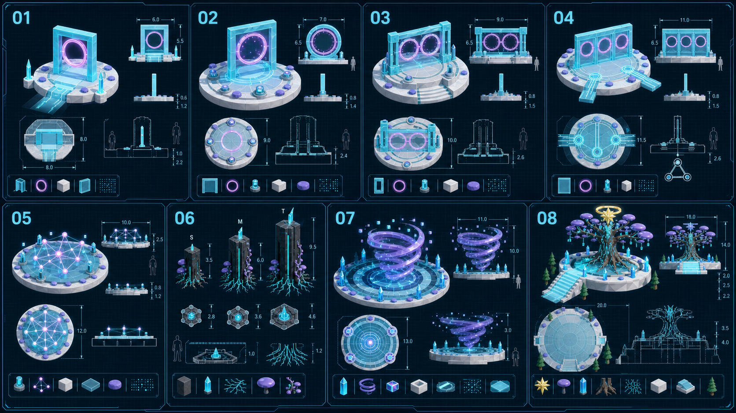
Numbered blueprint sheet. Match each picture number to the object list below.
ID | Object / group | What it does | What the developer builds
01 | Mind Spark World Gate | Brings the player from the Art Castle into Mind Spark and shows the first goal. | Add a glowing doorway, safe start point, clear view forward, and a return state that opens after the boss.
02 | Fear Gate | Shows the difference between a fact now and a fear about later. | Use a clear triangle shape. It holds one Thought Spark and never uses harsh flashing.
03 | Proof Gate | Checks proof and shows what information is missing. | Use three Spark holders. Show known, unknown, and complete with symbols as well as colour.
04 | Truth Gate | Helps the player find another possible truth and opens the Hope Path. | Use turning rings. More than one believable answer can work. The success light is gold.
05 | Constellation Court | Changes crossed thought lines into a clear pattern. | Use movable points on a round platform. Keep a clear view toward the Logic Plaza.
06 | Server-Tree Family | Makes the technology feel alive and shows if the world has power. | Make short, medium, and tall versions. Reuse roots, materials, detail levels, and the cyan power animation.
07 | Thought Storm Arena | Holds the safe three-stage combat-puzzle boss. | Use layered rings, three focus anchors, arena walls, a checkpoint, clear attack warnings, and a reduced-motion version.
08 | Oldest Tree Sanctuary | Gives the Star, shows the Guardian, and ends the world. | Make it the tallest landmark. Add stairs or a ramp, a place for the Star, and a permanent gentle-rain version.
BLUEPRINT PLATE B

World Building Kit
Six reusable object groups are enough to build the full path. They keep movement, collision, size, materials, and world changes consistent.
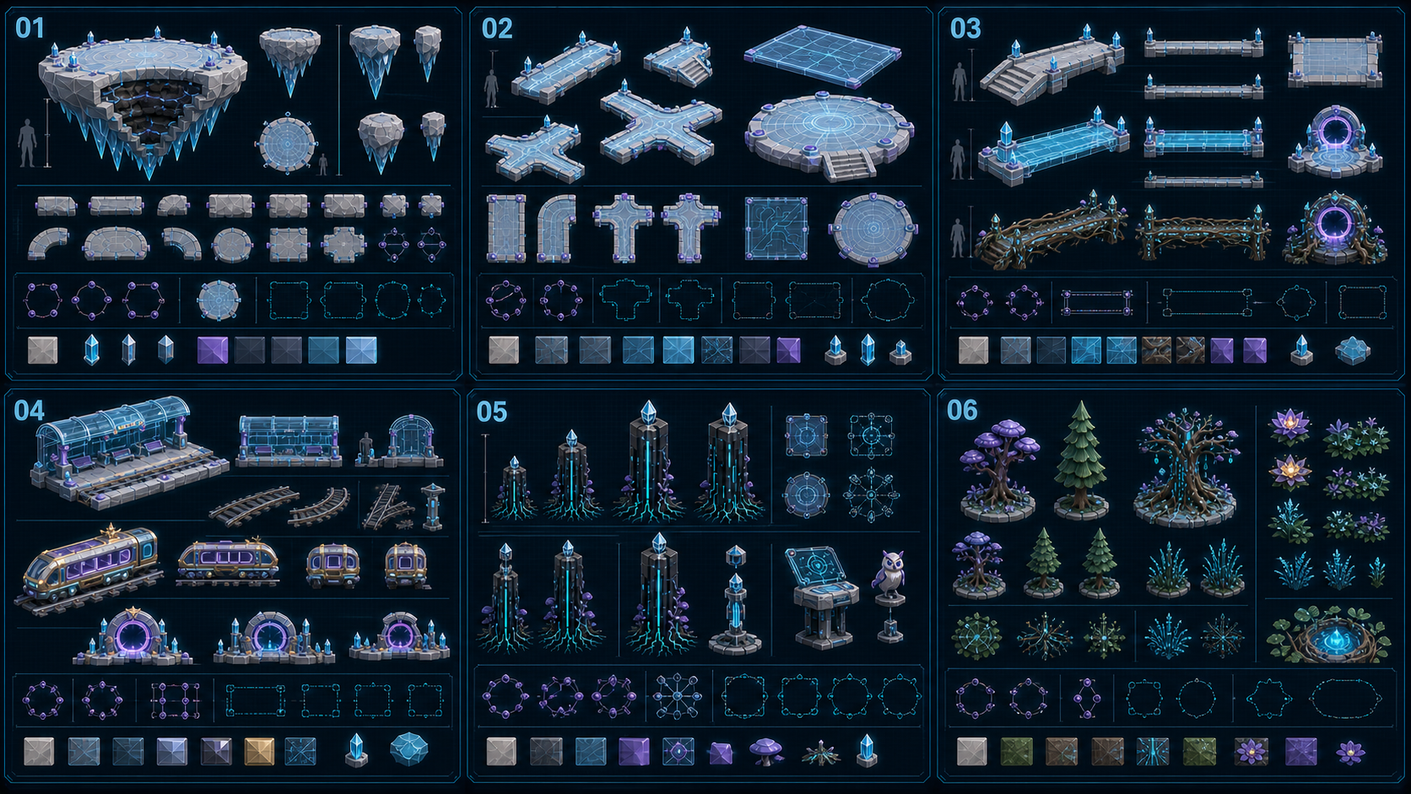
Numbered blueprint sheet. Match each picture number to the object list below.
ID | Object / group | What it does | What the developer builds
01 | Floating Island Base | Holds the world and gives it a safe outer edge. | Use reusable cliff pieces, crystal shapes below, a collision floor, fog recovery, and hidden walls.
02 | Path and Floor Group | Builds clear paths, plazas, ramps, stairs, and glass floors. | Use one snap grid and a clear 3–4 metre path. Keep the cyan guide line free from objects.
03 | Bridge Group | Connects the areas and opens new shortcuts. | The normal, energy, and root bridges use the same width, collision, rail height, and end snaps.
04 | Crown Railway Group | Becomes the travel system only after World One is complete. | Before the Star: train dark, doors sealed, no ride action. After the Star: lights turn gold, doors open, and Heart Melody appears on the route map.
05 | Technology Forest Group | Builds the science look and gives the player tools to use. | Server trees, glowing roots, and consoles share the same light material and detail rules.
06 | Living Nature Group | Makes the technology warmer and shows the world waking up. | Reuse trees, pines, mixed trees, flowers, grass, ferns, and pools with simple wind and growth movement.
BLUEPRINT PLATE C

Quest and Magic Kit
Six reusable groups cover collecting, puzzles, logic, help, growth, and the final Star reward.
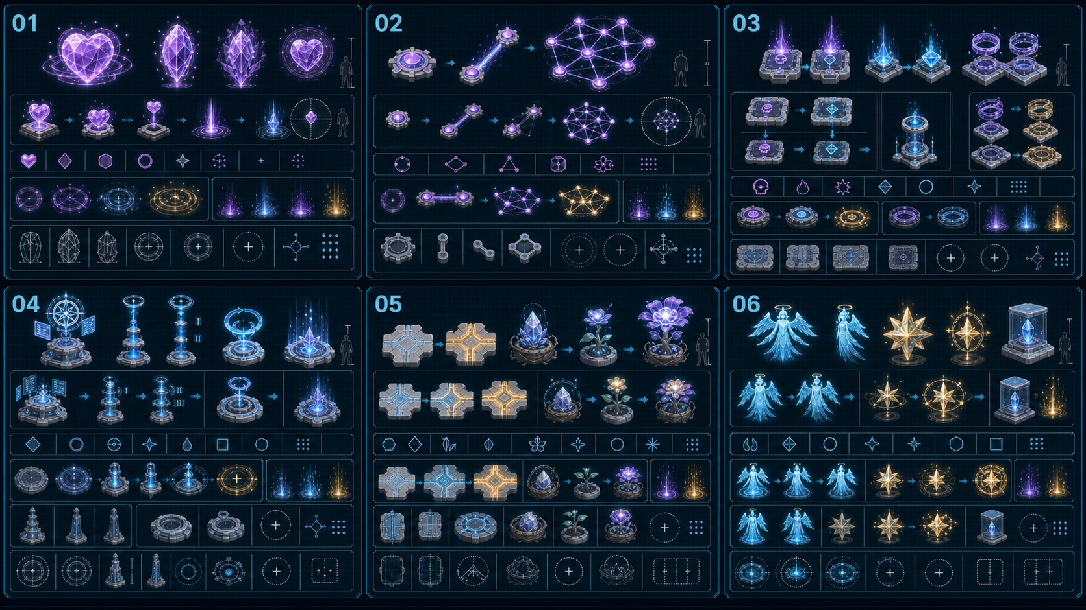
Numbered blueprint sheet. Match each picture number to the object list below.
ID | Object / group | What it does | What the developer builds
01 | Thought Spark Group | Shows feelings, facts, fears, and helpful ideas. | Use different shapes. All Sparks share idle, pick up, carry, place, and collected states.
02 | Constellation Puzzle Group | Helps the player see how thoughts connect. | Use movable points, link lines, snap places, a complete pattern, a hint glow, and a reset.
03 | Logic Tool Group | Combines fear or fact, proof, and another possible truth. | Choice pads, Spark holders, and rings use the same controls but have different shapes.
04 | Help and Hint Group | Gives Mayor Milo’s information, hints, save points, and a calm retry. | Use the Mayor’s Beacon, three hint levels, a reset control, and a clear safe node.
05 | Hope and Growth Group | Changes a helpful choice into a new path and living growth. | Hope tiles, Truth Path, memory seed, thought flower, and wisdom flower turn on in clear stages.
06 | Wisdom Reward Group | Shows the Guardian, gives the Star, and saves it in the Gallery. | The Guardian, Star, memory piece, and display case change from cyan to gold when complete.
BLUEPRINT PLATE D

Characters and World Objects
These six groups use the current fox player and elder Mayor Milo. They also cover the Guardian, small animals, path signs, rest places, and Gallery displays.
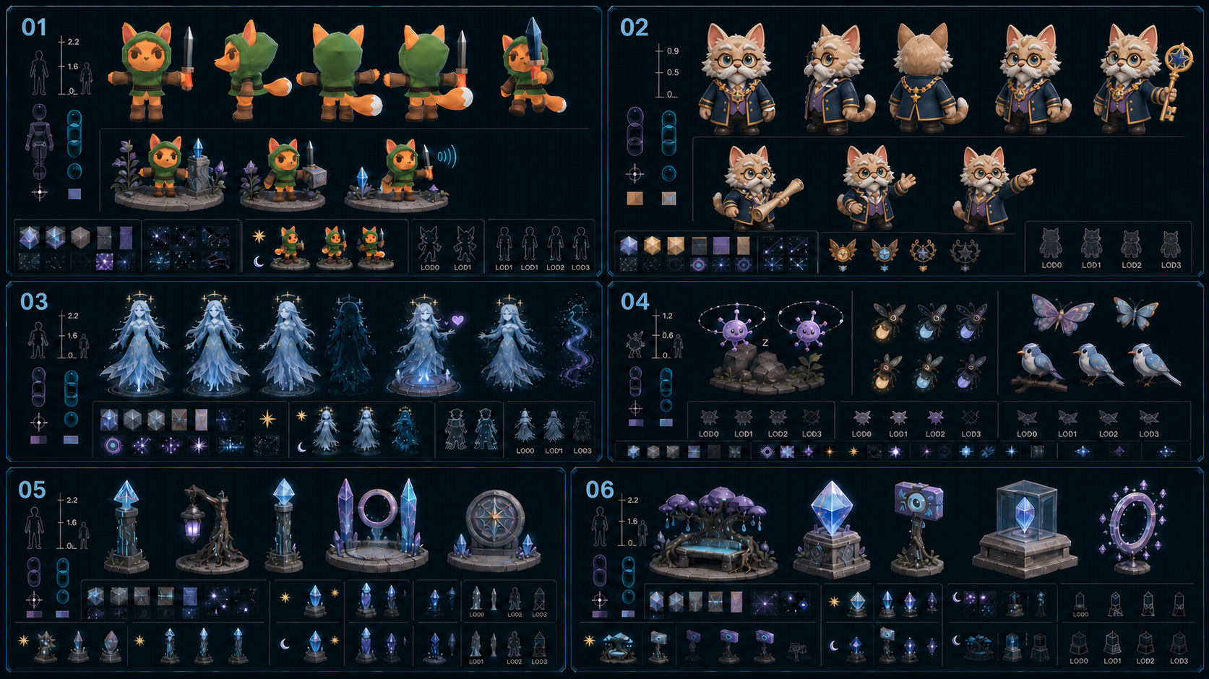
Numbered blueprint sheet. Match each picture number to the object list below.
ID | Object / group | What it does | What the developer builds
01 | In-Game Fox Player | Lets the player explore, carry, choose, fight, block, dodge, gain XP, and level up. | Use the current orange fox: dark-green hood, brown boots, gloves and belt, white tail tip, and crystal sword. Reuse the current health, sword Area3D, block, and take_damage system. Add strong attack, hit reaction, dodge, defeat, and level-up actions.
02 | Mayor Milo Cat | Wise elder mayor and fatherly guide who asks for help, leads the player to the castle, explains the mission, and gives hints. | Keep Milo as a cream, tan, and brown elder cat with blue eyes, round gold glasses, silver-white moustache, full silver cheeks, bushy eyebrows, and soft age lines. Use a midnight mayoral coat, violet waistcoat or sash, gold piping, gold chain of office, and Art Castle crest. Give him the town key and rolled map. Add welcome, listen, explain, encourage, and point-to-castle poses. Milo stays in safe areas and never fights.
03 | Guardian of Clear Thinking | Thanks the player for being brave and gives meaning to the reward. | Use a soft light body with appear, speak, and fade actions. Do not add fighting movement or a scary pose.
04 | Small Life Group | Makes the forest feel safe, alive, and friendly. | The Spark friend, firefly, moth, and bird use simple repeated movement, low-detail versions, and no blocking collision.
05 | Signs and Lights | Shows the path, gate state, world identity, and safe edge. | Guide posts, root lamps, short posts, status crystals, and emblems use the same clear symbols.
06 | Rest and Display | Gives places to rest, take pictures, and show memories in the Gallery. | Keep the root bench, memory crystal, photo marker, display case, and frame away from the main path.
BLUEPRINT PLATE E

Static Blight Monsters & Boss
All six designs are possible in Godot 4.7 and fit the current mobile/GL Compatibility renderer. The art is detailed, but the game models should stay low-poly and use simple shared systems.
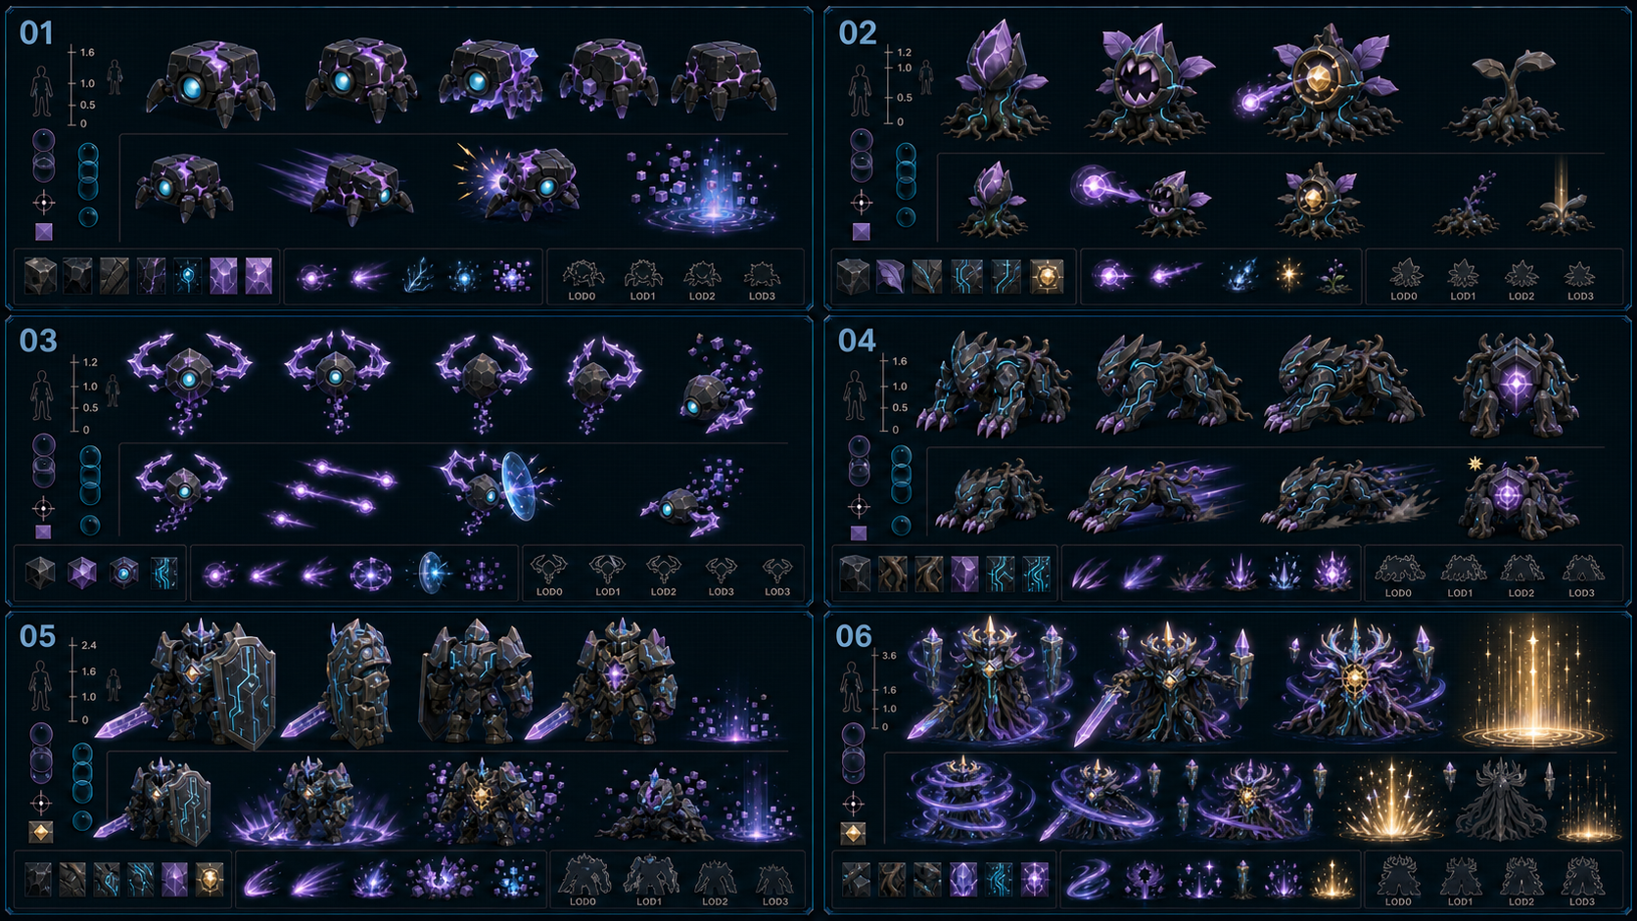
Numbered blueprint sheet. Match each picture number to the object list below.
ID | Object / group | What it does | What the developer builds
01 | Static Mite | Fast one-hit tutorial monster worth 10 XP. | Godot: CharacterBody3D, capsule collision, 25 HP, detection Area3D, lunge timer, 4 short animations, shared dissolve effect.
02 | Glitch Sprout | Stationary ranged monster worth 15 XP. | Godot: CharacterBody3D with no navigation, 50 HP, one projectile spawn point, aim timer, open-core hurt state, 4 short animations.
03 | Circuit Wisp | Flying ranged monster that teaches deflection; 20 XP. | Godot: floating CharacterBody3D, sphere collision, 50 HP, simple height spring, one shared projectile, stunned timer, 5 animations.
04 | Root Stalker | Charging beast with a rear weak point; 30 XP. | Godot: CharacterBody3D + NavigationAgent3D, box or capsule collision, 75 HP, charge RayCast3D, rear Area3D, 5 animations.
05 | Blight Sentinel | Shielded elite that guards the Truth Gate; 60 XP. | Godot: CharacterBody3D + NavigationAgent3D, capsule collision, 150 HP, shield bool, chest Area3D, slam timer, 6 animations.
06 | Thought Storm Warden | Three-stage World One boss worth 150 XP and the Star. | Godot: one boss scene, 300 core HP, three anchor nodes, one core Area3D, phase enum, timers, arena signals, checkpoint, and final Hope interaction.
PART 8

Simple Building Rules
These rules help the art, effects, sound, UI, access, and programming teams build the same clear world.
Team | What must be built
Art | Use simple low-poly shapes, white ice ground, black glass technology, lavender plants, cyan systems, violet thoughts, and small amounts of gold for wisdom.
Lights / Effects | Make three world versions: sleeping, waking, and complete. Goals are brighter than decorations. Add a reduced-motion option.
Sound | Use six sound groups: town and Milo, forest circuits, sword combat, logic puzzle, storm boss, and the first train unlock. Remove storm layers as the boss is freed.
UI | Show current task, health, XP bar, Level 1–5, 0/6 Sparks, hint, enemy health for elite and boss, boss stage, and the train unlock reward.
Access | Add subtitles, larger text, symbols that do not need colour, control changes, camera settings, reduced motion, combat assist, hints, checkpoints, and auto-help.
Programming | Build shared enemy damage, XP and levels, quest progress, checkpoints, Sparks, puzzles, boss phases, world lighting, train unlock, collision, sound areas, and test tools.

The world is ready when
☐ The player meets Mayor Milo in town, follows him to the Art Castle, and sees that the train is locked.
☐ The first playthrough takes about 55–70 minutes without optional exploration.
☐ All 4 quests, 10 main tasks, 5 choices, 6 main Sparks, 5 enemy types, 5 levels, and 3 boss stages save correctly.
☐ Each enemy works through the current sword hitbox and shared take_damage() contract in Godot 4.7.
☐ Normal encounters never use more than 4 enemies, and the mobile renderer stays at the target frame rate.
☐ Every blueprint object group has an owner, model plan, collision rule, action rule, and state list.
☐ The current task and next landmark are easy to see in all six areas.
☐ The sleeping, waking, and gentle-rain world versions save and load correctly.
☐ The player can return through the World Gate, place the Star, wake the train for the first time, and open Heart Melody.
☐ Reduced motion, symbols, subtitles, larger text, control choices, and help options work correctly.
FINAL WORLD MESSAGE You found the courage to understand your thoughts and choose hope. The wisdom was already growing inside you.

WORLD ONE • MIND SPARK
Meet the Mayor. Enter the Castle. Save World One. Unlock the train.
Mind Spark world style and the main player path.
DISCOVERY, NOT FIXING
Mind Spark teaches the player to protect the world, understand a problem, choose hope, and earn the journey to Heart Melody.

