World One — Mind Spark
The Two Lenses of Wisdom · three connected islands
Current-game edition • 18 October 2026
Mind Spark is the first Crown of Life journey. Players notice a difficult thought, test its signal with evidence and hope, and help the Warden without treating fear as an enemy. The current chapter has five canonical quests, twenty narrative tasks and ten saved walkable milestones. Its reward is the Star of Wisdom.
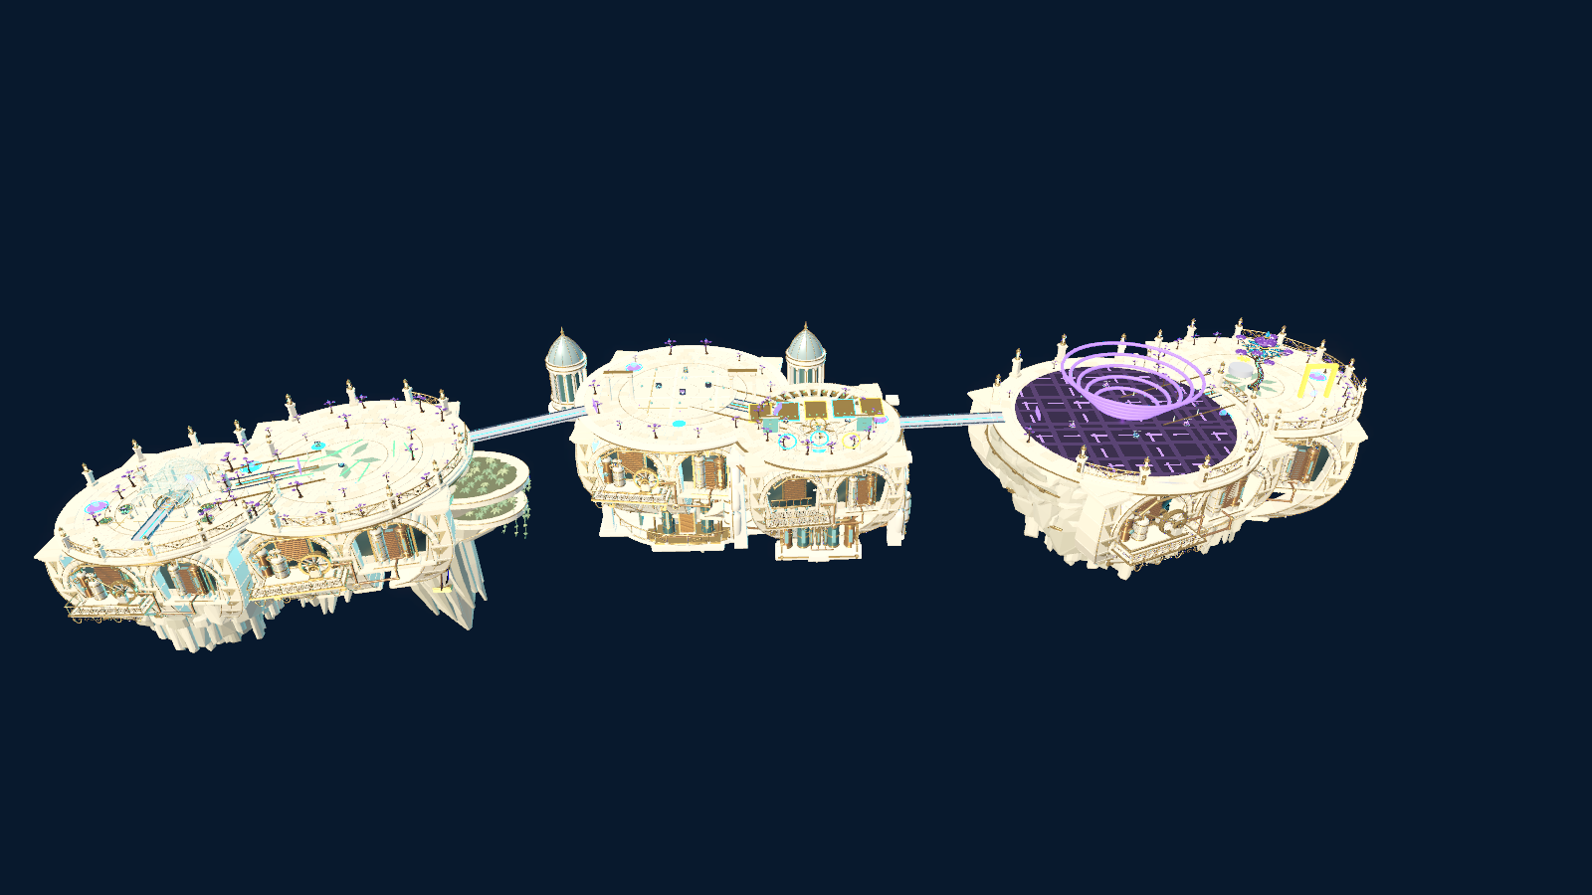
Project runtime capture of the three connected Mind Spark islands (archived 2026). This is rendered game geometry.

What the player sees
The route begins at the Signal Observatory, crosses an echo garden and the evidence and hope districts, then reaches the Thought Storm and the Oldest Tree Sanctuary. Six internal district identifiers support the route, but the player travels through three physical islands. Interaction stations, bridges, gates, changing weather and the final sanctuary make progress visible in the world.

Playable journey
Step | Place and action | Visible result
1 · Notice the Signal | Signal Observatory: route Thought, Feeling and Choice through separate instruments; synchronize the first gate. | The observatory lights and the way to the echo area opens.
2 · Listen to the Echo | Echo Forest/Garden: gather signals, sort fact from possibility, and turn a warning into a useful question. | The echo route stabilizes and the second island becomes reachable.
3 · Understand the Moment | Evidence Constellation Court: inspect evidence and memories, revise a pattern and restore a crossing. | The broken pattern becomes a traversable path.
4 · Build a Possible Tomorrow | Hope Path Ridge: change perspective, work with the lenses and choose a grounded next step. | The route through the storm opens.
5 · Calm the Thought Storm | Thought Storm Arena to Oldest Tree Sanctuary: combine the chapter’s tools and free the Warden. | Gentle rain, a restored sanctuary and the Star of Wisdom.

Player experience
- Mistakes invite revision. The story does not score a player’s inner state or require personal disclosure.
- Optional reflection choices can be skipped and do not change XP, gates or the Star reward.
- The same five quest IDs drive the narrative data and the physical-world presentation; legacy save aliases preserve older progress.

Entry and completion
The campaign’s Mind entry is the Thought menu scene. The castle gallery also presents the walkable three-island chapter. The Star of Wisdom is the first required treasure for the later Heart Melody and Creator’s Light routes.

Current implementation reference
The chapter structure is in artea/data/mind_spark_chapter.json. The walkable route and milestones are in artea/scripts/mind_spark/mind_spark_world_one.gd and mind_spark_world_one_quest.gd. For the full object system and production audit, see world_one_object_minigame_catalog.gd and artea/docs/MIND_SPARK_WORLD_ONE_IMPLEMENTATION_HANDBOOK.md.

What this edition corrects
The earlier guide described a generic four-quest, three-stage-boss, level-banded prototype. Those counts and a fixed playtime are not supported by the current chapter. This edition uses the five named quests, three-island route and actual Star completion path in the project.

Verification scope
The refreshed web export loaded the Artéa start screen and playable castle arrival on 18 October 2026. The island image above is an earlier project runtime capture. A complete browser playthrough of all five quests and a native/Web parity check remain to be performed.

