World Three — Creator’s Light
The artwork and gallery journey in the current game
Current-game edition • 18 October 2026
Creator’s Light opens after the Star of Wisdom and Harmony Jewel. The current reward route begins in the drawing studio and ends with a deliberate Gallery Frame Ritual. The player creates and saves artwork, chooses a motif, places it in a frame and confirms it. This act grants Creator’s Light; exporting or saving an image alone does not.
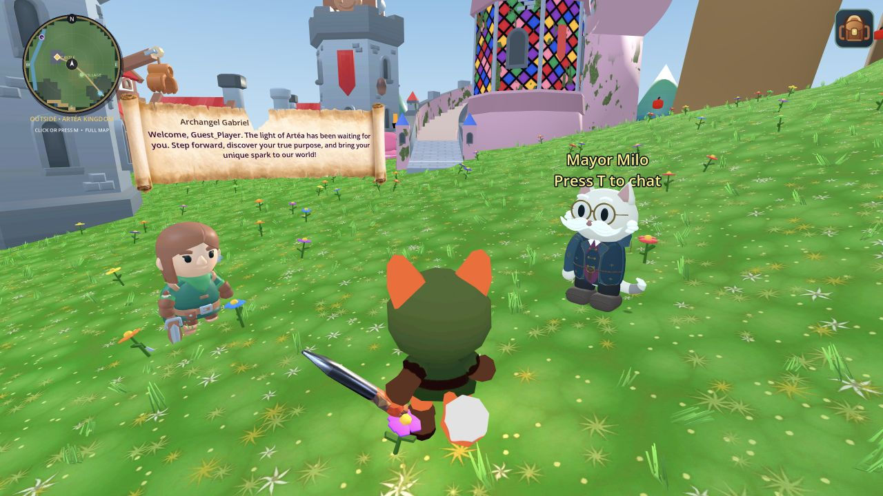
Fresh Web build screenshot: Artéa Castle, the shared journey hub.

Core experience
The studio supplies brush, stamp, eraser, clear and save tools. The player can keep the original or make an optional local colour variation; the original file remains intact. Saved work can be viewed in the gallery and prepared as an explorable artwork world. The gallery ritual lets the player give that creation a chosen meaning without analysing or judging the image.

Current reward flow
Step | Player action | Game result
1 · Enter the studio | Use the drawing tool after Mind Spark and Heart Melody rewards are earned. | Creator’s Light route is available.
2 · Make and save art | Draw or stamp a scene, save it locally, and optionally keep a separate colour variation. | A creation record and artwork file are available to the gallery.
3 · Frame the creation | Open Gallery Frame Ritual; choose Star Bridge, Dream Door or Constellation Mural. | A motif is placed over the chosen artwork. The player may undo or revise.
4 · Confirm | Confirm the placed motif. | The ritual is recorded and Creator’s Light is awarded.
5 · Explore further | Enter the artwork world from the gallery when a world is ready. | The painting becomes a small navigable space with an interactive environment.

Meaning of the three motifs
- Star Bridge suggests a hopeful next step.
- Dream Door suggests a possibility to explore.
- Constellation Mural celebrates parts of the player’s story.
There is no correct motif. The ritual records the player’s choice; it does not infer personality from the picture or use artwork analysis to award the treasure.

Current implementation reference
Area | Source in the game
Unlocks and reward | artea/scripts/journey_campaign.gd and JourneyState.gd — prerequisite treasures and frame ritual award.
Studio | artea/scenes/drawing_tool.tscn and artea/scripts/drawing_tool.gd — tools, save and gallery flow.
Ritual | artea/scripts/creation_world/gallery_frame_ritual.gd — three motifs, placement, undo and confirmation.
Artwork world | artea/scripts/creation_world/creation_world.gd — explorable world generated from a selected creation.

What this edition corrects
The previous four-quest kingdom, level curve and three-stage boss are not the current Creator’s Light completion path. The Art Castle also contains a Creator-themed landscape and other optional viewing systems, but the campaign treasure is awarded by the Gallery Frame Ritual. This guide describes that implemented path.

Verification scope
The refreshed Web build loaded the shared hub. The route and reward were checked in the current scenes and scripts. Studio, ritual, artwork-world interaction and completion have not yet been played through end to end in this browser session.

