World Two — Heart Melody
A playable music and feeling journey
Current-game edition • 18 October 2026
Heart Melody follows the Star of Wisdom. Its current chapter data defines three regions, six zones, four ordered quests and ten tasks. The player restores a silent garden and river through instruments, fruit and collaborative musical actions, then frees the Silent Conductor. The reward is the Harmony Jewel.
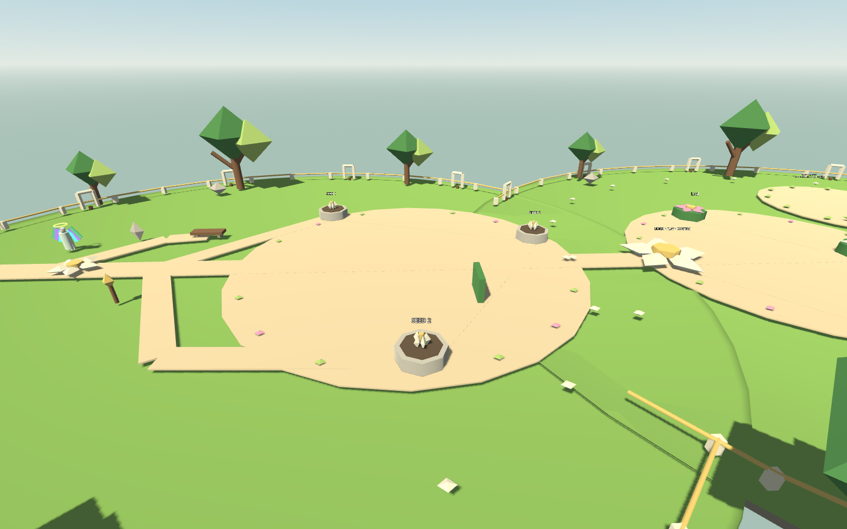
Project runtime capture (archived 2026): Heart Melody’s planter court on the Quiet Meadow and Feeling Garden route.

World layout
Region | Zones | Player focus
First Breath | Quiet Meadow · Feeling Garden | Plant feeling seeds, rebuild a rhythm, clear two Blight waves.
River Voice | Waterfall Organ River · Bell Grove Peace Garden | Tune the organ, release the Hush Vine Harp, call the Rain Boat, cross chimes and warning bells.
Shared Song | Harmony Stage · Harmony Jewel Sanctuary | Assemble the Heart Song and conduct the final orchestra.

Quest route in the game
Quest | Playable work | Completion
Wake the Feeling Garden | Plant three feeling seeds. Play the Leaf → Sun → Droplet phrase. Clear two Blight waves. | Garden restored.
Restore the River Song | Use three Dew Pears at the Waterfall Organ, five Sun Plums at the Hush Vine Harp and four Bell Apples for the Rain Boat. | River route restored.
Build the Heart Song | Restore three bridge chimes, cross the warning path with Moon Melons, then arrange the motif at the Heart Song Loom. | Song assembled.
Free the Silent Conductor | Join the beat anchors, place six fruits in the orchestra and conduct the final phrase. | Conductor freed; Harmony Jewel and Harmony Shield awarded.

Fruit and assistance
Six fruit types have musical roles: Echo Berry repeats, Sun Plum supports tempo, Dew Pear pitch, Bell Apple resonance, Moon Melon sustain and Harmony Fig harmony. Recipes provide replay, focus, healing, timing help, challenge assistance and a final cosmetic upgrade. Assistance and optional identity choices do not reduce rewards.

Progression
The campaign requires the Star of Wisdom before Heart Melody opens. Garden, river, song and harmony completion are separate saved states. The Harmony Jewel unlocks the Creator’s Light route together with the Star.

Current implementation reference
Area | Source in the game
Quest and item data | artea/data/heart_melody_chapter.json — regions, four quests, ten tasks, fruit and recipes.
Progression rules | artea/scripts/heart_melody/heart_garden_state.gd — current objective text and completion flags.
Playable world | artea/scripts/heart_melody/heart_garden_world.gd and heart_world.gd.
Campaign connection | artea/scripts/journey_campaign.gd and JourneyState.gd.

What this edition corrects
The old guide’s fixed level range, three-stage boss and estimated duration were concept targets. The checked-in chapter has four specific quests and a Silent Conductor finale. The early implementation plan described only the first garden; current state and chapter files include the river, song and harmony sequences.

Verification scope
The refreshed Web build loaded the shared Artéa hub. The garden image is an earlier project runtime capture. This update checks the quest data and state code, but does not claim an end-to-end browser completion of Heart Melody.

