Andrew Hostetler

Labyrinth Game
PA-4

CS 480

October 10, 2013

Project Overview

Main Project:

The goal of this project was to create a 3D rotating platform maze game. Specifically a labyrinth game with a ball the 'rolls' around a pivoted surface. This ball had to be contained in the maze by both outer and inner walls while traversing the maze to reach an end goal. In addition, holes in the maze were to be introduced to add obstacles and provide difficulty to the player. My project implements all of these required tasks except for implementing correct collisions with the inner maze walls. This issue will be discussed later in the Technical Manual. All other aspects have been implemented fully.

Listed EC:

This project implements no Extra Credit tasks.

User Manual

Game-play:
Your goal as the player is to navigate your player through a maze full of walls and holes. Falling through a hole will cause you to lose and you will have to restart. Reaching the red goal circle is the only way to win.

Controls:
  - The W-A-S-D keys can be used to rotate the board.
  - The mouse can also control the board's rotation.

Both controls rotate the board in the direction of movement. For example, moving the mouse to the right will make the board dip down on its right side.

Menu:
This is controlled by pressing the right mouse button (RMB).
Three Options are given:
    - Start : Restarts the game, placing the ball at the start (the green circle )
    - Pause/Restart : Causes all game function to stop, and then restart upon the next click.
    - Quit : This exits the game.

The Game:
Below is a screen shot of the running game:
The Green Circle in the bottom of the maze is the starting point.
The Red Circle in the middle bottom of the maze is the finish.
The Orange Ball is the player, and is what can be controlled.
The Holes are obstacles for the player to dodge.

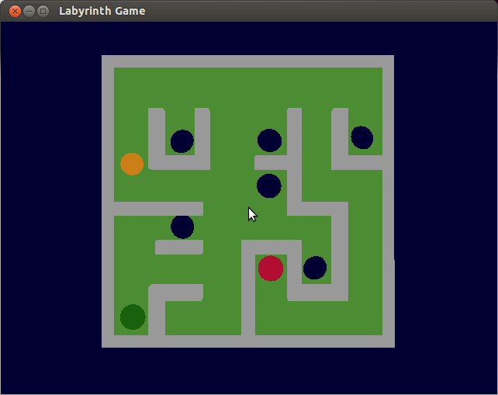

Technical Manual

Issues:

The two biggest problems that were found in this project was that of trying to interface with both a model loader, and a physics engine. Most of the time spent on this project was trying to get a working model loader running. I tried greatly to get ASSIMP working properly but gave up after much grief and decided to write my own .OBJ model loader. This was much simpler than trying to install a different loader. Separate entirely was the effort made to install and get a physics engine running for the game. I was able to install and test a little with the physics engine Box2D but did not have time to fully understand it and implement the necessary physics into the maze game. As of the 'finished' game now, my maze only keeps the player's ball from the leaving the outer wall, but does not do any sort of collisions with the inner maze.

Things to be done differently:

If I had more time and I had to do this project again I would get proper ball physics working on the inner maze of labyrinth. This would greatly improve the playability and feel of the game. Also, it would help improve my grade. Also, I would look into doing more EC tasks to help improve the all around grade of this project.

