**Business Report**

**Yuthika Khedwal**

***Content :***

***1) Introduction of the business problem***

*a) Defining problem statement (Pg - 02)*

*b) Need of the study/project (Pg - 02)*

*c) Understanding business/social opportunity (Pg - 02)*

***2)Data Report***

*a) Understanding how data was collected in terms of time, frequency and*

*methodology (Pg - 02-03)*

*b) Visual inspection of data (rows, columns, descriptive details) (Pg - 03-04)*

*c) Understanding of attributes (variable info, renaming if required) (Pg - 04-07)*

***3) Exploratory data analysis***

*a) Univariate analysis (distribution and spread for every continuous attribute,*

*distribution of data in categories for categorical ones) (Pg - 08-09)*

*b) Bivariate analysis (relationship between different variables , correlations) (Pg - 10-14)*

*c) Removal of unwanted variables (if applicable) (Pg - 14)*

*d) Missing Value treatment (if applicable) (Pg - 15-16)*

*e) Outlier treatment (if required) (Pg - 17-18)*

*f) Variable transformation (if applicable) (Pg - 19-20)*

*g) Addition of new variables (if required) (Pg - 20)*

***4) Business insights from EDA***

*a) Is the data unbalanced? If so, what can be done? Please explain in the context*

*of the business (Pg - 20)*

*b) Any business insights using clustering (if applicable) (Pg - 21)*

*c) Any other business insights (Pg - 22-23)*

***1) Introduction of the business problem***

***a) Problem statement***

*The major objective of this data set is to extract actionable insights from the leading life insurance company data and make strategic changes to make the company grow. Primary objective is to create Machine Learning models which correctly predicts the bonus for its agents so that it may provide information regarding high performing agents and low performing agents. Once a model is developed then it can extract actionable insights and recommendation, so based of which the company may design appropriate engagement activity and up skill programs for their agents as required.*

***b) Need of the study/project***

*Based on their agents to sell the policies, the insurance companies are heavily dependent on their success. So, it becomes very crucial to find and design engagement activity for their high performing agents giving them more and more incentives to keep up their performance and achieve more and also, up skill programs for their low performing agents to get better and perform better, and such that all together their agents are more able to sell the quality insurance to their customers and add more greater value to the company. And through this project with the help of data and its analysis help the insurance company to make data-driven business decisions. It empowers companies with high-level data and information that is leveraged into improved insurance processes and new opportunities.*

***c) Understanding business / social opportunity***

*Usually businesses benefit to the extent that they stay close to customers. Traditionally, the insurance company has relied on strong networking and trusted relationships. By transforming into social businesses, insurers can tap significant opportunities that enable them to generate more demand, win customer loyalty and maximize returns.*

1. ***Data Report***
2. ***Understanding how data was collected in terms of time, frequency and methodology***

*The data belongs to a leading life insurance company. The agent’s different sales data based on the customers’ varied attributes like age, tenure in organization, channel through which acquisition is done, their occupation, education, Designation Marital status, Gender, their location, complaint registered, income, customer satisfaction score, all collected in the course of time they were with the company. Certain attributes leading to the Agent’s bonus are also captured.*

|  |  |  |
| --- | --- | --- |
| ***Data*** | ***Variable*** | ***Discerption*** |
| *Sales* | *CustID* | *Unique customer ID* |
| *Sales* | *AgentBonus* | *Bonus amount given to each agents in last month* |
| *Sales* | *Age* | *Age of customer* |
| *Sales* | *CustTenure* | *Tenure of customer in organization* |
| *Sales* | *Channel* | *Channel through which acquisition of customer is done* |
| *Sales* | *Occupation* | *Occupation of customer* |
| *Sales* | *EducationField* | *Field of education of customer* |
| *Sales* | *Gender* | *Gender of customer* |
| *Sales* | *ExistingProdType* | *Existing product type of customer* |
| *Sales* | *Designation* | *Designation of customer in their organization* |
| *Sales* | *NumberOfPolicy* | *Total number of existing policy of a customer* |
| *Sales* | *MaritalStatus* | *Marital status of customer* |
| *Sales* | *MonthlyIncome* | *Gross monthly income of customer* |
| *Sales* | *Complaint* | *Indicator of complaint registered in last one month by customer* |
| *Sales* | *ExistingPolicyTenure* | *Max tenure in all existing policies of customer* |
| *Sales* | *SumAssured* | *Max of sum assured in all existing policies of customer* |
| *Sales* | *Zone* | *Customer belongs to which zone in India. Like East, West, North and South* |
| *Sales* | *PaymentMethod* | *Frequency of payment selected by customer like Monthly, quarterly, half yearly and yearly* |
| *Sales* | *LastMonthCalls* | *Total calls attempted by company to a customer for cross sell* |
| *Sales* | *CustCareScore* | *Customer satisfaction score given by customer in previous service call* |

1. ***Visual inspection of data (rows, columns, descriptive details)***

*RangeIndex: 4520 entries, 0 to 4519*

*Data columns (total 20 columns):*

*# Column Non-Null Count Dtype*

*--- ------ -------------- -----*

*0 CustID 4520 non-null int64*

*1 AgentBonus 4520 non-null int64*

*2 Age 4251 non-null float64*

*3 CustTenure 4294 non-null float64*

*4 Channel 4520 non-null object*

*5 Occupation 4520 non-null object*

*6 EducationField 4520 non-null object*

*7 Gender 4520 non-null object*

*8 ExistingProdType 4520 non-null int64*

*9 Designation 4520 non-null object*

*10 NumberOfPolicy 4475 non-null float64*

*11 MaritalStatus 4520 non-null object*

*12 MonthlyIncome 4284 non-null float64*

*13 Complaint 4520 non-null int64*

*14 ExistingPolicyTenure 4336 non-null float64*

*15 SumAssured 4366 non-null float64*

*16 Zone 4520 non-null object*

*17 PaymentMethod 4520 non-null object*

*18 LastMonthCalls 4520 non-null int64*

*19 CustCareScore 4468 non-null float64*

*dtypes: float64(7), int64(5), object(8)*

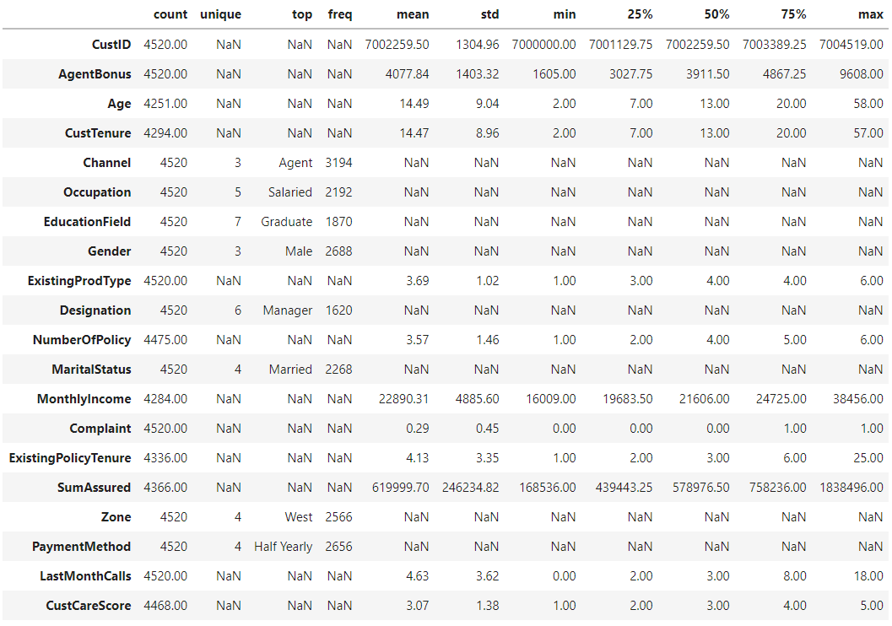

1. ***Understanding of attributes (variable info, renaming if required)***

***The name of the columns seems to be fine with no special characters or spaces between them.***

***Unique values of various Categories :***

*Channel : 3*

*Online 468*

*Third Party Partner 858*

*Agent 3194*

*Name: Channel, dtype: int64*

*Occupation : 5*

*Free Lancer 2*

*Laarge Business 153*

*Large Business 255*

*Small Business 1918*

*Salaried 2192*

*Name: Occupation, dtype: int64*

*EducationField : 7*

*MBA 74*

*UG 230*

*Post Graduate 252*

*Engineer 408*

*Diploma 496*

*Under Graduate 1190*

*Graduate 1870*

*Name: EducationField, dtype: int64*

*Gender : 3*

*Fe male 325*

*Female 1507*

*Male 2688*

*Name: Gender, dtype: int64*

*Designation : 6*

*Exe 127*

*VP 226*

*AVP 336*

*Senior Manager 676*

*Executive 1535*

*Manager 1620*

*Name: Designation, dtype: int64*

*MaritalStatus : 4*

*Unmarried 194*

*Divorced 804*

*Single 1254*

*Married 2268*

*Name: MaritalStatus, dtype: int64*

*Zone : 4*

*South 6*

*East 64*

*North 1884*

*West 2566*

*Name: Zone, dtype: int64*

*PaymentMethod : 4*

*Quarterly 76*

*Monthly 354*

*Yearly 1434*

*Half Yearly 2656*

*Name: PaymentMethod, dtype: int64*

***The highlighted data seems to be recorded incorrectly and required replacement and this was done to ensure the right categories are picked up by the model***

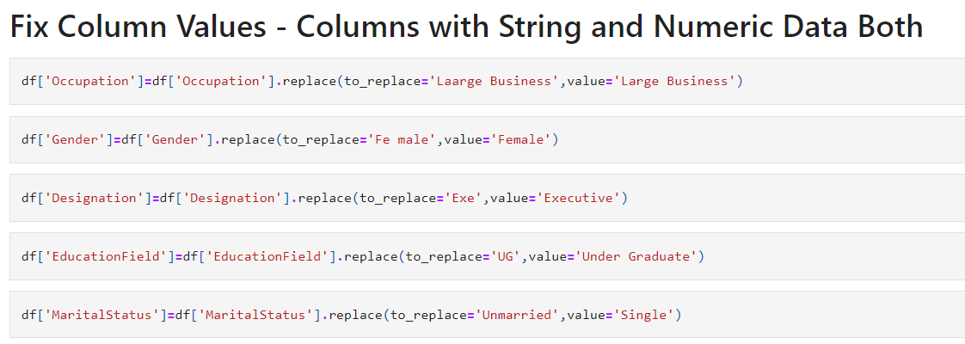

***Post fixing of the data :***

*Channel : 3*

*Online 468*

*Third Party Partner 858*

*Agent 3194*

*Name: Channel, dtype: int64*

*Occupation : 4*

*Free Lancer 2*

*Large Business 408*

*Small Business 1918*

*Salaried 2192*

*Name: Occupation, dtype: int64*

*EducationField : 6*

*MBA 74*

*Post Graduate 252*

*Engineer 408*

*Diploma 496*

*Under Graduate 1420*

*Graduate 1870*

*Name: EducationField, dtype: int64*

*Gender : 2*

*Female 1832*

*Male 2688*

*Name: Gender, dtype: int64*

*Designation : 5*

*VP 226*

*AVP 336*

*Senior Manager 676*

*Manager 1620*

*Executive 1662*

*Name: Designation, dtype: int64*

*MaritalStatus : 3*

*Divorced 804*

*Single 1448*

*Married 2268*

*Name: MaritalStatus, dtype: int64*

*Zone : 4*

*South 6*

*East 64*

*North 1884*

*West 2566*

*Name: Zone, dtype: int64*

*PaymentMethod : 4*

*Quarterly 76*

*Monthly 354*

*Yearly 1434*

*Half Yearly 2656*

*Name: PaymentMethod, dtype: int64*

1. ***Exploratory data analysis***
2. ***Univariate analysis (distribution and spread for every continuous attribute, distribution of data in categories for categorical ones)***

Right Skew

Continuous over a large range

Continuous

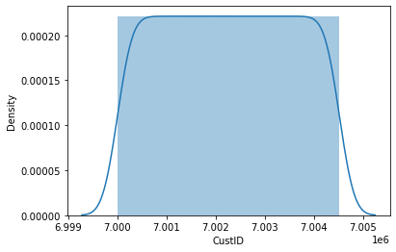 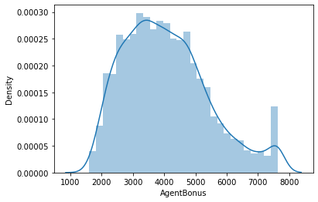

Right Skew

Continuous over a large range

Right Skew

Continuous over a large range

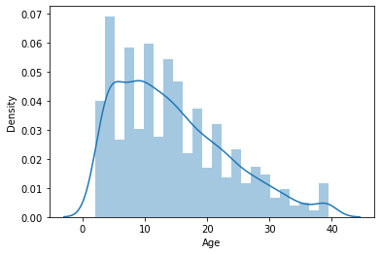 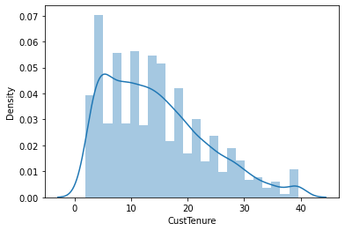

More Discrete Kind of data 4 is the most frequent observation

Continuous

Right Skewed

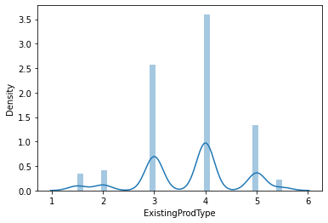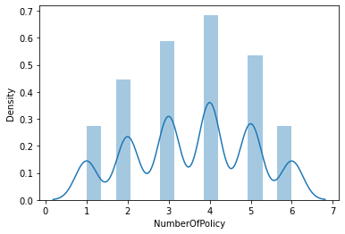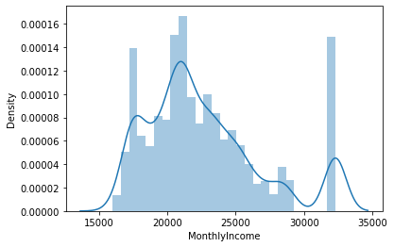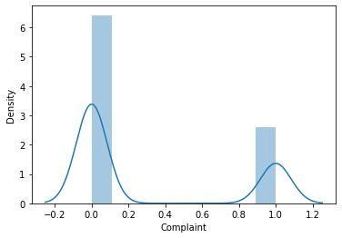

Continuous in a range with two peak values.

Discrete Values

Right Skew

Discrete Values

Right Skew

Continuous over a large range

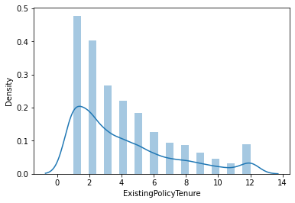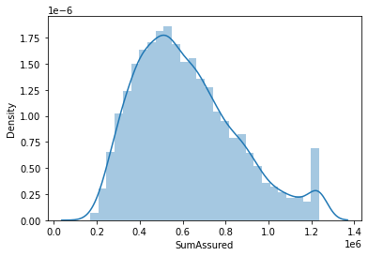

Discrete kind of data with 2 peak values in the range

More Discrete Kind of data. 3 is the most frequent observation

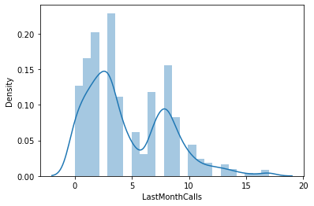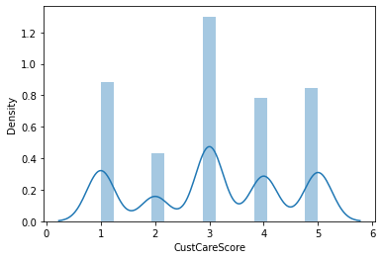

1. ***Bivariate analysis (relationship between different variables , correlations)***

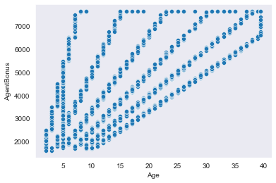 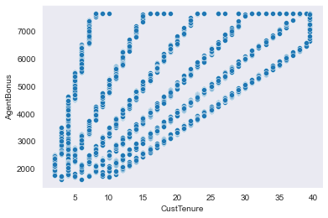

Positively Related

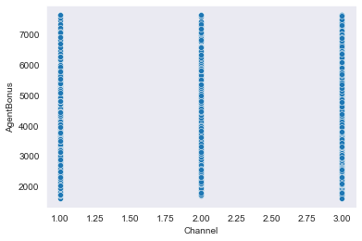 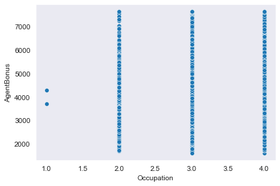

Not able to establish any relation between variables

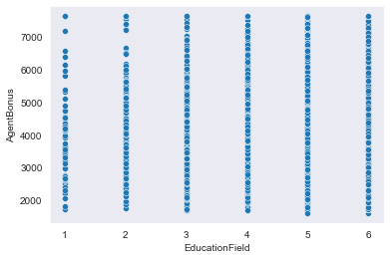 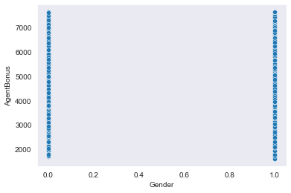

Not able to establish any relation between variables

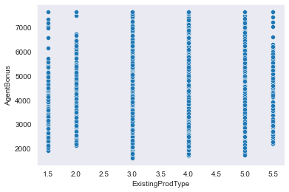 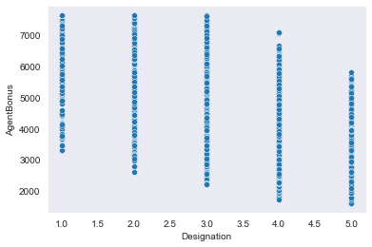

Not able to establish any relation between variables

Negatively Related

Positively Related

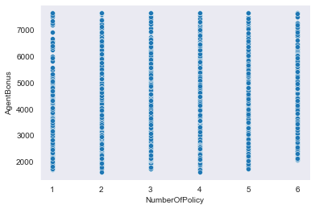 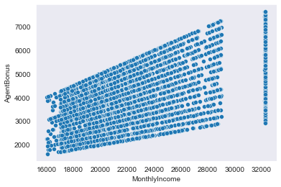

Not able to establish any relation between variables

Positively Related

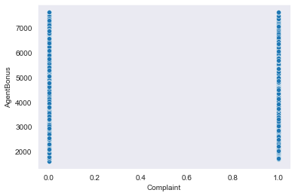 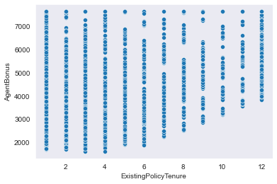

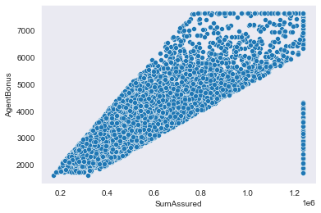 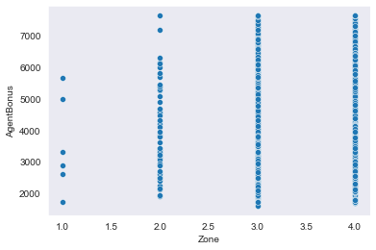

Positively Related

Not able to establish any relation between variables

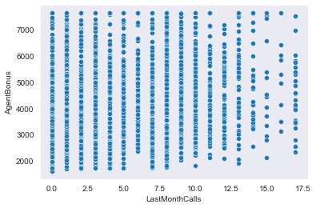 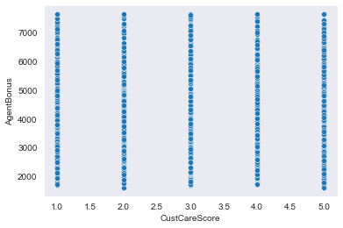

Not able to establish any relation between variables

*Most of the variables don’t seem to be related closely to each other which means there is low multi-collinearity in the data and each feature would have its importance in building the right model . because of this we have not dropped any columns and would want to build the model to see the variable importance.*

*The pair plot also seems to suggest the same thing . But due to the huge number of columns pair plot was not providing very clear insight and hence resorted to bi variate plots with every combination possible.*

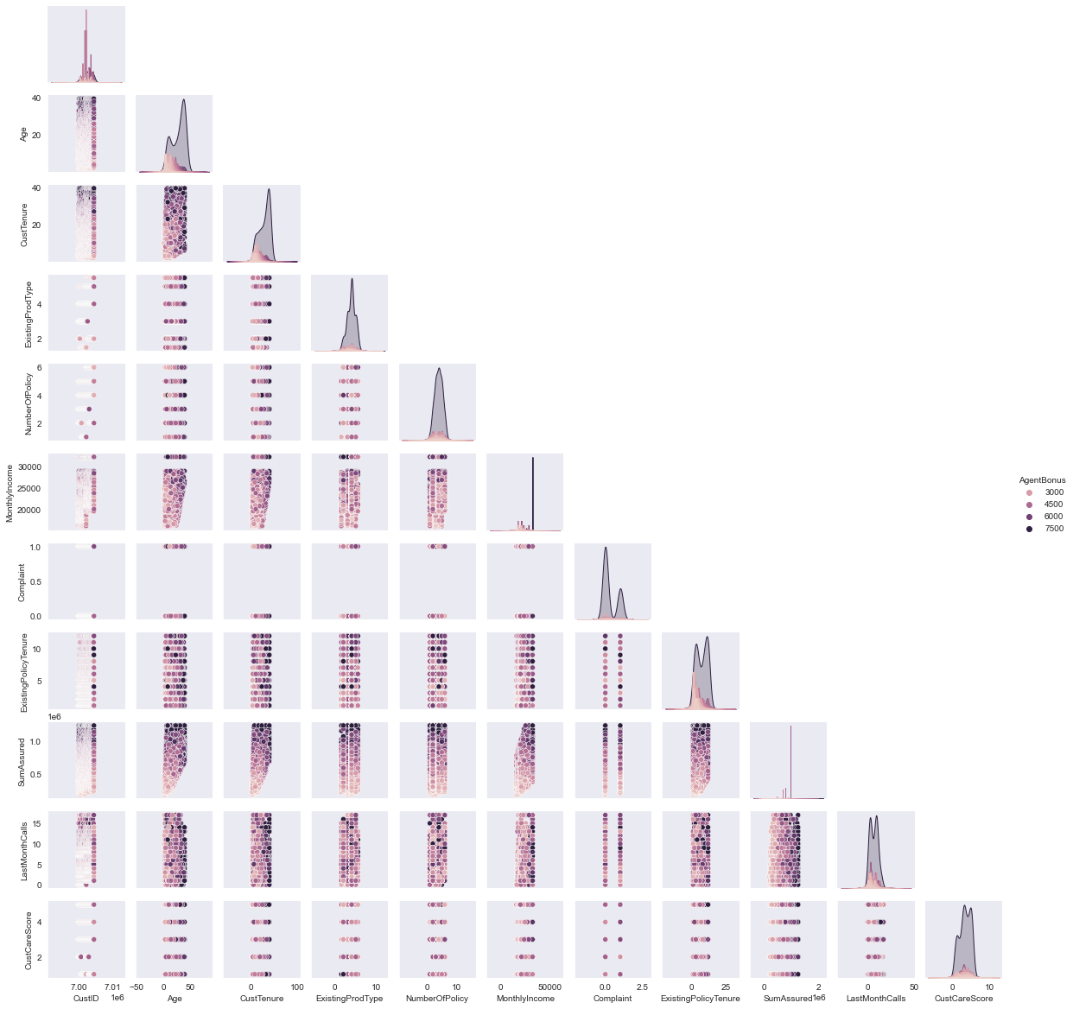

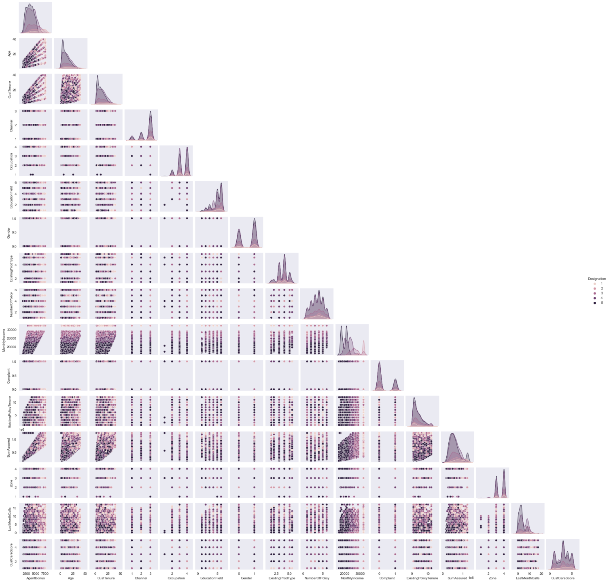

1. ***Removal of unwanted variables***

*In the dataset CustID, MaritalStatus and PaymentMethod are all redundant columns and thus have been removed. Chose not to remove any other columns and left to the model phase where the variable importance would be judged.*

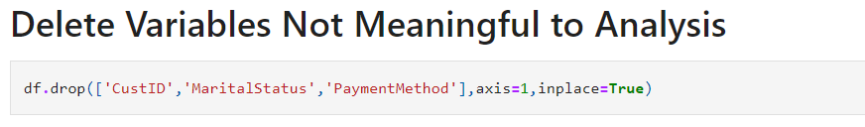

1. ***Missing Value treatment***

*There are 1166 missing values in the dataset :*

*Age 269*

*MonthlyIncome 236*

*CustTenure 226*

*ExistingPolicyTenure 184*

*SumAssured 154*

*CustCareScore 52*

*NumberOfPolicy 45*

*LastMonthCalls 0*

*Zone 0*

*Complaint 0*

*AgentBonus 0*

*ExistingProdType 0*

*Gender 0*

*EducationField 0*

*Occupation 0*

*Channel 0*

*Designation 0*

*dtype: int64*

*The missing values have been treated with most frequent values than median for numeric data including categorical data . The main reason of choosing mode or most frequent entry was it was making more sense considering the sports domain to which the problem belongs . More so as we have been in the various plots as well the numeric data has discrete pattern due to which we treated them as categorical data.*

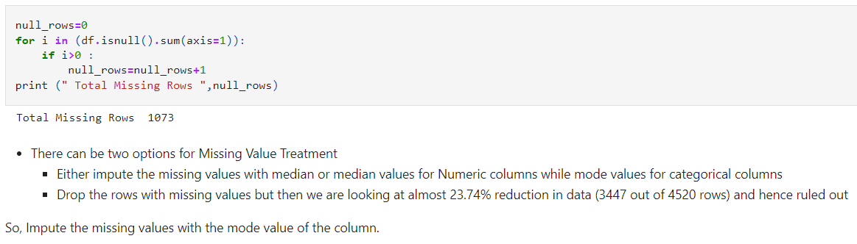

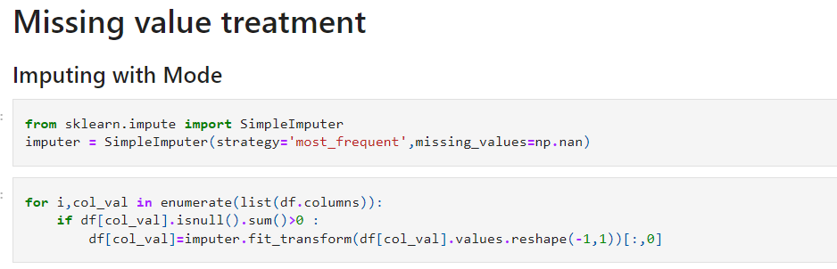

*After Treatment of missing value :*

*AgentBonus 0*

*Age 0*

*CustTenure 0*

*Channel 0*

*Occupation 0*

*EducationField 0*

*Gender 0*

*ExistingProdType 0*

*Designation 0*

*NumberOfPolicy 0*

*MonthlyIncome 0*

*Complaint 0*

*ExistingPolicyTenure 0*

*SumAssured 0*

*Zone 0*

*LastMonthCalls 0*

*CustCareScore 0*

*dtype: int64*

1. ***Outlier treatment***

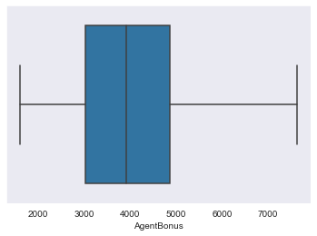 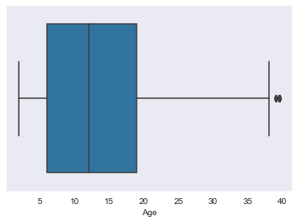

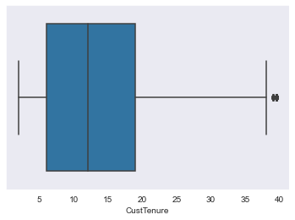 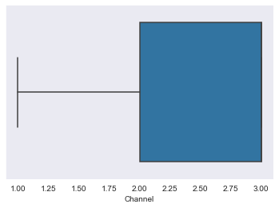

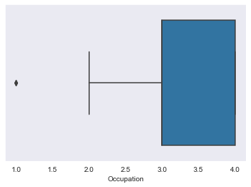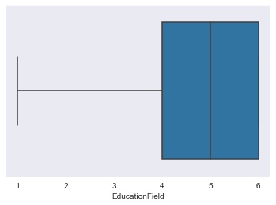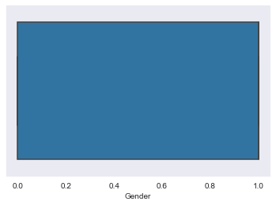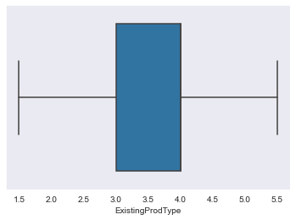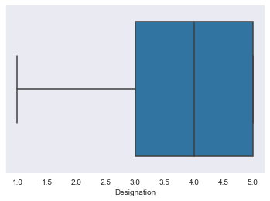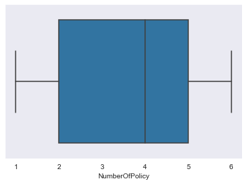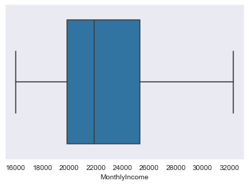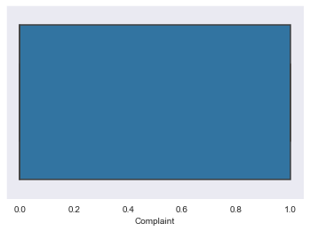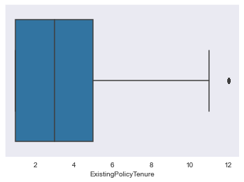

*Even though most of the numeric data here is discrete but few of the variables here are playing an important role in predicting the required value for the model which might get affected because of the outlying values, hence the outliers might reduce the value to the model. Like the age and customer tenure with the company which stands out while most of the others are in the right range.*

*So, in favour of doing the outlier treatment :*

*Detecting the Outliers*

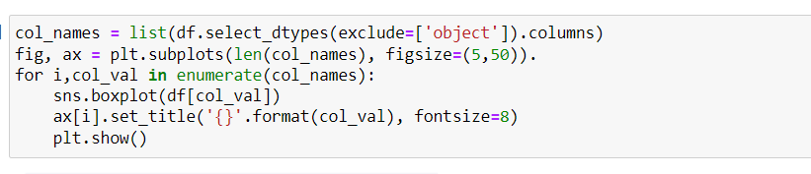

*Outlier Treatment :*

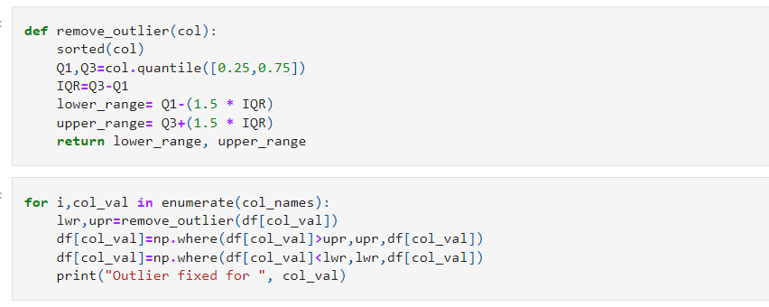

*Outlier fixed for CustID*

*Outlier fixed for AgentBonus*

*Outlier fixed for Age*

*Outlier fixed for CustTenure*

*Outlier fixed for ExistingProdType*

*Outlier fixed for NumberOfPolicy*

*Outlier fixed for MonthlyIncome*

*Outlier fixed for Complaint*

*Outlier fixed for ExistingPolicyTenure*

*Outlier fixed for SumAssured*

*Outlier fixed for LastMonthCalls*

*Outlier fixed for CustCareScore*

1. ***Variable transformation***

*The variables has been encoded to numeric values for the following variables :*

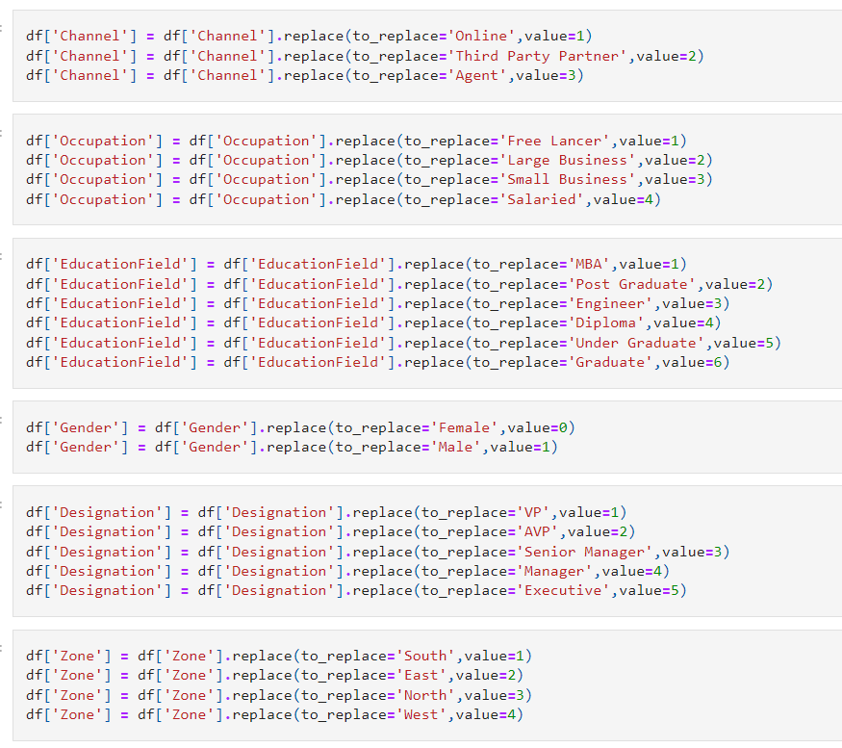

1. ***Addition of new variables***

*No new variables were added at this stage . But before proceeding with the model one hot encoding would be required on few categories which would increase the number of column not essentially the number of variables.*

***4) Business insights from EDA***

***a) Is the data unbalanced? If so, what can be done? Please explain in the context of the business***

*The data is balanced.*

***b) Any business insights using clustering (if applicable)***

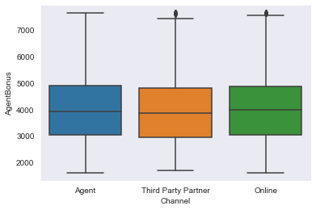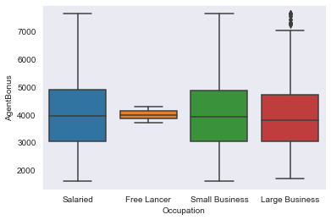

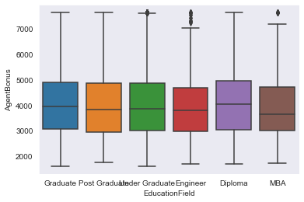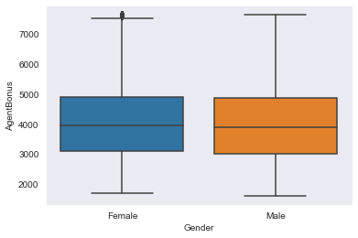

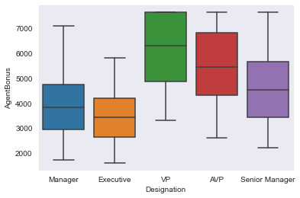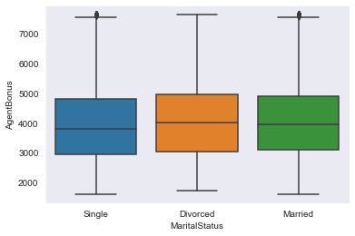

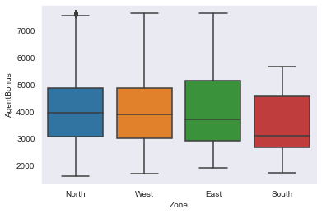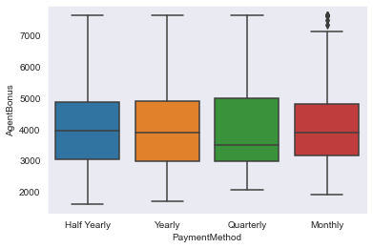

*Age, CustTenure, monthlyIncome, SumAssured seems to be correlated with AgentBonus which means with increase in age and then tenure of customer also increase in sumAssured and monthlyincome brings the best performance in an Agent, but may not be true for the everyone. Designation plays an negative role on the Agents Bonus as well.*

1. ***Any other business insights***

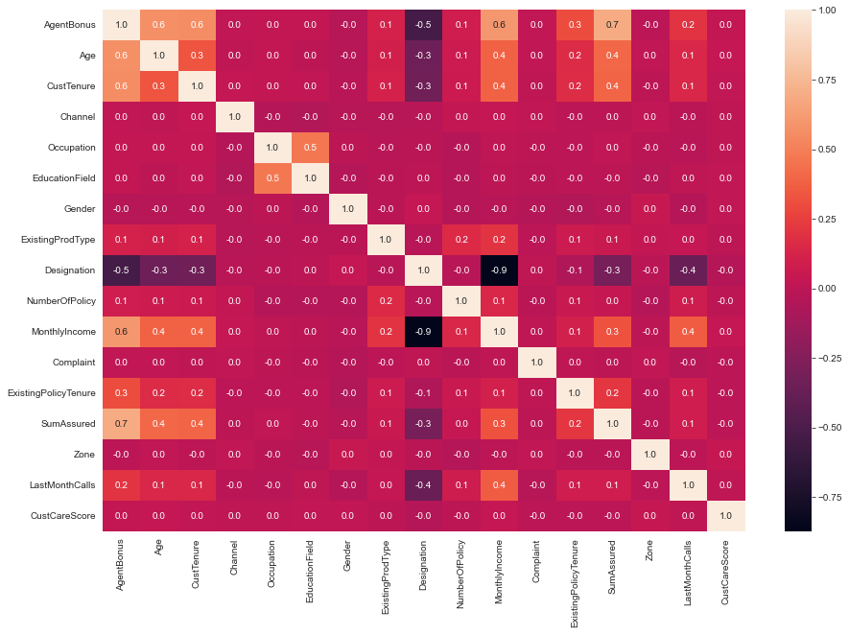

* *Age, CustTenure, monthlyIncome, SumAssured seems to be correlated with AgentBonus which means with increase in age and then tenure of customer also increase in sumAssured and monthlyincome brings the best performance in an Agent, but may not be true for the everyone.*
* *Designation plays an negative role on the Agents Bonus as well as at monthlyIncome which means as move from VP towards Executive the Bonus and monthy income decreases.*