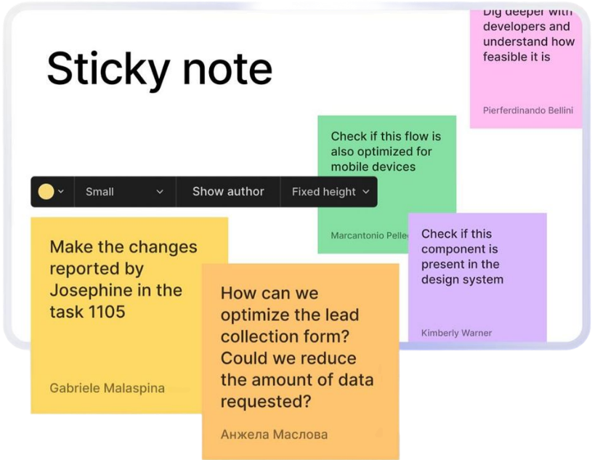
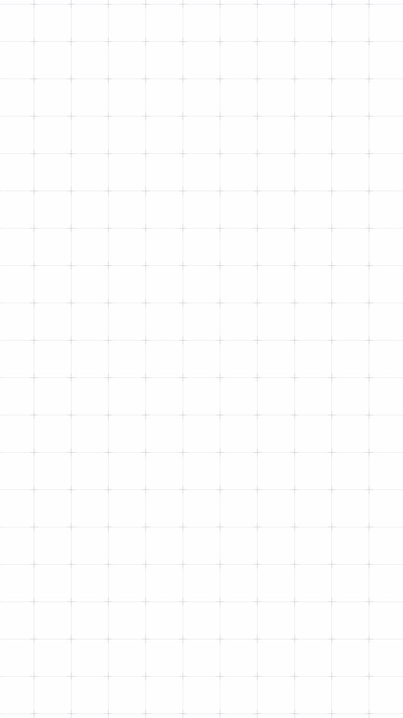

DECO7230
DESIGN
CONCEPT
REPORT-01

Concept Brief:
“A collaborative whiteboard reimagined for VR: clap to create a note, pull a thread to connect it, walk through your ideas instead of scrolling them.”

Yutika Shindolkar – 49595916

Application to Redesign
This concept redesigns a collaborative digital whiteboard tool (in the style of Miro or FigJam) as a fully immersive VR creation experience. Currently, these tools support visual collaboration, brainstorming, and idea-mapping on a flat, scrollable 2D canvas. This redesign fits the Creation category: its core purpose is generating and structurally organising visual and textual content, and it depends entirely on active, hands-on user interaction rather than passive viewing.

Tasks & User Goals

2.1 Goal 01 - Capture an idea in the moment
Create a note in the workspace and add text, an image, a video, or a document to it, either by typing, attaching a file, or dictating through a grabbable in-scene microphone.

2.2 Goal 02 - Structure and connect ideas

Freely move notes around the space, and physically connect related notes by pulling a thread between them and labelling the relationship. Multiple notes can be connected into their own workflows, flowcharts, or mind maps, and each flow can be grouped into its own section, giving the whole infinite canvas an overall structure rather than one flat scatter of notes.

2.3 Goal 03 - Present the finished workspace to others

Guide a group through a completed board as a spatial presentation, navigating along the chain of connected notes rather than flipping through slides.

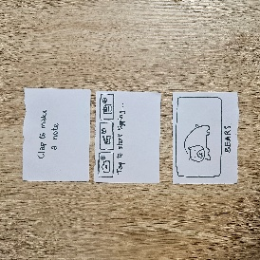
Ideation & Development Process
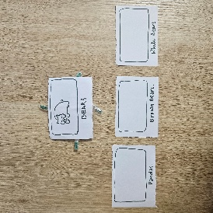
During the Week 2 Studio low-fidelity prototyping activity, the note-creation and note-connection tasks (Goals 1 and 2) were tested with a physical paper prototype: paper cards acted as screens or interface elements that appeared or changed as the interaction progressed. Once two notes existed, the original cards were swapped for versions with handles on each side, representing the micro-interaction that signals a note can be connected. Pulling a handle drew out an attached thread; the participant pulled it free and placed it against the second note to “connect” them.
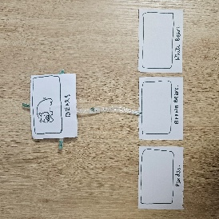
Testing used a Wizard-of-Oz method with two participants: each was told the concept and given a task (“create two notes and connect them”), while the facilitator manually swapped cards and added elements in response to their actions, simulating the system’s responses.
Both participants completed the task intuitively and successfully, and both discovered the “+” icon on the connecting thread without being told. Three points of feedback emerged: they might forget to clap to create a note until it becomes a habit; it was unclear whether one note could connect to more than one other note, since each side seemed to offer only a single, one-use handle; and clapping felt slightly awkward while holding controllers. (Images and footage of prototype - Link to GitHub)
This feedback directly clarified three parts of the concept going into the next iteration:
- Handles are reusable anchor points, not single-use plugs: pulling an already-connected handle starts a second thread, so one note can bran ch out to several others from the same point. An already-connected handle keeps a subtle glow/pulse rather than going dim, so it still invites another pull.
- A one-time onboarding hint (a brief pulsing hand icon or short text cue) appears the first time only, fading after the user’s first successful clap, to bridge the initial learning curve without a persistent tutorial overlay.
- Hand-tracking is offered as an alternative to controller-based clapping where the headset supports it, since clapping bare hands together is more natural than clapping with controllers gripped in each hand.

XR Concept Definition

4.1 Target environment - Full VR (not AR/MR)
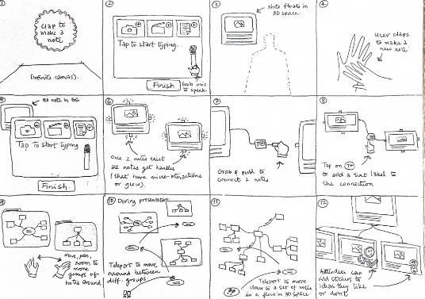
The workspace is an infinite, borderless blank white space rather than one anchored to the user's physical room. VR was chosen because the canvas needs to expand without limit as notes and threads are added, which real-world surfaces cannot support, and because ideation benefits from full visual immersion, free of real-world distraction.

4.2 Interactions & Affordances
- Clap to create: bringing both hands/controllers together is detected as a clap and spawns a new note, an embodied gesture rather than a menu button.
- Note input panel: a floating panel appears with a text field to start typing, buttons to attach an image, video, or document, and a grabbable microphone the user can tilt toward themselves to dictate text by voice instead of typing, then confirm with a submit/complete button.
- Connect handles: once a second note exists, all notes gain small handles on their four edges with a subtle glow/pulse micro-interaction signalling they can be grabbed, and handles remain reusable for further connections after their first use.
- Pull-to-connect: pulling a handle extends a physical thread from the note; dragging it onto another note connects them. A small “+” icon on the thread can be pressed to label the relationship with text.
- Move & rearrange: notes can be grabbed and repositioned anywhere in the infinite space, and related flows of connected notes can be grouped into labelled sections to structure the overall canvas.
- Guided presentation: to walk a (seated or standing) group through a finished board, the presenter teleports their viewpoint along the chain of connected notes rather than physically traversing the infinite canvas, avoiding the motion sickness of continuous movement across unbounded space.

(Concept and Storyboard Images - Link to GitHub)

Initial Testing Plan

5.1 What to test
- Whether the reusable, still-glowing handle successfully communicates that a note can support more than one connection.
- Whether the one-time onboarding hint is enough for users to remember the clap gesture across a longer session.
- Whether hand-tracking clapping feels meaningfully more comfortable than the controller-based version.
- Previously untested parts of the concept: the mic-tilt-to-dictate flow, attaching images/video/documents to a note, grouping connected flows into labelled sections, and the teleport-along-connections presentation mode (Goal 3).

5.2 Assumptions
- Users will notice a still-glowing handle and understand it can be pulled again to start another connection.
- A single first-use onboarding hint is enough to build the clap habit without a persistent reminder.
- Hand-tracking will feel more natural for clapping than gripping controllers.
- Grouping flows into labelled sections will help users navigate a large infinite canvas without feeling lost.

5.3 Data to collect
- Task success rate for connecting a single note to two or more other notes without guidance.
- Clap success rate later in a session, after the onboarding hint has faded, to check the habit has formed.
- Comparative comfort/ease ratings for controller-based clapping versus hand-tracking clapping.
- Task success rate and qualitative feedback for dictation, attaching media, grouping into sections, and the teleport presentation walkthrough.

