STAT 428: Homework 4: Chapter 6 Monte Carlo Methods in Inference

Du, Yuting, yutingd3 Collaborated with: Sun, Yifan, yifans8

Table of Contents

Please refer to the [**detailed homework policy document**] on Course Page for information about homework formatting, submission, and grading.

## Exercise 1

**An Exploration of Standard Error in Monte Carlo Estimation**

Consider the following integral:

$$\int_{0}^{1}{\frac{\text{ln}(x+1)}{π\sqrt{x(1−x)}}}dx.$$

1. Estimate the integral using naive Monte Carlo. What is the standard error of this estimate?

u = runif(1000)  
I0 = mean(log(u+1)/(pi*sqrt(u*(1-u))))  
I0

## [1] 0.3844

x = numeric()  
for(i in 1:1000){  
 x[i] = mean(log(u[i]+1)/(pi*sqrt(u[i]*(1-u[i]))))  
}  
E0 = sd(x)/sqrt(1000)  
E0

## [1] 0.02287

1. Let’s see if we can improve the standard error. Implement Monte Carlo with antithetic sampling to estimate this integral. What is the standard error of this estimate?

I1 = numeric()  
I11 = numeric()  
I12 = numeric()  
  
  
for(i in 1:1000){  
 k1 <- 500  
 u1 <- runif(500)  
 I11[i] <- mean(log(u[i]+1)/(pi*sqrt(u[i]*(1-u[i]))))  
   
 k2 <- 500  
 u2 <- runif(500)  
 I12[i] <- mean(log(1-u[i]+1)/(pi*sqrt(u[i]*(1-u[i]))))  
   
   
 I1[i] <- (I11[i] + I12[i])/2  
}  
  
E1 <- sd(I1)/sqrt(1000)  
E1

## [1] 0.01227

1. Would stratified sampling seem to help here? Why or why not? (Whatever you decide, you do not need to implement it).

I believe that stratified sampling will also work in reducing the standard error. It uses simaple random sampling from uniform distributions but stratify these to ensure balance over a partition into k subintervals of (0, 1)

1. $f(x)=\frac{1}{π\sqrt{x(1−x)}}$ for $x∈(0,1)$ is the probability density function for the [Arcsine distribution](https://en.wikipedia.org/wiki/Arcsine_distribution). Using inverse transformation method, sample 1000 random values from the Arcsine distribution.

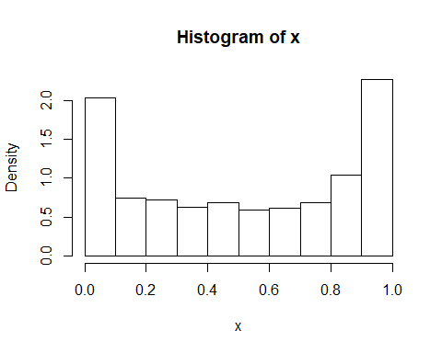

1. Use importance sampling and the code you wrote in part d to estimate this integral. What is the standard error?  
   The importance function we choose is the pdf of Arcsine distribution.

m = 1000  
  
gf = function(x){  
 g = log(x+1)/(pi*sqrt(x*(1-x)))  
 f = (x<1)*(x>0)  
 g*f  
}  
  
##try our importance function  
u = runif(m)  
x = (sin(pi*u/2))^2  
gfphi = gf(x)*(pi*sqrt(x*(1-x)))  
E2 = sd(gfphi)/sqrt(m)  
E2

## [1] 0.007742

1. Are all methods equally effective? Which method is the most efficient?

No. It seems like importance sampling is the most efficient way to reduce the error variance.

## Exercise 2

**Comparing MSE of estimators using MC.**

Let $f(x|θ)=t(ν,μ)$, the [non-central t-distribution](https://en.wikipedia.org/wiki/Noncentral_t-distribution), where $μ$ is a location parameter and $ν$ is the degrees of freedom.

Estimate the MSE of the level k trimmed means for random samples of size 20 generated from a a non-central t-distribution with degrees of freedom 3 and mean 4 (with $ν=3$ and $μ=4$). Summarize the estimates of MSE in a table for k = 1, 2, … , 9.

n = 20  
K = n/2 - 1  
m = 1000  
mse = matrix(0, n/2, 2)  
  
trimmed.mse = function(n, m, k){  
 tmean = numeric(m)  
 for(i in 1:m){  
 x = sort(rt(m, 3, 4))  
 tmean[i] = mean(x[(k+1):(n-k)])  
 }  
 mse.est = mean(tmean^2)  
 se.mse = sqrt(mean((tmean - mean(tmean))^2))/sqrt(m)  
 return (c(mse.est, se.mse))  
}  
  
for(k in 1:K){  
 mse[k, 1:2] = trimmed.mse(n,m,k)  
}  
  
round(mse, 3)

## [,1] [,2]  
## [1,] 1.885 0.003  
## [2,] 1.918 0.003  
## [3,] 1.931 0.003  
## [4,] 1.960 0.003  
## [5,] 1.983 0.003  
## [6,] 1.975 0.003  
## [7,] 1.995 0.003  
## [8,] 2.006 0.003  
## [9,] 2.016 0.003  
## [10,] 0.000 0.000

## Exercise 3

**Bayesian Statistics** Suppose $X_{1},…,X_{n}$ are $n$ independent and identical distributed random variables from $Exp(θ)$, where $θ$ is the unknown parameter. So,

$$f(x|θ)=θ e^{−θx}, x≥0.$$

We assume the prior distribution on $θ$ is the Gamma distribution ($Gamma(3,2)$).

$$g(θ)=4θ^{2}e^{−2θ}, x≥0.$$

1. Write down the posterior distribution of $θ$, $g(θ|X)$.

$$g(θ|x)=\frac{L(θ)g(θ)}{C}$$

where,

$$L(θ)=\prod_{n=1}^{n}{f}(x_{i}|θ)$$

and

$$g(θ|x)=∫\prod_{n=1}^{n}{f}(x_{i}|θ)g(θ)dx$$

1. Suppose $n=6$ and we observe that $x_{1}=0.4,x_{2}=1.1,x_{3}=0.2,x_{4}=1.6,x_{5}=1.4,x_{6}=0.9$. Estimate the posterior mean of $θ$ based on $1000$ simulated $θ$ from its prior distribution.

observed_x = c(0.4, 1.1, 0.2, 1.6, 1.4, 0.9)  
  
hx = numeric()  
post.mean = numeric()  
for(i in 1:length(observed_x)){  
theta = rgamma(n = 1000, shape = 3, rate = 2)  
hx[i] = theta*exp(-theta*observed_x[i])  
c = mean(hx)  
post.mean[i] = mean(theta*hx)/c  
}  
cbind(observed_x,post.mean)

## observed_x post.mean  
## [1,] 0.4 1.466  
## [2,] 1.1 1.473  
## [3,] 0.2 1.501  
## [4,] 1.6 1.504  
## [5,] 1.4 1.477  
## [6,] 0.9 1.450

1. Suppose $n=6$ and we observe that $x_{1}=0.4,x_{2}=1.1,x_{3}=0.2,x_{4}=1.6,x_{5}=1.4,x_{6}=0.9$.
   1. Design an acceptance-rejection sampling algorithm to generate $1000$ (accepted) samples of $θ$ from the posterior distribution of $θ$. Write down your algorithm with your instrumental distribution $g(θ)$. (Hint: for the acceptance-rejection sampling method, the normalizing constant in the posterior distribution can be ignored.)

Given that M = 0.5, for each observed x do folowing steps 1. generate 1 sample form gamma(3, 2) as the theta 2. generate 1 sample from uniform(1) 3. calculate f(x|theta) based on the observed x and theta from 1 4. calculate g(x) based on the observed x 5, Test uf the sample from 2 less than f(x|theta) / (M*g(x)) accept theta from 1 repeat until get 1000 accepted theta

1. Implement your acceptance-rejection sampling algorithm with R code. Plot the histogram of your generated sample and compare your sample mean with your estimated posterior mean obtained in Ex.3.2.

observed_x = c(0.4, 1.1, 0.2, 1.6, 1.4, 0.9)  
  
fx = function(theta, x){  
 theta*exp(-theta*x)*4*(theta^2)*exp(-2*theta)  
}  
AR = function(x, n){  
 i = 0  
 theta = numeric()  
 M = 0.5  
 while (i < n) {  
 theta0 = rgamma(1,shape = 3, rate = 2)  
 u = runif(1)  
 if(M*u < fx(theta0, x)/dgamma(x, shape = 3, rate = 2)){  
 i = i + 1  
 theta[i] = theta0  
 }  
 }  
 return(theta)  
}  
x = c(0.4,1.1,0.2,1.6,1.4,0.9)  
AR(x = x, n = 6)

## [1] 0.7299 1.0390 0.4748 1.3879 1.3453 0.6148

## Exercise 4

Do 6.1 in the book, except with $n=25$ and $k=1,2,⋯,10$.

m <- 2000  
K <- 10  
n <- 25  
tmean <- matrix(0,m,K)  
mse_est <- numeric(K)  
mse_se <- numeric(K)  
for(k in 1:K){  
 for (i in 1:m) {  
 x <- sort(rcauchy(n))  
 tmean[i,k] <- mean(x[(k+1):(n-k)])  
 }  
 mse_est[k] <- mean(tmean[,k]^2)  
 mse_se[k] <- sqrt(sum((tmean[,k] - mean(tmean[,k]))^2)) / m  
}  
table <- cbind(seq(1:K),round(mse_est,5),round(mse_se,5))  
colnames(table) <- c("k", "Estimated MSE of level k trimmed means", "Standard Error")  
knitr::kable(table, caption = 'Estimates of MSE')

Estimates of MSE

|  |  |  |
| --- | --- | --- |
| k | Estimated MSE of level k trimmed means | Standard Error |
| 1 | 3.5117 | 0.0419 |
| 2 | 0.4430 | 0.0149 |
| 3 | 0.2132 | 0.0103 |
| 4 | 0.1696 | 0.0092 |
| 5 | 0.1418 | 0.0084 |
| 6 | 0.1244 | 0.0079 |
| 7 | 0.1159 | 0.0076 |
| 8 | 0.1092 | 0.0074 |
| 9 | 0.1026 | 0.0072 |
| 10 | 0.1066 | 0.0073 |

## Exercise 5

Do exercise 6.2 from the book.

library(Hmisc) #for errbar  
  
alpha = 0.05  
mu <- c(seq(350, 650, 10)) #alternative H  
n <- 20  
sigma <- 100  
m <- 1000  
mu0 <- 500  
M <- length(mu)  
power <- numeric(M)  
for (i in 1 : M) {  
 pvalues <- replicate(m, expr = {x <- rnorm(n, mean = mu[i], sd = sigma)  
 ttest <- t.test(x, alternative = "two.sided", mu = mu0)  
 ttest$p.value})  
 power[i] <- mean(pvalues <= alpha)  
}  
  
plot(mu, power)  
abline(v = mu0, lty = 1)  
abline(h = alpha, lty = 1)

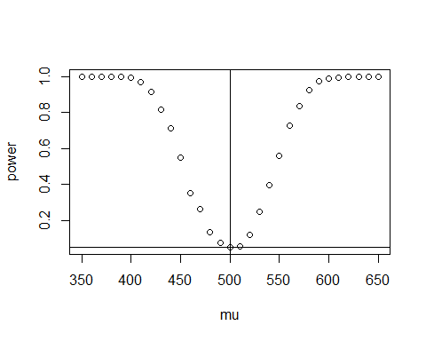

## Exercise 6

Do exercise 6.3 from the book.

n <- seq(10,50,10) #sample size  
mu <- c(seq(350, 650, 10))  
m <- 1000  
M <- length(mu)  
N <- length(n)  
power <- matrix(0,M,N)  
for(j in 1:N){  
 for (i in 1:M){  
 mu1 <- mu[i]  
 pvalues <- replicate(m, expr = {  
 #simulate under alternative mu1  
 x <- rnorm(n[j], mean = mu1, sd = 100)  
 ttest <- t.test(x,  
 alternative = "two.sided", mu = 500)  
 ttest$p.value })  
 power[i, j] <- mean(pvalues <= .05)  
 }  
}  
plot(mu, power[,1], type="l", lty = 2, col = 1, main="Power curve", xlab="mu", ylab="Power")  
lines(mu, power[,2], lty = 3, col = 2)  
lines(mu, power[,3], lty = 4, col = 3)  
lines(mu, power[,4], lty = 5, col = 4)  
lines(mu, power[,5], lty = 1, col = 5)  
legend("topright", c("sample size=10","sample size=20","sample size=30","sample size=40","sample size=50"), lty = c(2,3,4,5,1),col=c(1,2,3,4,5))  
abline(v = 500, lty = 1)  
lines(c(450,550),c(0.05,0.05))

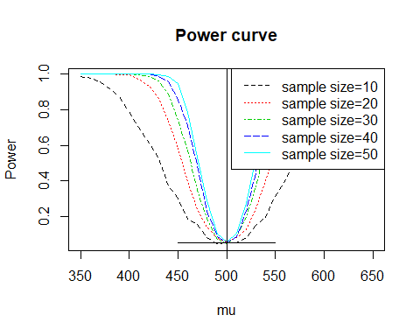

## Exercise 7

Do exercise 6.5 from the book.

alpha <- 0.05  
m <- 1000  
n <- 20  
qt <- qt(1-alpha/2, df = n-1)  
LCL <- replicate(m, expr = {  
 x <- rchisq(n, 2)  
 return(mean(x) - qt * sd(x) / sqrt(n))  
})  
UCL <- replicate(m, expr = {  
 x <- rchisq(n, 2)  
 return(mean(x) + qt * sd(x) / sqrt(n))  
})  
mean((LCL < 2) * (UCL > 2))

## [1] 0.91

## Exercise 8

Do exercise 6.8 from the book. Use 15 as small sample size, 50 as medium sample size, and 250 as large sample size.

alpha = 0.055  
mu1 <- mu2 <- 0  
sigma1 <- 1  
sigma2 <- 1.5  
sample_num <- c(15, 50, 250)  
  
m <- 1000  
tests_F <- numeric(3)  
tests_CF <- numeric(3)  
  
testF <- function(x, y) {  
 f_test <- var.test(x, y, alternative = "two.sided", conf.level = 1-alpha)  
 return(f_test$p.value < alpha)  
}  
tests5 = function(X, Y) {  
 outx <- sum(X > max(Y)) + sum(X < min(Y))  
 outy <- sum(Y > max(X)) + sum(Y < min(X))  
 return(as.integer(max(c(outx, outy)) > 5))  
}  
for (i in 1 : 3) {  
 n <- sample_num[i]  
 power_F <- mean(replicate(m, expr = {  
 x <- rnorm(n, mu1, sigma1)  
 y <- rnorm(n, mu2, sigma2)  
 testF(x, y)  
}))  
 power_CF <- mean(replicate(m, expr = {  
 x <- rnorm(n, mu1, sigma1)  
 y <- rnorm(n, mu2, sigma2)  
 tests5(x, y)  
}))  
   
 tests_F[i] <- power_F  
 tests_CF[i] <- power_CF  
}  
  
(table = rbind(tests_F, tests_CF))

## [,1] [,2] [,3]  
## tests_F 0.321 0.800 1.000  
## tests_CF 0.290 0.655 0.973