Seasonal and Temporal Patterns of PHS Pumping
The operating patterns of a 1 MW pumped-storage hydropower (PHS) reference plant were examined using independently optimised annual schedules for Poland and Lithuania in 2023-2025. The baseline assumes six hours of storage and 75% round-trip efficiency. Hours were classified in local time as midday (10:00-16:00), night (22:00-06:00), or other. Annual energy shares retain the UTC optimisation-year boundaries; daily patterns use complete local days, including daylight-saving transitions. The results describe modelled price-taking, perfect-foresight operation rather than observed plant schedules.
Pumping exhibited a clear seasonal pattern (Figure 1). In winter, night-time operation accounted for 80.3% of pumping energy in Poland and 75.0% in Lithuania. Midday pumping became more prominent in summer, reaching 64.1% and 47.7%, respectively. Lithuania retained a pronounced night-time peak alongside its daytime peak. Overall pumping utilisation was higher in Lithuania: mean annual pumping energy was 3,106 MWh, compared with 2,259 MWh in Poland, for the same rated capacity. Thus, both markets exhibited stronger midday pumping in summer, while Lithuania combined this pattern with more intensive night-time operation overall.
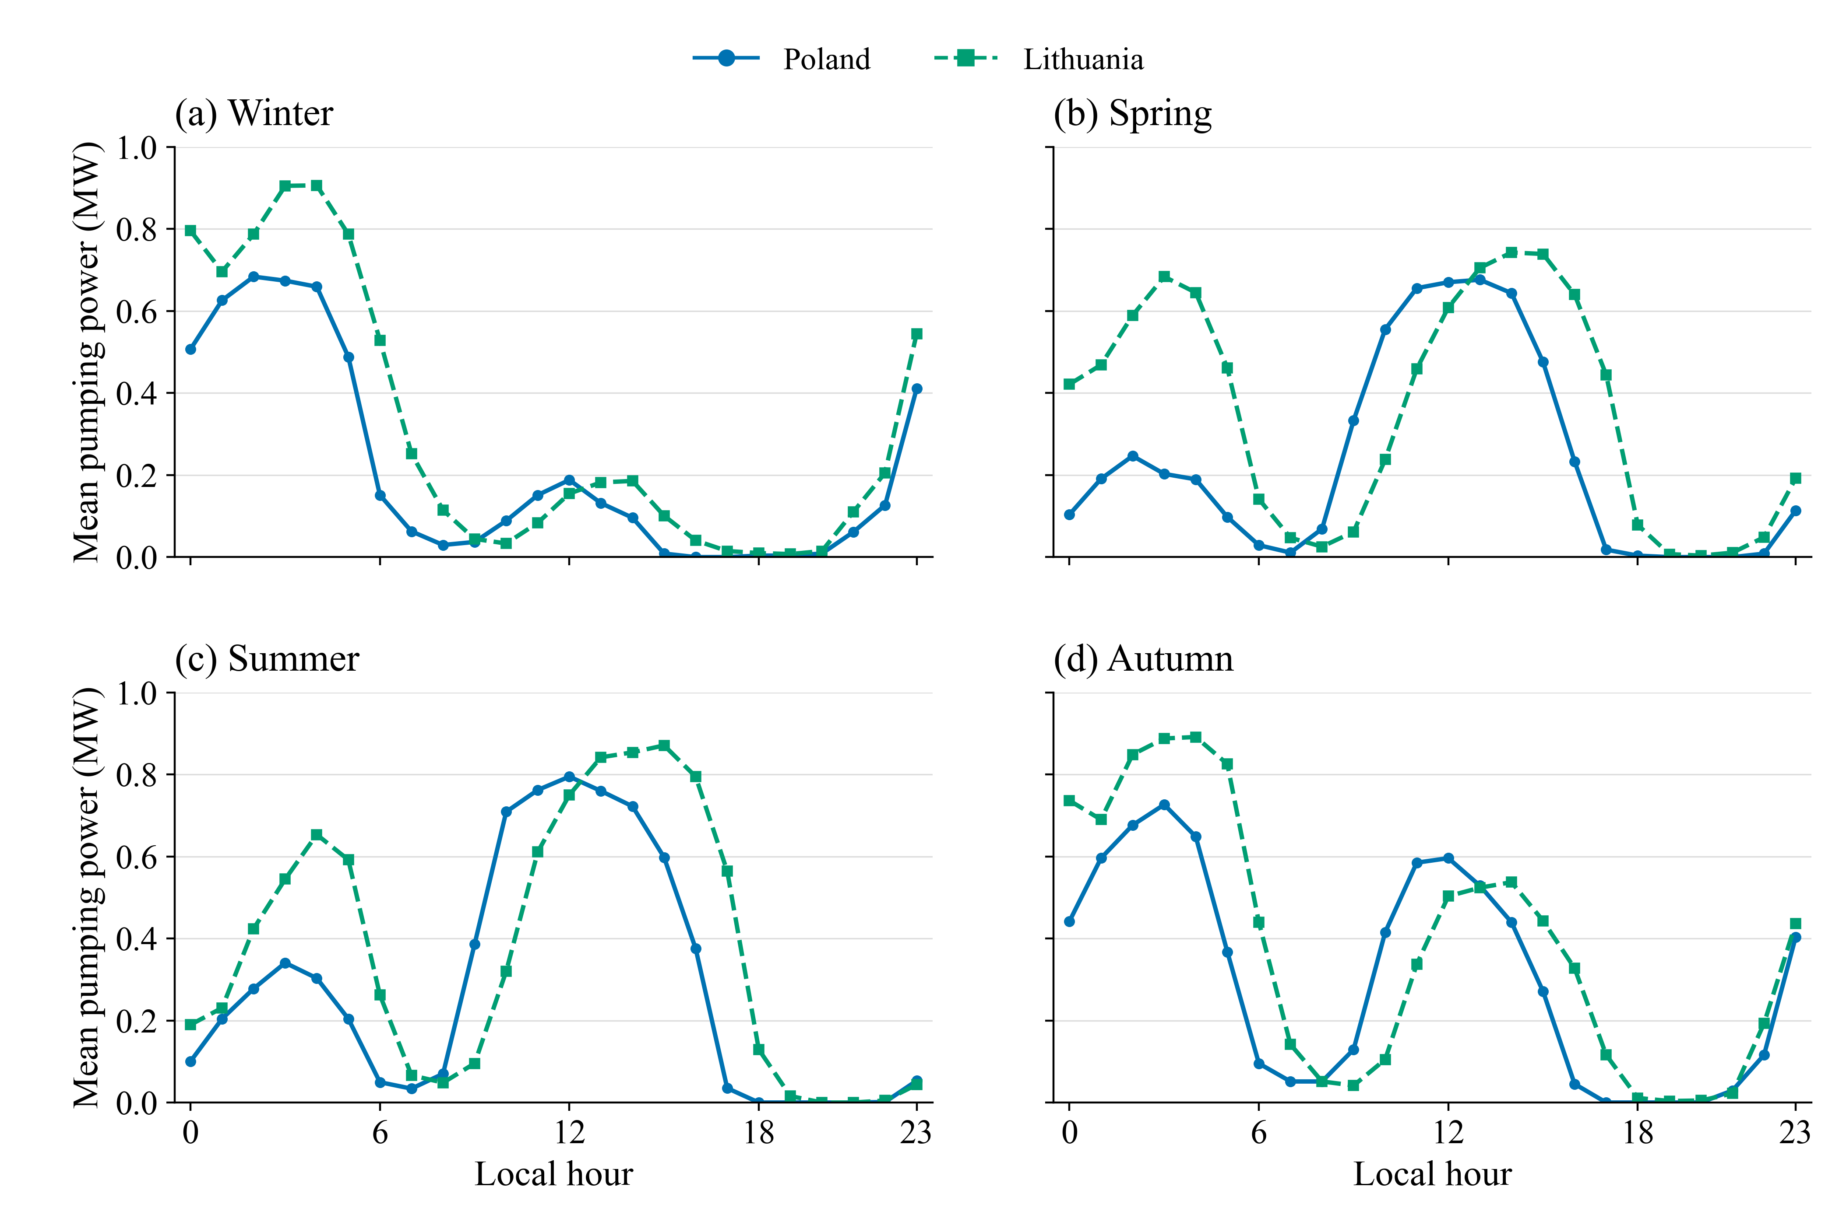
Figure 1. Mean modelled pumping power by local hour and season in Poland and Lithuania, pooled over 2023-2025. Each profile averages actual hourly observations for the 1 MW, six-hour, 75%-efficiency reference plant. Source: authors' dispatch calculations using ENTSO-E day-ahead prices.

Evolution of Daily Pumping Patterns
The annual allocation of pumping energy shifted towards midday between 2023 and 2025. In Poland, the midday share increased from 38.4% to 54.2%, while the night-time share declined from 52.9% to 35.1%. Lithuania showed a similar increase in midday pumping, from 25.7% to 35.9%, although night-time pumping remained the larger component in 2025 (47.3%). The shift towards midday was therefore more pronounced in Poland, whereas Lithuania maintained a stronger night-time orientation.
Daily classification further showed that substantial pumping in both windows became more frequent (Figure 2). Such days increased from 22.5% to 34.2% of complete days in Poland and from 40.9% to 52.1% in Lithuania. Across all three years, both-window days represented 28.1% and 47.7% of complete days, respectively. Lithuania therefore combined higher pumping utilisation with more frequent use of both midday and night-time windows within the same local day. The increase in midday participation and in both-window days persisted under the tested alternative time windows and classification thresholds.
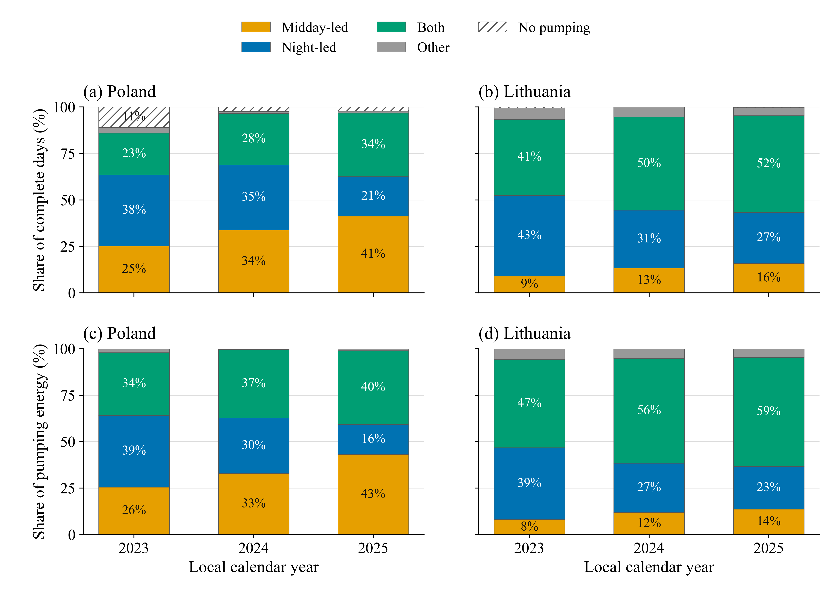
Figure 2. Daily pumping patterns by country and local calendar year. Upper panels show shares of complete days; lower panels show shares of total pumping energy on days of each type. Both requires midday and night each to provide at least 20% of daily pumping; otherwise a led category requires at least 60%. Night includes 00:00-06:00 and 22:00-24:00 of the same day. Source: authors' dispatch calculations using ENTSO-E day-ahead prices.

