**Relationship between the passage of the year and precipitation**

Yuto Yasuda(213x121x)

1. **Introduction** In recent years, global warming has been advancing and the average temperature of the world has been rising, which has had various effects on the environment such as rising sea levels and changes in precipitation. In this study, I investigated how the amount of precipitation in Japan has changed from 1980 to 2020, and examined what areas will receive more rainfall in the future.．
2. **Method** In this study, we used two types of graphs, a heat map using a map of Japan and a histogram classified by precipitation. The purpose of the heat map is to visualize how the precipitation changes by region and age. The color blue indicates more precipitation and the color yellow indicates less precipitation. In the heat map, the maximum value is 4000 mm and the minimum value is 0 mm. The purpose of the histogram is to visualize the overall increase or decrease of the precipitation distribution in each prefecture. Each class of the histogram is defined as follows: 0~1000mm is 0, 1001~2000mm is 1, 2001~3000mm is 2, 3001~4000mm is 3, and 4000mm or more is 4.
3. **Result**  
    We used the annual precipitation data observed by the Japan Meteorological Agency from 1980 to 2020 in the prefectural capitals of each prefecture for visualization.  
     
   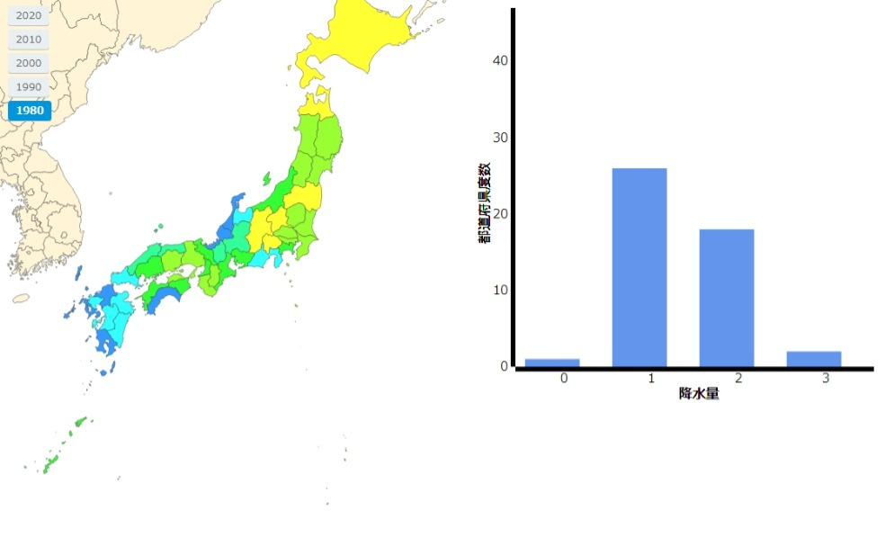  
   　　　　　　　　　　　　　　　　**Fig.1 1980 Result**  
   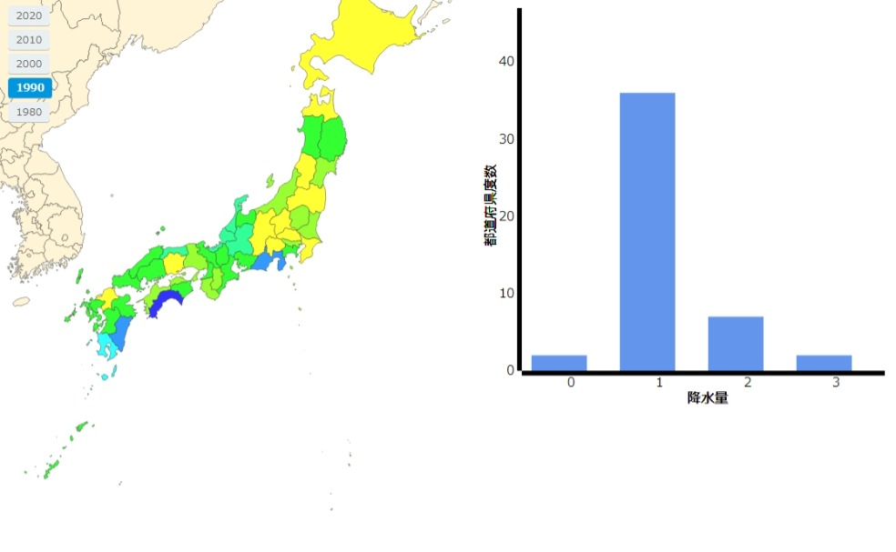  
   　　　　　　　　　　　　　　　　**Fig.2 1990 Result**  
   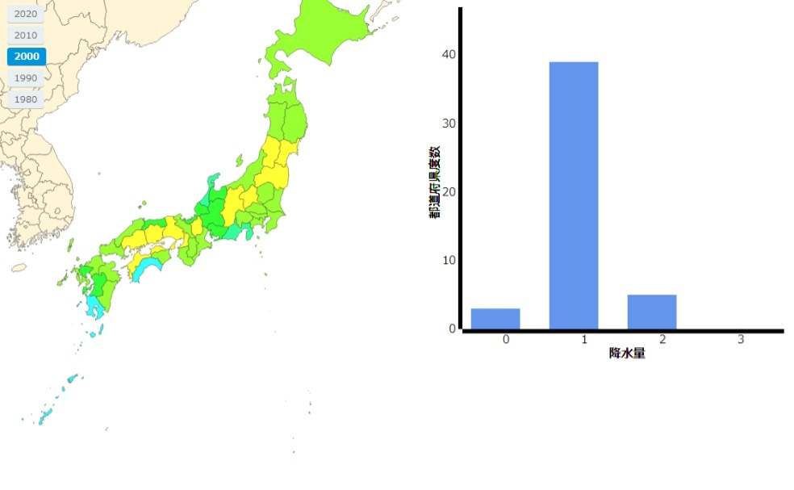  
   　　　　　　　　　　　　　　　**Fig.3 2000 Result**  
   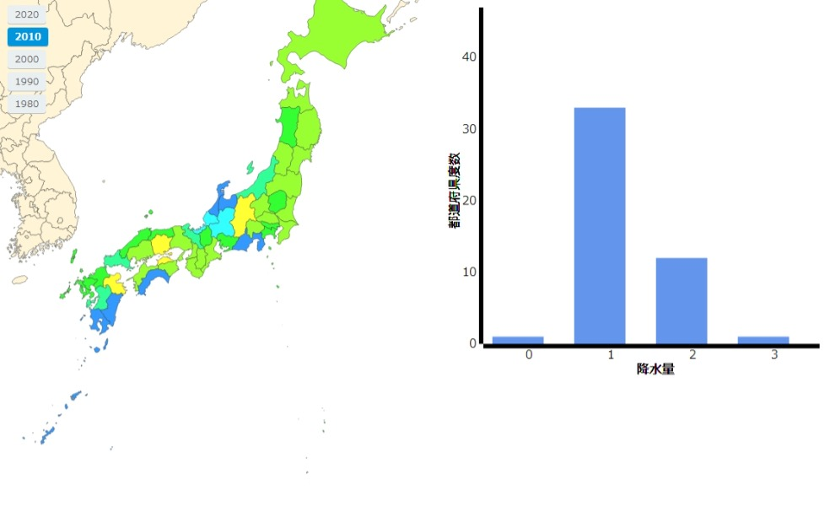  
   　　　　　　　　　　　　　　　　**Fig.4 2010 Result**  
   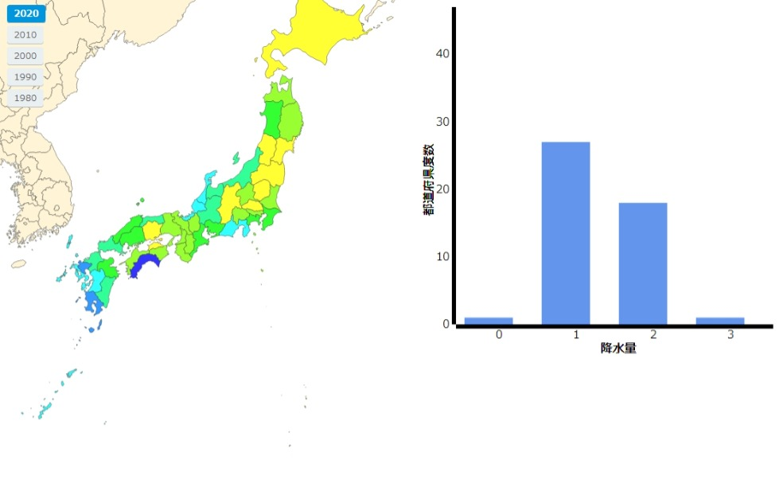  
   　　　　　　　　　　　　　　　　**Fig.5 2020 Result** From the histograms of Fig.2 ~ Fig.5, it can be seen that Class 1 (precipitation from 1001mm to 2000m) decreases and Class 2 (precipitation from 2001mm to 3000m) increases little by little as the years go by and The heat map shows that the precipitation in western Japan, such as Kyushu and Shikoku, is increasing. The result of 1980 in Fig.1 is different from the trend because the precipitation in the whole Kyushu area was much higher than usual.
4. **Discussion** From the results of the survey, precipitation is increasing, and the reason is considered to be the increase of air temperature due to global warming and the increase of maximum water vapor in the air. The maximum amount of water vapor increases by 6~7% for each increase in temperature. The number of land falling typhoons is one of the reasons for the increase in precipitation in western Japan. The number of land falling typhoons in western Japan is higher than that in eastern Japan, and the total number of typhoons has increased over the years, which is thought to have increased the precipitation in western Japan.
5. **Conclusion** In conclusion, the precipitation tends to increase with each passing year, especially in western Japan. However, the data used in this study are not a data performed moving average data for each year, so I need to investigate with such a data set.
6. **Reference**[1] Japan Meteorological Agency , [気象庁 Japan Meteorological Agency (jma.go.jp)](https://www.jma.go.jp/jma/index.html)  
   [2] D3.jsで日本地図を作成しデータを反映するサンプル, [D3.jsで日本地図を作成しデータを反映するサンプル（コロプレス地図） ｜ Tips Note by TAM (tam-tam.co.jp)](https://www.tam-tam.co.jp/tipsnote/javascript/post6174.html)