**Program Structures & Algorithms**

**Spring 2022**

**Assignment No. 4**

Name:Yutong Gao

(NUID):2194174

* **Code on modifying the number of thread.**

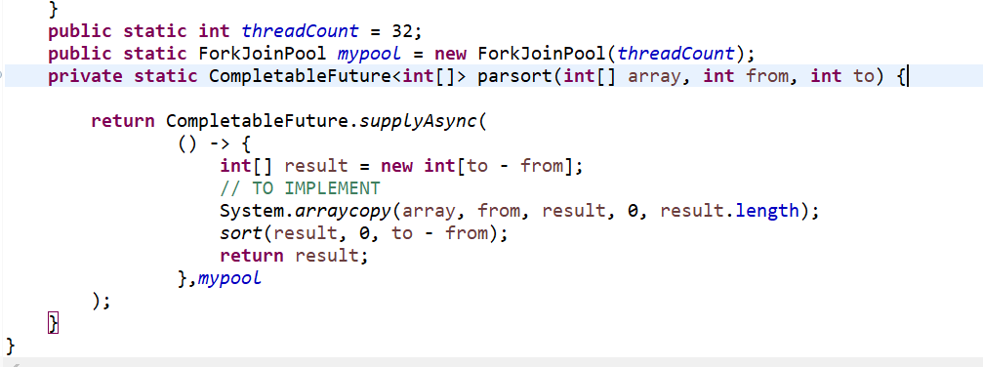

* **Output screenshot**

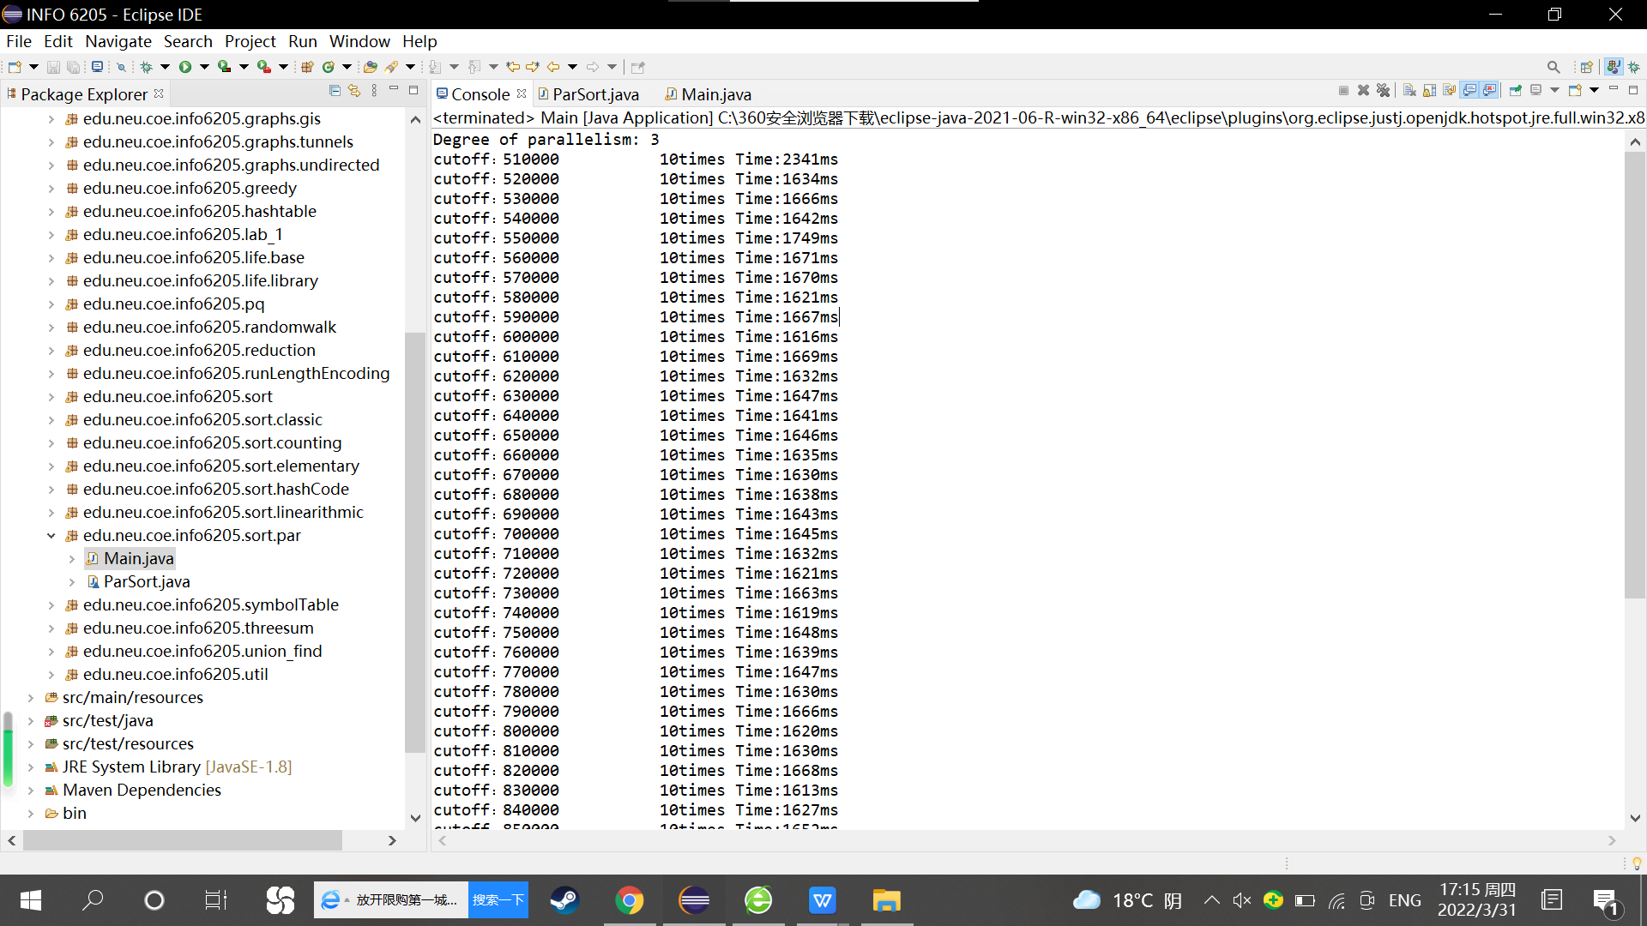

* **Evidence / Graph**

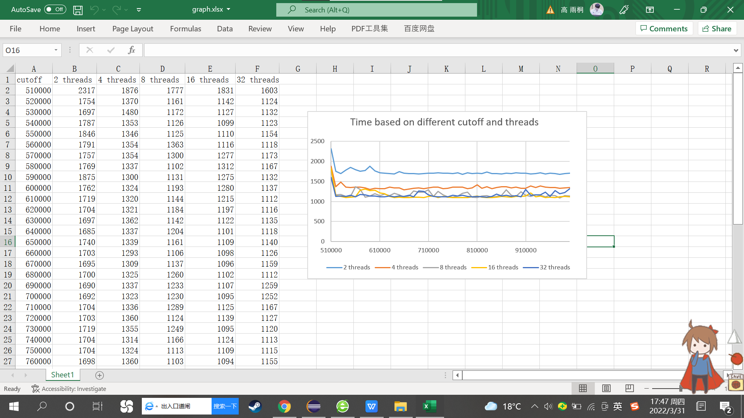

From the graph, we can conclude that when we changed the threads from 2 to 4 or 8, the advance of timing is significant, but the increase of 16 threads and 32 threads is not very much.