# How to make REUSABLE Dynamic Web TWAIN module with Composition API of Vue.js

Composition API is a new feature of Vue.js 3. Though it is designed for Vue.js 3, it is compatible for Vue.js 2.x. To resolve the reusability issue in Vue.js 2.x, Composition API organizes data and logics in functions. This change makes data and logics can be mixed together, instead of splitting into respective parts. In this article, we would demonstrate the usage of Composition API with Dynamic Web TWAIN.

## Issues with Options API of Vue.js 2.x

### Readability and Maintainability

Options API organizes data and logics into several sections: props, data, computed, watch, methods, etc.. When the scale of code is not large (usually less than hundreds of lines of code), the code is manageable. If the scale goes large, the possibility of scrolling up and down would be increased. Developers have to jump between methods and data. As a sequence, the readability is bad and possibly resulting difficulty of finding bugs.

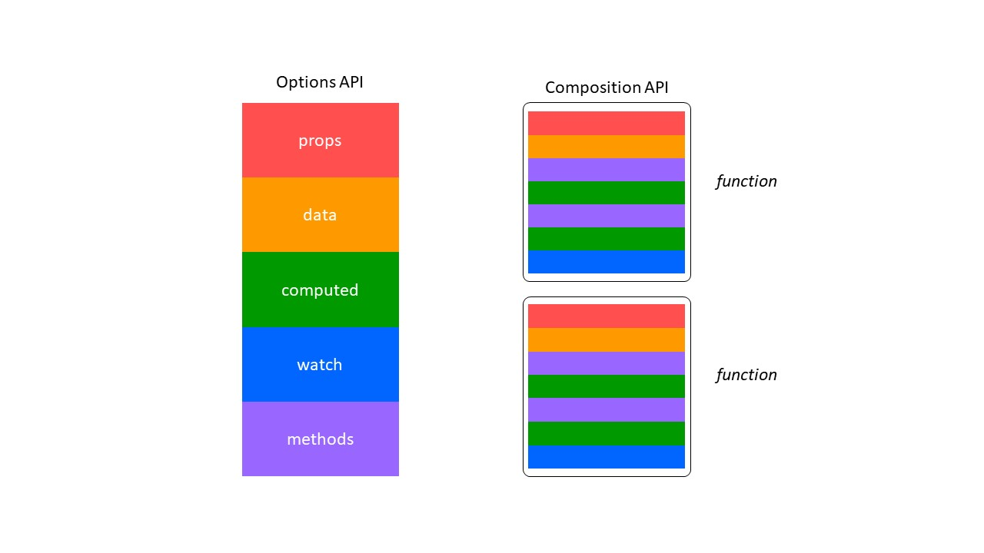

### Reusability and Maintainability

In Vue.js 2.x, there are three ways to wrap the similar logics into a module, they are **mixin**, **directive**, and **renderless component**. Definitely, these methodologies do extract the similar logics into one piece and avoid repeating the similar code for multiple times. However, they are not ideal for encapsulation. One of the serious issues is: **mixing the same part from multiple sources altogether**. Though the readability problem is resolved, the data origins are possibly blurred, especially when number of mixins and the lines of code are large.

## Composition API

Composition API divides the manageable unit into further lower pieces: **function**. Instead of defining an object, Composition API allows developers to mix their data and logic into one or several functions. Then, assembling these functions into a component to implement the required functionalities.

## Implementation with Composition API

### Preparation

To try with Composition API, we would create our application based on Vue.js 3.

vue create vue3-dwt

We add TypeScript support to our project. The better support of TypeScript is another main feature of Vue.js 3. We highly recommend our reader to start coding with TypeScript. We do provide the definition of Dynamic Web TWAIN library, which is a TWAIN SDK for web development. Refer to the [Dynamic Web TWAIN homepage](https://www.dynamsoft.com/Products/WebTWAIN_Overview.aspx) for more details. Also, don't forget to get a trial license if you have never tried Dynamic Web TWAIN.

Use the following commands to install dwt and its type definition.

npm install --save dwt  
npm install --save-dev @types/dwt

Regarding the integration with Dynamic Web TWAIN, there is no change compared to that in Vue.js 2.x. The previous method is applicable in Vue.js 3 projects. Install ncp to help us copy the resource files to public folder.

npm install --save-dev ncp

Then, edit the package.json to copy before the serve or after the build.

// package.json  
{  
 // ...  
 "scripts": {  
 "serve": "ncp node_modules/dwt/dist public/dwt-resources && vue-cli-service serve",  
 "build": "vue-cli-service build && ncp node_modules/dwt/dist public/dwt-resources",  
 "lint": "vue-cli-service lint"  
 },  
 //...  
}

### Design

We hope to implement a function that

1. accepts arguments to configure the WebTWAIN environment
2. initializes the web twain environment and create a dwt instance
3. returns the created DWT object

As WebTWAIN environment has numerous parameters, it is infeasible to expose them respectively via the arguments of function. We wrap the environment parameters into an object. At the time of initialization, we pass the config object, the creation mode indicator, and the id of dwt instance as the arguments.

interface DWTEnvConfig {  
 Containers?: Container[];  
 IfAddMD5UploadHeader?: boolean;  
 IfConfineMaskWithinTheViewer?: boolean;  
 IfUseActiveXForIE10Plus?: boolean;  
 ProductKey: string;  
 ResourcesPath: string;  
 UseCameraAddonWasm?: boolean;  
 UseLocalService?: boolean;  
}  
  
function useDwt(config: DWTEnvConfig, id: string, createEx: boolean) { }

Since the initialization process keeps the same among projects, we tend to maintain the initialization locally and do not expose to the outside environment.

The initialization process is shown as the following diagram.

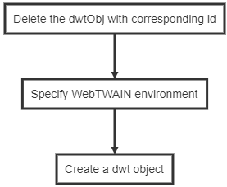

We define a function for each stage.

interface DWTInitResult {  
 status: boolean;  
 reason: string;  
}  
  
function _unmountDwt(id: string): Promise<DWTInitResult> { }  
function _mountDwt(id: string): Promise<DWTInitResult> { }  
function _createDwtObj(id: string, createEx: boolean): Promise<WebTwain> { }

Finally and most importantly, we return the created DWT instance to the calling component. This is the most differentiated step in comparison to direct return.

Vue.js monitors the change of data and take appropriate actions. In Vue.js 2.x, the data is registered in data section of Vue instance. However, Composition API is independent to the Vue instance. At the time of setup being invoked, the instance hasn't been created yet, let alone injecting to data. In Composition API, we need to create reactive proxies for the data, so that Vue.js could capture their change and update the view for us. Here, the common demand is getting the instance of DWT.

const dwtobj = ref(null as unknown as WebTwain)

The ref create a reactive proxy for dwtobj with initial value null. We cast it to the type WebTwain defined in @types/dwt.

### Accept The Arguments

We expose useDwt to the component. To initialize a dwt instance, configuration parameters are required. As we previously defined, we accept a configuration object, a id of type string, and headless indicator of type boolean.

export default function useDwt(config: DWTEnvConfig, id: string, createEx: boolean) {  
 // Empty check  
 if (!config) {  
 throw new Error('empty config')  
 }  
}

### Initialization Process

Secondly, let's implement the initialization process.

interface DWTInitResult {  
 status: boolean;  
 reason: string;  
}  
  
function _unmountDwt(id: string): Promise<DWTInitResult> {  
 const env: WebTwainEnv = dwt.WebTwainEnv  
 return new Promise<DWTInitResult>((res, rej) => {  
 const status: boolean = env.DeleteDWTObject(id)  
 if (status) {  
 res({ status: true, reason: '' })  
 } else {  
 rej({ status: false, reason: 'Unmount dwt instance failed' })  
 }  
 })  
}

async function _mountDwt(id: string): Promise<DWTInitResult> {  
 return new Promise<DWTInitResult>((res, rej) => {  
   
 const env: WebTwainEnv = dwt.WebTwainEnv  
   
 res({ status: true, reason: '' })  
 })  
}

async function _mountDwt(id: string, createEx: boolean): Promise<WebTwain> {  
 const unMountResult: DWTInitResult = await _unmountDwt(id)  
 const env: WebTwainEnv = dwt.WebTwainEnv  
 return new Promise((res, rej) => {  
 if (!unMountResult.status) {  
 console.error(unMountResult)  
 rej(unMountResult)  
 }  
 if (createEx) {  
 const config: DWTInitialConfig = {  
 WebTwainId: id  
 }  
 env.CreateDWTObjectEx(config, (twain) => {  
 console.log(twain)  
 res(twain)  
 }, (reason) => {  
 console.error(reason)  
 })  
 } else {  
 const containers = [  
 {  
 WebTwainId: id,  
 ContainerId: id,  
 Width: '100%',  
 Height: '100%',  
 bLocalService: true  
 }  
 ]  
 env.Containers = containers  
 env.OnWebTwainReady = (() => {  
 res(env.GetWebTwain(id))  
 }) as () => {}  
 env.OnWebTwainNotFound = rej as () => {}  
 env.Load()  
 }  
 })  
}

Then, let's sequence the initialization process into a single function named _init.

async function _init(config: DWTEnvConfig, id: string, createEx: boolean): Promise<WebTwain> {  
 const env = dwt.WebTwainEnv  
 dwt.WebTwainEnv = Object.assign(env, config)  
 let dwtObj!: WebTwain  
 try {  
 dwtObj = await _mountDwt(id, createEx)  
 } catch (e) {  
 console.error(e)  
 return Promise.reject({ status: false, reason: 'create dwt object failed' })  
 }  
 return Promise.resolve(dwtObj)  
}

### Built with Composition API

We call the _init in mounted in Vue.js 2.x. In Composition API, we use onMounted instead. We are expecting our script could get the scanner sources and choose the first one as the default scanner. The use of watch is to monitor the change of activeScanner and execute specified procedure in reaction to the change. watch() has the same functionality to watch in Options API.

import { ref, onMounted } from 'vue'  
  
export default function useDwt(config: DWTEnvConfig, id: string, createEx: boolean) {  
 if (!config) {  
 throw new Error('empty config')  
 }  
 const dwtObj = ref(null as unknown as WebTwain)  
 const scanners = ref([] as Scanner[])  
 const activeScanner = ref(null as unknown as Scanner)  
 const init = async () => {  
 try {  
 dwtObj.value = await _init(config, id, createEx)  
 scanners.value = await _getScanners(dwtObj.value)  
 activeScanner.value = scanners.value[0]  
 } catch(reason) {  
 console.error(reason)  
 }  
 }  
  
 onMounted(init)  
  
 watch(activeScanner, () => {  
 const obj: WebTwain = dwtObj.value  
 obj.SelectSourceByIndex(activeScanner.value.id)  
 })  
  
 return {  
 dwtObj,  
 scanners,  
 activeScanner  
 }  
}

### Consume The Module In Component

To consume the module, we import the file and invoke useDwt() in setup(), which is a newly added hook in Vue.js 3. Similarly, we need to wrap the props with reactive proxies. toRefs converts the props to a reactive one, and destruct them via {}. Therefore, while passing the props to useDwt(), it is necessary to explicitly use the value of variables rather than the variables themselves.

import { defineComponent, toRefs } from 'vue'  
import useDwt, { DWTEnvConfig } from '@/composable/useDwt'  
  
const Component = defineComponent({  
 name: 'dwt-composited',  
 props: {  
 license: {  
 type: String,  
 default: 'trial key'  
 },  
 resourcePath: {  
 type: String,  
 default: ''  
 },  
 webTwainId: {  
 type: String,  
 default: 'dwt-object'  
 }  
 },  
 setup (props) {  
 const { license, resourcePath, webTwainId } = toRefs(props)  
 const config: DWTEnvConfig = {  
 ProductKey: license.value,  
 ResourcesPath: resourcePath.value  
 }  
 const createEx = false  
 const { dwtObj, scanners, activeScanner } = useDwt(config, webTwainId.value, createEx)  
 return {  
 dwtObj: dwtObj,  
 scanners: scanners,  
 activeScanner: activeScanner  
 }  
 },  
 data: () => ({  
  
 }),  
 methods: {  
  
 }  
})  
export default Component

## Source Code

The entire project could be found at Github: Dynamsoft/vue3-dwt.

## Related Article

[How to Make a Component-based Document Scanning App](https://www.dynamsoft.com/codepool/vue-document-scanning-app.html)