Threshold-Triggered Cycles as Endogenous Relaxation Experiments: Mining a Biological Methanation Rate from Quantized Pressure
Cheng-Yu Li  Department of Computer Science and Information Engineering  National Kaohsiung University of Science and Technology  Kaohsiung, Taiwan  lkkyb555@gmail.com | Chun-Hao Chen  Department of Computer Science and Information Engineering  National Kaohsiung University of Science and Technology  Kaohsiung, Taiwan | Cheng-Yuan Hung  Opto-Electronics Technology Section  Energy and Agile System Department  Metal Industries Research & Development Centre  Kaohsiung, Taiwan | Yen-Jie Huang  Opto-Electronics Technology Section  Energy and Agile System Department  Metal Industries Research & Development Centre  Kaohsiung, Taiwan

ABSTRACT
In the final stage of anaerobic digestion, headspace pressure falls both because the biology consumes gas and because freshly injected gas dissolves; telling the two apart conventionally requires a second instrument. This paper recovers the biological rate from the pressure record alone. The reactor is a micro-pressurized recirculating vessel that refills whenever pressure falls below a controller threshold, so every refill begins an unforced descent and ordinary production supplies about two relaxation experiments a day at no cost to operation. The obstacle is that the two contributions to a single descent are nearly interchangeable, and the quantities estimated from one cycle are strongly correlated. We resolve this by calibrating the estimator against simulations that reuse each measured cycle's own fitted conditions and substitute only a known biological rate, so the distortion is measured and removed rather than assumed away. Across 207 screened cycles the calibration rules out a constant biological rate and returns a corrected consumption rate of 0.0125 kg/cm²/hr, accurate to 11 percent, of which 2 percent is systematic and does not shrink with a longer record. A classifier-based two-sample test shows that the simulator reproduces every marginal trajectory property we tested, while remaining distinguishable in joint structure.
CCS Concepts
• Information systems → Data mining • Computing methodologies → Model verification and validation • Mathematics of computing → Time series analysis • Applied computing → Physical sciences and engineering
Keywords
Process data mining; Practical identifiability; Anaerobic digestion; Quantized sensing; Biomethanation
1. INTRODUCTION
Carbon pricing has moved from proposal to enforced policy across many jurisdictions, and causal studies of national schemes now report reductions in emissions attributable to the tax itself [10]. As the cost of releasing carbon dioxide rises, what to do with the carbon dioxide that has been captured stops being an academic question and becomes an operating one, faced by plants that must handle a real gas stream every day.
Captured carbon dioxide can be routed in several directions: geological storage, mineralization into solid carbonates, catalytic conversion into fuels and chemicals, and biological conversion by micro-organisms; recent reviews survey these routes and the networks that connect them [7]. This paper concerns one of them. In biological methanation, hydrogenotrophic archaea combine CO₂ with hydrogen and release methane, so that captured carbon dioxide and surplus renewable electricity—stored as hydrogen—both leave through the existing natural-gas infrastructure [8]. The conversion runs under mild conditions, which is what makes a modest vessel a plausible unit of deployment.
What one wants from such a plant is the rate at which the culture consumes gas, because that rate, not the pressure itself, says whether the biology is working. It cannot be read off directly. In a closed headspace, methanogenesis consumes five moles of gas for every one it produces and so lowers pressure, while dissolution of the freshly injected CO₂ lowers it as well; a single descent records only their sum. The standard resolution is to add a second physical channel—manometric biomethane-potential practice, for instance, separates leakage from conversion by weighing the bottle [12]. That option is not available here, and it is not merely a matter of cost: a probe that resolves the liquid phase must cross a pressure boundary whose tightness is what licenses the two-term description in the first place, and any sample drawn from the vessel perturbs the very descent being measured.
Our contributions are as follows.
• A pressure-decomposition model. We separate the transient physical relaxation that follows a refill from the sustained biological removal that continues through the cycle, on a single quantized pressure channel, where the field instead adds a second instrument [12].
• A cycle-level estimation procedure. A curvature screen computed from the raw trajectory rejects cycles in which the two contributions are interchangeable before any model is fitted, and the retained cycles yield the relaxation rate k and the biological removal rate r_{b} (Algorithm 1).
• Two validations of what the estimate means. A design-matched simulation measures the degeneracy the estimator itself introduces (Algorithm 2), and a purely physical null model asks whether the observed removal could have been produced with no biology at all (Algorithm 3).
2. PRESSURE DYNAMICS AND PROBLEM FORMULATION
2.1 Pressure Cycles in Biomethanation
The data behind this paper come from an industrial biomethanation reactor (Fig. 1) built as a cascade of pressure tiers (Fig. 2): hydrogen and carbon dioxide are premixed at high pressure, stepped down to hold the culture under a small positive pressure, and vented at low pressure to a gas analyser, while a pump continuously returns headspace gas to the bottom of the liquid as bubbles. Gas-liquid mass transfer is the limiting step of biological methanation, and holding the gases under pressure and recirculating them is how this reactor addresses it [21]. Its logger records one pressure value a minute, quantized at 0.01 kg/cm². The controller that decides when to refill is a closed unit: its setpoint, its state and the timing of its decisions are never written down, nothing can be added to the instrument, and no excitation can be imposed on a vessel in production.
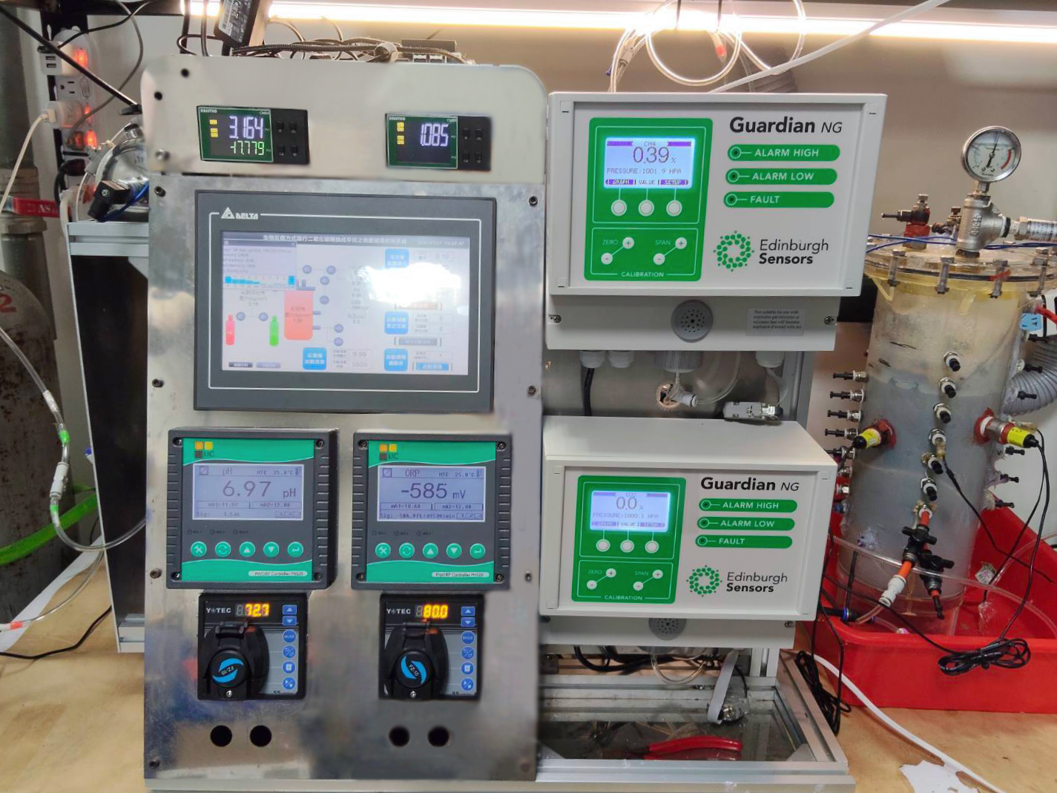
Figure 1. The instrument as built. The panel carries the touch-panel controller running the plant program, the pH and oxidation–reduction potential meters, and the two optical gas analysers reading CH₄ and CO₂; the reactor vessel is at the right. The pressure record analysed in this paper comes from a transducer in the headspace of that vessel.
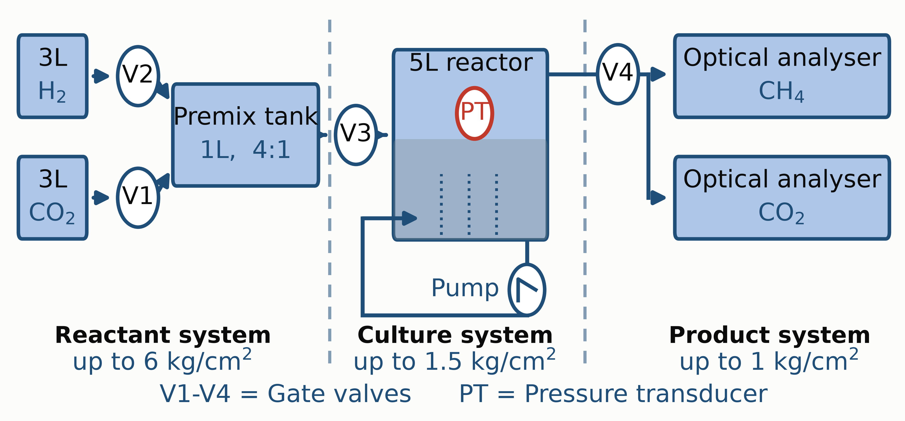
Figure 2. The cascaded pressure-tier design of the reactor. Gas is stepped down from the reactant tier through the culture tier to the product tier, so that the culture is held under a small positive pressure while the analyser downstream stays near ambient. The recirculation pump returns headspace gas to the bottom of the vessel as bubbles, which is what keeps the reactant gases dissolving. The pressure transducer (PT) marked in the headspace is the only channel this paper uses; the controller that opens valve V3 is a closed unit whose state is never logged.
The reactor is a micro-pressurized recirculating vessel operated under a granted invention patent (TW I923176). Liquid is recirculated continuously; the headspace is charged with an H₂:CO₂ mixture premixed at 4:1, the stoichiometric ratio for CO₂+4H₂→CH₄+2H₂O. The controller opens the inlet valve when headspace pressure falls below a threshold and closes it on reaching a target, so a refill is complete within about one minute and is treated here as instantaneous. The arrangement is that of Fig. 2; the controller reads pressure and commands the inlet valve, but its state is never logged.
Of the logged channels only four are trustworthy: two pressure transducers, oxidation–reduction potential (ORP), and pH. The gas-analyzer composition channels are stale for 99.98% of samples and are not used as evidence anywhere in this paper. The present analysis uses the headspace pressure channel alone.
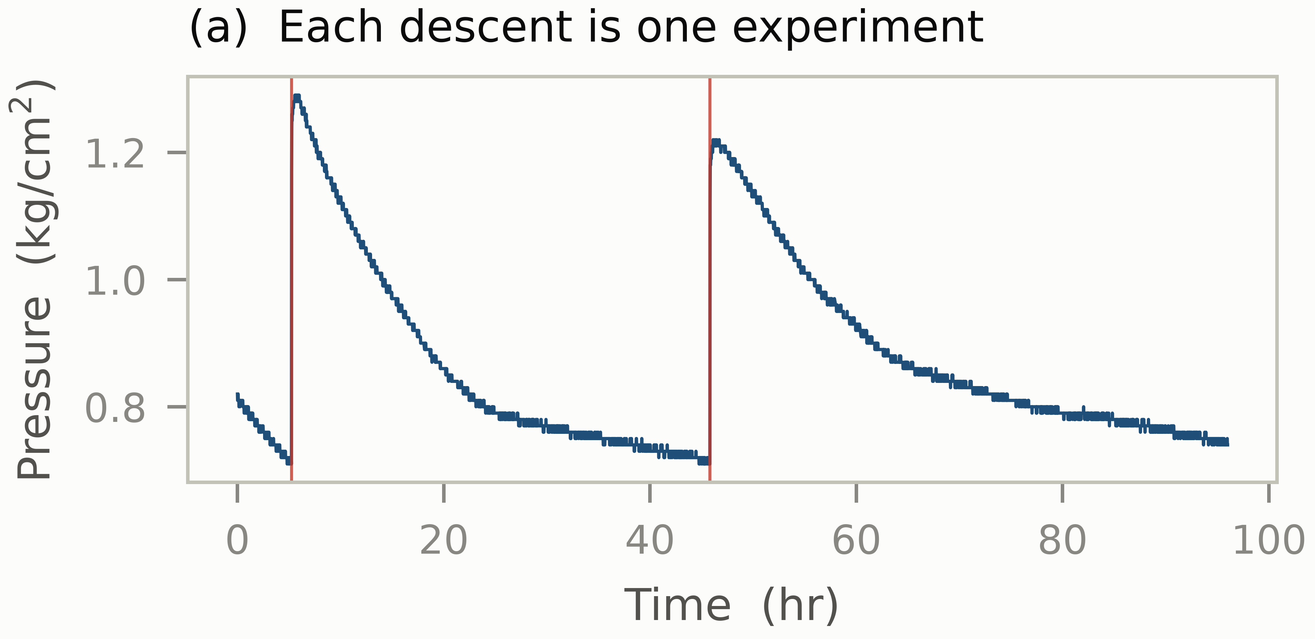
Figure 3. Four days of measured pressure; red lines mark threshold-triggered refills, about twice a day and 270 times in total. Each descending flank is one endogenous relaxation experiment, and the sawtooth is the signature of the trigger loop.
Fig. 3 shows a representative four-day window. Because a refill raises pressure by far more than the sensor quantum within a single sample interval, cycle boundaries need no changepoint machinery: a threshold rule on the rise above the running minimum yields 270 distinct descents.
Those cycles are long and shallow. Pressure is logged once a minute, so a cycle of median duration 10.2 hr carries roughly 610 samples. The median descent amplitude is 0.27 kg/cm², which is 27 quantization steps, while the median residual scale about a fitted trajectory is 0.0056 kg/cm², below a single step. The biological term accounts for roughly half of the descent, so the quantity to be recovered spans on the order of thirteen steps against a per-sample noise smaller than one. That is the regime the rest of the paper works in: many samples, a coarse ladder, and an effect large against the noise but small against the physical term it must be separated from.
2.2 Physical and Biological Contributions
The difficulty runs deeper than the missing channel. A single relaxation is not enough to separate the two contributions even in principle. Writing the descent as
P(t)=P_{eq}+A e^{-kt}-r_{b} t (1)
where P_{eq} is the pressure the headspace would settle at on physics alone, A=P(0)-P_{eq} is how far the refill leaves it from that value, and k sets how fast it returns. Table 1 collects the four quantities. The exponential term carries the physical approach to equilibrium and the linear term the constant-rate biological removal, and the only feature that tells them apart is the curvature of the exponential.
Table 1. The four quantities of Eq. (1). Only r_{b} is the target of this paper; the other three describe the physical transient that has to be separated from it.
Symbol | Meaning
P_{eq} | Physical equilibrium baseline of the headspace
A | Initial amplitude of the physical relaxation
k | Physical relaxation rate
r_{b} | Biological removal rate

Over a window in which kT is small that curvature is never expressed. Expanding e^{-kt}≈ 1-kt and collecting terms turns Eq. (1) into
P(t) ≈ (P_{eq}+A) - (Ak+r_{b}) t (2)
a straight line whose slope is the sum Ak+r_{b}. A descent of five units an hour is then explained equally well by Ak=4 with r_{b}=1, by Ak=2 with r_{b}=3, or by Ak=0 with r_{b}=5: the record fixes the sum and says nothing about the split. Recovering r_{b} from that sum is the problem this paper addresses. Practical identifiability of exactly this kind is a recognized open problem in the anaerobic-digestion modeling literature [5], and it persists in the mechanistic models written specifically for biomethanation: recent extensions of Anaerobic Digestion Model No. 1 (ADM1) to this process carry biological and mass-transfer parameters that must be identified together from the same measurements [1].
Given only the observed pressure trajectory P(t), the objective of this paper is to estimate r_{b} reliably while separating the transient physical contribution characterized by k. Sections? and? address, in turn, how that estimate is formed and how far it can be trusted.
3. RELATED WORK
Three lines of work bear directly on this problem, and the first is the one that most constrains what we may claim.
Two rates from one gas trace. The estimation geometry we face is fifty-nine years old. Bandyopadhyay, Humphrey and Taguchi addressed the problem of measuring a volumetric oxygen transfer coefficient in a fermenter whose culture keeps consuming oxygen throughout the measurement, and proposed the dynamic gassing-out method as the solution [3]. The procedure is to interrupt the aeration briefly, trace the dissolved oxygen concentration of the broth across that interruption, and analyse the resulting trace for the coefficient k_{L}a. One scalar channel therefore has to carry both a transfer term and a biological one, which is the structure we inherit and in which we claim no novelty. The authors report the technique as rapid and internally consistent, and they probe its limit with prolonged starvation experiments, finding that the oxygen uptake rate itself changes once the interruption lasts between two and ten minutes. Our regime differs in two ways: their protocol imposes the interruption where ours may not perturb a production vessel, and they report a point estimate where we report a degeneracy-calibrated aggregate.
Linek, Beneš and Vacek attacked a specific failure of such dynamic methods [13]. Their target was the error introduced when the transient is created by a step change in the oxygen concentration of the entering gas: interfacial nitrogen transport and the finite rate at which the concentration change propagates into individual bubbles can distort the reported coefficient by more than hundreds of percent. Their solution replaces that step with a change of roughly twenty percent in the total reactor pressure, which alters the oxygen concentration in every bubble of the dispersion simultaneously and so suppresses the influence of non-ideal mixing in the gas phase. They validate the procedure against two independent references, the standard dynamic method in which pure oxygen is absorbed into a previously degassed liquid, and the steady-state sulphite method, and they describe a test for the one requirement the method imposes, that the oxygen probe signal be independent of pressure. The method is reported as suitable for large-scale reactors because the necessary pressure changes are small and ordinary air can be used. Both references it is checked against are chemical rather than biological, which is the point of contact with our problem: the transient is imposed rather than observed, and the biological term is not among the quantities being estimated.
Adding a channel rather than resolving the degeneracy. Where the split matters in practice, the field measures something else. Hafner, Rennuit, Olsen and Pedersen took as their problem the leaks that undermine batch biogas assays, and proposed detecting and correcting them from the change in bottle mass during incubation [12]. Three experiments were run to test the method, on pure chemicals, on wastewater sludge and on other complex substrates, and leaks were found in all three; their frequency and magnitude tracked headspace pressure and the number of times the bottle septa had been punctured. Comparison against an independent estimate of leakage in two of the experiments showed the mass-based estimate to be accurate. The reported sensitivity is that leaks as small as twenty percent of total biogas or methane production can be detected, and smaller ones when production is high relative to the precision of the mass measurement, on the strength of which the authors recommend that the measurement always be made. What that method supplies is a second and physically independent observable, and that is why the degeneracy is rarely confronted directly; it is also precisely what our vessel cannot give us.
Where the quantity of interest is too costly or too slow to instrument continuously, the field instead infers it from measurements already available. Rutland, You, Liu and Bowman addressed the FOS/TAC ratio, which sets the volatile fatty acids of a digester against its buffering capacity and is used as an indicator of process stability; its continuous monitoring is limited by the cost and calibration burden of live sensors and by the delay of offline laboratory analysis [16]. Their solution is a soft sensor trained on variables that are already logged online, using data from a one-hundred-and-sixty-day pilot trial of a microbial-electrolysis-cell digester treating brewery wastewater. The procedure first reduces the variable set to seven by random-forest feature importance, with pH ranking highest and hydrogen sulphide second, and then compares decision trees, XGBoost, support vector regression and artificial neural networks under five-fold cross-validation in which the temporal order of the record is preserved rather than shuffled. The neural network performed best, reaching an explained variance of 0.77; an out-of-fold ensemble of that architecture averaged 0.62 across folds, or 0.74 once the single fold containing a loading and temperature excursion is set aside. The authors also report where the model degrades, with accuracy falling from 0.79 to 0.58 and F₁ from 0.89 to 0.73 once the ratio exceeds 0.6. Ours is an inference of that kind, but with no offline assay for r_{b} it cannot be supervised, and without a second channel the identifiability question is unavoidable.
Identifiability diagnostics. Raue and colleagues addressed the question of how well the parameters of a partially observed dynamical model are determined by the data at hand, and answered it by exploiting the profile likelihood [15], which re-optimises the remaining parameters while one is held fixed across a range of values. They report that the approach detects structural non-identifiabilities, which manifest as functionally related model parameters, and also practical non-identifiabilities, which arise from the limited amount and quality of the experimental data. Confidence intervals follow from the same computation. The authors describe the results as easy to interpret and directly usable both for planning further experiments and for reducing the model, and they provide an implementation for MATLAB and the PottersWheel toolbox.
Simpson and Baker have since set the same territory out as a self-contained course, aimed at the gap between the applied-statistics treatment of identifiability and the differential-equation models applied mathematicians actually use [18]. Their approach is likelihood-based throughout: a process model and a noise model together give a log-likelihood, numerical optimisation gives the maximum-likelihood estimate, and univariate profiles—each obtained by holding one parameter fixed on a grid while the others are optimised out—are thresholded against a χ² quantile to give confidence intervals, which are then propagated into prediction intervals by sampling parameter sets from inside the confidence set. Three exercises carry this through an ordinary differential equation, a partial differential equation and a boundary-value problem, supported by open-source code in Julia and Python. The first two problems are identifiable; the third is not, and it is the one that resembles ours. There the steady-state solution depends on the parameters only through the combinations J/√(kD) and √(k/D), so the univariate profiles for J, D and k come out flat—infinitely many triples fit the data equally well—whereas reparameterising in terms of those two combinations restores single-peaked profiles and finite intervals. The authors also caution that local diagnostics built from the Hessian at the estimate can mislead precisely when a problem is non-identifiable, which is why they treat the profile as a global method. Our degeneracy is of that kind: Eq. (2) identifies only the sum Ak+r_{b}, and the coupled alternative discussed in Sect. 4 identifies only P_{eq}-r_{b}/k.
The specific ill-conditioning we face was characterized by Varah, whose subject was the fitting of discrete data or a continuous function by least squares using exponential functions [19]. He examined the uniqueness and the sensitivity of the best least-squares solution and gave both analytic and numerical examples exhibiting possible non-uniqueness and extreme sensitivity in those solutions. That result is the mathematical root of the degeneracy in Eq. (1) rather than a defect of our implementation, since any model containing an exponential inherits it.
Both diagnostics, however, are computed from a fit, which is the gap our screen addresses: we must decide which cycles are worth fitting before we have a fit to diagnose.
4. PROPOSED METHOD
The method has one estimator and two validations, and it is worth separating them at the outset. Algorithm 1 is what produces a number: it screens a cycle and, if the cycle survives, returns k and r_{b}. Algorithms 2 and 3 produce no estimate of their own; they exist to answer two questions about the number Algorithm 1 gives—how much of it is an artifact of the estimator, and whether physics alone could have produced it. Fig. 4 places the three in that relation.
Two preparation steps come before any fitting. Their thresholds are set far from the values they must separate rather than tuned to them, as the comparisons below indicate. Segmentation cuts the record wherever pressure rises more than 0.03 kg/cm² above its running minimum. A refill lifts pressure by far more than that within a single sample interval, so this threshold separates refills from noise without any changepoint machinery. Three exclusions then remove what cannot carry a rate: segments shorter than 4 hr and segments shallower than 0.10 kg/cm², against median values of 10.2 hr and 0.27 kg/cm², and the first 3 min of every segment, which is the refill itself and therefore violates the assumption that refilling is instantaneous. Cleaning finally removes two contaminants that the equipment operators identified: pipe-washing days, on which the vessel is deliberately cycled to clean lines, and the refill interval.
Why should (1) take that particular form? Because the two processes act in different places. The culture lives in the liquid and consumes gas that is already dissolved, so the headspace never loses gas to the biology directly—it loses gas only across the gas–liquid interface. That one fact splits the descent into two stages. Just after a refill the liquid is undersaturated, transfer across the interface is fast, and it slows as saturation is approached: this is the exponential term A e^{-kt}. Once the liquid is near saturation, transfer no longer runs ahead of consumption but merely replaces what the culture has removed, so the headspace drains at whatever rate the biology sets: this is the linear term -r_{b} t. The two terms are added because they describe two stages of one descent, not two sinks acting at once.
Writing them additively is also what keeps r_{b} visible, which is worth stating because the alternative fails silently. Had the biological sink been attached to the headspace instead, as in Ṗ=-k(P-P_{eq})-r_{b}, the rate would enter only through the combination P_{eq}-r_{b}/k and the equilibrium pressure would absorb it entirely. The data prefer the additive form as well: by the Akaike information criterion (AIC) it wins on 74.9% of the analysed cycles, against 4.8% for a pure line and 20.3% for a pure exponential.
Its degeneracy is not a defect of our implementation but a long-known property of exponential fitting, whose non-uniqueness and extreme sensitivity to the data Varah characterized directly [19]; in the language of Gutenkunst et al. [11] the model is sloppy along the direction that trades A and k against r_{b}. On real data two fits differing by a factor of 2.5 in r_{b} lie within 1% of the same residual sum of squares.
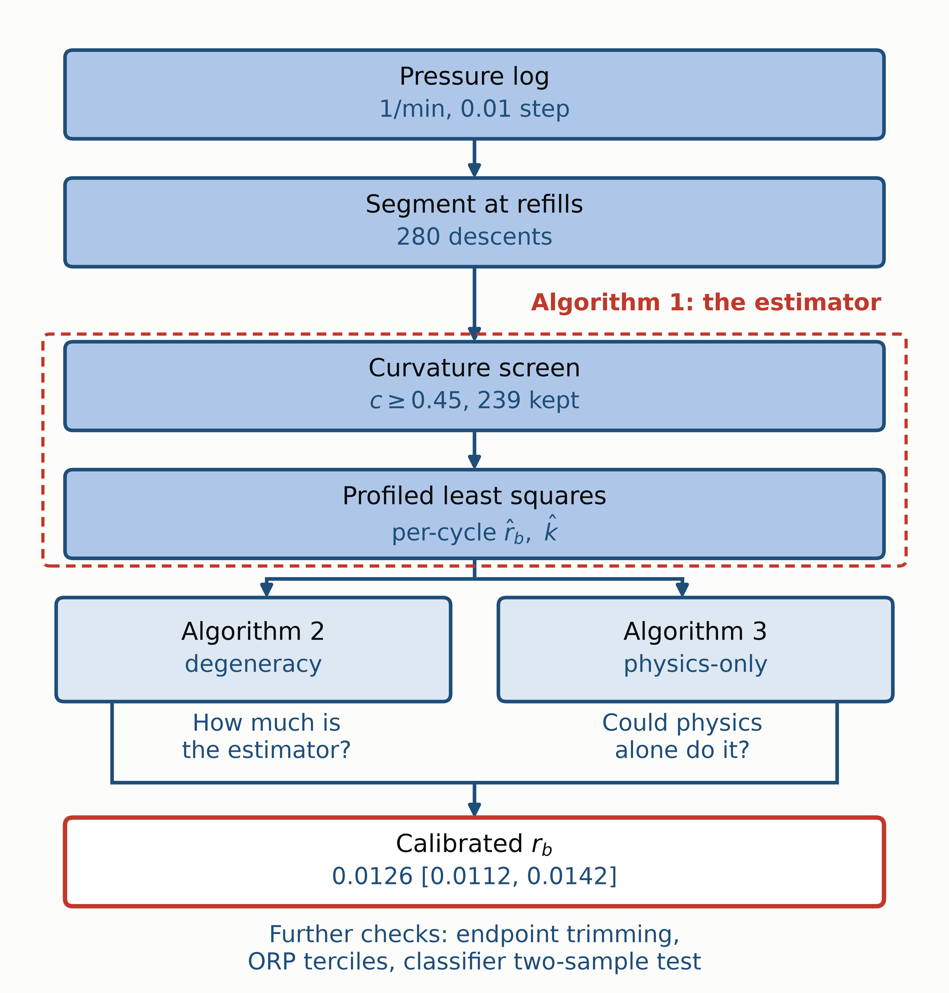
Figure 4. The method. Algorithm 1 is the only step that produces a number: it screens each descent and, for those retained, returns the pair (r̂_{b},k̂). Those same estimates are then put to two independent questions. Algorithm 2 asks how much of the number the estimator itself introduced, and Algorithm 3 asks whether physics with no biological term could have produced it. The two answers together bound what the calibrated rate means.
4.1 Cycle-Level Rate Estimation
The profile likelihood [15] would diagnose this degeneracy, but it is computed from a fit, and on this data a fit is exactly what we do not yet trust. We therefore screen on the shape of the raw trajectory before fitting anything.
The screen statistic is the normalized mid-point curvature
c = (y(0)-y(T/2)) / (y(0)-y(T)) (3)
which equals exactly 0.5 for a straight descent, where the two terms of (1) are indistinguishable, and rises as the trajectory bends. A cycle is retained when c ≥ c*, with c*=0.45 fixed by recovery on synthetic cycles of known truth r_{b}=0.012: below that value the recovered median is biased by more than 25%.
For a cycle that survives the screen, Eq. (1) is non-linear in k alone: once k is held fixed the model is linear in A, P_{eq} and r_{b}. Writing the design matrix for a candidate k as
D(k)=[ e^{-kt}, t, 1 ] (4)
the remaining three coefficients follow in closed form from ordinary least squares, β̂(k)=argmin_{β} ‖y-D(k)β‖², with residual
S(k)=‖y-D(k) β̂(k)‖² , k̂=argmin_{k∈K} S(k) . (5)
The four-parameter non-linear fit therefore reduces to a scan over a grid K of 150 values with one exact 3×3 solve at each, and r̂_{b} is read off as the negative of the coefficient on t at k̂. Profiling is preferred to a joint non-linear optimiser for reasons beyond speed. The scan is exhaustive over K, so the minimum reported is global on that grid and no starting value has to be guessed—which matters precisely here, because Eq. (2) makes the objective nearly flat and a descent method can halt anywhere along it while reporting convergence. The profile is also its own diagnostic: where the degeneracy bites, S(k) has no distinct minimum, so the curve that yields k̂ shows at the same time how weakly the data constrain it. Eq. (3) is the cheaper test that anticipates this before any fit is run. Algorithm 1 states the screen and this estimator together; both run in NumPy alone, within the 60 MB budget of the monitoring computer.
Algorithm 1 Extracting a Trustworthy Rate from One Cycle
Input: one cycle (t, y) of duration T
Parameter: c* = 0.45, grid K over k
Output: the estimates r_{b} and k for the cycle
1: c ← (y(0)-y(T/2)) / (y(0)-y(T)) // shape only
2: if c < c* then reject the cycle and stop
3: for each k ∈ K do
4: D(k) ← [exp(-k t), t, 1] // design matrix
5: b(k) ← argmin_{v} |y - D(k)v|² // 3x3 solve
6: s(k) ← |y - D(k) b(k)|² // residual
7: end for
8: k_{fit} ← argmin_{k} s(k)
9: return r_{b} = -b₂(k_{fit}) and k_{fit}
[Cycles too straight to constrain the relaxation constant are rejected before any fit is attempted. The profiled least-squares estimator for (1). Solving all 150 grid values of k as one stacked 3×3 system keeps a full pass over 239 cycles under one second]
Line 1 computes the curvature c of Eq. (3) from three points of the raw trajectory; no model is fitted, so nothing about a fit can influence what follows. Line 2 discards the cycle outright when c falls below c*: such a descent is too straight for the two terms of Eq. (1) to be told apart, and no estimate is preferable to a meaningless one. Line 3 opens a sweep over the grid K, which is worth doing because Eq. (1) is linear in P_{eq}, A and r_{b} once k is held fixed. Line 4 builds the design matrix D(k) of Eq. (4) for the current k, Line 5 solves the resulting 3×3 least-squares problem in closed form, and Line 6 records the residual sum of squares S(k) of Eq. (5). Line 7 closes the sweep, which has by then replaced one four-parameter non-linear fit with 150 exact linear ones—the reason a full pass stays inside the memory budget of the monitoring computer. Line 8 keeps the k whose residual was smallest, and Line 9 returns it together with r_{b}, read off as the negative of the coefficient on t because the linear term enters Eq. (1) with a minus sign.
Algorithms 2 and 3 both call three small subroutines, listed together below so that each is defined before it is used. What separates the two validations is not these routines but the numbers they are given.
Algorithm 2
1: FitPhysical(t, y):
2: for each k ∈ K do
3: fit P_{eq} + A exp(-k t) by least squares
4: return the (P_{eq}, A, k) of smallest residual
5: ResidualSD(t, y, P_{eq}, A, k):
6: r ← y - (P_{eq} + A exp(-k t))
7: return sqrt(r.r / (n - 3)) // 3 fitted
8: DrawAR1(n, σ, φ):
9: s ← σ sqrt(1 - φ²)
10: z(1) ← Normal(0, σ)
11: for j ← 2 to n do
12: z(j) ← φ z(j-1) + Normal(0, s)
13: return z
FitPhysical is Algorithm 1 with the biological term deleted: the same grid over k, but a design matrix of two columns instead of three, so the fit returns the best account of the descent that a purely physical model can give. ResidualSD then measures what that account failed to explain, dividing by n-3 because three parameters were fitted; the result is a single number per cycle, in the units of pressure. DrawAR1 returns a first-order autoregressive sequence whose innovations are scaled by σ1-φ² rather than by σ, which is what keeps the standard deviation of the sequence itself at σ regardless of φ; without that factor a larger autocorrelation would silently inflate the noise as well.
4.2 Parameter-Degeneracy Assessment
Across the retained cycles the fitted r̂_{b} and k̂ correlate at ρ=0.790, which read naively looks like proof that the estimate is an artifact. It is not readable in isolation: r̂_{b} and k̂ jointly absorb the same descent, so they correlate even when the truth is fixed. The question is how far the correlation exceeds what a fixed truth already produces.
We therefore apply empirical calibration in the sense of Schuemie et al. [17], replacing the theoretical null ρ=0 with one estimated from cases where the truth is known. The null is generated by design-matched simulation (Algorithm 2): each real cycle contributes its own fitted k̂,Â,P̂_{eq}, duration, residual scale and first-order autoregressive (AR(1)) coefficient, only the true r_{b} is substituted, and the result passes through the identical pipeline, so the estimator's distortion appears on both sides and cancels—the logic of indirect inference [9]. Our adaptation is the source of the negative controls: ours are simulations reusing the real designs, which fixes the truth exactly instead of assuming it.
Algorithm 3 Measuring and Removing the Degeneracy Bias
Input: per-cycle LE fits k, A, P_{eq}, t, σ, φ
Parameter: truth r_{b}(.), R = 25, quantum q = 0.01
Output: baseline distributions of ρ and m
1: for r ← 1 to R do
2: for i ← 1 to 207 do
3: e ← DrawAR1(n, σ, 1.3 φ) // from LE fit
4: z ← P_{eq} + A exp(-k t) - r_{b}(k) t + e
5: y ← q round(z / q) // same quantum
6: (rb, kk) ← Algorithm 1 (t, y)
7: end for
8: ρ(r) ← Spearman(rb, kk) // over the 207
9: m(r) ← median(rb)
10: end for
11: return the distributions of ρ and m
[Sweeping β with this routine gives the curve of Fig. 6; a constant truth (β=0) returns ρ=0.290±0.048, and a truth independent of k returns ρ=0.122±0.079, against an observed 0.790]
Line 1 repeats the whole pipeline R times, so that the baseline comes out as a distribution rather than a single number, and Line 2 walks the 207 retained cycles inside each repetition. Line 3 calls DrawAR1, which returns a first-order autoregressive sequence at that cycle's own residual scale rather than white noise, because the measured residuals are not white. Line 4 assembles the synthetic trace from that same cycle's own fitted P_{eq}, A and k, with only the biological rate replaced by the candidate truth r_{b}(k): every quantity except the one under test is inherited from the real cycle, so the distortion measured is the distortion that applies to that cycle. Line 5 puts the trace through the same 0.01 kg/cm² quantization as the instrument, and Line 6 through the estimator of Algorithm 1, unchanged. Line 7 closes the pass over the cycles. Line 8 then records the correlation the pipeline produces from a truth that is known, which is the quantity to be compared against the observed ρ, and Line 9 records the aggregate median, whose departure from the truth put in is the bias to be removed. Line 10 closes the repetitions and Line 11 returns both distributions.
The simulator itself must be shown adequate, or the baseline means nothing. We use a classifier two-sample test, introduced for this purpose by Friedman [6] and revisited by Lopez-Paz and Oquab [14], and applied to simulator and emulator validation by Dalmasso et al. [4]: a classifier is trained to tell real trajectories from simulated ones, and an area under the receiver operating characteristic curve (AUC) near 0.5 indicates the two are indistinguishable. The noise model is calibrated on one half of the cycles and the AUC computed on the held-out half.
4.3 Purely Physical Null-Model Test

The validity of the test behind p=0.024 (Algorithm 3) rests on what the null is allowed to contain. For each retained cycle we fit the two-parameter form P(t)=P_{eq}+A e^{-kt}, that is (1) with r_{b} forced to zero, so the fitted null reproduces the cycle's own equilibrium, amplitude and relaxation constant. We regenerate the cycle from that fit, add AR(1) noise at its own residual scale, quantize to 0.01 kg/cm², and pass it through the identical screen and estimator. Over all 207 cycles this yields one draw of the aggregate median under a physics-only truth; 60 draws give its null distribution.
Algorithm 4 Ruling Out a Purely Physical Explanation
Input: the retained cycles (t, y), i = 1..207
Parameter: draws D, grid K, quantum q = 0.01
Output: reference distribution of the median
1: for i ← 1 to 207 do
2: (P_{eq}, A, k) ← FitPhysical(t, y) // r_{b} fixed 0
3: σ ← ResidualSD(t, y, P_{eq}, A, k)
4: end for
5: for d ← 1 to D do
6: for i ← 1 to 207 do
7: e ← DrawAR1(n, σ, 1.3 φ) // physics-only
8: z ← P_{eq} + A exp(-k t) + e
9: w ← q round(z / q) // same quantum
10: rb ← Algorithm 1 (t, w) // same estimator
11: end for
12: m(d) ← median(rb)
13: end for
14: return the distribution of m over D draws
[The reference is fitted per cycle, so it inherits every degree of freedom the alternative has except the biological rate itself, and it passes through the same quantization, screen and estimator]
Line 1 opens a first pass over the retained cycles, in which the reference itself is constructed. Line 2 calls FitPhysical, which refits the cycle with the rate held at zero and returns the P_{eq}, A and k that give the best purely physical account of that particular descent. Line 3 calls ResidualSD, which returns the root-mean-square residual of that same fit with its three fitted parameters removed from the degrees of freedom; that scalar is how much scatter physics alone leaves behind on this cycle, and it sets the amplitude of the synthetic noise added later at Line 7. Line 4 closes the pass. Line 5 then draws D realisations of the reference and Line 6 walks the cycles within each. Line 7 calls the same DrawAR1 routine that Algorithm 2 uses, but not with the same numbers: there the scale and the autocorrelation come from the residuals of the full fit of (1), whereas here they come from the residuals of the physics-only fit at Line 2. The distinction matters and it runs in our favour. A straight biological trend that the physics-only model cannot represent is left in its residuals, so those residuals are both larger and smoother: across the retained cycles the median scale rises from 0.0056 to 0.0064 kg/cm² and the median autocorrelation from 0.30 to 0.48. The reference is therefore granted more noise, and noise of exactly the slowly varying kind that a linear term can be mistaken for, than the alternative it is being compared against. Line 8 generates a trace from the physics-only fit, with no linear term present at all. Line 9 applies the same quantization and Line 10 the same estimator, which is what makes the outcome interpretable: any rate reported here is an artifact of the pipeline, since there is no biological rate in the data to find. Line 11 closes the pass over cycles, Line 12 records the aggregate median of that realisation, Line 13 closes the draws, and Line 14 returns the resulting distribution.
The null is fitted per cycle rather than pooled, so it is granted every degree of freedom the alternative has except r_{b} itself. Under it the aggregate median is +0.00008 ± 0.00010 kg/cm²/hr, two orders of magnitude below the observed 0.0132.
5. EXPERIMENTAL RESULTS
The results are organised by question rather than by algorithm: which cycles enter the analysis, what rate they give, how much of that rate survives the degeneracy, whether physics alone can account for it, and whether an independent channel agrees.
5.1 Experimental Setup and Pressure Cycles

The record analysed here is the plant's own operating log: one pressure value a minute, quantized at 0.01 kg/cm², with nothing added to the instrument and no excitation imposed on it. Applying the threshold rule of Sect. 2 to the whole archive returns 351 segments, of which 270 are distinct: the same logger files are stored in more than one folder, and the copies are removed before anything is fitted. The distinct descents were logged over periods that do not all share the same operating condition, and three groups are set aside before any rate is compared. One period was charged at an H₂:CO₂ ratio of 1:1 instead of the 4:1 of Sect. 2, which changes the proportion in which the two gases leave the headspace. One covers an interval during which liquid recirculation was switched off, so gas–liquid transfer is not the regime Eq. (1) describes. The third returns a negative median rate—biology producing pressure—which is physically impossible and points to a fault in the record rather than to a slow culture.
The first two criteria are settled by the recorded operating condition alone. The third is not: it is settled by the fitted result, and we therefore report what happens without it. Keeping only the two condition-based exclusions moves the screened median from 0.0132 to 0.0126 kg/cm²/hr, and applying none of the three moves it to 0.0120 kg/cm²/hr; the two shifts, -4.6% and -8.8%, are both smaller than the accuracy quoted for the reported rate, so the result does not rest on the exclusion that looked at an outcome. What the exclusions leave is 239 cycles, of which the curvature screen retains 207. The median descent runs for 10.2 hr, with quartiles at 7.1 and 21.6 hr, and ends in a narrow band—three quarters of them between 0.70 and 0.80 kg/cm²—which is the refill threshold making itself visible in a record that never states it.
Those 207 cycles come from four logging periods whose individual medians run from 0.0113 to 0.0203 kg/cm²/hr, and dropping either of the two largest periods moves the aggregate by -13.6% or +26.6%. That spread is wider than the ± 11.0% accuracy that Sect. 5.3 will attach to the calibrated rate, and the two statements do not contradict each other: the interval says how precisely the median of this record is pinned down, not how steady the culture is from month to month. The rate reported below is an aggregate over the record analysed, and the variation between periods is itself what Sect. 5.3 establishes on independent grounds—a rate that is constant across cycles is excluded by the calibration.
5.2 Physical and Biological Rate Estimation
Fig. 5 shows what Algorithm 1 returns on the retained cycles. Panel (a) is a single cycle whose k̂ and r̂_{b} both sit close to the medians of the retained set: the fitted trajectory follows the quantized record over ten hours, and the gap between the fitted total and its physical part is the biological contribution the decomposition is there to isolate. Panels (b) and (c) give the distributions over all retained cycles. The relaxation constant spans two orders of magnitude with median 0.15 /hr, and the per-cycle rate has median 0.0132 kg/cm²/hr before calibration.

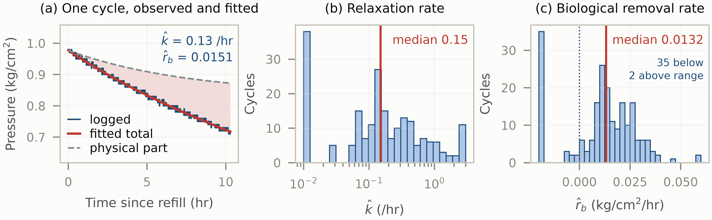
Figure 5. What the estimator returns on the 207 retained cycles. (a) A cycle with k̂ and r̂_{b} near the medians of the set; the logged trace advances in steps of 0.01 kg/cm², and the shaded band between the fitted total and its physical part is the biological contribution. (b) Distribution of the fitted relaxation constant, on a logarithmic axis. (c) Distribution of the fitted biological rate; the dotted line marks zero, and values outside the plotted range are collected in the end bars rather than shown at their own positions.

The spread in panel (c) is why the aggregate is reported and the per-cycle value is not: 42 of the 207 cycles return a negative rate, which is physically impossible and is the degeneracy of Sect. 2 expressing itself on individual descents.
That spread also fixes how the cycles are pooled. With those negative values at one end and a tail reaching several times the centre at the other, the mean over per-cycle estimates is neither robust nor interpretable, whereas the median of a set whose members are noisy but not systematically ordered remains a usable summary. The median is equally what the calibration is built around: the matched simulations of Sect. 5.3 report that same functional on data generated from a known truth, so the distortion measured there is the distortion of the quantity actually reported. The estimand is therefore the median rate over the cycles the screen retains, and every correction and interval quoted below refers to that functional rather than to any individual cycle. What the median survives and a single cycle does not is the subject of the next two subsections.
5.3 Robustness Against Parameter Degeneracy

Rather than assume a form for the k dependence, we treat its strength as the quantity to be inverted. Writing the truth as r_{b}(k)=r_{b}⁰(k/k_{med})^{β}—a power law, so that r_{b} cannot turn negative and the median truth is r_{b}⁰ for every β—we sweep β and run the full matched pipeline at each value, obtaining the calibration curve of Fig. 6(a). Table 2 collects the resulting figures alongside the counts and the rate they lead to.
Table 2. The recovered rate and the calibration checks behind it. The baseline rows are design-matched simulations in which the true rate is known, so the estimator's own distortion can be read off directly.
Quantity | Value | Note
Descents segmented | 351 | threshold rule
Distinct descents | 270 | duplicate copies removed
Cycles analysed | 239 | after condition exclusions
Cycles retained | 207 | c ≥ 0.45
Calibrated r_{b} | 0.0125 kg/cm²/hr | 95% [0.0112, 0.0139]
sampling component | 6.0% | standard error, 207 cycles
systematic component | ± 2.2% | range over the compatible set
Physics-only reference | p=0.024 | pure exponential truth
Observed ρ(r̂_{b},k̂) | 0.790
Calibration, β=0 (constant) | 0.290 ± 0.048 | artefact level
Baseline, r_{b} independent of k | 0.122 ± 0.079
Compatible set | 0.15 ≤ β ≤ 0.80 | within calibration scatter
Raw profiled median | 0.0132 kg/cm²/hr | before correction
Calibrated correction | -4.8% | estimator distortion only

A constant truth is excluded: β=0 produces only ρ=0.290 ± 0.048 against the observed 0.790, a gap of roughly ten standard deviations, and making r_{b} merely variable without tying it to k lowers the correlation further, to 0.122. Truths with β between 0.15 and 0.80 reproduce the observed correlation to within the calibration scatter, and it is that compatible set we carry forward.
The same calibration then supplies the correction (Fig. 6(b)), and it separates two effects that must not be conflated. The screen admits cycles by curvature, so the truths it keeps are not those of the whole population; that displacement grows with β and reaches 30% at the top of the compatible set. This displacement must not be corrected, because it is not a distortion of the estimate but a property of the quantity being estimated: what we report is the rate on the cycles where it is identifiable, and the screen is what selects them. Correcting it would mean reporting a rate for cycles on which no rate can be recovered. What must be corrected is the estimator's own distortion, measured against the truths actually kept, and that stays between +2.1% and +6.7% across the whole compatible set—positive at every value of β, so the estimator overstates the rate throughout. Inverting it corrects the raw profiled median by -4.8%, to 0.0125 kg/cm²/hr, at the centre of the compatible set. That single point is not the reported value. Because the correction enters as a quotient and the bias is not symmetric across the set, we draw the bias and the sampling error together by Monte Carlo, which shifts the centre slightly. The calibrated rate, with the bracket giving its 95% confidence interval, is
r_{b} = 0.0125 [0.0112, 0.0139] kg/cm²/hr . (6)
That confidence interval combines two sources that behave differently. Resampling the 207 cycles gives a standard error of 6.0% on the median, which shrinks as logging continues; the spread over the compatible truths is ± 2.2% and does not, being set by how sharply the calibration separates members of the family rather than by how many cycles are seen. Since the correction enters as a quotient we draw from both by Monte Carlo. The two figures are quoted in different units—the first is one standard error, the second a full range—so they do not add: the Monte Carlo returns the 95% half-width of ± 11.0% in (6)—the accuracy with which a single quantized pressure channel fixes the biological rate, and the main quantitative result of this paper.
The classifier two-sample test is reported next. A white-Gaussian noise model is separated at AUC=0.954; the residuals of real cycles in fact carry a lag-1 autocorrelation with median 0.237. Modeling the noise as AR(1) reduces this to 0.766, and inflating φ̂ by the factor 1.3 calibrated on the held-out split reaches 0.706. All ten marginal trajectory features then agree to within 0.34 pooled standard deviations, the largest gap being the monotone fraction (0.815 against 0.788), with curvature, residual scale, lag-1 autocorrelation, amplitude and duration all within 0.18; we return to the residual mismatch in Sect. 6.
Segmentation ends each cycle at the sample immediately before a refill, and that sample is selected because pressure fell far enough to trigger, so it should sit below the underlying trend. It does: across the retained cycles the terminal residual averages -0.0067 of the cycle amplitude, with a 95% interval of [-0.0115, -0.0019] that excludes zero, against a mid-cycle mean indistinguishable from zero with a spread of 0.0017. Most of the effect has already been removed by the screen, and not by design: on the unscreened descents the same statistic is -0.0675, ten times larger, because a cycle too straight to constrain k is also one whose fit is least anchored at its ends. Since a linear slope is most sensitive at its endpoints, what remains is still a route to an inflated rate, though small enough to move the slope by about a percent.
Trimming settles it. Removing the last 5 to 90 minutes of every cycle moves the median r_{b} within 0.0125–0.0142 kg/cm²/hr, a scatter of ± 6% about the untrimmed value with no monotone trend, and a design-matched simulation carrying no trigger selection at all drifts over a comparable range as the same samples are removed. The displacement is therefore a property of shortening the window rather than of the trigger: one anomalous sample among roughly 610 has too little leverage to bend the slope.
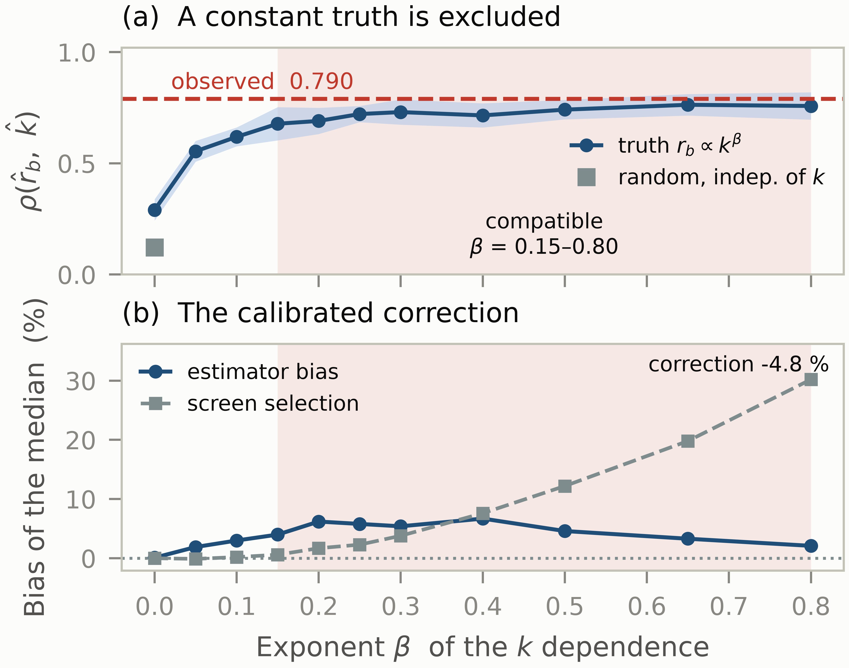
Figure 6. Calibration against the strength β of the k dependence, each point a full matched pipeline; the band in (a) is ±1 standard deviation and the shading in both is the compatible set. (a) A constant truth (β=0) falls ten standard deviations below the observation. (b) The estimator's own distortion, which we correct, and the screen's selection of truths, which is definitional; inverting the first gives the -4.8% correction.
5.4 Evaluation Against the Purely Physical Null Model
The remaining question is whether the observed rate could have arisen with no biology at all. Following Algorithm 3, each retained cycle is refitted with r_{b} forced to zero, regenerated from that fit with AR(1) noise at its own residual scale, quantized to 0.01 kg/cm², and passed through the same screen and the same estimator. The reference therefore keeps every degree of freedom the alternative has except the biological term itself.
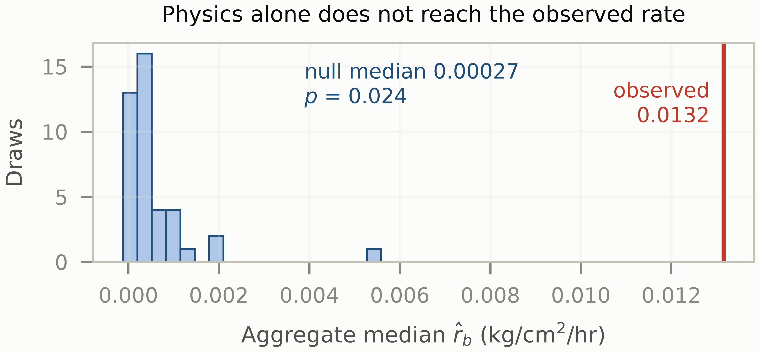
Figure 7. The physics-only reference never reaches the observed rate. Bars are the aggregate median returned by the same pipeline when the truth is r_{b}≡ 0; the vertical line is the observed median.
The reference does not come close. Its aggregate median is 0.00027 kg/cm²/hr and its largest draw reaches 0.0056, against an observed median of 0.0132: no draw attains the observation, which gives a permutation p=0.024 over 41 draws (Fig. 7). The pressure descent therefore contains a component that a physics-only model cannot produce. We stress the direction of this inference: it excludes a purely physical explanation; it does not by itself establish that the residual component is biological.
5.5 An Independent Channel: Redox Potential
Everything above is derived from pressure, and surviving a physics-only reference says what the residual component cannot be, not what it is. The reactor also logs ORP. It enters no part of the estimate and is not a rate. Redox potential is an established monitoring variable for anaerobic digestion, used as an indicator of process state and as an early warning of instability [2], with methanogenesis reported to proceed in a characteristic reducing window [20]; the potential recorded here, referred to the standard hydrogen electrode, falls inside that window. It is a mixed potential rather than a probe of any single species, so we use it only to order cycles, never to measure a rate, and that is what makes it usable as a check.
The comparison has to be made per unit time. Taken over a whole cycle the net change in redox potential is largely a clock: a long descent accumulates more of it, and long descents also carry a lower fitted rate, so ordering cycles by the cumulative change reproduces the duration effect rather than any activity. Using the change per hour instead, and comparing the aggregate rate across terciles, gives 0.0120, 0.0129 and 0.0150 kg/cm²/hr from least to most active—a 25% span, in the direction the interpretation predicts.
That span is not resolved by the present record. Its bootstrap interval, [-0.0043, 0.0077], contains zero, so the ordering is consistent with the redox channel tracking the same variation the calibration found in r_{b}, but does not on its own establish it. We report it as a direction that agrees rather than as a confirmation, and the reason is the one the rest of the paper keeps meeting: ORP is a mixed potential with no composition anchor, so what it supplies is a ranking of limited precision, not a second measurement of the rate. Sharpening it needs the chemical channel discussed in Sect. 6, not more cycles.
6. DISCUSSION
Why pressure decline cannot be read as biological activity. The pressure record is cheap, continuous and already being logged, which is what makes it attractive for process monitoring; the difficulty is that a descent is not a measurement of the culture. Every refill leaves the liquid undersaturated, so for part of each cycle the headspace is losing gas to dissolution at the same time as the culture is consuming it. Reading the descent rate as biological activity therefore overstates it, and the overstatement is largest exactly when the plant has just been refilled. That is the reason the decomposition of Eq. (1) is needed at all, and the reason a screen has to run before the fit: on a cycle whose curvature is too weak, the two contributions are interchangeable and no fit can apportion them.
What the recovered rate is, and what it is not. The quantity in Eq. (6) is a pressure-derived biological removal rate: the part of the headspace pressure loss that a purely physical model cannot produce. It is not a methane production rate. Converting one into the other would require the headspace volume and the operating temperature, and would then have to be checked against a composition measurement, which this instrument cannot supply because its analyser channels are stale for 99.98% of samples. The direction of the inference matters as much as its size: the null test of Sect. 4.3 excludes a purely physical explanation, but what excludes physics does not by itself identify biology. That attribution rests on the stoichiometry of the process, and on a redox ordering that agrees in direction without resolving the size, rather than on the pressure channel itself. Used as a relative indicator on one vessel over time—has the rate fallen since last week, did the new circulation setting help—the number is on firmer ground than it would be as an absolute figure.
Limitations. Three limits bound what the preceding numbers support. First, Eq. (1) treats r_{b} as constant within a cycle. That is a simplifying assumption: the culture is not obliged to consume at a fixed rate across ten hours, and a slow decline within the cycle would be partly absorbed by the exponential term. It is the assumption that makes the linear term identifiable at all, and relaxing it would require a second observable.
Second, the aggregate median is recoverable but the per-cycle estimates are not: individual values scatter widely and are coupled to k̂, so nothing here licenses reading a single cycle as a rate measurement. The same applies to the redox check: it also responds to pH and to dissolved carbon dioxide, so it is not a hydrogen probe, and without a composition anchor it cannot be turned into a rate to set against Eq. (6). Of the ± 11.0% on the rate, the ± 2.2% systematic part is fixed by the calibration rather than by the record length; narrowing it needs the form of r_{b}(k) itself, which a second chemical channel would supply.
Third, the simulator remains distinguishable from reality at AUC=0.706 even after all ten marginal features are matched, so the mismatch lies in joint structure we have not identified. The matched baselines are consequently approximate, and we do not attempt simulation-based inference on this simulator: a posterior learned from a misspecified simulator would be narrow and wrong rather than merely uncertain.
7. CONCLUSION
We have presented a pressure-based framework that separates the transient physical relaxation following a refill from the sustained biological gas removal that continues through a biomethanation cycle, using a single pressure channel quantized at 0.01 kg/cm² and nothing added to a vessel in production. A screen computed from the raw trajectory decides which cycles can carry the separation at all, and the estimator returns a rate only for those.
Two validations bound what that rate means. A design-matched calibration measures the distortion the estimator itself introduces and removes it, and in doing so rules out a constant biological rate across cycles. A purely physical null model, fitted per cycle and passed through the same screen and estimator, shows that physical relaxation alone does not reproduce the observed removal. Across 207 screened cycles the recovered rate is 0.0125 kg/cm²/hr, accurate to 11.0%, of which 2.2% is systematic and does not shrink with a longer record.
Future work will validate this pressure-derived biological removal rate against direct methane-production measurements, which would also fix the conversion to molar units, and will examine its use as a real-time indicator of culture activity in continuous biomethanation.
Acknowledgements. The reactor is operated under invention patent TW I923176 held by the Metal Industries Research & Development Centre.
8. REFERENCES
[1] Acosta-Pavas, J. C., Robles-Rodríguez, C. E., Morchain, J., Dumas, C., Cockx, A., and Aceves-Lara, C. A. 2023. Dynamic modeling of biological methanation for different reactor configurations: An extension of the anaerobic digestion model No. 1. Fuel 344, 128106. DOI: https://doi.org/10.1016/j.fuel.2023.128106
[2] Ao, T., Chen, L., Zhou, P., Liu, X., and Li, D. 2021. The role of oxidation–reduction potential as an early warning indicator, and a microbial instability mechanism in a pilot-scale anaerobic mesophilic digestion of chicken manure. Renewable Energy 179, 223-232. DOI: https://doi.org/10.1016/j.renene.2021.07.047
[3] Bandyopadhyay, B., Humphrey, A. E., and Taguchi, H. 1967. Dynamic measurement of the volumetric oxygen transfer coefficient in fermentation systems. Biotechnology and Bioengineering 9, 4, 533-544. DOI: https://doi.org/10.1002/bit.260090408
[4] Dalmasso, N., Lee, A. B., Izbicki, R., Pospisil, T., Kim, I., and Lin, C.-A. 2020. Validation of approximate likelihood and emulator models for computationally intensive simulations. In Proceedings of the 23rd International Conference on Artificial Intelligence and Statistics (AISTATS), Proceedings of Machine Learning Research 108, 3349-3361. PMLR v108; AISTATS proceedings are not assigned DOIs.
[5] Donoso-Bravo, A., Mailier, J., Martin, C., Rodríguez, J., Aceves-Lara, C. A., and Vande Wouwer, A. 2011. Model selection, identification and validation in anaerobic digestion: A review. Water Research 45, 17, 5347-5364. DOI: https://doi.org/10.1016/j.watres.2011.08.059
[6] Friedman, J. H. 2003. On multivariate goodness-of-fit and two-sample testing. In Proceedings of PHYSTAT2003, SLAC, Stanford, California, September 8–11, 2003. SLAC-PUB-10325. DOI: https://doi.org/10.2172/826696
[7] Ghiat, I., Banu, A., Bicer, Y., Amhamed, A. I., and Al-Ansari, T. 2025. Circularity within carbon capture networks: a review of capture and utilization technologies. Journal of CO2 Utilization 95, 103075. DOI: https://doi.org/10.1016/j.jcou.2025.103075
[8] González, R., Cabeza, I. O., Casallas-Ojeda, M., and Gómez, X. 2023. Biological hydrogen methanation with carbon dioxide utilization: methanation acting as mediator in the hydrogen economy. Environments 10, 5, 82. DOI: https://doi.org/10.3390/environments10050082
[9] Gouriéroux, C., Monfort, A., and Renault, E. 1993. Indirect inference. Journal of Applied Econometrics 8, S1, S85-S118. DOI: https://doi.org/10.1002/jae.3950080507
[10] Gugler, K., Haxhimusa, A., and Liebensteiner, M. 2023. Carbon pricing and emissions: causal effects of Britain's carbon tax. Energy Economics 121, 106655. DOI: https://doi.org/10.1016/j.eneco.2023.106655
[11] Gutenkunst, R. N., Waterfall, J. J., Casey, F. P., Brown, K. S., Myers, C. R., and Sethna, J. P. 2007. Universally sloppy parameter sensitivities in systems biology models. PLoS Computational Biology 3, 10, e189. DOI: https://doi.org/10.1371/journal.pcbi.0030189
[12] Hafner, S. D., Rennuit, C., Olsen, P. J., and Pedersen, J. M. 2018. Quantification of leakage in batch biogas assays. Water Practice and Technology 13, 1, 52-61. DOI: https://doi.org/10.2166/wpt.2018.012
[13] Linek, V., Beneš, P., and Vacek, V. 1989. Dynamic pressure method for kLa measurement in large-scale bioreactors. Biotechnology and Bioengineering 33, 11, 1406-1412. DOI: https://doi.org/10.1002/bit.260331107
[14] Lopez-Paz, D. and Oquab, M. 2017. Revisiting classifier two-sample tests. In International Conference on Learning Representations (ICLR). arXiv:1610.06545.
[15] Raue, A., Kreutz, C., Maiwald, T., Bachmann, J., Schilling, M., Klingmüller, U., and Timmer, J. 2009. Structural and practical identifiability analysis of partially observed dynamical models by exploiting the profile likelihood. Bioinformatics 25, 15, 1923-1929. DOI: https://doi.org/10.1093/bioinformatics/btp358
[16] Rutland, H., You, J., Liu, H., and Bowman, K. 2025. Application of machine learning for FOS/TAC soft sensing in bio-electrochemical anaerobic digestion. Molecules 30, 5, 1092. DOI: https://doi.org/10.3390/molecules30051092
[17] Schuemie, M. J., Ryan, P. B., DuMouchel, W., Suchard, M. A., and Madigan, D. 2014. Interpreting observational studies: why empirical calibration is needed to correct p-values. Statistics in Medicine 33, 2, 209-218. DOI: https://doi.org/10.1002/sim.5925
[18] Simpson, M. J. and Baker, R. E. 2026. Parameter identifiability, parameter estimation, and model prediction for differential equation models. SIAM Review 68, 1, 153-171. DOI: https://doi.org/10.1137/24M1667968
[19] Varah, J. M. 1985. On fitting exponentials by nonlinear least squares. SIAM Journal on Scientific and Statistical Computing 6, 1, 30-44. DOI: https://doi.org/10.1137/0906003
[20] Vongvichiankul, C., Deebao, J., and Khongnakorn, W. 2017. Relationship between pH, oxidation reduction potential (ORP) and biogas production in mesophilic screw anaerobic digester. Energy Procedia 138, 877-882. DOI: https://doi.org/10.1016/j.egypro.2017.10.113
[21] Yörüklü, H. C., Kamravamanesh, D., Köroğlu, E. O., Patel, G. H., Havukainen, J., Karjunen, H., Sillman, J., and Kokko, M. 2025. A comprehensive review on biological methanation processes: from gaseous feedstocks to biomethane. Energy Conversion and Management 341, 120075. DOI: https://doi.org/10.1016/j.enconman.2025.120075

