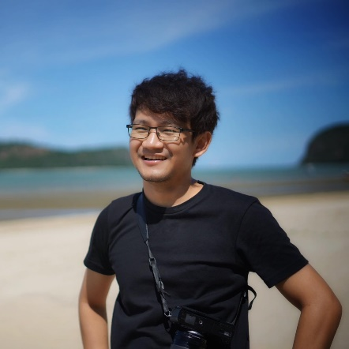

Skills

|  |  |
| --- | --- |
| -Font-end Language   * Html, CSS, razor , jquery, javascript, c#   -Framework and build up   * Asp.net, vuejs, nuxtjs,   Reactjs, nextjs | -Back-end Language   * C#, javascript   -Framework   * .net, .net core   -Server   * IIS, Vercel, Heroku, Azure   -Database   * Sql Server, Mongo, Oracle |

Experience

**SCG Packaging** – May 2019 to Present

**Developer**, Bangkok

* Design database and design flow
* Development new feature font-end, back-end and job schedule
* Fixed bug and maintain application
* Config github action ci/cd automate deploy to Azure
* Config server and build and deploy application to IIS and Azure

**PTT Digital** – May 2018 to May 2019

**Developer**, Bangkok

* Design database and design flow
* Development new feature font-end, back-end and job schedule
* Fixed bug and maintain application
* Config server and build and deploy application to IIS

**AYCAP Of Krungsri Bank** – Jan 2018 to May 2018

**Developer**, Bangkok

**Chanwanich co,.ltd** – Dec 2016 to Dec 2017

**Developer**, Bangkok

**AIG** – Jan 2015 to Nov 2016

**Developer**, Bangkok

**Bangkok Medical Software** – Nov 2013 to Dec 2014

**Developer**, Bangkok

Education

**2010-2013** **Bachelor of Accounting, Major of Business Computer Mahasarakham University** GPA 3.12

Yutthaphum Seekiaw

Contact

**Address:**

260/305 Unio H Tiwanon, bangkhen, mueng nonthaburi, Nonthaburi 11000

**Phone:**

0626983863

**Email:**

[Yutthaphum_bo@hotmail.com](mailto:Yutthaphum_bo@hotmail.com)

**Website:**

<https://cv-boo-nextjs.vercel.app/>

**Languages:**

Thai – very good

English – beginner

Hobbies

* Lean modern web
* Travel
* Sleep
* Play football