

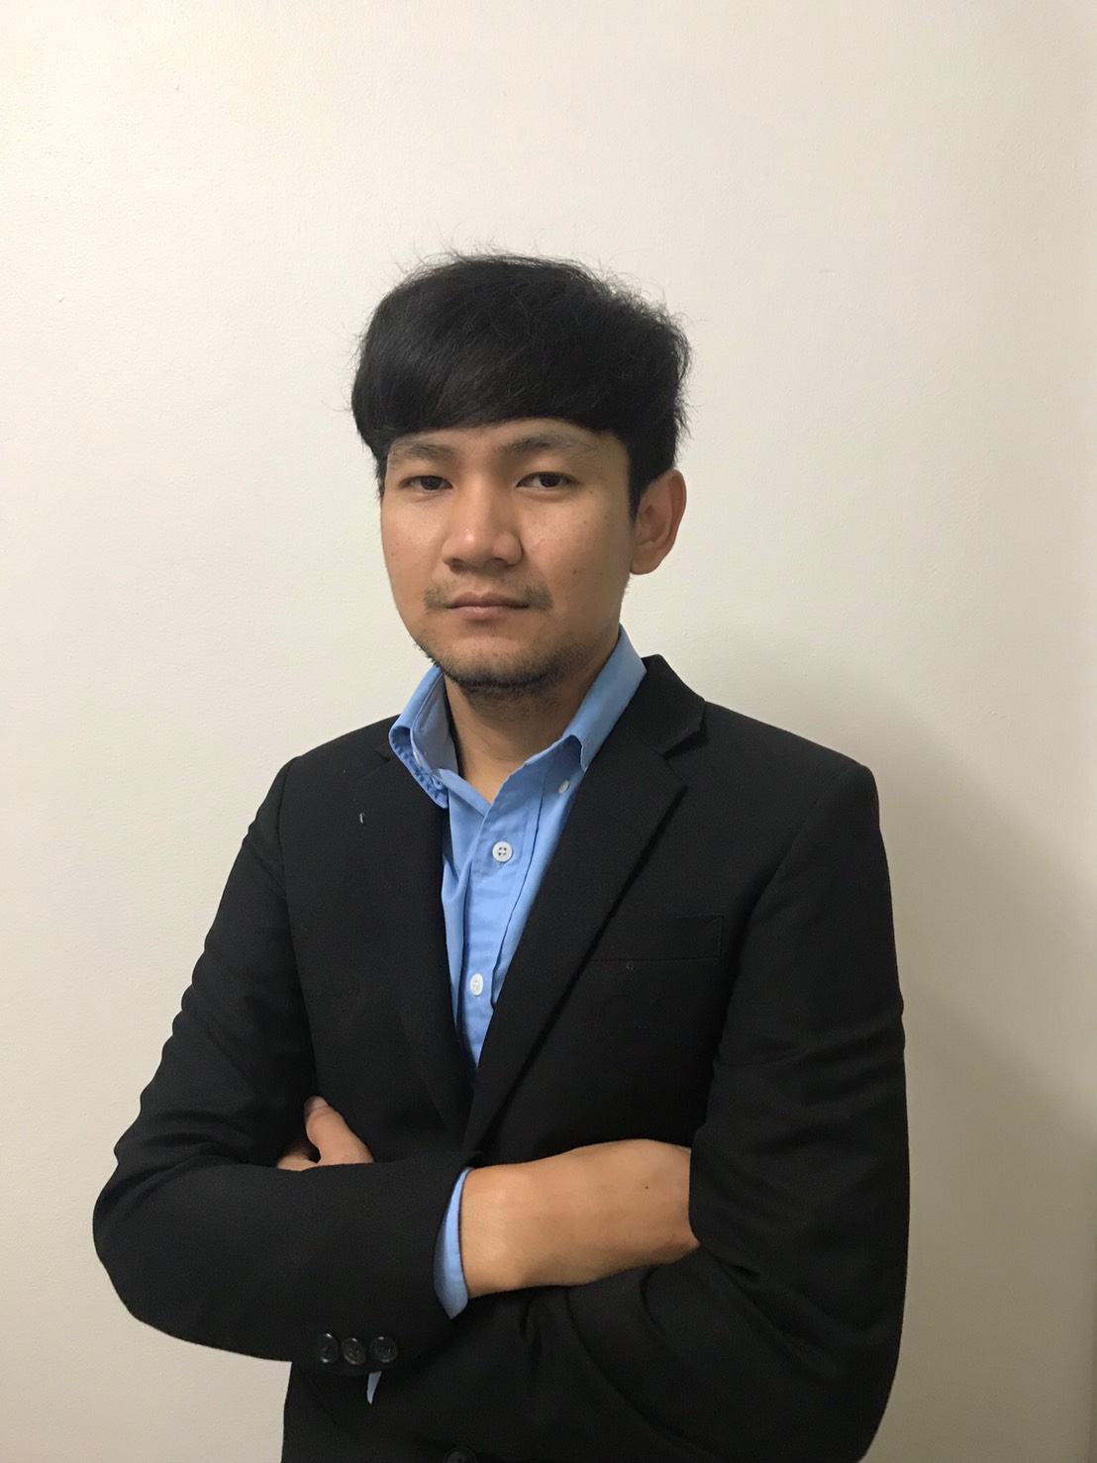

**APPLY FOR:** [C#.net, .net core] **\* Experienced more 8+ years**

**EXPECTED SALARY: xx**,000 – xx,000 Baht/month **\*Negotiable**

C:\Users\gaitp464\AppData\Local\Microsoft\Windows\INetCache\Content.Word\49709.png

**WORK EXPERIENCES**

**May 2019 – Present**

● **OUTSOURCE for SCG as**  **Developer C#.net , .net core**

- Design database domain

- Design Flow

- Development new features

- Fixed bug application and Maintain application

- Build and deploy application

- Work with Scrum

**May 2018 – May 2019**

● **OUTSOURCE for PTT Digital as**  **Developer C#.net , .net core (1 year)**

**January 2018 – May 2018**

● **OUTSOURCE for** **AYCAP Of Krungsri Bank as** **Developer** c#.net, function (6 months)

**December 2016 – December 2017**

● **OUTSOURCE for Chanwanich co,.ltd** **as** **Developer** c#.net, function

(1 year)

**January 2014 – November 2016**

● **OUTSOURCE for AIG as** **Developer** c#.net, function

(1 year 11 months)

**November 2013 – December 2014**

● **Bangkok Medical Software** as Programmer c#.net, function (1 year 1 month)

C:\Users\gaitp464\AppData\Local\Microsoft\Windows\INetCache\Content.Word\user-male-icon_34332.png

**Mr.Yutthaphum Seekiaw** (Bo)

C:\Users\gaitp464\AppData\Local\Microsoft\Windows\INetCache\Content.Word\location-icon-png-27.png

**CONTACT**

**Address:** 310 Moo.1

Buangung,

Nampong,

KhonKhan, 40140

Thailand

**Mobile:** 0626983863

**Email:** yutthaphum\_bo@hotmail.com

**Line:** yutthaphumbo

**Present Address:** 46 room212

Thanya place

Phahonyotin 35,

ladyao,

jatujak,

Bangkok, 10900

Thailand

**ACADEMIC SKILLS**



C:\Users\gaitp464\AppData\Local\Microsoft\Windows\INetCache\Content.Word\details_detail_view_application-512.png

**PERSONAL INFORMATION**

**Date of birth:** Fabruary 23, 1991

**Age: 29**

**Gender:** Male

**Marital Status:** Single

**Nationality:** Thai

**Religion:** Buddhism

**Military Status:** Exempted (Finished Reserved Officers Training Corps Course)

● Good C#, .net, .net core Backend Development

● Experienced in Web Service, API Development (REST)

● Experienced in SQL Server, MySQL,Oracle

● Experienced in Microsoft Internet Information Server (IIS)

● Experienced in Source Code Control : Git, SVN

● Experienced in export report with EPPlus and OfficeOpenXml

● Good understanding in the Object Oriented Programming (OOP)

and Model-View-Controller (MVC)

● Good Design Patterns in software development

● Knowledge in programming language: asp.net, VB , nodejs , vuejs , nuxtjs , html , javascript , razor , linq

● Fair to read, write, listen, and speak English

● Able to learning new technologies and business





**EDUCATION BACKGROUND**

**2010-2013** **Bachelor of Accounting, Major of Business Computer Mahasarakham University** GPA 3.12

**2007-2010**  **Nampong Suksa School, Khon Kaen** [Science-Mathematics program GPA 2.41]

**REFERENCES**

References will be sent on request.