Experiment logs

To prevent accuracy bias caused by the randomness of the model, the experiment's accuracy results are obtained by averaging the accuracy from three separate training runs. First, the training data was filtered to remove images with excessive background elements, and the number of images for each of the three fruits was controlled to 70. Additionally, incorrect labels were corrected.

**1**

Following the example of CNN, a preliminary model was constructed. Training data of images is read in, resized to 224×224, and stored in a numpy-array. The CNN model used the kernel_size=(3, 3) as in the class example. I processed 10 epochs of training. The resulting images from three runs were evaluated, and the average accuracy on the test data was found to be 0.85. It appears that the model achieves a high accuracy on the training data, but the results on the test data are not satisfactory. I think it was caused by overfitting.

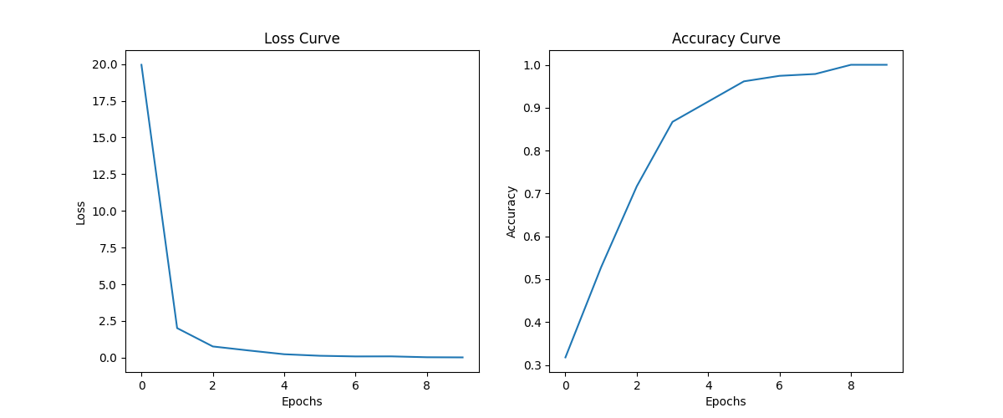







2

Due to the limited amount of training data, data augmentation was employed to increase the diversity of images. Specifically, images were randomly rotated within 20 degrees, horizontally and vertically shifted within a range of 0.2, and horizontal flipping was allowed to improve the model's fit to the data. Despite three rounds of training, the average test accuracy remained at 0.85, consistent with previous results. However, in theory, the model's generalization ability has been enhanced.

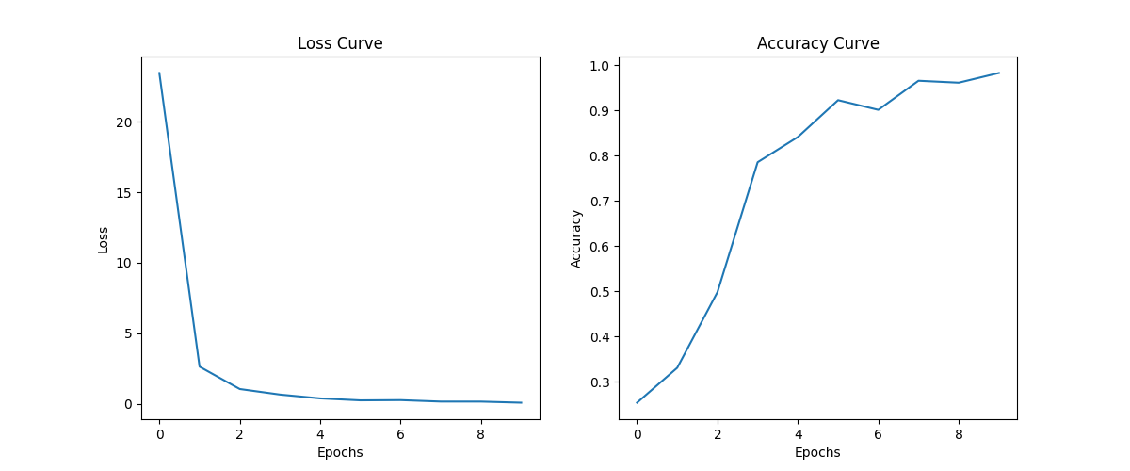







3

Subsequently, it was found that the large horizontal and vertical shift ranges during data augmentation were hindering the improvement of accuracy. After reducing the shift range to 0.1, the accuracy increased. Following three experiments, the average accuracy reached 0.89.







4

The model was adjusted to prevent overfitting by adding an additional convolutional-pooling layer. In conjunction with this adjustment, the number of training epochs was reduced to 8, and the dropout rate for the first layer was set to 0.4. As a result, there was a slight improvement in overall accuracy, with an average accuracy of 0.91 across three training sessions.

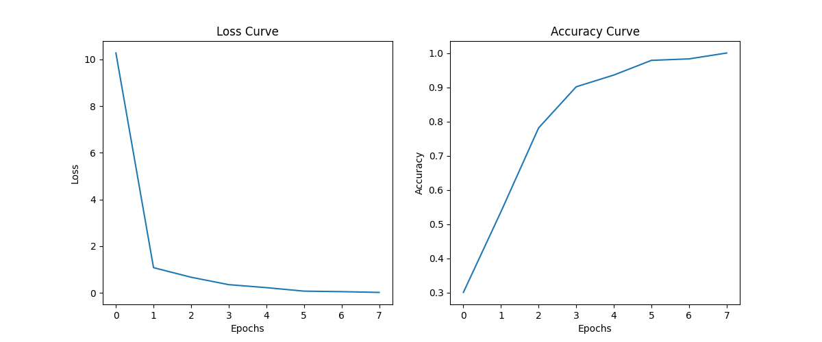







In summary, achieving high accuracy relies on the adjustment of hyperparameters. Firstly, the size of the convolutional kernel needs to be appropriately chosen as an excessively large kernel may lead to loss of details and potential overfitting. Secondly, for preventing overfitting, an appropriate dropout rate needs to be selected, with a tested optimal value of 0.4. Lastly, concerning data augmentation, it is essential to control the magnitude of image variations for fruit image recognition tasks to avoid the model learning excessive noise from the training set, which may hinder generalization to the test set. Therefore, it is crucial to keep the changes in images within an appropriate range to ensure a stable training process.