Verbてあげる・くれる・もらう

Write the sentence to describe each picture for the following three settings. Do not skip any elements of the sentence.

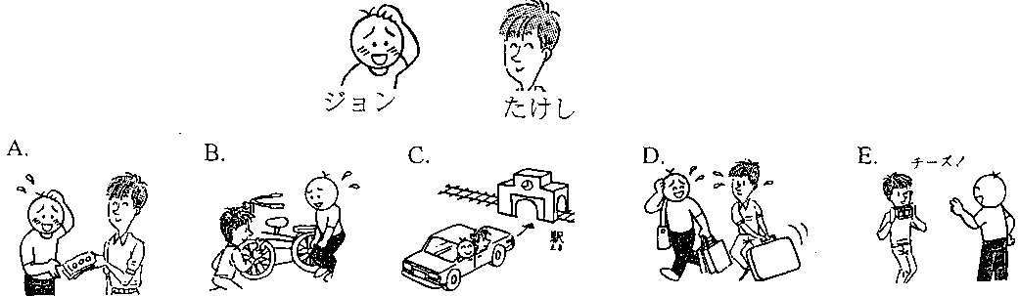

1. You are たけし. Say 「私は…」.

A. ___________________________________________________________________________________

B. ___________________________________________________________________________________

C. ___________________________________________________________________________________

D. ___________________________________________________________________________________

E. ___________________________________________________________________________________

2. You are ジョン. Say 「私は…」.

A. ___________________________________________________________________________________

B. ___________________________________________________________________________________

C. ___________________________________________________________________________________

D. ___________________________________________________________________________________

E. ___________________________________________________________________________________

3. You areジョン. Say 「たけしは…」.

A. ___________________________________________________________________________________

B. ___________________________________________________________________________________

C. ___________________________________________________________________________________

D. ___________________________________________________________________________________

E. ___________________________________________________________________________________