1 Preliminary Study
The median passenger waiting time in the preliminary run was 466 s, or 7.77 min.
The preliminary run served all 10,000 trip requests without any rejections, which indicates that the system had sufficient capacity. The fleet travelled about 38,134 km in total, including roughly 2,041 km without passengers. The empty-distance share was therefore only about 5%. Most vehicle kilometres were associated with passenger service, suggesting that the dispatching process used the fleet efficiently. The passenger-kilometre-to-vehicle-kilometre ratio was 2.23, which also shows a clear pooling effect and suggests that shared DRT trips can reduce some of the traffic generated by individual travel.
The system nevertheless used 300 small vehicles and produced a substantial amount of vehicle travel. If DRT replaced conventional buses completely, the road network could carry more small vehicles instead of a smaller number of high-capacity buses. DRT may therefore improve service flexibility while increasing traffic volumes, particularly during peak periods, around pick-up and drop-off locations, and in areas where demand is concentrated. These conditions could cause local congestion and kerbside disturbance.
Based on the preliminary run, an eight-seat minivan or small shuttle is recommended. The baseline fleet of 300 eight-seat vehicles served all 10,000 requests with no rejections, a median waiting time of about 7.8 min, and an empty-distance share of about 5%. An eight-seat vehicle offers more scope for pooling than a standard taxi, while remaining more flexible than a bus or a large shuttle for door-to-door operation. It therefore provides a reasonable balance between service quality, pooling capacity, and operational flexibility.

2 Systematic Study

2.1 Improving Service Quality

2.1.1 Evaluation Criteria
Following the evaluation framework used in recent research on on-demand public transport [1], six criteria were selected to cover passenger experience, reliability, operational efficiency, and transport efficiency: average waiting time, P95 waiting time, average total travel time, number of rejected requests, minimum idle vehicle share, and the passenger-kilometre-to-vehicle-kilometre ratio (d_p/d_t). The first five criteria were treated as cost criteria, while d_p/d_t was treated as a benefit criterion. Since the city had not specified a policy preference among these dimensions, all six criteria were given equal weight.
Table 1. Service quality criteria and equal weights
Dimension | Criterion | Weight
Passenger experience | Average waiting time | 1/6
Passenger experience | P95 waiting time | 1/6
Passenger experience | Average total travel time | 1/6
Service reliability | Rejected requests | 1/6
Operational efficiency | Minimum idle vehicle share | 1/6
Transport efficiency | d_p/d_t | 1/6

2.1.2 Parameter Sets and Simulation Results
The systematic study varied three parameters: fleet size, vehicle capacity, and maximum waiting time. Together with the preliminary setting, these choices produced nine scenarios, S1-S9. Table 2 lists the parameter combinations and the main simulation results.

Table 2. Parameter settings and simulation results for S1-S9
Scenario | Fleet | Seats | Max wait | Avg wait | P95 wait | Total travel | Rejections | Idle share | d_p/d_t | Total distance (km)
S1 | 300 | 8 | 1200s | 8.6763 | 18.6667 | 22.8962 | 0 | 0.43 | 2.23 | 38133.75
S2 | 300 | 6 | 1200s | 8.4957 | 18.6325 | 22.7875 | 0 | 0.41 | 2.26 | 37692.60
S3 | 300 | 4 | 1200s | 9.0293 | 18.7833 | 22.5855 | 0 | 0.38 | 2.08 | 40032.16
S4 | 250 | 8 | 1200s | 8.9497 | 18.7833 | 23.1285 | 0 | 0.29 | 2.19 | 38756.51
S5 | 250 | 6 | 1200s | 8.8193 | 18.7333 | 22.9623 | 0 | 0.28 | 2.19 | 38833.92
S6 | 250 | 4 | 1200s | 9.2223 | 18.7667 | 22.8735 | 0 | 0.27 | 2.07 | 40490.24
S7 | 300 | 8 | 900s | 7.5105 | 14.5333 | 22.3413 | 1 | 0.41 | 2.36 | 36946.34
S8 | 300 | 8 | 700s | 6.5393 | 11.3833 | 21.8253 | 5 | 0.41 | 2.43 | 36889.94
S9 | 250 | 6 | 900s | 7.7880 | 14.5333 | 22.6343 | 1 | 0.29 | 2.31 | 38198.59
Note: Blue cells mark the maximum-wait comparison; orange cells mark the seat-capacity comparison with 300 vehicles; purple cells mark the fleet-size comparison; green cells mark the seat-capacity and operating-result comparison with 250 vehicles.

2.1.3 AHP Evaluation of the Parameter Sets
The Analytic Hierarchy Process (AHP) was used to compare the scenarios across the six criteria. Pairwise preferences were expressed on Saaty's 1-9 scale [2]. A value of 1 means that two alternatives are equally preferred, while 9 indicates an extreme preference for one alternative. Even numbers represent intermediate judgements.
Table 3. Saaty's 1-9 scale and its interpretation [2]
Intensity | Definition | Explanation
1 | Equal importance | The two elements contribute equally to the objective
3 | Moderate importance | Experience and judgement slightly favour one element
5 | Strong importance | Experience and judgement strongly favour one element
7 | Very strong importance | One element is strongly favoured and its dominance is demonstrated
9 | Extreme importance | The preference for one element is of the highest possible order
2, 4, 6, 8 | Intermediate values | Compromises between the adjacent levels above
For each criterion, the scenarios were first ordered according to whether a lower or higher value was preferred. Their relative differences were then mapped to the 1-9 scale. If scenario i has a preference value a_ij over scenario j, the reverse comparison is a_ji = 1/a_ij, and each diagonal element is a_ii = 1. The same relative-gap thresholds were used for all criteria.
delta_ij = |v_i - v_j| / min(|v_i|, |v_j|), a_ji = 1 / a_ij, a_ii = 1
Applying the reciprocal condition gives the following matrix:
1 | # Average waiting time (cost criterion): S1-S9 pairwise comparison matrix
2 | avg_wait <- matrix(c(
3 | 1, 0.5, 3, 3, 2, 3, 0.2, 0.1429, 0.25,
4 | 2, 1, 3, 3, 3, 4, 0.2, 0.1667, 0.25,
5 | 0.3333, 0.3333, 1, 1, 0.5, 2, 0.1667, 0.1429, 0.2,
6 | 0.3333, 0.3333, 1, 1, 0.5, 3, 0.2, 0.1429, 0.2,
7 | 0.5, 0.3333, 2, 2, 1, 3, 0.2, 0.1429, 0.2,
8 | 0.3333, 0.25, 0.5, 0.3333, 0.3333, 1, 0.1667, 0.1429, 0.2,
9 | 5, 5, 6, 5, 5, 6, 1, 0.2, 3,
10 | 7, 6, 7, 7, 7, 7, 5, 1, 5,
11 | 4, 4, 5, 5, 5, 5, 0.3333, 0.2, 1
12 | ), nrow = 9, byrow = TRUE,
13 | dimnames = list(alternatives, alternatives))
14 | APCL[["avg_wait"]] <- avg_wait

Because the six criteria were assigned equal importance, their pairwise comparison matrix is:
1 | # Equal criterion weights: all six criteria are treated as equally important
2 | criteria <- names(APCL)
3 | CWPC <- matrix(
4 | 1,
5 | nrow = length(criteria),
6 | ncol = length(criteria),
7 | dimnames = list(criteria, criteria)
8 | )
9 | criteria_weights <- getWeights(CWPC)
Figure 1 shows the final scores. S8 received the highest score (23.4%), followed by S7 (13.4%) and S9 (12.6%).
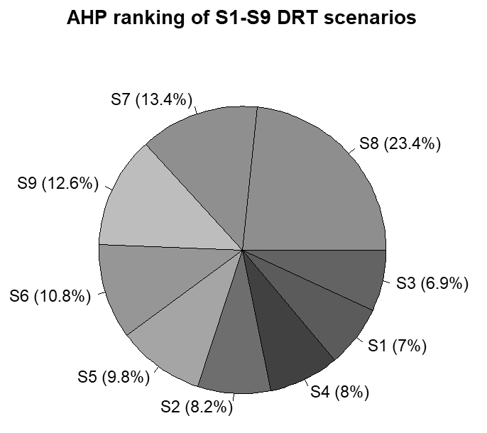
Figure 1. Overall AHP scores for scenarios S1-S9 with equal criterion weights

2.1.4 Findings
The coloured cells in Table 2 identify the four comparisons discussed below.
(1) The blue cells compare S1, S7, and S8. With fleet size and vehicle capacity unchanged, reducing the maximum waiting time from 1,200 s to 900 s and 700 s lowered the average waiting time from 8.6763 min to 7.5105 min and 6.5393 min. P95 waiting time fell from 18.6667 min to 14.5333 min and 11.3833 min. The improvement came at a cost: rejected requests increased from 0 to 1 and 5. A tighter waiting-time limit improves the experience of passengers who are served, but makes it harder to accept every request.
(2) The orange cells show that a larger vehicle is not automatically better, although four seats appear to restrict pooling. Among the 300-vehicle scenarios S1-S3, the six-seat scenario S2 achieved a slightly shorter average waiting time than the eight-seat baseline S1 (8.4957 min versus 8.6763 min) and a slightly higher d_p/d_t ratio (2.26 versus 2.23). With four seats, S3 had an average waiting time of 9.0293 min and a d_p/d_t ratio of 2.08. At this demand level, six to eight seats appear sufficient, whereas four seats leave less flexibility for matching and pooling passengers.
(3) The purple cells compare S1 and S4. Both scenarios used eight-seat vehicles and a maximum waiting time of 1,200 s, but the fleet was reduced from 300 to 250 vehicles in S4. The minimum idle share fell from 0.43 to 0.29, so the smaller fleet was used more intensively. However, average waiting time increased from 8.6763 min to 8.9497 min, and average total travel time increased from 22.8962 min to 23.1285 min. The gain in vehicle utilisation therefore came with a small loss in passenger service quality.
(4) The green cells compare S4-S6 under a fleet size of 250 vehicles. The six-seat scenario S5 gave the most balanced result. Its average waiting time was 8.8193 min, lower than in the eight-seat S4 and four-seat S6 scenarios. It also maintained zero rejections, with a minimum idle share of 0.28 and d_p/d_t = 2.19. If the aim is to reduce fleet size without rejecting requests, 250 six-seat vehicles are a plausible lower-cost option.
(5) The AHP ranking should not be treated as the final recommendation without considering policy constraints. S8 ranked first because it performed well on waiting time, total travel time, and d_p/d_t, but it rejected five requests. If universal access and zero rejections are firm requirements, S8 is not an acceptable final choice. A more defensible approach is to remove scenarios that violate the policy constraints before comparing AHP scores. Under a zero-rejection requirement, S5 offers a balanced and relatively economical option. If a very small number of rejections is acceptable in return for shorter waiting times, S7 or S9 could be examined further.
No single scenario performed best on every criterion. Shorter waiting-time limits improved the experience of accepted passengers but increased the risk of rejection. A smaller fleet reduced the idle share but led to longer waiting and travel times. The final parameter choice therefore depends on how the city prioritises zero rejections, waiting time, and fleet cost.

References
[1] Liyanage, S., Dia, H., & Duncan, G. (2025). AI-powered evaluation of on-demand public transport: A hybrid simulation approach. Smart Cities, 9(1), Article 4. https://doi.org/10.3390/smartcities9010004
[2] Saaty, T. L. (1980). The analytic hierarchy process: Planning, priority setting, resource allocation. McGraw-Hill International Book Company.

