Heart Pipeline-LONGLEAF Manual ~

Tengfei Li @ UNC

March 21, 2020

**This step is to segment heart images of UKBiobank data according to**

*A population-based phenome-wide association study of cardiac and aortic structure and function****.*** *Nature Medicine*, *26*(10), pp.1654-1662.

1. Login on the department Longleaf cluster. For Windows users, using x-win32 or putty, and connect to the host “longleaf”; for Mac users, open a terminal to type the following command.

ssh username@longleaf.unc.edu

And then type you UNC usrname and password. Install software Winscp or sshClient for windows, or filezilla or cyberduck for Mac. These softwares are for **uploading/downloading** files from longleaf. Install Mango and Mricron software to check the result quality.

1. Generate the nifti data based on the UKBiobank dicom data. Convert dicom to nifti. Modify the code at /ms/depts/bric/htzhu/ukb_heart/UKB_Heart/convert_tengfei.m. You can copy the code to /ms/depts/bric/htzhu/ukb_heart/UKB_Heart/convert_ youronyen.m and modify the "YourPattern" "YourOnyen" in the script. Then run the code to copy the data. Before running the code, make sure the following packages have been successfully installed on your python.

module load python/3.5.1

export PATH=/ms/depts/bric/htzhu/ukb_heart/UKB_Heart/data:${PATH}

export PYTHONPATH=/ms/depts/bric/htzhu/ukb_heart/UKB_Heart/data:${PYTHONPATH}

pip3 install pydicom --user

pip3 install opencv-python --user

pip3 install SimpleITK –user

Try different python versions until you can install the packages successfully.

The Output of this step include 5 images generated at downloaded/nii/Youronyen/subjectID/*.nii.gz

Ao.nii.gz sa.nii.gz la_2ch.nii.gz

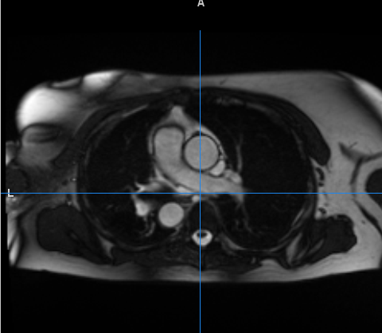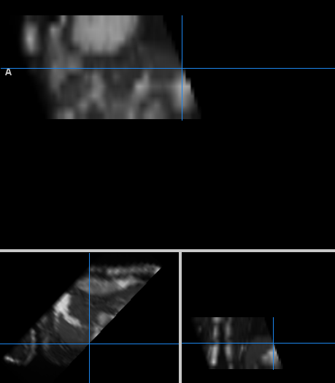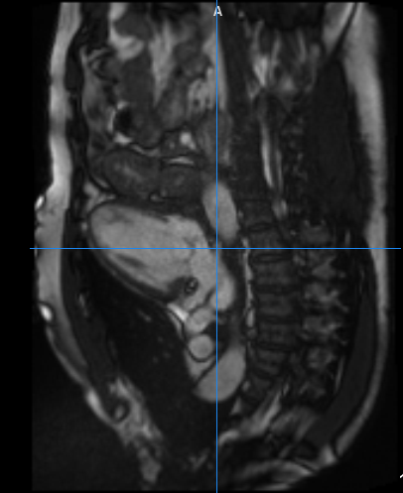

la_3.nii.gz la_4.nii.gz

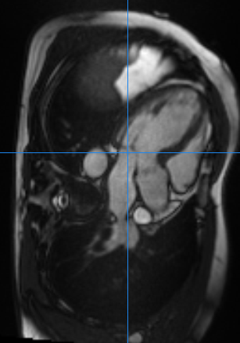 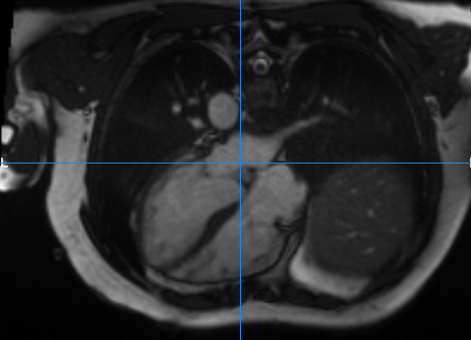

1. Copy folder /proj/tengfei/pipeline/UKB_Heart to your working space Youpath=/pine/scr/youronyen

copy your data (converted nii.gz files) of last step in

/ms/depts/bric/htzhu/ukb_heart/UKB_Heart/downloaded/youronyen

(please make sure you have done all your subjects in your previous step) to

/Yourpath/UKB_Heart/downloaded/nii

We have to copy the data out from /ms space since ms is only a space to store data and the compute nodes of longleaf have no access to ms space.

1. Change your PATH in the file

/Yourpath/UKB_Heart/data/step1_process.m

      and run it. Parallel code will be generated in UKB_Heart/code. Run

chmod 775 All.sh

              ./All.sh

to submit all your jobs. Each job will take about within 24 hours if you set N=50 in step1_process.m

The output will be the segmentation files (the following figures as example) generated in

Yourpath/UKB_Heart/downloaded/nii/youronyen/subjID/subjID/

folder.

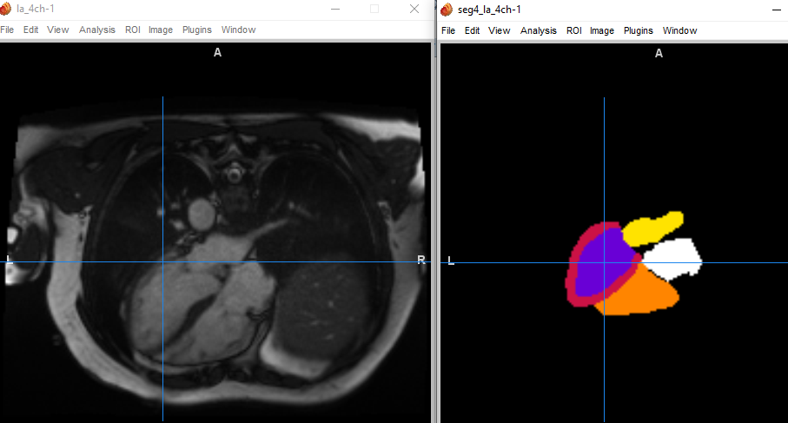

And 6 summary statistics of the images have been generated in

Yourpath/UKB_Heart/downloaded/nii/youronyen/subjID/out

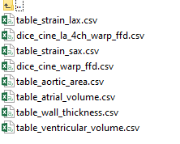

1. **Quality Control Procedure:**

Change your path in

/Yourpath/UKB_Heart/data/step2_qc.r

And the quality control files output will be generated at

/Yourpath/UKB_Heart/qc/*_png*/

Copy all qc folders *_png* to your own desktop and check the heart image segmentation qualities.

1. AO image quality control. Open AO_png/index.html

If segmentations look like in the following then segmentations are correct

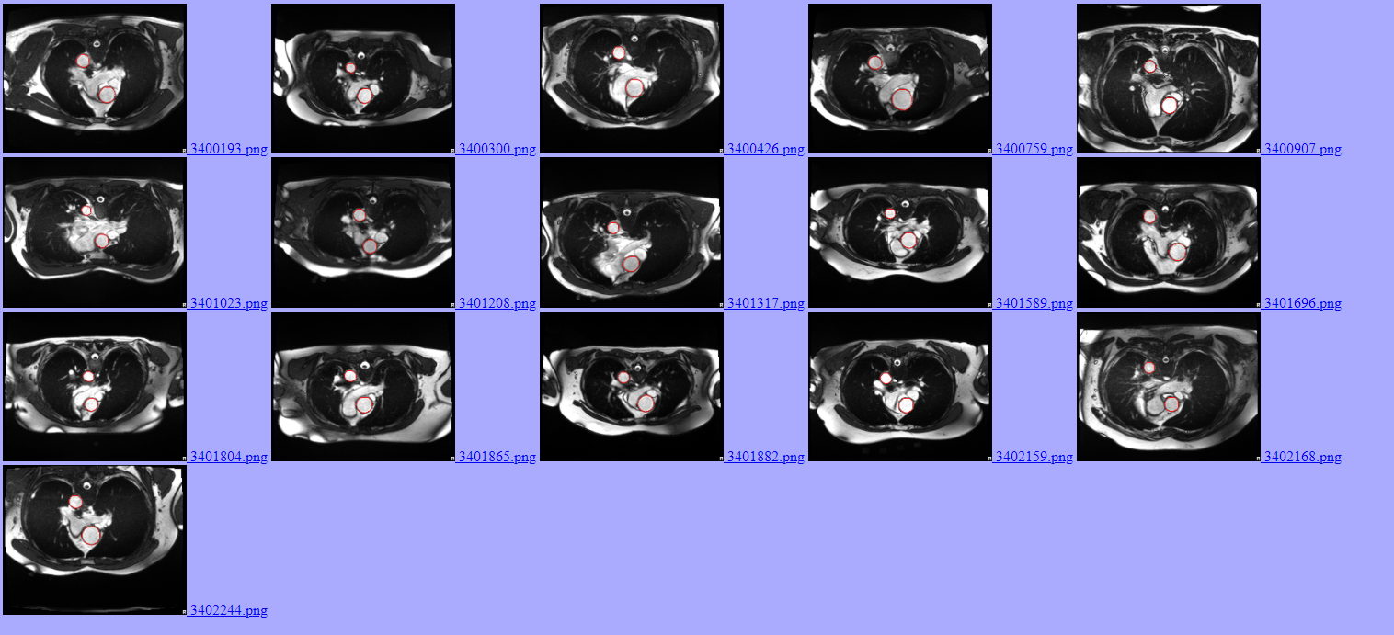

Focus on the red circle, which indicates the segmented heart tissues. Pick those subjects with bad heart segmentation of AO image, create a txt file AO-badqc.txt and then record those subjects’ IDs with bad segmentation in the txt file.

1. L2ES image quality control. Good example looks like:

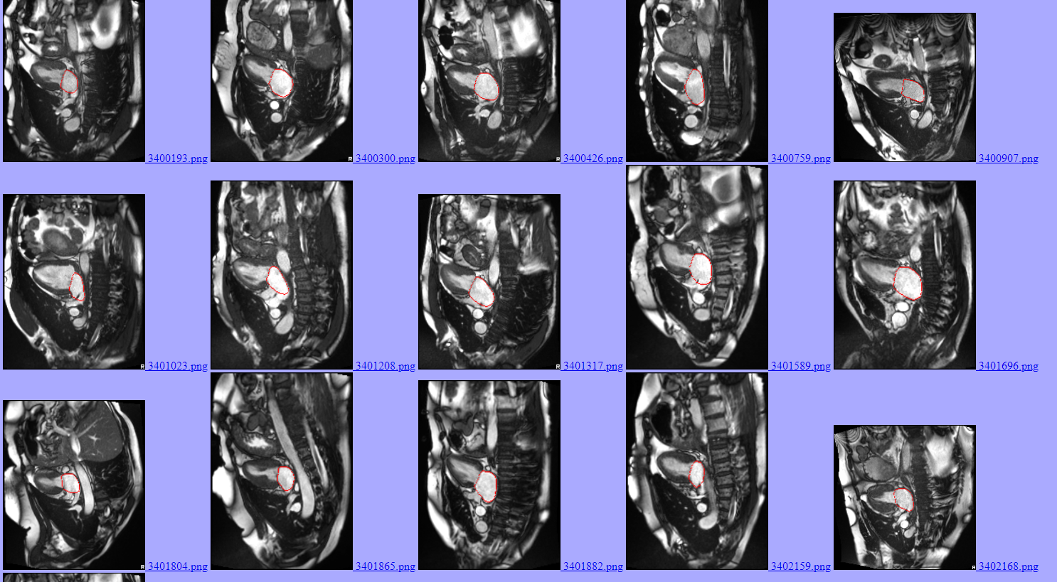

Please do the same thing as 1)

1. L4ES image quality control. Good example looks like:

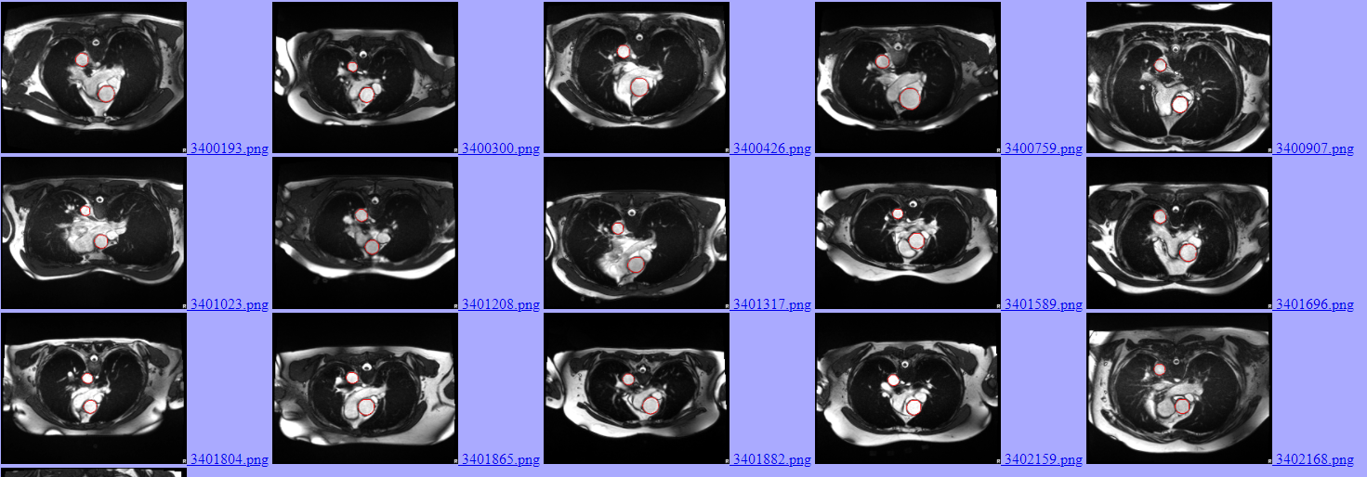

Please do the same thing as 1)

1. SES image quality control. This is a modality not easy for qc.

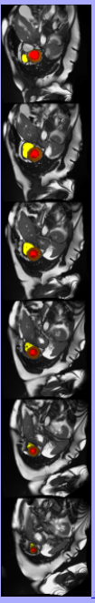 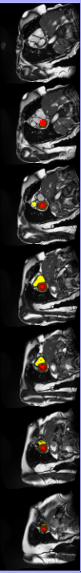

The left one is a bad example, because the 1st slice doesn’t start from the heart beginning slice. It misses some slices of the heart. This will cause problems when calculating the volume of heart.

You are done here!