Stefan Griyego G. Mangalino

CPE-301

Verify that Terraform is installed in local device

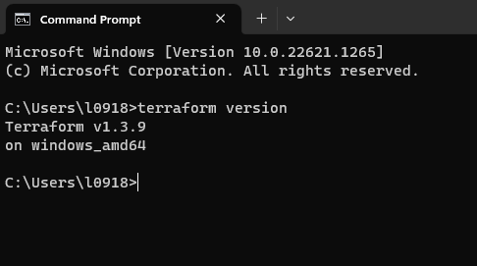

Initialize Terraform

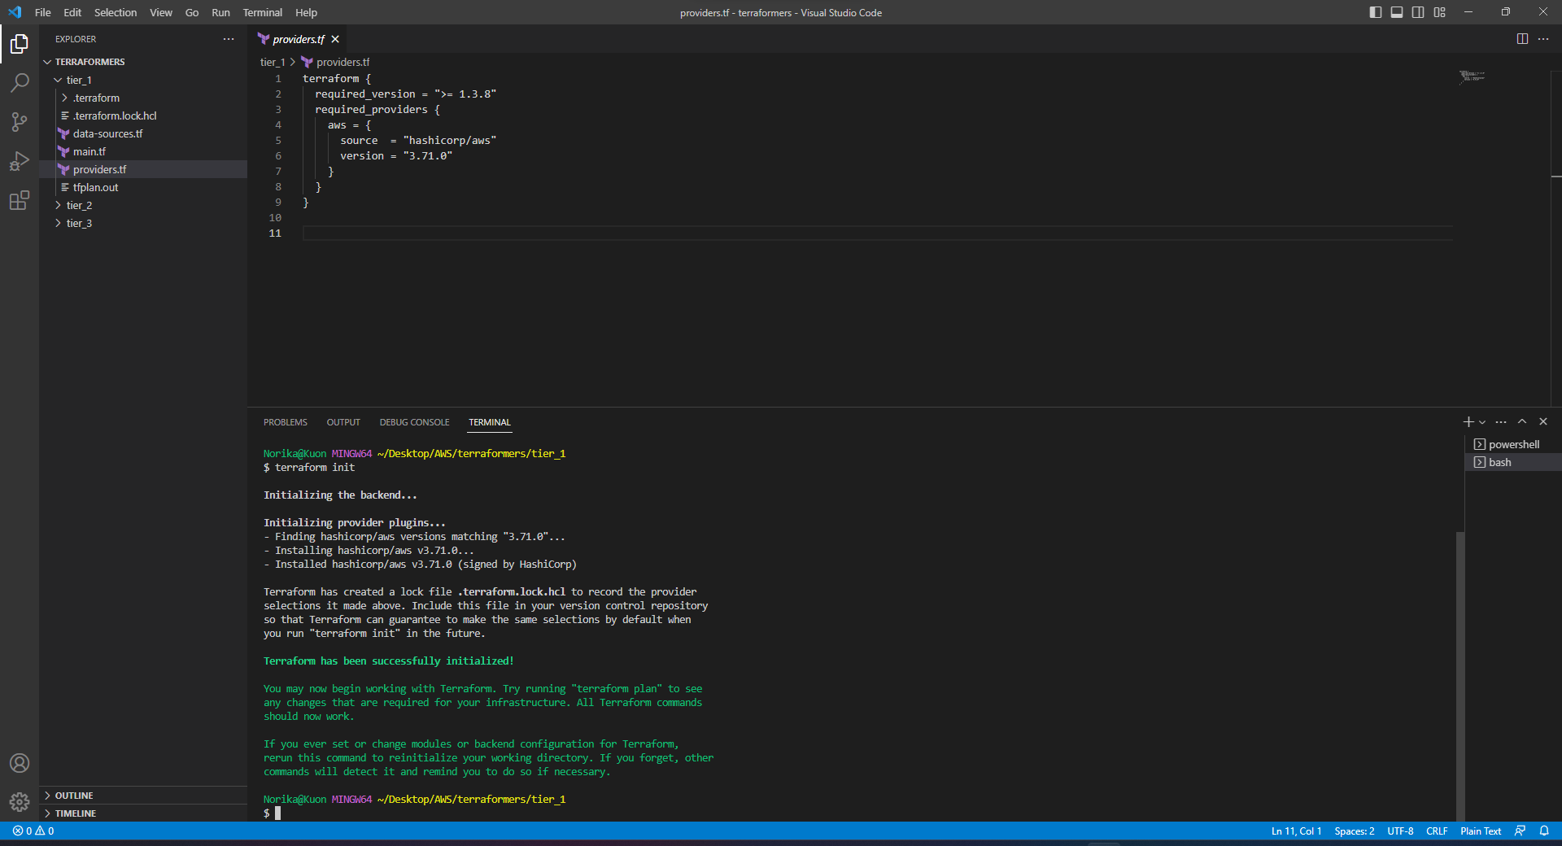

Install Terraform in VS Code

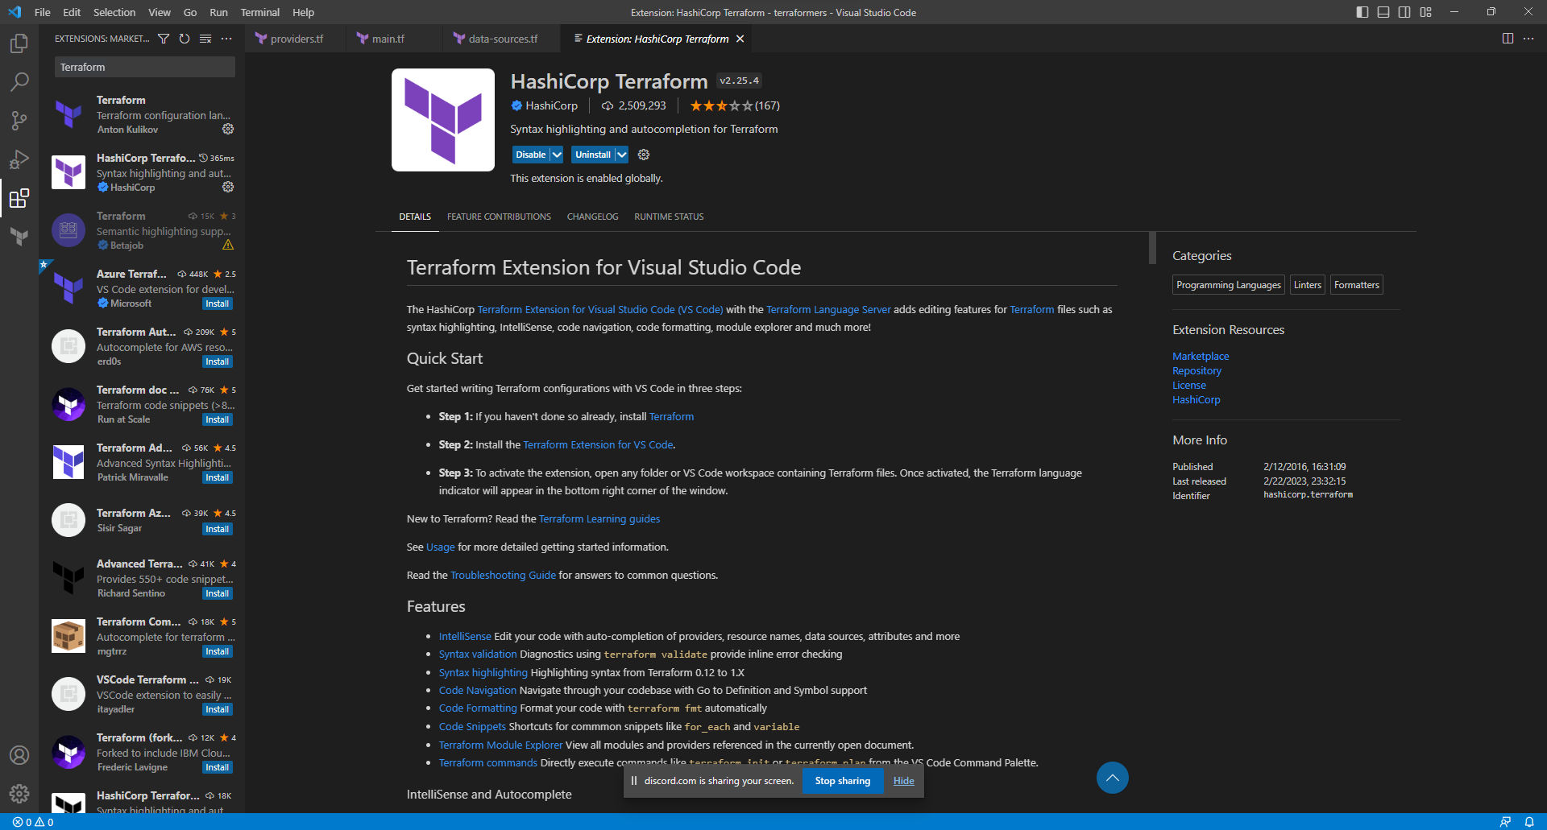

Create Keypair for AWS / Terraform

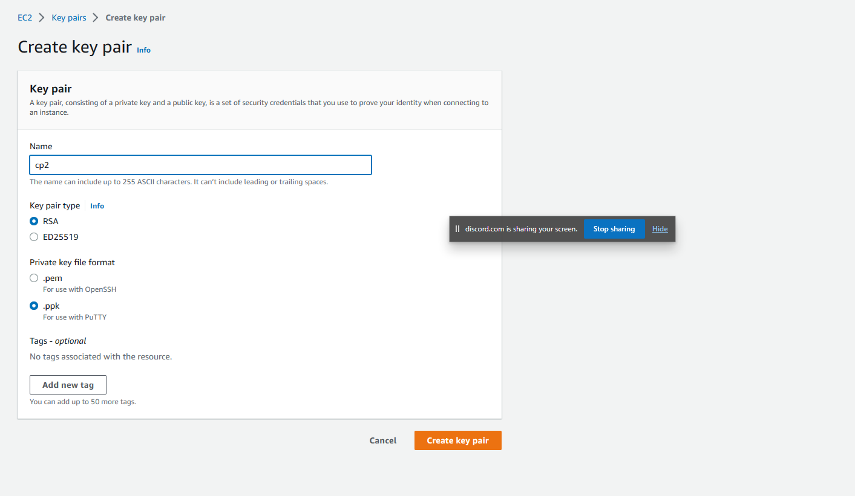

Configure AWS

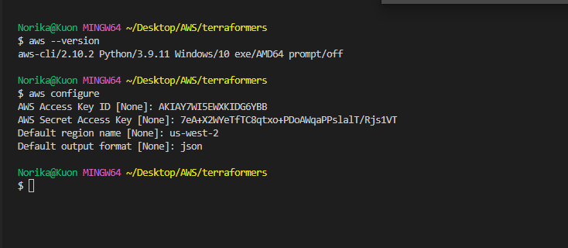

Initialize Terraform

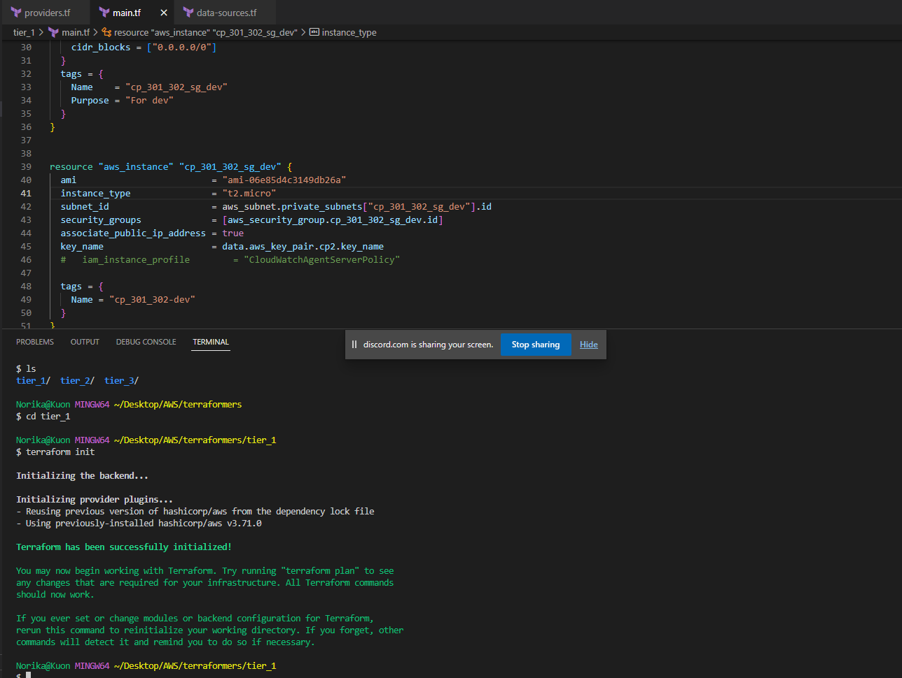

Plan Terraform

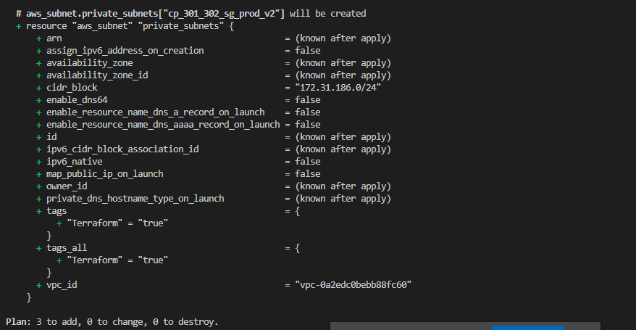

Apply Terraform

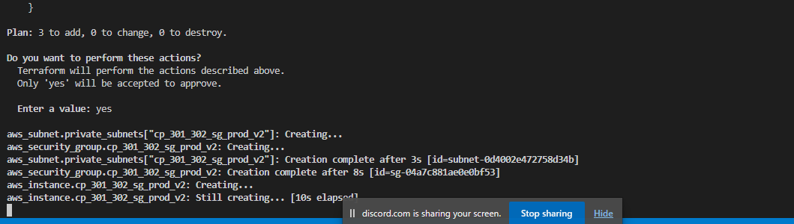

Repeat for Tier 3

Verify that the Tiers has been installed

