Managing multiple clauses split into 2 parts, the table merging and the retrieving of the result.

The table merging algorithm takes care of four different scenarios.

1. Table a and b where there is one common column header and one of the tables a or b is a one-column table, filter the result

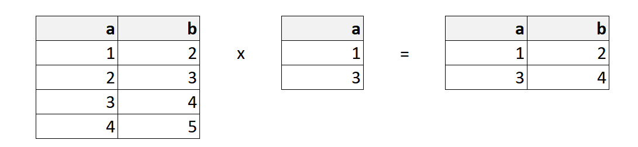

1. Table a and b where there are two common column headers and one of the a or b is a two-column table, filter the result.

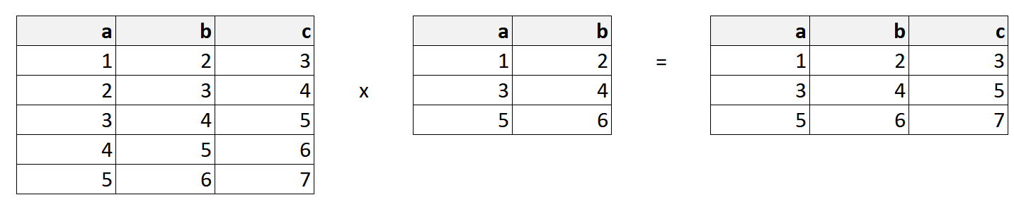

1. Table a and b where there is one common column header and both tables a and b have more than one column, join the table result according to the common header.

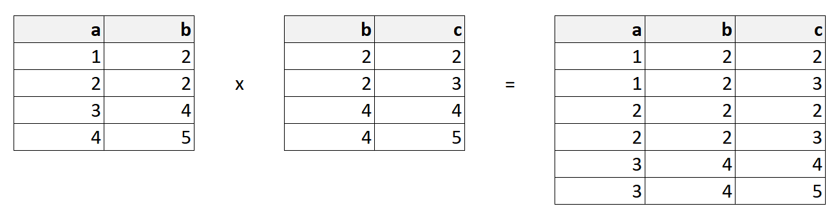

1. Table a and b where there are two common column headers and both tables a and b have more than two-column, join the table result according to the common header.

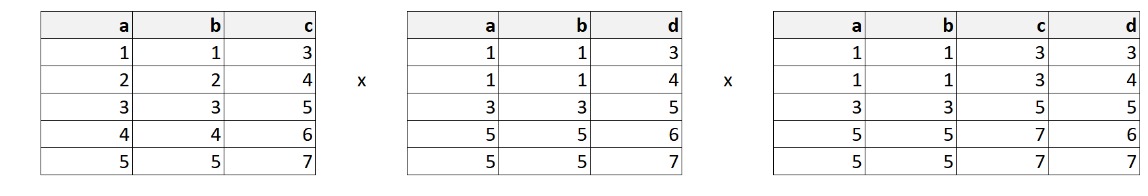

In the scenario of joining the table, the column of table b (to join) will be appended directly at the left side of the table a (main table). The header column of table b (except the common header) will also be appended directly to the left of table a. Resulting in a new table with no duplicate header.

The tables are managed by a tables manager, where all tables added will be checked for if it is mergeable before adding to the table list. Since all relations and patterns will produce a table size of at most 2 columns. There is at most 2 common headers for any new table result. Since the algorithm handles the merging of the table for two common headers and below, there can be an unlimited number of tables added as long as all tables were merged before they were added to the table list.

When receiving the result of e.g synonym x, the system will first check if there is a result (non-empty table for all filled table). If any of the tables in the tables manager have an empty table, the system will return an empty list. Else it will check with the table manager if there is a table header with the synonym x. If there is, retrieve the result from the tables manager, else return the unfiltered result of synonym x types.