Lab2-24560039

- Setup environment:
We will set up a VPN tunnel between a client computer and a gateway, allowing the computer to securely access the private network through the gateway.
This will include at least 3 VM: 1 Host U, 1 Gateway, 1 Host V.
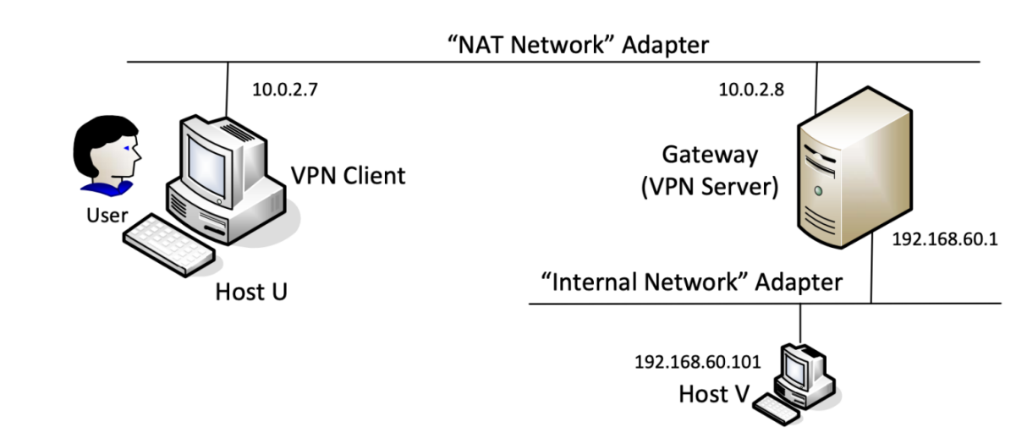
192.168.139.136
192.168.139.137
- Build a VPN tunnel using TUN/TAP:
Step 1: Run the VPN server
After running the vpnserver program, new network interface name tun0 was created. Then assigned ip address for it. Enable ip forwarding for the vpn server can forward packets form private network to the tunnel.



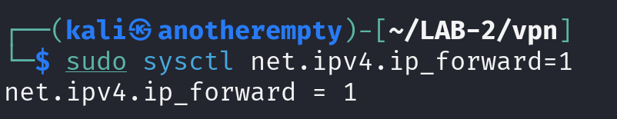
After running all these commands, I checked the vpn server with ifconfig to see if it works.
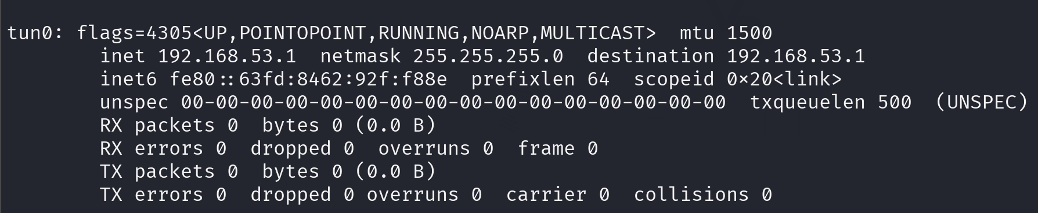
Seeing the interface tun0 confirming the vpn server is working.

Step2: Run the vpn client
Before running the vpnclient program, I have to modify the ip of SERVER_IP in vpnclient.c.
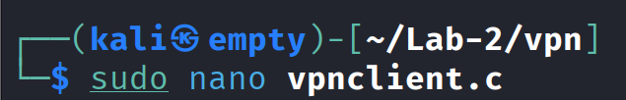
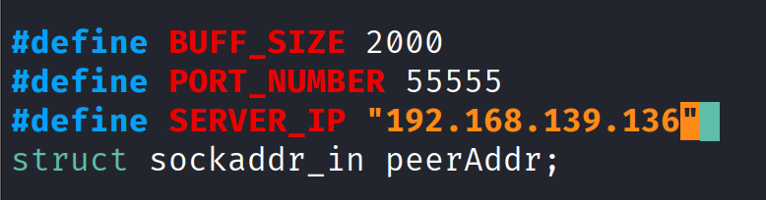
Now, we can compile the C source code file, and run it to initialize a vpn client.
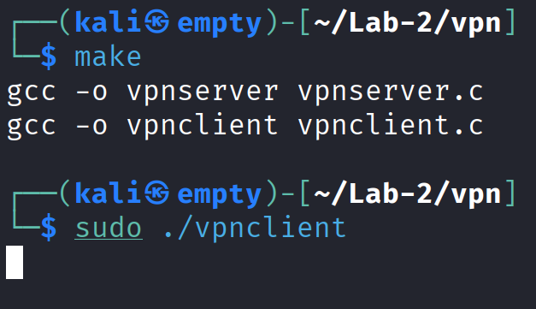
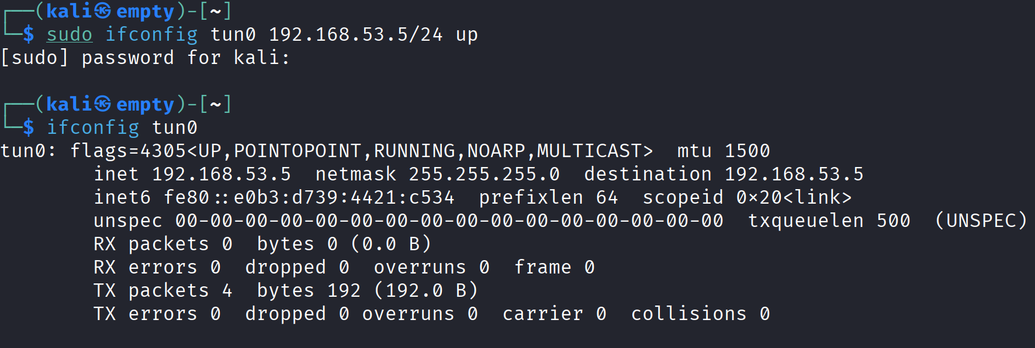
The interface tun0 appears can confirm the initializing step works perfectly.

Step 3: Configure routing on VPN server and VPN client
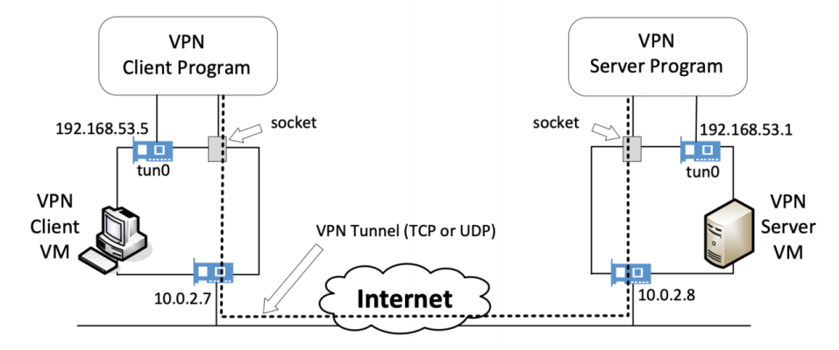
After 2 steps above, the tunnel has been created, now we have to route the traffic to go through the tunnel. In the client machine, we have to route the traffic to go the interface tun0, so the packets can to through the tunnel.
In both client and server, we have to configure the route to automatically route all the packets that go to ip 192.168.53.0/24 go through interface tun0.
In the vpn server.

In the vpn client.
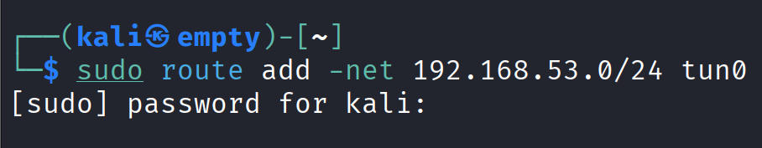
Ping from client to vpn server with private ip
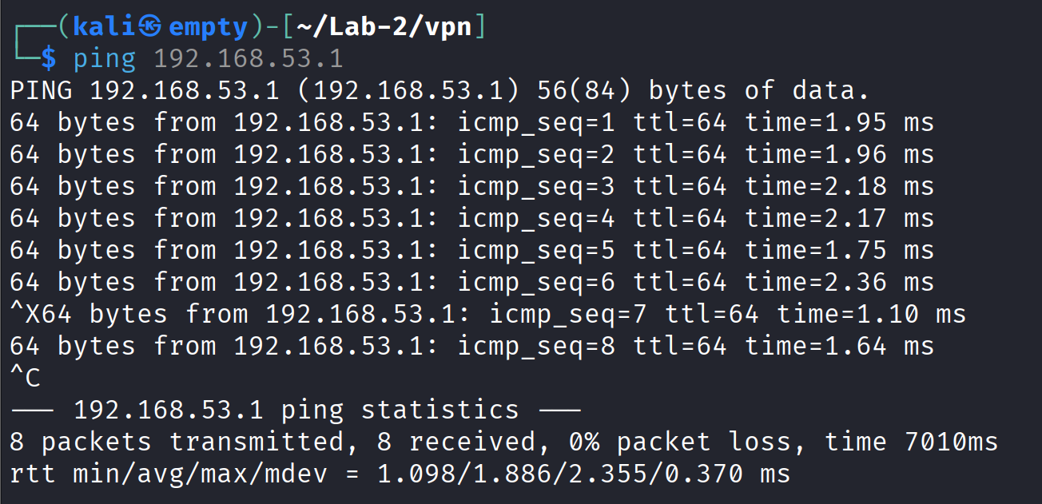
Reply in the vpn application terminal
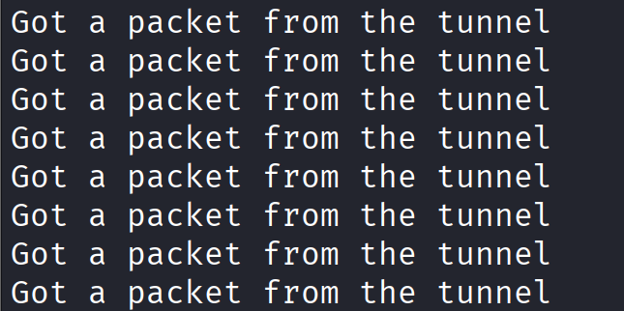

Step 4: Configure route on host V

