Lab2-24560039

- Setup environment:
We will set up a VPN tunnel between a client computer and a gateway, allowing the computer to securely access the private network through the gateway.
This will include at least 3 VM: 1 Host U, 1 Gateway, 1 Host V.
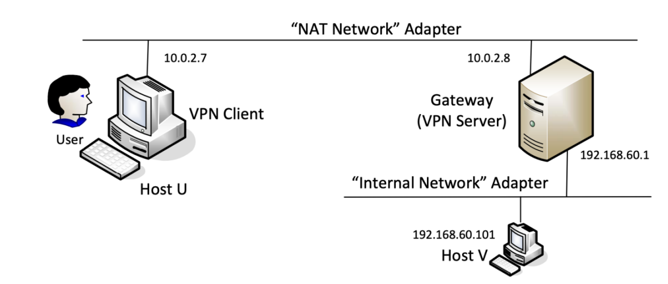
192.168.139.148
192.168.139.149
VPN Server (Gateway): 2 network card:
+ Card 1: NAT network for VPN client connection
+ Card 2: Internal network for private network with Host V
VPN Client (Host U): 1 network card NAT to connected to VPN Server
Host V: 1 network card Internal network

VPN Server network configuration
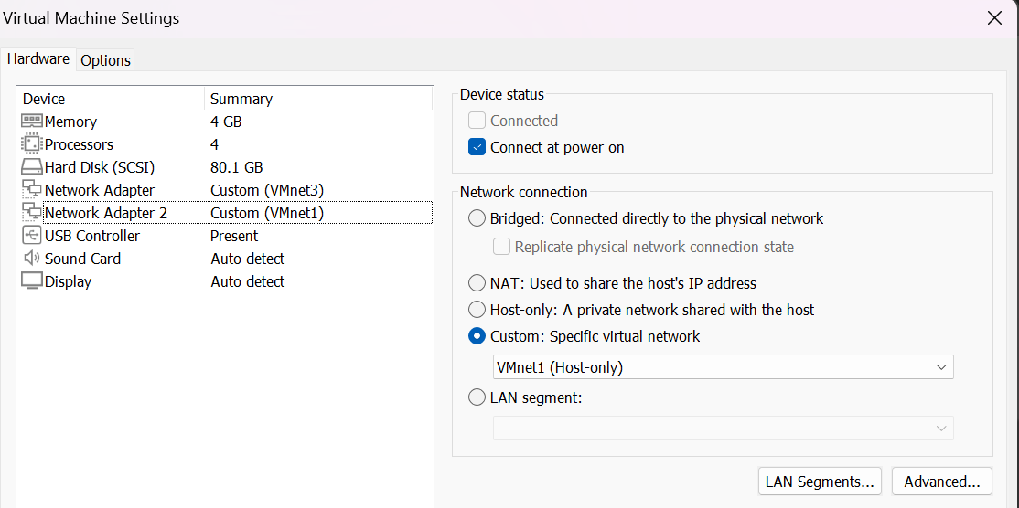
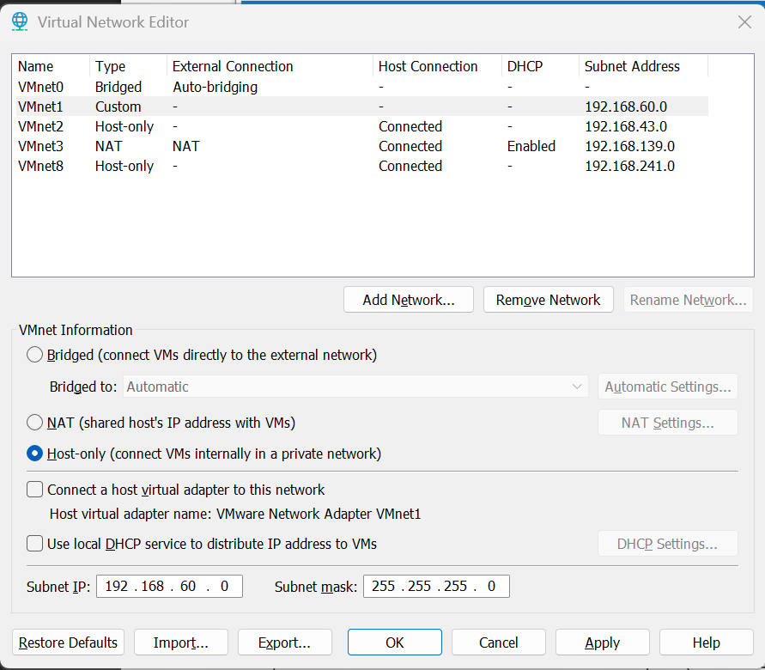
Host V network configuration
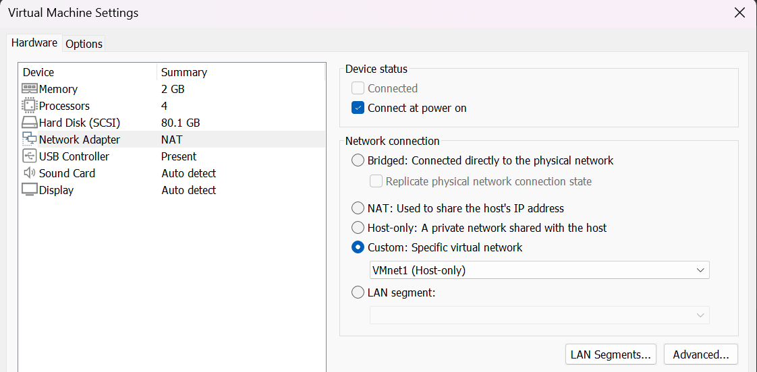
After added the network adapter, we also need to configurate the IP for VPN Server and Host V
Host V
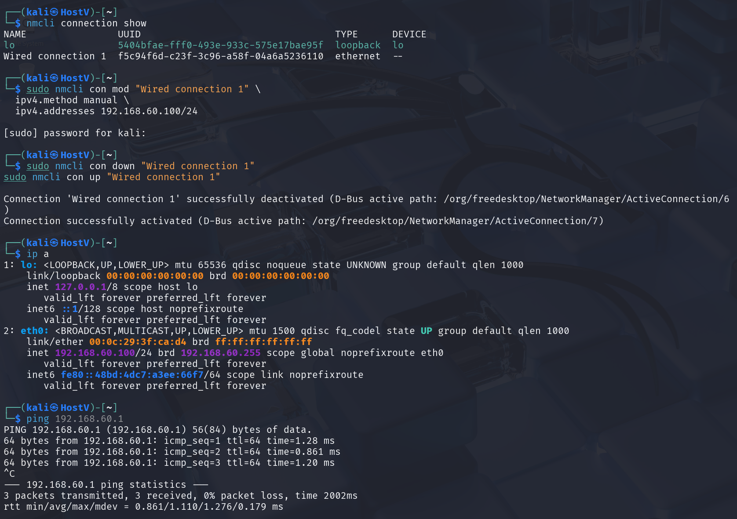
nmcli connection show
sudo nmcli con mod "Wired connection 1" \
ipv4.method manual \
ipv4.addresses 192.168.60.100/24
sudo nmcli con down "Wired connection 1"
sudo nmcli con up "Wired connection 1"

VPN Server

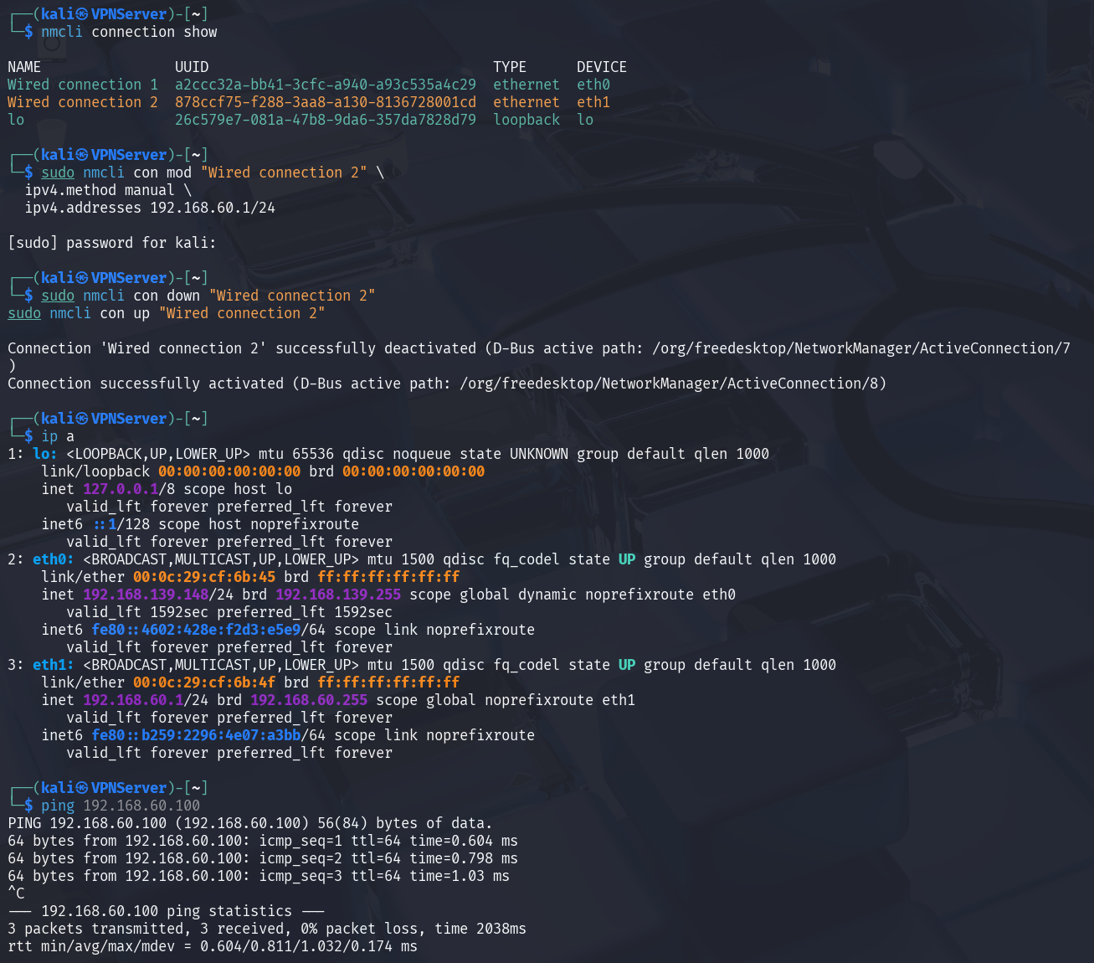
nmcli connection show
sudo nmcli con mod "Wired connection 2" \
ipv4.method manual \
ipv4.addresses 192.168.60.1/24
sudo nmcli con down "Wired connection 2"
sudo nmcli con up "Wired connection 2"

- Build a VPN tunnel using TUN/TAP:
Step 1: Run the VPN server
After running the vpnserver program, new network interface name tun0 was created. Then assigned ip address for it. Enable ip forwarding for the vpn server can forward packets form private network to the tunnel.
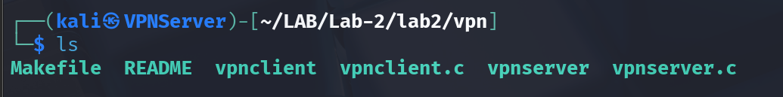
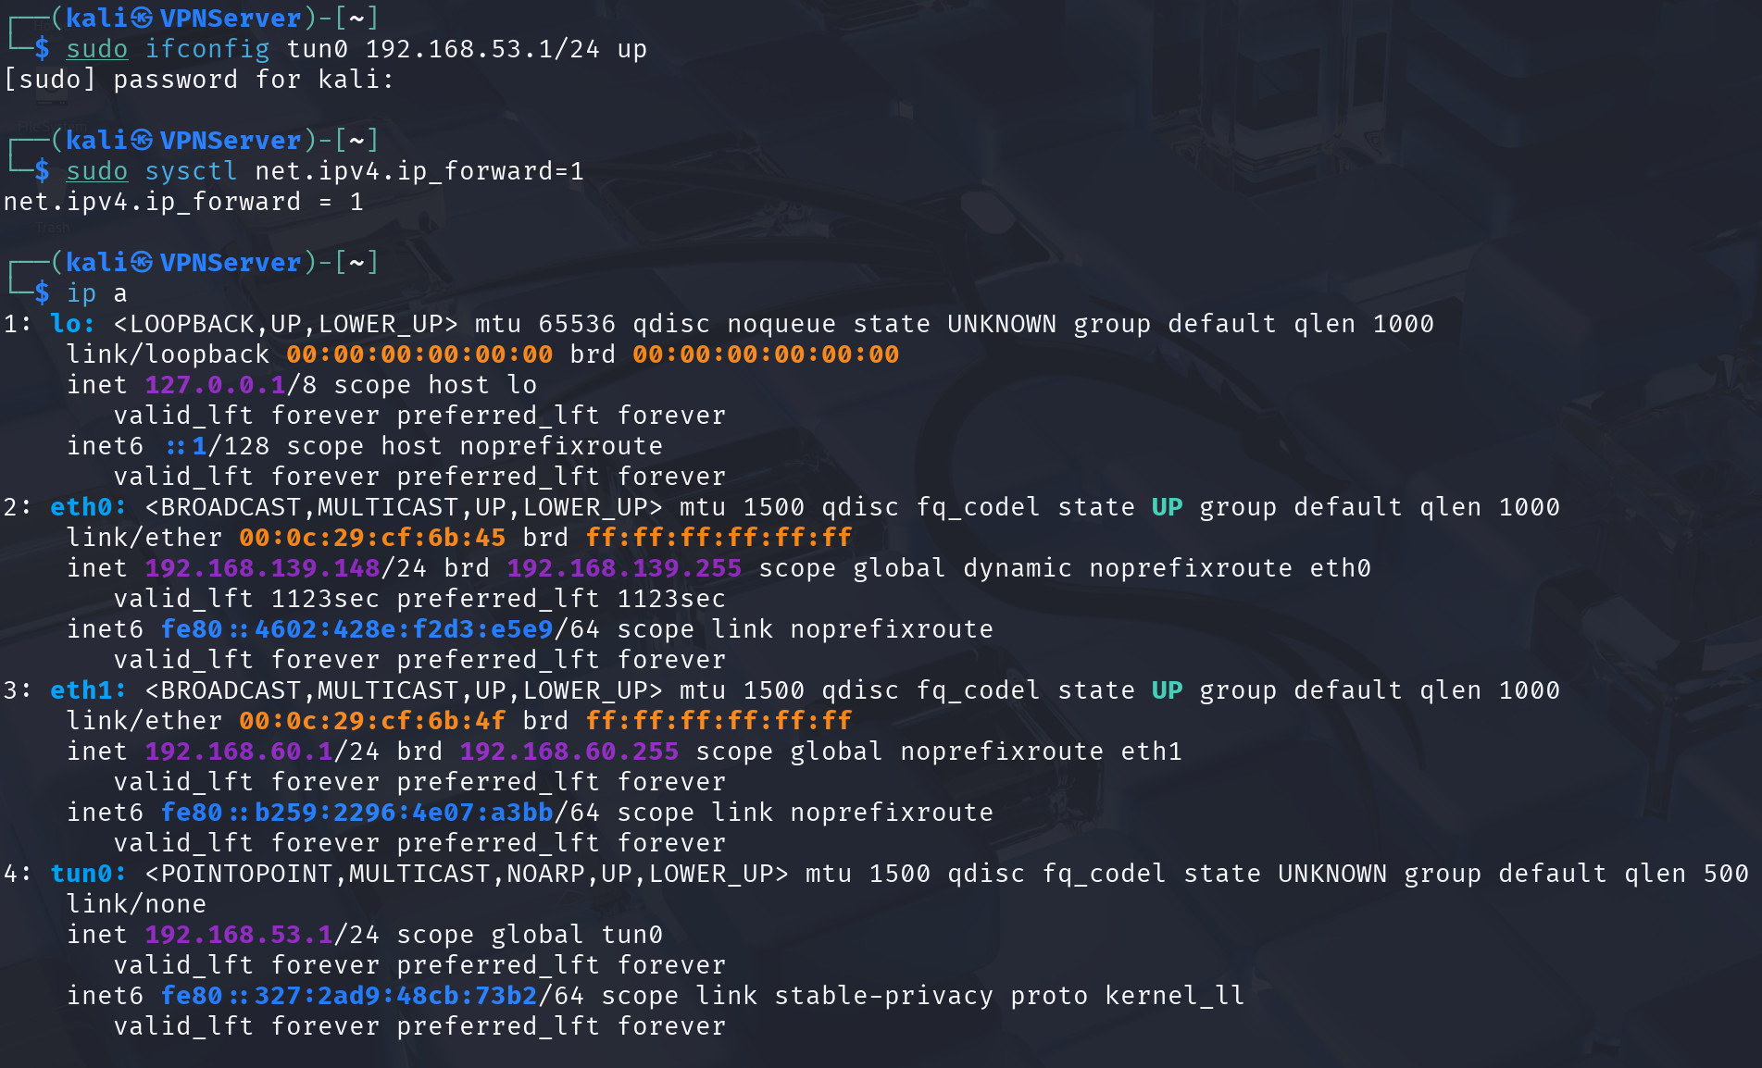
sudo ifconfig tun0 192.168.53.1/24 up

After running all these commands, I checked the vpn server with ifconfig to see if it works.
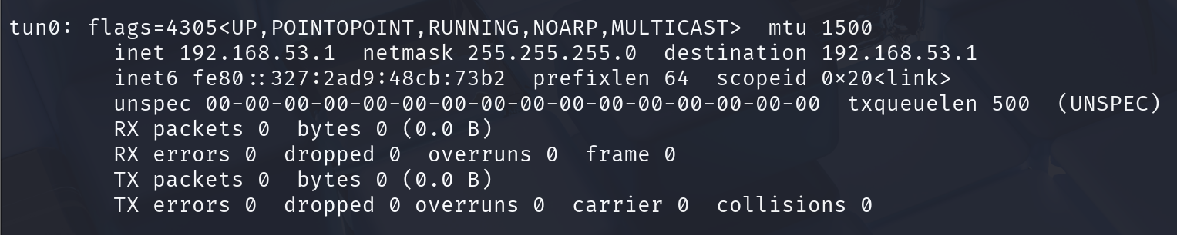
Seeing the interface tun0 confirming the vpn server is working.

Step2: Run the vpn client
Before running the vpnclient program, I have to modify the ip of SERVER_IP in vpnclient.c.
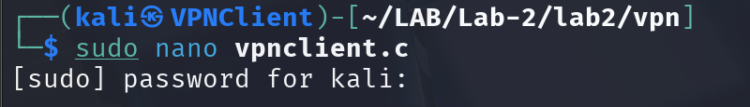
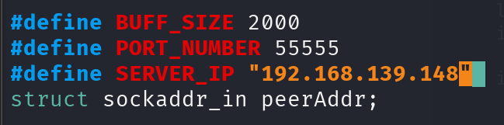
Now, we can compile the C source code file, and run it to initialize a vpn client.

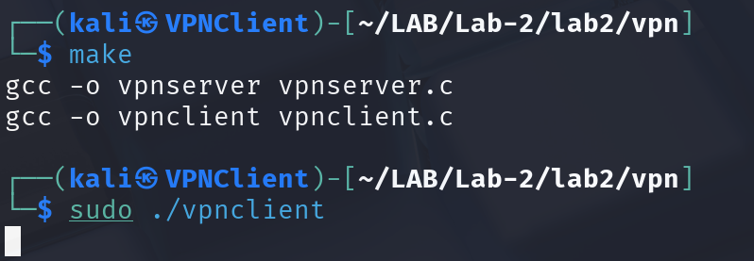
The interface tun0 appears can confirm the initializing step works perfectly.
sudo ifconfig tun0 192.168.53.5/24 up
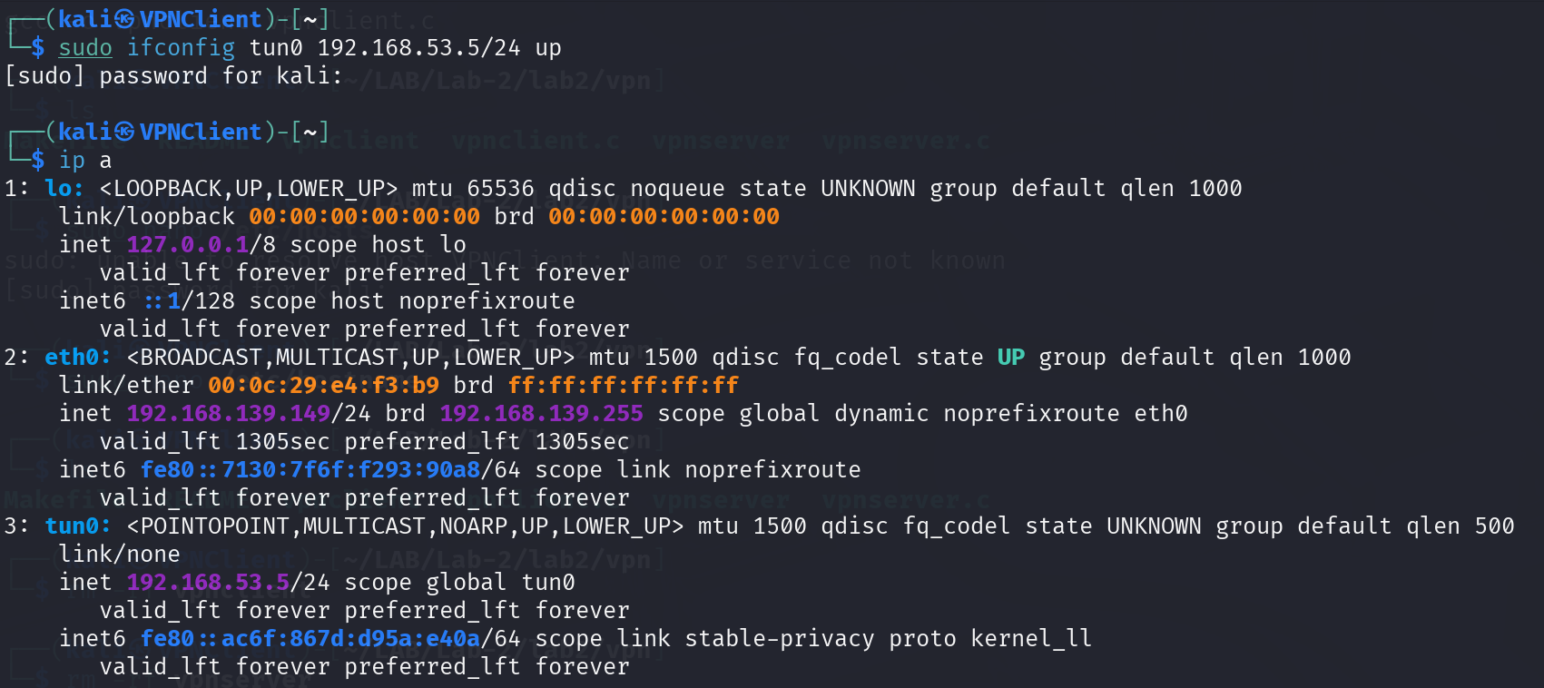
There is the different between tunnel and TUN
+ "Got a packet from the tunnel": The VPN Client received a packet from the VPN Server through the socket (TCP/UDP connection). This is data that has already been tunneled.
+ "Got a packet from TUN": The VPN Client received a packet from the virtual interface tun0. This could be a packet sent by the operating system into the tunnel.

Step 3: Configure routing on VPN server and VPN client
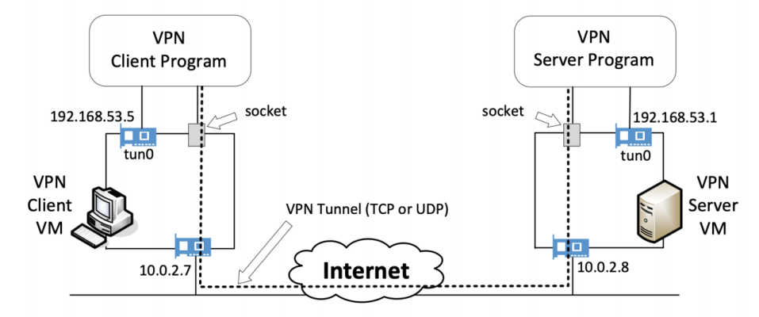
192.168.139.149
192.168.139.148
The flow:
Client OS → tun0 (192.168.53.5) → VPN Client Program → socket (192.168.139.149 → 192.168.139.148) → Internet → VPN Server Program → tun0 (192.168.53.1) → Server OS → Host V Host V → Server OS → tun0 → VPN Server Program → socket → Internet → VPN Client Program → tun0 → Client OS
After 2 steps above, the tunnel has been created, now we have to route the traffic to go through the tunnel. In the client machine, we have to route the traffic to go the interface tun0, so the packets can to through the tunnel.
In both client and server, we have to configure the route to automatically route all the packets that go to ip 192.168.53.0/24 go through interface tun0.

In the VPN Client:
Host U only knows about the NAT network ( 192.168.35.0/24 ) and the tunnel network ( 192.168.53.0/24 ). It does not know about the internal network of Host V (192.168.60.0/24 ). If you try to ping 192.168.60.100, the Client OS has no route to that network, so the packet would be dropped. So we need to add a route to the interface network.
sudo route add -net 192.168.60.0/24 tun0

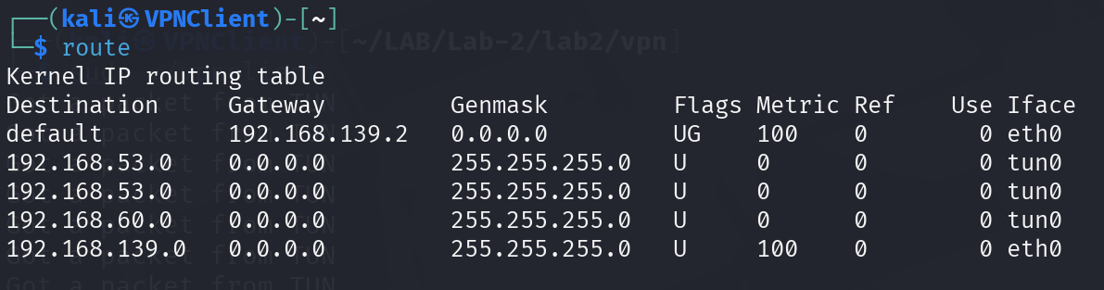
In the VPN Server:
The VPN Server has 3 network interfaces:
eth0, eth1, and tun0
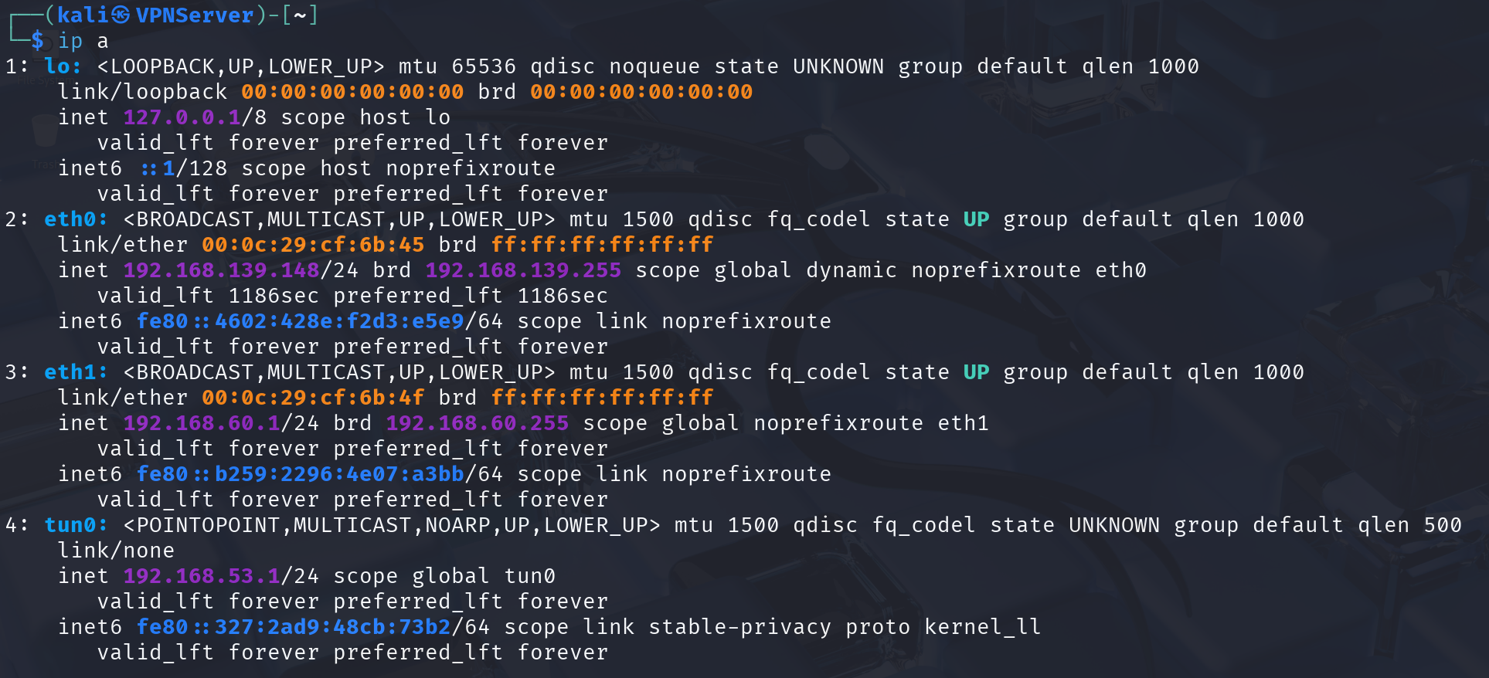
When the Server receives packets from the Client via the tunnel, it must know how to forward them to Host V. Likewise, when Host V replies, the Server must know how to send those packets back into the tunnel toward the Client. So we have to configure it.

# Forward packets from tunnel to internal network
sudo route add -net 192.168.60.0/24 eth1

# Forward packets from internal network back into the tunnel
sudo route add -net 192.168.53.0/24 tun0

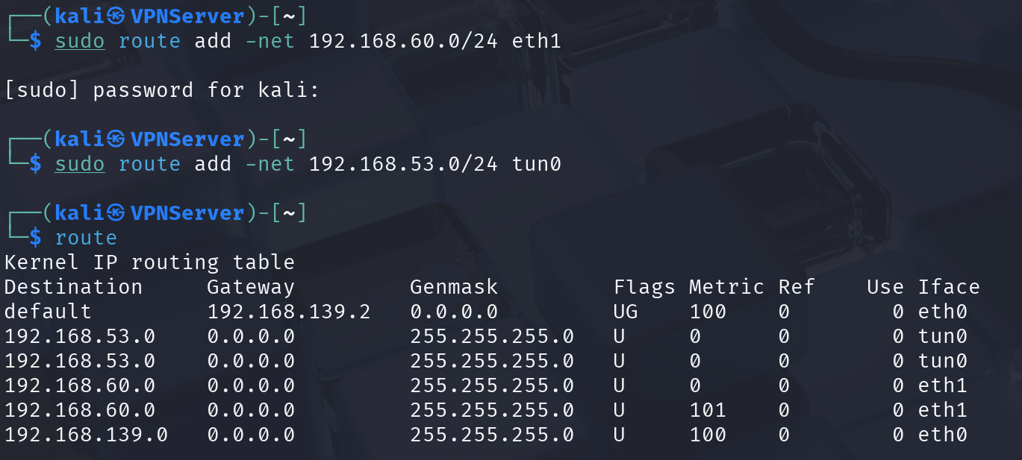
Step 4: Configure route on host V
In the Host V:
Host V only knows the internal network 192.168.60.0/24 (connected directly to the Server via eth0 ). When Host V receives a packet from Host U (source address 192.168.53.5 ), it does not know the route to the tunnel network 192.168.53.0/24 .
In order to reach the tunnel network 192.168.53.0/24 , send packets to the gateway 192.168.60.1 (the VPN Server).
sudo route add -net 192.168.53.0/24 gw 192.168.60.1

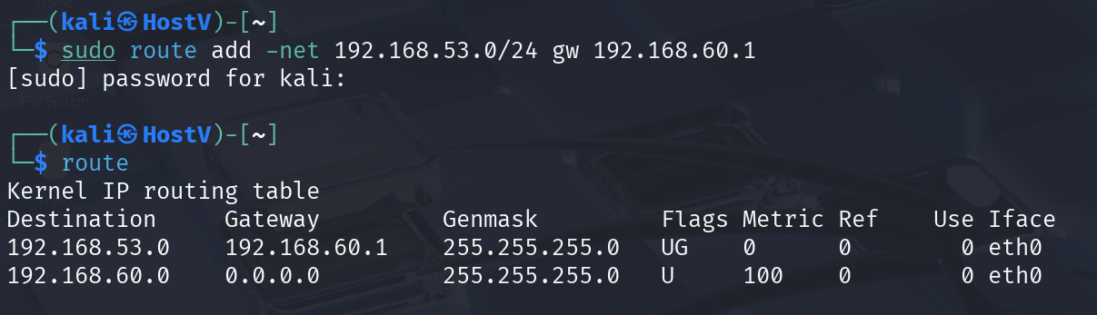
Now, lets test our configuration.
Execute ping and telnet commands and use Wireshark to capture packets and demonstrate that the VPN system is working correctly.
Ping from Host U to VPN Tunnel
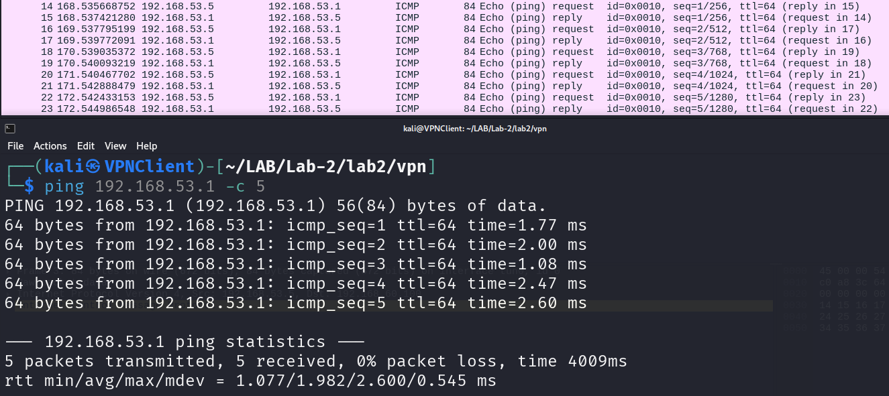
Ping from Host U to Host V
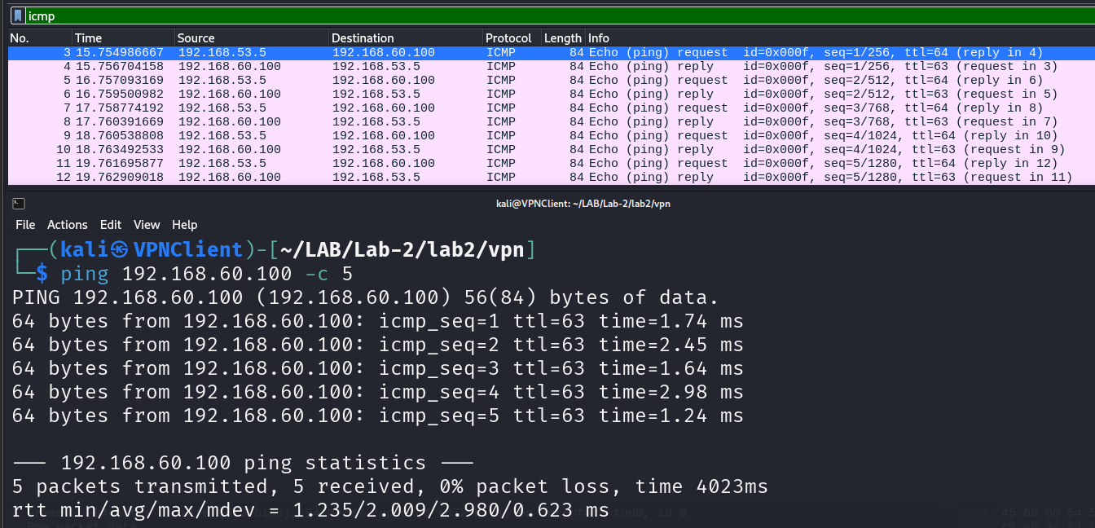

Telnet test
Telnet from Host U to Host V
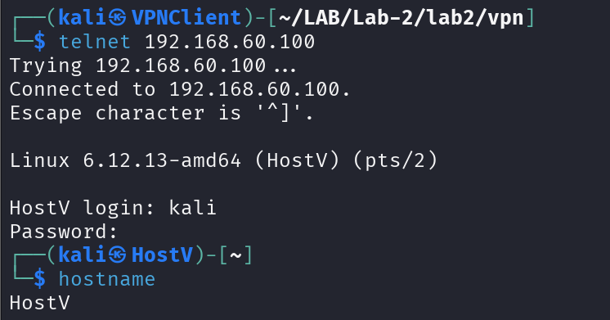
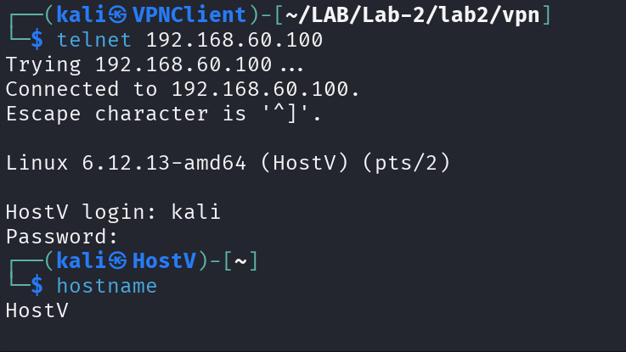
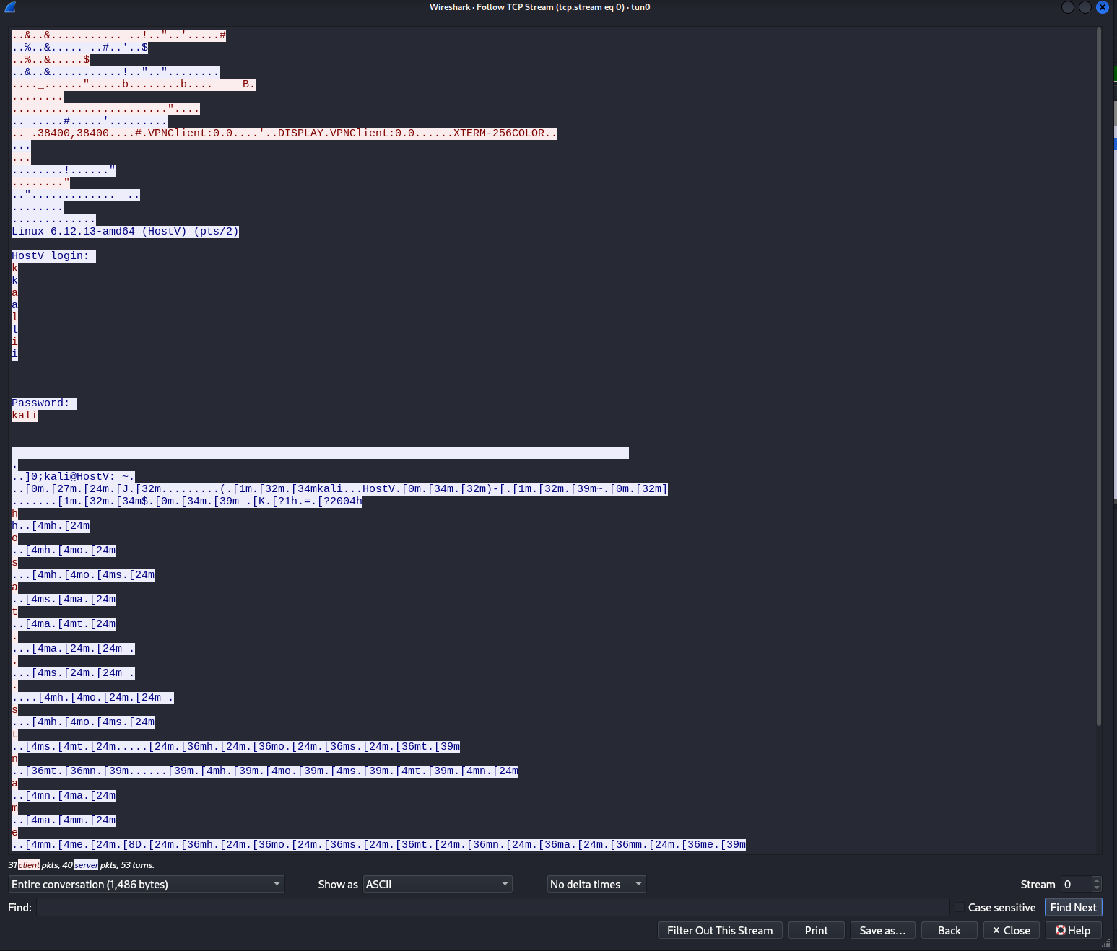
We can see in the wireshark that there is the login credential.

Move to the next test against the VPN
On Host U, telnet to Host V. While maintaining the telnet connection, disconnect the VPN tunnel. Then, type any character into the telnet window and report what observe. After that, reconnect the VPN tunnel. What will happen to the telnet connection? Will it be disconnected or resumed?
In this test, lets begin with the disconnection of VPN tunnel cause we have established the connection in the previous test.
Stopped the VPN Client program
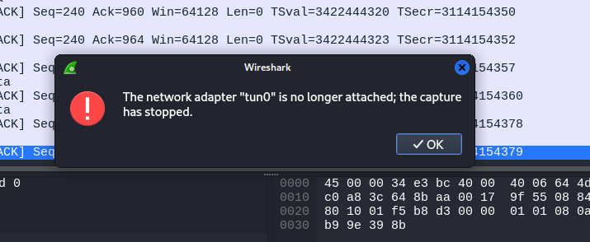
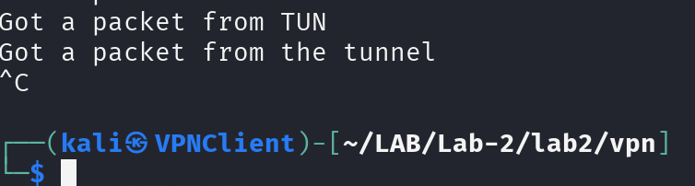
Then I cannot type anything on the telnet terminal, it’s totally frozen.
After that, I turned on the VPN Client program
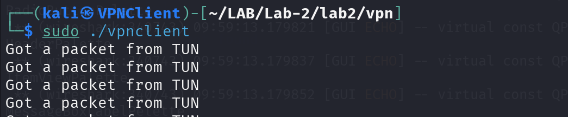
The most exciting part here is that the telnet session continue and I can enter command in it after 5 minutes of waiting for the connection to recover.
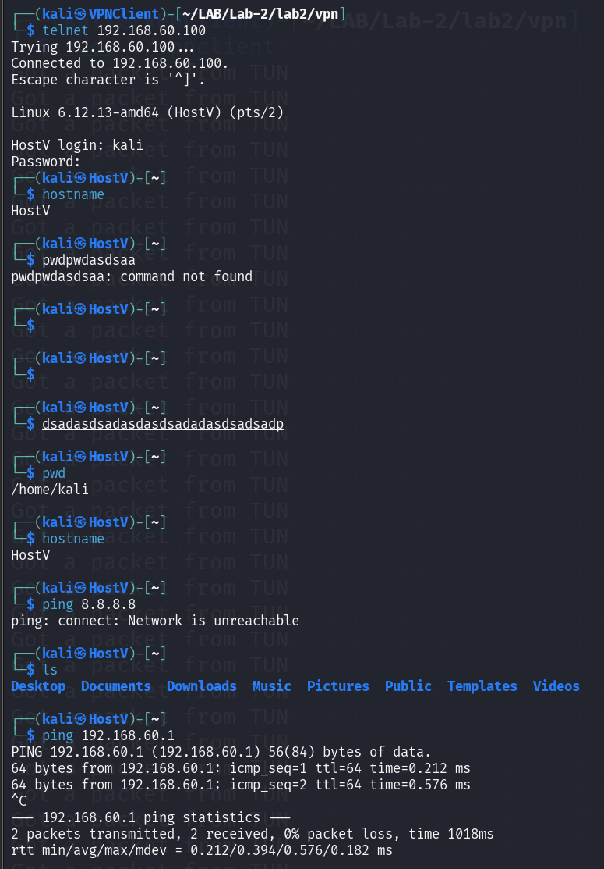
These scrambled words are what I typed when the VPN Client program was disconnected but I cannot see anything appeared on the screen, and when the connection resume, it show there these scrambled words that I typed, then I can type the command again as you can see.
Technical explanation:
1. TCP Connection Persistence:
The TCP (Transport Control Protocol) protocol has a connection resilience mechanism that helps maintain connectivity in the event of temporary network disconnection. When the VPN tunnel is interrupted:
The TCP connection enters a waiting/retransmitting state.
The TCP stack in the kernel continues to maintain the connection state (sequence numbers, acknowledgment numbers, window size).
TCP has a retransmission timer (usually 10-15 minutes depending on the operating system configuration) before abandoning the connection.
2. Buffer Mechanism:
Characters typed during the VPN interruption are stored in the client's output buffer:
The application (telnet client) sends data down to the TCP layer.
The TCP layer cannot send packets because there is no route to the destination.
Data is held in the send buffer waiting for network restoration.
When the VPN reconnects, TCP automatically flushes the buffer and sends the pending packets.
3. Telnet Echo Mechanism:
Telnet operates in remote echo mode:
Client sends characters → Server receives and echoes back → Client displays.
When the VPN is interrupted: Client sends → packets are dropped → no echo → blank screen.
When VPN Recovery: Server receives buffered packets → echoes them → characters appear on the screen.
4. Why the connection is restored:
The TCP connection is successfully restored because:
Reconnection time less than TCP timeout: VPN is restored within 5 minutes, faster than the TCP timeout threshold.
IP addresses remain unchanged: VPN tunnels use static IP (192.168.53.x), so the TCP connection identity (IP:port pairs) remains unchanged.
TCP state still exists: The kernel has not cleared the TCP connection state, allowing for seamless resumption.
Conclusion:
Experiments demonstrate that TCP connections can survive temporary network outages if the connection is restored before a timeout. This is an important feature of TCP, helping to maintain session reliability in unstable network environments.
The "scrambled characters" phenomenon that appears after reconnection is a result of the TCP buffering mechanism and telnet remote echo behavior, proving that no packets are lost during the VPN reconnection process.

3. TLS practice
First let’s install some dependencies
sudo apt update
sudo apt install libssl-dev
In VPN Server:
Compiled the VPN program code
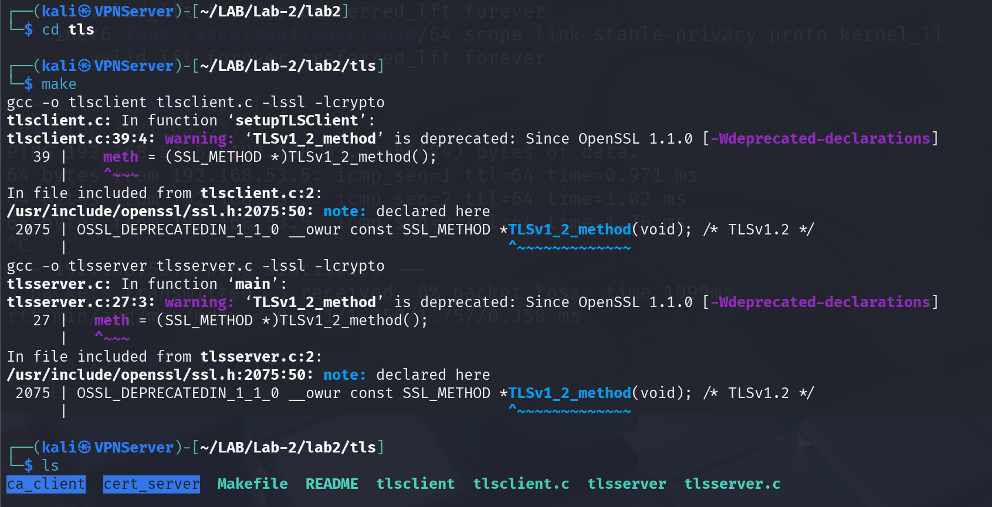
Warnings about TLSv1_2_method deprecated are normal and do not affect anything.
Then run the program.
sudo ./tlsserver
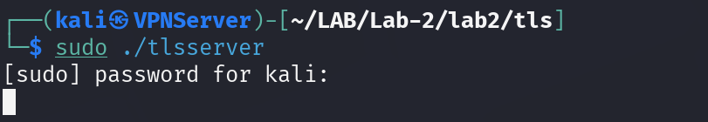
In VPN Client:
Compiled the code
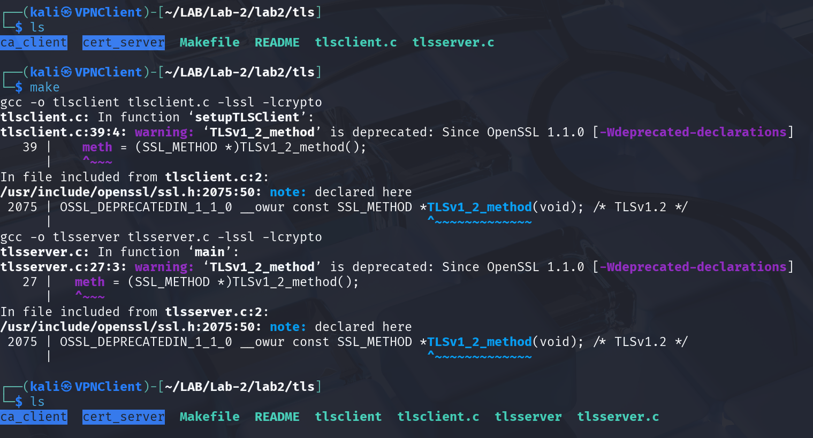
Add the hostname to /etc/hosts
sudo /etc/hosts
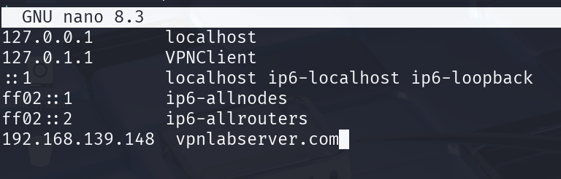
Then run the client program to test out the TLS
sudo ./tlsclient vpnlabserver.com 4433
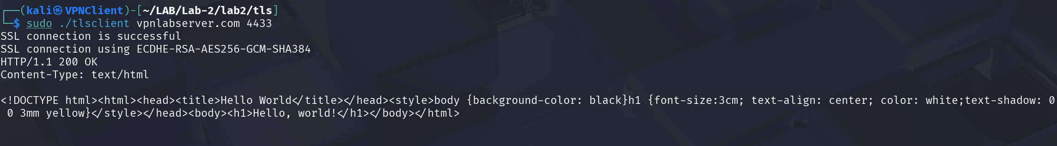
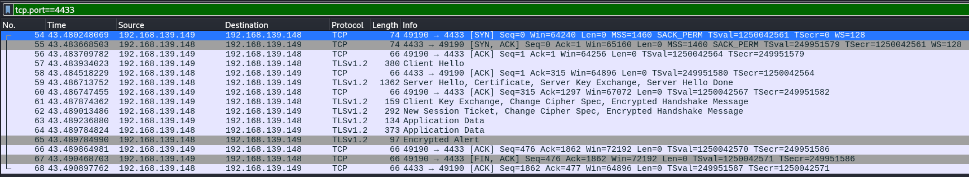
We can see the information was encrypted in wireshark
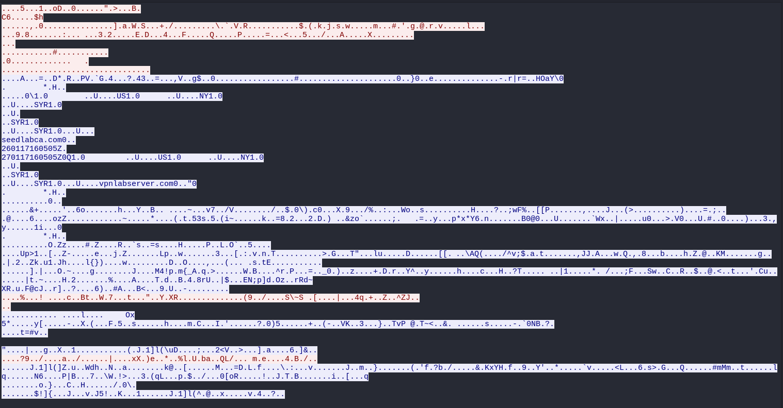
Comparing to what we can see in the terminal
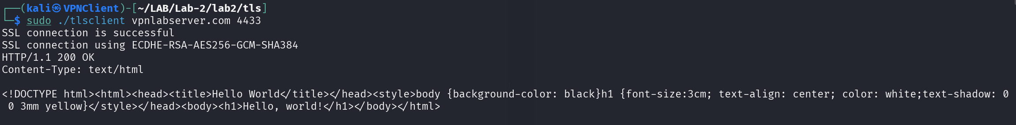
In the VPN Server we can see that it received the connection from client and then sent the data to the client.
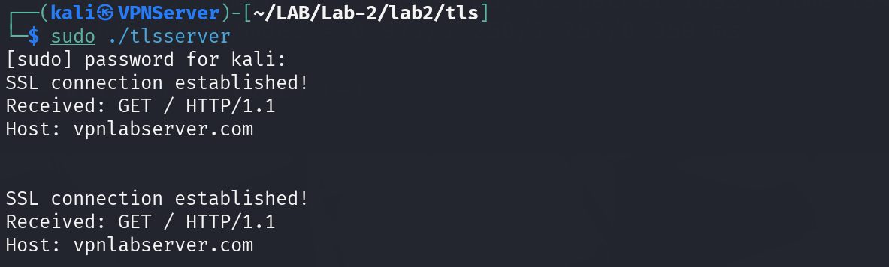
Observation: In the Wireshark capture, we can observe that the TLS handshake phase (including the certificate exchange) is transmitted in plain text. This is expected behavior, as the certificate must be readable by the client to verify the server's identity before establishing the encrypted channel. The certificate clearly shows:
+ Issuer: seedlabca.com (our CA)
+ Subject: vpnlabserver.com (server hostname)
+ Validity: January 17, 2026 to January 17, 2027
However, once the TLS handshake completes and the encrypted session is established, all Application Data packets are fully encrypted. The HTTP GET request and the HTML response containing "Hello, world!" cannot be read from the captured packets - they appear as random binary data. This proves that TLS successfully encrypts the application-layer communication while maintaining the ability to authenticate the server through its certificate.
TLS connection structure:
1. TLS Handshake (No encryption):
├─ Client Hello
├─ Server Hello
├─ Certificate ← See seedlabca.com, vpnlabserver.com, dates
├─ Key Exchange
└─ Change Cipher Spec
2. Application Data (Encryption):
├─ HTTP GET request ← Gibberish in Wireshark
└─ HTTP response ← Gibberish in Wireshark

CLIENT SERVER
| |
|------ TCP Connect -----------→ | (Port 4433)
| |
|<----- Certificate ------------- | (CN=vpnlabserver.com)
| (Client verify: hostname match)|
| |
|------ TLS Handshake ---------→ | (Exchange keys)
|←------------------------------ |
| |
|------ Encrypted Request -----→ | "GET / HTTP/1.1"
| (gibberish in Wireshark) |
| |
|<----- Encrypted Response ------| "Hello, world!"
| (gibberish in Wireshark) |
| |
| (Client decrypts and prints) |
| "Hello, world!" on terminal |

