Proxy
- Objective
- Purpose of this lab
Learn how NGINX reverse proxy works.
- Setup
Need atleast 3 virtual machines ( WEB 01, WEB 02, NGINX ).
Configuring the machines like the image below.
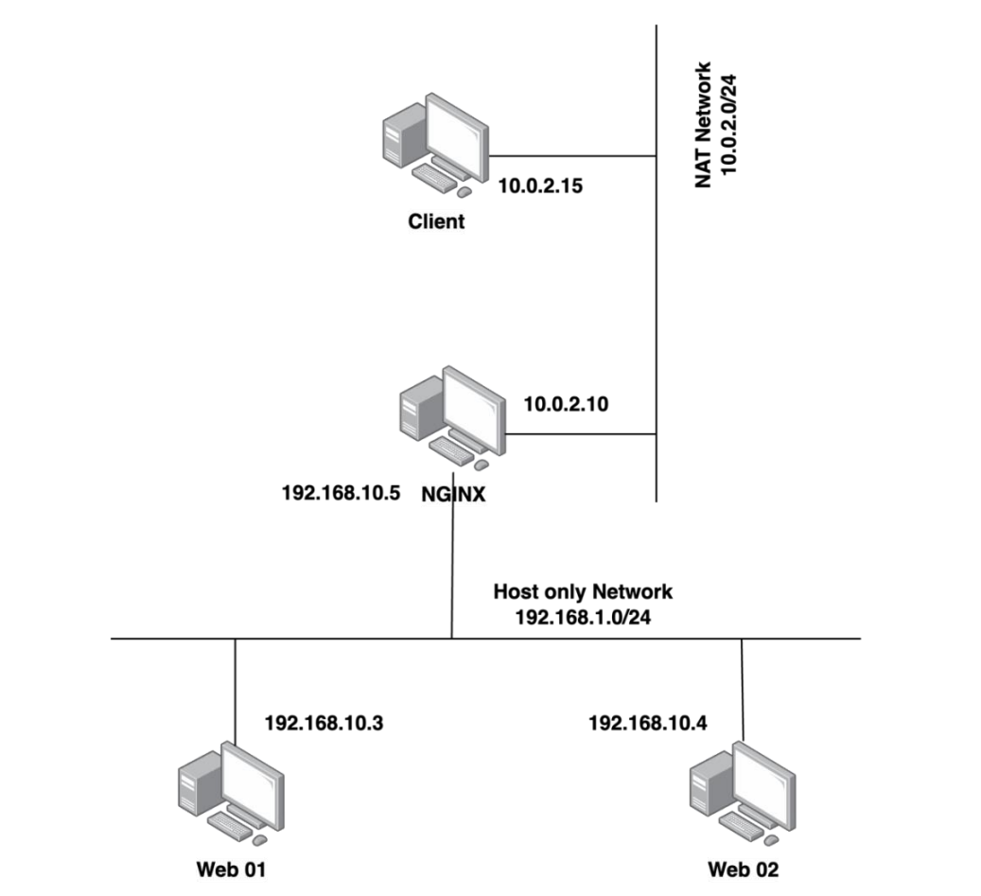
- Practice
- Install Apache and NGINX
- Install Apache
On Web 1 virtual machine, install Apache using the following commands.
sudo apt update
sudo apt upgrade -y
sudo apt install apache2 -y
sudo systemctl enable apache2
sudo systemctl start apache2
After installation, access the link http://localhost to check. If the website displays as shown in the image below, the installation was successful.
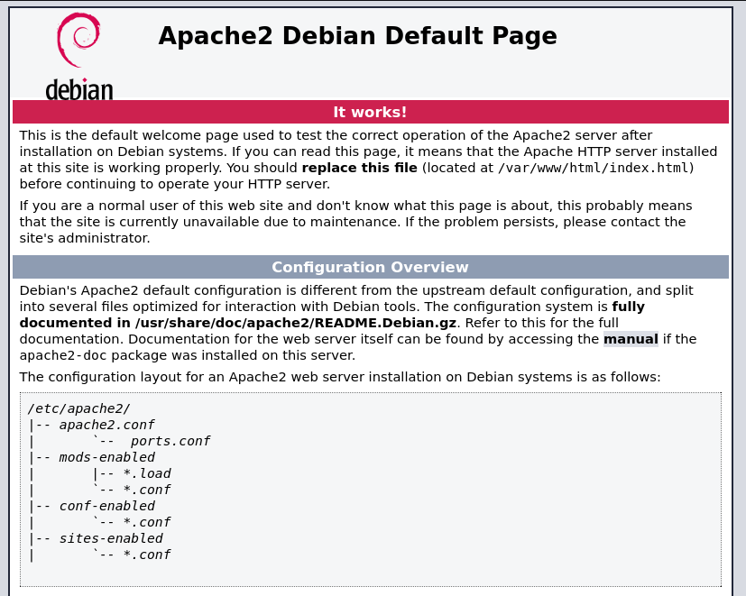
Now, let’s create a new html file to know that this is Web 1 machine
Cd /var/www/html
sudo rm -rf touch index.html #delete the welcome page of apache, we do not need it.
Sudo touch index.html
Sudo nano index.html
Then pass this line “<center><h1>This is website on Web Server 01</h1></center>”, after that press “Ctrl + x” then “y”.
Reload the page and we can see a new website appear.


Do the same installation and configuration for Web 2 machine.

- Install NGINX
On the NGINX machine, install nginx with these commands below.
sudo apt install nginx
sudo systemctl enable nginx
sudo systemctl start nginx
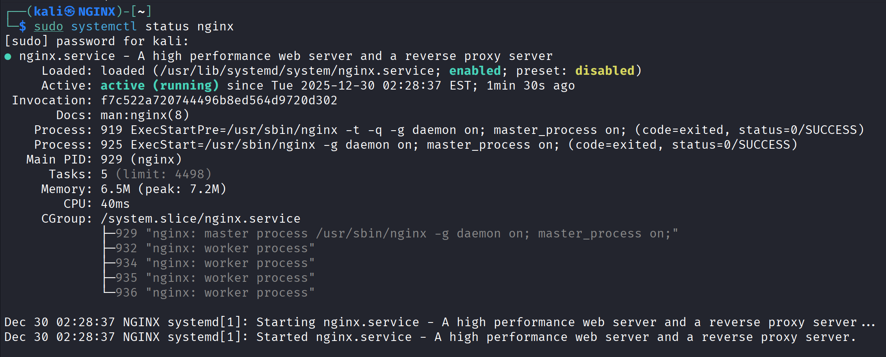
- Configure NGINX
- Simple proxy server setup
Edit the /etc/hosts file and add a domain mapping nginx.test to the address 127.0.0.1
sudo nano /etc/hosts
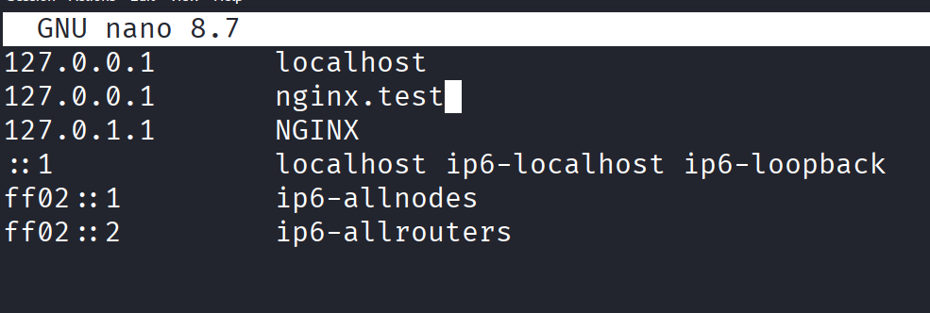
Open the configuration file /etc/nginx/nginx.conf and edit it.
sudo nano /etc/nginx/nginx.conf
Modify the nginx.conf like the image below.
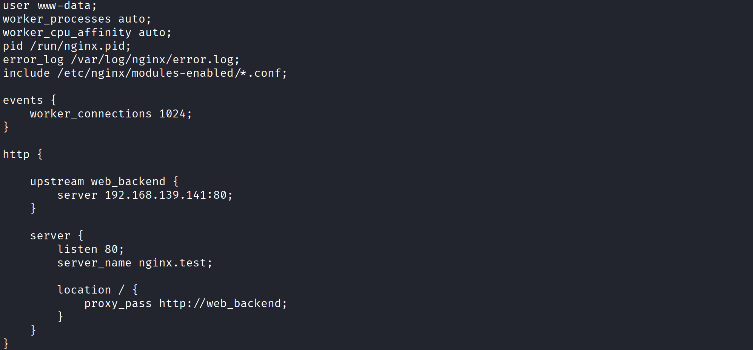
Reload NGINX to apply the configurations.
sudo nginx -t
sudo systemctl restart nginx
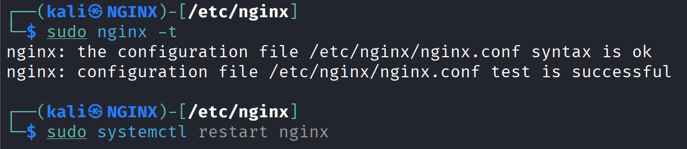
Then test with simple curl command.
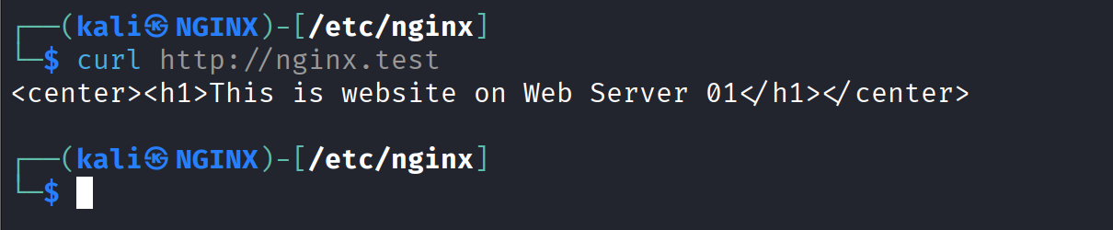
- Load Balancing
One of the standout functions of a reverse proxy is load balancing, which helps distribute user traffic to multiple backend servers to ensure system performance and reliability. When the system has to handle a large number of user requests, the reverse proxy acts as an intermediary gateway, routing each request to backend servers based on algorithms such as round-robin, least connections, or IP hash. This function not only reduces the load on each backend server but also improves response times and ensures that the system remains stable even if one or more servers fail.
Next, we will configure nginx as a load balancer based on the Round Robin algorithm.
Round Robin explanation:
Round Robin is a load-balancing algorithm that distributes incoming requests sequentially across all available servers in a circular order. When a request arrives, it is assigned to the first server in the pool; the next request goes to the second server, and so on, cycling back to the first server after reaching the last one.
This method treats all servers equally regardless of their current load, capacity, or response time. Round Robin is best suited for environments where all backend servers have similar hardware specifications and processing capabilities, and where session persistence is not required.
It's commonly used in DNS load balancing, web server clusters, and simple application deployments where requests are stateless and can be handled by any server without maintaining user session data.
Open the previous configuration file /etc/nginx/nginx.conf and edit it to.
Note that: Nginx always uses round robin unless otherwise specified.
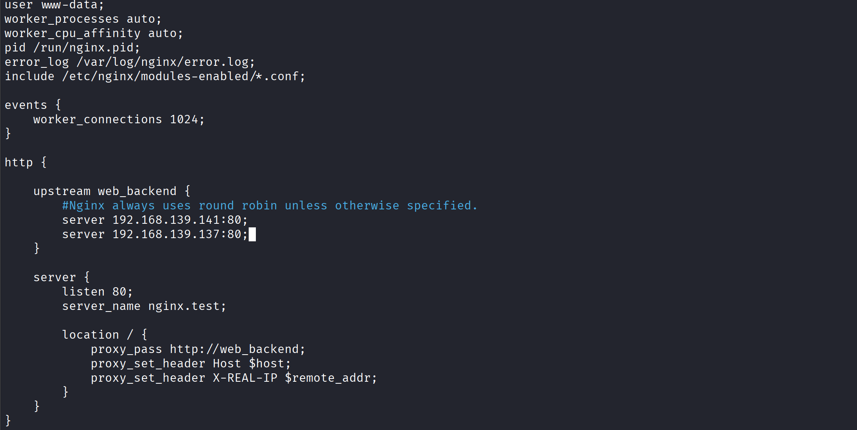
Then reload nginx to apply new configurations.
sudo nginx -t
sudo systemctl restart nginx

Test with script: for i in {1..6}; do curl http://nginx.test; done
We can see that, if I curl http://nginx.test, each time it do will have different outcomes.
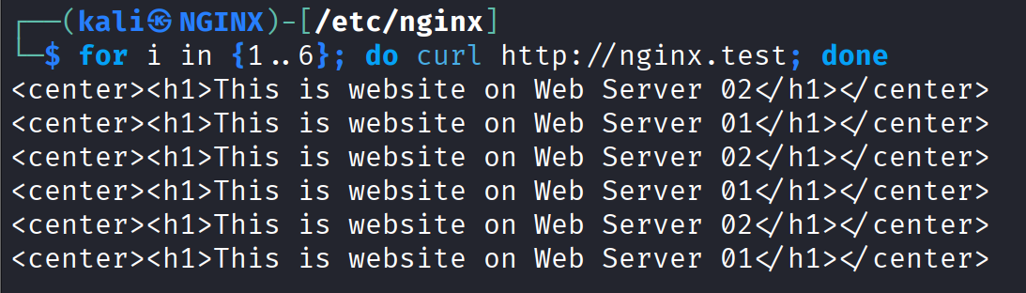
Now, shutdown the Web 1 and test again. All the traffic will be passed to Web 2.
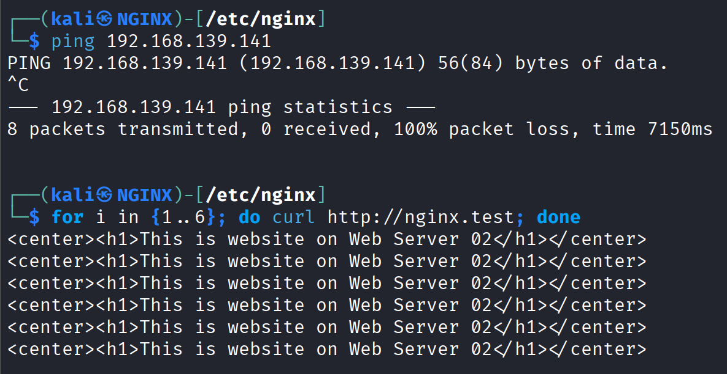
Then power on the Web 1, the traffic distributed evenly again
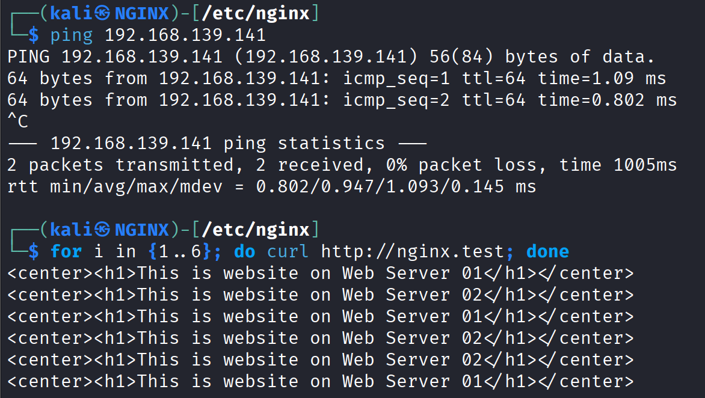
Next, we will configure nginx as a load balancer based on the IP Hash algorithm.
IP Hash explanation:
IP Hashing is a load balancing algorithm that assigns requests to servers based on a hash function applied to the client's IP address. The algorithm calculates a hash value from the source IP address and uses this value to consistently route all requests from the same client to the same backend server throughout the session.
This ensures session persistence (sticky sessions) without requiring additional session storage or cookies, as the same client IP will always map to the same server unless the server pool configuration changes.
IP Hashing is particularly valuable in applications that require session affinity, such as e-commerce platforms with shopping carts, web applications with user authentication states, or any scenario where maintaining session continuity is critical. However, it can lead to uneven load distribution if traffic comes from behind NAT gateways or proxy servers where multiple users share the same IP address.
Open the previous configuration file /etc/nginx/nginx.conf and edit it to.

Then restart nginx to apply new configurations.
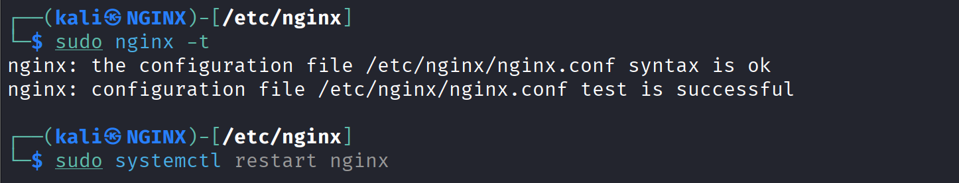
Test with script: for i in {1..6}; do curl http://nginx.test; done
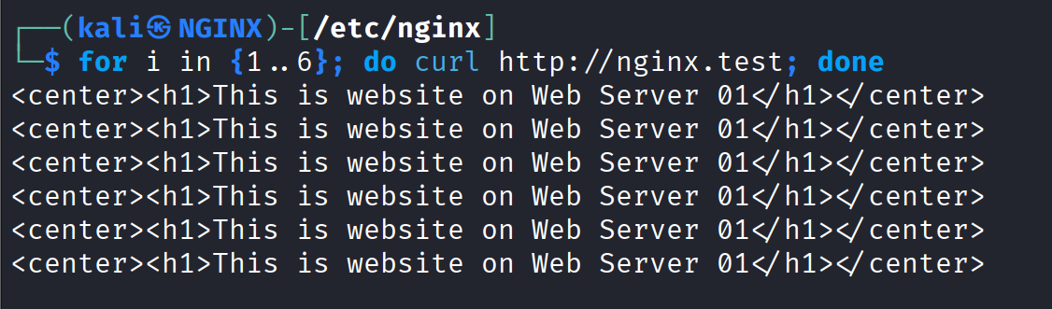
We got the result with no Web 2 be accessed; although the Web 2 machine is still running.

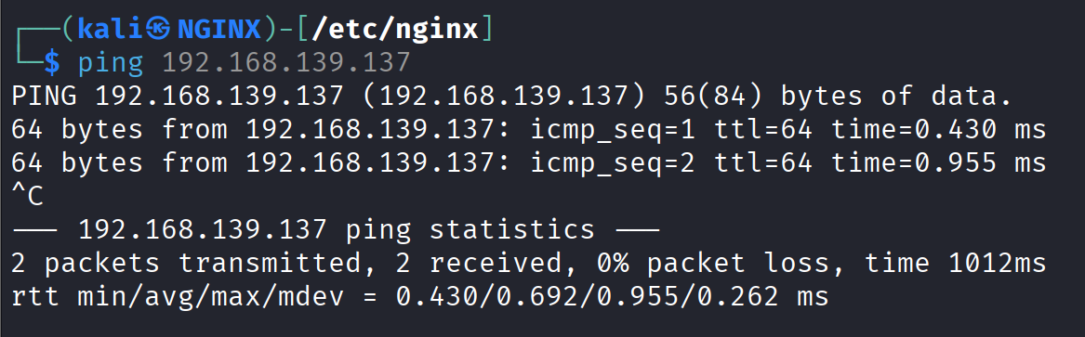
Now, let’s shutdown the Web 1 machine to see if the laod balancing work properly
All the traffic are now redirected to Web 2, but it would take a while for the load balancing to work.
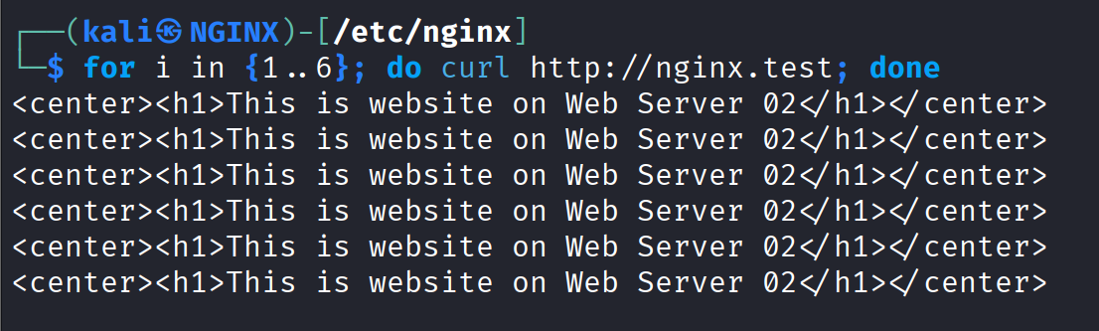
Power on the Web 1 machine again, if it is right, all the traffic should be sent directly to Web 1.
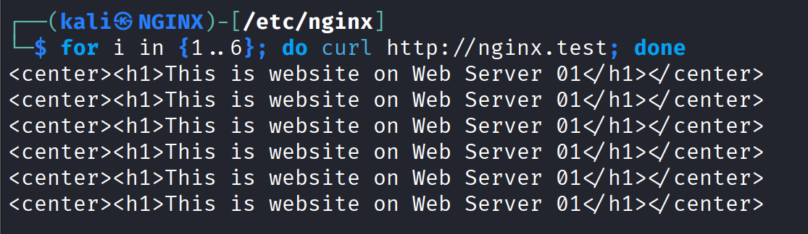
Explanation:
IP Hashing has a backend recovery behavior is that when using IP Hashing, Nginx hashes the client's source IP and maps it to the list of currently available backends. This mapping is recalculated whenever the backend pool changes. When Web 1 goes down, the pool becomes [web2] only, forcing all traffic to Web 2.
When Web 1 recovers, the pool returns to [web1, web2], triggering a hash recalculation that redistributes client IPs across both servers again. My IP, which was temporarily mapped to Web 2 during the outage, may now hash to Web 1 in the restored two-server pool.
This "traffic jump" is correct by design – IP Hashing prioritizes availability and load redistribution over absolute session persistence when backend topology changes, making it unsuitable for applications requiring guaranteed session stickiness across server failures and recoveries.

